Supplemental Figure 1. Data partition using group 4-fold cross-validation (CV) method. Within training data, each split represents independently trained model. For example, model CV1 used CV Split 1 (N=Training data) with Analysis set for training (Fold 2, Fold 3, Fold 4) and Assessment set for performance validation (Fold 1).

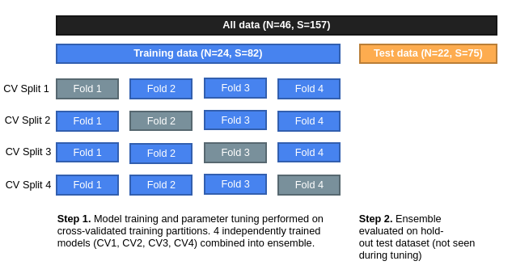

Supplemental Figure 2. Forest plot for patient-subgroup analyses.
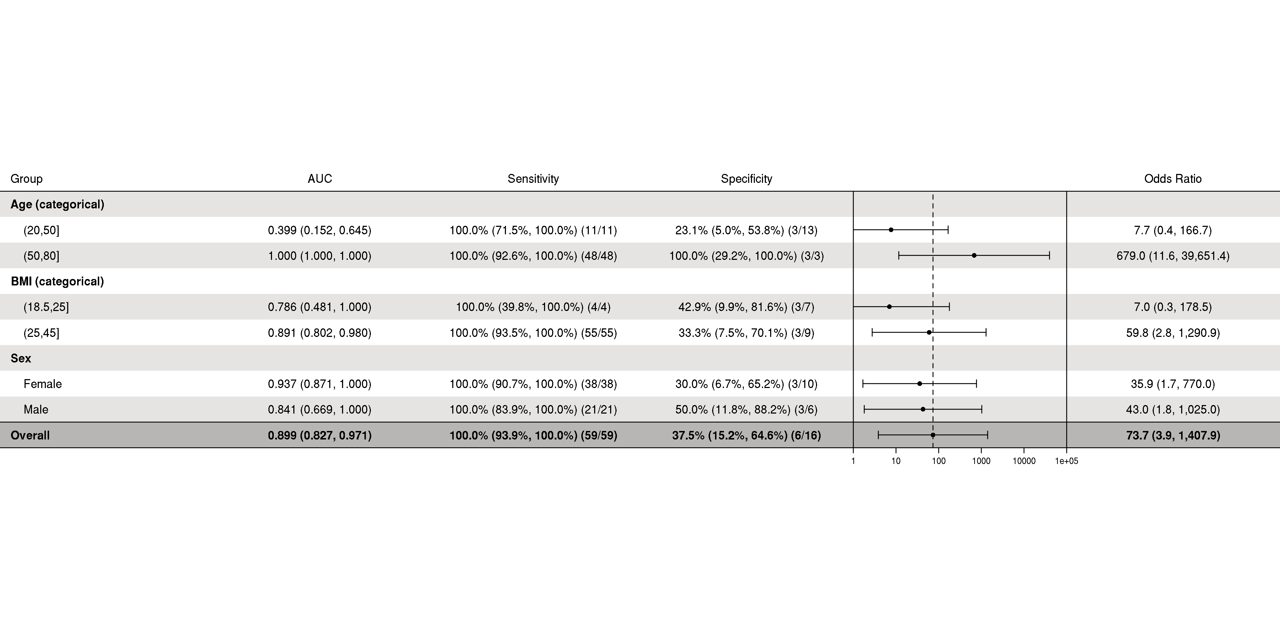
Supplemental Table 1. Comparison of characteristics across disease stage for the cirrhosis study population.

 |  | Median (minimum, maximum) or No. (%) of patients
 | N | Cirrhosis Stage I, Compensated (N=13) | Cirrhosis Stage II, Compensated (N=12) | Cirrhosis Stage III, Decompensated (N=10)
Ascites | 35 | 0 (0.0%) | 0 (0.0%) | 10 (100.0%)
Varices | 35 | 0 (0.0%) | 12 (100.0%) | 8 (80.0%)
Platelets | 35 | 185.0 (123.0, 272.0) | 92.5 (44.0, 279.0) | 83.0 (36.0, 238.0)
MELD | 35 | 8.0 (6.0, 20.0) | 10.0 (7.0, 19.0) | 13.0 (7.0, 28.0)
APRI | 35 | 0.4 (0.2, 1.1) | 0.8 (0.2, 3.5) | 0.9 (0.3, 3.5)
FIB4 | 35 | 2.4 (0.6, 4.2) | 3.7 (1.2, 10.7) | 6.0 (1.3, 14.8)
Etiology | 35
Nonalcoholic Steatohepatitis (NASH) |  | 10 (76.9%) | 8 (66.7%) | 3 (30.0%)
Alcoholic liver cirrhosis (ALC) |  | 0 (0.0%) | 2 (16.7%) | 0 (0.0%)
Hepatitis C Virus (HCV) |  | 1 (7.7%) | 1 (8.3%) | 1 (10.0%)
HCV+ALC |  | 0 (0.0%) | 0 (0.0%) | 2 (20.0%)
Primary sclerosing cholangitis 2 (PSC 2) |  | 2 (15.4%) | 1 (8.3%) | 3 (30.0%)
Hemochromatosis |  | 0 (0.0%) | 0 (0.0%) | 1 (10.0%)
Total Bilirubin | 35 | 0.8 (0.2, 4.3) | 1.0 (0.5, 9.2) | 1.0 (0.4, 2.4)
AST | 35 | 39.0 (24.0, 66.0) | 33.5 (25.0, 188.0) | 36.5 (20.0, 116.0)
ALT | 35 | 41.0 (20.0, 81.0) | 34.0 (21.0, 357.0) | 28.0 (20.0, 78.0)
Alkaline Phosphatase | 35 | 110.0 (45.0, 158.0) | 93.0 (71.0, 1612.0) | 113.5 (39.0, 247.0)
Creatine | 35 | 0.8 (0.5, 1.9) | 0.8 (0.4, 1.0) | 0.9 (0.6, 4.1)
Serum Sodium | 35 | 140.0 (135.0, 144.0) | 139.5 (136.0, 142.0) | 138.0 (127.0, 143.0)
Albumin | 35 | 4.2 (2.7, 4.7) | 4.0 (3.5, 4.4) | 3.8 (3.1, 4.8)
AFP | 21 | 3.1 (1.3, 6.7) | 3.0 (1.8, 7.7) | 2.5 (1.2, 5.3)
Leukocytes | 35 | 5.3 (3.4, 10.5) | 4.9 (1.8, 9.9) | 3.8 (1.7, 7.0)
Hemoglobin | 35 | 12.9 (9.8, 14.9) | 12.9 (11.0, 16.1) | 11.6 (7.4, 16.1)
INR | 35 | 1.1 (0.8, 1.8) | 1.2 (1.1, 1.5) | 1.3 (0.9, 2.7)
Abbreviations: MELD = model for end-stage liver disease, APRI = aspartate aminotransferase to platelet ratio index, FIB4 = Fibrosis-4 index for liver fibrosis, AST = aspartate aminotransferase, ALT = alanine transaminase, AFP = alpha-fetoprotein, INR = international normalized ratio.

Supplemental Table 2. Number (percentage) of samples and patients in each Cross-Validation (CV) split.

 | Disease | Healthy | Total
Sample level | N=123 | N=34 | N=157
Test | 59 (48.0%) | 16 (47.1%) | 75 (47.8%)
Train | 64 (52.0%) | 18 (52.9%) | 82 (52.2%)
CV Split 1
- Analysis | 50 (78.1%) | 12 (66.7%) | 62 (75.6%)
- Assessment | 14 (21.9%) | 6 (33.3%) | 20 (24.4%)
CV Split 2
- Analysis | 42 (65.6%) | 13 (72.2%) | 55 (67.1%)
- Assessment | 22 (34.4%) | 5 (27.8%) | 27 (32.9%)
CV Split 3
- Analysis | 50 (78.1%) | 14 (77.8%) | 64 (78.0%)
- Assessment | 14 (21.9%) | 4 (22.2%) | 18 (22.0%)
CV Split 4
- Analysis | 50 (78.1%) | 15 (83.3%) | 65 (79.3%)
- Assessment | 14 (21.9%) | 3 (16.7%) | 17 (20.7%)
Patient level | N=35 | N=11 | N=46
Test | 17 (48.6%) | 5 (45.5%) | 22 (47.8%)
Train | 18 (51.4%) | 6 (54.5%) | 24 (52.2%)
CV Split 1
- Analysis | 14 (77.8%) | 4 (66.7%) | 18 (75.0%)
- Assessment | 4 (22.2%) | 2 (33.3%) | 6 (25.0%)
CV Split 2
- Analysis | 12 (66.7%) | 4 (66.7%) | 16 (66.7%)
- Assessment | 6 (33.3%) | 2 (33.3%) | 8 (33.3%)
CV Split 3
- Analysis | 14 (77.8%) | 5 (83.3%) | 19 (79.2%)
- Assessment | 4 (22.2%) | 1 (16.7%) | 5 (20.8%)
CV Split 4
- Analysis | 14 (77.8%) | 5 (83.3%) | 19 (79.2%)
- Assessment | 4 (22.2%) | 1 (16.7%) | 5 (20.8%)

Supplemental Table 3. Hyperparameter configuration for optimal model

Hyperparameter | Value
Learning Rate | 0.005
Learning Rate Optimizers | Adam [32],  Reduce LR by 0.5 after 10 epoch plateau
Batch Size | 5
Loss | Categorical cross-entropy
Regularization | L2 (alpha = 0.01)  Batch normalization  (momentum = 0.99, epsilon=0.001)
Training epochs | 200
Validation | 4-fold cross validation

