Supplemental Material for
Stabilization of S₃O₄ at High Pressure-Implications for the Sulfur Excess Paradox
Siyu Liu¹, Jian Lv¹, ﻿Pengyue Gao¹, Andreas Hermann², Guochun Yang³, ﻿Yanchao Wang^{1,*}, and Yanming Ma^{1,4,*}
¹State key laboratory of superhard materials & International center of computational method and software, College of Physics, Jilin University, Changchun 130012, China
²Centre for Science at Extreme Conditions and SUPA, School of Physics and Astronomy, The University of Edinburgh, Edinburgh EH9 3FD, United Kingdom
³School of Science, Yanshan University, Qinhuangdao 066004, China
⁴International Center of Future Science, Jilin University, Changchun 130012, China

Figure S1. Relative enthalpies and Gibbs free energy of ﻿proposed reactions for 4SO₃+5S→3S₃O₄ (blue line) and 2SO₂+S→S₃O₄ (red line) with various van der Waals (vdW) methods at high-pressure and high-temperature. Due to the typical layer structure of S₃O₄, the vdW methods were adopted to include the dispersion interactions. All the calculations reveal that S₃O₄ is stable at high-pressure and temperature.

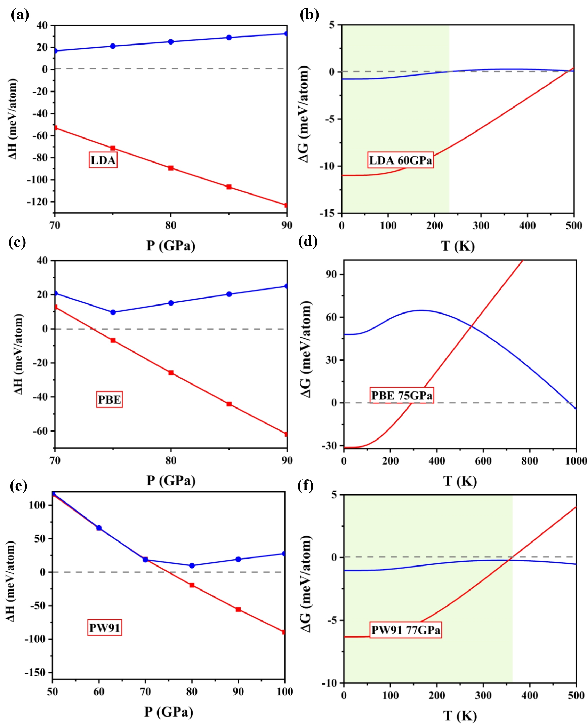
Figure S2. Relative enthalpies and Gibbs free energy of ﻿proposed reactions for 4SO₃+5S→3S₃O₄ (blue line) and 2SO₂+S→S₃O₄ (red line) with three different exchange-correlation functionals at high-pressure and high-temperature. The calculations within LDA and PW91 indicate that the S₃O₄ is stable at high-pressure and high temperature.

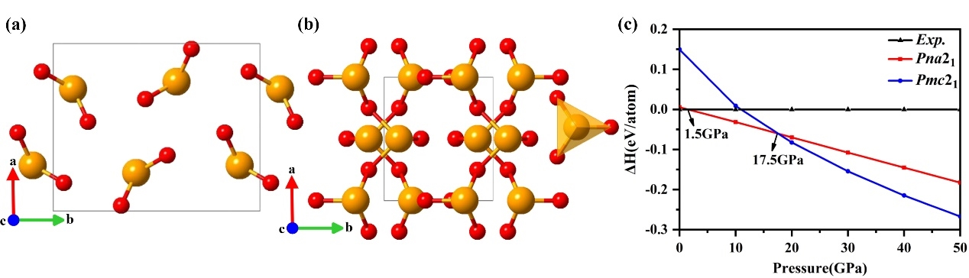
Figure S3. (a) Crystal structure of Pna2₁-SO₂. (b) Crystal structure of Pmc2₁-SO₂. (c) Static enthalpy differences relative to experimental Aba2 phase as a function of pressure for the predicted structures of SO₂ at 0-50 GPa.

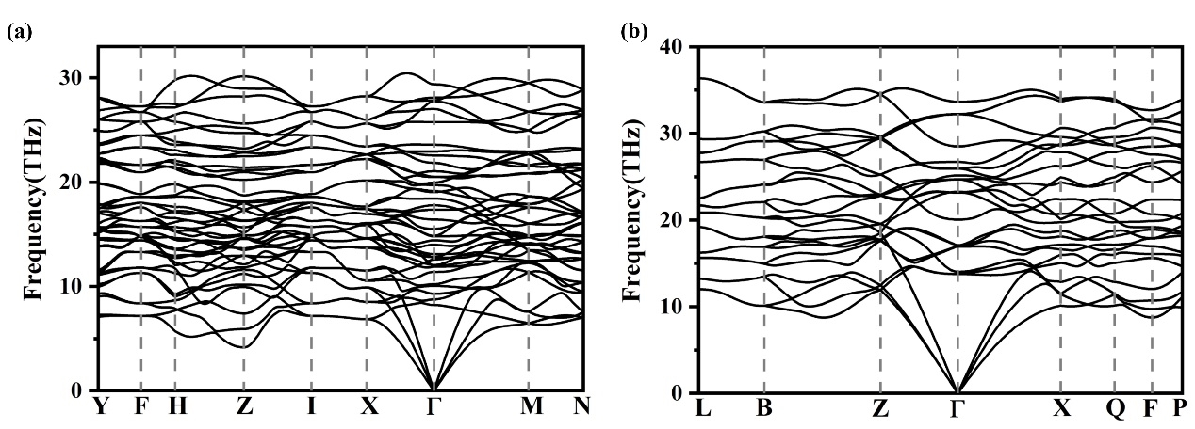
Figure S4. Dynamic stability of S₃O₄ and SO₃. Phonon dispersion relations along select high-symmetry points in the Brillouin zone for (a) C2/m-S₃O₄ (b) $R\overline{3}c$-SO₃ at 100 GPa.

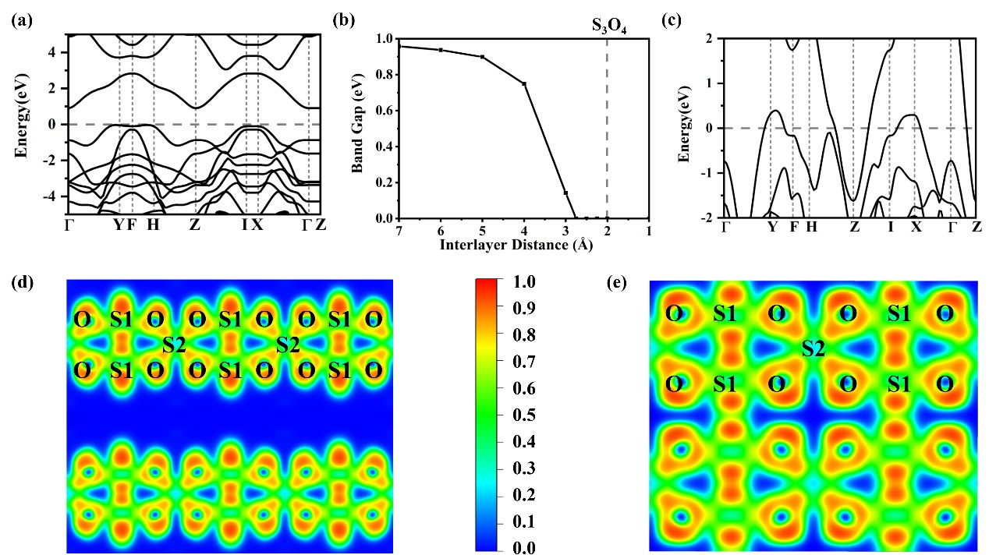
Figure S5. (a) Band structure of the S₃O₄ with 10 Å interlayer distance. (b) The band gaps as a function of interlayer distance. (c) Band structure of the S₃O₄. The horizontal dashed line indicated the Fermi energy level. Calculated ELF in (100) plane of (d) S₃O₄ with 5 Å interlayer distance and (e) S₃O₄ phase. The band gap strongly depends on interlayer distance. The S₃O₄ shows insulating character when the interlayer distance is larger than 2.75 Å. Interestingly, reducing interlayer distance makes part of electrons in the layer transfer into the interlayer regions, enhancing the delocalized degree of electrons and resulting in the metallization.

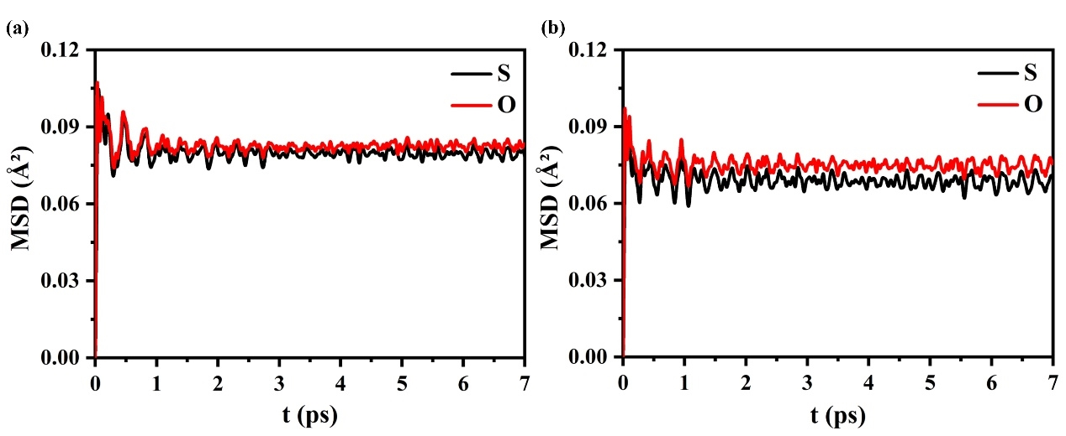
Figure S6. Calculated mean-square-deviation (MSD) of S and O in S₃O₄ at 2,000 K at (a) 80 GPa and (b)100 GPa.

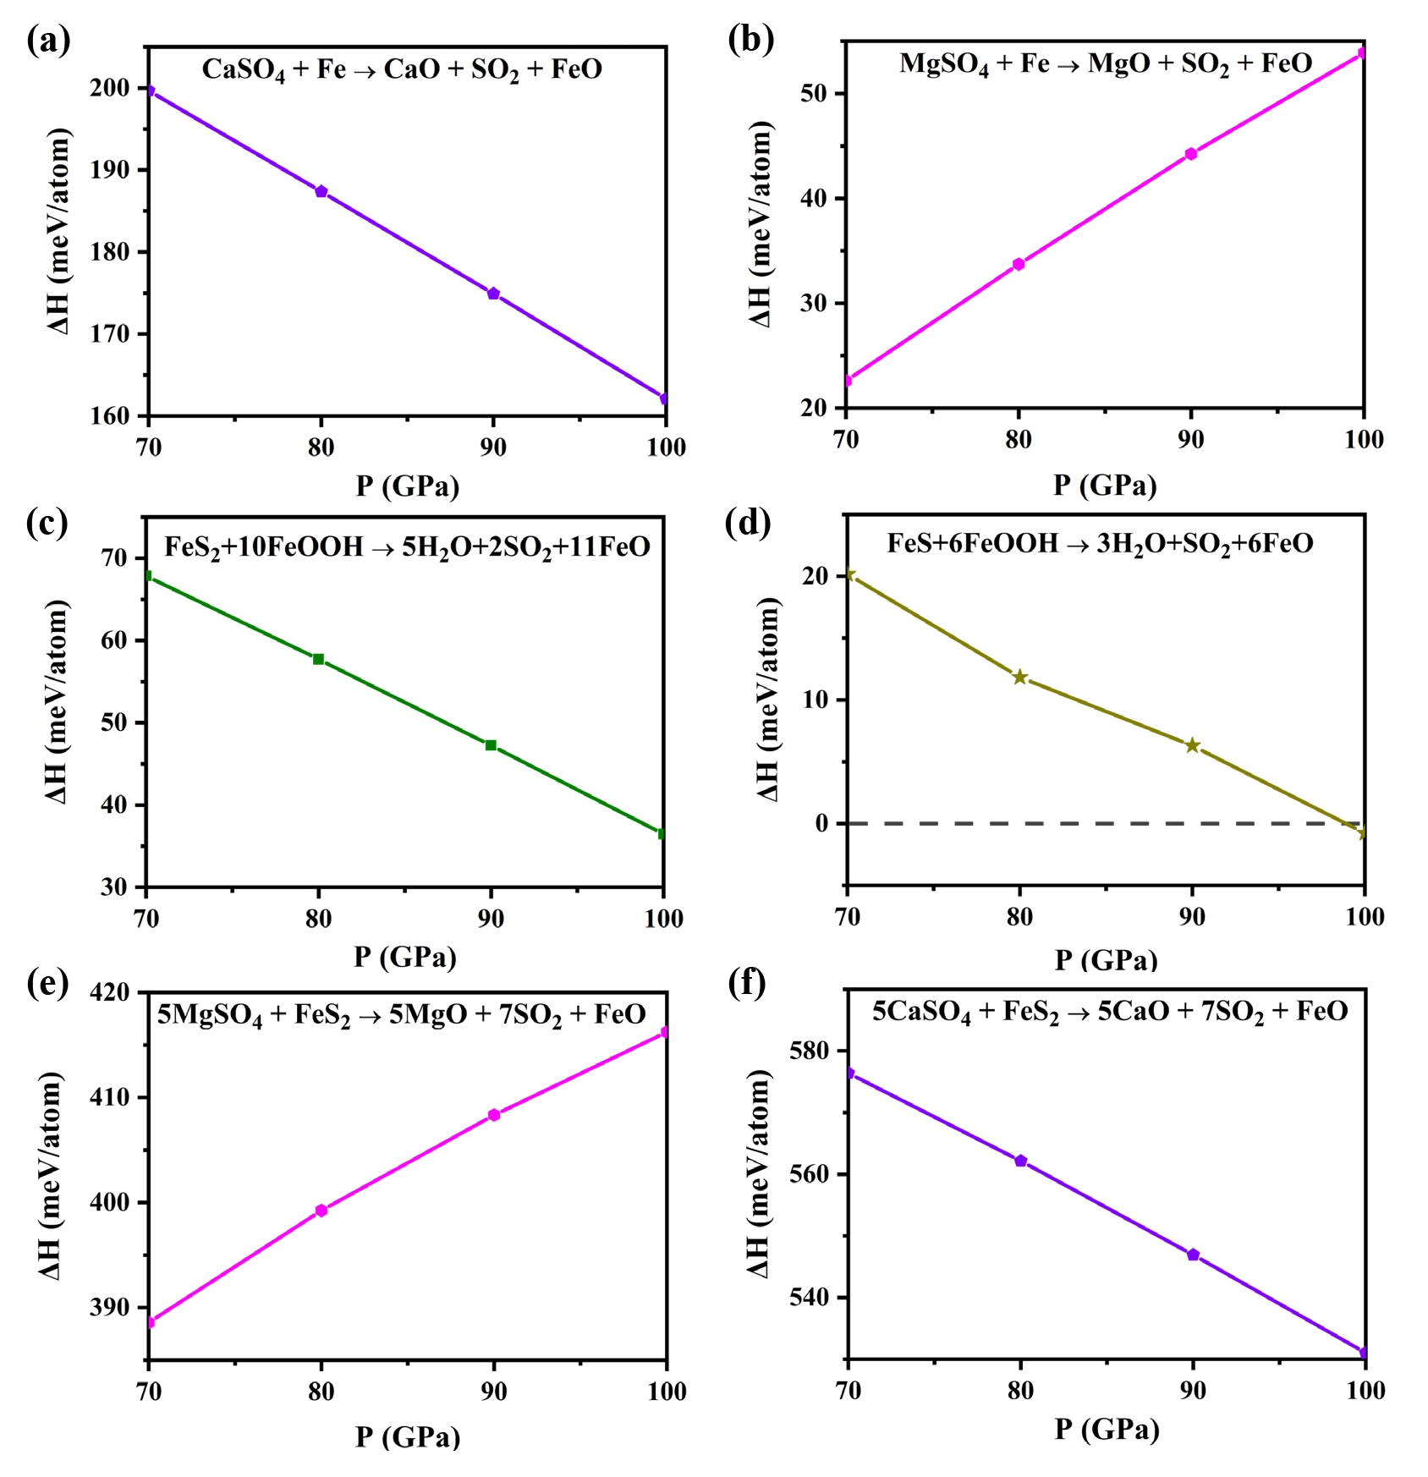
Figure S7. Relative enthalpy of ﻿the some reactions at high pressure. (a-f) The positive reaction enthalpies demonstrate that the reactions involving sulfates (CaSO₄/MgSO₄) and sulfides (FeS₂/FeS) cannot directly produce SO₂ at low pressure.

Figure S8. Volumes as function of pressure for R$\overline{3}$c-SO₃ calculated by PAW of VASP and all-electron potential of WIEN2k. The relative error is nearly 2%, validating our calculations within the PAW.

Table S1. Detailed crystallographic information for the energetically stable structures of S-O compounds identified in our structure search.

P(GPa) | System | Space  group | Lattice constants  (Å,°) | Atom | Atomic coordinates (Fractional)
 |  |  |  |  | X | Y | Z
50 | SO₂ | Pmc2₁ | a=4.4794  b=3.9383  c=5.6596 | S(2a) | 0.00000 | 0.74077 | -0.56433
 |  |  |  | S(2b) | 0.50000 | 0.13662 | -0.45431
 |  |  |  | O(2a) | 0.00000 | 0.62093 | -0.01845
 |  |  |  | O(2b) | 0.50000 | 0.34177 | -0.24091
 |  |  |  | O(4c) | 0.74985 | 0.13991 | -0.87690
100 | SO₃ | R$\overline{3}$c | a=3.9610  b=3.9610  c=10.7980 | S(6b) | 0.33333 | 0.66667 | -0.33333
 |  |  |  | O(18e) | 0.34160 | 0.00000 | -0.25000
100 | S₃O₄ | C2/m | a=4.6818  b=5.5553  c=4.6304  β=119.1969 | S(4i) | 0.97725 | 0.00000 | 0.74981
 |  |  |  | S(2b) | 0.00000 | 0.50000 | 0.00000
 |  |  |  | O(8j) | 0.99654 | 0.69447 | 0.24908
10 | SO₂ | Pna2₁ | a=5.8326  b=7.1641  c=3.3970 | S(4a) | -0.27598 | 0.59731 | -0.75029
 |  |  |  | O(4a) | -0.33403 | -0.05263 | -0.04025
 |  |  |  | O(4a) | -0.52563 | 0.32999 | -0.03386

