Molecular diagnosis of inversions resulting from intron 22 rearrangement of F8 gene in a patients with hemophilia A and their families and genotype-phenotype association analysis
Howra Bahrulolum¹*, Mehrdad Hashemi¹*

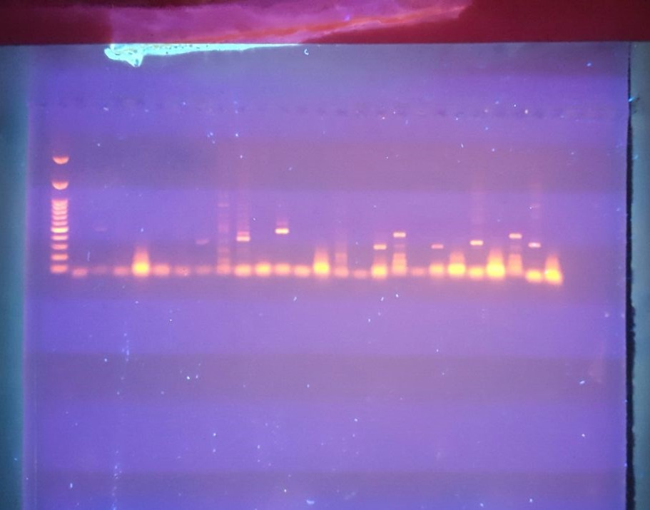
Supplementary Fig. 1. The analysis of the IS-PCR products by standard agarose gel electrophoresis of Inv22 type I and type II in HA patients and carriers.

