SUPPLEMENTARY INFORMATION

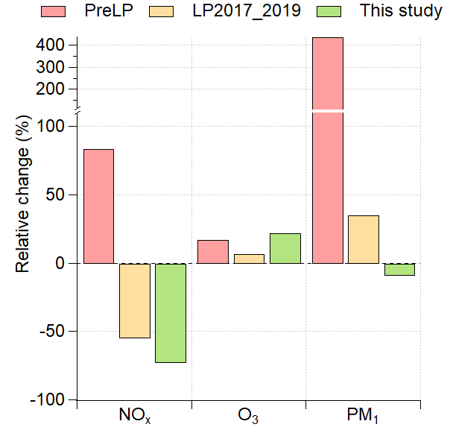
Fig.S1 Relative change (%) in concentrations during lockdown for NO_{x}, O₃, PM₁, SO₂ and BC with several reference periods. Bars correspond to the median relative change of daily concentrations of selected pollutants during lockdown, when applying PreLP and LP2017_2019 methodologies.

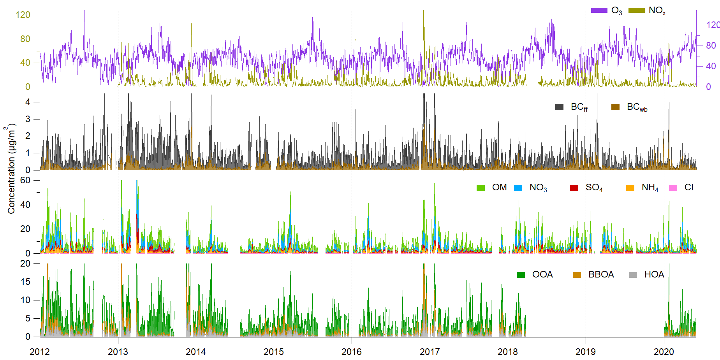
Fig.S2 Concentration timeseries (daily average, µg/m³) of the in-situ dataset used in this study.

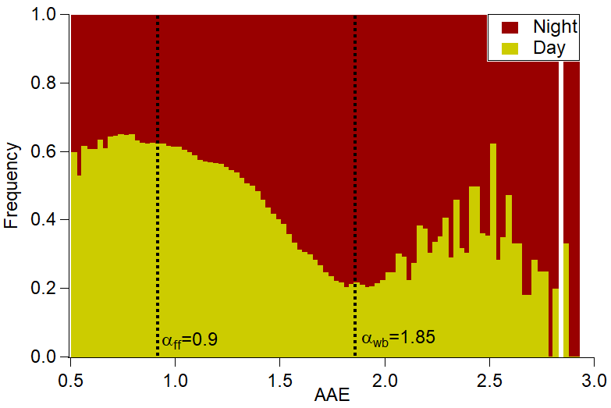
Fig.S3 Diurnal variations of AAE between night and day hours. Night and day were defined as UTC 18h00-5h00 and 6h00-17h00, respectively.

26/03/2020 | Analog #1 | Analog #2
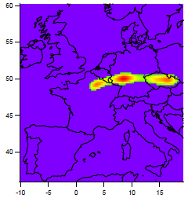a) | 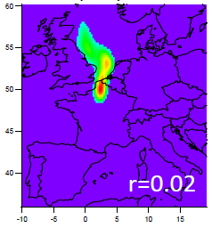b) | 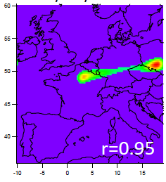c)
Fig.S4 Origin of air masses arriving at SIRTA. a) on March, 26th 2020; b) for one analog day from synoptic circulation analysis; c) for another day of the analog list. Pearson correlation coefficients are shown on the plot.

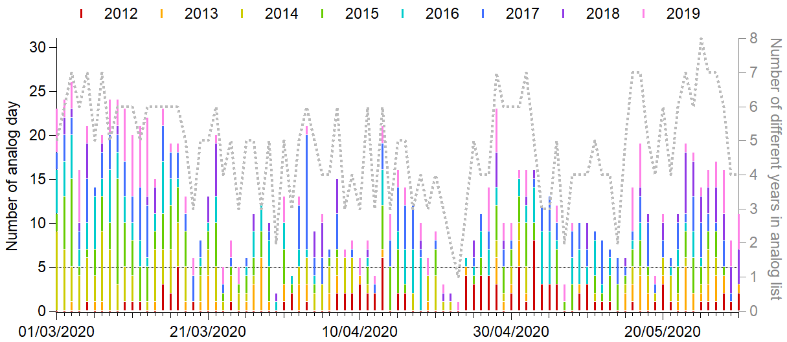
Fig.S5 Occurrence of years in the analog list for each day of March-May 2020. Grey dotted line represents the daily number of different years on the analog list. The minimum number of analogs (5) is shown with the black horizontal line.

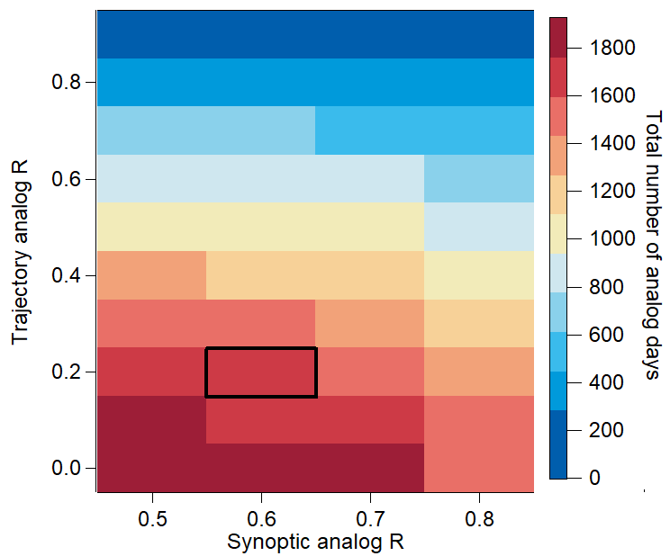
Fig.S6 Influence of correlation coefficients on the total number of analog days. Black box corresponds to the scenario used in the main text.

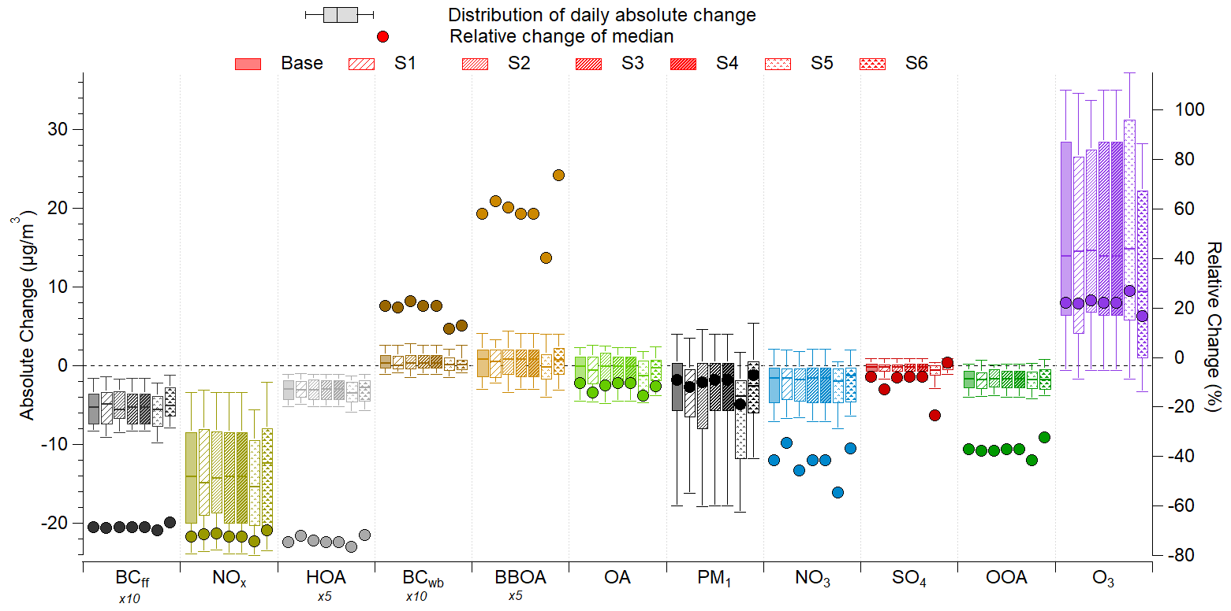
Fig.S7 Absolute and relative changes of ambient concentrations of reactive gases and particulate pollutants due to lockdown, calculated for different analog scenarios (Table S1). Left axis: Boxplots represent the distribution of daily absolute change (µg/m³); 10th, 25th, 50th, 75th and 90th percentiles were used. BC_{ff}, HOA, BC_{wb} and BBOA concentration changes have been scaled for clarity. Right axis: Round markers refer to the relative change (%) of median concentrations.

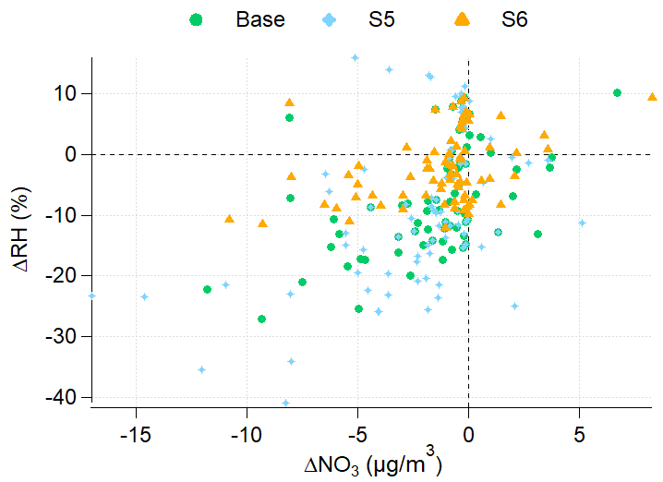a) | 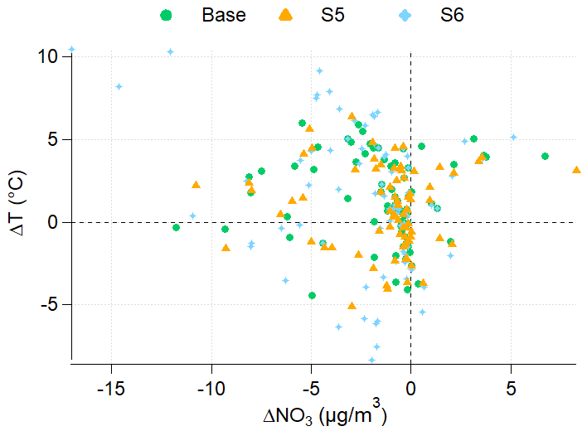b)
Fig.S8 Influence of meteorological filtering on the concentration change of NO₃. Daily concentration change of NO₃ versus RH (a) and temperature (b) change for Base, S5 and S6 scenarios.

