Table A Comparison of social-demographic characteristics and study variables among population
Characteristics | Total  (N = 67861) | Subjects |  | χ2 / t | P
Characteristics | Total  (N = 67861) | Enrolled  (N = 62372) | Excluded  (N = 5489) | χ2 / t | P
Child sex (%) |  |  |  | 3.013 | 0.083
Boy | 36812 | 33773 (54.1) | 3039 (55.4)
Girl | 31049 | 28599 (45.9) | 2450 (44.6)
Child age (mean (SD)) | 67861 | 4.61 (0.88) | 4.69 (0.85) | 6.493 | <0.001
Maternal education level (%) |  |  |  | 241.456 | <0.001
Junior high school or lower | 17462 | 15659 (25.1) | 1803 (33.9)
High school | 36480 | 33755 (54.1) | 2725 (51.3)
College or higher | 13744 | 12958 (20.8) | 786 (14.8)
Missing | 175 |  | 175
Maternal occupation (%) |  |  |  | 6.380 | 0.012
Employed | 57400 | 52957 (84.9) | 4443 (83.6)
Housewife | 10286 | 9415 (15.1) | 871 (16.4)
Missing | 175 |  | 175
Paternal education level (%) |  |  |  | 149.492 | <0.001
Junior high school or lower | 14130 | 12717 (20.4) | 1413 (26.9)
High school diploma | 34209 | 31594 (50.7) | 2615 (49.7)
College or higher | 19295 | 18061 (29.0) | 1234 (23.5)
Missing | 227 |  | 227
Family income, RMB/month (%) |  |  |  | 219.835 | <0.001
<5000 | 10319 | 9188 (14.7) | 1131 (21.1)
5001-10000 | 18417 | 16874 (27.1) | 1543 (28.8)
10001-20000 | 22583 | 20884 (33.5) | 1699 (31.7)
>20000 | 16419 | 15426 (24.7) | 993 (18.5)
Missing | 123 |  | 123
Marital status |  |  |  | 360.664 | <0.001
Single | 1913 | 1535 (2.5) | 378 (6.9)
Married | 65948 | 60837 (97.5) | 5111 (93.1)
Single child or not |  |  |  | 4.087 | 0.043
No | 36756 | 33773 (54.1) | 2983 (55.6)
Yes | 30983 | 28599 (45.9) | 2384 (44.4)
Missing | 122 |  | 122
Maternal age at child birth | 67861 | 27.00 (4.16) | 26.85 (4.39) | -2.455 | 0.014
Paternal age at child birth | 67861 | 29.57 (4.75) | 29.60 (5.00) | 0.538 | 0.591
Premature Birth |  |  |  | 0.058 | 0.809
No | 62592 | 57639 (92.4) | 4953 (92.3)
Yes | 5145 | 4733 (7.6) | 412 (7.7)
Missing | 124 |  | 124
BMI | 67861 | 20.36 (4.71) | 21.32 (48.81) | 1.435 | 0.151
Low Birth Weight |  |  |  | 3.382 | 0.066
No | 63819 | 58854 (94.4) | 4965 (93.8)
Yes | 3849 | 3518 (5.6) | 331 (6.2)
Missing | 193 |  | 193
ETS exposure in pregnancy |  |  |  | 39.281 | <0.001
No | 48363 | 44729 (71.7) | 3634 (67.7)
Yes | 19378 | 17643 (28.3) | 1735 (32.3)
Missing | 120 |  | 120
Cooking
No | 14622 | 14622 (23.4)
Yes | 47750 | 47750 (76.6)
Missing | 5489 |  | 5489
Total score of ABC (mean (SD)) | 67861 | 4.94 (10.68) | 5.57 (12.81) | 3.502 | <0.001

Table B Associations of COFs Exposure during Pregnancy with the ABC Subscales [ln(ABC score + 1)] in Preschoolers ^{a, b}
Variables | ABC Scores | Sensory | Relating | Body and object use | Language | Social and self-help skills
 | β (95% CI) | β (95% CI) | β (95% CI) | β (95% CI) | β (95% CI) | β (95% CI)
No COFs exposure | 0 | 0 | 0 | 0 | 0 | 0
COFs exposure | 0.22 (0.79, 0.81) *** | 0.35 (0.28, 0.42) *** | 0.24 (0.18, 0.29) *** | 0.30 (0.20, 0.41) *** | 0.32 (0.25, 0.39) *** | 0.19 (0.15, 0.24) ***
ª: Adjusting for maternal and paternal age at childbirth, maternal and paternal education level, family monthly income, marital status and maternal passive smoking during pregnancy.
^{b}: β of Tobit regression on the natural log scale can be interpreted as percentage changes in original ABC scores obtained by exponentiating the coefficient and subtracting 1.
COFs: Cooking Oil Fumes; ***: P <0.001.

Table C The number distribution of methods of ventilation in different type fuels of cooker used
Variables |  | Total (N = 47750) | %
Type fuels of cooker used | Methods of ventilation | Total (N = 47750) | % | χ² | P
Coal or others | No | 219 | 9.9%
 | Kitchen ventilator | 603 | 27.2%
 | Extractor fan use | 314 | 14.1%
 | Window opening | 1084 | 48.8%
Coal gas | No | 1672 | 5.1%
 | Kitchen ventilator | 17587 | 53.2%
 | Extractor fan use | 7357 | 22.3%
 | Window opening | 6419 | 19.4%
Natural gas | No | 136 | 1.9%
 | Kitchen ventilator | 5975 | 84.1%
 | Extractor fan use | 572 | 8.0%
 | Window opening | 425 | 6.0%
Electricity | No | 436 | 8.1%
 | Kitchen ventilator | 1715 | 31.8%
 | Extractor fan use | 1102 | 20.5%
 | Window opening | 2134 | 39.6%
 |  |  |  | 5444.6 | < 0.001

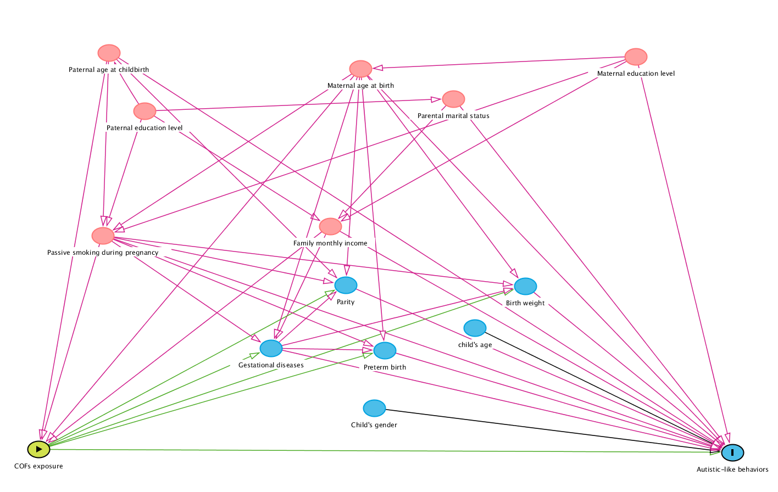
Figure A Directed acyclic graph for the association between maternal exposure to cooking oil fumes during pregnancy and autistic-like behaviors in Chinese preschoolers, showing all potential confounders. Pink lines indicate potential confounders.

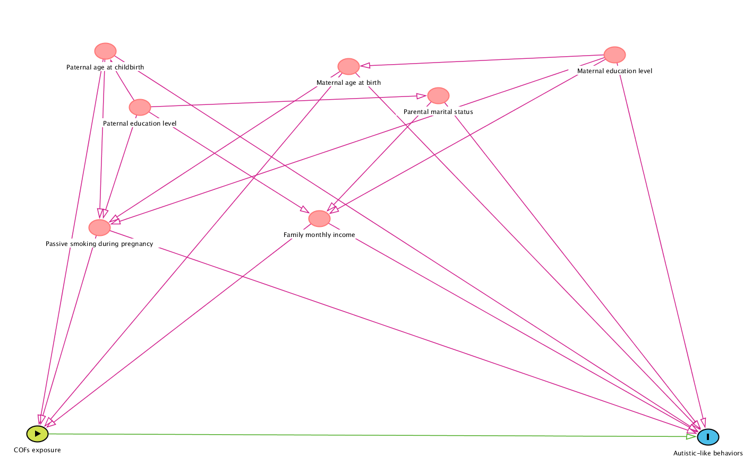
Figure B Directed acyclic graph for the association between maternal exposure to cooking oil fumes during pregnancy and autistic-like behaviors in Chinese preschoolers, showing only confounders retained in the final models. Pink lines indicate potential confounders.

