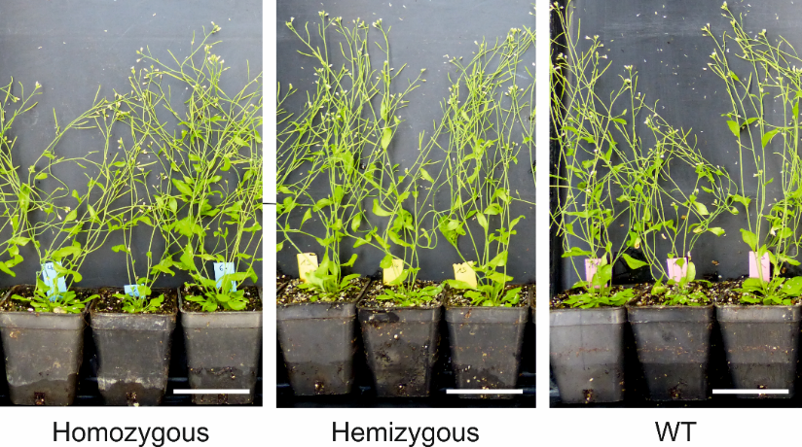
Supplemental Figure 1. Phenotype analysis of homozygous, hemizygous and WT plants. Representative pictures were taken from three homozygous, hemizygous and WT plants at 7.5 weeks-old. No phenotypic differences were observed. Scale bars represent 5 cm.

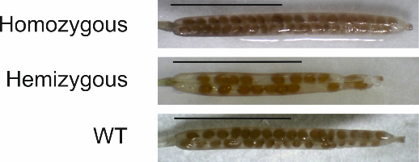
Supplemental Figure 2. Representative siliques from homozygous, hemizygous and WT plants. We observed empty spaces in place of seeds in several siliques of the hemizygous plants.

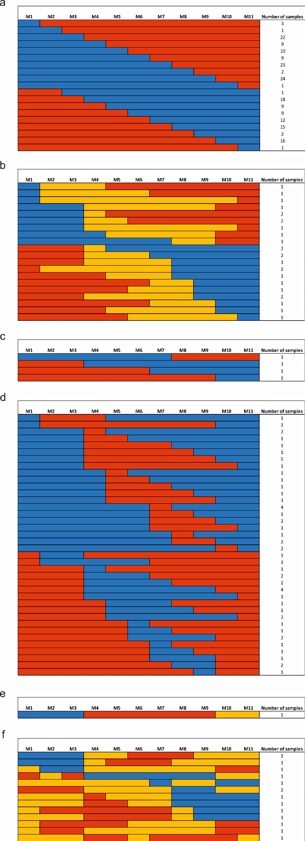
Supplemental Figure 3. Overview of the detected CO events in the Col-0 x Ler-1 line on chromosome 2. a, Overview of marker changes which originated from a single CO on one chromosome (187). The Col-0 allele is represented by blue bars and the Ler-1 allele by red bars. b, Overview of marker changes which originated from two different single CO, one on each chromosome (30). The Col-0 allele is represented by blue bars and the Ler-1 allele by red bars. The detection of both the Col-0 and Ler-1 allele is represented by orange bars. c, Overview of marker changes which originated from an identical single CO on both chromosomes (8). The Col-0 allele is represented by blue bars and the Ler-1 allele by red bars. d, Overview of marker changes which originated from a double CO on one chromosome (59). The Col-0 allele is represented by blue bars and the Ler-1 allele by red bars. e, In one sample, we detected 3 CO: a double CO on one chromosome and a single CO on the second chromosome. The Col-0 allele is represented by blue bars and the Ler-1 allele by red bars. The detection of both the Col-0 and Ler-1 allele is represented by orange bars. f, 14 samples showed marker changes originating from multiple CO events that could not be clearly assigned to either of the two chromosomes. The Col-0 allele is represented by blue bars and the Ler-1 allele by red bars. The detection of both the Col-0 and Ler-1 allele is represented by orange bars.

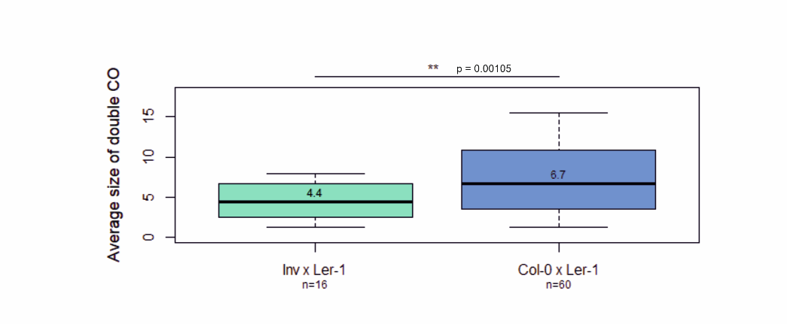
Supplemental Figure 4. Average size of double COs on chromosome 2 in offspring of the Inversion x Ler-1 (green) and Col-0 x Ler-1 (blue) lines. The average size of each double CO was determined by first calculating the distance between the position of the first and last changed SNP (minimum double CO size) and then calculating the distance between the neighbouring unchanged markers (largest possible size of the double CO). Then, the average size of each double CO was determined by calculating the average of the minimum and maximum size of the CO. The boxplot shows the average size of each double CO of the offspring of the Inv x Ler-1 (n=16) and Col-0 x Ler-1 (n=60) line. The middle line represents the median, box edges represent first and third quartiles and whiskers extend to the minimum and maximum, respectively. The p values were calculated using a two-tailed t-test (** p < 0.01). Source data are provided as Source Data file.

Supplemental Table 1. Mendelian segregation of the inversion line. The progeny of the heimzygous inversion line was genotyped via PCR in the T3 generation by screening for the presence of the inversion-specific and WT junctions. Using the χ² test with the critical value χ² (1; 0.95), it was confirmed that the number of homozygous, heterozygous and WT plants corresponded to Mendel’s laws of segregation. The analysis was repeated two times, with 41 and 37 plants, respectively.
Number of screened plants | Hemizygous | Homozygous | WT | E_{hemizygous} | E_{homozygous} | E_{WT} | B_{i}²/E_{i hemizygous} | B_{i}²/E_{i} _{homozygous} | B_{i}²/E_{i} _{WT} | X² | Mendelian segregation
41 | 18 | 8 | 14 | 20.50 | 10.25 | 10.25 | 15.80 | 6.24 | 19.12 | 0.17 | yes
37 | 22 | 5 | 10 | 18.50 | 9.25 | 9.25 | 26.16 | 2.70 | 10.81 | 2.68 | yes

Supplementary Table 2. BACs used for FISH analysis.

Supplemental Table 3. Overview of the position and sequence of the used SNP markers with corresponding intervals on chromosome 2 (top) and chromosome 3 (bottom). SNPs between Col-0 and Ler-1 are marked in red. The oligonucleotides were modified by adding a fluorophore (HEX/FAM) at the 5’ end and a quencher (BHQ1) at the 3’ end. LNAs integrated into the probe are represented by blue square brackets and a plus sign.

Supplemental Table 4. List of used oligonucleotides. Overhangs are represented by lowercase letters.

