Top six provinces TB inflows
The top six provinces TB inflows were appeared in Guangdong, Zhejiang, Fujian, Shanghai, Jiangsu and Beijing, which accounted for 84.5% of the TB migration flows.
The most obvious TB inflows to Guangdong accounted for 62.0% TB migration flows (Fig. S1), such as from Hunan to Guangdong (21.3%), Sichuan to Guangdong (17.3%), Guangxi to Guangdong (13.4%), and Guizhou to Guangdong (10.1%). The more obvious TB inflows to Guangdong were from Hubei to Guangdong (9.2%), Jiangxi to Guangdong (6.2%), Chongqing to Guangdong (5.8%), Yunnan to Guangdong (4.1%) and from Henan to Guangdong (3.9%), the TB migrant workers from the five provinces totally accounted for 29.2% TB migration flows to Guangdong.
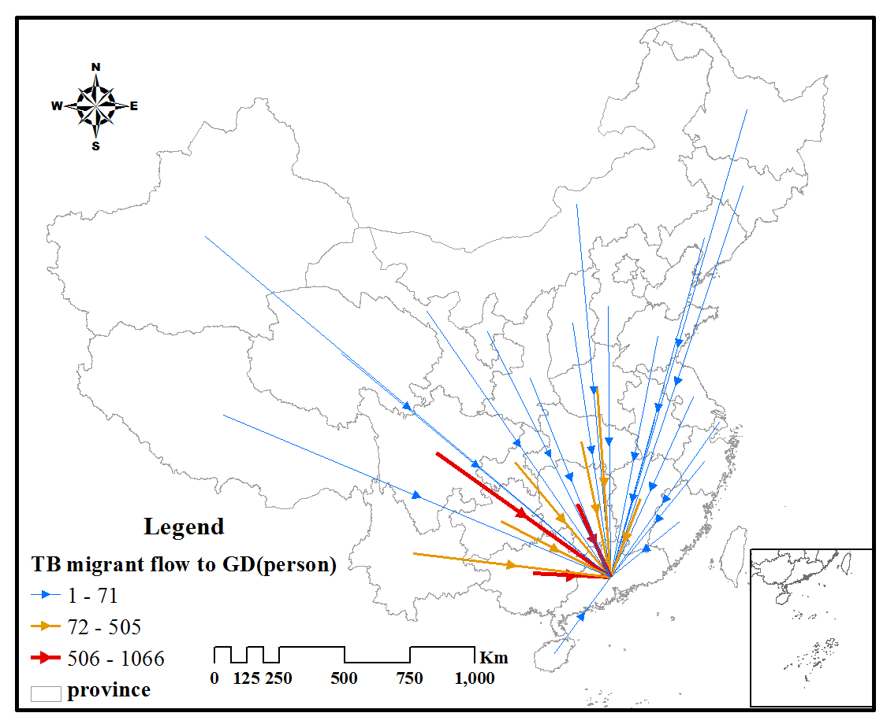
Fig. S1 Flow map of China’s TB inflow to Guangdong in 2012

The most abvious TB inflow to Zhejiang was from Guizhou, which accounted for 29.1% (Fig. S2). The other following TB inflows to Zhejiang were from Sichuan (11.6%), Yunnan (10.3%), Jiangxi (9.0%), Anhui (8.5%), Hubei (6.7%), Hunan (6.1%) and Chongqing (5.8%). These seven provinces TB inflow to Zhejiang accounted for 58.1% of Zhejiang's TB migration flows.

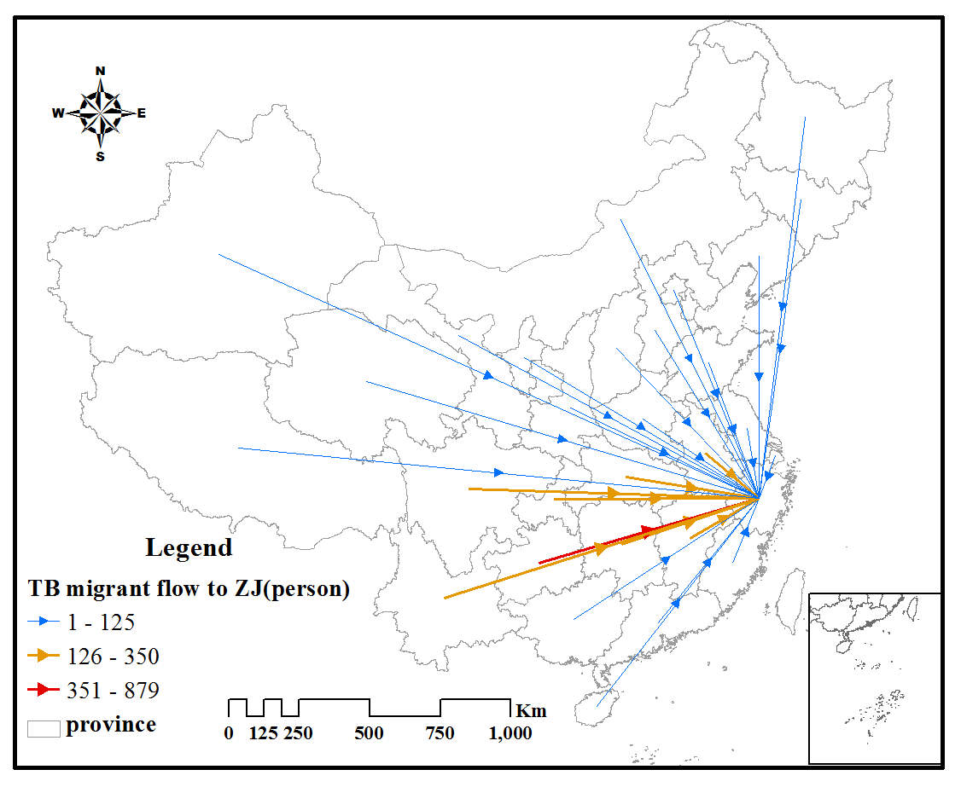
Fig. S2 Flow map of China’s TB inflow to Zhejiang in 2012

The most TB inflows to Fujian (Fig. S3) were from Guizhou (25.2%), Sichuan (20.0%), Chongqing (14.0%), and Jiangxi (12.2%). These four provinces accounted for 71.4% of Fujian's TB migration flows.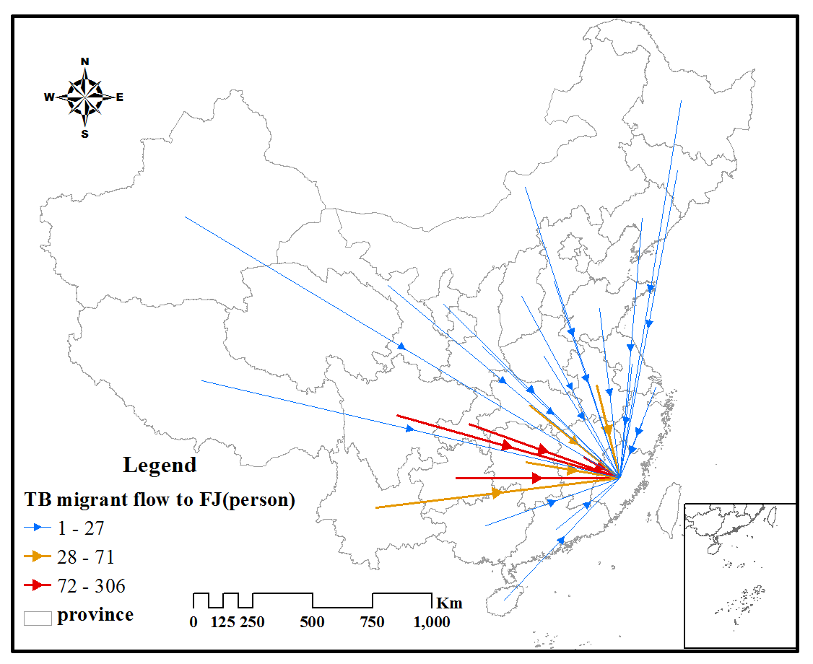
Fig. S3 Flow map of China’s TB inflow to Fujian in 2012

The most TB inflows to Shanghai (Fig. S4) were from Anhui (22.2%) and Sichuan (13.7%), Jiangsu (9.4%), Hubei (5.4%), Henan (5.3%), Chongqing (5.2%). These provinces accounted for 61.2% of Shanghai's TB migration flows.
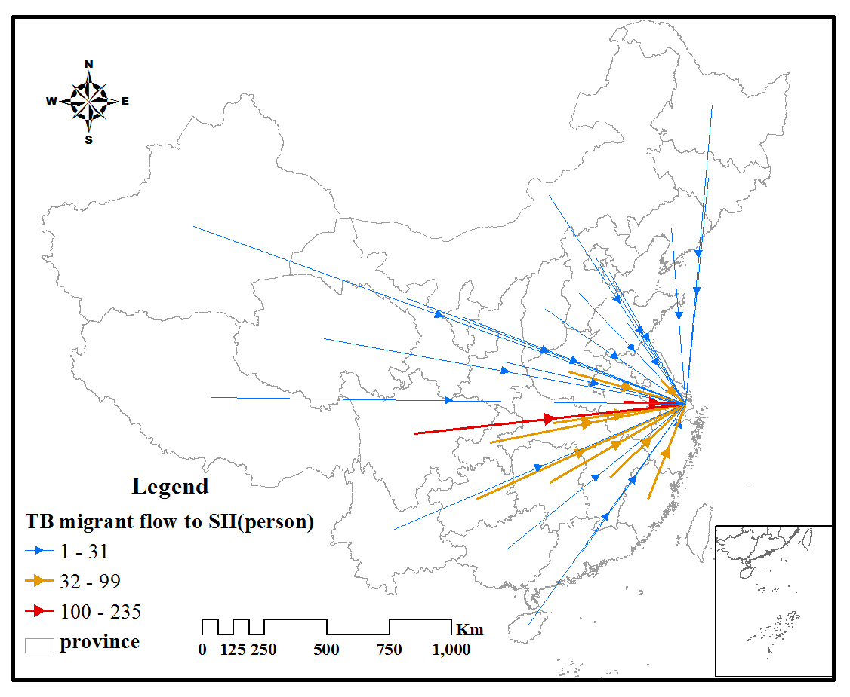
Fig. S4 Flow map of China’s TB inflow to Shanghai in 2012

The most TB inflows to Jiangsu (Fig. S5) were from Anhui (21.9%) , Sichuan (15.6%), Guizhou (9.7%), Henan (8.0%), Hubei (6.4%), Yunnan(6.4%). These provinces accounted for 68.0% of Jiangsu's TB migration flows.
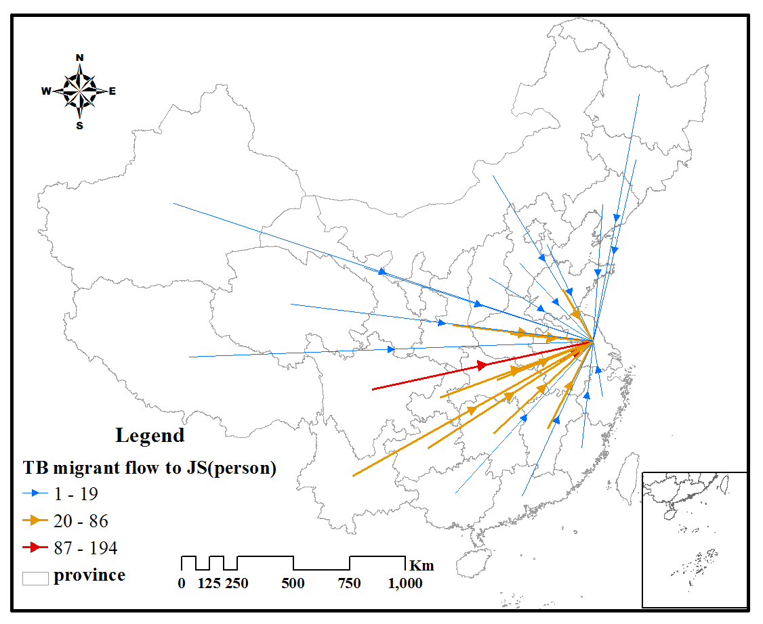
Fig. S5 Flow map of China’s TB inflow to Jiangsu in 2012

The most TB inflows to Beijing were from Hebei, which accounted for 23.3% of Beijing's TB migration flows (Fig. S6). Other TB inflows were mainly from Henan (10.3%) , Sichuan (9.1%), Heilongjiang (8.7%), Shandong (6.9%), and Anhui (5.9%).
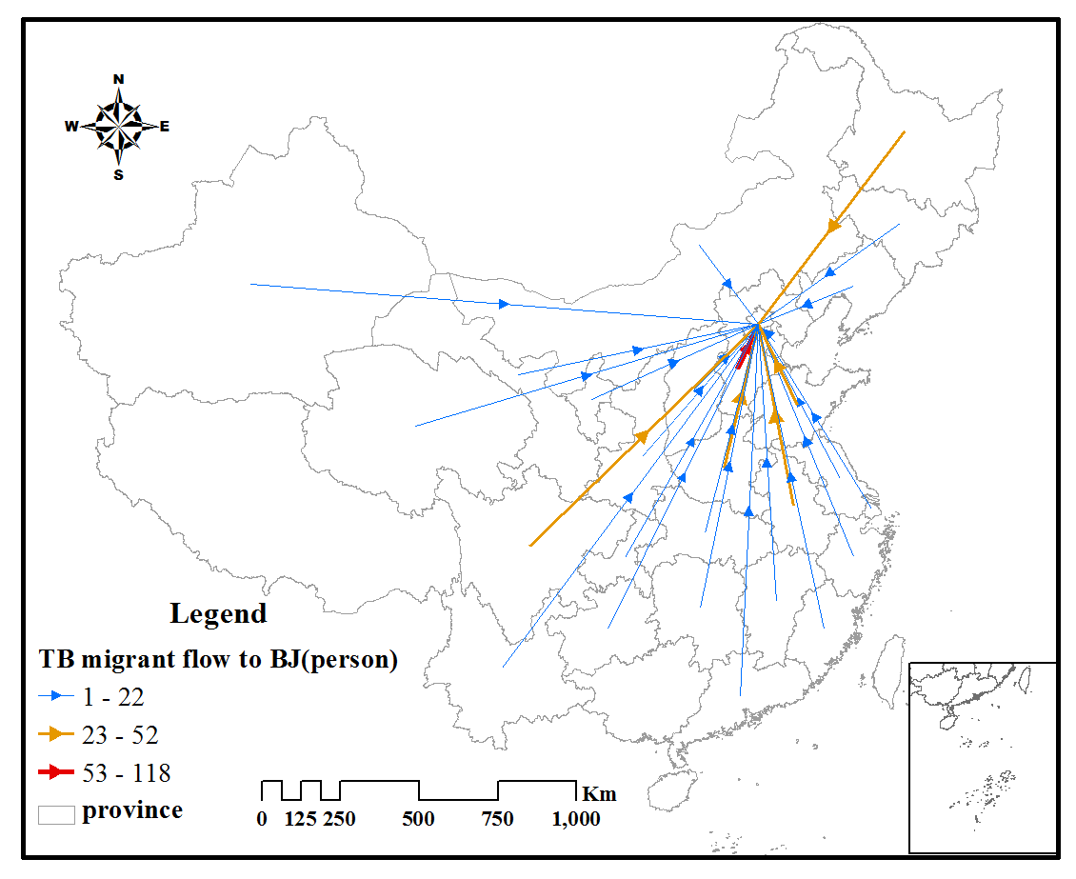
Fig. S6 Flow map of China’s TB inflow to Beijing in 2012

