Supplementary materials

A complete inventory of long-chain polyunsaturated fatty acids biosynthesis pathway enzymes in the miniaturized cyprinid Paedocypris micromegethes

Ka-Kei Sam¹, Nyok-Sean Lau¹, Meng-Kiat Kuah³, Engkamat anak Lading⁴
Alexander Chong Shu-Chien^{1,2*}

¹Centre for Chemical Biology, Universiti Sains Malaysia, Bayan Lepas, 11900 Penang, Malaysia.
²School of Biological Sciences, Universiti Sains Malaysia, Minden, 11800 Penang, Malaysia.
³Lab-Ind Resource Sdn. Bhd., Bukit Beruntung, 48300 Selangor, Malaysia
⁴Forest Department Sarawak, Level 15, East Wing, Baitul Makmur II, Medan Raya, Petra Jaya, 93050 Kuching, Sarawak, Malaysia

*Corresponding author:
Alexander Chong Shu-Chien
alex@usm.my

Table S1 Primers used for cloning of full-length open reading frame (ORF) of P. micromegethes fads2, elovl5, elovl2, elovl4a, and elovl4b. The restriction sites HindIII (AAGCTT) and XhoI (CTCGAG) are underlined

Application | Transcript |  | Primer | Sequence (5’ − 3’) | Product size (bp)
ORF cloning | fads2 | Pmfads2 cdsF |  | TTAAGCTTATGGGAGGCGGAGCAC | 1,351
 |  | Pmfads2 cdsR |  | TTCTCGAGCTACTTGTTGAGGTAAGCG
 | elovl5 | Pmelovl5 cdsF |  | TTAAGCTTATGGAGGGCATTAGCAGCAGCG | 826
 |  | Pmelovl5 cdsR |  | TTCTCGAGTCAGTCTGCGCGGAGCTT
 | elovl2 | Pmelovl2 cdsF |  | TTAAGCTTATGGAACACTTTGAGACATTCGACCG | 865
 |  | Pmelovl2 cdsR |  | TTCTCGAGTCACTGCCGCTTCTGCTTG
 | elovl4a | Pmelovl4a cdsF |  | TTAAGCTTATGGAGGTCATAAAACACATCTTCA | 946
 |  | Pmelovl4a cdsR |  | TTCTCGAGTCACTCCCGCTTGGGT
 | elovl4b | Pmelovl4b cdsF |  | TTAAGCTTATGGACGCGGTGGTCCACTAC | 919
 |  | Pmelovl4b cdsR |  | TTCTCGAGCTAGTCGTGTTTGCCTTTGCAT

Table S2 Total number of KEGG annotated pathways with transcripts for P. micromegethes
KEGG Orthology ID | Pathway | N° Enzymes/Proteins Mapped
00010 | Glycolysis / Gluconeogenesis | 34
00020 | Citrate cycle (TCA cycle) | 20
00030 | Pentose phosphate pathway | 21
00040 | Pentose and glucuronate interconversions | 15
00051 | Fructose and mannose metabolism | 23
00052 | Galactose metabolism | 20
00053 | Ascorbate and aldarate metabolism | 12
00500 | Starch and sucrose metabolism | 20
00520 | Amino sugar and nucleotide sugar metabolism | 37
00620 | Pyruvate metabolism | 30
00630 | Glyoxylate and dicarboxylate metabolism | 25
00640 | Propanoate metabolism | 26
00650 | Butanoate metabolism | 17
00660 | C5-Branched dibasic acid metabolism | 1
00562 | Inositol phosphate metabolism | 45
00190 | Oxidative phosphorylation | 44
00196 | Photosynthesis - antenna proteins | 1
00710 | Carbon fixation in photosynthetic organisms | 18
00720 | Carbon fixation pathways in prokaryotes | 13
00680 | Methane metabolism | 17
00910 | Nitrogen metabolism | 8
00920 | Sulfur metabolism | 11
00061 | Fatty acid biosynthesis | 13
00062 | Fatty acid elongation | 19
00071 | Fatty acid degradation | 26
00072 | Synthesis and degradation of ketone bodies | 6
00073 | Cutin, suberine and wax biosynthesis | 1
00100 | Steroid biosynthesis | 20
00120 | Primary bile acid biosynthesis | 12
00140 | Steroid hormone biosynthesis | 25
00561 | Glycerolipid metabolism | 34
00564 | Glycerophospholipid metabolism | 56
00565 | Ether lipid metabolism | 23
00600 | Sphingolipid metabolism | 37
00590 | Arachidonic acid metabolism | 20
00591 | Linoleic acid metabolism | 7
00592 | alpha-Linolenic acid metabolism | 8
01040 | Biosynthesis of unsaturated fatty acids | 17
00230 | Purine metabolism | 90
00240 | Pyrimidine metabolism | 38
00250 | Alanine, aspartate and glutamate metabolism | 33
00260 | Glycine, serine and threonine metabolism | 36
00270 | Cysteine and methionine metabolism | 37
00280 | Valine, leucine and isoleucine degradation | 41
00290 | Valine, leucine and isoleucine biosynthesis | 4
00300 | Lysine biosynthesis | 4
00310 | Lysine degradation | 52
00220 | Arginine biosynthesis | 18
00330 | Arginine and proline metabolism | 36
00340 | Histidine metabolism | 15
00350 | Tyrosine metabolism | 24
00360 | Phenylalanine metabolism | 14
00380 | Tryptophan metabolism | 34
00400 | Phenylalanine, tyrosine and tryptophan biosynthesis | 6
00410 | beta-Alanine metabolism | 22
00430 | Taurine and hypotaurine metabolism | 7
00440 | Phosphonate and phosphinate metabolism | 5
00450 | Selenocompound metabolism | 12
00460 | Cyanoamino acid metabolism | 7
00471 | D-Glutamine and D-glutamate metabolism | 3
00472 | D-Arginine and D-ornithine metabolism | 1
00480 | Glutathione metabolism | 27
00510 | N-Glycan biosynthesis | 39
00513 | Various types of N-glycan biosynthesis | 31
00512 | Mucin type O-glycan biosynthesis | 9
00515 | Mannose type O-glycan biosynthesis | 21
00514 | Other types of O-glycan biosynthesis | 20
00532 | Glycosaminoglycan biosynthesis - chondroitin sulfate / dermatan sulfate | 16
00534 | Glycosaminoglycan biosynthesis - heparan sulfate / heparin | 18
00533 | Glycosaminoglycan biosynthesis - keratan sulfate | 13
00531 | Glycosaminoglycan degradation | 14
00563 | Glycosylphosphatidylinositol (GPI)-anchor biosynthesis | 19
00601 | Glycosphingolipid biosynthesis - lacto and neolacto series | 15
00603 | Glycosphingolipid biosynthesis - globo and isoglobo series | 8
00604 | Glycosphingolipid biosynthesis - ganglio series | 14
00541 | O-Antigen nucleotide sugar biosynthesis | 9
00511 | Other glycan degradation | 13
00730 | Thiamine metabolism | 6
00740 | Riboflavin metabolism | 5
00750 | Vitamin B6 metabolism | 6
00760 | Nicotinate and nicotinamide metabolism | 25
00770 | Pantothenate and CoA biosynthesis | 13
00780 | Biotin metabolism | 4
00785 | Lipoic acid metabolism | 3
00790 | Folate biosynthesis | 17
00670 | One carbon pool by folate | 17
00830 | Retinol metabolism | 21
00860 | Porphyrin and chlorophyll metabolism | 21
00130 | Ubiquinone and other terpenoid-quinone biosynthesis | 8
00900 | Terpenoid backbone biosynthesis | 18
00909 | Sesquiterpenoid and triterpenoid biosynthesis | 2
00981 | Insect hormone biosynthesis | 2
00908 | Zeatin biosynthesis | 1
00903 | Limonene and pinene degradation | 1
00281 | Geraniol degradation | 3
01051 | Biosynthesis of ansamycins | 1
00523 | Polyketide sugar unit biosynthesis | 2
01055 | Biosynthesis of vancomycin group antibiotics | 1
00940 | Phenylpropanoid biosynthesis | 4
00944 | Flavone and flavonol biosynthesis | 1
00901 | Indole alkaloid biosynthesis | 1
00950 | Isoquinoline alkaloid biosynthesis | 10
00960 | Tropane, piperidine and pyridine alkaloid biosynthesis | 5
00232 | Caffeine metabolism | 3
00965 | Betalain biosynthesis | 3
00966 | Glucosinolate biosynthesis | 1
00311 | Penicillin and cephalosporin biosynthesis | 1
00261 | Monobactam biosynthesis | 2
00521 | Streptomycin biosynthesis | 5
00524 | Neomycin, kanamycin and gentamicin biosynthesis | 1
00525 | Acarbose and validamycin biosynthesis | 2
00401 | Novobiocin biosynthesis | 2
00333 | Prodigiosin biosynthesis | 1
00254 | Aflatoxin biosynthesis | 2
00362 | Benzoate degradation | 2
00627 | Aminobenzoate degradation | 4
00364 | Fluorobenzoate degradation | 1
00625 | Chloroalkane and chloroalkene degradation | 3
00361 | Chlorocyclohexane and chlorobenzene degradation | 1
00623 | Toluene degradation | 1
00633 | Nitrotoluene degradation | 1
00643 | Styrene degradation | 4
00930 | Caprolactam degradation | 6
00626 | Naphthalene degradation | 1
00980 | Metabolism of xenobiotics by cytochrome P450 | 12
00982 | Drug metabolism - cytochrome P450 | 9
00983 | Drug metabolism - other enzymes | 26
03020 | RNA polymerase | 19
03022 | Basal transcription factors | 27
03040 | Spliceosome | 89
03010 | Ribosome | 47
00970 | Aminoacyl-tRNA biosynthesis | 28
03013 | RNA transport | 110
03015 | mRNA surveillance pathway | 55
03008 | Ribosome biogenesis in eukaryotes | 58
03060 | Protein export | 11
04141 | Protein processing in endoplasmic reticulum | 117
04130 | SNARE interactions in vesicular transport | 19
04120 | Ubiquitin mediated proteolysis | 93
04122 | Sulfur relay system | 8
03050 | Proteasome | 41
03018 | RNA degradation | 48
03030 | DNA replication | 27
03410 | Base excision repair | 26
03420 | Nucleotide excision repair | 32
03430 | Mismatch repair | 18
03440 | Homologous recombination | 34
03450 | Non-homologous end-joining | 12
03460 | Fanconi anemia pathway | 41
02010 | ABC transporters | 41
03070 | Bacterial secretion system | 2
02020 | Two-component system | 12
04010 | MAPK signaling pathway | 189
04013 | MAPK signaling pathway - fly | 56
04016 | MAPK signaling pathway - plant | 5
04011 | MAPK signaling pathway - yeast | 30
04012 | ErbB signaling pathway | 53
04014 | Ras signaling pathway | 133
04015 | Rap1 signaling pathway | 129
04310 | Wnt signaling pathway | 106
04330 | Notch signaling pathway | 28
04340 | Hedgehog signaling pathway | 43
04341 | Hedgehog signaling pathway - fly | 20
04350 | TGF-beta signaling pathway | 63
04390 | Hippo signaling pathway | 104
04391 | Hippo signaling pathway - fly | 39
04392 | Hippo signaling pathway - multiple species | 20
04370 | VEGF signaling pathway | 29
04371 | Apelin signaling pathway | 76
04630 | JAK-STAT signaling pathway | 83
04064 | NF-kappa B signaling pathway | 73
04668 | TNF signaling pathway | 66
04066 | HIF-1 signaling pathway | 55
04068 | FoxO signaling pathway | 81
04020 | Calcium signaling pathway | 158
04070 | Phosphatidylinositol signaling system | 49
04072 | Phospholipase D signaling pathway | 88
04071 | Sphingolipid signaling pathway | 67
04024 | cAMP signaling pathway | 122
04022 | cGMP-PKG signaling pathway | 101
04151 | PI3K-Akt signaling pathway | 202
04152 | AMPK signaling pathway | 73
04150 | mTOR signaling pathway | 101
04080 | Neuroactive ligand-receptor interaction | 205
04060 | Cytokine-cytokine receptor interaction | 118
04061 | Viral protein interaction with cytokine and cytokine receptor | 27
04512 | ECM-receptor interaction | 55
04514 | Cell adhesion molecules | 75
04144 | Endocytosis | 144
04145 | Phagosome | 69
04142 | Lysosome | 88
04146 | Peroxisome | 62
04140 | Autophagy - animal | 93
04138 | Autophagy - yeast | 48
04136 | Autophagy - other | 20
04137 | Mitophagy - animal | 46
04139 | Mitophagy - yeast | 14
04110 | Cell cycle | 92
04111 | Cell cycle - yeast | 61
04112 | Cell cycle - Caulobacter | 3
04113 | Meiosis - yeast | 47
04114 | Oocyte meiosis | 63
04210 | Apoptosis | 85
04214 | Apoptosis - fly | 39
04215 | Apoptosis - multiple species | 21
04216 | Ferroptosis | 27
04217 | Necroptosis | 73
04115 | p53 signaling pathway | 52
04218 | Cellular senescence | 99
04510 | Focal adhesion | 123
04520 | Adherens junction | 57
04530 | Tight junction | 89
04540 | Gap junction | 53
04550 | Signaling pathways regulating pluripotency of stem cells | 94
02024 | Quorum sensing | 6
02025 | Biofilm formation - Pseudomonas aeruginosa | 1
02026 | Biofilm formation - Escherichia coli | 1
04810 | Regulation of actin cytoskeleton | 126
04640 | Hematopoietic cell lineage | 44
04610 | Complement and coagulation cascades | 54
04611 | Platelet activation | 72
04613 | Neutrophil extracellular trap formation | 63
04620 | Toll-like receptor signaling pathway | 53
04624 | Toll and Imd signaling pathway | 25
04621 | NOD-like receptor signaling pathway | 90
04622 | RIG-I-like receptor signaling pathway | 36
04623 | Cytosolic DNA-sensing pathway | 27
04625 | C-type lectin receptor signaling pathway | 61
04650 | Natural killer cell mediated cytotoxicity | 45
04612 | Antigen processing and presentation | 31
04660 | T cell receptor signaling pathway | 66
04658 | Th1 and Th2 cell differentiation | 51
04659 | Th17 cell differentiation | 63
04657 | IL-17 signaling pathway | 48
04662 | B cell receptor signaling pathway | 47
04664 | Fc epsilon RI signaling pathway | 31
04666 | Fc gamma R-mediated phagocytosis | 54
04670 | Leukocyte transendothelial migration | 58
04672 | Intestinal immune network for IgA production | 15
04062 | Chemokine signaling pathway | 83
04911 | Insulin secretion | 52
04910 | Insulin signaling pathway | 73
04922 | Glucagon signaling pathway | 53
04923 | Regulation of lipolysis in adipocytes | 34
04920 | Adipocytokine signaling pathway | 43
03320 | PPAR signaling pathway | 38
04929 | GnRH secretion | 40
04912 | GnRH signaling pathway | 51
04913 | Ovarian steroidogenesis | 29
04915 | Estrogen signaling pathway | 66
04914 | Progesterone-mediated oocyte maturation | 52
04917 | Prolactin signaling pathway | 41
04921 | Oxytocin signaling pathway | 89
04926 | Relaxin signaling pathway | 65
04935 | Growth hormone synthesis, secretion and action | 72
04918 | Thyroid hormone synthesis | 42
04919 | Thyroid hormone signaling pathway | 74
04928 | Parathyroid hormone synthesis, secretion and action | 76
04916 | Melanogenesis | 60
04924 | Renin secretion | 40
04614 | Renin-angiotensin system | 16
04925 | Aldosterone synthesis and secretion | 57
04927 | Cortisol synthesis and secretion | 47
04260 | Cardiac muscle contraction | 40
04261 | Adrenergic signaling in cardiomyocytes | 80
04270 | Vascular smooth muscle contraction | 69
04970 | Salivary secretion | 43
04971 | Gastric acid secretion | 39
04972 | Pancreatic secretion | 50
04976 | Bile secretion | 48
04973 | Carbohydrate digestion and absorption | 15
04974 | Protein digestion and absorption | 57
04975 | Fat digestion and absorption | 20
04979 | Cholesterol metabolism | 41
04977 | Vitamin digestion and absorption | 18
04978 | Mineral absorption | 26
04962 | Vasopressin-regulated water reabsorption | 26
04960 | Aldosterone-regulated sodium reabsorption | 17
04961 | Endocrine and other factor-regulated calcium reabsorption | 28
04964 | Proximal tubule bicarbonate reclamation | 13
04966 | Collecting duct acid secretion | 10
04724 | Glutamatergic synapse | 70
04727 | GABAergic synapse | 49
04725 | Cholinergic synapse | 69
04728 | Dopaminergic synapse | 65
04726 | Serotonergic synapse | 57
04720 | Long-term potentiation | 35
04730 | Long-term depression | 38
04723 | Retrograde endocannabinoid signaling | 71
04721 | Synaptic vesicle cycle | 47
04722 | Neurotrophin signaling pathway | 74
04744 | Phototransduction | 15
04745 | Phototransduction - fly | 10
04740 | Olfactory transduction | 20
04742 | Taste transduction | 28
04750 | Inflammatory mediator regulation of TRP channels | 55
04320 | Dorso-ventral axis formation | 17
04360 | Axon guidance | 108
04361 | Axon regeneration | 52
04380 | Osteoclast differentiation | 82
04211 | Longevity regulating pathway | 56
04212 | Longevity regulating pathway - worm | 39
04213 | Longevity regulating pathway - multiple species | 35
04710 | Circadian rhythm | 22
04713 | Circadian entrainment | 61
04711 | Circadian rhythm - fly | 8
04712 | Circadian rhythm - plant | 5
04714 | Thermogenesis | 99
04626 | Plant-pathogen interaction | 10
05200 | Pathways in cancer | 326
05202 | Transcriptional misregulation in cancer | 122
05206 | MicroRNAs in cancer | 117
05205 | Proteoglycans in cancer | 137
05204 | Chemical carcinogenesis | 16
05203 | Viral carcinogenesis | 110
05230 | Central carbon metabolism in cancer | 45
05231 | Choline metabolism in cancer | 51
05235 | PD-L1 expression and PD-1 checkpoint pathway in cancer | 55
05210 | Colorectal cancer | 56
05212 | Pancreatic cancer | 54
05225 | Hepatocellular carcinoma | 102
05226 | Gastric cancer | 89
05214 | Glioma | 44
05216 | Thyroid cancer | 28
05221 | Acute myeloid leukemia | 43
05220 | Chronic myeloid leukemia | 53
05217 | Basal cell carcinoma | 46
05218 | Melanoma | 38
05211 | Renal cell carcinoma | 42
05219 | Bladder cancer | 29
05215 | Prostate cancer | 65
05213 | Endometrial cancer | 39
05224 | Breast cancer | 88
05222 | Small cell lung cancer | 62
05223 | Non-small cell lung cancer | 48
05166 | Human T-cell leukemia virus 1 infection | 140
05170 | Human immunodeficiency virus 1 infection | 108
05161 | Hepatitis B | 102
05160 | Hepatitis C | 82
05171 | Coronavirus disease - COVID-19 | 116
05164 | Influenza A | 82
05162 | Measles | 78
05168 | Herpes simplex virus 1 infection | 98
05163 | Human cytomegalovirus infection | 125
05167 | Kaposi sarcoma-associated herpesvirus infection | 103
05169 | Epstein-Barr virus infection | 118
05165 | Human papillomavirus infection | 193
05110 | Vibrio cholerae infection | 26
05120 | Epithelial cell signaling in Helicobacter pylori infection | 43
05130 | Pathogenic Escherichia coli infection | 96
05132 | Salmonella infection | 132
05131 | Shigellosis | 131
05135 | Yersinia infection | 82
05133 | Pertussis | 37
05134 | Legionellosis | 28
05150 | Staphylococcus aureus infection | 26
05152 | Tuberculosis | 85
05100 | Bacterial invasion of epithelial cells | 48
05146 | Amoebiasis | 53
05144 | Malaria | 22
05145 | Toxoplasmosis | 67
05140 | Leishmaniasis | 44
05142 | Chagas disease | 54
05143 | African trypanosomiasis | 16
05310 | Asthma | 4
05322 | Systemic lupus erythematosus | 27
05323 | Rheumatoid arthritis | 33
05320 | Autoimmune thyroid disease | 14
05321 | Inflammatory bowel disease | 30
05330 | Allograft rejection | 11
05332 | Graft-versus-host disease | 8
05340 | Primary immunodeficiency | 28
05010 | Alzheimer disease | 204
05012 | Parkinson disease | 127
05014 | Amyotrophic lateral sclerosis | 200
05016 | Huntington disease | 152
05017 | Spinocerebellar ataxia | 110
05020 | Prion disease | 136
05022 | Pathways of neurodegeneration - multiple diseases | 271
05030 | Cocaine addiction | 37
05031 | Amphetamine addiction | 40
05032 | Morphine addiction | 50
05033 | Nicotine addiction | 25
05034 | Alcoholism | 61
05417 | Lipid and atherosclerosis | 113
05418 | Fluid shear stress and atherosclerosis | 78
05410 | Hypertrophic cardiomyopathy | 64
05412 | Arrhythmogenic right ventricular cardiomyopathy | 62
05414 | Dilated cardiomyopathy | 72
05415 | Diabetic cardiomyopathy | 91
05416 | Viral myocarditis | 28
04930 | Type II diabetes mellitus | 27
04940 | Type I diabetes mellitus | 15
04950 | Maturity onset diabetes of the young | 18
04932 | Non-alcoholic fatty liver disease | 67
04931 | Insulin resistance | 63
04933 | AGE-RAGE signaling pathway in diabetic complications | 57
04934 | Cushing syndrome | 107
01501 | beta-Lactam resistance | 2
01521 | EGFR tyrosine kinase inhibitor resistance | 55
01524 | Platinum drug resistance | 33
01523 | Antifolate resistance | 24
01522 | Endocrine resistance | 62

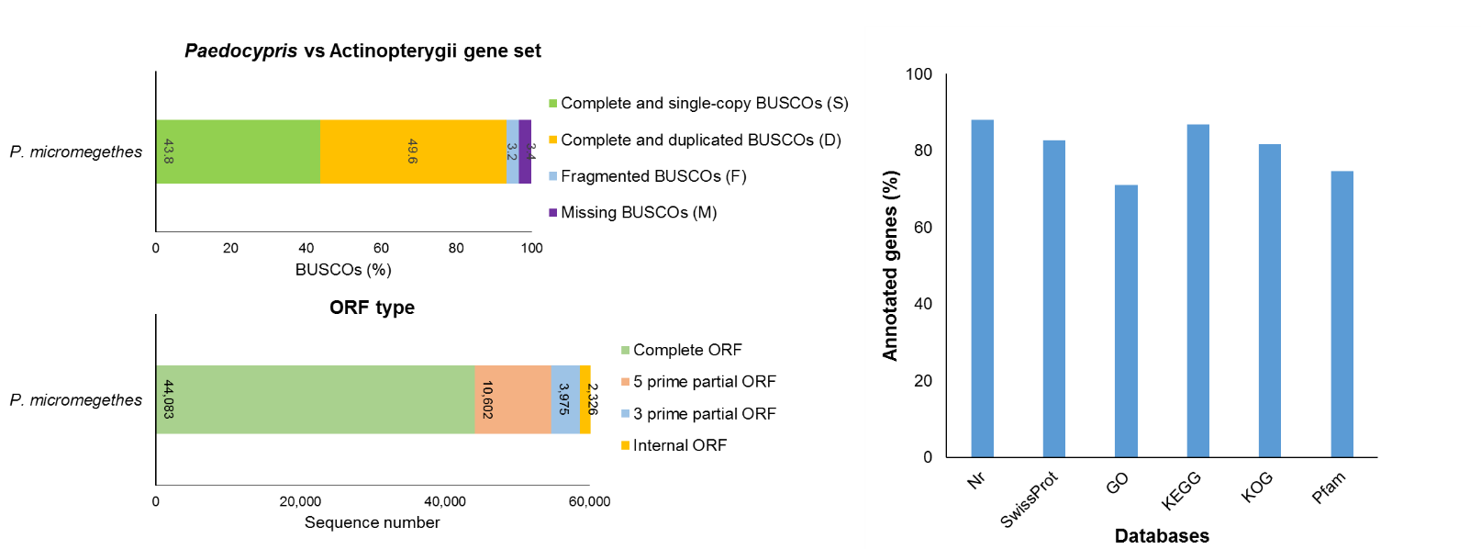
c
a

b

Fig. S1 (a) BUSCOs analysis of P. micromegethes non-redundant transcripts against Actinopterygii gene set. (b) TransDecoder-predicted open reading frame (ORF) of P. micromegethes. ‘Complete ORF’ refers to sequence containing start and stop codon; ‘5 prime partial ORF’ refers to sequence lacking of start codon; ‘3 prime partial ORF’ refers to sequence containing start codon but lacking of stop codon; ‘Internal ORF’ refers to sequence lacking of both start and stop codon. (c) Number of annotated genes from each databases

Fig. S2 Level two classification of the gene ontology functional annotation for P. micromegethes transcripts

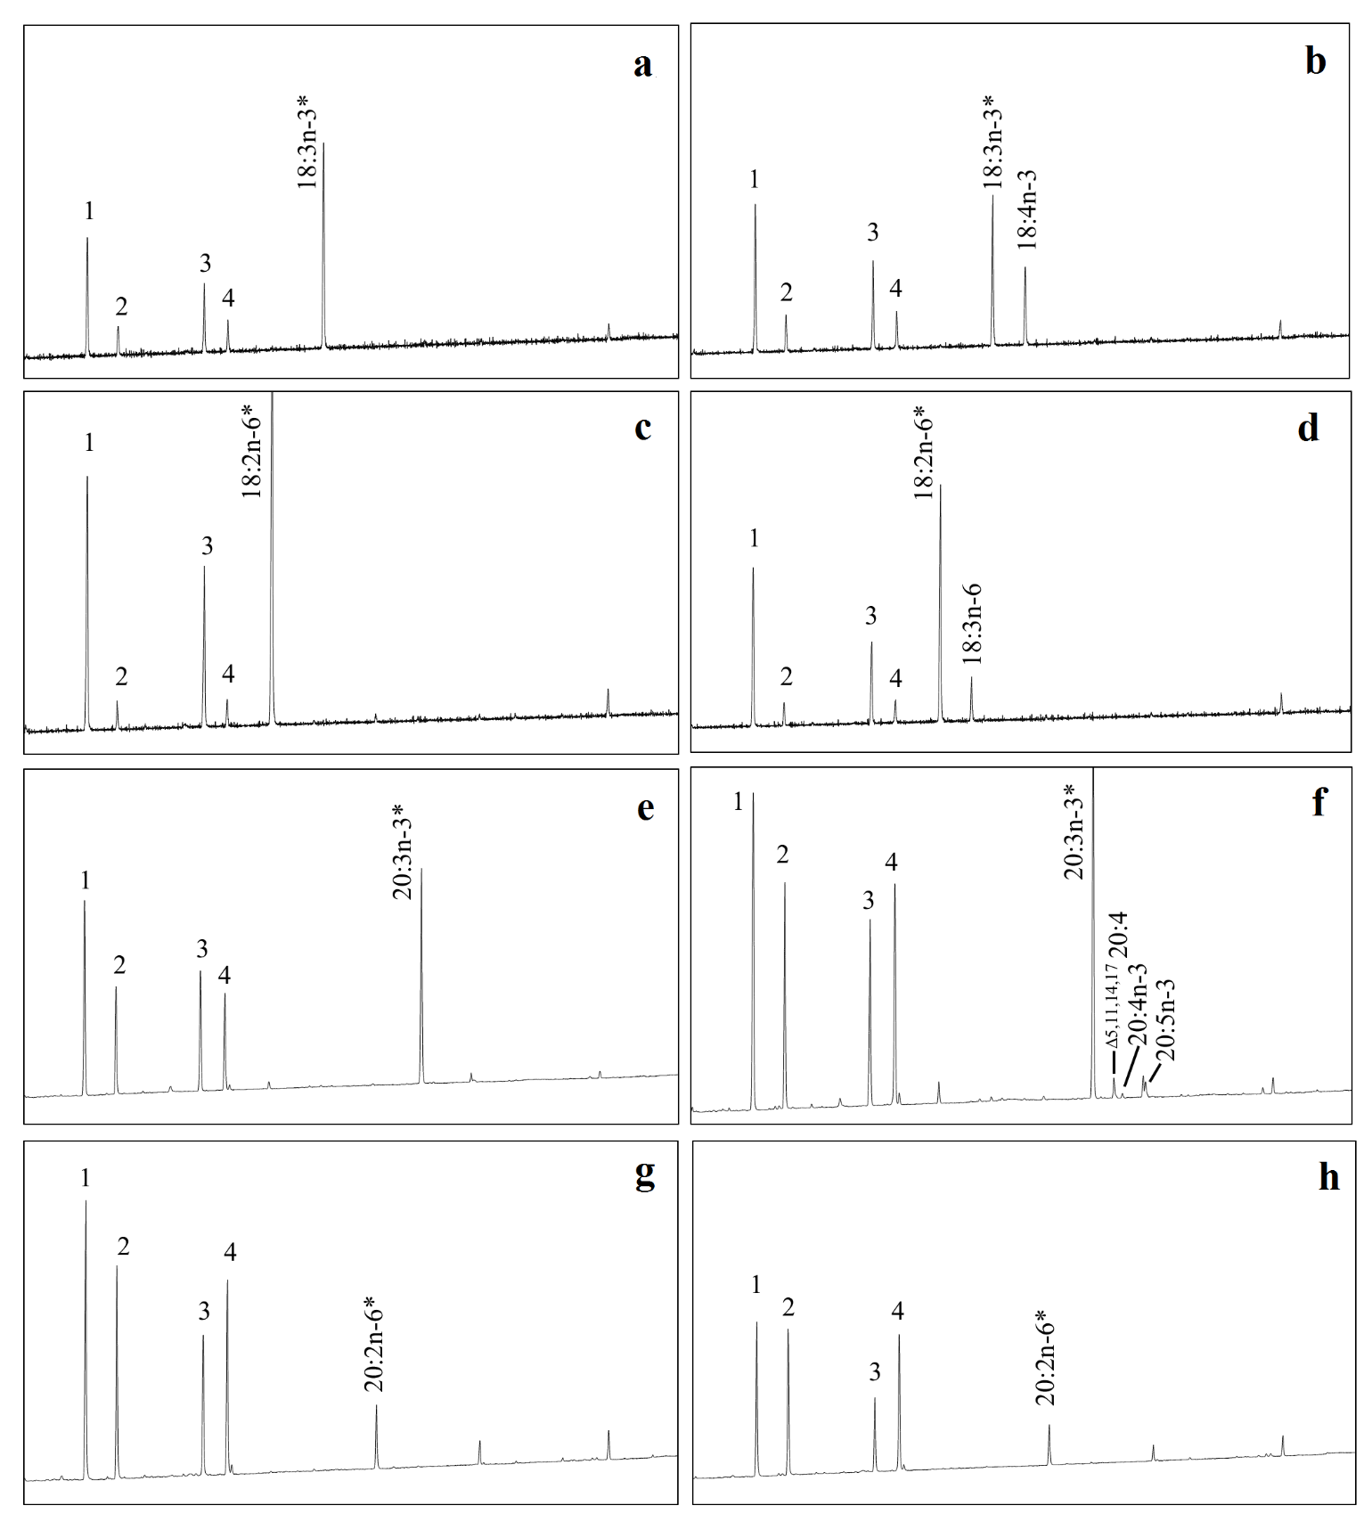

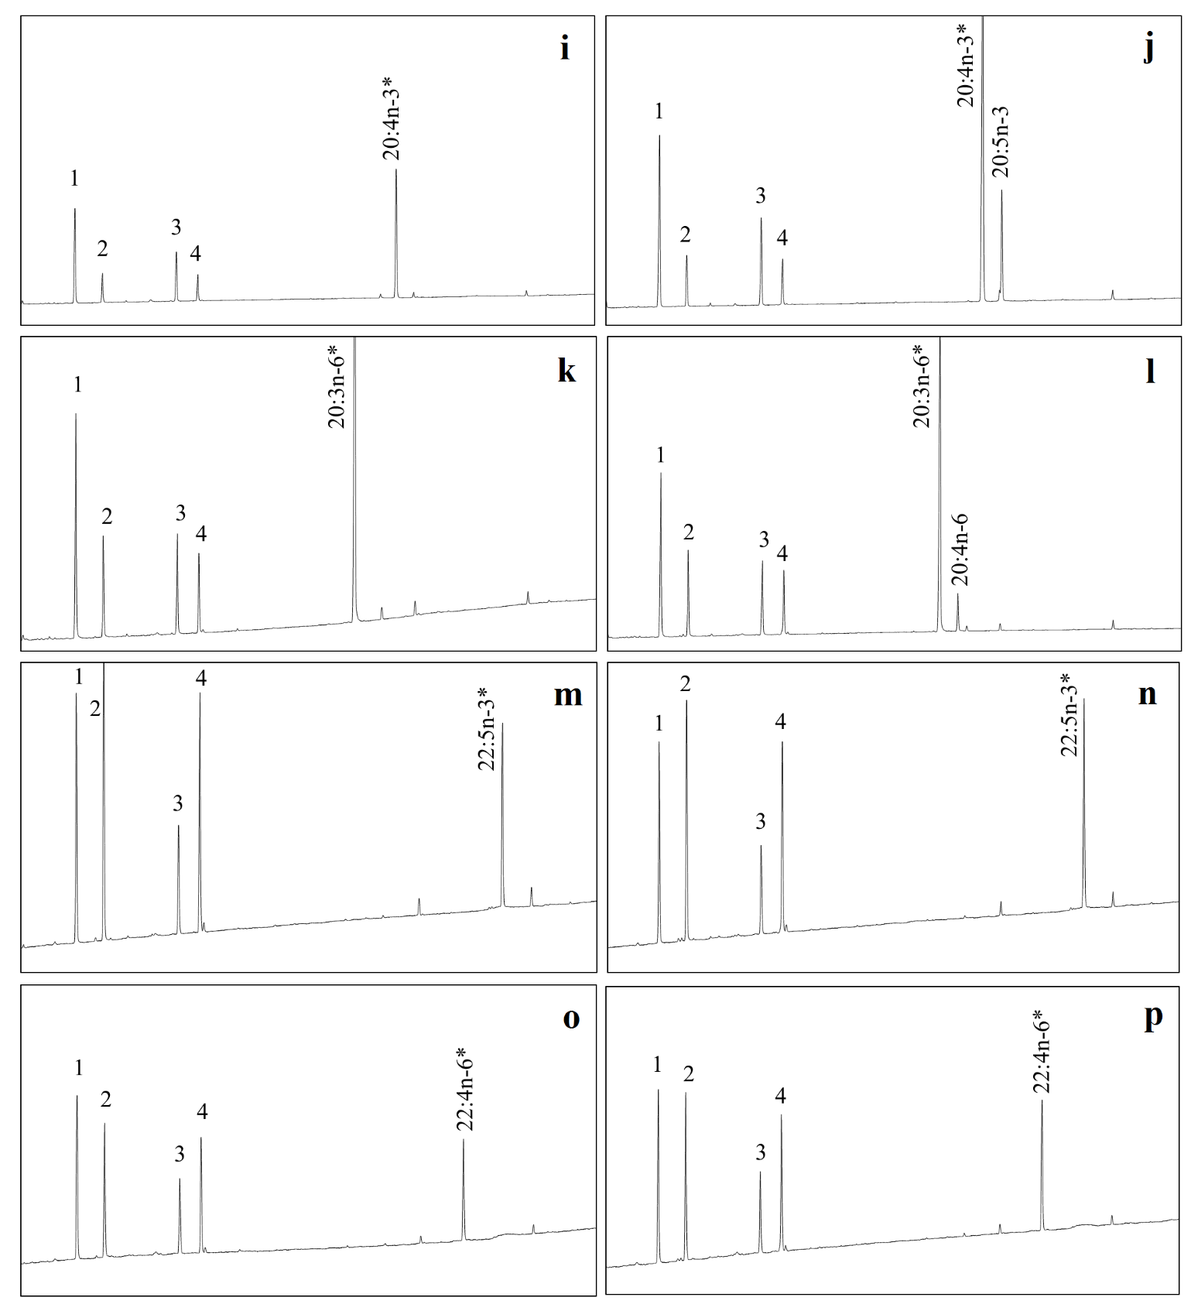

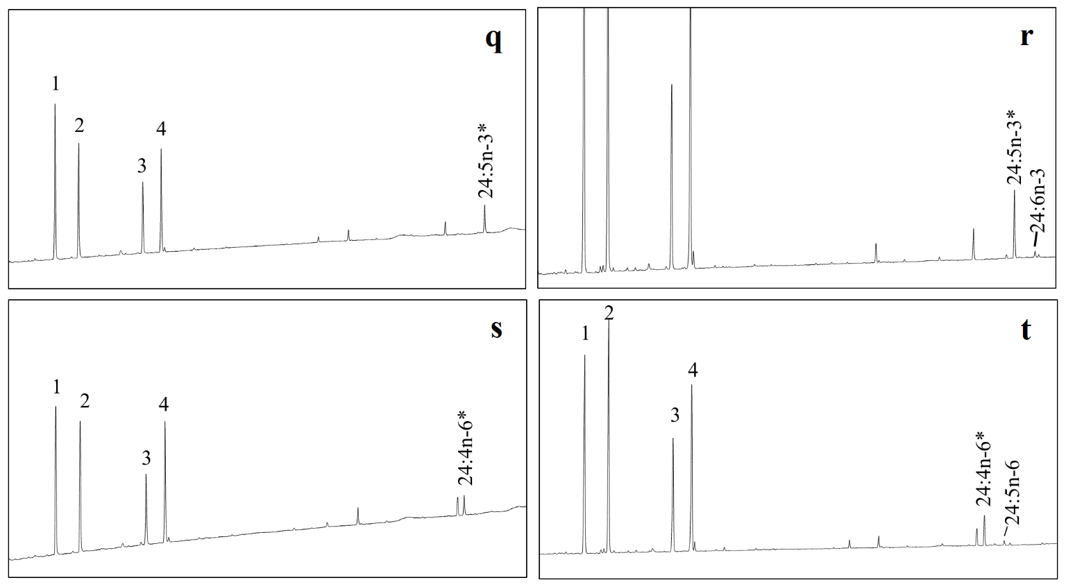
Fig. S3 Functional characterization of P. micromegethes Fads2 in transgenic yeast (Saccharomyces cerevisiae) cultured in one of the exogenously added fatty acid (FA) substrates: Δ6: 18:3n-3 (b), 18:2n-6 (d), 24:5n-3 (r), and 24:4n-6 (t); Δ8: 20:3n-3 (f) and 20:2n-6 (h); Δ5: 20:4n-3 (j) and 20:3n-6 (l); and Δ4: 22:5n-3 (n) and 22:4n-6 (p). Chromatograms a, c, e, g, i, k, m, o, q, and s represent the fatty acid profile of yeast transformed with the pYES2 empty vector alone. Peaks marked as 1-4 are the main endogenous fatty acids of yeast, namely 16:0 (1), 16:1n-7 (2), 18:0 (3), and 18:1n-9 (4). Peaks labelled with * indicates exogenously added FA substrates, while the subsequent peak indicates desaturated products

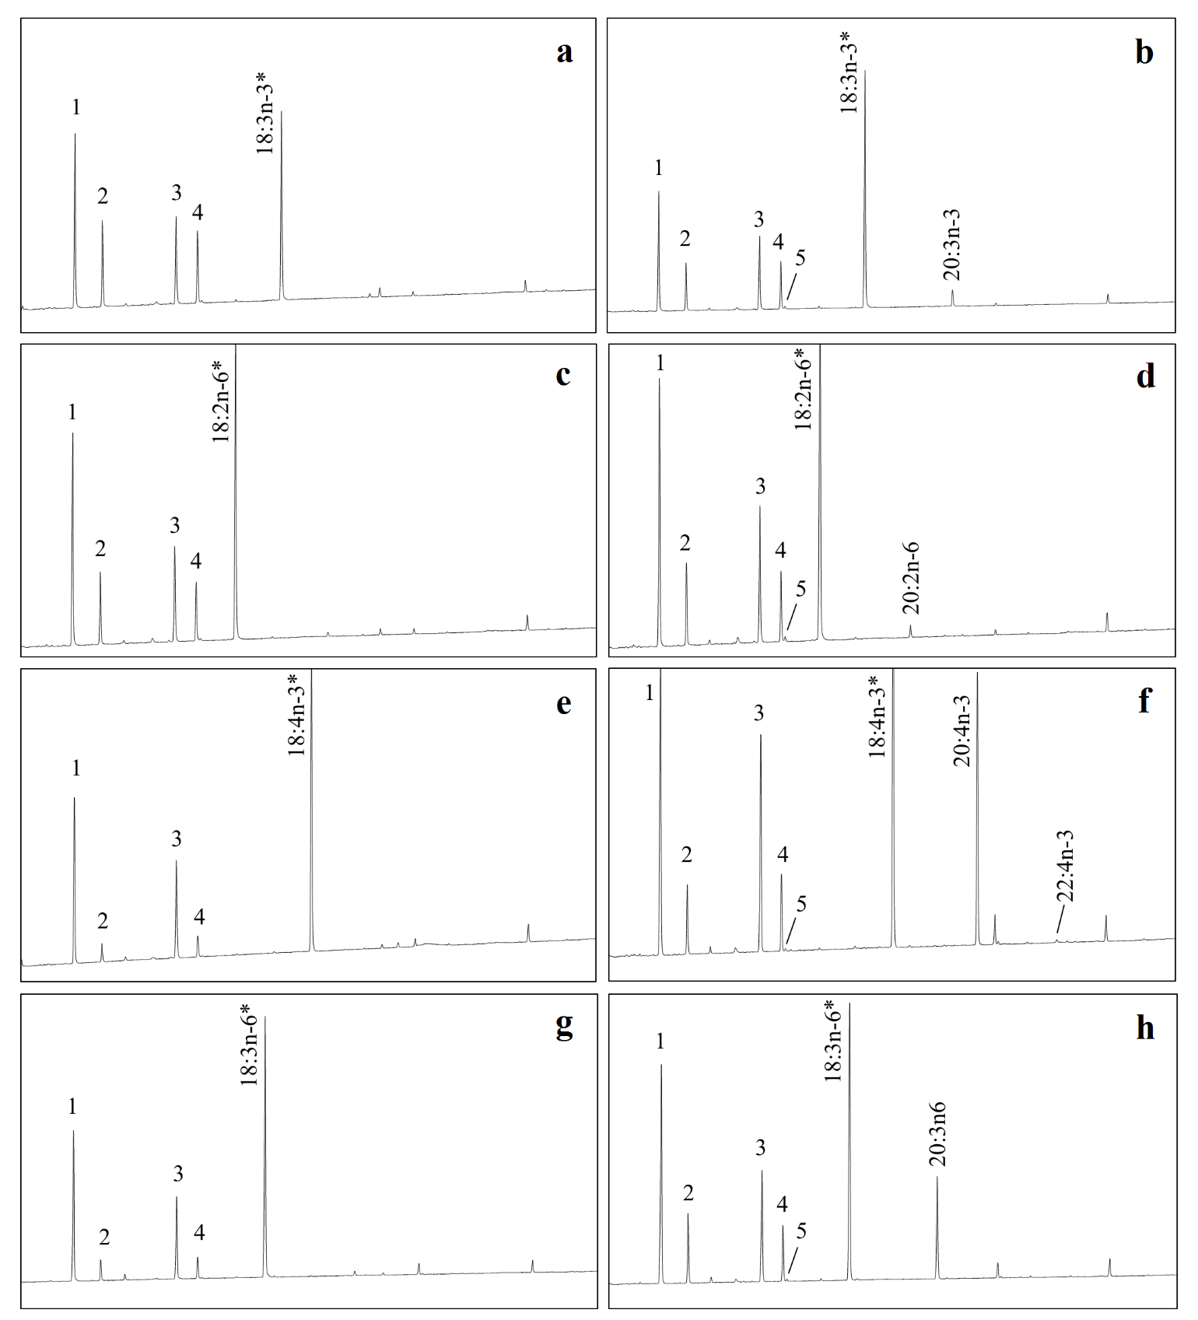

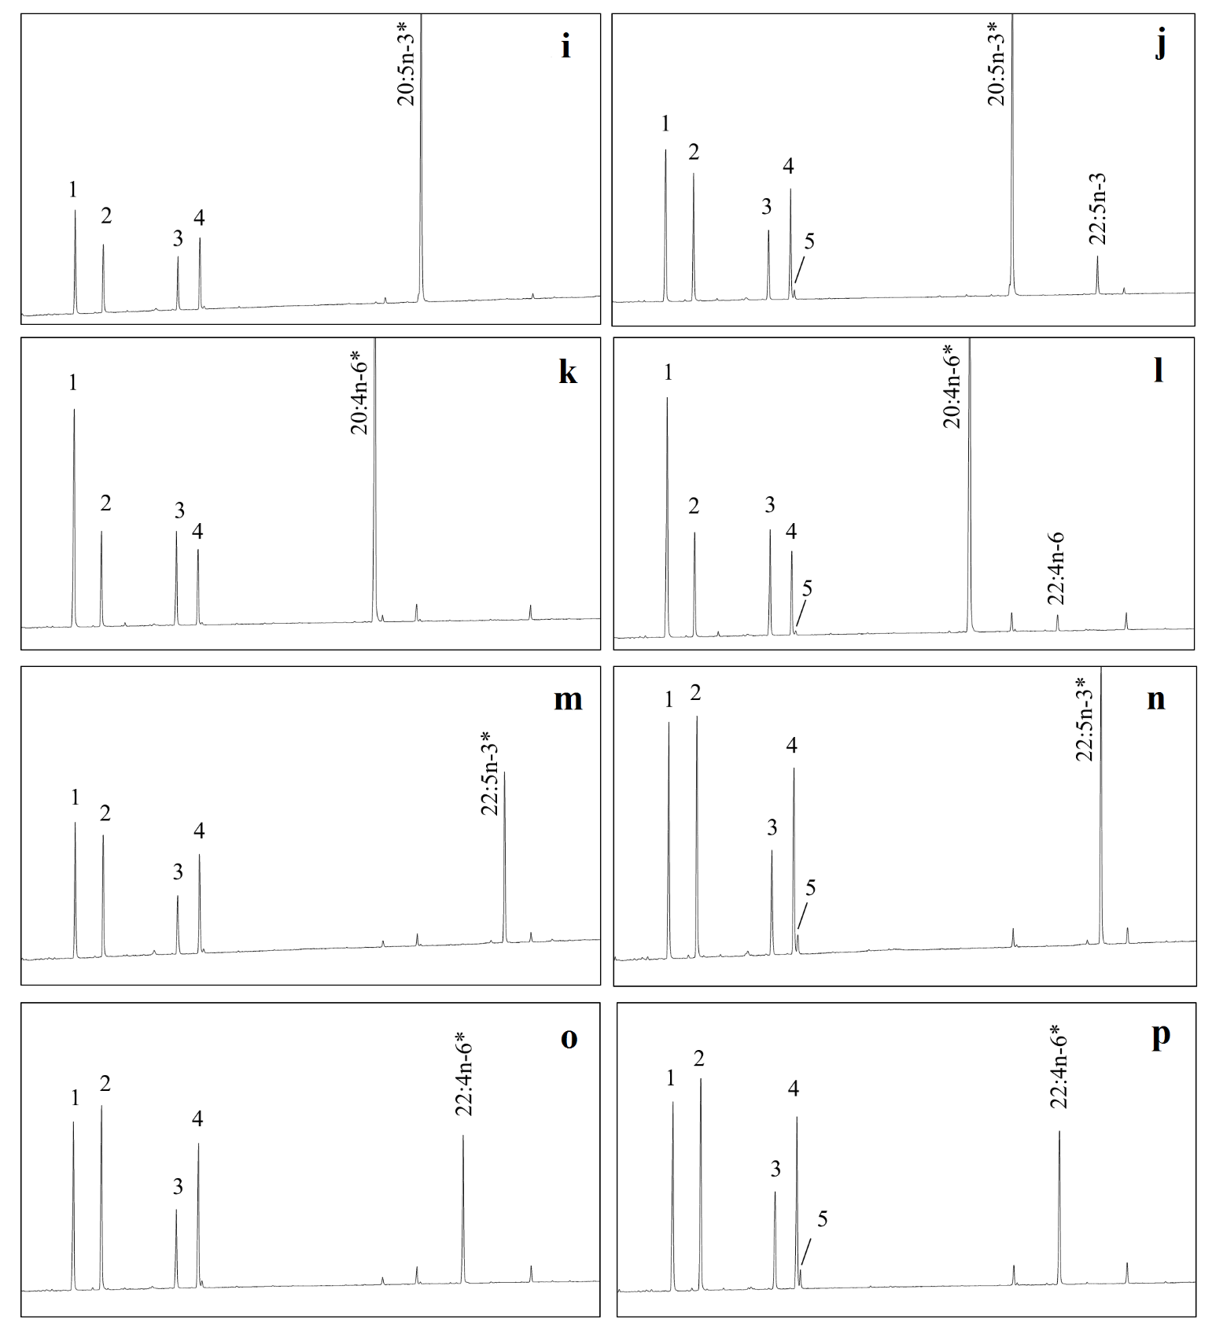
Fig. S4 Functional characterization of P. micromegethes Elovl5 in transgenic yeast (Saccharomyces cerevisiae) cultured in one of the exogenously added fatty acid (FA) substrates: 18:3n-3 (b), 18:2n-6 (d), 18:4n-3 (f), 18:3n-6 (h), 20:5n-3 (j), 20:4n-6 (l), 22:5n-3 (n), and 22:4n-6 (p). Chromatograms a, c, e, g, i, k, m, and o represent the fatty acid profile of yeast transformed with the pYES2 empty vector alone. Peaks marked as 1-4 are the main endogenous fatty acids of yeast, namely 16:0 (1), 16:1n-7 (2), 18:0 (3), and 18:1n-9 (4). Peak 5 corresponds to the 18:1n-7, arising from the elongation of yeast endogenous 16:1n-7 (2). Peaks labelled with * indicates exogenously added FA substrates, while the subsequent peak indicates elongation products
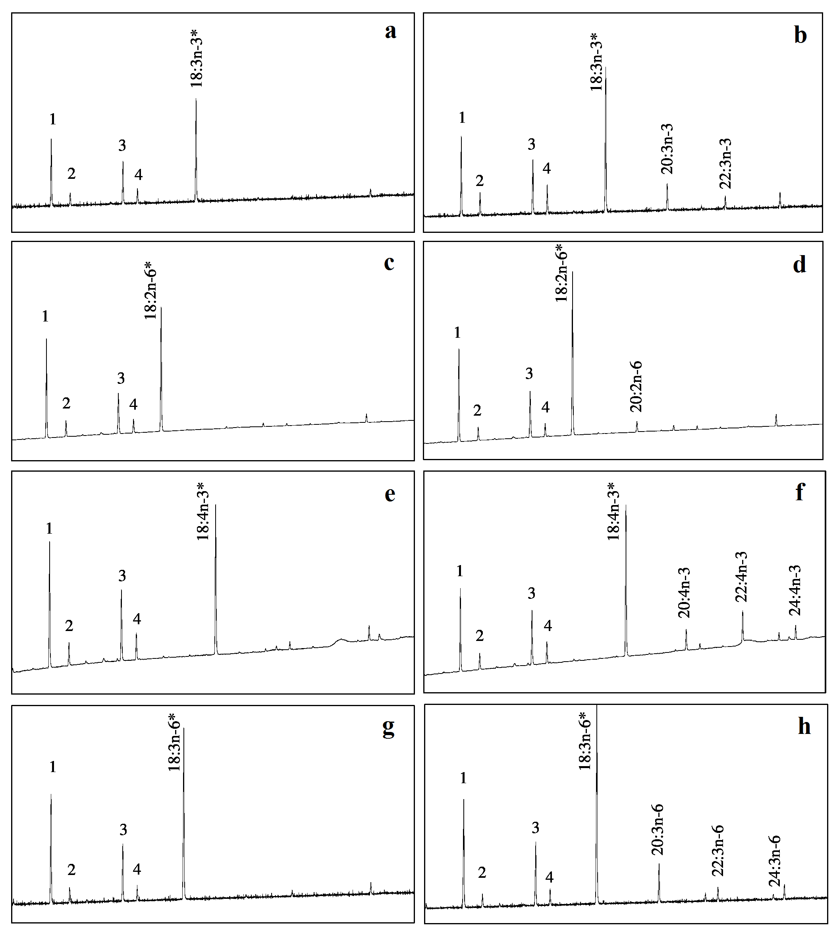

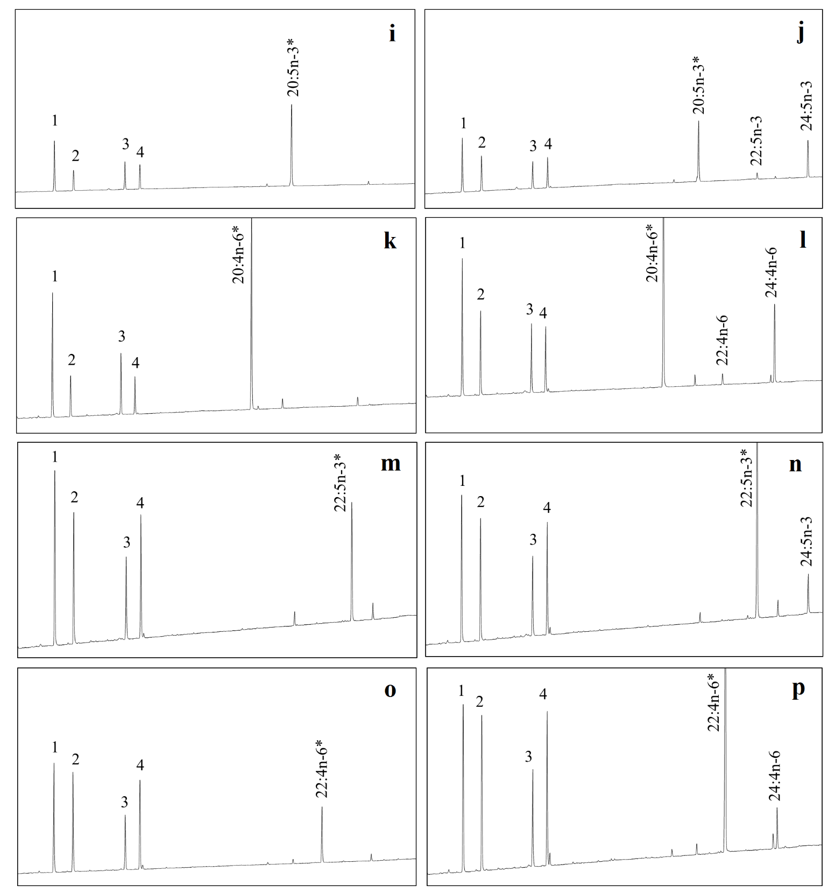
Fig. S5 Functional characterization of P. micromegethes Elovl2 in transgenic yeast (Saccharomyces cerevisiae) cultured in one of the exogenously added fatty acid (FA) substrates: 18:3n-3 (b), 18:2n-6 (d), 18:4n-3 (f), 18:3n-6 (h), 20:5n-3 (j), 20:4n-6 (l), 22:5n-3 (n), and 22:4n-6 (p). Chromatograms a, c, e, g, i, k, m, and o represent the fatty acid profile of yeast transformed with the pYES2 empty vector alone. Peaks marked as 1-4 are the main endogenous fatty acids of yeast, namely 16:0 (1), 16:1n-7 (2), 18:0 (3), and 18:1n-9 (4). Peaks labelled with * indicates exogenously added FA substrates, while the subsequent peak indicates elongation products
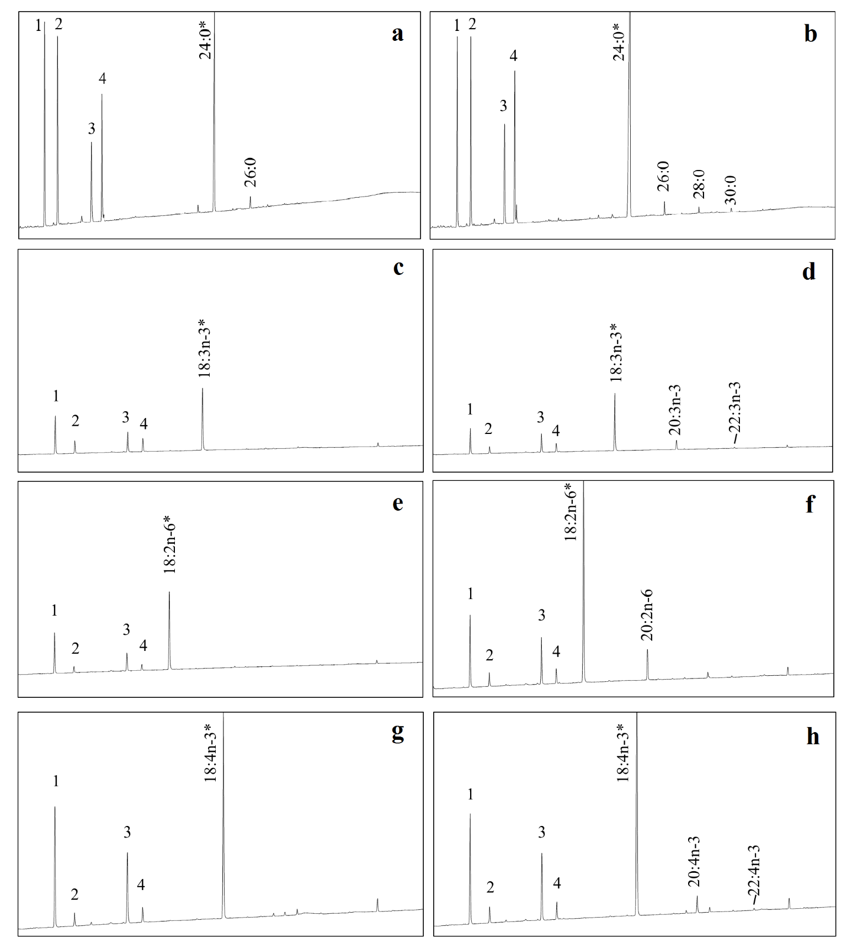

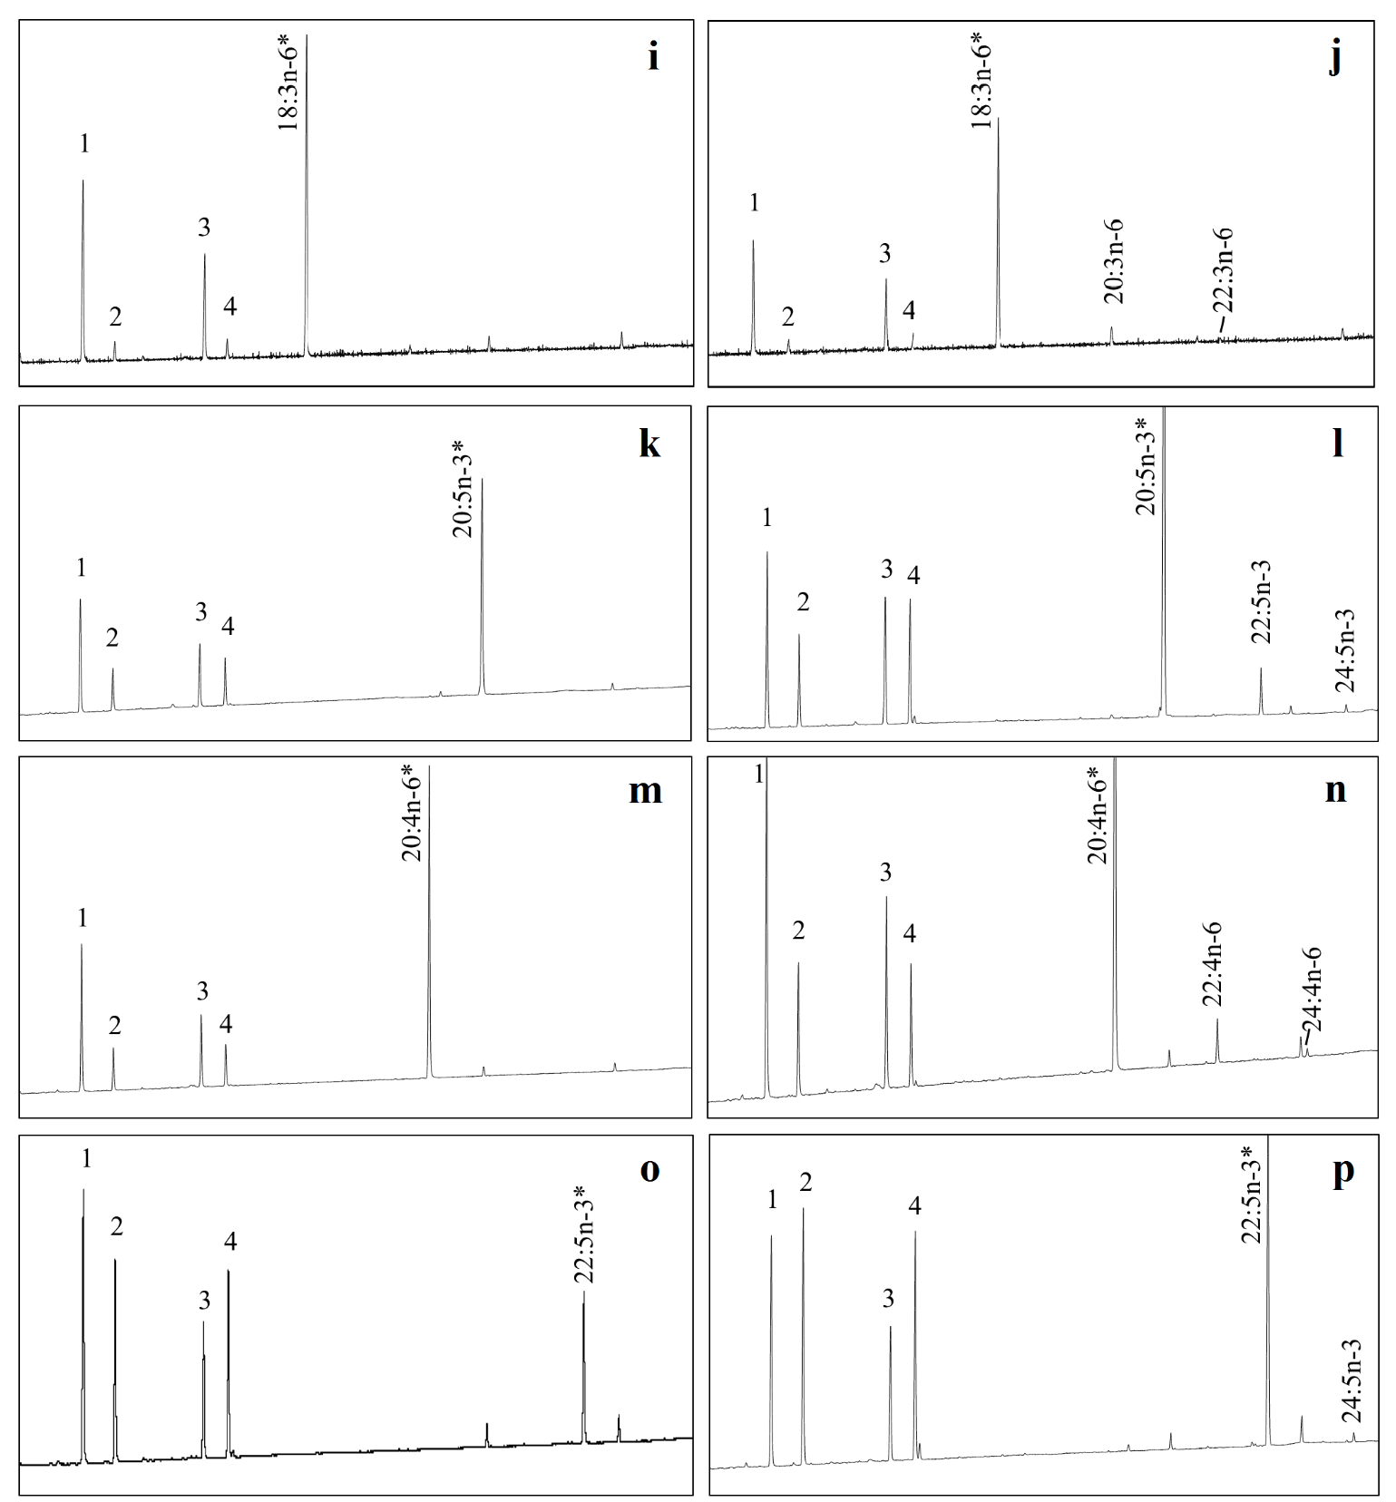

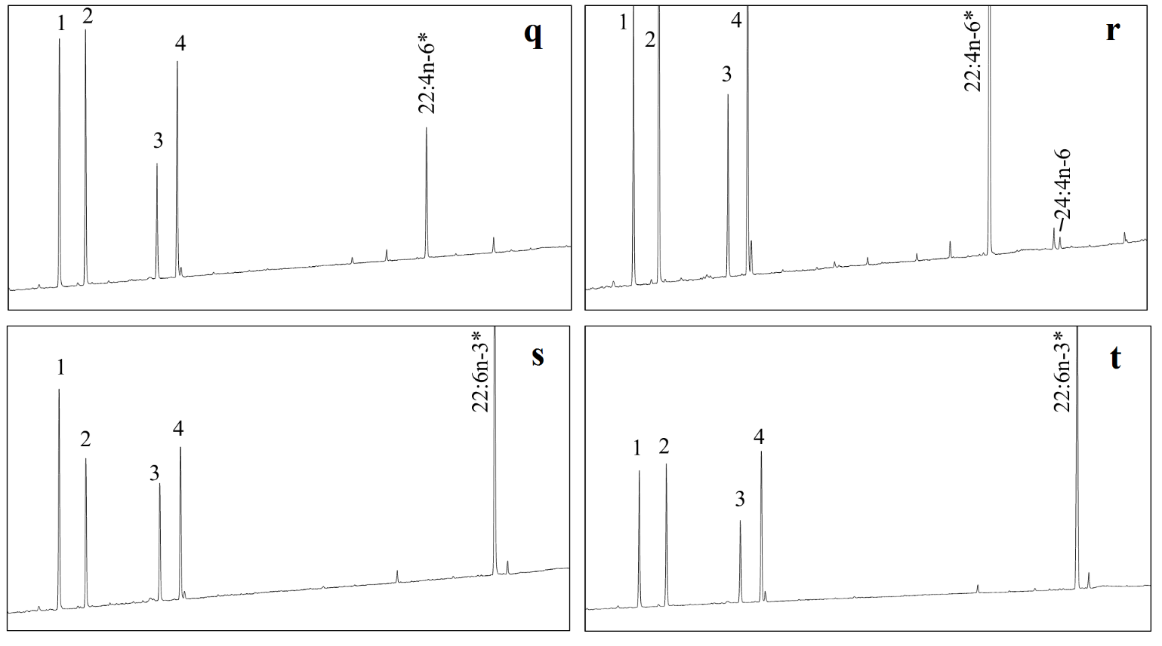
Fig. S6 Functional characterization of P. micromegethes Elovl4a in transgenic yeast (Saccharomyces cerevisiae) cultured in one of the exogenously added fatty acid (FA) substrates: 24:0 (b), 18:3n-3 (d), 18:2n-6 (f), 18:4n-3 (h), 18:3n-6 (j), 20:5n-3 (l), 20:4n-6 (n), 22:5n-3 (p), 22:4n-6 (r), and 22:6n-3 (t). Chromatograms a, c, e, g, i, k, m, o, q, s, and u represent the fatty acid profile of yeast transformed with the pYES2 empty vector alone. Peaks marked as 1-4 are the main endogenous fatty acids of yeast, namely 16:0 (1), 16:1n-7 (2), 18:0 (3), and 18:1n-9 (4). Peaks labelled with * indicates exogenously added FA substrates, while the subsequent peak indicates elongation products

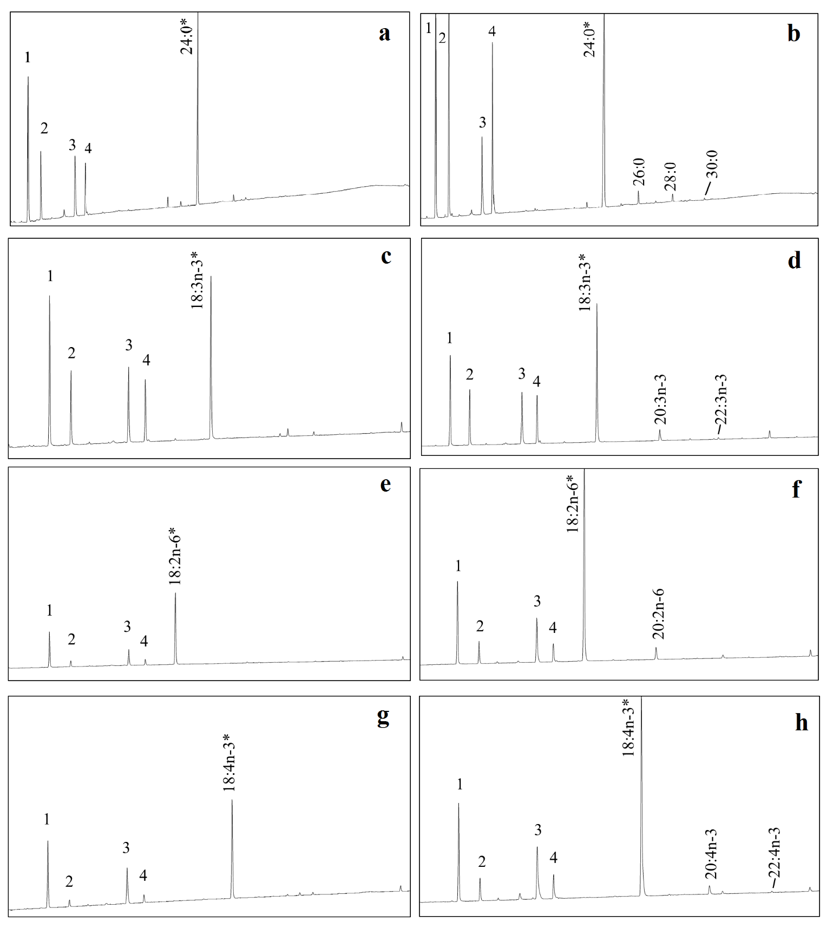

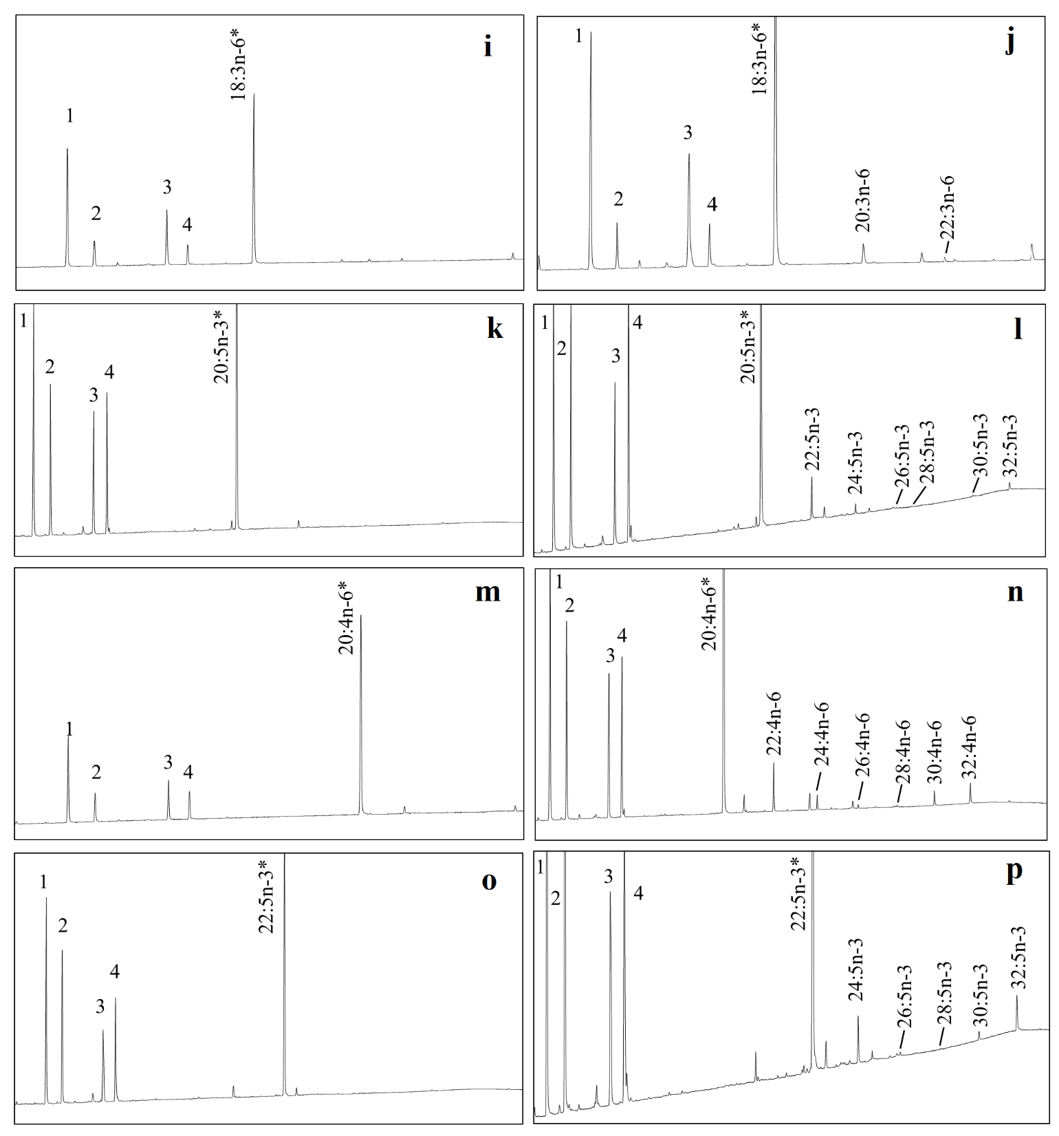

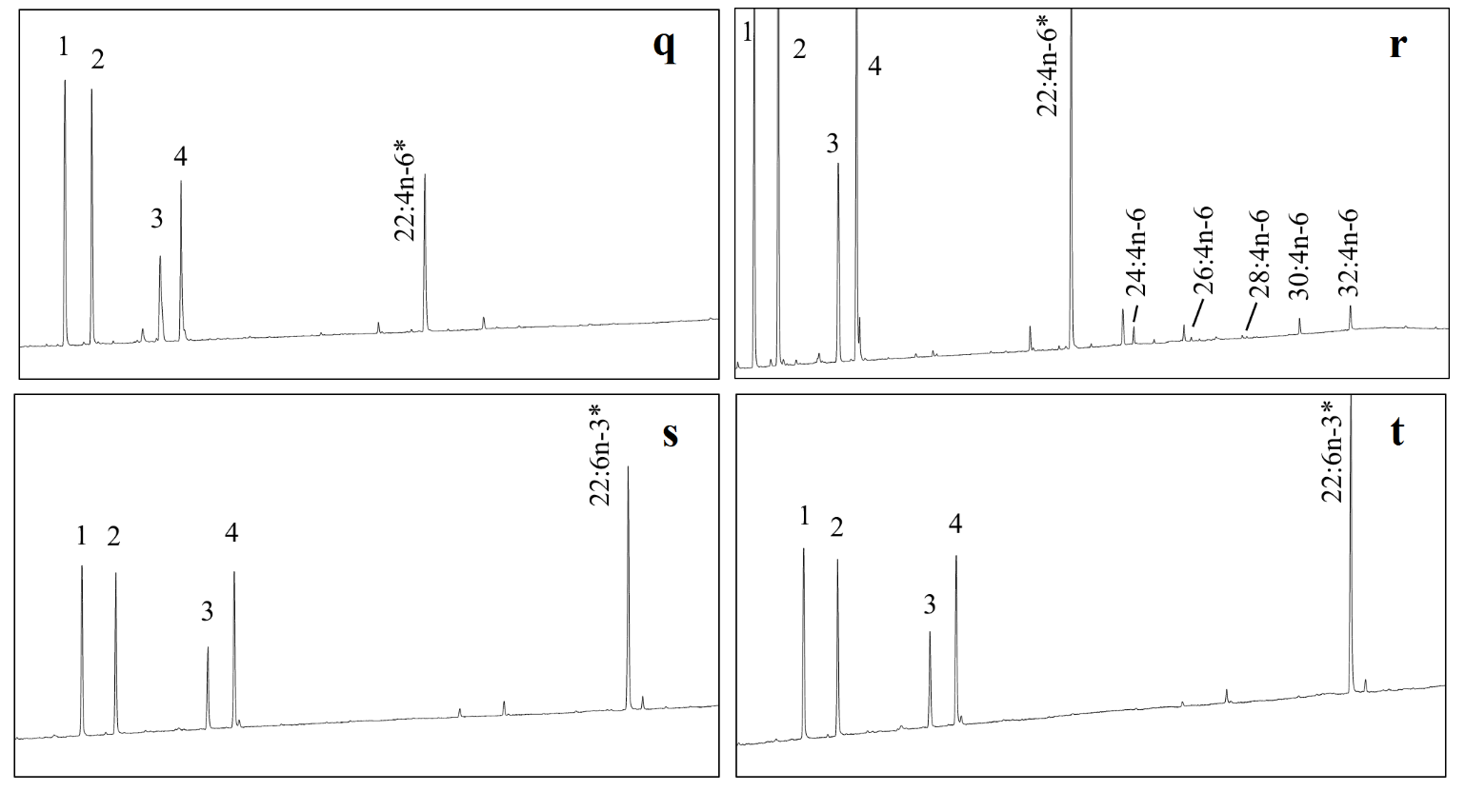
Fig. S7 Functional characterization of P. micromegethes Elovl4b in transgenic yeast (Saccharomyces cerevisiae) cultured in one of the exogenously added fatty acid (FA) substrates: 24:0 (b), 18:3n-3 (d), 18:2n-6 (f), 18:4n-3 (h), 18:3n-6 (j), 20:5n-3 (l), 20:4n-6 (n), 22:5n-3 (p), 22:4n-6 (r), and 22:6n-3 (t). Chromatograms a, c, e, g, i, k, m, o, q, s, and u represent the fatty acid profile of yeast transformed with the pYES2 empty vector alone. Peaks marked as 1-4 are the main endogenous fatty acids of yeast, namely 16:0 (1), 16:1n-7 (2), 18:0 (3), and 18:1n-9 (4). Peaks labelled with * indicates exogenously added FA substrates, while the subsequent peak indicates elongation products

