Title: Trends in co-mention of stimulants and opioids: A natural language processing driven analysis of Reddit forums

Authors:

Abeed Sarker, PhD¹
Mohammed Ali Al-Garadi, PhD¹
Yao Ge, MS¹
Nisha Nataraj, PhD, MS²
Christopher M Jones, PharmD, DrPH²
Steven A Sumner, MD, MSc²

¹Department of Biomedical Informatics, School of Medicine, Emory University, Atlanta, GA 30322
²National Center for Injury Prevention and Control, Centers for Disease Control and Prevention, Atlanta, GA 30341

Corresponding author:
Abeed Sarker
101 Woodruff Circle
Suite 4101
Atlanta, GA 30322
Email: abeed@dbmi.emory.edu

Word Count: 3,879 (excluding abstract, figures, tables, and references)

Abstract: 250

Acknowledgements: We are grateful to Londell McGlone and Herschel Smith for providing assistance in detecting mentions of substances in the data.

Disclaimer: The findings and conclusions in this report are those of the authors and do not necessarily represent the official position of the Centers for Disease Control and Prevention.

The authors have no conflicts of issues to disclose.
Abstract

250 words

Background
Despite recent increasing focus on fatal overdoses involving multiple substances, there is a paucity of knowledge about stimulant co-use patterns among people who use opioids (PWUO) or people being treated with medication for opioid use disorder (PTMOUD). This study examines stimulant co-mention trends among PWUO/PTMOUD on social media.

Methods
We collected publicly-available data from 14 prescription and illicit opioid and MOUD-related forums on Reddit (subreddits) between 2011-2020 and timelines comprising past posts from a sample of Reddit users (Redditors) on these forums. We applied natural language processing to detect mentions of opioids, opioid-related medications, and stimulants and described trends and patterns in co-mentions.

Results
Posts collected for 13,812 Redditors indicated 12,306 (89.1%) mentioned ≥1 opioid, opioid-related medication or stimulant. Analyses showed the number and proportion of Redditors mentioning both opioids and/or opioid-related medications and stimulants steadily increased over time. Relative rates of co-mentions of heroin and methamphetamine, substances most commonly co-mentioned, decreased in recent years while those of fentanyl and MOUD with methamphetamine increased.

Conclusion
Data from Reddit reflect increasing mentions of stimulants, particularly methamphetamine, among PWUO/PTMOUD and closely resemble the growth in overdose deaths involving both opioids and stimulants. These findings are consistent with recent reports suggesting increasing stimulant use among people receiving treatment for opioid use disorder. These data offer insights on emerging trends in the overdose epidemic and underscore the importance of scaling efforts to address co-occurring opioid and stimulant use including harm reduction and comprehensive healthcare access spanning mental-health services and substance use disorder treatment.

Keywords:
Opioids
Stimulants
Substance use
Natural language processing
Social media

Manuscript

3,879 words

1. Background
Stimulant co-use^{1–3}, specifically methamphetamine, and stimulant co-involvement in overdose fatalities⁴, including among people with opioid use disorder (OUD) are of growing concern in the US. This increase in co-use is likely contributing to statistically significant increases in overdose deaths involving both opioids and stimulants.⁵ The rise in overdose deaths involving opioids and stimulants has exacerbated the challenge of addressing the decades-long opioid overdose crisis, and reflects the evolving, polysubstance nature of the broader overdose epidemic and the presence of illicitly manufactured fentanyl. Studies have shown that stimulant co-use exposes people who use opioids (PWUO) to additional health risks, including overdose, infectious disease transmission, and suboptimal treatment outcomes.^{6,7} Further, these changes in substance use patterns and related harms have occurred against the backdrop of a substantial increase in availability of methamphetamine across the US. Based on drug product submissions to the Drug Enforcement Administration’s National Forensic Laboratory Information System, methamphetamine submissions more than doubled from 2011 to 2019.⁸ In addition, in the 2020 National Drug Threat Assessment, methamphetamine seizures and price data as well as law enforcement reporting all indicate that methamphetamine is now readily available at a greater purity and potency throughout the US.⁹
Recent findings also suggest that reasons for co-use, particularly with methamphetamine, are multifaceted—such as ease of access, helping boost the “high”, improving daily function (e.g., increasing productivity or staying alert), and helping manage withdrawal symptoms.¹⁰ However, little is known about when stimulants enter into the substance use trajectory of PWUO, how co-use patterns have shifted over recent years, and how patterns of opioid and stimulant co-use evolve at an individual-level. One potential source for gathering exploratory information on this emerging health concern is longitudinal social media data obtained from Reddit. Reddit data are being increasingly used for conducting observational research, particularly on sensitive topics such as substance use.^{14,16–18}

1.1 Objectives
The overarching objectives of this study are to utilize social media conversation data on Reddit to:
- Estimate the volumes and short- and long-term trends of opioid-stimulant co-mentions
- Quantify estimated co-use rates between pairs of specific opioids and stimulants based on these discussions
- Identify when stimulants are initiated evidenced by mentions among PWUO at an individual level based on timelines of posts

The insights we derive in this study are purely data-driven through natural language processing (NLP) methods, as opposed to hypothesis-driven, and our methods account for growth in the number of Reddit users over time. A better understanding of the timing and patterns in stimulant co-use among PWUO as evidenced by mentions of these substances on social media can help inform prevention efforts including harm reduction, as well as future research directions. In the remainder of the article, we refer to people who post on specific subreddits of interest as Redditors; people who use or used prescription and/or illicit opioids, people who used an opioid reversal agent (e.g., naloxone), and people with OUD who are being treated with medications for opioid use disorder (MOUD) as PWUO/PTMOUD, people who use stimulants as PWUS, people who use drugs more broadly as PWUD, and people who co-use opioids and stimulants as PWCU.

2. Methods
2.1 Data
Reddit is particularly popular among PWUO and the broader community of people who use drugs (PWUD) as it can offer anonymity.¹¹ Reddit has seen rapid growth in its user base over the last several years. In 2021, it is estimated that Reddit has over 430 million¹² monthly active users (Redditors), surpassing the number of active Twitter users.¹³ These increases may be driven by factors such as the organization of discussions through specialized topical-interest forums called subreddits and the moderation of forum-specific content by forum users. Reddit communities have also been found to serve as a means of social support for PWUD.^{14–16}

To find potential PWUO on Reddit, we identified 14 opioid-related subreddits spanning discussions on prescription and illicit opioids, and MOUD (Appendix A1) and collected all retrievable posts contained using the Python-Reddit application programming interface (API) Wrapper for Reddit.¹⁹ Since these subreddits serve as specific discussion forums for topics related to opioid use and recovery and empirical examination of posts revealed that most Redditors discussed personal use and experience, we assumed that all authors of posts that mentioned any opioid or opioid-related medications defined as opioid reversal agents and MOUD were either current or past PWUO/PTMOUD. We also assumed that mentions of a substance corresponded with presumed use of that substance. Thus, Redditors who mentioned opioids and/or opioid-related medications and stimulants were presumed to co-use both substances (PWCU) during the study period – in our analyses, we separately examined co-mentions of both substances within a given year as well as mentions that may have spanned multiple years. After retrieving subreddit posts of the 47,327 Redditors who had posted on the selected sub-reddits, we selected a random sample of these Redditors (N=13,812) and collected each of their past public posts across all subreddits (i.e., timelines), between November 2006 (corresponding to the earliest post available) and July 2021 (corresponding to the last date of data collection). Each timeline took approximately 20 minutes to obtain, so the number of Redditors included in the sample was limited by the rate at which we could collect full timelines via the API. We studied trends in opioid and stimulant co-use between January 1, 2011 and December 31, 2020. We excluded earlier years from this analysis because the numbers of posts (and correspondingly, Redditors) prior to 2011 were very low (i.e., ≤20 posts) , and we excluded 2021 because complete data for this year were not available. Due to similar concerns related to low posts with specific substances mentioned, we restricted our study of specific opioid and opioid-related medications, and stimulant categories to the years 2015 – 2020. We then chronologically ordered the posts per Redditor to enable an exploration of substance use timelines. All analyses described in this study were conducted using Python.

2.2 Identifying substance mentions
We apply natural language processing methods to improve the detection of true mentions of opioids and stimulants, and to exclude false positives (e.g., negated concepts and ambiguous expressions). We focused the study on a set of common opioids, opioid-related medications, and stimulants, including both prescription and illicit types (Appendix A2). Since drug names and related expressions are often misspelled on social media, we generated commonly used lexical variants of the terms using the LexExp tool.²⁰ We found that some non-standard terms and lexical variants tend to have high noise associated with them (i.e., expressions not actually referring to a stimulant or opioid, e.g., oxy clean). Thus, we included additional filters for the terms stimulant, meth, and oxy (Appendix A3). We applied an additional negation detection strategy, customized for Reddit data, to exclude negated drug mentions. Specifically, we used a subset of negation terms from the NegEx algorithm²¹ (Appendix A4) with a moving context window, determined empirically, of size n = 5 following the mention of a negation trigger. Any opioid, opioid-related medication, or stimulant term was considered negated if it appeared in the context window following a detected negation expression and if an end of sentence marker (e.g., a period) did not occur between the negation term and the drug term. Negated terms were excluded from the final count of mentions. We also manually reviewed samples of posts detected by our searches to identify keywords with a large amount of noise (e.g., ‘dope’ for heroin and ‘coke’ for cocaine) and excluded those from our counts and further analysis. Of the 13,812 Redditors sampled, a subset who posted in these subreddits had no mention of either an opioid, opioid-related medication, or a stimulant (N=1,506) and were excluded from the analyses. All analyses except for those examining the total numbers of redditors (including PWCU) over time were based on subsets of the remaining 12,306 Redditors who posted about at least one opioid, opioid-related medication, or stimulant.

2.3 Opioid and stimulant co-use trends
We first studied trends in opioid and stimulant co-use between 2011-2020 through multiple metrics, including, the number of Redditors posting each year; the number of Redditors who mentioned at least one opioid or opioid-related medication and one stimulant (i.e., PWCU) over the same time frame; and the annual ratio of PWCU to PWUO/PTMOUD . Due to the growing user-base of Reddit over time, we expected numbers of PWUO/PTMOUD and PWCU to both increase annually. Hence, the ratio of PWCU to PWUO/PTMOUD likely serves as the best indicator of social media trends in opioid and stimulant co-use within this population.
Next, we calculated and visualized three main explorations of co-use patterns for our dataset, focusing on the years 2015-2020 due to lower counts of posts by specific substances in prior years, – i) frequency of co-use of specific types of opioid-stimulant pairs among PWUO/PTMOUD aggregated over the entire study period; ii) proportion of specific opioids co-used with any stimulant in a given year among the total number of PWCU in that year, to study how mentions of specific opioids or opioid-related medications co-used with any stimulant changed over time; iii) proportion of specific stimulants co-used with any opioid or opioid-related medication in a given year among the total number of PWCU in that year, to study how mentions of specific stimulants co-used with any opioid changed over time. Redditors with mentions of more than one type of opioid or opioid-related medication or stimulant within a given year were separately considered for each specific opioid-stimulant pair.
We combined the opioids and opioid-related medications listed in our analytic sample into 5 categories: (i) heroin, (ii) fentanyl & analogs (including carfentanil), (iii) Medications for Opioid Use Disorder (MOUD; e.g., buprenorphine, methadone, naltrexone), (iv) opioid overdose reversal agents (e.g., naloxone), and (v) prescription opioid pain relievers (e.g., oxycodone, hydrocodone, and tramadol). We combined stimulants into 4 categories: (i) methamphetamine, (ii) amphetamine-type stimulants (e.g., Adderall®, dextroamphetamine, levoamphetamine), (iii) methylphenidate-type stimulants (e.g., Ritalin®), and (iv) a combination of methamphetamine and heroin (i.e., goofball/speedball). Categories included generic names, trade names, and common misspellings or lexical variants (Appendix A2). Due to aforementioned challenges of appropriately identifying keywords with substantial noise, we excluded mentions of cocaine from our analysis.

2.4 Timeline analyses
One of our objectives was to explore when stimulants are initiated and used by PWUO/PTMOUD over time. We focused specifically on methamphetamine initiation and use as our analyses revealed methamphetamine to be the most commonly used stimulant by a large margin (Appendix A5). We constructed a cohort by selecting the subset of Redditors who mentioned an opioid or opioid-related medication first in their timelines of posts from our randomly selected sample. To align the timelines of different Redditors, we considered the date of the first opioid mention to be Day 0. Timelines were stratified based on opioid type by grouping together Redditors who mentioned the same or similar opioids on Day 0. We tracked timelines for each PWUO/PTMOUD by computing the monthly frequencies of methamphetamine mentions for 24 months starting from Day 0. We excluded Redditors whose first and last post on Reddit were less than 24 months apart and those who had any stimulant-related posts within 30 days of their first opioid or opioid-related medication post (i.e., individuals with presumed co-use within the first month). By mapping the first post to Day 0 for all Redditors who posted, the distribution of posts over the 24 months was naturally skewed— each Redditor had at least one post in the first month, but the frequency of posts over the following months varied. To adjust for this, we normalized the monthly methamphetamine mention frequencies by the total posts made by PWUO/PTMOUD each month. Since most mentions correspond to personal use, we assumed Redditors with an opioid or opioid-related medication mention first and subsequent methamphetamine mention had transitioned to co-use. We developed heatmaps of these timelines to visualize temporal patterns of methamphetamine use.

3. Results
3.1 Study sample characteristics
We collected 13,812 Redditor timelines from the 14 subreddits, 12,306 of whom mentioned at least one of our selected opioid, opioid-related medication or stimulant keywords. Redditors mentioning any opioid or opioid-related medication, or any stimulant in their timelines were approximately evenly distributed—9,329 Redditors mentioned opioids or opioid-related medication at some point in their timeline; 9,151 mentioned stimulants (Appendix A5). There was a substantial proportion of presumed PWCU among Redditors who mentioned at least one opioid, opioid-related medication or stimulant keyword – 6,174 (50.2%) Redditors mentioned both an opioid or opioid-related medication and a stimulant. However, there was a large difference in the first substance mentioned – almost twice as many Redditors mentioned an opioid or opioid-related medication first in their timelines (n=8,276/12,306; 67.3%) versus those who mentioned a stimulant first (n=4,012/12,306; 32.6%).

3.2 Co-use characteristics
Figure 1 shows the (a) total number of Redditors per year posting in the 14 opioid-related subreddits, (b) number of PWCU per year as defined by the number of persons posting about both opioids and stimulants within the same year, and (c) ratio of PWCU to total Redditors per year from 2011-2020 in our analytic sample. These metrics were computed independently each year, i.e., a PWUO/PTMOUD or PWCU was determined based only on the posts within that year (Appendix A6 provides additional metrics). Figures 1a-b illustrates that the total number of Redditors posting on opioid-related subreddits (including Redditors with and without mentions of opioid or stimulant keywords of interest) as well as those posting about both opioids or opioid-related medications and stimulants (PWCU) increased each year since 2011, with sharp increases observed after 2016. The proportion of individuals posting about both opioids or opioid-related medications and stimulants as a fraction of all individuals posting also showed consistent annual growth (Figure 1c). By 2020, more than 15% of individuals posting in opioid-related subreddits had also posted about a stimulant.
Figure 2 shows heatmaps of the proportion reporting opioid and stimulant co-use among PWUO/PTMOUD. Within our sample, co-mentions of heroin and methamphetamine were most commonly observed relative to other opioid and opioid-related medications and stimulant types across 2011-2020. Indeed, across all opioids and opioid-related medications, methamphetamine was the most frequently co-mentioned stimulant. Amphetamine-type stimulants appeared to have the highest co-mentions after methamphetamine, followed by methamphetamine-heroin combinations (speedball/goofball). The relatively large volume of mentions of amphetamine-type stimulants was primarily driven by discussions of Adderall®, a prescription stimulant (Appendix A5). Interestingly, amphetamine-type stimulants appeared to have the highest probability of co-use with prescription opioid pain relievers (e.g., hydrocodone and oxycodone) relative to illicit opioids such as heroin.

Figure 1. (a) Total number of Redditors who posted in the opioid-related subreddits each year from 2011 to 2020; (b) total number of people who co-use opioids and stimulants (PWCU), i.e., who posted about both opioids and/or opioid-related medications and stimulants; (c) ratio of PWCU to total number of Redditors each year.

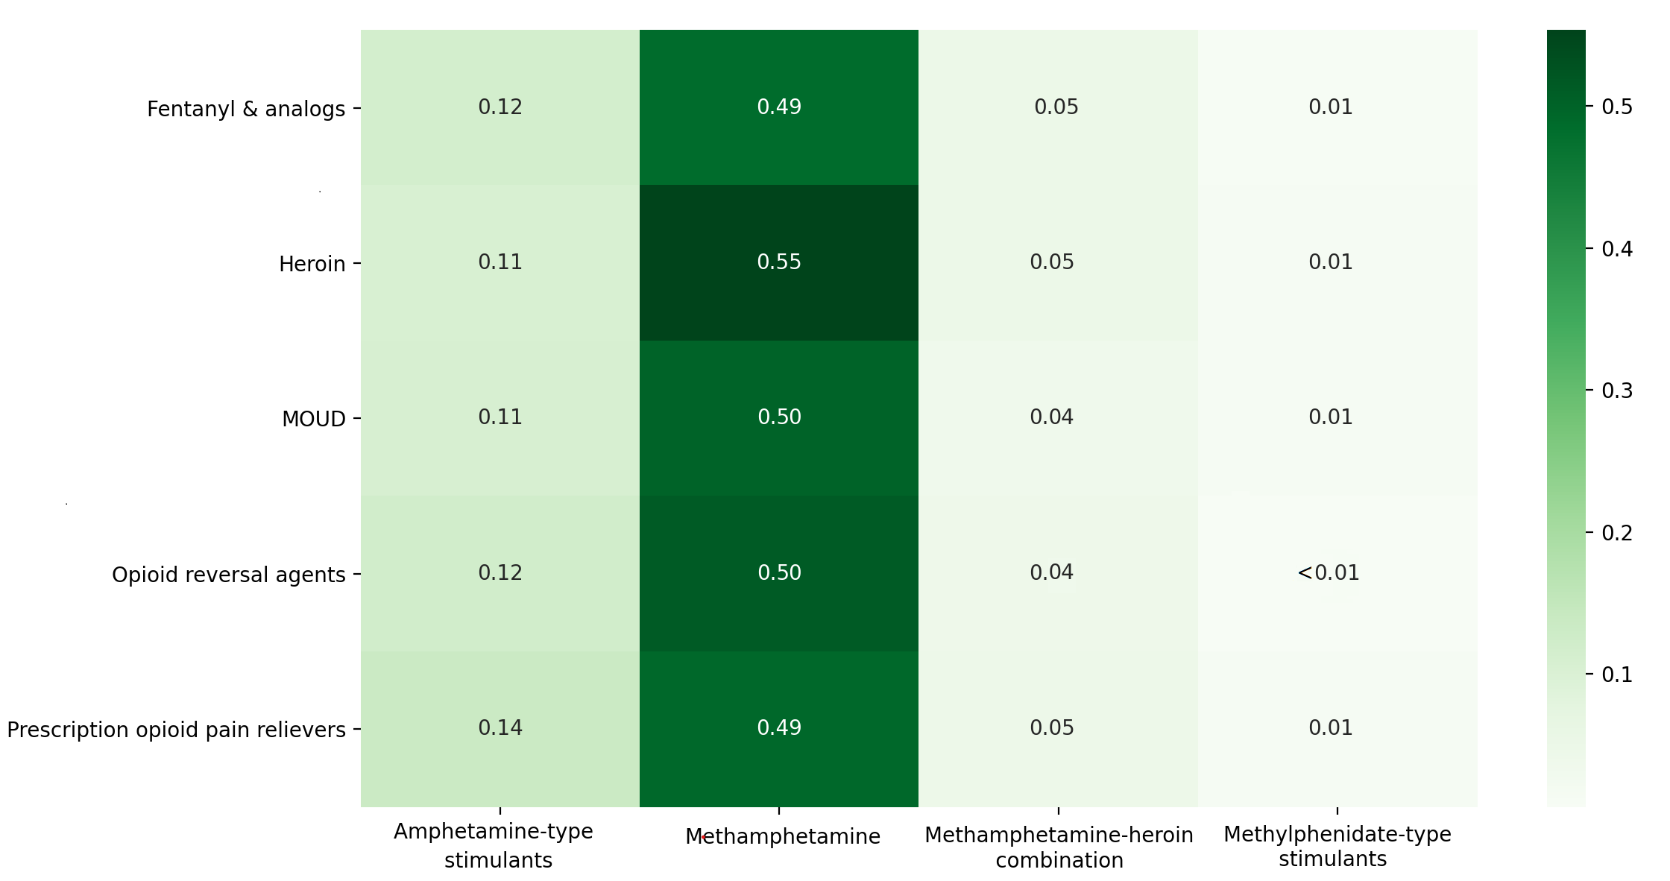
Figure 2. Proportions of Redditors who posted about specific opioid and opioid-related medication and stimulant pairs (e.g., opioid i and stimulant j) among all Redditors who posted about each specific opioid or opioid-related medication (e.g., opioid i). Opioids, opioid-related medication and stimulants are grouped as described in section 2.3. Total number of Redditors who mentioned at least one opioid = 9,329. Total number of Redditors who mentioned at least 1 stimulant = 9,151.

3.3 Co-use over years

Figure 3 shows the proportion of individuals who posted about particular opioid-related categories among those posting about both opioids and stimulants within a given year. This helps illustrate which opioid-related categories were most commonly mentioned among PWCU and how mentions of these opioids and opioid-related medications in the setting of co-use have potentially changed over time – e.g., fentanyl and its analogs had a relatively low probability of being discussed with stimulants in 2015, but nearly doubled by 2020. Mentions of MOUD similarly increased while those of heroin decreased over time among PWCU.
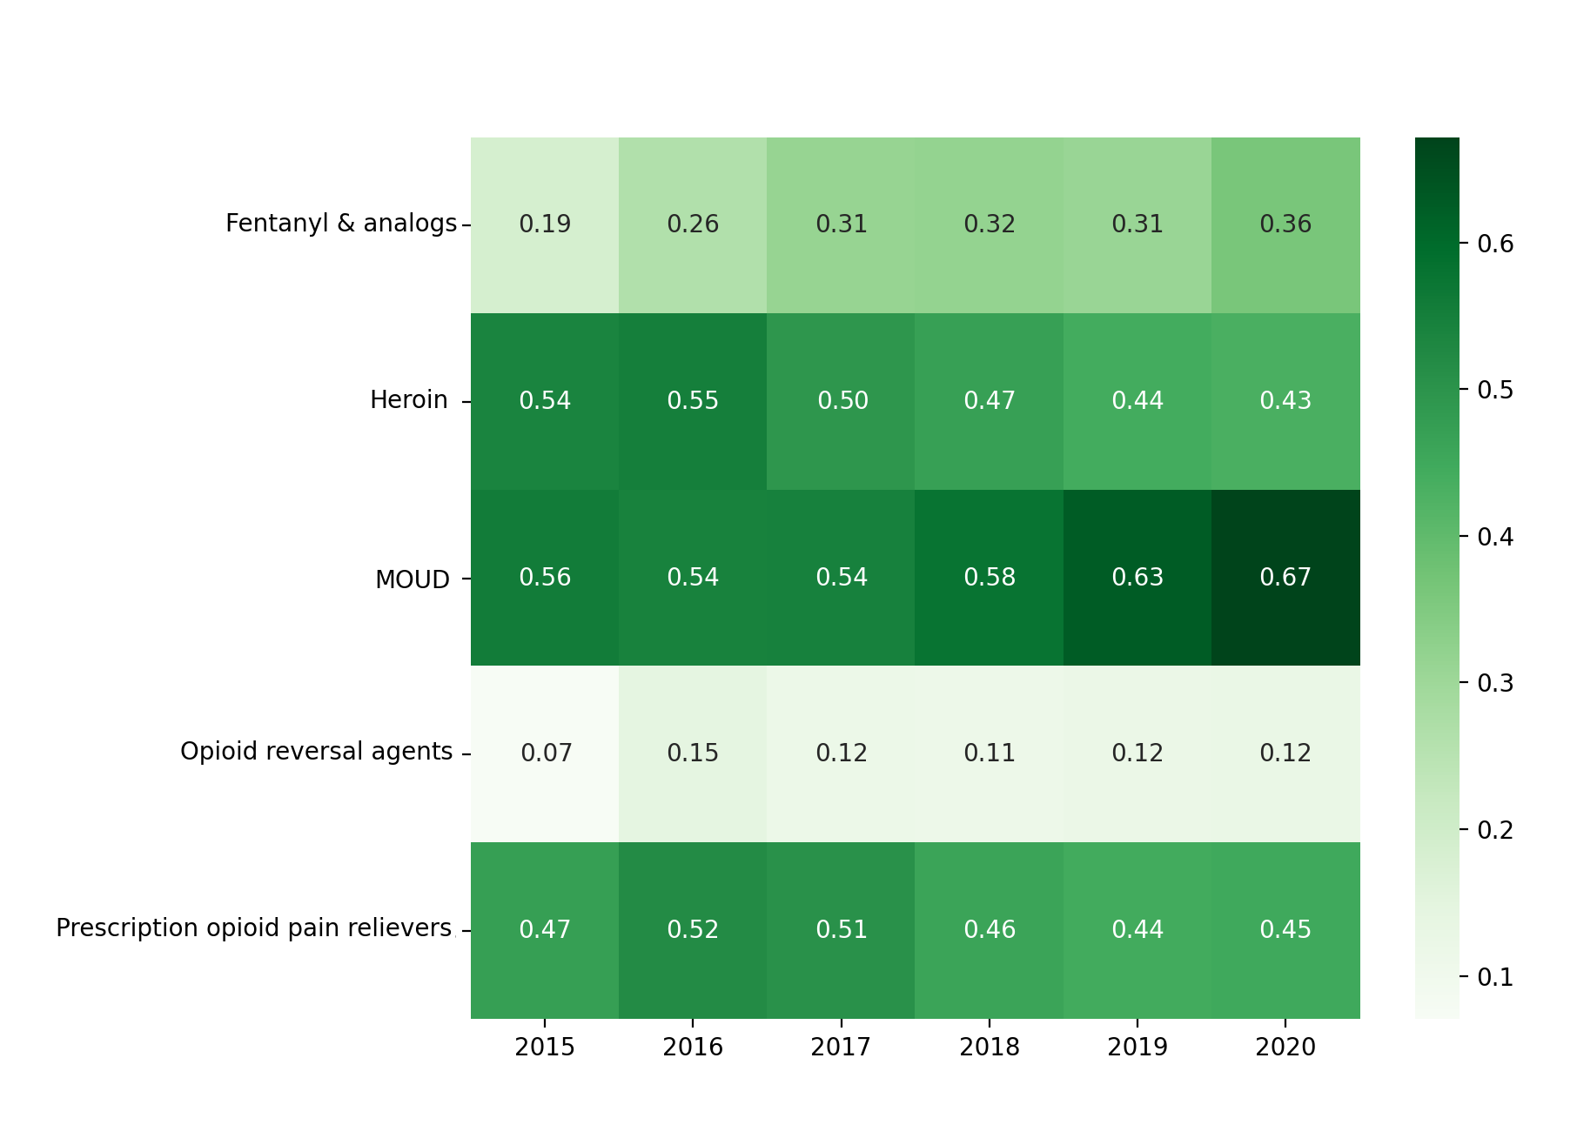
Figure 3. Proportions of people who co-use opioids and stimulants (PWCU, N = 4,786) who mentioned co-use of specific groups of opioids or opioid-related medications with any stimulant by year from 2015 – 2020. Total number of unique people who use opioids (PWUO)/ people with OUD who are being treated with medications for opioid use disorder (PTMOUD) within this timeframe = 8,831. Opioid-related categories – Fentanyl and analogs (fentanyl and carfentanil); Heroin; Medications for opioid use disorder (MOUD: suboxone, sublocade, methadone, buprenorphine, naltrexone); Opioid reversal agents (Naloxone); Prescription opioid pain relievers (hydrocodone, oxycodone, morphine, tramadol).

Figure 4 shows the proportion of individuals posting about a particular stimulant among all individuals posting about both opioids or opioid-related medications and stimulants that same year. Methamphetamine mentions largely eclipsed all other stimulants studied. Amphetamine-type stimulants showed the next highest co-use and increase over time.

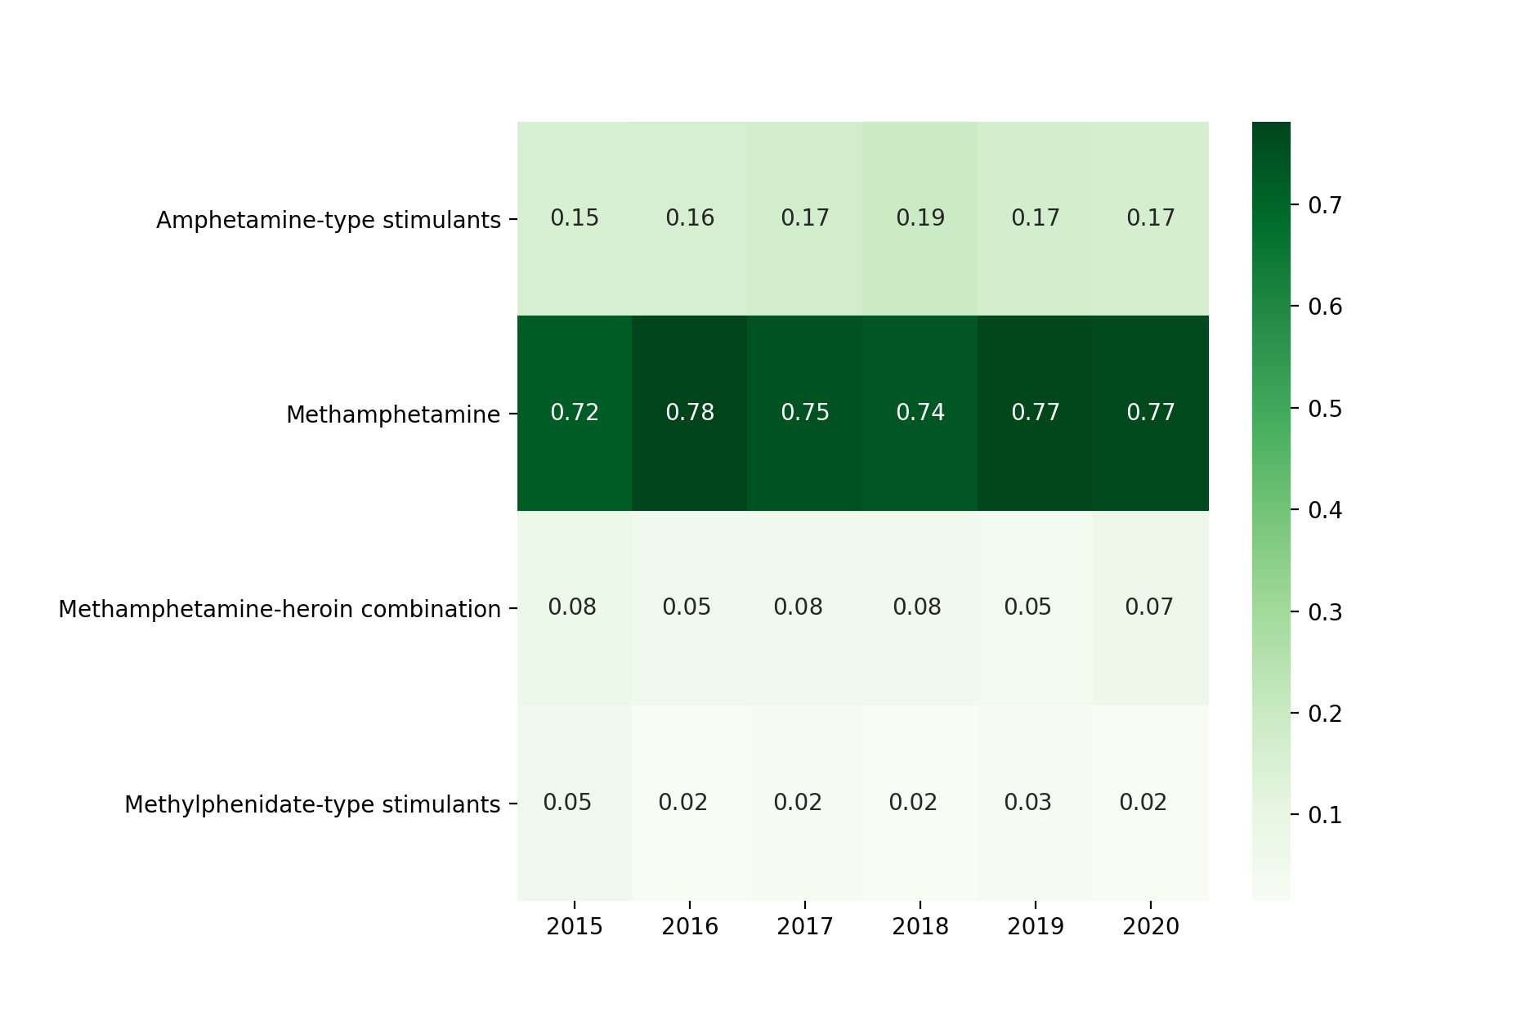
Figure 4. Proportions of people who mentioned co-use of specific groups of stimulants with any opioid or opioid-related medication (PWCU, N = 4,786) by year from 2015 – 2020. Total number of people who use stimulants (PWUS) within this timeframe = 8,266. Stimulant categories – Amphetamine type stimulants (amphetamine, dextroamphetamine, levoamphetamine, and lisdexamphetamine); Methamphetamine; Methylphenidate type stimulants (methylphenidate); a combination of methamphetamine and heroin (Speedball/Goofball).

3.4 Timeline analysis results

Figure 5 illustrates the initiation of and patterns in methamphetamine mentions among the cohort of individuals who first mentioned opioids. Overall, 849 Redditors from our sample met the inclusion criteria (i.e., had posts spanning >24 months, first mentioned an opioid or opioid-related medication, and no stimulant posts prior to or <30 days of first opioid post) with a total of 4,303 posts. Specifically, our figures show 24-month heatmaps where each month displays the relative frequencies of methamphetamine mentions normalized by the total number of posts made by PWUO/PTMOUD in that month. The heatmaps are stratified by the first opioid or opioid-related medication type the individual posted about in their timeline.
There are observable differences between the heat maps associated with the different types of opioids. The heatmap for heroin suggests co-use discussions with methamphetamine occurred most frequent relatively early in PWCU timelines. Conversely, the fentanyl & analogs heatmap shows a different pattern—methamphetamine co-use for these individuals demonstrates periods with elevated discussions at the beginning, middle, and end of the 24-month timeline. Heatmaps for prescription opioid pain relievers and MOUD were similar, with higher methamphetamine mentions at the beginning of the timelines and decreases toward the end; however, these decreases in mentions were smaller in magnitude relative to decreases among individuals who initially discussed heroin.
Figure 5. 24-month (excluding the first month) monthly relative frequencies of methamphetamine mentions among Redditors who first mentioned an opioid or opioid-related medication (N = 849). Mention frequencies per month are normalized by the total number of posts by the same set of Redditors within that specific time span. Opioid-related categories – Fentanyl and analogs (fentanyl and carfentanil); Heroin; Medications for opioid use disorder (MOUD: suboxone, sublocade, methadone, buprenorphine, naltrexone); Opioid reversal agents (Naloxone); Prescription opioid pain relievers (hydrocodone, oxycodone, morphine, tramadol). Stimulant categories – Amphetamine type stimulants (amphetamine, dextroamphetamine, levoamphetamine, and lisdexamphetamine); Methamphetamine; Methylphenidate type stimulants (methylphenidate); a combination of methamphetamine and heroin (Speedball/Goofball).

4. Discussion
The findings from our analysis of social media data are consistent with those from traditional health data sources indicating increased opioid and stimulant co-use over time^{3,6}, while also offering unique exploratory insights. While the opioid overdose epidemic has been ongoing for over a decade now, the surge in stimulant use, in particular methamphetamine use, among PWUO is a relatively recent public health concern. Several hypotheses have been suggested to explain this growing trend, including efforts to improve prescribing practices to reduce the availability of opioids³ which may have resulted in shifts to other substances by PWUO, increased accessibility and popularity coupled with low costs of stimulants,³ using stimulants to manage or reduce opioid withdrawal symptoms, and co-using stimulants for synergistic euphoric effects.^{10,22}
When examining the most frequently co-mentioned substances between 2011-2020, we found illicit opioids were more frequently mentioned with illicit stimulants (e.g., heroin and methamphetamine) and prescription opioids were most frequently mentioned with prescription amphetamine-type stimulants (e.g., oxycodone/hydrocodone and Adderall®). This suggests possibly distinct populations within the social media substance use forums we studied with preferences for particular types of substances. Further understanding the distinction between populations focused primarily on prescription drug misuse and those focused on illicit substance use, and the transitions between these preferences, is a future area for exploration of online data that may yield insights for better targeting prevention and harm reduction efforts. Indeed, while there is research on prescription stimulant misuse²⁴, less is known about its relationship to substance use trajectories, especially among individuals who misuse prescription opioids.²³
We found noticeable increases in the proportion of stimulant mentions among individuals also discussing MOUD over time, consistent with recent reports indicating that stimulant use among people receiving treatment for OUD may be increasing.^{2,25} Co-use of stimulants among people with OUD is concerning given prior research demonstrating increased risk for health harms such as overdose as well as suboptimal treatment outcomes, including poorer retention in MOUD, among people with OUD who use stimulants.^{26,27} These findings together underscore the importance of scaling efforts to address co-occurring opioid and stimulant use through expansion of MOUD in combination with nonpharmacological treatment modalities that address stimulant use such as contingency management and community reinforcement approach or cognitive behavioral therapy, along with recovery support services.²⁸
Interestingly, while relative rates of stimulant co-use among individuals using fentanyl appear to be on the rise, the relative rate for co-use among individuals using heroin showed a gradual decrease. This is perhaps a result of changes in the illicit opioid supply over recent years, as heroin has experienced supply shortages²⁹ ³⁰ and the illicit drug market in many communities has transition from a heroin-based market to a fentanyl-based market.³⁰ For persons using stimulants to counteract the depressant-type effects of opioids,³¹ the stronger potency of fentanyl may also be driving increased interest in stimulant use. Recent literature also suggests that PWUO/PTMOUD who knowingly or unknowingly consume fentanyl, tend to have more severe withdrawal symptoms when taking MOUD,³² which may partially explain the greater interest over time in stimulants among Redditors discussing both MOUD and fentanyl. Our results suggest that as availability and use of synthetic opioids such as fentanyl continue to increase, interest in and co-use of stimulants could persist. Individuals with polysubstance use have unique treatment needs and have higher risks for mental-health comorbidities,³³ further emphasizing the need for increased availability of comprehensive healthcare including mental-health services and substance use disorder treatment for PWUD. Qualitative research is needed to help better characterize timing and concerns associated with initiation of co-use among PWUO in order to develop and appropriately direct prevention and response strategies that can address the needs of this population.

4.1 Limitations
Our study has several limitations. Absent contextual information, the primary limitation is the assumption that an individual mentioning an opioid, opioid-related medication or stimulant is currently using that substance, which may result in overestimation of the number of PWUO/PTMOUD, PWUS, and PWCU, particularly in analyses where these mentions spanned multiple years. Nonetheless, the number of mentions could be a proxy for use and at minimum, mentions of a substance represent some degree of interest or consideration of a particular substance. Also, since the forums from which the Redditors were initially identified are topic-specific, most posts explicitly or implicitly refer to personal experiences. Second, individuals who post on Reddit may not necessarily be representative of all PWUD and caution when generalizing from these findings is warranted. According to a 2019 PEW Research Center report, Reddit has an overrepresentation of males and younger people.³⁴ Since then, however, the user base or Reddit has grown significantly. Third, not all PWUO, PWUS and PWCU necessarily mention all the substances they may use. Additionally, we excluded cocaine from our analyses due to challenges associated with accurately identifying mentions. Further, our analyses were limited to opioid-related subreddits and excluded any stimulant-related subreddits given our focus on PWUO/PTMOUDs. These limitations may both lead to an underestimation of stimulant and opioid-stimulant co-use. Fourth, we were only able to conduct our analyses on a sample of Redditors due to the rate limitations of the API. Our concerns about this limitation are mitigated by the finding that statistics derived from smaller samples of Redditors early on in our study remained almost identical to those obtained when larger numbers of individuals were included. The exponentially rising number of Reddit subscribers over time also posed a challenge for us, since we could not quantify how much of the increasing opioid or opioid-related medications and stimulant mentions could be attributed to increases in their use in the community versus the growing Redditor numbers. To address this, we examined the ratio of PWCUs to Redditors, which revealed that the growth rate in substance mentions was higher than the growth rate of Redditors. It is possible that other factors contributed to the rising substance mention rates, but we were unable to include such confounding factors in this analysis. Lastly, methodological limitations inherent to all analyses of unstructured text data apply as not all mentions/expressions are detectable by NLP methods.^{35,36} However, we employ robust and well-validated approaches for capturing spelling variants and non-standard expressions.

5. Conclusion

We examined real-world, longitudinal social media data from online opioid-related forums to explore patterns in opioid and stimulant discussions and found large increases in co-mentions of opioids or opioid-related medications and stimulants. These findings are consistent with those from other health data sources suggesting growing co-use of these substances and resultant harms. Although a multitude of factors may influence substance use trends, many are difficult to elucidate and explore using traditional data sources such as survey records or health care data. The social media data we explored offers important exploratory insights into which opioids or opioid-related medications and stimulants are most frequently co-mentioned and how these patterns have changed over time. These data derived from real world conversations may help in hypothesis generation and yield early insights to shape prevention activities addressing health harms associated with opioid and stimulant co-use.

List of abbreviations
PWUO: people who use opioids
PTMOUD: people being treated with medications for opioid use disorder
OUD: opioid use disorder
MOUD: medication for opioid use disorder
NLP: natural language processing
PWUD: people who use drugs
PWCU: people who co-use (opioids and stimulants)
PWUS: people who use stimulants
API: application programming interface

Declarations
Ethics approval and consent to participate
This study was approved by the Emory University Institutional Review Board (IRB). The study was deemed to fall under exemption category 4 (publicly available data). Consent from Reddit subscribers was not sought since the data is publicly available. No identifiable information is presented in the paper.

Consent for publication
N/A

Availability of data and materials
All posts used in this study were publicly available at the time of collection. Data can be collected via the API mentioned in the article. Aggregated statistics presented in the paper will be shared by the authors upon request.

Competing interests
None declared.

Funding
The study was funded in part by the Centers for Disease Control and Prevention and Emory University. The findings and conclusions in this report are those of the authors and do not necessarily represent the official position of the Centers for Disease Control and Prevention or Emory University.

Authors' contributions
AS performed the primary data analysis and interpretation, and authored the original draft of the manuscript. MAA and YG assisted AS with the data collection, analysis and presentation, including the statistical analysis and the generation of figures. NN, CMJ and SAS contributed to the data analysis and interpretation, and performed substantial revisions to the manuscript. CMJ and SAS provided domain expertise and high-level guidance for the study, and contributed to critical revisions. All authors contributed to the writing of the manuscript and approved the final version.

Acknowledgements
The authors are grateful to Londell McGlone and Herschel Smith of the Centers for Disease Control and Prevention for providing assistance in detecting mentions of substances in the data.

References

1. Strickland JC, Havens JR, Stoops WW. A nationally representative analysis of “twin epidemics”: Rising rates of methamphetamine use among persons who use opioids. Drug Alcohol Depend. 2019;204. doi:10.1016/J.DRUGALCDEP.2019.107592
2. Jones CM, Underwood N, Compton WM. Increases in methamphetamine use among heroin treatment admissions in the United States, 2008-17. Addiction. 2020;115(2):347-353. doi:10.1111/ADD.14812
3. Ellis MS, Kasper ZA, Cicero TJ. Twin epidemics: The surging rise of methamphetamine use in chronic opioid users. Drug Alcohol Depend. 2018;193:14-20. doi:10.1016/J.DRUGALCDEP.2018.08.029
4. O’Donnell J. Vital Signs: Characteristics of Drug Overdose Deaths Involving Opioids and Stimulants — 24 States and the District of Columbia, January–June 2019. MMWR Morb Mortal Wkly Rep. 2020;69(35):1189-1197. doi:10.15585/MMWR.MM6935A1
5. Jones CM, Bekheet F, Park JN, Alexander GC. Review The Evolving Overdose Epidemic: Synthetic Opioids and Rising Stimulant-Related Harms. doi:10.1093/epirev/mxaa011
6. Al-Tayyib A, Koester S, Langegger S, Raville L. Heroin and Methamphetamine Injection: An Emerging Drug Use Pattern. Subst Use Misuse. 2017;52(8):1051-1058. doi:10.1080/10826084.2016.1271432
7. Jones C, Houry D, Han B, Baldwin G, Vivolo-Kantor A, Compton W. Methamphetamine Use in the U.S.: Epidemiological Update and Implications for Prevention, Treatment, and Harm Reduction. Ann N Y Acad Sci. Published online 2021. doi:10.1111/nyas.14688
8. U.S. Drug Enforcement Administration, Diversion Control Division. National Forensic Laboratory Information System: NFLIS-Drug 2019 Annual Report.; 2020.
9. U.S. Drug Enforcement Administration. 2020 National Drug Threat Assessment (NDTA).; 2021.
10. Lopez AM, Dhatt Z, Howe M, et al. Co-use of methamphetamine and opioids among people in treatment in Oregon: A qualitative examination of interrelated structural, community, and individual-level factors. Int J Drug Policy. 2021;91:103098. doi:10.1016/J.DRUGPO.2020.103098
11. De Choudhury M, De S. Mental health discourse on reddit: Self-disclosure, social support, and anonymity. In Eighth international AAAI conference on weblogs and social media 2014 May 16.
12. Reddit Usage and Growth Statistics: How Many People Use Reddit in 2021? Accessed May 28, 2021. https://backlinko.com/reddit-users#reddit-statistics
13. How Many People Use Twitter in 2021? [New Twitter Stats]. Accessed August 4, 2021. https://backlinko.com/twitter-users
14. Bunting AM, Frank D, Arshonsky J, Bragg MA, Friedman SR, Krawczyk N. Socially-supportive norms and mutual aid of people who use opioids: An analysis of Reddit during the initial COVID-19 pandemic. Drug Alcohol Depend. 2021;222:108672. doi:10.1016/J.DRUGALCDEP.2021.108672
15. Sowles SJ, Krauss MJ, Gebremedhn L, Cavazos-Rehg PA. “I feel like I’ve hit the bottom and have no idea what to do”: Supportive social networking on Reddit for individuals with a desire to quit cannabis use. https://doi.org/101080/0889707720171354956. 2017;38(4):477-482. doi:10.1080/08897077.2017.1354956
16. D’Agostino AR, Optican AR, Sowles SJ, Krauss MJ, Escobar Lee K, Cavazos-Rehg PA. Social networking online to recover from opioid use disorder: A study of community interactions. Drug Alcohol Depend. 2017;181:5-10. doi:10.1016/j.drugalcdep.2017.09.010
17. Pandrekar S, Chen X, Gopalkrishna G, et al. Social Media Based Analysis of Opioid Epidemic Using Reddit. AMIA . Annu Symp proceedings AMIA Symp. 2018;2018:867-876.
18. Lu J, Sridhar S, Pandey R, Hasan M Al, Mohler G. Redditors in Recovery : Text Mining Reddit to Investigate Transitions into Drug Addiction. In: 2018 IEEE International Conference on Big Data. IEEE; 2018:2521-2530. doi:10.1109/BigData.2018.8622552
19. Boe B. PRAW: The Python Reddit API Wrapper. Published 2017. https://praw.readthedocs.io/en/latest/
20. Sarker A. LexExp: a system for automatically expanding concept lexicons for noisy biomedical texts. Jonathan W, ed. Bioinformatics. Published online November 27, 2020. doi:10.1093/bioinformatics/btaa995
21. Chapman WW, Bridewell W, Hanbury P, Cooper GF, Buchanan BG. A simple algorithm for identifying negated findings and diseases in discharge summaries. J Biomed Inform. 2001;34(5):301-310. doi:10.1006/jbin.2001.1029
22. Shapira B, Berkovitz R, Rosca P, Lev-Ran S, Kaptsan A, Neumark Y. Why Switch? - Motivations for Self-Substitution of Illegal Drugs. https://doi.org/101080/1082608420211887246. 2021;56(5):627-638. doi:10.1080/10826084.2021.1887246
23. Faraone S V., Rostain AL, Montano CB, Mason O, Antshel KM, Newcorn JH. Systematic Review: Nonmedical Use of Prescription Stimulants: Risk Factors, Outcomes, and Risk Reduction Strategies. J Am Acad Child Adolesc Psychiatry. 2020;59(1):100-112. doi:10.1016/J.JAAC.2019.06.012
24. Hanson CL, Burton SH, Giraud-Carrier C, West JH, Barnes MD, Hansen B. Tweaking and tweeting: exploring Twitter for nonmedical use of a psychostimulant drug (Adderall) among college students. J Med Internet Res. 2013;15(4):e62. doi:10.2196/jmir.2503
25. Ellis MS, Kasper ZA, Cicero TJ. Twin epidemics: The surging rise of methamphetamine use in chronic opioid users. Drug Alcohol Depend. 2018;193:14-20. doi:10.1016/J.DRUGALCDEP.2018.08.029
26. Tsui JI, Mayfield J, Speaker EC, et al. Association between methamphetamine use and retention among patients with opioid use disorders treated with buprenorphine. J Subst Abuse Treat. 2020;109:80-85. doi:10.1016/J.JSAT.2019.10.005
27. Glick SN, Burt R, Kummer K, Tinsley J, Banta-Green CJ, Golden MR. Increasing methamphetamine injection among non-MSM who inject drugs in King County, Washington. Drug Alcohol Depend. 2018;182:86-92. doi:10.1016/J.DRUGALCDEP.2017.10.011
28. Crescenzo F De, Ciabattini M, D’Alò GL, et al. Comparative efficacy and acceptability of psychosocial interventions for individuals with cocaine and amphetamine addiction: A systematic review and network meta-analysis. PLOS Med. 2018;15(12):e1002715. doi:10.1371/JOURNAL.PMED.1002715
29. Ciccarone D. Fentanyl in the US heroin supply: A rapidly changing risk environment. Int J Drug Policy. 2017;46:107-111. doi:10.1016/J.DRUGPO.2017.06.010
30. Mars SG, Rosenblum D, Ciccarone D. Illicit fentanyls in the opioid street market: desired or imposed? Addiction. 2019;114(5):774-780. doi:10.1111/ADD.14474
31. Valente PK, Bazzi AR, Childs E, et al. Patterns, contexts, and motivations for polysubstance use among people who inject drugs in non-urban settings in the U.S. Northeast. Int J Drug Policy. 2020;85:102934. doi:10.1016/J.DRUGPO.2020.102934
32. Quattlebaum THN, Kiyokawa M, Murata KA. A case of buprenorphine-precipitated withdrawal managed with high-dose buprenorphine. Fam Pract. Published online June 26, 2021. doi:10.1093/FAMPRA/CMAB073
33. Connor JP, Gullo MJ, White A, Kelly AB. Polysubstance use: Diagnostic challenges, patterns of use and health. Curr Opin Psychiatry. 2014;27(4):269-275. doi:10.1097/YCO.0000000000000069
34. PEW Research Center. Who uses YouTube, WhatsApp and Reddit | Pew Research Center. Published June 2019. Accessed September 2, 2021. https://www.pewresearch.org/internet/chart/who-uses-youtube-whatsapp-and-reddit/
35. Adnan K, Akbar R. Limitations of information extraction methods and techniques for heterogeneous unstructured big data: https://doi.org/101177/1847979019890771. 2019;11. doi:10.1177/1847979019890771
36. Gonzalez-Hernandez G, Sarker A, O’Connor K, Savova G. Capturing the Patient’s Perspective: a Review of Advances in Natural Language Processing of Health-Related Text. Yearb Med Inform. 2017;26(1):214-227. doi:10.15265/IY-2017-029

Appendix

Table A1. Names of subreddits included in this study and corresponding numbers of Redditors subscribing to the subreddits at the time
of writing of the manuscript (August, 2021).
Subreddit name | Number of Redditors subscribing
opiates | 127,000
heroin | 32,400
OpiatesRecovery | 32,300
OpiateChurch | 27,800
Methadone | 16,400
suboxone | 14,700
opiates_gonewild | 9,700
fentanyl | 6,800
HeroinHeroines | 4,300
OurOverUsedVeins | 3,200
opiateswriters | 2,400
Carfentanil | 481
Vivitrol | 303
InAHeroinSunrise | <100; [currently removed]

Table A2. Substance names and their automatically-generated misspellings.
OPIOIDS

Prescription Opioids
hydrocodone hyrdrocodone hydrocodiene hydro_codone hydrocodene hydrocordone hydorcodone hydrocodeine hidrocodone hyrocodone hydrocone hydrodone hyrdocodone hydrcodone hydrocodones hydrocordisone hydocodone hydrocode hydrocodons hydracodone hydrocodone hydrocodin hydrocodine hydrocodon hydrocondone hydrocodne hydrocdone hydros 357s lortab lortabs lorcet lorcets lortab norco
vicodin vicoden vicadin viodin vicodin vicodines vicodan vicodien viccodin vocodin vicondin vicoding vicodins vicodon vicidin vidodin vikodin viacodin vicodine vicdin vicotin
percocet perkocet percocete percacet pecocet percocette perocets percoets percoet percot perocet percoset percocets percocett pecocets percocoet percocit percet percoct percocet10 percicet percocetes percecet percocet
oxycodone oxocodone oxycodene oxycondone oycodone oxyxodone oxycodones oxicodone oxy_codone oxycodone oxycodine roxycodone ocycodone oxycodons oxcodone oycondone oxycodon oyxcodone oxcycodone oxycodne oxy oxys roxy roxies roxicodone OC OP percs M30 M30s dilaudid hydromorphone oxymorphone
oxycontin ocycontin oxcontin oxcotin oxcycontin oxycotine oxycontin roxycontin oycotin oxyconton oxycontine oxycotins oxycontin oxycintin oxy_contin oxicontin oxycontins oxycottin oycontin
morphine morphin morfin morphs
tramadol tramadol trmadol tramdol tramadol

Illicit Opioids
fentanyl fentinyl fentenyl fenanyl fentanly fentnyal fentanol fental fetanyl fentayl fentanayl fentanyl fentyl fentanal fetnyl fentynyl fentnayl fentanl fentyanl fentonyl fentanyal fentany fentnyl fent fents
carfentanil carfentanyl carfentanyl carfent
heroin heroin herroin herioin heroins

Medications for Opioid Use Disorder (MOUD)
suboxone suboxine subuxone suboxne suboxone saboxone seboxone subxone suboxene suboxones soboxone suboxon subs subutex zubsolv bunavail probuphine
sublocade sublocade
methadone methodone methadon methadrone methadose methadones methadone mathadone methedone metadone mehtadone methdone
blue_methadone blue_methadone
buprenorphine bupenorphine burprenorphine bupronorphine buprenophine bupernorphine buprenorphin buprenorphine bup bupe bupes
naltrexone naltrexone naltraxone natrexone naltrexon naltroxone vivitrol vivitrol
Opioid Reversal Agents
naloxone naloxone nalaxone
narcan narcan evzio

STIMULANTS

speedball speedballin speedballing speedballs speedball
methamphetamine methamphetamines meth methl meths methi methy crystal_meth crystalmeth crystal ice speed crank crystal_meth crystalmeth meth methl meths meth methy methamphetamine
lisdexamfetamine lisdexamfetamine dexamfetamine lisdexamphetamine
ritalin ritialin ritallin ritaline ritlian ritalan ritatlin ritlin riain retalin ritalins ridalin rittalin rittlin ritalyn rialin ritilin ritalin
vyvanse vyvans vvyvanse vyvanses vyvanes vyavanse vyvanse17 vyvense vyvannse vyvance vyvanse vanse vyvanss vivanse vyvanze vyvnase vyvase vyvan vyvansse vyvanase vyanese vyvanse” vyvanese vynanse vyanse vvyanse
dextroamphetamine dextroamphetamines dextroamphetamine levoamphetamine dexamphetamines dextromethamphetamine dexamphetamine
levoamphetamine dexamphetamine dextroamphetamine levoamphetamine levomethamphetamine
dexedrine dexerdrine dexodrine dexetrine dexidrine dexadrine dexedrine
amphetamine amphetamine amphetimines amphetemine amphetimine amphetaminesalt amphetemines anphetamine amphetamines amphetamine amfetamine
biphetamine biphetamine
adderall adderall addrerall sadderall adderell addrall adderals addera adderall adderoll addorall addarall adderrall dadderall aderal adderalll adderallll adderal badderall smadderall addreall adderallxr madderall aderall aderrall adderral adderally adderalls seadderall
goofball goofballs goofball goof

*Note: Cocaine was excluded from our analyses due to challenges associated with accurately identifying mentions of the drug

Table A3. Negation phrases associated with specific substance keywords.
stimulant cardiac-stimulant|cardiac stimulant|cardiac-stimulant
methamphetamine meth gmt|meth group|meth obstet|meth odist|meth germantown|meth gmt|meth group|meth obstet
oxycodone not enough oxy|oxy clean|oxy deep cleaner|oxy given|oxy high|oxy level|oxy low|oxy mask|pulse oxy

Table A4. List of negations used for detecting negated substance mentions.
no
not
without
absence of
cannot
couldn't
could not
didn't
did not
denied
denies
free of
negative for
never had
resolved
exclude
with no
rule out
aside from
except
apart from

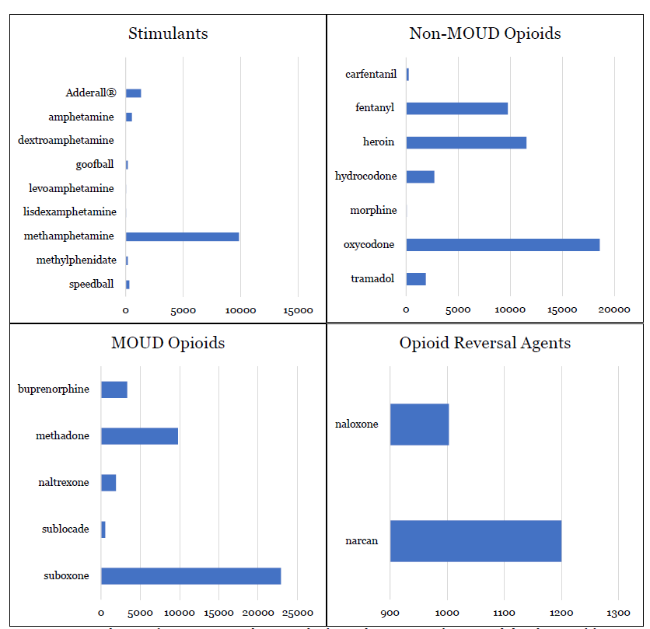
MOUD
Illicit and Prescription Opioids
Figure A5. Distribution of mentions per substance, organized alphabetically. The figure shows a more fine-grained distribution of frequencies compared to the groupings used in the article. In the article, the following mentions of substances are grouped together: (i) Speedball/Goofball (a combination of methamphetamine and heroin), (ii) levoamphetamine, amphetamine, dextroamphetamine, Adderall® and lisdexamphetamine (amphetamine type stimulants), (iii) carfentanil and fentanyl (fentanyl & analogs), (iv) morphine, hydrocodone, tramadol and oxycodone (prescription opioid pain relievers), (v) naltrexone, sublocade, buprenorphine, methadone and suboxone (MOUD), and (vi) narcan and naloxone (opioid reversal agents). Heroin and methamphetamine are not grouped with any other keyword/substance.

Table A6. Metrics for posts and Redditors from 2011 to 2020.
Year | Total posts | Total Redditors | Opioids and opioid-related medications mentions | Stimulant mentions | People who use opioids or being treated for with medication for opioid use disorder (PWUO/PTMOUD) | People who use stimulants (PWUS) | People who co-use opioids and stimulants (PWCU) | Ratio: PWCU/Redditors
2011 | 9,001 | 244 | 75 | 36 | 22 | 29 | 9 | 0.037
2012 | 32,152 | 579 | 353 | 132 | 89 | 103 | 35 | 0.060
2013 | 57,443 | 982 | 885 | 246 | 165 | 195 | 71 | 0.072
2014 | 84,697 | 1,440 | 1,284 | 326 | 243 | 263 | 98 | 0.068
2015 | 141,044 | 1,959 | 1,756 | 474 | 381 | 370 | 156 | 0.080
2016 | 212,145 | 2,898 | 3,529 | 750 | 619 | 578 | 261 | 0.090
2017 | 398,217 | 4,474 | 6,852 | 1,298 | 1,132 | 997 | 523 | 0.117
2018 | 772,258 | 6,713 | 13,507 | 2,166 | 2,053 | 1,660 | 910 | 0.136
2019 | 1,306,354 | 9,128 | 20,624 | 3,021 | 2,944 | 2,351 | 1,288 | 0.141
2020 | 2,140,854 | 11,072 | 31,417 | 3,669 | 3,930 | 2,866 | 1,718 | 0.155

