SNTA1-deficient human cardiomyocytes are associated with increased structural components, calcium handling disorder, and shorter field potential duration
Tao Dong¹*, Yan Zhao², Hai-Feng Jin¹, Lei Shen ¹, Long-Long Si³, Li Chen³
* Correspondence to:
Tao Dong PhD: Basic Medicine School, Qiqihar Medical University, 333 Bukui Street, Qiqihar 161006, Heilongjiang, China.
E-mail: 924516982@qq.com
1. Basic Medicine School, Qiqihar Medical University, Qiqihar 161006, Heilongjiang, China.
2. College of Life Science and Agroforestry, Qiqihar University, Qiqihar 161006, Heilongjiang, China.
3. CAS Key Laboratory of Quantitative Engineering Biology, Shenzhen Institute of Synthetic Biology, Shenzhen Institute of Advanced Technology, Chinese Academy of Sciences, Shenzhen 518055, China.

Supplementary data Fig.1

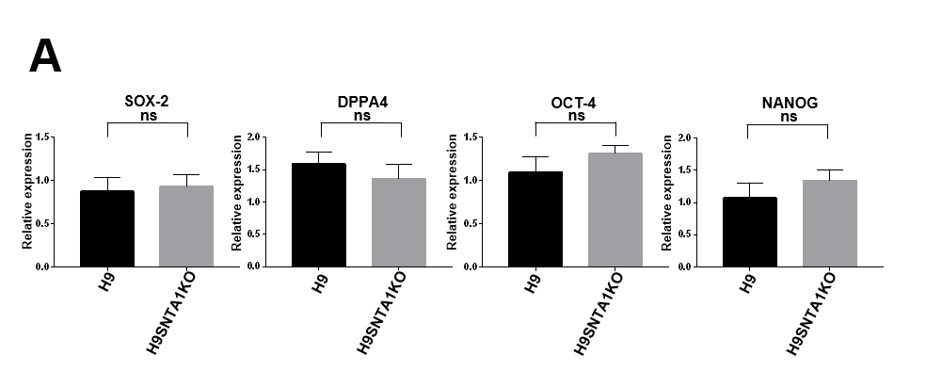
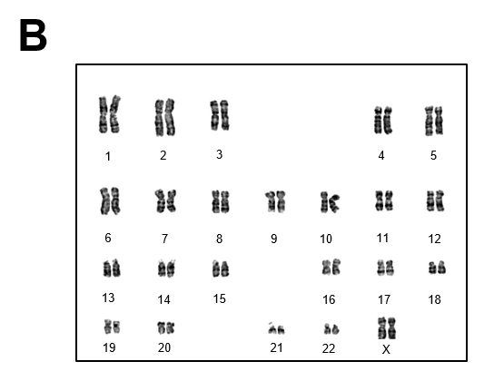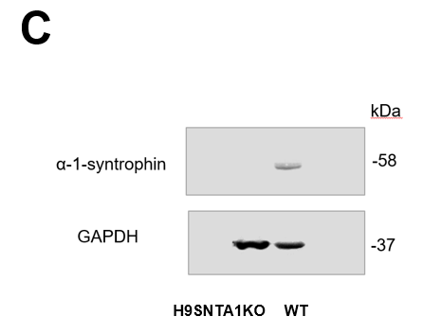

Supplementary data Fig.1 legend
A. Comparison of multipotent markers between H9 cells and H9SNTA1KO cells. The expression of pluripotent markers SOX2, DPPA4, OCT-4, and NANOG in H9SNTA1KO cells was similar to H9 cells using qRT-PCR analysis.
B. The karyotype analysis of H9SNTA1KO was normal (46, XX).
C. Western blots confirmed H9SNTA1KO to be actually deficient in SNTA1.

Supplementary data Fig.2

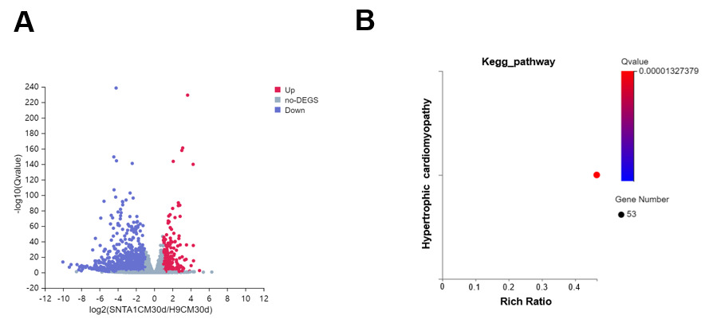
D
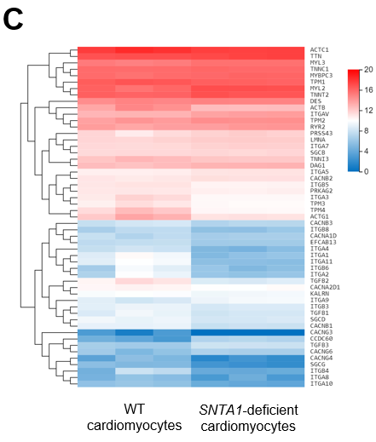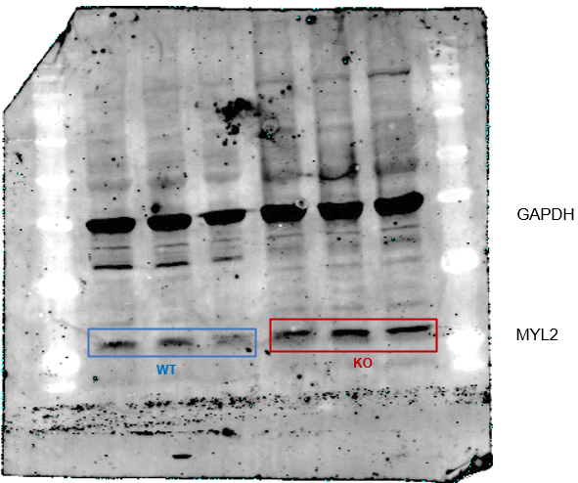
E
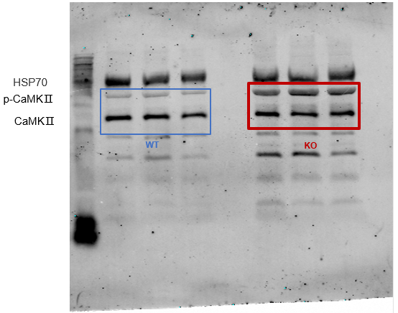
Supplementary data Fig.2 legend
A. The volcano map showed the statistics differentially expressed genes in WT and KO on the 30th day cardiac differentiation using RNA-seq.
B. The KEGG_pathway enrichment bubble chart showed there were 53 genes differentially expressed in the disease of hypertrophic cardiomyopathy pathway between WT and KO on the 30th day cardiac differentiation.
C. The heatmap showed the 53 genes transcriptional level expressed in the disease of hypertrophic cardiomyopathy pathway between WT and KO on the 30th day cardiac differentiation.
D. Western blots showed expression level of MYL2 in WT and KO on the 45th of cardiac differentiation.
E. Western blots showed expression level of CaMKⅡin WT and KO on the 45th of cardiac differentiation.

Supplementary data Fig.3
A

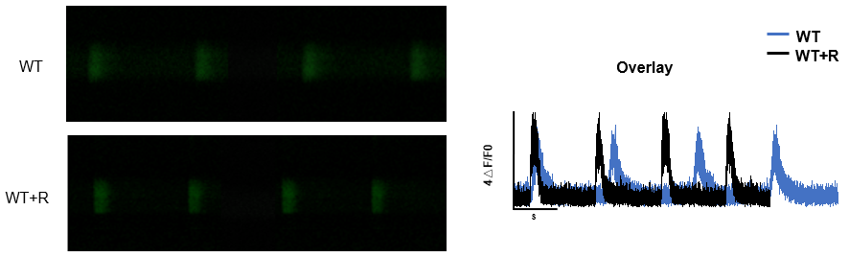

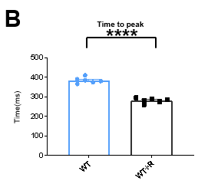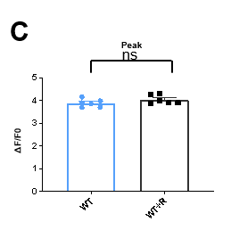

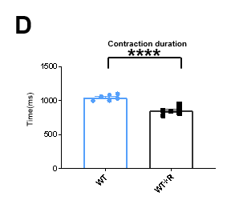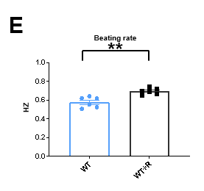
Supplementary data Fig.3 legend
A. The left panel: The representative line-scan image of WT and WT+R (WT cardiomyocytes treated with 10 μM ranolazine) stained with Fluo-4 AM.
The right panel: Calcium transient profile derived from line-scan image of the left panel.
B. to E. Quantification of time to peak, peak, contraction duration, and beating rate in WT and WT+R (WT cardiomyocytes treated with 10 μM ranolazine), n = 6. **P < 0.01; ****P < 0.0001; ns; not significant, unpaired two-sided Student’s t test.

