Cyanobacterial diversity through culture-dependent and independent approaches in Chapada das Mesas National Park, Maranhão, Brazil
Ana Carolina de Araújo Butarelli^{1,2}, Lucas Salomão de Sousa Ferreira^{1,2}, Raquel Riyuzo³, Hivana Melo Barbosa Dall′Agnol⁴, Carlos Morais Piroupo³, Aline Maria da Silva³, João Carlos Setubal³, and Leonardo Teixeira Dall′Agnol¹*

¹ Department of Biology, Center for Biological and Health Sciences, Federal University of Maranhão, Cidade Universitária Dom Delgado, Av. dos Portugueses, 1966 - Vila Bacanga 65080-805 - São Luís (MA) – Brazil
² Department of Biological Oceanography, Oceanographic Institute, University of São Paulo, Praça do Oceanográfico, 191 - Cidade Universitária 05508-120 - São Paulo (SP) - Brazil
³ Department of Biochemistry, Institute of Chemistry, University of São Paulo, Av. Prof. Lineu Prestes, 748 - Cidade Universitária 05508-000 - São Paulo (SP) – Brazil
⁴ Department of Pathology, Center for Biological and Health Sciences, Federal University of Maranhão, Cidade Universitária Dom Delgado, Av. dos Portugueses, 1966 - Vila Bacanga 65080-805 - São Luís (MA) - Brazil

*Corresponding author(s). E-mail(s): Leonardo Teixeira Dall’Agnol. leonardo.td@ufma.br. Phone: +55 (98) 32728543. Fax: +55 (98) 3301-8703

Supplementary Table 1. Table with information about the sample collection location, including latitude and longitude, altitude, waterfall ID and the date of sampling.
 | Sample point | Latitude | Longitude | Altitude | Waterfall ID | Sampling date
Pedra Caída | 1 | S 07º02.7378’ | W 047º26.6191 | 220m | Santuário Waterfall | 10/03/2017
Pedra Caída | 2 | S 07º02.6575’ | W 047º26.5968 | 231m | Santuário Waterfall | 10/03/2017
Pedra Caída | 3 | S 07º81.0476’ | W 047º28.6497 | 195m | Garrote Waterfall | 10/03/2017
Pedra Caída | 4 | S 07º01.0251’ | W 047º28.6311’ | 161m | Garrote Waterfall | 10/03/2017
Pedra Caída | 5 | S 06º58.6201’ | W 047º30.4508 | 163m | Porteira Waterfall | 10/03/2017
Pedra Caída | 6 | S 06º58.6253’ | W 047º30.4658 | 178m | Porteira Waterfall | 10/03/2017
Farinha River | 7 | S 06º59.681’ | W 047º09.9168’ | 212m | Prata Waterfall | 11/03/2017
Farinha River | 8 | S 06º59.6258’ | W 047º09.9564’ | 178m | Prata Waterfall | 11/03/2017
Farinha River | 9 | S 07º01.2129’ | W 047º02.3985’ | 236m | São Romão Waterfall | 11/03/2017
Farinha River | 10 | S 07º01.2129’ | W 047º02.4175’ | 239m | São Romão Waterfall | 11/03/2017
Farinha River | 11 | S 07º01.2179’ | W 047º02.4392’ | 243m | São Romão Waterfall | 11/03/2017
Farinha River | 12 | S 07º01.2274’ | W 047º01.2274’ | 247m | São Romão Waterfall | 11/03/2017

Supplementary Figure 1. The location of the study area and sample distribution in the Farinha River and in the Pedra Caída region within the Chapada das Mesas National Park, Manhão, Brazil.
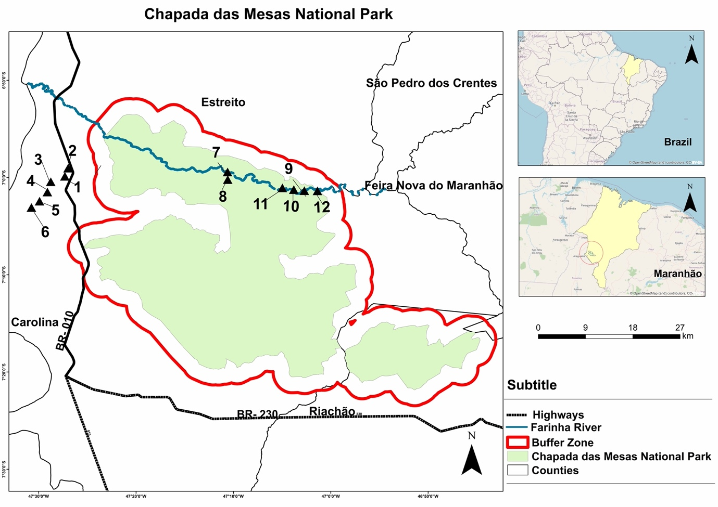

Supplementary Table 2. Count of reads per sample. Samples E1-E12 refer to the environmental microbiome and samples C1-C12 refer to the microbiome of the consortia.

Sample ID | Sequence count
E1 | 46427
E2 | 44010
E3 | 158988
E4 | 169921
E5 | 110167
E6 | 123795
E7 | 44872
E8 | 19144
E9 | 157386
E10 | 218195
E11 | 33390
E12 | 35960
C1 | 193343
C2 | 237603
C3 | 310412
C4 | 234119
C5 | 397829
C6 | 376622
C7 | 446258
C8 | 396519
C9 | 390508
C10 | 379580
C11 | 362581
C12 | 319270

Supplementary Table 3. Estimates regarding reads during processing in the QIIME2 software, including all sequenced samples.

 | Reads
Minimum | 19144
Median | 205769
Mean | 216954
Maximum | 446258
Total | 5206899

Supplementary Table 4. Filter, cut, remove chimeric sequences and denoise reads.

Sample-id | Input | Filtered | Percentage of input passed filter | Denoised | Non-chimeric | Percentage of input non-chimeric
C1 | 193343 | 46103 | 23.85 | 45257 | 10423 | 5.39
C2 | 237603 | 70967 | 29.87 | 69929 | 30146 | 12.69
C3 | 310412 | 80807 | 26.03 | 77163 | 58862 | 18.96
C4 | 234119 | 71859 | 30.69 | 66046 | 49271 | 21.05
C5 | 397829 | 128692 | 32.35 | 126529 | 63041 | 15.85
C6 | 376622 | 97537 | 25.9 | 96945 | 46852 | 12.44
C7 | 446258 | 130060 | 29.14 | 127030 | 74227 | 16.63
C8 | 396519 | 111737 | 28.18 | 107895 | 48988 | 12.35
C9 | 390508 | 145453 | 37.25 | 140942 | 68136 | 17.45
C10 | 379580 | 131629 | 34.68 | 130490 | 61299 | 16.15
C11 | 362581 | 78120 | 21.55 | 76649 | 46466 | 12.82
C12 | 319270 | 81863 | 25.64 | 79986 | 54687 | 17.13
E1 | 46427 | 15581 | 33.56 | 10459 | 10279 | 22.14
E2 | 44010 | 18325 | 41.64 | 14130 | 13936 | 31.67
E3 | 158988 | 28379 | 17.85 | 24265 | 24177 | 15.21
E4 | 169921 | 43381 | 25.53 | 32795 | 31598 | 18.6
E5 | 110167 | 33991 | 30.85 | 29949 | 28420 | 25.8
E6 | 123795 | 40144 | 32.43 | 36182 | 34703 | 28.03
E7 | 44872 | 18419 | 41.05 | 13603 | 13369 | 29.79
E8 | 19144 | 5587 | 29.18 | 2537 | 2537 | 13.25
E9 | 157386 | 25790 | 16.39 | 22223 | 22029 | 14
E10 | 218195 | 62091 | 28.46 | 60416 | 57467 | 26.34
E11 | 33390 | 12266 | 36.74 | 7953 | 7953 | 23.82
E12 | 35960 | 10586 | 29.44 | 4531 | 4531 | 12.6

Supplementary Figure 2. Sample-based rarefaction curve of different samples.
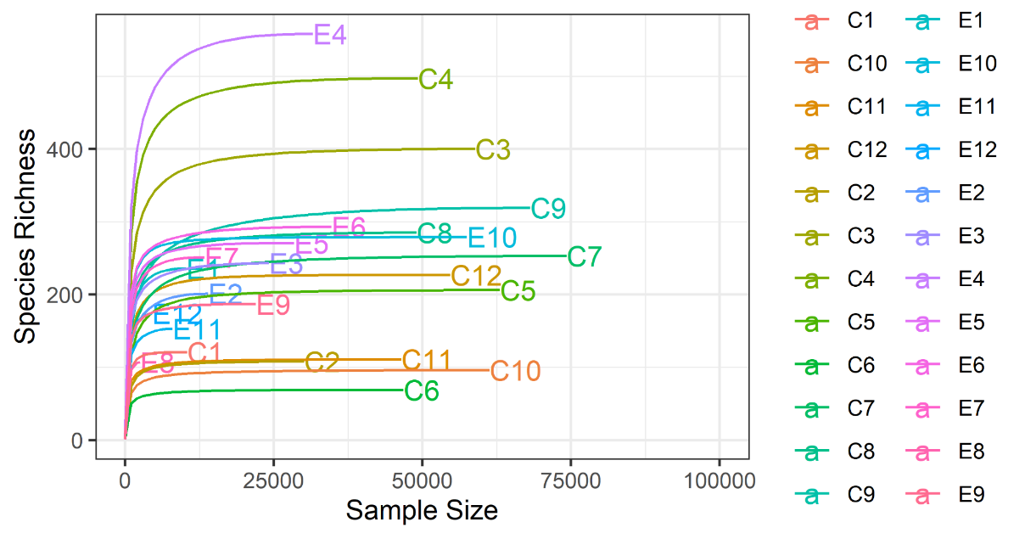

Supplementary Table 5. Physicochemical parameters for each collection point, collected during sampling. E1-E12 refer to the environmental samples.
Samples | pH | Turbidity | NH₃ | NO⁻² | NO⁻³ | PO₃⁻⁴ | SiO₂
Samples | pH | (NTU) | µmol.L⁻¹ | µmol.L⁻² | µmol.L⁻³ | µmol.L⁻⁴ | µmol.L⁻⁵
E1 | 7.1 | 4.39 | 112.56 | 0.02 | 4.03 | 0.02 | 1.73
E2 | 7.3 | 4.82 | 18.59 | 0.03 | 2.63 | 0.26 | 2.64
E3 | 7.3 | 3.97 | 17.20 | 0.04 | 4.63 | 1.21 | 1.20
E4 | 7.2 | 4.57 | 12.33 | 0.05 | 4.17 | 0.07 | 2.00
E5 | 7.3 | 7.44 | 10.93 | 0.04 | 3.88 | 0.02 | 0.57
E6 | 6.9 | 5.93 | 6.76 | 0.06 | 3.60 | 0.11 | 0.62
E7 | 6.9 | 14.3 | 7.45 | 0.11 | 2.20 | 0.38 | 0.81
E8 | 6.9 | 11.7 | 26.25 | 0.24 | 7.57 | 0.53 | 2.52
E9 | 7.0 | 12.9 | 8.85 | 0.14 | 5.46 | 0.26 | 3.78
E10 | 7.3 | 22.3 | 10.24 | 0.08 | 5.71 | 0.60 | 4.26
E11 | 7.4 | 16 | 8.85 | 0.10 | 6.74 | 0.55 | 3.93
E12 | 7.4 | 20.6 | 6.76 | 0.16 | 58.07 | 0.40 | 4.30

Supplementary Table 6. It expresses the comparative analysis of the variables between the two places evaluated. Significant differences were observed for the variables turbidity (P = 0.003). NO-2 (P = 0.003). SiO2 (P = 0.037) and Temperature (P = 0.003). The samples from Pedra Caída showed turbidity. NO-2 and SiO2 lower and temperature higher than the samples from Rio Farinha. (* = significantly different.)

Variables | Pedra Caída  (Median) | Rio Farinha  (Median) | p-value
pH | 7.25 (0.17) | 7.15 (0.45) | 0.936
Turbidity (NTU) | 4.69 (1.21) | 15.15 (6.20) | 0.003*
NH3 | 14.76 (6.96) | 8.85 (2.09) | 0.173
NO-2 | 0.04 (0.01) | 0.12 (0.05) | 0.003*
NO-3 | 3.95 (0.46) | 6.22 (1.84) | 0.054
PO3-4 | 0.09 (0.19) | 0.46 (0.16) | 0.065
SiO2 | 1.46 (1.16) | 3.85 (1.34) | 0.037*
Temperature (˚C) | 27.50 (0.30) | 16.30 (0.27) | 0.003*

Supplementary Table 7. Observed ASVs. Chao1 and Shannon indexes for Environmental and Constia samples.

Environmental |  |  |  | Consortia
Sample ID | Observed | Chao1 | Shannon | Sample ID | Observed | Chao1 | Shannon
E1 | 207 | 242.15 | 4.542065 | C1 | 121 | 121.5000 | 3.865046
E2 | 167 | 196.5263 | 3.711336 | C2 | 105 | 115.5 | 2.582421
E3 | 196 | 210.5000 | 4.492067 | C3 | 375 | 401.25 | 4.627583
E4 | 432 | 504.8 | 5.562125 | C4 | 459 | 485.037 | 5.256377
E5 | 221 | 228.7000 | 4.81986 | C5 | 196 | 213.7692 | 3.429492
E6 | 249 | 264.5000 | 4.924061 | C6 | 68 | 70.5000 | 2.292853
E7 | 217 | 240.8 | 4.352945 | C7 | 232 | 245.0435 | 3.395543
E8 | 105 | 109.5000 | 4.020624 | C8 | 259 | 275.8667 | 4.160754
E9 | 163 | 170.4348 | 4.303786 | C9 | 277 | 305.12 | 3.704432
E10 | 254 | 266.2368 | 4.637677 | C10 | 91 | 98.0000 | 2.662157
E11 | 135 | 148.9091 | 4.068458 | C11 | 107 | 121 | 3.652702
E12 | 158 | 165.1250 | 4.3748 | C12 | 215 | 223.5000 | 3.766451

Supplementary Table 8. Abundance of microbial phyla in samples from the environmental microbiome (E1-E12).

Phylum | Abundance | Percentage
Acidobacteriota | 0.09773663 | 9.77%
Actinobacteriota | 0.05782744 | 5.78%
Bacteroidota | 0.02001575 | 2.00%
Chloroflexi | 0.01874684 | 1.87%
Cyanobacteria | 0.01383642 | 1.38%
Desulfobacterota | 0.04862551 | 4.86%
Firmicutes | 0.10958671 | 10.95%
Myxococcota | 0.01873269 | 1.87%
Proteobacteria | 0.55847902 | 55.84%
Verrucomicrobiota | 0.05641299 | 5.64%

Supplementary Table 9. Abundance of microbial phyla in microbiome samples enriched in consortia (C1-C12).

Phylum | Abundance | Percentage
Acidobacteriota | 0.02294661 | 2.2%
Armatimonadota | 0.01893884 | 1.8%
Bacteroidota | 0.18099551 | 18%
Cyanobacteria | 0.26518901 | 26.5%
Planctomycetota | 0.03330194 | 3.3%
Proteobacteria | 0.45264151 | 45.2 %
Verrucomicrobiota | 0.02598658 | 2.5 %

Supplementary Figure 3. (A) Alpha diversity for the consortium samples; (B). Beta Diversity for consortium samples.
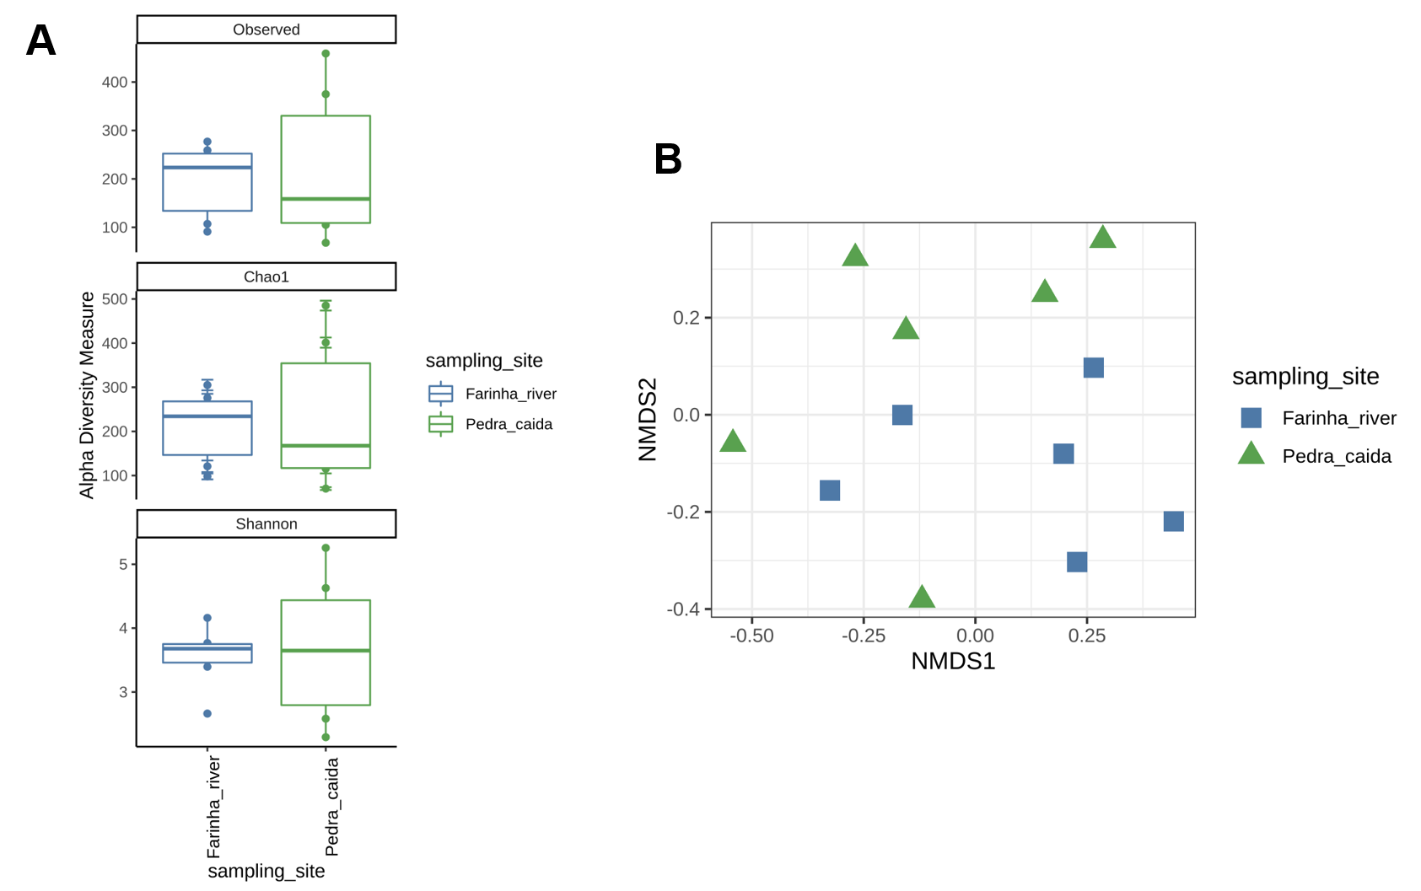

Supplementary Table 10. Statistics performed through the envifit function in R's vegan package. (* = significantly different.)

 | NMDS1 | NMDS2 | R2 | Pr(r)
pH | 0.21288 | 0.97708 | 0.2662 | 0.249
Turbidity | 0.99103 | 0.13362 | 0.1462 | 0.516
NH₃ | -0.4004 | -0.9164 | 0.1975 | 0.275
NO⁻² | 0.89521 | -0.4456 | 0.5839 | 0.027*
NO⁻³ | 0.75559 | 0.65504 | 0.6843 | 0.023*
PO₃⁻⁴ | 0.78371 | -0.6211 | 0.026 | 0.87
SiO₂ | 0.87048 | 0.4922 | 0.2335 | 0.281
Temperature | -0.6104 | 0.7921 | 0.6532 | 0.010**

Supplementary Table 11. Abundance of microbial genera identified in the consortium microbiome samples.

Genus | Abundance | Percentage
A0839 | 0.02183653 | 2.18%
Brevundimonas | 0.03455741 | 3.45%
BSV26 | 0.08231133 | 8.23%
Burkholderia-Caballeronia-Paraburkholderia | 0.03689792 | 3.68%
Chloroplast | 0.19759259 | 19.75%
Cyanobacteriia | 0.02574248 | 2.57%
Edaphobaculum | 0.01711149 | 1.71%
Fimbriimonadaceae | 0.02703331 | 2.70%
Geminocystis_PCC-6308 | 0.06021451 | 6.02%
Hydrogenophaga | 0.02538091 | 2.53%
Kapabacteriales | 0.02735311 | 2.73%
Lacibacter | 0.05913344 | 5.91%
OLB12 | 0.039188 | 3.91%
Pseudomonas | 0.19861316 | 19.86%
SJA-28 | 0.02815609 | 2.81%
SM1A02 | 0.02023712 | 2.02%
SWB02 | 0.01564501 | 1.56%
Synechocystis_CCALA_700 | 0.01713383 | 1.71%
Terrimonas | 0.01393576 | 1.39%
YB-42 | 0.051926 | 5.19%

Supplementary Table 12. Abundance of genera of photosynthetic microorganisms identified in the consortia microbiome samples.

Genus | Abundance | Percentage
Ancylothrix_8PC | 4.86E-02 | 4.86%
Arthronema_SAG_12.89 | 1.38E-03 | 0.13%
Candidatus_Obscuribacter | 1.44E-03 | 0.14%
Cephalothrix_SAG_75.79 | 3.46E-04 | 0.03%
Chloroplast | 4.56E-01 | 45.6%
Cyanobacteriia | 3.62E-02 | 3.62%
Cyanobacterium_PCC-10605 | 2.01E-02 | 2.01%
Cyanothece_PCC_7425 | 4.94E-04 | 0.04%
Desmonostoc_PCC-7422 | 9.70E-03 | 0.97%
Fischerella_PCC-9339 | 8.11E-03 | 0.81%
EcFYyy-200 | 1.95E-03 | 0.19%
Geitlerinema_LD9 | 1.38E-04 | 0.01%
Geminocystis_PCC-6308 | 9.38E-02 | 9.38%
Greenland-10 | 2.28E-03 | 0.22%
HAVOmat113 | 1.06E-02 | 1.06%
JSC-12 | 3.99E-02 | 3.99%
Kamptonema_PCC-6407 | 5.78E-03 | 0.57%
Leptolyngbya_ANT.L52.2 | 4.47E-03 | 0.44%
Limnolyngbya_CHAB4449 | 1.69E-03 | 0.16%
Limnothrix | 1.27E-03 | 0.12%
Nostoc_PCC-73102 | 3.97E-04 | 0.03%
Obscuribacteraceae | 2.93E-03 | 0.29%
Pantalinema | 7.86E-04 | 0.07%
Phormidium_IAM_M-71 | 2.91E-02 | 2.91%
Phormidium_SAG_81.79 | 1.48E-03 | 0.14%
Pleurocapsa_PCC-7327 | 1.71E-02 | 1.71%
Pseudanabaena_PCC-6802 | 3.78E-05 | 0.003%
Pseudanabaena_PCC-7429 | 3.12E-03 | 0.31%
SU2_symbiont_group | 1.12E-02 | 1.12%
Synechococcus_PCC-6312 | 7.31E-03 | 0.73%
Synechocystis_CCALA_700 | 1.01E-01 | 10.1%
Thermosynechococcus_BP-1 | 6.77E-03 | 0.67%
Vampirovibrionales | 3.66E-05 | 0.003%
YB-42 | 7.38E-02 | 7.38%

Supplementary Table 13 . Comparison between the environmental functions identified between the environmental and cultured samples using the FAPROTAX software. (* = significantly different.)

Function | Shapiro-Wilk test | Test | p-value
Methanotrophy * | 3.25E-07 | Wilcox | 9.01E-07
Methanogenesis_by_CO2_reduction_with_H2 | 4.81E-10 | Wilcox | 0.07881
Methanogenesis_by_reduction_of_methyl_compounds_with_H2 | 2.19E-10 | Wilcox | 0.3593
Hydrogenotrophic_methanogenesis | 3.44E-10 | Wilcox | 0.07881
Methanogenesis | 3.44E-10 | Wilcox | 0.07881
Methanol_oxidation | 4.87E-08 | Wilcox | 0.1561
Methylotrophy * | 1.68E-05 | Wilcox | 0.001229
Aerobic_ammonia_oxidation | 1.16E-08 | Wilcox | 0.1137
Nitrification | 1.16E-08 | Wilcox | 0.1137
Sulfate_respiration | 2.27E-09 | Wilcox | 0.5139
Sulfur_respiration | 2.19E-10 | Wilcox | 0.3593
Respiration_of_sulfur_compounds | 3.75E-06 | Wilcox | 0.2662
Nitrate_denitrification | 4.44E-08 | Wilcox | 0.2076
Nitrite_denitrification | 4.435-08 | Wilcox | 0.2076
Nitrous_oxide_denitrification | 4.44E-08 | Wilcox | 0.2076
Denitrification | 4.44E-08 | Wilcox | 0.2076
Chitinolysis | 8.86E-10 | Wilcox | 1
Knallgas_bacteria | 1.30E-09 | Wilcox | 1
Dark_hydrogen_oxidation | 1.22E-08 | Wilcox | 0.5238
Nitrogen_fixation * | 0.01873 | Wilcox | 0.01873
Nitrite_respiration | 4.44E-08 | Wilcox | 0.2076
Cellulolysis * | 1.00E-08 | Wilcox | 0.01089
Xylanolysis | 2.19E-10 | Wilcox | 0.3593
Dark_thiosulfate_oxidation | 2.19E-10 | Wilcox | 0.3593
Manganese_oxidation | 6.40E-10 | Wilcox | 0.1662
Fermentation * | 1.33E-05 | Wilcox | 0.007134
Aerobic_chemoheterotrophy | 3.89E-07 | Wilcox | 0.1782
Human_pathogens | 0.003006 | Wilcox | 0.5413
Human_gut * | 1.03E-05 | Wilcox | 0.003884
Human_associated | 0.0003346 | Wilcox | 0.8397
Mammal_gut * | 1.03E-05 | Wilcox | 0.003884
Animal_parasites_or_symbionts | 0.0004815 | Wilcox | 0.4353
Aromatic_hydrocarbon_degradation | 4.64E-10 | Wilcox | 0.1662
Aromatic_compound_degradation * | 2.46E-07 | Wilcox | 0.008124
Aliphatic_non_methane_hydrocarbon_degradation | 4.64E-10 | Wilcox | 0.1662
Hydrocarbon_degradation * | 3.79E-06 | Wilcox | 3.12E-05
Dark_iron_oxidation | 2.19E-10 | Wilcox | 0.3593
Iron_respiration * | 4.99E-08 | Wilcox | 0.007054
Nitrate_respiration | 4.31E+07 | Wilcox | 0.6416
Nitrate_reduction | 0.002943 | Wilcox | 0.3777
Nitrogen_respiration | 4.31E-07 | Wilcox | 0.6416
Intracellular_parasites * | 7.36E-07 | Wilcox | 0.01861
Chlorate_reducers | 7.02E-10 | Wilcox | 0.5807
Predatory_or_exoparasitic | 5.03E-07 | Wilcox | 0.2548
Chloroplasts * | 1.97E-08 | Wilcox | 3.33E-05
Nonphotosynthetic_cyanobacteria | 3.70E-10 | Wilcox | 0.3281
Photosynthetic_cyanobacteria * | 5.32E-08 | Wilcox | 7.40E-07
Anoxygenic_photoautotrophy_S_oxidizing | 1.22E-09 | Wilcox | 1
Anoxygenic_photoautotrophy | 1.52E-09 | Wilcox | 1
Oxygenic_photoautotrophy * | 5.32E-08 | Wilcox | 7.40E-07
Photoautotrophy * | 5.18E-08 | Wilcox | 2.96E-06
aerobic_anoxygenic_phototrophy | 2.19E-10 | Wilcox | 0.3593
Photoheterotrophy | 7.18E-09 | Wilcox | 0.8014
Phototrophy * | 5.21E-08 | Wilcox | 2.96E-06
Ureolysis | 2.66E-05 | Wilcox | 0.295
Reductive_acetogenesis | 2.19E-10 | Wilcox | 0.3593
Chemoheterotrophy | 5.49E-06 | Wilcox | 0.4428

Supplementary Table 14. NCBI (amplicon sequences) accession numbers of samples collected in the Chapada das Mesas National Park. S_C1-S_C12: Samples grown in microbial consortia in BG-11 culture medium /S_E1-S_E12: Environmental samples.

BioSample name | Accession | BioProject | SRA | Submission
S_C1 | SAMN23441228 | PRJNA783649 | SRR17038890 | SUB10722512
S_C2 | SAMN23441229 | PRJNA783649 | SRR17038889 | SUB10722512
S_C3 | SAMN23441230 | PRJNA783649 | SRR17038878 | SUB10722512
S_C4 | SAMN23441231 | PRJNA783649 | SRR17038873 | SUB10722512
S_C5 | SAMN23441232 | PRJNA783649 | SRR17038872 | SUB10722512
S_C6 | SAMN23441233 | PRJNA783649 | SRR17038871 | SUB10722512
S_C7 | SAMN23441234 | PRJNA783649 | SRR17038870 | SUB10722512
S_C8 | SAMN23441235 | PRJNA783649 | SRR17038869 | SUB10722512
S_C9 | SAMN23441236 | PRJNA783649 | SRR17038868 | SUB10722512
S_C10 | SAMN23441237 | PRJNA783649 | SRR17038867 | SUB10722512
S_C11 | SAMN23441238 | PRJNA783649 | SRR17038888 | SUB10722512
S_C12 | SAMN23441239 | PRJNA783649 | SRR17038887 | SUB10722512
S_E1 | SAMN23441240 | PRJNA783649 | SRR17038886 | SUB10722512
S_E2 | SAMN23441241 | PRJNA783649 | SRR17038885 | SUB10722512
S_E3 | SAMN23441242 | PRJNA783649 | SRR17038884 | SUB10722512
S_E4 | SAMN23441243 | PRJNA783649 | SRR17038883 | SUB10722512
S_E5 | SAMN23441244 | PRJNA783649 | SRR17038882 | SUB10722512
S_E6 | SAMN23441245 | PRJNA783649 | SRR17038881 | SUB10722512
S_E7 | SAMN23441246 | PRJNA783649 | SRR17038880 | SUB10722512
S_E8 | SAMN23441247 | PRJNA783649 | SRR17038879 | SUB10722512
S_E9 | SAMN23441248 | PRJNA783649 | SRR17038877 | SUB10722512
S_E10 | SAMN23441249 | PRJNA783649 | SRR17038876 | SUB10722512
S_E11 | SAMN23441250 | PRJNA783649 | SRR17038875 | SUB10722512
S_E12 | SAMN23441251 | PRJNA783649 | SRR17038874 | SUB10722512

