Supplementary information
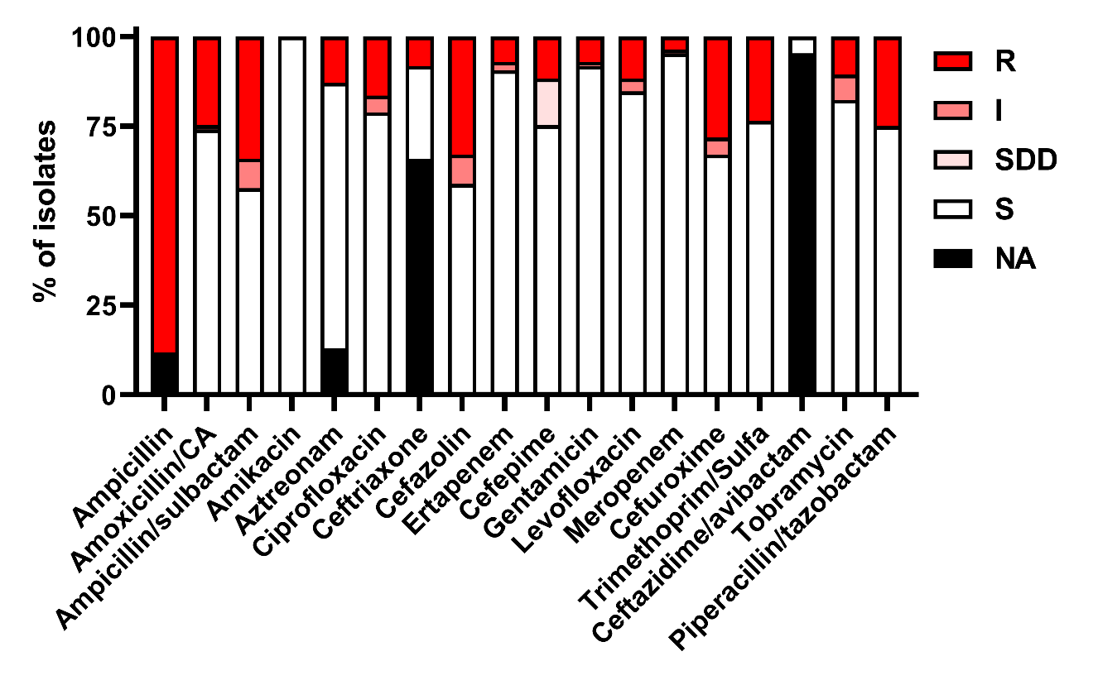
Supplementary Figure S1. Antibiotic susceptibility results from Klebsiella clinical isolates.
Categorical results of antibiotic susceptibility testing by broth microdilution. R = resistant, I = Intermediate, SDD = Susceptible-Dose-Dependent, S = Sensitive.

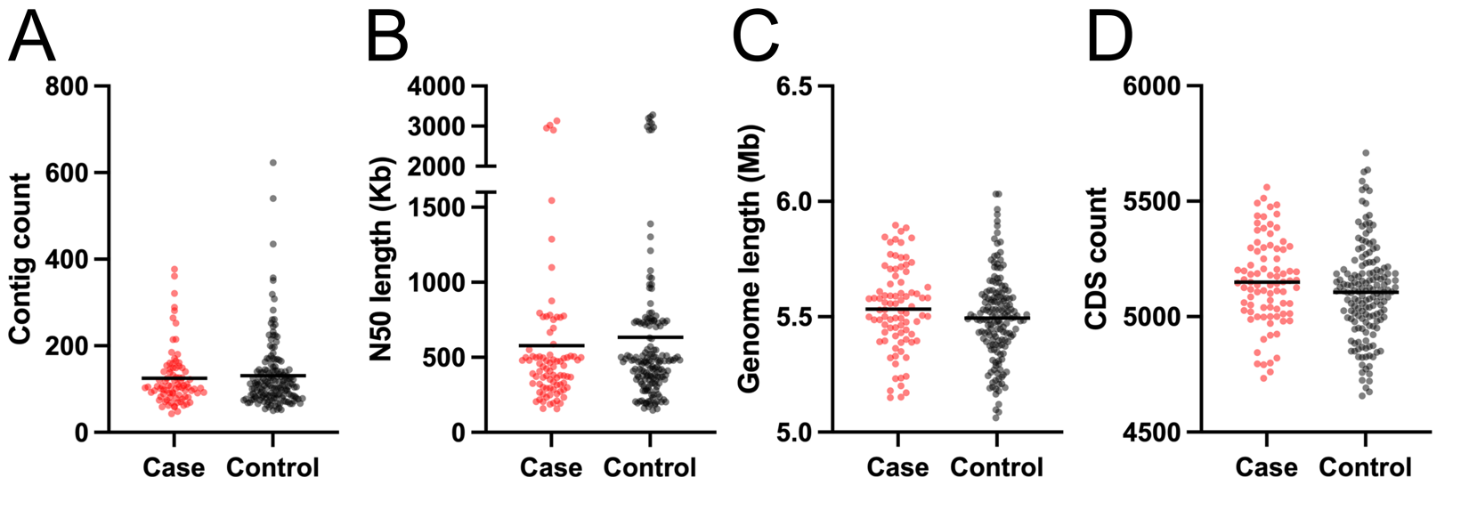
Supplementary Figure S2. Klebsiella genome assembly details compared between case and control rectal isolates.
(A) Comparison of number of contigs for Klebsiella genome assemblies between cases and controls (mean displayed, Student’s t-test). (B) Comparison of N50 length for Klebsiella genome assemblies between cases and controls (mean displayed, Student’s t-test). (C) Comparison Klebsiella genome length between cases and controls (mean displayed, Student’s t-test). (D) Comparison of number of coding sequences (CDS) for Klebsiella genome assemblies between cases and controls (mean displayed, Student’s t-test). For A-D, each data point represents a single Klebsiella genome assembly. No comparisons met our criteria for statistically significant differences (P value ≤ 0.05).

Supplementary Figure S3. Klebsiella genome alignments.
(A) Klebsiella species distribution across infection and colonization sites. (B) Histogram of case rectal-control rectal nucleotide alignment. (C) Histogram of case clinical-case rectal nucleotide alignment. (D) Correlation between the number of days between identification of a rectal Klebsiella isolate concordant with the clinical isolate from the same patient and case clinical-case rectal nucleotide alignment. (E) Plot of case clinical genome length and case rectal genome length. (F) Plot of number of annotated coding sequences (CDS) and genome length for each rectal case genome. For D-F, strata that diverge from overall data trends are highlighted by black data points and indicated by their respective stratum number. (G) Heatmap of presence/absence of infection-associated genes for strata that diverge from overall data trends in D-F.

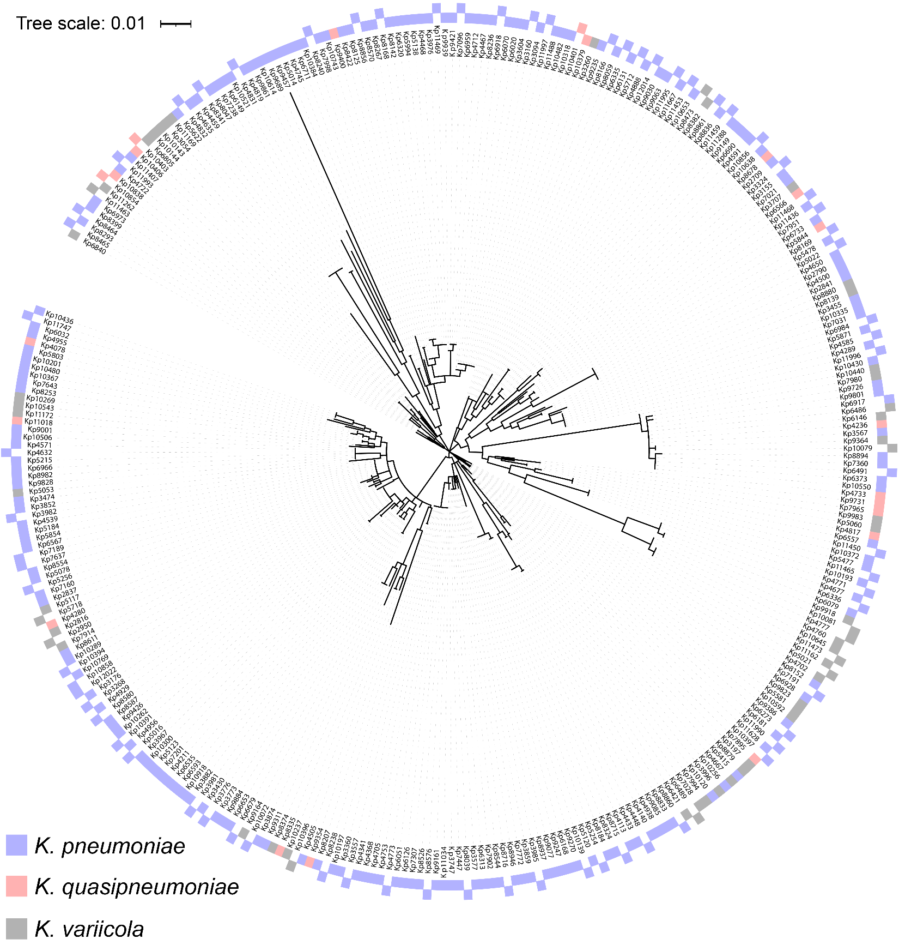
Supplementary Figure S4. wzi phylogeny of sequences Klebsiella isolates.
Phylogenetic tree of sequenced Klebsiella rectal isolates based on wzi sequence. Filled rectangles on the inner track indicate a rectal isolate and filled rectangles on the outer track indicate a clinical isolate.
Supplementary Figure S5. Rarefaction of Klebsiella sequence types.
There was no difference in the richness of sequence types (STs) between cases and controls, when compared at 85 (the number of cases) or when cases were extrapolated to 160 (the number of controls). The estimated asymptotes of these curves do not differ (Case = 529.653 ± 259.103, Control = 591.953 ± 170.906 [mean ± SE]).

Supplementary Figure S6. Characterization of pangenome annotation
(A) Cumulative count of Klebsiella genome annotations stratified by core and accessory genome. (B) Mean pairwise Jaccard distances were calculated for all rectal isolates and compared between case and control group (mean displayed, Student’s t-test). Each data point represents an individual isolate.

Supplementary Figure S7. Associations within and between infection-associated genes and prior exposure to individual antibiotics.
Odds ratios and Fisher P values were calculated between all pairs of infection-associated genes and prior antibiotics. Log ORs displayed in red and blue have a Fisher P value ≤ 0.01. group_2513 is shown in blue to highlight its negative association with case status.

Supplementary Figure S8. Evaluation of association between gene presence and infection using treeWAS
Manhattan plots for the “Terminal score,” “Simultaneous score,” and “Subsequent score” outputs from treeWAS applied to the 34 infection-associated loci. The Terminal score counts the four possible combinations of genotype and phenotype without regard to phylogeny. The Simultaneous and Subsequent scores are based on the number of branches with simultaneous changes in genotype and phenotype, and the proportion of the tree where the phenotype and genotype co-exist, respectively, and account for population structure. Black symbols indicate a P value ≤ 0.01, and grey symbols indicate a P value > 0.01. Raw values can be found in Table S5.

Supplementary Figure S9. Adjustment of association between gene presence and infection for prior exposure to individual antibiotics
The association of each gene (columns) was adjusted for prior exposure to each antibiotic (rows). Log ORs displayed in red and blue have an adjusted P value ≤ 0.01. group_2513 is shown in blue to highlight its negative association with case status.

Supplementary Figure S10. Gut relative abundance in rectal swabs from Klebsiella colonized patients.
(A) Comparison of Klebsiella gut relative abundance in patient rectal swabs stratified by Klebsiella species (mean ± SE displayed, Tukey's multiple comparisons test following ordinary one-way ANOVA). (B) Comparison of Klebsiella gut relative abundance in patient rectal swabs between patients with and without a history of exposure to high-risk antibiotics (“abx,” mean ± SE displayed, **P value ≤ 0.005, Student’s t-test). (C) Comparison of Klebsiella gut relative abundance in patient rectal swabs stratified by patient case status and history of exposure to high-risk antibiotics (“abx,” mean ± SE displayed, *P value ≤ 0.05, ****P value ≤ 0.00005, Tukey's multiple comparisons test following ordinary one-way ANOVA). (D) Heatmap of mean Klebsiella gut relative abundance in patient rectal swabs stratified by gene presence/absence (*P value ≤ 0.05, **P value ≤ 0.005, ***P value ≤ 0.0005, ****P value ≤ 0.00005, Student’s t-test). For A-C, each data point represents a single patient rectal swab.
Supplementary Figure S11. Replicon presence in sequences Klebsiella isolates.
(A) Comparison of the number of replicons per isolates between cases and controls (mean ± SE displayed, Student’s t-test). Each data point represents an individual isolate. (B) Heatmap of replicon presence/absence organized vertically by core genome phylogeny and horizontally by replicon type.

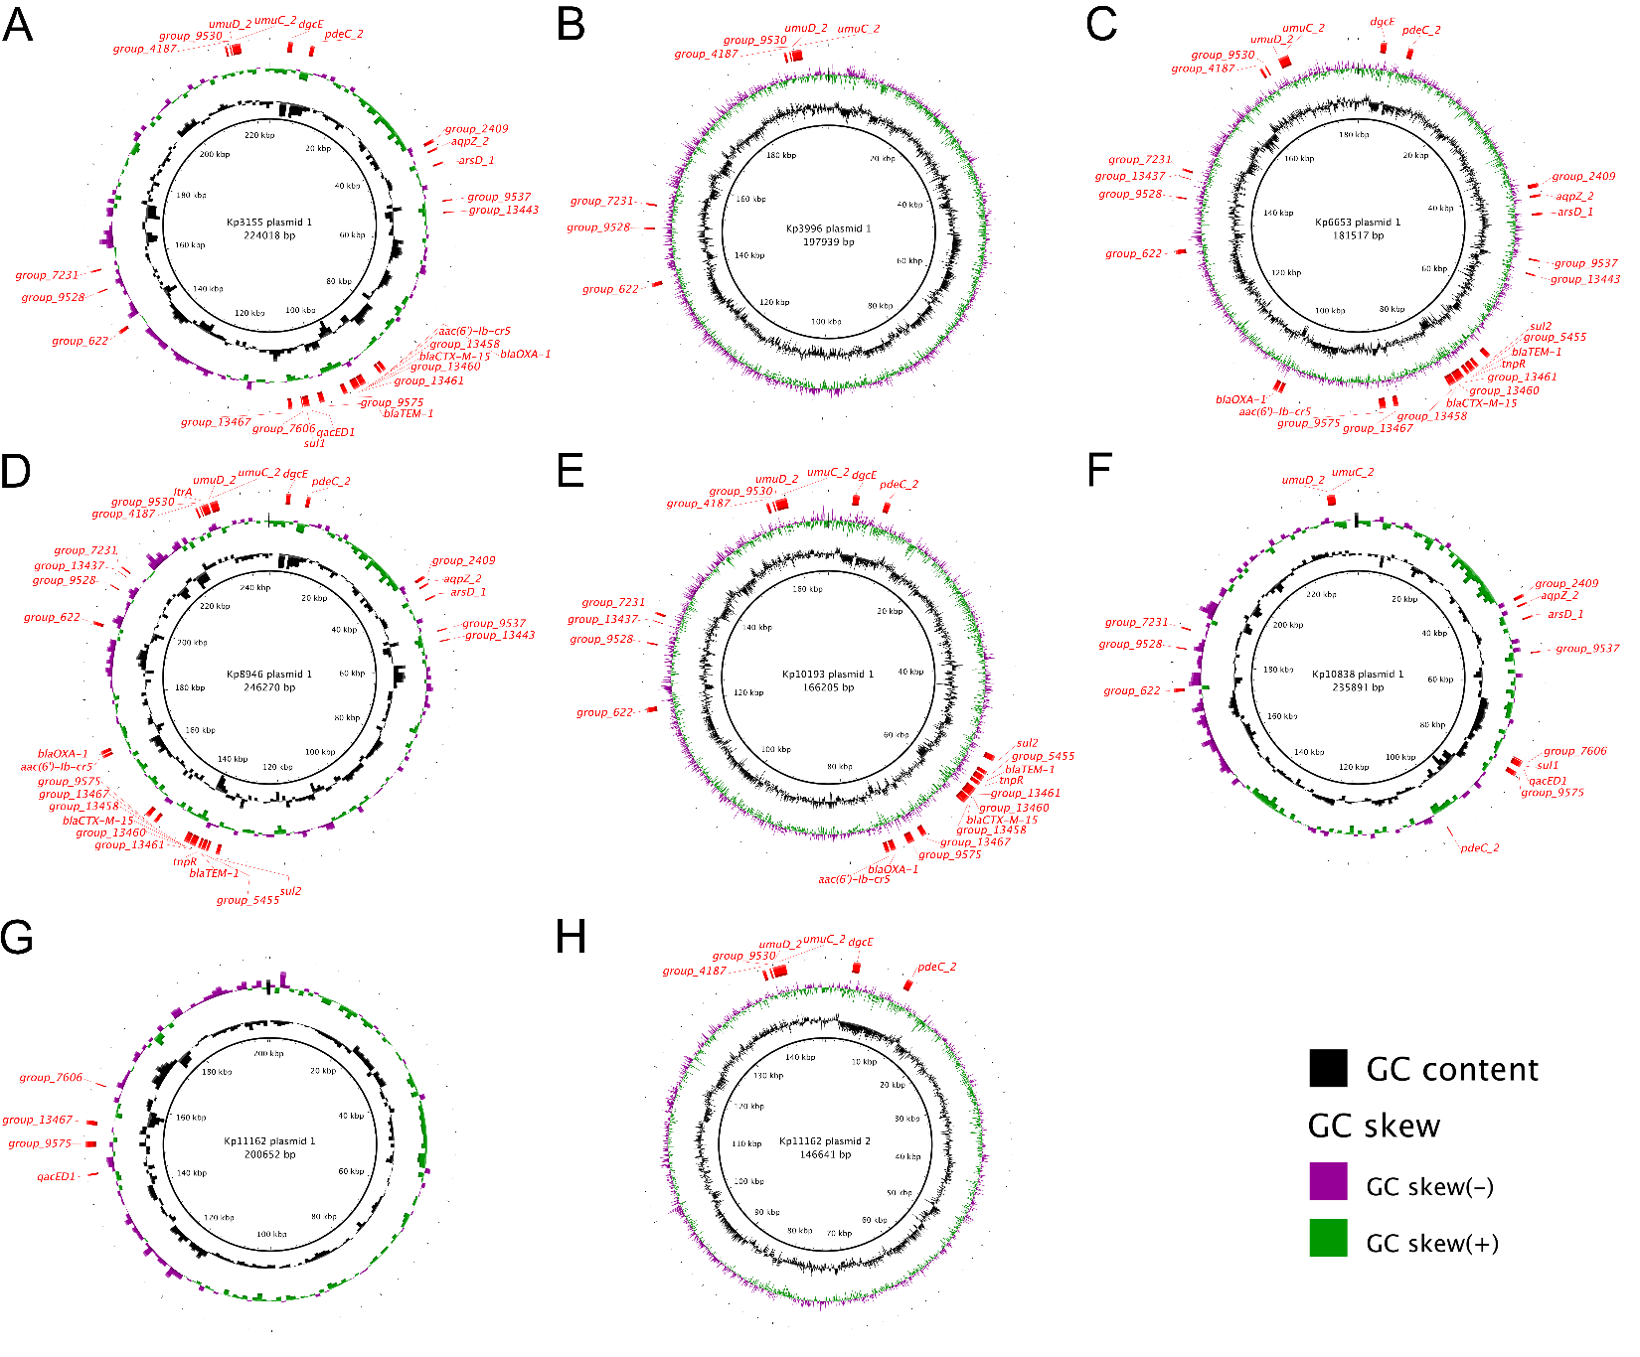
Supplementary Figure S12. Mapping of infection-associated genes to select Klebsiella plasmids
(A-H) Visualization of various hybrid assemblies of Klebsiella plasmids with mapped locations of infection-associated genes.

Supplementary Figure S13. Association between infection-associated genes in a geographically independent cohort of Klebsiella colonized patients
Odds ratios and Fisher P values were calculated between all pairs of infection-associated genes. Log ORs displayed in red have a Fisher P value ≤ 0.01, and those displayed in black have incalculable ORs due to identical presence/absence patterns.

