Table 1: The baseline characteristics of patients after IPTW
Characteristics | TACE+Iodine 125  n=54.44 | TACE+RFA  n=74 | P value
Age (Years) | 57.2±12.6 | 57.7±8.9 | 0.794
ALT (U/L) | 40.1±24.7 | 48.8±40.9 | 0.141
Hemoglobin (g/L) | 122.6±26.9 | 127±22.4 | 0.304
Platelet (×10⁹/L) | 137.1±78.3 | 131.1±68.5 | 0.641
Lymphocyte(×10⁹/L) | 1.2±0.6 | 1. 3±0.62 | 0.453
Neutrophil (×10⁹/L) | 3±2.3 | 3.1±1.7 | 0.883
Neutrophil (×10⁹/L) | 4.9±3.1 | 5±2.3 | 0.782
Gender (Male, %) | 80.90 | 87.8 | 0.278
HBV (+, %) | 72.42 | 75.7 | 0.676
AFP (>200ug/L, %) | 24.02 | 23 | 0.890
TACE number (≥2, %) | 89.41 | 73 | 0.022
Tumor number (≥2, %) | 46.82 | 35.1 | 0.182
Tumor size (>3cm, %) | 63.98 | 56.8 | 0.409
CHILD (B, %) | 27.72 | 23 | 0.540
BCLC (B, %) | 53.8 | 41.9 | 0.183
Abbreviations: HBV, Hepatitis B Virus; +, Positive, -, Other, ALT, Alanine Aminotransferase; AST, Aspartate Aminotransferase; AFP, Alpha Fetoprotein; BCLC, Barcelona Clinic Liver Cancer

Table 2: Associations between TACE-Iodine 125 treatment and mortality and recurrence in patients with early-intermediate HCC after IPTW
Characteristics | Mortality |  | Recurrence
 | Adjusted HR (95%CI) | P value | Adjusted HR (95%CI) | P value
Overall
TACE-RFA | Reference |  | Reference
TACE-Iodine 125 | 0.495 (0.280,0.874) | 0.015 | 0.724 (0.472,1.110) | 0.138
Abbreviations: TACE, Transarterial chemoembolization; RFA, Radiofrequency ablation; BCLC, Barcelona Clinic Liver Cancer.

Table 3: Comparison the mOS and mPFS of BCLC A and B patients between TACE-Iodine 125 group and TACE-RFA group before and after PSM and after IPTW.
 | mOS (Months) |  |  |  |  |  | mPFS (Months)
 | BCLC A |  |  | BCLC B |  |  | BCLC A |  |  | BCLC B
 | TACE+  Iodine 125 | TACE+RFA | P value | TACE+  Iodine 125 | TACE+RFA | P value | TACE+ Iodine 125 | TACE+RFA | P value | TACE+ Iodine 125 | TACE+RFA | P value
Before PSM | N | 44 | 0.805 | 36 | 30 | 0.565 | 33 | 24 | 0.630 | 11 | 14 | 0.405
After PSM | N | N | 0.459 | 38 | 30 | 0.313 | 33 | 33 | 0.532 | 11 | 14 | 0.603
After IPTW | N | 44 | 0.251 | 38 | 30 | 0.464 | 43 | 24 | 0.128 | 12 | 14 | 0.618
Abbreviations: OS, Overall survival; PFS, Progress Free Survival; TACE, Transarterial chemoembolization; RFA, Radiofrequency ablation; BCLC, Barcelona Clinic Liver Cancer; N, The exact survival time was not available.

Figure 1: The flowchart of patients inclusion

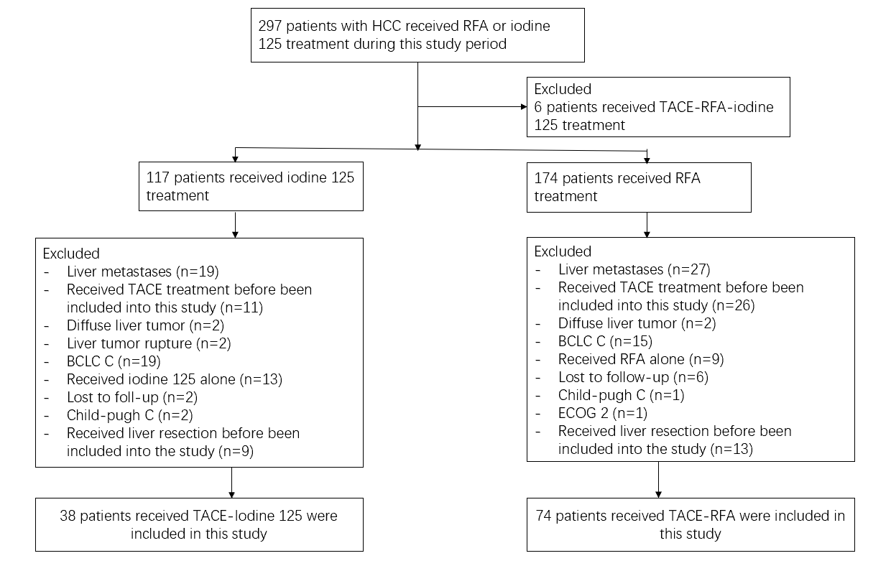

Figure 2: The Kaplan-Meier curve of overall survival (A) and progression free survival (B) of patients after IPTW
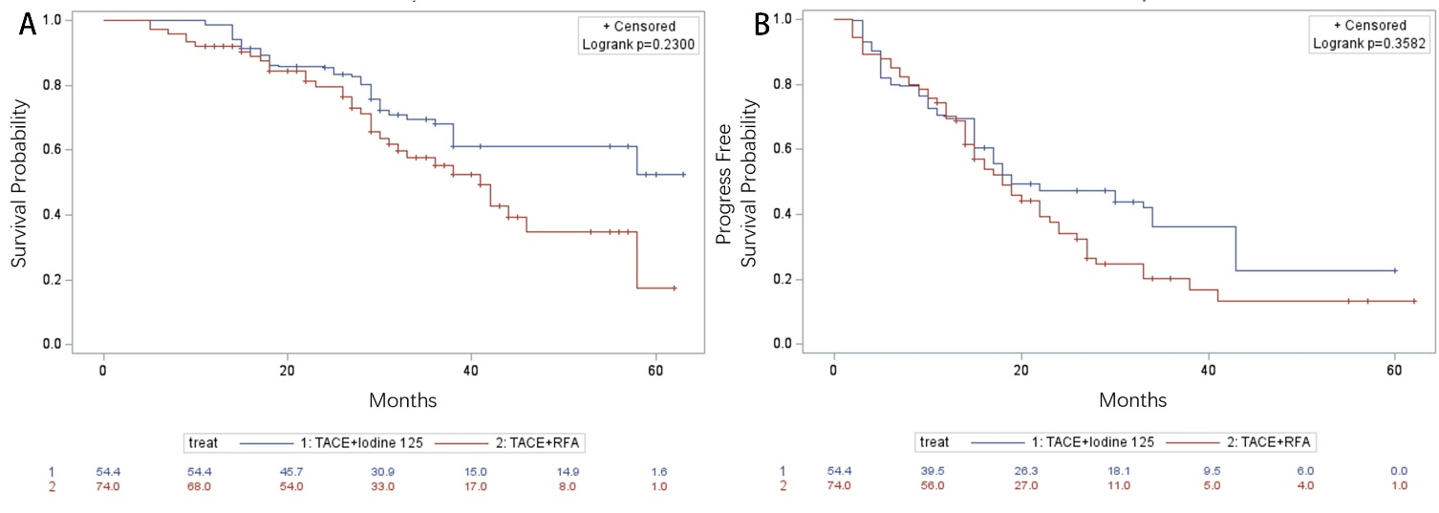

Figure 3: The Kaplan-Meier curve of overall survival and progression free survival of BCLC A (A-B) and BCLC B (C-D) patients before PSM
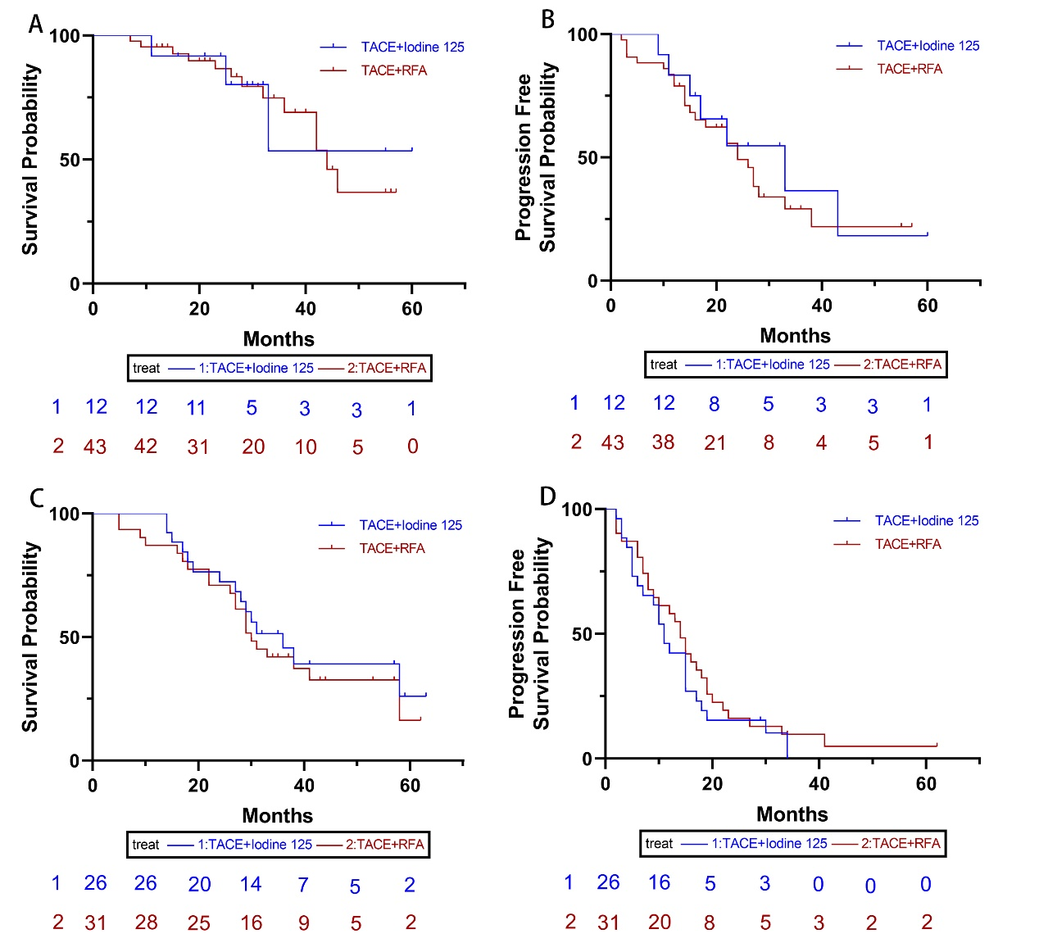
Figure 4: The Kaplan-Meier curve of overall survival and progression free survival of BCLC A (A-B) and BCLC B (C-D) patients after PSM

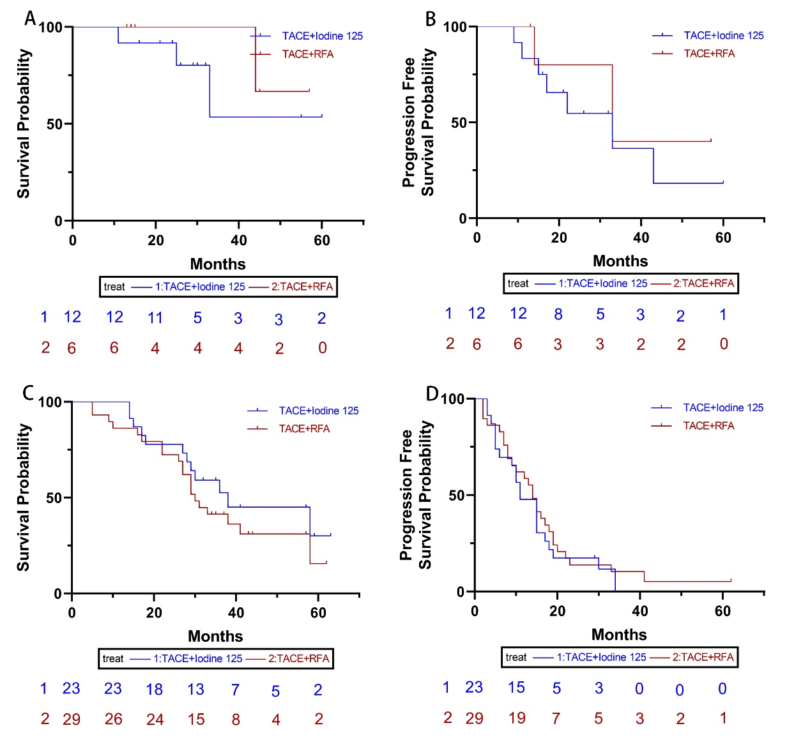

Figure 5: The Kaplan-Meier curve of overall survival and progression free survival of BCLC A (A-B) and BCLC B (C-D) patients after IPTW
