Table S1. Sepsis‐induced coagulopathy (SIC) criteria

 | Score | Range
Platelet count (−10⁹/L) | 2 | < 100
 | 1 | ≧ 100, < 150
INR | 2 | > 1.4
 | 1 | > 1.2, ≦1.4
SOFA score | 2 | ≧ 2
 | 1 | 1
Total score for SIC |  | ≧ 4

SOFA score is the sum of 4 items (respiratory SOFA, cardiovascular SOFA, hepatic SOFA, renal SOFA).
Abbreviations: SIC sepsis‐induced coagulopathy, INR international normalized ratio, SOFA sequential organ failure assessment.

Table S3. Hyperparameter search domain in Bayesian Optimization and final settings

Hyperparameters | Search domain | Final setting
'depth' | [2, 8] (integer) | 3
'bagging_temperature' | [1, 50] | 44.2
'reg_lambda' | [1, 200] | 106.6
'learning_rate' | [0.01, 0.2] | 0.081
'min_data_in_leaf' | [1, 3] | 1

Table S4. Results of Logistic Regression
 | Coef. | OR | 95% CI | Std.Err. | z | P>|z|
Hypertension | 0.289 | 0.749 | [0.699, 0.803] | 0.035 | 8.236 | <0.001
DM | -0.048 | 1.049 | [0.969, 1.135] | 0.040 | -1.183 | 0.237
COPD | 0.270 | 0.763 | [0.708, 0.824] | 0.039 | 6.943 | <0.001
CHF | 0.188 | 0.829 | [0.770, 0.893] | 0.038 | 4.938 | <0.001
MI | -0.037 | 1.038 | [0.936, 1.151] | 0.053 | -0.711 | 0.477
CKD | -0.112 | 1.119 | [1.036, 1.209] | 0.040 | -2.840 | 0.005
Leukemia | -1.339 | 3.815 | [2.989, 4.865] | 0.124 | -10.779 | <0.001
Strokes | -0.705 | 2.024 | [1.815, 2.255] | 0.055 | -12.724 | <0.001
Cancer | 0.437 | 0.646 | [0.600, 0.696] | 0.038 | 11.526 | <0.001
Liver disease | -0.224 | 1.251 | [1.133, 1.383] | 0.051 | -4.420 | <0.001
Age | 0.012 | 0.988 | [0.986, 0.991] | 0.001 | 9.176 | <0.001
Gender | 0.083 | 0.920 | [0.860, 0.984] | 0.034 | 2.434 | 0.015
BMI | 0.004 | 0.996 | [0.993, 0.999] | 0.002 | 2.662 | 0.008
Admission type 1 | -0.246 | 1.279 | [1.185, 1.380] | 0.039 | -6.333 | <0.001
Admission type 2 | 0.472 | 0.624 | [0.523, 0.744] | 0.090 | 5.252 | <0.001
Admission type 3 | -0.241 | 1.273 | [1.175, 1.379] | 0.041 | -5.912 | <0.001
Ethnicity 1 | 0.202 | 0.817 | [0.738, 0.904] | 0.052 | 3.903 | <0.001
Ethnicity 2 | -0.974 | 2.649 | [2.010, 3.490] | 0.141 | -6.927 | <0.001
Ethnicity 3 | 0.707 | 0.493 | [0.435, 0.559] | 0.064 | 10.980 | <0.001
Ethnicity 4 | -0.652 | 1.919 | [0.842, 4.371] | 0.420 | -1.551 | 0.121
Ethnicity 5 | -0.017 | 1.017 | [0.933, 1.108] | 0.044 | -0.388 | 0.698
SAPS-II | 0.010 | 0.990 | [0.988, 0.993] | 0.001 | 7.646 | <0.001
GCS | 0.035 | 0.966 | [0.947, 0.985] | 0.010 | 3.529 | <0.001
Heart rate | 0.007 | 0.993 | [0.991, 0.995] | 0.001 | 6.189 | <0.001
Respiratory rate | 0.004 | 0.996 | [0.974, 1.018] | 0.011 | 0.339 | 0.735
MAP | -0.005 | 1.005 | [1.003, 1.008] | 0.001 | -3.774 | <0.001
SpO2 | 0.026 | 0.974 | [0.959, 0.990] | 0.008 | 3.210 | 0.001
Temperature | -0.073 | 1.076 | [1.021, 1.133] | 0.026 | -2.748 | 0.006
Plateau pressure | 0.013 | 0.987 | [0.979, 0.994] | 0.004 | 3.464 | 0.001
Tidal volume | 0.000 | 1.000 | [0.999, 1.000] | 0.000 | 1.003 | 0.316
PEEP | -0.009 | 1.009 | [0.996, 1.022] | 0.006 | -1.376 | 0.169
RSBI | -0.002 | 1.002 | [0.997, 1.007] | 0.003 | -0.914 | 0.361
Albumin | 0.185 | 0.831 | [0.732, 0.944] | 0.065 | 2.853 | 0.004
Total protein | -0.219 | 1.245 | [1.100, 1.408] | 0.063 | -3.476 | 0.001
Anion gap | 0.011 | 0.989 | [0.975, 1.003] | 0.007 | 1.514 | 0.130
BUN | -0.007 | 1.007 | [1.005, 1.008] | 0.001 | -8.538 | <0.001
Creatinine | 0.150 | 0.861 | [0.836, 0.886] | 0.015 | 10.138 | <0.001
Globulin | 0.094 | 0.910 | [0.803, 1.033] | 0.064 | 1.467 | 0.142
Fibrinogen | 0.000 | 1.000 | [1.000, 1.000] | 0.000 | -0.105 | 0.916
INR | 0.179 | 0.836 | [0.616, 1.135] | 0.156 | 1.147 | 0.251
PT | -0.009 | 1.009 | [0.980, 1.039] | 0.015 | -0.597 | 0.551
PTT | 0.008 | 0.992 | [0.990, 0.993] | 0.001 | 10.545 | <0.001
ALT | -0.001 | 1.001 | [1.000, 1.002] | 0.000 | -3.568 | <0.001
AST | 0.001 | 0.999 | [0.999, 1.000] | 0.000 | 3.228 | 0.001
ALP | 0.000 | 1.000 | [1.000, 1.001] | 0.000 | -4.369 | <0.001
Total bilirubin | 0.106 | 0.899 | [0.829, 0.976] | 0.042 | 2.536 | 0.011
Direct bilirubin | -0.101 | 1.106 | [1.005, 1.219] | 0.049 | -2.052 | 0.040
Indirect bilirubin | -0.057 | 1.059 | [0.935, 1.198] | 0.063 | -0.897 | 0.370
MCH | -0.305 | 1.357 | [1.146, 1.606] | 0.086 | -3.541 | <0.001
MCHC | 0.261 | 0.770 | [0.660, 0.899] | 0.079 | 3.293 | 0.001
MCV | 0.092 | 0.912 | [0.865, 0.961] | 0.027 | 3.442 | 0.001
Platelet | -0.001 | 1.001 | [1.000, 1.001] | 0.000 | -5.815 | <0.001
RBC | 0.089 | 0.915 | [0.591, 1.418] | 0.223 | 0.397 | 0.691
RDW | 0.034 | 0.967 | [0.953, 0.981] | 0.007 | 4.614 | <0.001
WBC | 0.000 | 1.000 | [0.996, 1.004] | 0.002 | 0.181 | 0.857
pH | -1.091 | 2.977 | [0.541, 16.395] | 0.871 | -1.253 | 0.210
PaO2 | -0.001 | 1.001 | [0.999, 1.002] | 0.001 | -0.996 | 0.319
PaCO2 | -0.014 | 1.014 | [1.002, 1.025] | 0.006 | -2.356 | 0.018
FiO2 | -0.003 | 1.003 | [0.994, 1.011] | 0.004 | -0.631 | 0.528
PaO2/FiO2 | 0.001 | 0.999 | [0.999, 1.000] | 0.000 | 1.648 | 0.099
SO2 | -0.002 | 1.002 | [0.996, 1.008] | 0.003 | -0.594 | 0.553
BE | -0.005 | 1.005 | [0.957, 1.055] | 0.025 | -0.200 | 0.842
Bicarbonate | -0.030 | 1.030 | [1.018, 1.043] | 0.006 | -4.870 | <0.001
AADO2 | 0.001 | 0.999 | [0.998, 1.001] | 0.001 | 0.998 | 0.318
Total CO2 | 0.041 | 0.960 | [0.920, 1.001] | 0.021 | 1.913 | 0.056
Hematocrit | -0.002 | 1.002 | [0.950, 1.058] | 0.027 | -0.087 | 0.930
Hemoglobin | 0.003 | 0.997 | [0.836, 1.188] | 0.090 | 0.037 | 0.971
Chloride | 0.001 | 0.999 | [0.988, 1.010] | 0.006 | 0.195 | 0.845
Calcium | -0.011 | 1.011 | [0.983, 1.039] | 0.014 | -0.765 | 0.444
Potassium | 0.006 | 0.994 | [0.942, 1.048] | 0.027 | 0.231 | 0.817
Sodium | 0.009 | 0.991 | [0.980, 1.002] | 0.006 | 1.529 | 0.126
Lactate | 0.062 | 0.940 | [0.908, 0.971] | 0.017 | 3.666 | <0.001
Glucose | 0.000 | 1.000 | [1.000, 1.001] | 0.000 | -2.438 | 0.015
SpO2/FiO2 | 0.065 | 0.937 | [0.728, 1.208] | 0.129 | 0.500 | 0.617
ROX index | -2.705 | 14.954 | [0.668, 334.956] | 1.586 | -1.705 | 0.088
Urine output | 0.000 | 1.000 | [1.000, 1.000] | 0.000 | -0.259 | 0.796
SIC platelet | 0.539 | 0.583 | [0.541, 0.629] | 0.039 | 13.989 | <0.001
SIC INR | 0.332 | 0.717 | [0.682, 0.755] | 0.026 | 12.796 | <0.001
Respiratory SOFA | 0.014 | 0.986 | [0.955, 1.017] | 0.016 | 0.893 | 0.372
Liver SOFA | 0.074 | 0.929 | [0.868, 0.994] | 0.035 | 2.141 | 0.032
Renal SOFA | 0.046 | 0.955 | [0.928, 0.984] | 0.015 | 3.064 | 0.002
Cardiovascular SOFA | -0.032 | 1.033 | [0.999, 1.068] | 0.017 | -1.887 | 0.059
SIC days | 0.083 | 0.920 | [0.915, 0.926] | 0.003 | 28.877 | <0.001
RBC Transfusion | 0.000 | 1.000 | [1.000, 1.000] | 0.000 | -1.207 | 0.228
FFP Transfusion | 0.000 | 1.000 | [0.999, 1.000] | 0.000 | 0.977 | 0.329
PLT Transfusion | 0.002 | 0.998 | [0.997, 0.999] | 0.001 | 3.496 | <0.001
Heparin use | -0.133 | 1.142 | [1.068, 1.221] | 0.034 | -3.890 | <0.001
Heparin days | -0.013 | 1.013 | [1.009, 1.017] | 0.002 | -6.694 | <0.001
Antibiotic types | 0.074 | 0.929 | [0.900, 0.957] | 0.015 | 4.823 | <0.001
Linezolid | 0.039 | 0.962 | [0.821, 1.127] | 0.081 | 0.478 | 0.633
Vancomycin | -0.209 | 1.232 | [1.141, 1.330] | 0.039 | -5.359 | <0.001
CRRT use | 0.085 | 0.919 | [0.817, 1.031] | 0.060 | 1.432 | 0.152
Vasopressor use | 0.179 | 0.836 | [0.764, 0.915] | 0.046 | 3.891 | <0.001
MV durations | -0.001 | 1.001 | [1.001, 1.001] | 0.000 | -12.630 | <0.001

Admission type 0: Emergency (reference); Admission type 1: Urgent; Admission type 2: Elective; Admission type 3: Other; Ethnicity 0: White (reference); Ethnicity 1: Black; Ethnicity 2: Asian; Ethnicity 3: Hispanic; Ethnicity 4: Native; Ethnicity 5: Other/Unknown

Fig S1. Model performance in different patient cohorts in MIMIC-IV
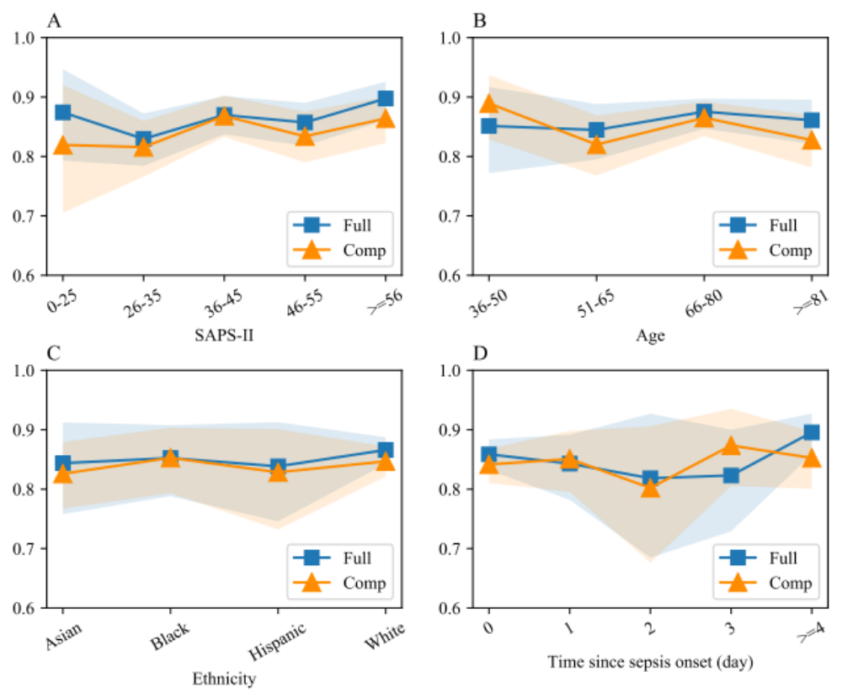
Different validation sets were derived based on SPAS-II (A), age (B), ethnicity (C) and time since sepsis onset (D). AUC of the full and the compact models in each set was measured by using bootstrap method. The colored area represents 95% confidence intervals.
Abbreviations: Full the full model, Comp the compact model, AUC area under receiver operating characteristic curve, SAPS-II Simplified Acute Physiology Score-IV.

Fig S2. Model interpretation of the full model in eICU-CRD
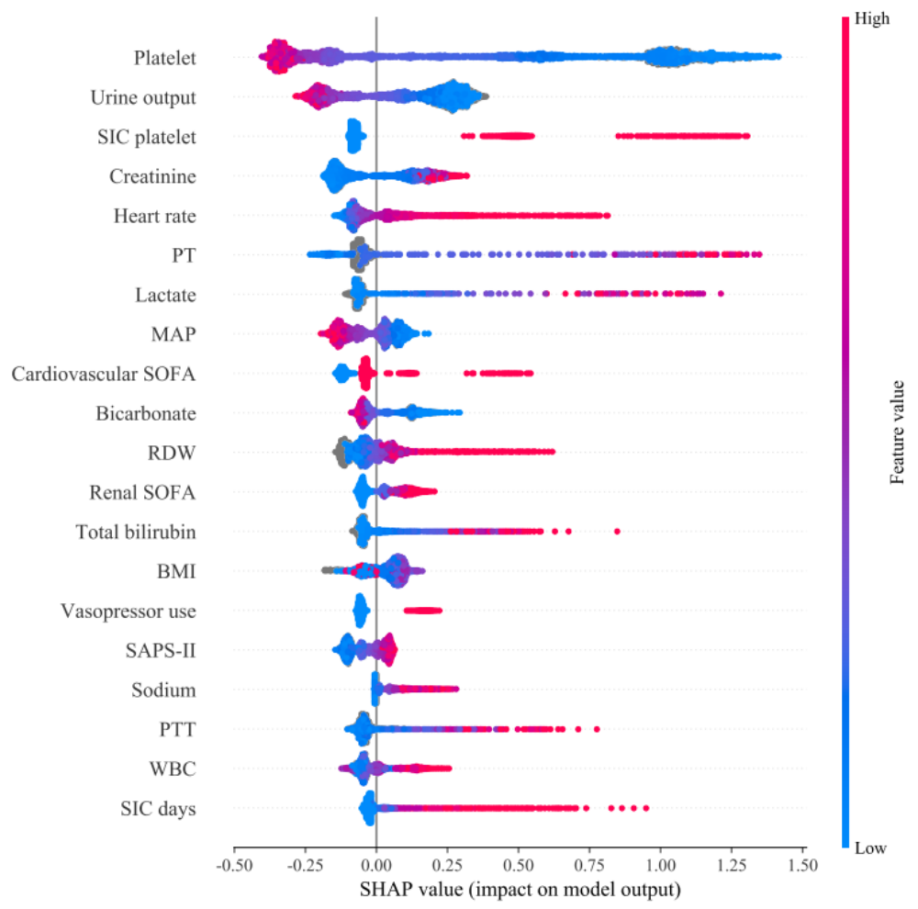

Fig S3. Model interpretation of the compact model in eICU-CRD
