High flow nasal oxygen in patients with COVID-19 associated acute respiratory failure

Ricard Mellado-Artigas (MD)¹, Bruno L. Ferreyro (MD)², Federico Angriman (MD, MPH)^{3,4}, María Hernández-Sanz (MD)⁵, Egoitz Arruti (PhD)⁶, Antoni Torres (MD, PhD)^{7,8,9} , Jesús Villar (MD, PhD)^{8,10}, Laurent Brochard (MD, PhD)^{3, 11}, Carlos Ferrando (MD, PhD)^{1,8}, for the COVID-19 Spanish ICU Network.
From
- Department of Anesthesiology and Critical Care, Hospital Clínic, Institut D'investigació August Pi i Sunyer, Barcelona, Spain;
- Department of Medicine, Sinai Health System and University Health Network, Toronto, Canada.
- Interdepartmental Division of Critical Care Medicine, University of Toronto, Canada;
- Department of Critical Care Medicine. Sunnybrook Health Sciences Centre. Toronto, Canada;
- Department of Anesthesiology and Critical Care, Hospital de Cruces, Vizcaya, Spain;
- Ubikare Technology, Vizcaya, Spain;
- Department of Respirology, Hospital Clínic, Institut D'investigació August Pi i Sunyer, Barcelona, Spain;
- CIBER de Enfermedades Respiratorias, Instituto de Salud Carlos III, Madrid, Spain;
- CIBERESUCICOVID, Instituto de Salud Carlos III, Madrid, Spain;
- Multidisciplinary Organ Dysfunction Evaluation Research Network, Research Unit, Hospital Universitario Dr. Negrin, Las Palmas de Gran Canaria, Spain.
- Keenan Research Centre for Biomedical Science, St Michael’s Hospital, Toronto, Canada

SUPPLEMENTARY APENDIX

1. Further details on statistical analysis 2
1.a. Selection of variables for adjustment of confounding 2
1.b. Multiple data imputation 2
1.c. Estimation of E-value 3
2. Figures and tables 4
E-figure 1. Directed acyclic graph (DAG) 5
E-FIGURE 2. E-value calculation for primary outcome of interest (ventilator free days) 6
E-TABLE 1. Overall cohort design and differences with a pre-planned pragmatic target randomized trial of high flow nasal oxygen compared to an early intubation strategy for patients with COVID-19 associated acute respiratory failure. 7
E-TABLE 2. Characteristics of the baseline study sample before matching. 8
E-TABLE 3. Summary of sensitivity analysis 9
E-TABLE 4. Subgroup analysis by baseline PaO₂:FiO₂ ratio 10
3. REFERENCES 11

1.- Further details on statistical analysis

1.a. Selection of variables for adjustment of confounding

Covariate adjustment poses the risk to induce selection bias if conditioning is performed on variables that act as colliders. The structural relationship between the exposure of interest and outcome, including all other potential covariates can be depicted using a direct acyclic graph (DAG)^{1–4}. This form of causal diagram is constructed from subject matter knowledge including previous research and describes the roadmap of causal connections between variables of interest. Through the assessment of relationships between variables, DAGs help to identify potential sources of bias and how to control for them when estimating causal associations⁴. The DAG used for this study is depicted on supplementary figure 1. With the DAG, we identified six nodes to be controlled during matching; namely the degree of respiratory failure and extrapulmonary involvement, the number of comorbidities, the age, and the ICU were a particular patient was admitted. For 5 out of 6 nodes we were able to identify variables that could be used to control for confounding such as age, the number of comorbidities and type of comorbidities, oxygenation and severity scores or vital signs as well as laboratory markers. Gender was included since some reports suggest higher severity in male individuals. Covariate adjustment was assessed using standardized mean differences.

1.b. Multiple data imputation

Overall, 881 (4%) variable-observation pairs were missing. For that reason, multiple imputation using a Monte Carlo Markov chain method was carried out with the mice package in R^{5,6}. For every missing value, we created 1000 imputations and final imputed values for each missing observation were later calculated as the median of all the imputations. There was no missing data in the study exposure.

1.c. Estimation of E-value

Unmeasured confounding represents a major concern when estimating causal effects in observational studies thus a metric that calculates how strong an unmeasured confounder should be to overturn the reported results is advisable. The E-value, which is presented in the risk ratio scale (with values from 1 to infinite), represents the strength of association that a confounder should present with both the exposure and the outcome to explain away the estimated findings⁷. We performed the calculation of the e-value for the primary outcome using the e-value calculator: https://www.evalue-calculator.com.

2.- Figures and tables

Figure S1. Directed acyclic graph (DAG)
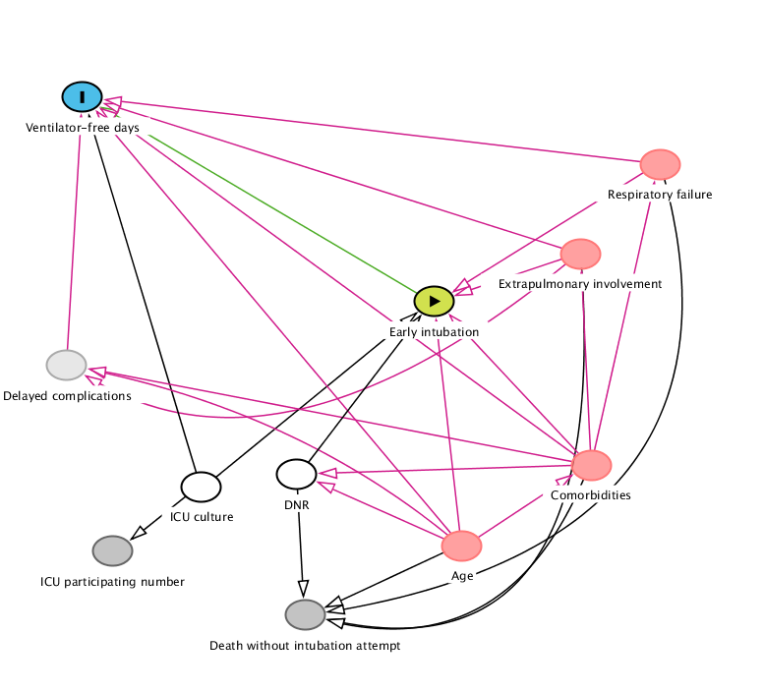
Direct acyclic graph (DAG) depicting variables of interest (dots) and causal relationships (arrows). Top left in blue: primary outcome. Green dot in the middle: exposure. The relationship of interest in this study is the one connecting both points. In red: predictor variables that affect both the exposure and the outcome in which direct data was available. In white: unobserved predictor variables. In dark grey: surrogate markers for unobserved variables. In light grey: the presence of delayed complications (after day 1) could influence the outcome but not the treatment received (either early intubation or not), hence it was not adjusted for.

Figure S2. E-value calculation for primary outcome of interest (ventilator free days)

The E-value shows, on the risk ratio scale, the strength of association between the unmeasured confounder and both the exposure and the outcome that would explain away the reported association.
Specifically, for the estimated effect of high flow nasal oxygen on ventilator free days, a risk ratio of 3.28 for both the confounder-outcome relationship and the exposure-confounder relationship would be needed to draw the results to the null value. This shows moderate robustness to potential unmeasured confounding.

Table S1. Overall cohort design and differences with a pre-planned pragmatic target randomized trial of high flow nasal oxygen compared to an early intubation strategy for patients with COVID-19 associated acute respiratory failure.

Component | Target trial | Emulation
Eligibility | Adult patients (18 years or older) with COVID-19 related acute respiratory failure suitable for either a conservative or early intubation strategy; PaO₂/FiO₂ ratio < 300 mmHg; a respiratory rate on day 1 < 35 breaths/min; Glasgow Coma Score <13 and pH ≤7.25 | Adult patients (18 years or older) with COVID-19 related acute respiratory failure suitable for either a conservative or early intubation strategy; PaO₂/FiO₂ ratio < 300 mmHg; a respiratory rate on day 1 < 35 breaths/min; Glasgow Coma Score <13 and pH ≤7.25
Treatment strategies | High flow nasal oxygen or invasive mechanical ventilation. Treatment started after randomization. | High flow nasal oxygen or invasive mechanical ventilation. Treatment within the first day of intensive care unit admission.
Treatment assignment | Permuted randomization scheme with varying block sizes from 4 to 8 | We will assume that patients were “randomly assigned” within levels of included confounders (i.e., conditional exchangeability).
Follow-up | In-hospital mortality; up to 60 days | In-hospital mortality; up to 60 days
Primary end point | Ventilator free days | Same as target trial
Secondary end point | Intensive care unit length of stay  All-cause in hospital mortality | Intensive care unit length of stay  All-cause in hospital mortality
Causal contrast of interest | Intention to treat effect | Observational analogue of the intention to treat effect
Statistical analysis | Survival curves will be estimated according to the Kaplan–Meier procedure. Crude generalized linear models for primary and secondary outcomes. | Same as target trial

Table S2. Characteristics of the baseline study sample before matching.

Baseline characteristic | Early intubation  (N=312) | High flow nasal canula  (N=156) | p value
Age, mean (SD) | 62.3(10.9) | 60.6 (12.7) | 0.10
Female gender | 101 (32.4%) | 43 (27.6%) | 0.29
Body mass index, mean (SD) | 29.4 (4.9) | 28.1 (4.3) | < 0.01
N. of comorbidities, median (IQR) | 1 (0-2) | 1 (0-2) | 0.93
Immunosuppression | 13 (4.2%) | 10 (6.4%) | 0.29
Cancer | 10 (3.2%) | 8 (5.1%) | 0.31
SOFA, median (IQR) | 7 (5-8) | 4 (3-5) | <0.01
Glasgow, median (IQR) | 15 (15-15) | 15 (15-15) | 0.01
APACHE, median (IQR) | 12 (10-14) | 10 (7-13) | <0.01
PaO2:FiO2 ratio, mean (SD) | 121.2 (58.0) | 122.7 (48.5) | 0.78
Respiratory rate, mean (SD) | 24.7 (6.0) | 25.3 (5.2) | 0.26
Sat, mean (SD) | 87.2 (9.2) | 90.4 (4.9) | < 0.01
ROX index, median (IQR) | 4 (3.2-6) | 5.1 (4.1-6.6) | < 0.01
PaCO2, mean (SD) | 44.7 (12.9) | 35.4 (9.4) | < 0.01
Gas flow during HFNO, mean (SD) |  | 54 (12) | -
FiO2, mean (SD) | 84.6 (18.2) | 71.2 (16.8) | < 0.01
Heart rate, mean (SD) | 84.8 (19.2) | 81.2 (15.4) | 0.04
Systolic BP, mean (SD) | 120.9 (21.5) | 126.8 (18.3) | < 0.01
PH, mean (SD) | 7.4 (.1) | 7.5 (.1) | < 0.01
Creatinine, mean (SD) | 1.0 (.6) | 1.1 (1.0) | 0.19
Bilirubin, mean (SD) | 0.9 (1.5) | 0.9 (1.9) | 0.92
Lactate, mean (SD) | 0.3 (1.0) | 0.4 (.6) | 0.19
D-Dimer, mean (SD) | 4486 (11467) | 2029 (3616) | < 0.01
Leucocytes, mean (SD) | 10.3 (5.9) | 8.4 (5.3) | < 0.01
Lymphocytes, mean (SD) | 0.8 (.8) | 0.7 (0.6) | 0.23
Platelets, mean (SD) | 247 (103) | 250 (112) | 0.78
Categorical variables presented as count (%). PaCO2: arterial pressure of carbon dioxide. FiO₂: inspired oxygen fraction. ROX: ratio of oxygen saturation to FiO₂, divided by respiratory rate: (Saturation/FiO2)/Respiratory rate. Continuous variables are expressed as medians (interquartile range); APACHE: Acute Physiology And Chronic Health Evaluation; SOFA: Sequential Organ Failure Assessment.

Table S3. Summary of sensitivity analysis
 | Mean difference (95% CI)
Outcome of interest | Adjusting for imbalance in matched sample | Adjusting on propensity score (entire sample) | Complete case analysis (matched analysis) | Adjusting on propensity score and considering HFNO at baseline (disregarding day 1)
Ventilator free days | 7.7 (3.6, 11.9) | 7.3 (4.5, 10.1) | 6.8 (1.4, 12.1) | 5.0 (2.7, 7.4)
Intensive care unit length of stay - days | -9.4 (-14.7, -4.0) | -8.0 (-11.3, -4.7) | -12.3 (-19.8, -4.7) | -6.0 (-9.2, -2.8)
In-hospital mortality¹ | 0.75 (0.22, 2.55) | 0.69 (0.33 – 1.44) | 1.64 (0.40, 6.66) | 0.77 (0.43, 1.36)
SMD: standardized mean difference VFD: Ventilator-free days. Continuous variables are expressed as median difference while in-hospital mortality is expressed as odds ratio. 95% CI: 95% confidence interval.
- Results for in hospital mortality shown as odds ratio (95%CI)

Table S4. Subgroup analysis by baseline PaO₂:FiO₂ ratio

Effect of HFNO vs. early intubation | Ventilator free days  [Mean difference (95% CI)]¹
PaO₂:FiO₂ ratio < 200 | 6.3 (-10.1 to 22.8)
PaO₂:FiO₂ ratio >= 200 | 8.2 (-1.2 to 17.6)
- P for interaction = 0.97.
HFNO: high flow nasal oxygen.

3.- REFERENCES

1. VanderWeele TJ, Hernán MA, Robins JM. Causal directed acyclic graphs and the direction of unmeasured confounding bias. Epidemiology. 2008;19(5):720-728. doi:10.1097/EDE.0b013e3181810e29
2. Etminan M, Collins GS, Mansournia MA. Using Causal Diagrams to Improve the Design and Interpretation of Medical Research. Chest. 2020;158(1):S21-S28. doi:10.1016/j.chest.2020.03.011
3. Hernán MA, Hernández-Díaz S, Robins JM. A Structural Approach to Selection Bias. Epidemiology. 2004;15(5):615-625. doi:10.1097/01.ede.0000135174.63482.43
4. Lederer DJ, Bell SC, Branson RD, et al. Control of confounding and reporting of results in causal inference studies. Ann Am Thorac Soc. 2019;16(1):22-28. doi:10.1513/AnnalsATS.201808-564PS
5. Sterne JAC, White IR, Carlin JB, et al. Multiple imputation for missing data in epidemiological and clinical research: potential and pitfalls. BMJ. 2009;338:b2393. doi:10.1136/bmj.b2393
6. van Buuren S, Groothuis-Oudshoorn K. mice: Multivariate imputation by chained equations in R. J Stat Softw. 2011;45(3):1-67. doi:10.18637/jss.v045.i03
7. Haneuse S, Vanderweele TJ, Arterburn D. Using the E-Value to Assess the Potential Effect of Unmeasured Confounding in Observational Studies. JAMA - J Am Med Assoc. 2019;321(6):602-603. doi:10.1001/jama.2018.21554

