Additional file R1

Deploying unsupervised clustering analysis to derive clinical phenotypes and risk factors associated with mortality risk in 2,022 critically ill patients with COVID-19 in Spain Supplementary Online Content

e-Methods. Supplemental Methods
e-Figure 1: Heat map of correlation between clinical variables for analysis and phenotyping
e-Table 1. Definitions of Baseline Characteristics, Comorbidities, Treatments, and Outcomes
e-Figure 2. The Random-effects plot for hospital
e-Table 2. Crude ICU Mortality according to predefined age cut-off.
e-Figure 3. Crude ICU mortality plot according to age
e-Table 3. Characteristics of 2022 patients according to outcome
e-Figure 4. ROC curve plot for the GLM ICU mortality model
e-Table 4. Variance Inflation Factors (VIF)
e-Table 5. Ranking of variables according to the information value(IV)
e-Figure 5. Categorized variables independently associated with ICU mortality
e-Figure 6. Silhouette plot
e-Figure 7. PAM Plot
e-Figure 8. Plot of clinical phenotypes
e-Table 6. Ranking of variables according to the iv in each phenotype.
e-Figure 9. Variables independently associated with ICU mortality rate in global model and in each phenotype

eMethods: Supplemental Methods
Data Collection and Validation
Data were collected using a paper CRF (case Report Form). CRF collect and record all protocol-required information, which is transcribed from patient source documents, such as hospital records and laboratory reports during the patient's participation in the study. Before being sent to the Study Coordinator (AR) this data was de-identified (not traceable to the patient) by removing the patient's name, medical record number, etc., and giving the patient a unique study number. We implemented a double data entry model for potential errors in real-time. Data was entered twice by two different Data Entry personnel based on the same set of data collected in the paper CRFs. All data were reviewed, and values that appeared incongruent or out of range were manually validated by confirming the accuracy of the data with the Study Coordinator (AR). The database was validated and cleaned before the statistical analysis and finally, the study database was locked to prevent any further changes, and to ensure data consistency and integrity for the statistical reporting and analysis.
Approach to missing data
Continuous variables with missing data > 30% were excluded of database. Missing data for continuous variables were imputed using R-package "missForest" for the statistical software R/CRAN. The imputation was applied to impute the missing values of D dimer (20%), Ferritin (20%), D-Lactate dehydrogenase (17%), Procalcitonin (17%), creatinine (16%), SOFA score (16%), APACHE II score (10%) and C-reactive protein (CRP) (5%). Categorical data (including ICU mortality) were available for all patients.
Study definitions
Community-acquired pneumonia (CAP) was defined in accordance with current American Thoracic Society and Infectious Diseases Society of America guidelines (ATS/IDSA )(1).
Primary viral pneumonia due to SARS-CoV-2 infection was defined by the presence of acute respiratory failure and unequivocal alveolar opacities involving one or more lobes, with negative respiratory and blood bacterial cultures at ICU admission.
Community-acquired respiratory co-infection (CARC) was considered in patients with confirmation of SARS-CoV-2 infection showing recurrence of fever, increase in cough and production of purulent sputum plus positive bacterial/fungal respiratory or blood cultures at ICU admission (2).
Shock was defined in accordance with the Surviving Sepsis Campaign guidelines (3); that is, patients in whom adequate fluid resuscitation and vasopressor therapy are unable to restore hemodynamic stability.
Acute Kidney injury (AKI) was defined according to Consensus Conference of the Acute Dialysis Quality Initiative (4).
Acute respiratory distress syndrome (ARDS) was defined according Berlin definition (5) in 3 categories based on degree of hypoxemia: mild (PaO2/FIO2 ≤ 300 mm Hg), moderate (PaO2/FIO2 ≤ 200 mm Hg), and severe (PaO2/FIO2 ≤ 100 mm Hg)
Statistical analysis
To performed multivariate model and to derive the phenotypes, we first assessed the candidate variables, missing data and correlation by Cramer’s V. After evaluating correlation, highly correlated were excluded (eFigure1).
To determine if a significant inter-hospital variation is present, multilevel conditional logistic modelling with patients nested in hospital to characterize hospital-level variation of ICU mortality was done. We built an empty model, to assess the variation of the log-odds from one hospital to another and calculate the intraclass correlation coefficient (ICC) for one-way random-effects model. The ICC quantifies the degree of homogeneity of the outcome within clusters and represents the proportion of the between-hospital variation in the total variation. When the ICC is not different from zero or negligible, indicates perfect independence of residuals and traditional one level regression analysis can be done (6). The ICC obtained when considering all hospital (n=63) was 0.04 (eFigure 2) and was no different when excluded hospitals that submitted data on few than 10 patients (ICC=0.04, data no shown). This ICC represents that the hospital-level variation was very poor (4%) and a one-level regression analysis can be used.
Mod1 <- glmer(deadUCI ~ ( 1 | hospital), data=df, family = "binomial")
summary(Mod1)
Generalized linear mixed model fit by maximum likelihood (Laplace Approximation) [glmerMod]
Family: binomial ( logit )
Formula: deadUCI ~ (1 | hospital)
Data: df
AIC BIC logLik deviance df.resid
2537.4 2548.6 -1266.7 2533.4 2020
Scaled residuals:
Min 1Q Median 3Q Max
-0.9513 -0.6949 -0.6204 1.2060 1.9144
Random effects:
Groups Name Variance Std.Dev.
hospital (Intercept) 0.1492 0.3862
Number of obs: 2022, groups: hospital, 63
Fixed effects:
Estimate Std. Error z value Pr(>|z|)
(Intercept) -0.74458 0.07417 -10.04 <2e-16 ***
---
Signif. codes: 0 ‘***’ 0.001 ‘**’ 0.01 ‘*’ 0.05 ‘.’ 0.1 ‘ ’ 1

Intraclass correlation coefficient
icc <- Mod1@theta[1]^2/ (Mod1@theta[1]^2 + (3.14159^2/3))
icc
[1] 0.04337433

To investigate the association between baseline (on ICU admission) variables and ICU-mortality, a multivariate analysis (GLM: Generalized linear Regression model) in R statistical software was performed (Stats package https://www.rdocumentation.org/packages/stats). The multivariate model comprised factors of clinical interest and all significant covariates (p<0.05) in the univariate analysis of ICU mortality. GLM in R is a class of regression models that supports non-normal distributions, and can be implemented in R through glm() function that takes various parameters and the model works well with a variable which depicts a non-constant variance.
We studied presence of collinearity between explanatory variables with the use of variance inflation factors (VIF). A VIF value greater than 5 was considered as potentially severe correlation between predictor variables and the variable was excluded of model.
Finally, and to determine presence of clinical phenotypes an unsupervised clustering analysis was applied to the database at ICU admission. In order to carry out this analysis, a discretization of the numerical variables into categorical ones was done. The information provided by each variable regarding ICU mortality was defined using the Information Value (IF).
IV is one of the most useful technique to select important variables in a predictive model. It helps to rank variables on the basis of their importance. The IV was calculated using the following formula:
IV = ∑ (% of non-events - % of events) * WOE#
#The weight of evidence (WOE) tells the predictive power of an independent variable in relation to the dependent variable.
According to Sidoqqui recommendation (7) an IF greater than 0.03 was considered clinically important and this variable was included in the GLM analysis. Model performance was examined using accuracy test, Sensibility, Specificity and AUC. Subsequently, the unsupervised cluster analysis was performed using the important variables.
The Podani distance was used to calculate the distance between patients and the “partition around medoids” (PAM) algorithm to perform the clustering (8). The algorithm is intended to find a sequence of objects called medoids that are centrally located in clusters. Objects that are tentatively defined as medoids are placed into a set S of selected objects. If O is the set of objects that the set U = O − S is the set of unselected objects. The goal of the algorithm is to minimize the average dissimilarity of objects to their closest selected object. It is more robust to noise and outliers as compared to k-means because it minimizes a sum of pairwise dissimilarities instead of a sum of squared Euclidean distances. The optimal number of clusters were determined after studying the silhouette (9) and the PAM objective for different numbers of clusters. Each of these clusters represent a specific patient’s phenotype.
Circularity Bias approach during model selection and evaluation
The term "circular analysis" or “circularity bias” covers a wide variety of situations and their can appear for example, with the use of the same data to train and test a classifier (10). To avoid the circularity bias, in our analysis a cross-validation (80%+20%) K-Fold= 10 was made to obtain the classic model. On the other hand, to develop the automatic model, the variables to include were selected by automatic methods and subsequently a validation of the model was performed with a subset of train and test.
Finally, circularity bias can arise when the data are first analyzed to select a subset, and then the subset is reanalyzed to obtain the results. In this context, assumptions and hypotheses determine the selection criterion, and selection, in turn, can distort the results (11). Our analysis to derivation of phenotypes was performed by an unsupervised analysis and each model was validated with a subset of train and test. This prevents the presence of circulatory bias.
References
1.- Metlay JP,Waterer GW,Long AC, Anzueto A, Brozek J, Crothers K, et al. Diagnosis and Treatment of Adults with Community-acquired Pneumonia. An Official Clinical Practice Guideline of the American Thoracic Society and Infectious Diseases Society of America. Am J Resp Crit Care Med 2019 ;200(7): e45-e67. https://www.atsjournals.org/doi/full/10.1164/rccm.201908-1581ST
2.- Martin-Loeches I, Schultz MJ, Vincent JL, Alvarez-Lerma F, Bos LD, Sole-Violan J et al. Increased incidence of co-infection in critically ill patients with influenza. Intensive Care Med 2017; 43:48–58. https://www/doi/10.1007/s00134-016-4578-y
3.-Dellinger RP, Levy MM, Rhodes A, Annane D, Gerlach H, Opal SM et al. Surviving sepsis campaign: international guidelines for management of severe sepsis and septic shock: 2012. Crit Care Med 2013;41(2):580-637. https://www/doi/10.1097/CCM.0b013e31827e83af.
4.- Bellomo R. Ronco C. Kellum J.A. et al. Acute renal failure—definition, outcome measures, animal models, fluid therapy and information technology needs: the Second International Consensus Conference of the Acute Dialysis Quality Initiative (ADQI) Group. Crit Care. 2004; 8: R204-R212
5.- Ranieri VM, Rubenfeld GD, Thompson BT, Ferguson ND, Caldwell E, Fan E, Camporota L, Slutsky AS. Acute respiratory distress syndrome: The Berlin Definition ARDS Definition Task Force. JAMA 2012;307(23):2526-33. https://doi/10.1001/jama.2012.5669.
6.- Sommet, N. and Morselli, D. (2017). Keep Calm and Learn Multilevel Logistic Modeling: A Simplified Three-Step Procedure Using Stata, R, Mplus, and SPSS. International Review of Social Psychology, 30(1), 203–218, DOI: https://doi.org/10.5334/irsp.90.
7.- Siddoqi N. Scorecard Development Process. En: Siddoqi N, editor. Credit Risk Scorecards: Developing and Implementing Intelligent Credit Scoring. New Jersey: John Wiley & Sons; 2015. p. 73---127.
8.- Van der Laan M, Pollard K, Bryan J. A new partitioning around medoids algorithm, Journal of Statistical Computation and Simulation 2003; 73:8, 575-584. https://www/doi/10.1080/0094965031000136012
9.-Rousseeuw, P.J. (1987) Silhouettes: A graphical aid to the interpretation and validation of cluster analysis. J. Comput. Appl. Math. 1987; 20:53–65 https://doi.org/10.1016/0377-0427(87)90125-7
10.- Kriegeskorte N, Lindquist MA, E Nichols TE et al. Everything you never wanted to know about circular analysis, but were afraid to ask. Journal of Cerebral Blood Flow & Metabolism 2010; 30, 1551–1557
11.- Kriegeskorte N, Simmons WK, Bellgowan PSF, Baker CI. Circular analysis in systems neuroscience – the dangers of double dipping. Nat Neurosci. 2009; 12(5): 535–540.

eFigure 1: Heatmap of correlation between clinical variables for analysis and phenotyping

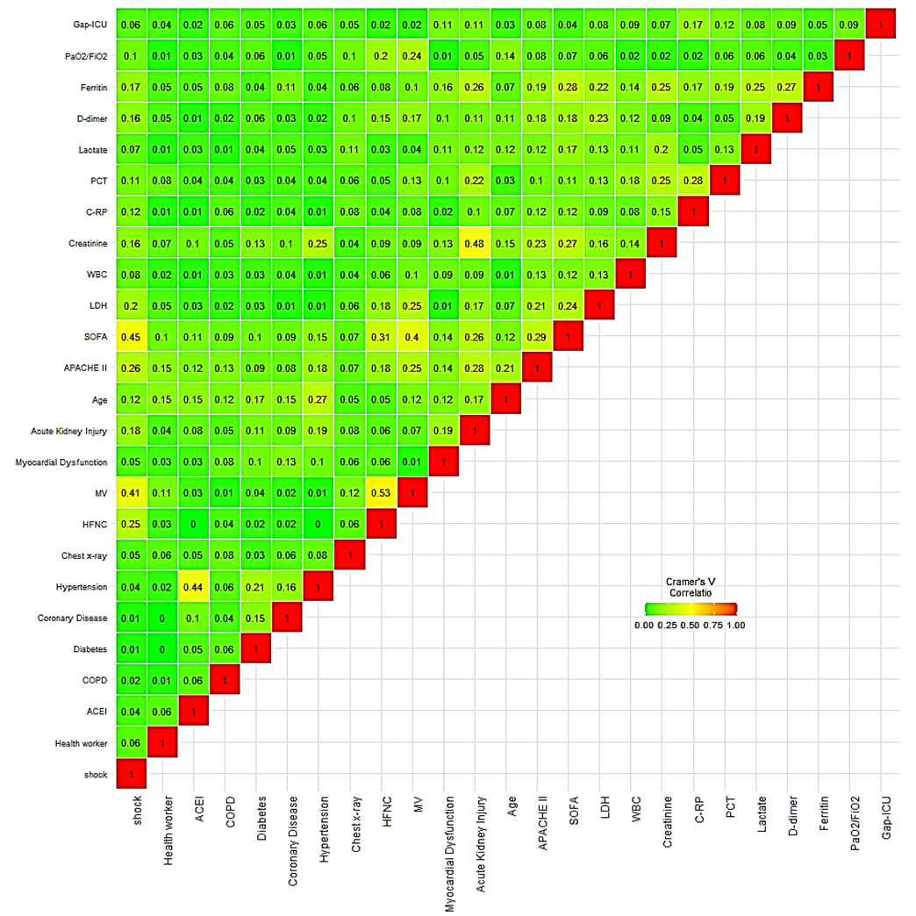

eTable 1: Definitions of variables recorded, Comorbidities, Treatments, and Outcomes Collected in patients
General characteristics and severity of illness
Hospital type | According to beds number (<200 ; 200-500 and > 500 beds)
Sex | 1:Male; 0: Female
Age | Number of years of age at the time of ICU admission
Date of Hospital admission | Per chart review
Data of ICU admission | Per chart review
Data of ICU discharge | Per chart review
Data of Hospital discharge | Per chart review
GAP ICU | Time in days from Hospital to ICU admission
GAP diagnosis | Time in days from onset of symptoms to diagnosis
GAP antiviral treatment | Time in days from onset of symptoms to first dose of antiviral
APACHE II score | Acute Physiology and Chronic Health Evaluation (APACHE) II score was calculated for all patients within the first 24 h of ICU admission
SOFA score | Sequential Organ Failure Assessment (SOFA) scoring system was calculated for all patients within the first 24 h of ICU admission.
Health worker | People who work in the hospital or other areas of health care
Comorbidities and coexisting conditions
9.- Asthma | Per chart review
10.- Chronic Pulmonary Obstructive Disease | Per chart review
11.- Arterial Hypertension | Per chart review
12.- Chronic Heart disease | Per chart review. New York Heart Association (NYHA) Functional Classification III and IV
13.- Chronic kidney disease | Baseline eGFR< 60 on at least two consecutive values at least 12 weeks apart prior or hemodialysis
14.- Hematologic disease | Per chart review, included acute leukemia, myelodysplastic syndrome and Lymphomas.
15.- Pregnancy | Per chart review
16.- Obesity | Body mass index > 30
17.- Diabetes mellitus | Per chart review
18.- HIV/AIDS | Per chart review
19.- Coronary artery disease | Per chart review
20.- Neuromuscular disease | Per chart review
21.- Immunological disease | Per chart review
22.- Other Immunodeficiency disorders | Per chart review
Laboratory findings
D-Lactate dehydrogenase | U/L, Per laboratory report
White blood cell | x10⁹ Per laboratory report
Serum Creatinine | mg/dL, Per laboratory report
C-Reactive Protein (CRP) | mg/mL, Per laboratory report
Procalcitonin (PCT) | ng/mL, Per laboratory report
Serum lactate | mmol/L, Per laboratory report
D dimer | ng/mL, Per laboratory report
Ferritin | ng/mL, Per laboratory report
Arterial blood gas (ABG) test | Per laboratory report
Treatment at ICU admission
Corticosteroids | Per chart review
Antibiotics | Per chart review
Lopinavir/ritonavir | Per chart review
Hydroxychloroquine | Per chart review
Tocilizumab | Per chart review
Interferon β | Per chart review
Corticosteroids | Per chart review
Antibiotics | Per chart review
Lopinavir/ritonavir | Per chart review
Anti-hypertensive treatment | ACEI: Angiotensin Converting Enzyme Inhibitors; ARB: Angiotensin receptor blockers
Oxygenation and ventilator support at ICU admission and at first 24 hours
Oxygen mask | Per chart review
High Flow nasal cannula | Per chart review
Non-invasive ventilation | Per chart review
Invasive mechanical ventilation | Per chart review
Oxygen mask | Per chart review
High Flow nasal cannula | Per chart review
Complications at ICU admission
Shock | Per chat review
Acute kidney dysfunction | Per chat review
Myocardial dysfunction | Per chat review
Community-acquired co-infection | Per chat review
> 2 Quadrant infiltrates in chest x-ray | Per chest x-ray review
Outcome
ICU crude mortality | Per chart review

eFigure 2: Random-effects plot for hospital. The intercept or average math score for each hospital (ID). The random-effects was obtained using the function ranef().
bi<-ranef(Mod1)
hosp.intercept <- bi$hospital + -0.74458
plot(hosp.intercept[,1],type='h',
xlab='hospital ID', ylab='Intercept')
abline(h=-0.74458)
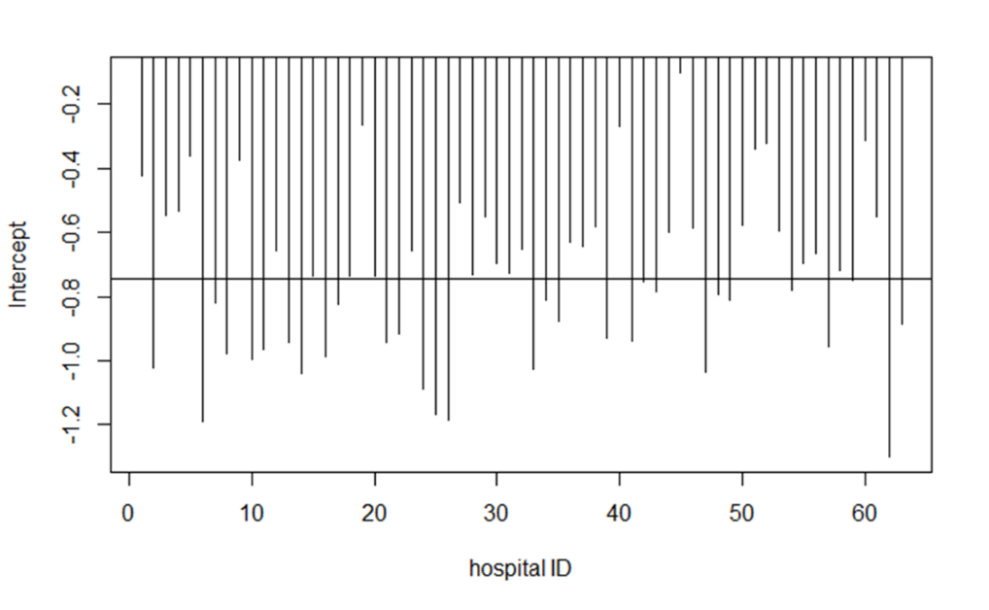
eTable 2: Crude ICU Mortality according to predefined age cut-off

Age cut-off | N | Nonsurvivors (%) | p-value
16-30 | 24 | 5(17.2) | 0.01
31-40 | 74 | 11(14.9) | 0.01
41-50 | 208 | 21(10.0) | 0.01
51-60 | 457 | 91(19.9) | 0.01
61-70 | 678 | 232(34.2) | 0.01
71-80 | 539 | 270(50.0) | 0.01
>80 | 37 | 30(81.0) | 0.01

eFigure 3: Crude ICU mortality plot according to age

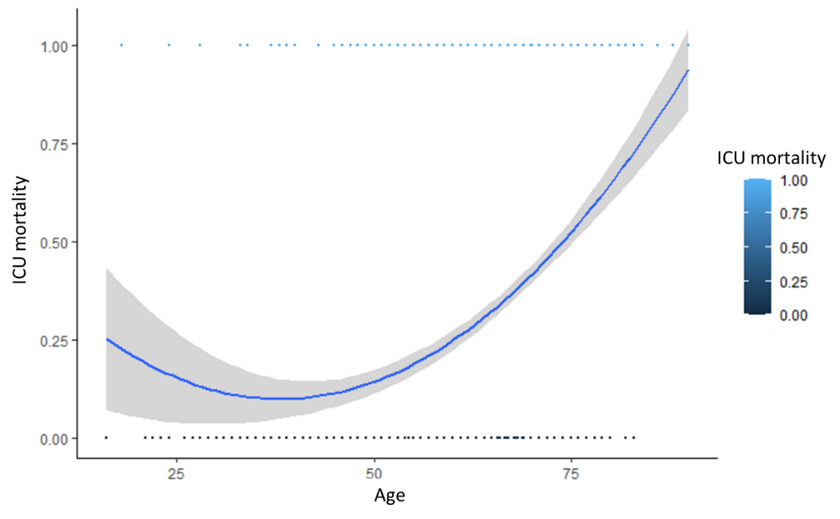

e-Table 3: Characteristics of 2022 critically ill patients included in the study at ICU admission according to train or test population
Variable^{a,l} | Overall | Train population | Test population | p-value
General characteristics and severity of illness
No. of patients(%) | 2022 (100.0) | 1618 (80.0) | 404 (20.0) | -----
Age ,median (IQR), y | 64(55-71) | 64(55-71) | 65(56-72) | 0.55
Age >60 years, No.(%) | 1254(62.0) | 1006(62.2) | 248(61.4) | 0.81
Male, No.(%) | 1423(70.4) | 1129(69.7) | 294(72.7) | 0.26
APACHE II , median (IQR)^{b} | 13(10-17) | 14(11-18) | 15(11-18) | 0.59
SOFA, median (IQR)^{c} | 5.0(3-7) | 5.6(4.0-7.7) | 5.2(4.0-7.0) | 0.10
Laboratory findings
D-Lactate dehydrogenase, median (IQR), U/L | 537(417-707) | 535(410-690) | 528(417-680) | 0.92
White blood cell, median (IQR), x10⁹ | 8.8(6.2-12.2) | 8.8(6.2-12.3) | 9.0(6.2-11.7) | 0.98
Serum Creatinine , median (IQR), mg/dL | 0.8(0.7-1.1) | 0.8(0.7-1.1) | 0.8(0.7-1.1) | 0.36
C-Reactive Protein, median (IQR), mg/mL | 15.5(9.1-24.3) | 15.6(9.3-23.8) | 15.7(8.6-24.5) | 0.15
Procalcitonin, median (IQR), ng/mL | 0.3(0.1-2.0) | 0.3(0.1-0.8) | 0.3(0.1-0.8) | 0.83
Serum lactate, median (IQR), mmol/L | 1.5(1.1-2.0) | 1.5(1.1-2.0) | 1.6(1.2-2.0) | 0.09
D dimer, median (IQR), ng/mL | 1593(720-3790) | 1570(735-3390) | 1515(680-3380) | 0.97
Ferritin ng/mL, median (IQR), | 1617(1290-2240) | 1481(1200-1780) | 1476(1252-1740) | 0.66
Treatments
Corticosteroids, No.(%) | 1174(58.1) | 942(58.2) | 232(57.4) | 0.67
Antibiotics , No.(%) | 1818(89.9) | 1452(89.7) | 366(90.6) | 0.57
Lopinavir/ritonavir , No.(%) | 1662(82.2) | 1321(81.6) | 341(84.4) | 0.22
Hydroxychloroquine, No.(%) | 1866(92.3) | 1492(92.2) | 374(92.5) | 0.88
Tocilizumab , No.(%) | 577(28.5) | 477(29.5) | 100(24.7) | 0.06
Interferon β, No.(%) | 715(35.4) | 568(35.1) | 174(43.0) | 0.67
Coexisting condition and Comorbidities
Arterial hypertension, No.(%) | 936(46.3) | 752(46.5) | 184(45.5) | 0.73
Obesity , No.(%)^{d} | 655(32.4) | 527(32.5) | 128(31.7) | 0.73
Diabetes, No.(%) | 420(20.8) | 339(20.9) | 81(20.1) | 0.74
Coronary arterial disease, No.(%) | 124( 6.1) | 96(5.9) | 28(6.9) | 0.52
COPD , No.(%) | 148(7.3) | 111(6.8) | 37(9.1) | 0.13
Chronic renal disease , No.(%)^{e} | 85(4.2) | 71(4.4) | 14(3.5) | 0.49
Hematologic disease , No.(%)^{f} | 73(3.6) | 62(3.8) | 11(2.7) | 0.35
Asthma, No.(%) | 121(5.9) | 98(6.0) | 23(5.7) | 0.87
HIV, No.(%) | 5(2.0) | 4(0.2) | 1(0.2) | 0.54
Pregnancy , No.(%) | 4(0.2) | 3(0.18) | 1(0.2) | 1.0
Autoimmune disease, No.(%) | 74(3.7) | 56(3.5) | 18(4.4) | 0.42
Chronic heart disease , No.(%)^{g} | 57(2.8) | 46(2.8) | 11(2.7) | 1.0
Neuromuscular disease , No.(%) | 16(0.8) | 12(0.7) | 4(1.0) | 0.89
Other immunosuppression , No.(%)^{h} | 53(2.6) | 46(2.8) | 7(1.7) | 0.28
Oxygenation and ventilator support
Oxygen mask , No.(%) | 333(6.4) | 267(16.5) | 66(16.3) | 0.87
High Flow nasal cannula, No.(%) | 375(18.5) | 298(18.4) | 77(19.1) | 0.82
Non-invasive ventilation , No.(%) | 140(6.9) | 107(6.6) | 33(8.1) | 0.32
Invasive mechanical ventilation, No.(%) | 1174(58.0) | 941(58.1) | 233(57.6) | 0.99
Complications
Shock , No.(%)^{i} | 906(44.8) | 729(45.0) | 177(43.8) | 0.69
Acute kidney dysfunction , No.(%)^{j} | 580(28.7) | 477(29.5) | 103(25.5) | 0.12
Community-acquired co-infection ^{k}, No.(%) | 190(9.4) | 149(9.2) | 41(10.1) | 0.62
> 2 Quadrant infiltrates in chest x-ray , No.(%) | 1333(65.9) | 1062(65.6) | 271(67.0) | 0.59
ICU crude mortality , No.(%) | 660(32.6) | 528(32.6) | 132(32.6) | 1.0

Abbreviations: IQR, interquartile range; APACHE II, Acute Physiology and Chronic Health Evaluation II; SOFA, Sequential Organ Failure Assessment; BMI, body mass index; COPD, Chronic obstructive pulmonary disease; HIV, human immunodeficiency viruses; PaO2/FiO2, Partial pressure arterial oxygen/ fraction of inspired oxygen
ª Corresponds to minimum or maximum value, as appropriate, within 12 hours of ICU admission. The variables in this Table were no transformed for your comparison.
^{b} APACHE II score to the severity of illness, the score is obtained by adding the following components 1) 12 clinical and laboratory variables each with a score range of 0 to 4 points (APS). The APS is determined from the worst physiologic values during the initial 24 h after ICU admission, 2) age with a range 0 to 6 points and 3) Chronic health points if the patients has history of severe organ system insufficiency or is immunocompromised assign 5 points if the patients is no operative or emergency postoperative and 2 points for elective postoperative patients with a total score range of 0 to 71.
^{c} SOFA score corresponds to the severity of organ dysfunction, reflecting six organ systems each with a score range of 0 to 4 points (cardiovascular, hepatic, hematologic, respiratory, neurological, renal), with a total score range of 0 to 24,
^{d} Defined as a body mass index (calculated as weight in kilograms divided by height in meters squared) of 30 or greater.
^{e} Baseline eGFR< 60 on at least two consecutive values at least 12 weeks apart prior or hemodialysis
^{f} included acute leukemia, myelodysplastic syndrome and Lymphomas.
^{g} According to the New York Heart Association (NYHA) Functional Classification III and IV
^{h} included Chronic corticosteroid treatment (>20 mg prednisolone /day or equivalent dose), chemotherapy or therapy with biological agents
^{I} Defined as patients in whom adequate fluid resuscitation therapy are unable to restore hemodynamic stability and need any dose of vasopressor drugs.
^{j} Define as an abrupt and sustained (more than 24 hours) decrease in kidney function and categorized according to RIFLE criteria
^{k} Was considered in patients with confirmation of SARS-CoV-2 infection showing recurrence of fever, increase in cough and production of purulent sputum plus positive bacterial/fungal respiratory or blood cultures at ICU admission
^{l} Kruskal-Wallis, ANOVA, or chi-square p-value as appropriate comparing train and test population, p>.01 for all comparison

e-Table 4: Variance Inflation Factors (VIF) to determine presence of collinearity between explanatory variables included in the training model

Variable | VIF
Age , years | 1.165966
Male | 1.131517
APACHE II | 1.341185
SOFA | 1.577309
D-Lactate dehydrogenase, U/L | 1.156532
White blood cell x10⁹ | 1.129158
Serum Creatinine mg/dL | 1.455142
C-Reactive Protein mg/mL | 1.074133
Procalcitonin ng/mL | 1.140735
Serum lactate mmol/L | 1.038744
D dimer ng/mL | 1.137709
Ferritin ng/mL | 1.288754
Arterial hypertension | 1.157518
Diabetes | 1.090715
Coronary arterial disease | 1.095681
COPD | 1.057170
Chronic renal disease | 1.186092
Hematologic disease | 1.036348
Other immunosuppression | 1.049225
PaO2/FiO2 at ICU admission | 1.115001
Invasive mechanical ventilation | 1.384719
Shock | 1.378355
Acute kidney dysfunction | 1.169113
> 2 Quadrant infiltrates in chest x-ray | 1.048113
Myocardial dysfunction | 1.080125

eFigure 4: ROC curve plot for the classic ICU mortality model. AUC represents the degree or measure of discrimination of the model for distinguishing between classes.
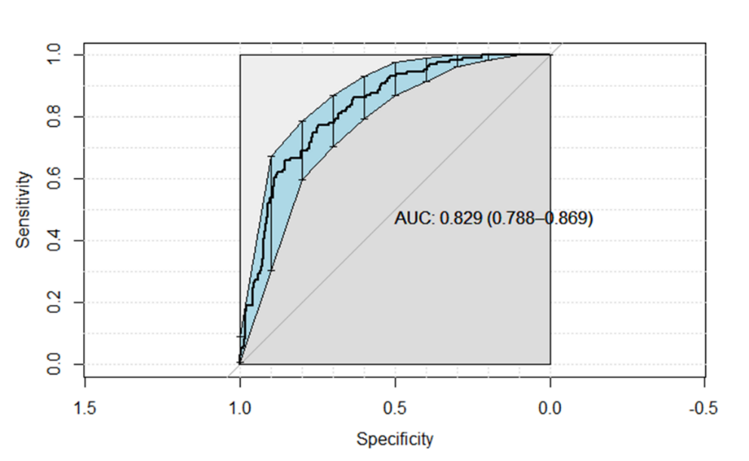

e-Table 5: Ranking of variables according to the information value to select important variables in a predictive model. Highly and somewhat predictive variables were included in the model.
## VARIABLES Information Value HSTRENGTH
## 1 Hospital type 4.041964e-03 Not Predictive
## 2 Male 9.730608e-03 Not Predictive
## 3 Influenza vaccine 2.719595e-02 Not Predictive
## 4 shock 1.025376e-01 Highly Predictive
## 5 Health worker 3.939070e-02 Somewhat Predictive
## 6 ACEI 5.176515e-02 Somewhat Predictive
## 7 ARB 1.407840e-02 Not Predictive
## 8 asthma 4.023492e-04 Not Predictive
## 9 COPD 4.605924e-02 Somewhat Predictive
## 10 Chronic Cardiac Dis 3.472710e-03 Not Predictive
## 11 Chronic Renal Dis 2.721800e-02 Not Predictive
## 12 Hematological Dis 2.144353e-02 Not Predictive
## 13 Pregnancy 2.253727e-03 Not Predictive
## 14 Obesity 2.452981e-03 Not Predictive
## 15 Diabetes 4.266095e-02 Somewhat Predictive
## 16 HIV 9.368383e-04 Not Predictive
## 17 Neuromuscular Dis 8.444705e-03 Not Predictive
## 18 Autoimmune Dis 5.088465e-04 Not Predictive
## 19 Coronary Dis 5.313002e-02 Somewhat Predictive
## 20 Hypertension 9.908557e-02 Somewhat Predictive
## 21 Infiltrates chest x-ray 3.931693e-02 Somewhat Predictive
## 22 Corticosteroids 4.460850e-03 Not Predictive
## 23 Antibiotics 7.133596e-05 Not Predictive
## 24 Empiric treatment 1.926115e-04 Not Predictive
## 25 Lopinavir/ritonavir 2.828696e-03 Not Predictive
## 26 interferon beta-1 1.351955e-02 Not Predictive
## 27 Hydroxychloroquine 8.557354e-03 Not Predictive
## 28 Tocilizumab 9.848787e-03 Not Predictive
## 29 O2 7.471572e-03 Not Predictive
## 30 Bacterial coinfection 6.317831e-03 Not predictive
## 31 HFNC 6.584694e-02 Somewhat Predictive
## 32 NIV 1.044679e-03 Not Predictive
## 33 MV 1.195287e-01 Highly Predictive
## 34 Myocardial Dysf. 1.020782e-01 Highly Predictive
## 35 Acute Kidney injury 4.267500e-01 Highly Predictive
## 36 Age 5.583901e-01 Highly Predictive
## 37 APACHE II 5.038235e-01 Highly Predictive
## 38 SOFA 3.964658e-01 Highly Predictive
## 39 Lactate dehydrogenase 1.623883e-01 Highly Predictive
## 40 WBC 5.118266e-02 Somewhat Predictive
## 41 Creatinine 2.605650e-01 Highly Predictive
## 42 CRP 5.374965e-02 Somewhat Predictive
## 43 PCT 1.590328e-01 Highly Predictive
## 44 Lactate 1.674733e-01 Highly Predictive
## 45 D Dimer 1.728036e-01 Highly Predictive
## 46 Ferritin 3.332789e-01 Highly Predictive
## 47 Gap antiviral 0.000000e+00 Not Predictive
## 48 PaO2/FiO2 6.116536e-02 Somewhat Predictive
## 49 Gap diagnostic 1.738805e-02 Not Predictive
## 50 Gap ICU 5.325043e-02 Somewhat Predictive

ACEI: Angiotensin Converting Enzyme Inhibitors; ARB: Angiotensin receptor blockers; WBC: White blood cells; HFNC: High Flow nasal cannula, NIV: non-invasive ventilation, MV: invasive mechanical ventilation, CRP: C-Reactive Protein; PCT: Procalcitonin ; GAP antiviral: Time from the symptoms onset to the first dose of antiviral, GAP diagnostic: Time from the symptoms onset to diagnosis, GAP ICU: time from the symptoms onset to ICU admission.

e-Figure 5: Categorized variables independently associated with ICU mortality
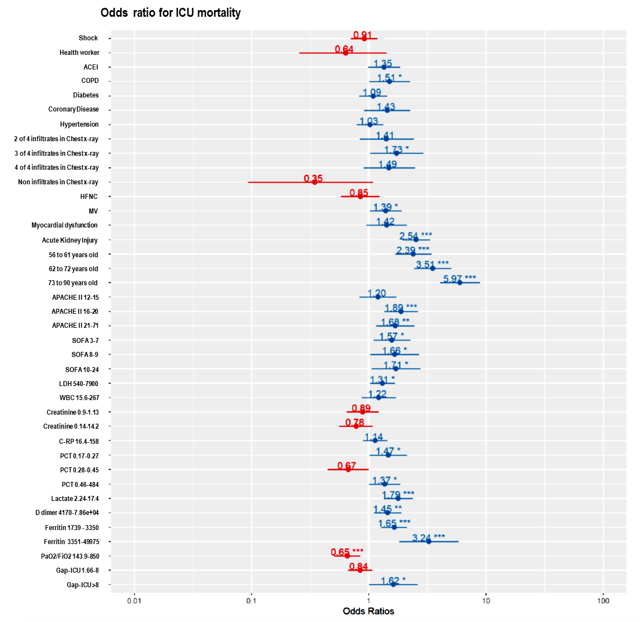
ACEI: Angiotensin Converting Enzyme Inhibitors; COPD; Chronic obstructive pulmonary disease; WBC: White blood cells; HFNC: High Flow nasal cannula, MV: invasive mechanical ventilation; APACHE II: Acute Physiology and Chronic Health Evaluation II; SOFA: Sequential Organ Failure Assessment; LDH: D-Lactate dehydrogenase; CRP: C-Reactive Protein; PCT: Procalcitonin; GAP ICU: time from the symptoms onset to ICU admission. *p<0.05, **p<0.01, ***p<0.001

e-Figure 6: Silhouette plot. The silhouette coefficient contrasts the average distance to elements in the same cluster with the average distance to elements in other clusters. Objects with a high silhouette value are considered well clustered, objects with a low value may be outliers. This index works well with k-medoids clustering, and is used to determine the optimal number of clusters. In our case, 3 clusters had the adequate silhouette width. 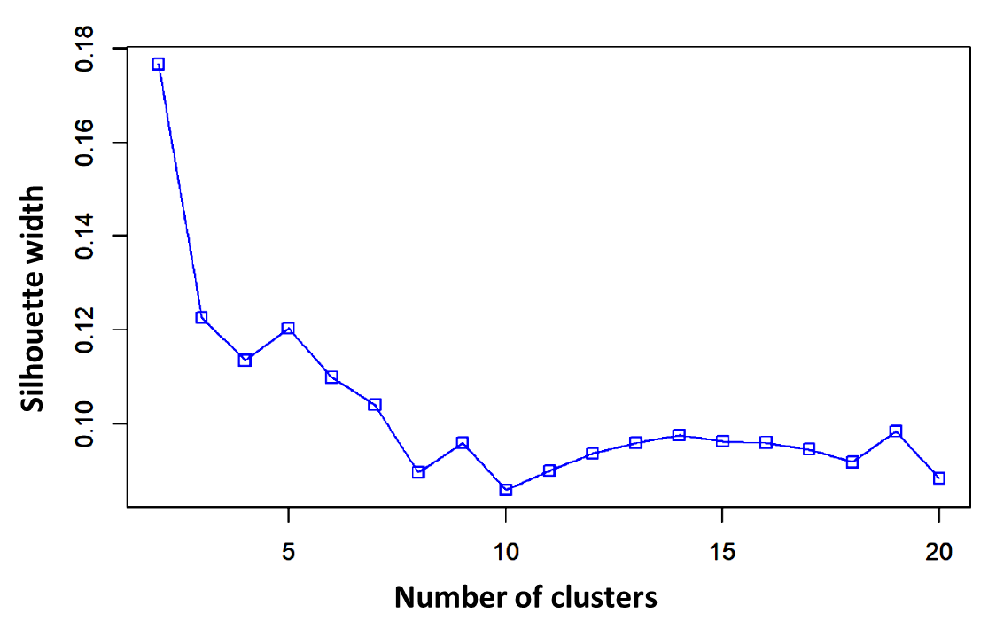
e-Figure 7: PAM Plot.
PAM is a per-partition clustering method that searches for "medoids" or prototypes, that is, cluster representative objects that have a minimum distance to the rest of the members of their cluster. In the PAM method the aim is to minimisation of the sum of dissimilarities between cluster members and their medoid. This difference in function to optimize makes PAM store to be more robust than k-means data sets with outliers. When working with the dissimilarity matrix there is more flexibility as to the type of data and distance measures that can be applied.
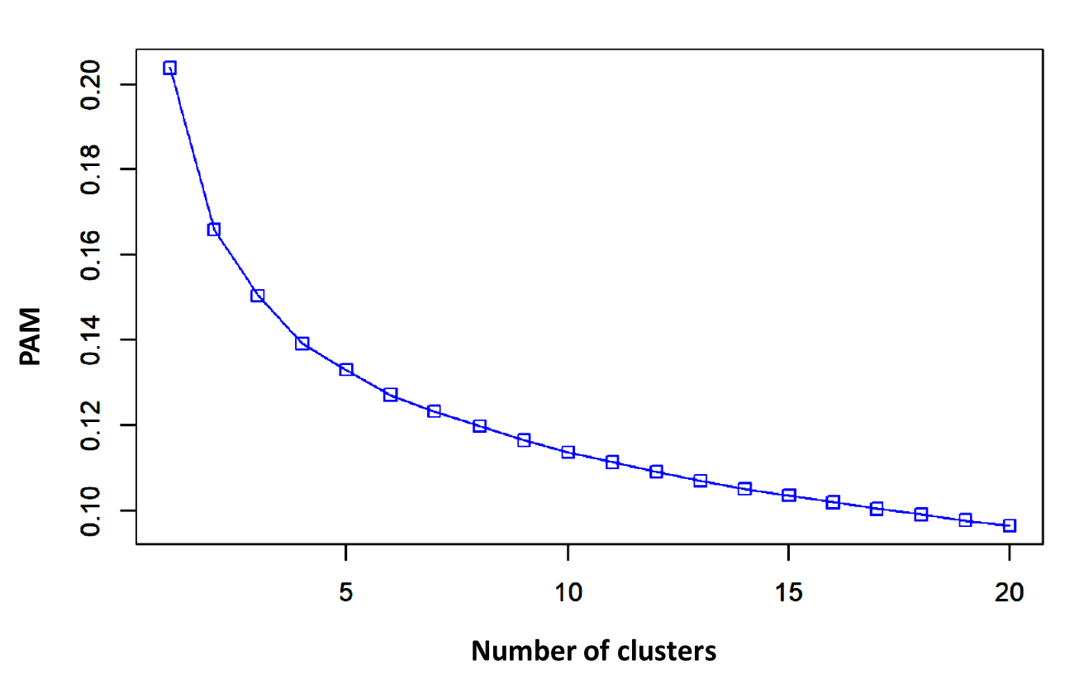

e-Figure 8: Plot of clinical phenotypes (clusters analysis) in a lower dimensional space using Principal Component Analysis.

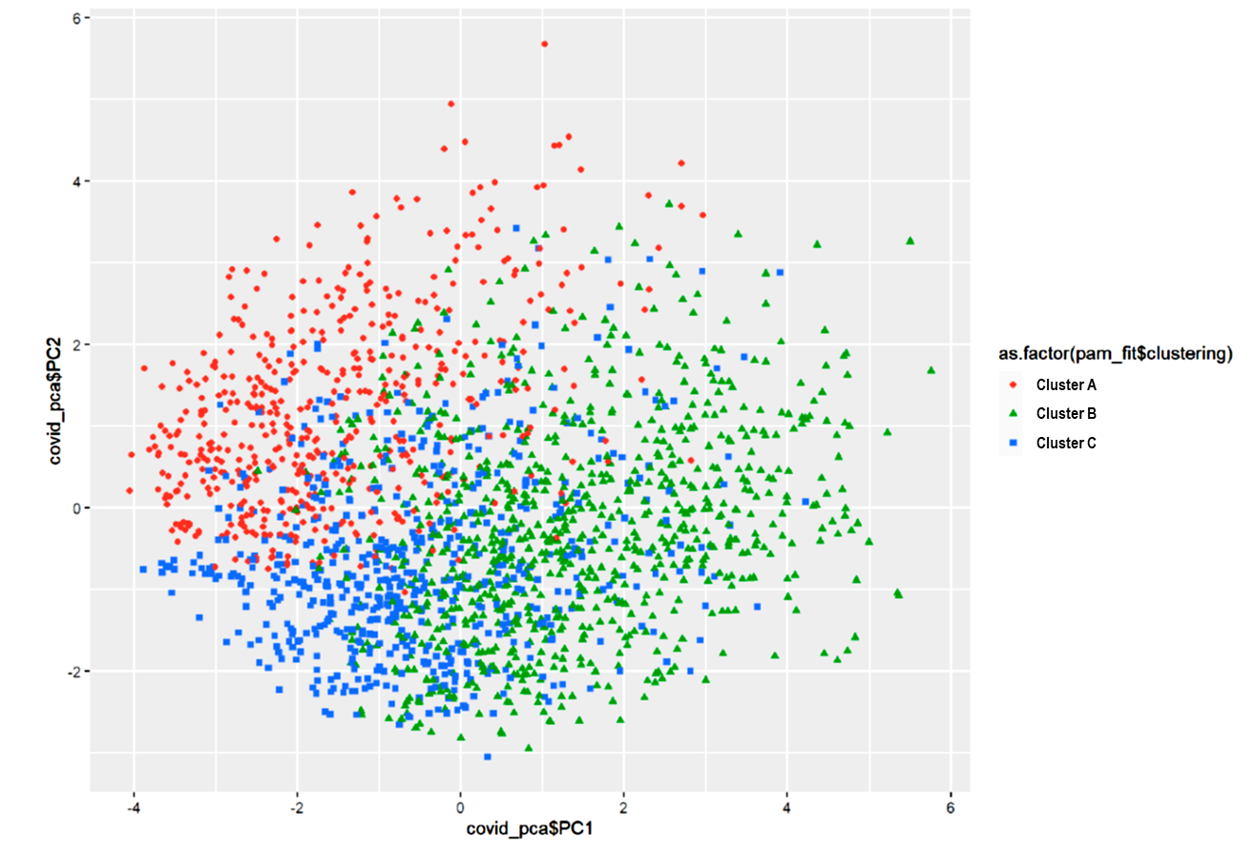

e-Table 6: Ranking of variables according to the information value to select important variables in each phenotype. Variables highlighted in red were included in each model.
 | A Phenotype | B Phenotype | C Phenotype
Variables | IV PREDICTIVE | IV PREDICTIVE | IV PREDICTIVE
## 1 Hospital type | 9.132863e-03 No | 1.559446e-03 No | 2.944340e-02 No
## 2 Male | 1.444146e-04 No | 2.590207e-02 No | 3.869809e-03 No
## 3 Influenza vaccine | 9.431129e-02 Somewhat | 2.126550e-02 No | 3.765656e-02 Somewhat
## 4 shock | 3.964703e-02 Somewhat | 5.164118e-03 No | 4.618684e-04 No
## 5 Health worker | 7.215440e-02 Somewhat | 6.021809e-02 Somewhat | 9.813392e-03 No
## 6 ACEI | 1.684165e-01 Highly | 6.080522e-03 No | 1.076237e-02 No
## 7 ARB | 1.828984e-02 No | 2.404218e-04 No | 1.177667e-03 No
## 8 asthma | 1.227356e-02 No | 2.533545e-04 No | 1.092745e-04 No
## 9 COPD | 1.749341e-01 Highly | 7.302773e-02 Somewhat | 6.691157e-03 No
## 10 Chronic Cardiac Disease | 6.204765e-02 Somewhat | 1.492305e-03 No | 2.960268e-05 No
## 11 Chronic Renal Disease | 1.738024e-01 Highly | 1.492305e-03 No | 1.146307e-02 No
## 12 Hematological Disease | 2.654456e-02 No | 3.754947e-03 No | 4.883194e-02 Somewhat
## 13 Pregnancy | 9.222784e-03 No | 1.283035e-02 No | 0.000000e+00 No
## 14 Obesity | 3.637363e-02 Somewhat | 6.145638e-07 No | 2.066138e-04 No
## 15 Diabetes | 1.866242e-01 Highly | 5.704696e-03 No | 2.479443e-02 No
## 16 HIV | 1.819062e-02 No | 4.376645e-03 No | 8.041982e-05 No
## 17 Neuromuscular Disease | 3.325893e-02 Somewhat | 4.106090e-03 No | 4.524557e-03 No
## 18 Autoimmune Disease | 1.319137e-05 No | 7.433381e-03 No | 3.870564e-03 No
## 19 Coronary Disease | 1.340642e-01 Highly | 2.627084e-03 No | 1.221929e-01 Highly
## 20 Hypertension | 2.210587e-01 Highly | 1.186944e-02 No | 1.223492e-02 No
## 21 Infiltrates chest x-ray | 2.817873e-02 No | 1.564487e-01 Highly | 3.578773e-02 Somewhat
## 22 Corticosteroids | 1.229703e-03 No | 1.560437e-04 No | 1.635793e-03 No
## 23 Antibiotics | 6.889626e-03 No | 3.134299e-03 No | 2.975869e-04 No
## 24 Empiric treatment | 5.959459e-03 No | 4.937022e-03 No | 2.287937e-03 No
## 25 Lopinavir/ritonavir | 1.598323e-03 No | 5.711297e-02 Somewhat | 1.005827e-04 No
## 26 interferon beta-1 | 2.656602e-02 No | 2.371890e-02 No | 8.530341e-03 No
## 27 Hydroxychloroquine | 4.276412e-02 Somewhat | 2.599639e-04 No | 3.468705e-02 Somewhat
## 28 Tocilizumab | 1.916296e-02 No | 2.610744e-03 No | 1.415470e-02 No
## 29 O2 | 2.146274e-05 No | 3.402079e-02 Somewhat | 4.340230e-03 No
## 30 HFNC | 2.353027e-03 No | 7.516552e-04 No | 1.157880e-03 No
## 31 NIV | 1.070219e-02 No | 3.063022e-02 Somewhat | 3.737383e-05 No
## 32 MV | 3.057185e-03 No | 1.653186e-01 Highly | 2.370305e-08 No
## 33 Myocardial Dysfunction | 2.228904e-01 Highly | 6.177601e-02 Somewhat | 6.055540e-02 Somewhat
## 34 Acute Kidney injury | 6.306028e-01 Highly | 3.646921e-01 Highly | 2.337694e-01 Highly
## 35 Age | 6.513748e-01 Highly | 7.408417e-01 Highly | 4.622984e-01 Highly
## 36 APACHE II | 4.310389e-01 Highly | 2.986345e-01 Highly | 2.939476e-01 Highly
## 37 SOFA | 4.038444e-01 Highly | 2.953304e-01 Highly | 1.487510e-01 Highly
## 38 Lactate dehydrogenase | 5.366081e-02 Somewhat | 1.041057e-01 Highly | 3.504073e-02 Somewhat
## 39 WBC | 4.581520e-02 Somewhat | 2.181871e-03 No | 3.820653e-02 Somewhat
## 40 Creatinine | 5.615214e-01 Highly | 2.412052e-01 Highly | 9.217995e-02 Somewhat
## 41 CRP | 7.164503e-02 Somewhat | 8.547374e-02 Somewhat | 3.204018e-03 No
## 42 PCT | 3.048025e-01 Highly | 8.008344e-02 Somewhat | 0.000000e+00 No
## 43 Lactate | 6.190517e-02 Somewhat | 1.543924e-01 Highly | 2.290830e-01 Highly
## 44 D Dimer | 2.521748e-01 Highly | 4.644420e-01 Highly | 8.243056e-02 Somewhat
## 45 Ferritin | 4.180265e-01 Highly | 3.490296e-01 Highly | 1.818192e-01 Highly
## 46 Gap antiviral | 2.766619e-01 Highly | 0.000000e+00 No | 0.000000e+00 No
## 47 PaO2/FiO2 | 0.000000e+00 No | 0.000000e+00 No | 1.018619e-01 Highly
## 48 Gap diagnostic | 0.000000e+00 No | 0.000000e+00 No | 0.000000e+00 No
## 49 Gap ICU | 6.204765e-02 Somewhat | 0.000000e+00 No | 7.482980e-02 Somewhat

ACEI: Angiotensin Converting Enzyme Inhibitors; ARB: Angiotensin receptor blockers; WBC: White blood cells; HFNC: High Flow nasal cannula, NIV: non-invasive ventilation, MV: invasive mechanical ventilation, CRP: C-Reactive Protein; PCT: Procalcitonin; GAP antiviral: Time from the symptoms onset to the first dose of antiviral, GAP diagnostic: Time from the symptoms onset to diagnosis, GAP ICU: time from the symptoms onset to ICU admission.

e-Figure 9: Variables independently associated with ICU mortality rate in global model (all population) and in each phenotype observed in COVID-19 patients

