Supplementary table 1. Components of clinical scores for predicting stroke-associated pneumonia after ICH

 | ICH-APS-A | ICH-APS-B | ISAN | ACDD4 | PASS
Age
Gender
COPD
Diabetes mellitus
Current smoking
excess alcohol consumption
pre-stroke mRS
Dysphagia
Dysarthria
Congestive heart failure
NIHSS
GCS
hematoma location
ventricular extension
hematoma volume
Abbreviation: COPD : chronic obstructive pulmonary disease; NIHSS: National Institutes of Health Stroke Scale score; GCS : Glasgow coma scale.
Supplementary Table 2. Performance of the clinical scores for predicting SAP in the derivation and internal validation cohorts
Model | stroke subtype | study design | Sample Size of  derivation cohort | AUROC | Validation
ICH-APS-B | Spontaneous ICH | Registry | 2998 | Overall cohort:0.74 (0.71-0.76）  Patients with LOS>48h: 0.77(0.73-0.81) | Internal
ICH-APS-A | Spontaneous ICH | Registry | 2998 | Overall cohort:0.75 (0.72-0.77）  Patients with LOS>48h: 0.78(0.75-0.81) | Internal
ISAN | AIS and ICH | Registry | AIS: 10635  ICH: 916 | Overall cohort : 0.79 (0.77-0.81)  Patients with ICH: 0.71 (0.66-0.77)  Patients with LOS>72h: 0.75 (0.69-0.80) | External
ACDD⁴ | AIS and ICH | Retrospective cohort | AIS: 965  ICH: 690 | Overall cohort : 0.82 (not reported) | Internal
PASS | AIS and ICH | RCT | AIS: 2125  ICH: 269 | Overall cohort : 0.84 (0.81-0.87) | Internal
Abbreviation: AIS：acute ischemic stroke; ICH: intracerebral hemorrhage; AUROC: area under the receiver operating characteristic curve RCT: randomized controlled trial; LOS: length of stay.
Supplementary figure 1. Plot of observed versus predicted risk of in-hospital SAP after ICH in the derivation and validation cohorts (n=1964)

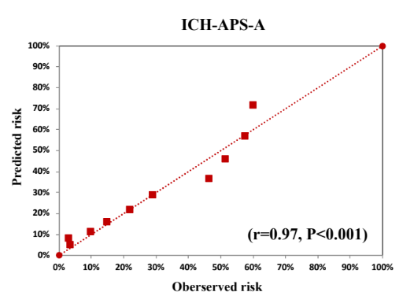 | 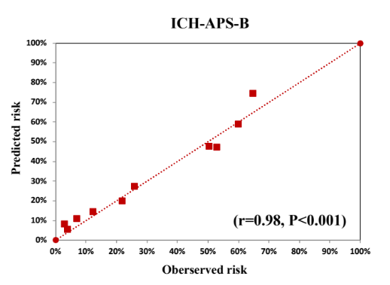
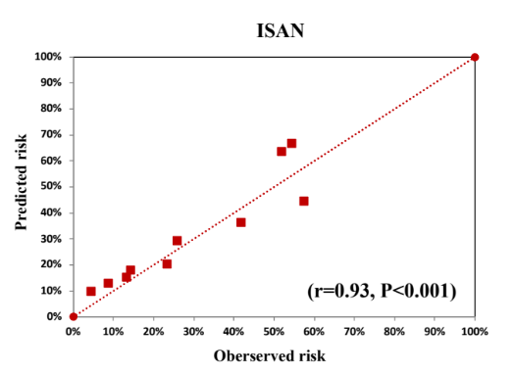 | 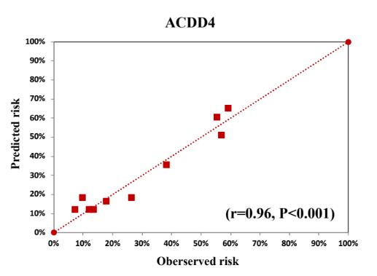
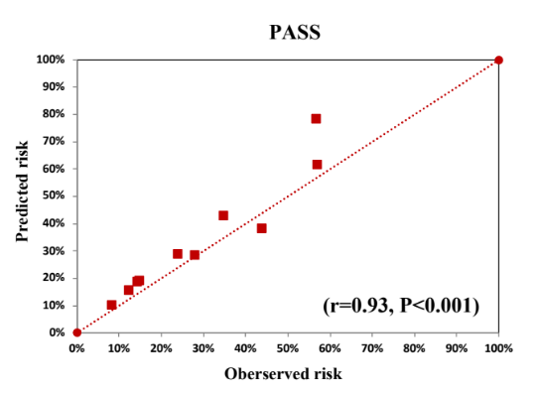
Figure legend: Plot of observed versus predicted risk of in-hospital SAP after ICH overall cohorts according to 10 deciles of predicted risk. All correlation coefficient of five models was greater than 0.90 (all P<0.001) , which indicated excellent calibration.. The ICH-SAP-B had the largest Pearson correlation coefficient (n=1964; r=0.98, P<0.001).

