LED-pump-X-ray-multiprobe crystallography for sub-second timescales
Extended Data

L. E. Hatcher,^{1,2} M. R. Warren,³ J. M. Skelton,^{1,4} A. R. Pallipurath,^{1,5} L. K. Saunders,³ D. R. Allan,³ P. Hathaway,³ G. Crevatin,³ D. Omar,³ B. H. Williams,³ C. C. Wilson¹ and P. R. Raithby¹*

¹ Department of Chemistry, University of Bath, Bath, UK.
² School of Chemistry, Cardiff University, Cardiff, UK.
³ Diamond Light Source, Harwell Science and Innovation Campus, Didcot, UK.
⁴ Department of Chemistry, University of Manchester, Manchester, UK.
⁵ School of Chemical and Process Engineering, University of Leeds, Leeds, UK.
* E-mail: p.r.raithby@bath.ac.uk

Section 1: Test crystal information

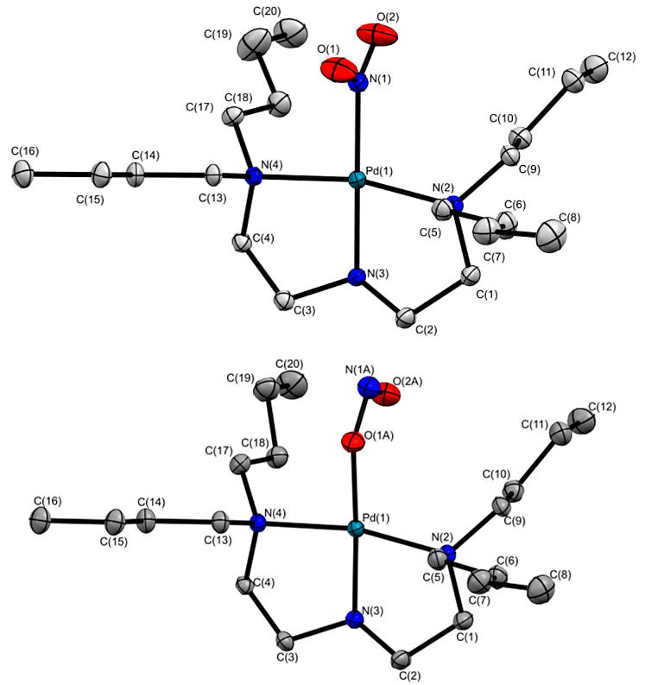
Figure S1 Crystal structures of the photoactive [Pd(Bu₄dien)(NO₂)]⁺ cation showing the ground-state nitro (η¹-NO₂; top) and excited state endo-nitrito (η¹-ONO; bottom) isomers.¹

Crystal data for GS of 1 at 100 K (100 % nitro-NO₂ isomer): C₄₈H₇₃B₁N₄O₃Pd₁ (M = 871.31 g mol⁻¹): monoclinic, space group P2₁/n (no. 14), a = 11.5457(4) Å, b = 13.4021(5) Å, c = 29.7173(12) Å, β = 95.335(4) °, V = 4578.4(3) Å³, Z = 4, T = 100(2) K, μ(MoK_{α}) = 0.451 mm⁻¹, $ρ$_{calc} = 1.264 g cm⁻³, 19,627 reflections measured (6.032° ≤ 2Θ ≤ 52.744°), 9,355 unique (R_{int} = 0.0459) used in solution and refinement. The final R₁ was 0.0428 (I > 2σ(I)) and wR₂ was 0.0863 (all data).¹

Crystal data for ES of 1 at 100 K (100 % nitrito-ONO isomer): C₄₈H₇₃B₁N₄O₃Pd₁ (M = 871.31 g/mol): monoclinic, space group P2₁/n (no. 14), a = 11.4775(4) Å, b = 13.3647(5) Å, c = 29.9849(8) Å, β = 94.569(3) °, V = 4584.9(3) Å³, Z = 4, T = 100(2) K, μ(MoK_{α}) = 0.448 mm⁻¹, $ρ$_{calc} = 1.262 g cm⁻³, 31,062 reflections measured (6.032° ≤ 2Θ ≤ 52.744°), 9,355 unique (R_{int} = 0.0661) used in solution and refinement. The final R₁ was 0.0428 (I > 2σ(I)) and wR₂ was 0.0901 (all data).¹

Section 2: Excitation Source

(i) LED sphere design and performance testing
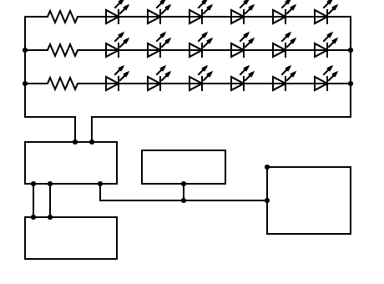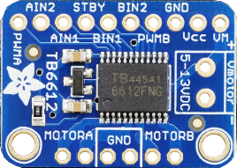
120 Ω
120 Ω
120 Ω
Function
Generator
TFG2
Oscilloscope
Adafruit driver
TB6612
Laboratory
Power Supply
TTL Signal
from TFG2
5V driver board
power supply

LED circuit
laboratory
power supply
(4.5 to 13.5 V)
Figure S2 LED sphere circuit. (a) Circuit wiring diagram for LED sphere with connections for time-resolved synchronisation. (b) Photograph of Adafruit TB16612 circuit board used to drive the LED sphere array with connections as marked.

(ii) LED sphere power test experiments
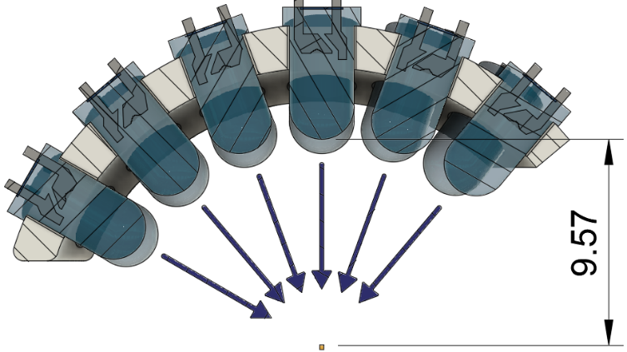
The power provided to the crystal during a typical pump-multiprobe data collection by the LED sphere set-up was recorded using a Thorlabs PM400 optical power meter equipped with a Thorlabs S401C with sensor head. The sensor was placed at the crystal position, at a distance of 9.57 cm from the LED sphere. Obstructing the sensor with a 100 um pin hole provided a sample test area similar to that of the single crystal samples used in pump-multiprobe experiments and gave a power measurement of 23 mW.

(iii) LED sphere array performance test experiments
The pulse separation of LED set-up was tested using an Osram SFH203P silicon pin photodiode (wavelength range 400-1100 nm, switching time 5 ns). The photodiode was placed at a distance of 9.57 cm from the LED array, simulating the position of the crystal during the pump-multiprobe data collection on the diffractometer, and connected to a Tektronix TDS3012B oscilloscope to measure its output. The LEDs were connected as described above, and a series of pulse widths and separations were tested. A reliable pulse separation was recorded down to a resolution of ~ 1 ms , and a rise time of c.a. 22 μs and fall time of c.a. 400 μs were observed (Figures S3(a) and S3(b), respectively).

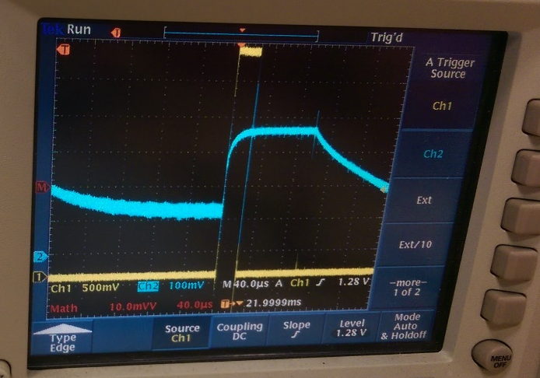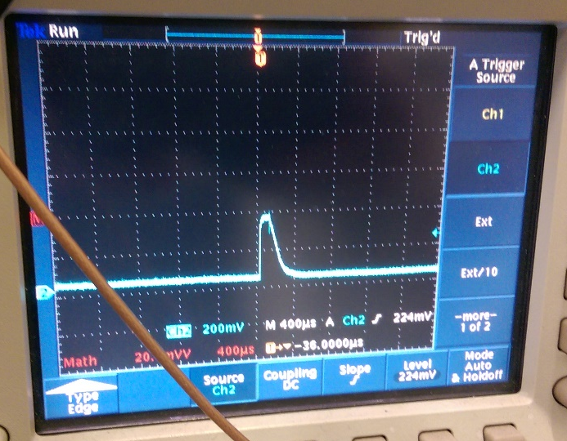
Figure S3 Photograph of the oscilloscope reading showing a pulse rise time of 22 μs (the x-axis displays the time, with 1 graduation = 40 μs). (b) Photograph of the oscilloscope reading confirming the pulse shape for the LED set-up and showing a fall time of approximately 200 μs (the x-axis displays the time, with 1 graduation = 400 μs).

Section 3: Sample excitation pre-experiments

(i) X-ray exposure tests
To test for X-ray damage and/or X-ray-induced excitation, crystals of 1 were exposed to the synchrotron X-ray beam at 150 K continuously for 25 mins while five standard single-crystal X-ray datasets were collected. As at this temperature, the thermal decay of the photo-induced nitrito-ONO isomer is negligible so the excited state is cryo-trapped and any build-up over time is thus easily identified by solving and refining a crystal structure from each of the five datasets. The synchrotron X-ray beam was attenuated to 25 % (X-ray test 1) and 5 % (X-ray test 2) of the available flux. The results of these two experiments are provided in Figure S4 and S5 respectively.
While we observed no appreciable crystal degradation in either experiment, both indicated a steady increase in the excited state conversion fraction, $∆α(t)$, with time, reaching a maximum of 2.5 and 10 % after 25 min with the 5 and 25 % beam intensity respectively. As a result of these preliminary investigations, we selected the lower 5 % beam intensity for the final pump-multiprobe experiments, as a compromise between obtaining sufficient signal-to-noise from short X-ray exposures and minimising undesirable X-ray induced excitation.

Figure S4 ES conversion fraction $α(t)$ as a function of extended X-ray exposure time, utilising 25 % of the synchrotron beam, showing the steady increase in X-ray induced excitation in 1 with prolonged X-ray exposure (max. 9.1 %).

Figure S5 ES conversion fraction $α(t)$ as a function of extended X-ray exposure time, utilising 5 % of the synchrotron beam, showing the steady increase in X-ray induced excitation in 1 with prolonged X-ray exposure (max. 2.5 %).

(ii) LED exposure tests
To assess the extent of any crystal degradation caused by light exposure, a crystal of 1 was mounted on the diffractometer and illuminated continuously using the LED sphere for a period of c.a. 4 h at 270 K. At this temperature the photoisomerisation process in 1 is reversible (i.e. the photo-excited state is not cryo-trapped), but continuous illumination produces a measurable steady-state population of the excited state corresponding to c.a. 20 % conversion. Complete single-crystal X-ray datasets were collected at regular intervals during the illumination period, utilising 5 % of the available synchrotron beam so as to minimise X-ray induced excitation. Structures were solved and refined by standard procedures, to determine the excited-state conversion fraction as a function of illumination time. The results are shown in Figure S6 below.
There is a gradual reduction in the steady-state $α(t)$ with increasing irradiation time, indicating that a gradual photobleaching process is occurring. After a total of 15,254 s (04:14:05) at the end of the test experiment, $α(t)$ had decreased by 6 %. This change was accompanied by a visible change in the crystal colour from pale yellow at the start of the experiment to mid orange by the end (Figure S7). These observations led us to select a new crystal for each pump-multiprobe data collection in order to minimise the effect of photobleaching in our measurements.

Figure S6 ES conversion fraction $α(t)$ in crystals of 1 as a function of extended LED irradiation time at 270 K, showing the gradual photobleaching with prolonged 400 nm pump light exposure

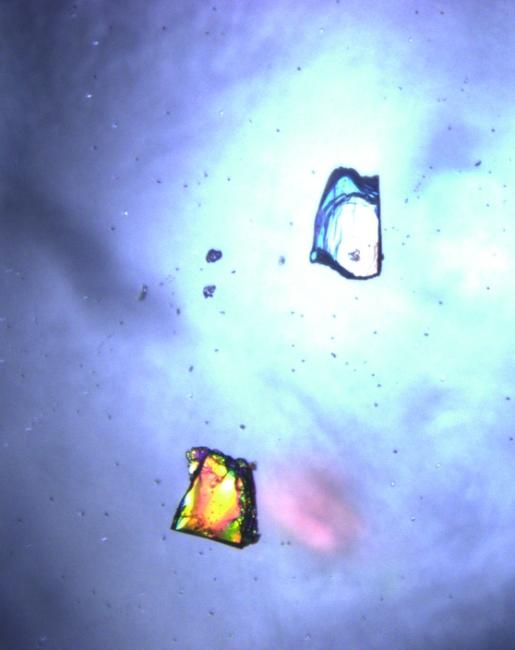
Figure S7 Microscope image of two crystals of 1 before (right) and after (left) illumination with 400 nm LEDs for c.a. 4 h at 270 K.

Section 4: Preliminary kinetic measurements, model parameterisation and numerical simulations

(i) Preliminary experiments
A series of preliminary X-ray photocrystallography experiments to investigate the excitation and decay kinetics in single-crystals of 1 were carried out following the procedures outlined in our previous work.² The excitation kinetics were measured at 150 K, where the excited state is cryo-trapped, and the decay kinetics were measured between 240 and 270 K. The results of these experiments are outlined in Tables S1-S11 below. In addition, a series of pseudo-steady-state photocrystallographic measurements were performed where a crystal was subject to continuous illumination while complete X-ray datasets were collected to measure the steady-state ES occupations $α_{SS}$ between 250 and 300 K. These data are summarised in Table S12.

Table S1 Excitation kinetic experiments on 1 performed at 150 K. Full single-crystal X-ray datasets were collected and refined at regular time intervals after a set cumulative excitation time to obtain values for the excitation state conversion fraction, $α(t)$, with respect to irradiation time $t$.
Excitation time [s] | Refined GS nitro-NO₂ occupancy | Refined ES nitrito-ONO occupancy (ES conversion fraction, $α(t)$)
1 | 0.97 | 0.03
2 | 0.95 | 0.05
4 | 0.93 | 0.07
8 | 0.88 | 0.12
16 | 0.79 | 0.21
32 | 0.62 | 0.38
64 | 0.36 | 0.64
128 | 0.13 | 0.87

Table S2 Decay kinetic experiments on 1 performed at 240 K. After complete excitation at 100 K, the temperature was raised to 240 K and a series of full single-crystal X-ray datasets were collected and refined at regular time intervals to obtain values for the excitation state conversion fraction, $α(t)$, with respect to decay time.
Decay time [s] | Refined GS nitro-NO₂ occupancy | Refined ES nitrito-ONO occupancy (ES conversion fraction, $α(t)$)
0.0 | 0.00 | 1.00
85 | 0.24 | 0.76
426 | 0.40 | 0.60
766 | 0.53 | 0.47
1106 | 0.64 | 0.36
1448 | 0.71 | 0.29

Table S3 Decay kinetic experiments on 1 performed at 242.5 K. After complete excitation at 100 K, the temperature was raised to 242.5 K and a series of full single-crystal X-ray datasets were collected and refined at regular time intervals to obtain values for the excitation state conversion fraction, $α(t)$, with respect to decay time.
Decay time [s] | Refined GS nitro-NO₂ occupancy | Refined ES nitrito-ONO occupancy (ES conversion fraction, $α(t)$)
0.0 | 0.00 | 1.00
139.0 | 0.30 | 0.70
599.0 | 0.61 | 0.39
1057.0 | 0.78 | 0.22
1515.0 | 0.86 | 0.14
1975.0 | 0.91 | 0.09

Table S4 Decay kinetic experiments on 1 performed at 245 K. After complete excitation at 100 K, the temperature was raised to 245 K and a series of full single-crystal X-ray datasets were collected and refined at regular time intervals to obtain values for the excitation state conversion fraction, $α(t)$, with respect to decay time.
Decay time [s] | Refined GS nitro-NO₂ occupancy | Refined ES nitrito-ONO occupancy (ES conversion fraction, $α(t)$)
0.0 | 0.00 | 1.00
85.0 | 0.26 | 0.74
426.0 | 0.56 | 0.44
767.0 | 0.75 | 0.25
1108.0 | 0.85 | 0.15
1449.0 | 0.91 | 0.09

Table S5 Decay kinetic experiments on 1 performed at 247.5 K. After complete excitation at 100 K, the temperature was raised to 247.5 K and a series of full single-crystal X-ray datasets were collected and refined at regular time intervals to obtain values for the excitation state conversion fraction, $α(t)$, with respect to decay time.
Decay time [s] | Refined GS nitro-NO₂ occupancy | Refined ES nitrito-ONO occupancy (ES conversion fraction, $α(t)$)
0.0 | 0.00 | 1.00
139.0 | 0.44 | 0.56
599.0 | 0.81 | 0.19
1058.0 | 0.93 | 0.07
1517.0 | 0.95 | 0.05
1976.0 | 0.96 | 0.04

Table S6 Decay kinetic experiments on 1 performed at 250 K. After complete excitation at 100 K, the temperature was raised to 250 K and a series of full single-crystal X-ray datasets were collected and refined at regular time intervals to obtain values for the excitation state conversion fraction, $α(t)$, with respect to decay time.
Decay time [s] | Refined GS nitro-NO₂ occupancy | Refined ES nitrito-ONO occupancy (ES conversion fraction, $α(t)$)
0.0 | 0.00 | 1.00
85.0 | 0.54 | 0.46
425.0 | 0.83 | 0.17
765.0 | 0.92 | 0.08
1106.0 | 0.94 | 0.06
1447.0 | 0.96 | 0.04

Table S7 Decay kinetic experiments on 1 performed at 252.5 K. After complete excitation at 100 K, the temperature was raised to 252.5 K and a series of full single-crystal X-ray datasets were collected and refined at regular time intervals to obtain values for the excitation state conversion fraction, $α(t)$, with respect to decay time.
Decay time [s] | Refined GS nitro-NO₂ occupancy | Refined ES nitrito-ONO occupancy (ES conversion fraction, $α(t)$)
0.0 | 0.00 | 1.00
139.0 | 0.50 | 0.50
597.0 | 0.94 | 0.06
1056.0 | 0.97 | 0.03
1516.0 | 0.97 | 0.03
1975.0 | 0.96 | 0.04

Table S8 Decay kinetic experiments on 1 performed at 255 K. After complete excitation at 100 K, the temperature was raised to 255 K and a series of full single-crystal X-ray datasets were collected and refined at regular time intervals to obtain values for the excitation state conversion fraction, $α(t)$, with respect to decay time.
Decay time [s] | Refined GS nitro-NO₂ occupancy | Refined ES nitrito-ONO occupancy (ES conversion fraction, $α(t)$)
0.0 | 0.00 | 1.00
85.0 | 0.61 | 0.39
427.0 | 0.94 | 0.06
767.0 | 0.97 | 0.03
1109.0 | 0.96 | 0.04
1450.0 | 0.97 | 0.03

Table S9 Decay kinetic experiments on 1 performed at 257.5 K. After complete excitation at 100 K, the temperature was raised to 257.5 K and a series of full single-crystal X-ray datasets were collected and refined at regular time intervals to obtain values for the excitation state conversion fraction, $α(t)$, with respect to decay time.
Decay time [s] | Refined GS nitro-NO₂ occupancy | Refined ES nitrito-ONO occupancy (ES conversion fraction, $α(t)$)
0.0 | 0.00 | 1.00
138.0 | 0.85 | 0.15
598.0 | 0.96 | 0.04
1058.0 | 0.97 | 0.03
1516.0 | 0.97 | 0.03
1976.0 | 0.97 | 0.03

Table S10 Decay kinetic experiments on 1 performed at 260 K. After complete excitation at 100 K, the temperature was raised to 260 K and a series of full single-crystal X-ray datasets were collected and refined at regular time intervals to obtain values for the excitation state conversion fraction, $α(t)$, with respect to decay time.
Decay time [s] | Refined GS nitro-NO₂ occupancy | Refined ES nitrito-ONO occupancy (ES conversion fraction, $α(t)$)
0.0 | 0.00 | 1.00
85.0 | 0.88 | 0.12
426.0 | 0.96 | 0.04
767.0 | 0.96 | 0.04
1107.0 | 0.96 | 0.04
1448.0 | 0.95 | 0.05

Table S11 Decay kinetic experiments on 1 performed at 270 K. After complete excitation at 100 K, the temperature was raised to 270 K and a series of full single-crystal X-ray datasets were collected and refined at regular time intervals to obtain values for the excitation state conversion fraction, $α(t)$, with respect to decay time.
Decay time [s] | Refined GS nitro-NO₂ occupancy | Refined ES nitrito-ONO occupancy (ES conversion fraction, $α(t)$)
0.0 | 0.00 | 1.00
85.0 | 0.95 | 0.05
425.0 | 0.95 | 0.05
765.0 | 0.95 | 0.05
1106.0 | 0.95 | 0.05
1448.0 | 0.95 | 0.05

Table S12 Pseudo-steady-state photocrystallographic measurements performed on 1 between 250 and 300 K. A crystal of 1 was continuously illuminated and a series of full single-crystal X-ray datasets were collected at several temperature intervals between 250 and 300 K. The data were refined to obtain values for the steady-state conversion fraction to the excited state with respect to temperature, $α_{SS}(T)$.
Temperature [K] | Refined GS nitro-NO₂ occupancy | Refined ES nitrito-ONO occupancy (ES conversion fraction, $α_{SS}(T)$)
250 | 0.16 | 0.84
260 | 0.25 | 0.75
270 | 0.58 | 0.42
272 | 0.68 | 0.32
274 | 0.73 | 0.27
276 | 0.78 | 0.22
278 | 0.80 | 0.20
280 | 0.84 | 0.16
290 | 0.91 | 0.09
300 | 0.93 | 0.07

(ii) Kinetic model parameterisation and numerical simulations

The kinetic measurements in Tables S1-S11 were fitted to the Johnson-Mehl-Avrami-Kohnogorov (JMAK) kinetic model:³⁻⁵

$$α\left(t\right)=α_{∞}+\left(α_{0}-α_{∞}\right)exp\left[-kt^{n}\right]$$

where $α\left(t\right)$ is the time-dependent population of the excited state, $α_{0}$ and $α_{∞}$ are the initial and final ES populations, $k$ is the rate constant, and n is the Avrami exponent. $n$ is related to the dimensionality $D$ of the transformation as $D=n-1$. For linkage-isomer systems it is accepted that the isomerisation is non-cooperative and occurs homogenously throughout the crystal bulk, and thus it is common practice to fix $n$ = 1, which we do here.² Figures S8 and S9 show the JMAK fits to the excitation and decay measurements in Tables S1 and S2-S11, respectively, and the fit parameters are collected in Table S13.

The decay rate constant $k_{dec}$ is strongly temperature dependent, and this temperature dependence is usually well described by the Arrhenius law:

$$k\left(T\right)=Aexp\left[-{E_{A}}/{RT}\right]$$

$$\ln\left[k\left(T\right)\right]=-\frac{E_{A}}{R}\frac{1}{T}$$

where $E_{A}$ is the activation energy and the pre-exponential factor $A$ can be roughly equated to an attempt frequency. An analysis of the decay rates in Table S13 using the linearised Arrhenius equation is shown in Figure S10 and yields an activation energy $E_{A}$ of 74.2 kJ mol⁻¹ and an attempt frequency $lnA$ of 30.6, which are both in line with our previous kinetic study on this system.²
Using the excitation rate constant, which is assumed to be independent of temperature, and the Arrhenius parameterisation of the decay rate, it is possible to set up a numerical simulation to predict the time evolution of the ES population, $α(t)$, under different conditions.² We assume that the excitation and decay processes are independent over a short time interval $∆t$, which we choose such that the change in $α$, $∆α$, is < 10⁻⁴, and use the appropriate JMAK equations to update the populations for the following timestep.
These simulations can be used to predict the $α$ reached at photostationary equilibrium under continuous illumination at a given temperature, or to predict the dynamic behaviour during a simulated pump-probe cycle. (In the latter case, we run sufficient simulated cycles for the populations at the start/end of the cycle to stabilise, which typically takes 2-3 cycles.)
Using these numerical simulations, we first refine our initial excitation rate and Arrhenius parameterisation against the measured pseudo-steady-state ES population as a function of temperature (Table S12, Figure S11). The refinement was performed in two stages: first, the excitation rate constant $k_{exc}$ was refined, and second, $k_{exc}$ and the Arrhenius parameters for the decay rate were refined. The final model parameters are listed in Table S14.
With this parameterisation, we then performed for each of the pump-probe cycle times $t_{cyc}$, viz. 170, 108, 35, 22 and 14 s, a series of simulations in which the excitation time $t_{exc}$ and temperature $T$ were varied in order to estimate the maximum and minimum ES populations, $α_{min}$ and $α_{max}$, at $t = 0$ and $t = t_{exc}$, and hence the difference $∆α=α_{max}-α_{min}$. The results of these simulations are shown in Figures S12-S16.
For each $t_{cyc}$ selected, the model predicts the optimum $t_{exc}$, $t_{dec}$ and $T$ subject to two conditions: (1) complete ES decay between sequential cycles; and (2) maximising the difference $∆α$ between the start of the cycle at $t = 0$ and the end of the excitation period at $t = t_{exc}$. These are tabulated in Table S15. In general, the trade-off here is that measuring at a lower temperature and allowing for incomplete decay between pump-probe cycles allows for a larger $∆α$, which is mainly due to the exponential nature of the decay process.² However, it is generally desirable to have complete decay so that at least one of the X-ray datasets is a clean ground-state structure to use as a reference point for e.g. generating photo-difference maps.
The excitation rate $k_{exc}$ depends very strongly on the crystal size and morphology,² so these parameters are only a rough guide. In practice, we found that the two predictions provided a good guide to the optimum $t_{exc}$ and $t_{dec}$ and a window of temperatures. Using these, we were able to select pump-multiprobe cycle timings and rapidly optimise the measurement temperature through experimentation while collecting datasets.

Table S13 Kinetic parameters obtained by fitting the experimental data in Tables S1-S11 to the Johnson-Mehl-Avrami-Kohnogorov (JMAK) model: $α_{0}$ - initial excited-state occupation; $α_{∞}$ final ES occupation; $k$ - rate constant; n - Avrami exponent; RMS - root-mean-square fitting error.
Type | $T$ [K] | $α_{0}$ [%] | $α_{∞}$ [%] | $k$ [s^{-n}] | n | RMS [%]
Exc. | 150.0 | 1.19 | 100.0 | 1.54 $×$ 10⁻² | 1 | 0.98
Dec. | 240.0 | 93.6 | 24.2 | 1.62 $×$ 10⁻³ | 1 | 4.62
Dec. | 242.5 | 96.5 | 9.11 | 1.94 $×$ 10⁻³ | 1 | 3.15
Dec. | 245.0 | 95.5 | 6.60 | 2.16 $×$ 10⁻³ | 1 | 3.46
Dec. | 247.5 | 98.6 | 5.76 | 3.98 $×$ 10⁻³ | 1 | 2.52
Dec. | 250.0 | 99.6 | 8.21 | 1.00 $×$ 10⁻² | 1 | 3.66
Dec. | 252.5 | 100 | 2.93 | 5.27 $×$ 10⁻³ | 1 | 0.66
Dec. | 255.0 | 100 | 3.82 | 1.18 $×$ 10⁻² | 1 | 0.80
Dec. | 257.5 | 100 | 3.25 | 1.53 $×$ 10⁻² | 1 | 0.35
Dec. | 260.0 | 100 | 4.25 | 2.96 $×$ 10⁻² | 1 | 0.35

Table S14 Refined kinetic model parameters for the numerical simulations in Figures S12-S16 and Table S13: $k_{exc}$ - excitation rate constant; $E_{A}$/$lnA$ activation energy and pre-exponential factor for the Arrhenius parameterisation of the temperature-dependent decay rate constant $k_{dec}(T)$; $n$ - Avrami exponent for the excitation and decay processes.
Parameter | Value
$k_{exc}$ [s⁻¹] | 4.35 $×$ 10⁻²
$E_{A}$ [kJ mol⁻¹] | 74.3
$$lnA$$ | 30.4
$$n$$ | 1

Table S15 Predicted parameters for pump-multiprobe experiments with the five cycle times $t_{cyc}$ used in the experiments, viz. 170, 108, 35, 22 and 14 s, obtained from the numerical simulations in Figures S12-S16. For each cycle time, the optimised excitation and decay times, $t_{exc}$/$t_{dec}$, measurement temperature $T$, and the minimum and maximum excited-state population $α$ at $t = 0$ and $t = t_{exc}$ and the difference, $∆α$, are listed for two conditions: (1) complete excited-state decay between sequential cycles, and (2) maximum $∆α$.
$t_{cyc}$ [s] | $t_{exc}$ [s] | $t_{dec}$ [s] | $T$ [K] | $α\left(t=0\right)$ $[\%]$ | $$α\left(t=t_{exc}\right)$$  [%] | $∆α$ [%]
170 | 52.7 | 117.3 | 260.0 | 7.8 | 67.9 | 60.1
170 | 34.0 | 136.0 | 269.5 | 0.0 | 40.2 | 40.2
108 | 37.8 | 70.2 | 263.0 | 8.6 | 57.9 | 49.3
108 | 22.7 | 85.3 | 273.0 | 0.0 | 30.2 | 30.2
35 | 15.0 | 20.0 | 270.0 | 9.1 | 33.9 | 24.8
35 | 8.1 | 26.9 | 282.0 | 0.0 | 12.8 | 12.8
22 | 9.9 | 12.1 | 272.5 | 9.0 | 26.4 | 17.4
22 | 5.7 | 16.3 | 286.0 | 0.0 | 8.8 | 8.8
14 | 6.4 | 7.6 | 275.5 | 7.4 | 19.5 | 12.0
14 | 3.5 | 10.5 | 289.5 | 0.0 | 6.0 | 6.0

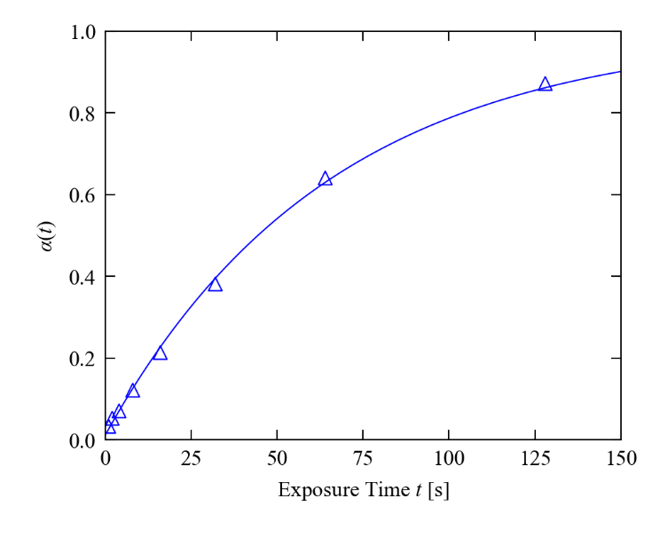
Figure S8 Johnson-Mehl-Avrami-Kohnogorov (JMAK) fit to the excitation kinetic data in Table S1. The markers show the experimental measurements and the solid line shows the fit. The fit parameters are listed in Table S14.

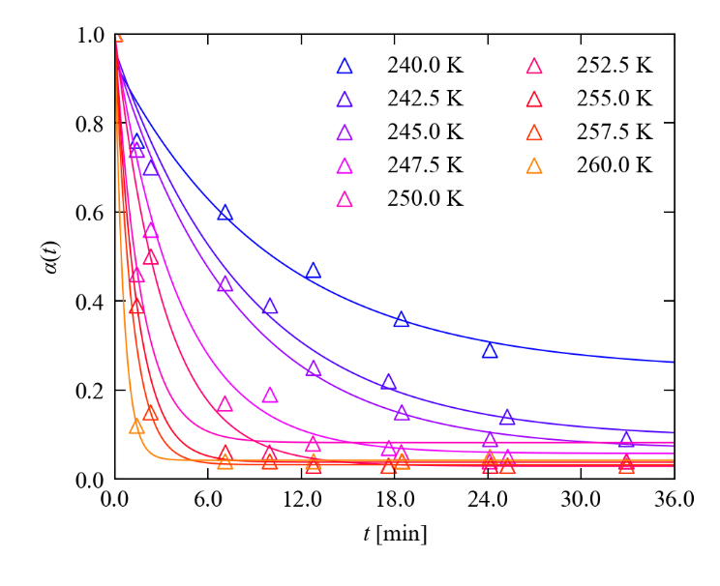
Figure S9 Johnson-Mehl-Avrami-Kohnogorov (JMAK) fit to the decay kinetic data in Tables S2-S11. The markers show the experimental measurements and the solid line shows the fit, and each set of data is coloured from blue (250 K) to yellow (260 K). Note that in the 270 K measurement the decay was too rapid to obtain a meaningful fit. The fit parameters are listed in Table S14.

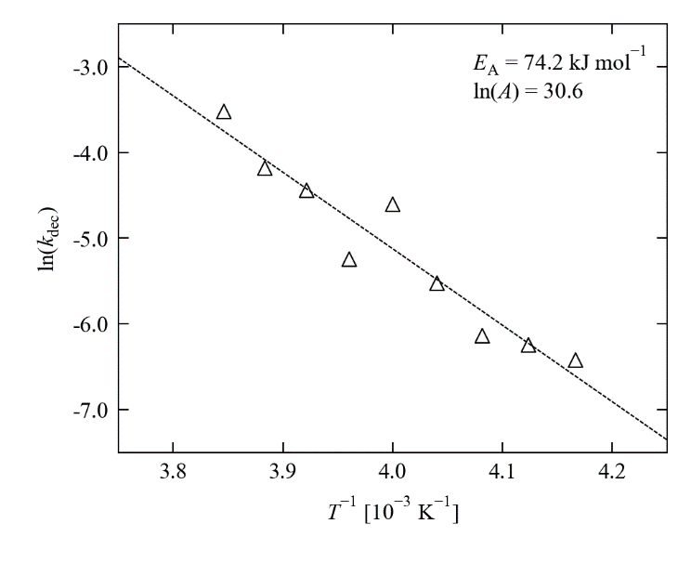
Figure S10 Arrhenius analysis of the temperature dependence of the decay rate constants in Table S13. The markers show the experimental data and the dashed line shows the fit to the linearised Arrhenius equation with the parameters indicated.

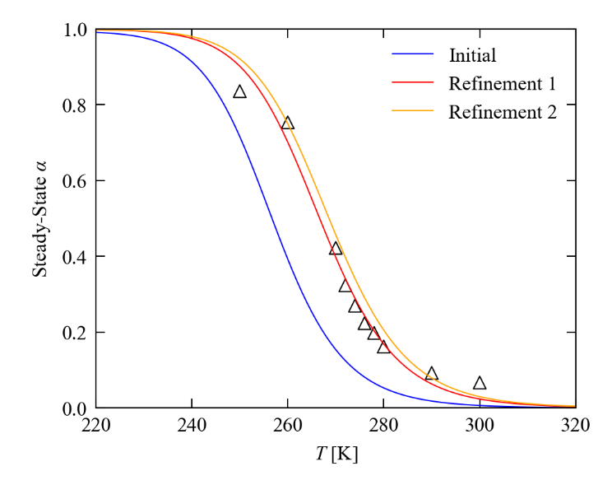
Figure S11 Refinement of the two-process JMAK model against the steady-state measurements in Table S12. The markers show the experimental measurements. The blue line shows the predicted temperature dependence of the steady-state excited-state population, $α_{SS}$, obtained using the excitation rate constant from the JMAK fit in Figure S8 and the Arrhenius parameters from the analysis in Figure S10. The red line shows the predicted dependence after refinement of the initial excitation rate constant ("Refinement 1"), and the yellow line shows the dependence after refinement of both the excitation rate and the Arrhenius parameters ("Refinement 2"). The final model parameters used to perform the initial numerical simulations of the pump-probe cycles are listed in Table S14.

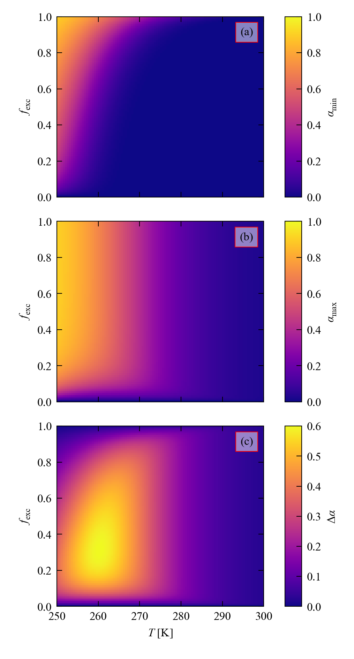
Figure S12 Numerical simulations to optimise the excitation and decay times, $t_{exc}$/$t_{dec}$, and measurement temperature $T$ for a fixed pump-probe cycle time of $t_{cyc}$ = 170 s. The kinetic parameters for the two-process JMAK model are listed in Table S14. (a) Minimum excited-state occupation, $α_{min}$, at $t = 0$, as a function of the fraction $f_{exc}$ of $t_{cyc}$ used for the excitation ($t_{exc}=f_{exc}×t_{cyc}$ and $t_{dec}=t_{cyc}-t_{exc}=(1-f_{exc})×t_{cyc}$). (b) Maximum ES occupation, $α_{max}$, at $t = t_{exc}$. (c) Difference $∆α=α_{max}-α_{min}$.

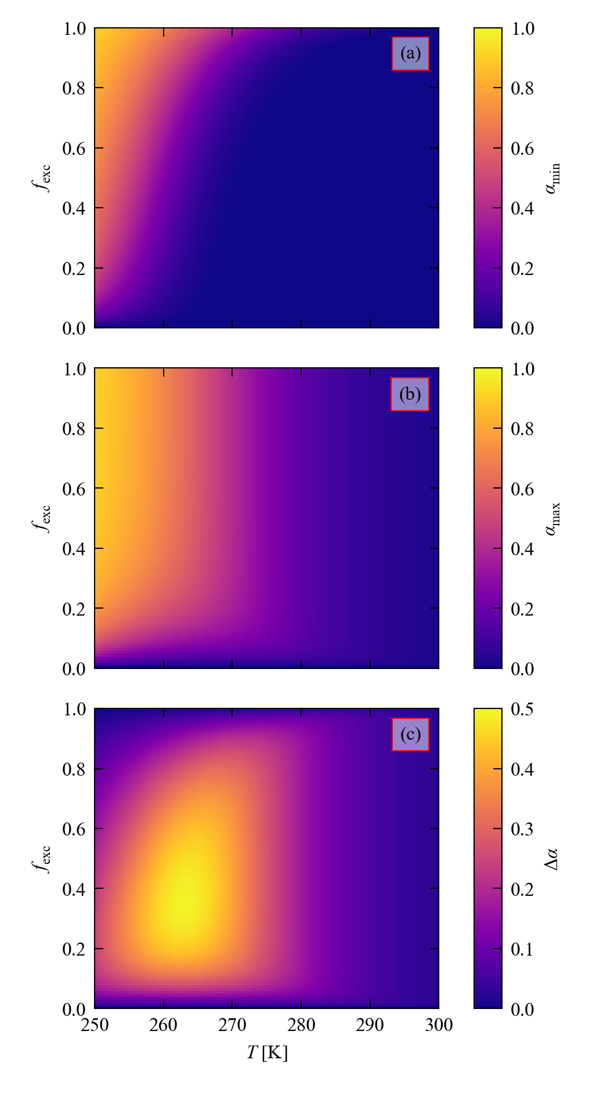
Figure S13 Numerical simulations to optimise the excitation and decay times, $t_{exc}$/$t_{dec}$, and measurement temperature $T$ for a fixed pump-probe cycle time of $t_{cyc}$ = 108 s. The kinetic parameters for the two-process JMAK model are listed in Table S14. (a) Minimum excited-state occupation, $α_{min}$, at $t = 0$, as a function of the fraction $f_{exc}$ of $t_{cyc}$ used for the excitation ($t_{exc}=f_{exc}×t_{cyc}$ and $t_{dec}=t_{cyc}-t_{exc}=(1-f_{exc})×t_{cyc}$). (b) Maximum ES occupation, $α_{max}$, at $t = t_{exc}$. (c) Difference $∆α=α_{max}-α_{min}$.

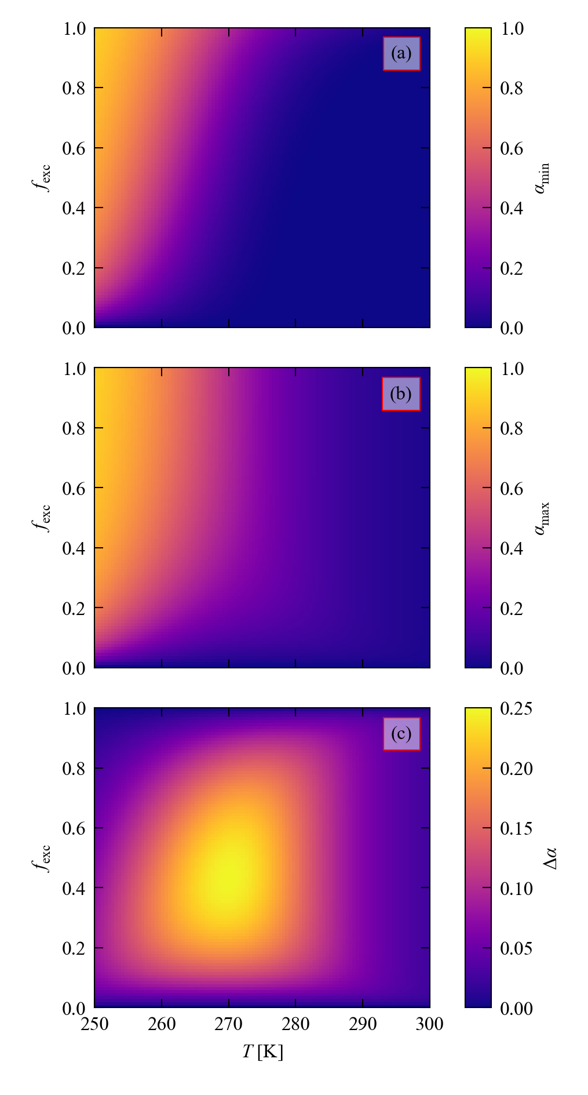
Figure S14 Numerical simulations to optimise the excitation and decay times, $t_{exc}$/$t_{dec}$, and measurement temperature $T$ for a fixed pump-probe cycle time of $t_{cyc}$ = 35 s. The kinetic parameters for the two-process JMAK model are listed in Table S14. (a) Minimum excited-state occupation, $α_{min}$, at $t = 0$, as a function of the fraction $f_{exc}$ of $t_{cyc}$ used for the excitation ($t_{exc}=f_{exc}×t_{cyc}$ and $t_{dec}=t_{cyc}-t_{exc}=(1-f_{exc})×t_{cyc}$). (b) Maximum ES occupation, $α_{max}$, at $t = t_{exc}$. (c) Difference $∆α=α_{max}-α_{min}$.

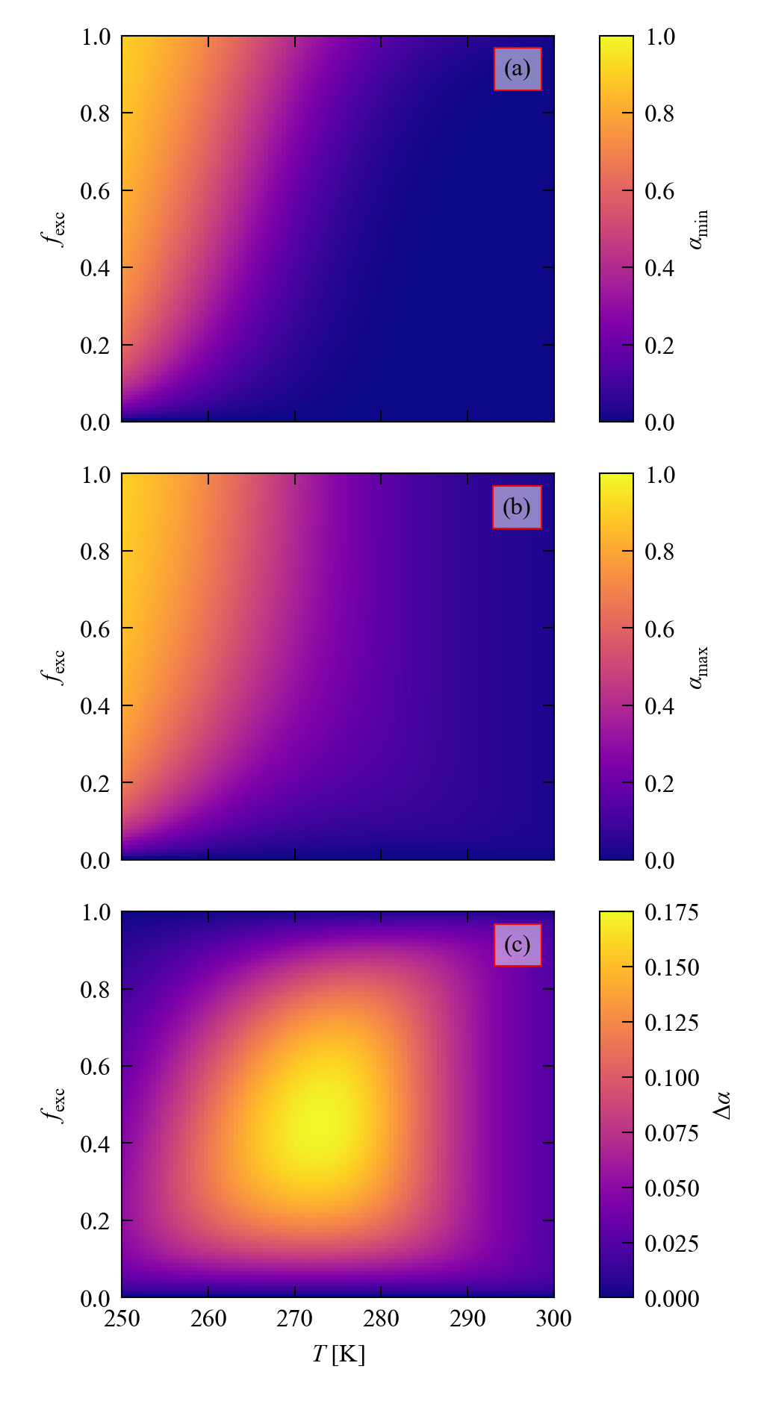
Figure S15 Numerical simulations to optimise the excitation and decay times, $t_{exc}$/$t_{dec}$, and measurement temperature $T$ for a fixed pump-probe cycle time of $t_{cyc}$ = 22 s. The kinetic parameters for the two-process JMAK model are listed in Table S14. (a) Minimum excited-state occupation, $α_{min}$, at $t = 0$, as a function of the fraction $f_{exc}$ of $t_{cyc}$ used for the excitation ($t_{exc}=f_{exc}×t_{cyc}$ and $t_{dec}=t_{cyc}-t_{exc}=(1-f_{exc})×t_{cyc}$). (b) Maximum ES occupation, $α_{max}$, at $t = t_{exc}$. (c) Difference $∆α=α_{max}-α_{min}$.

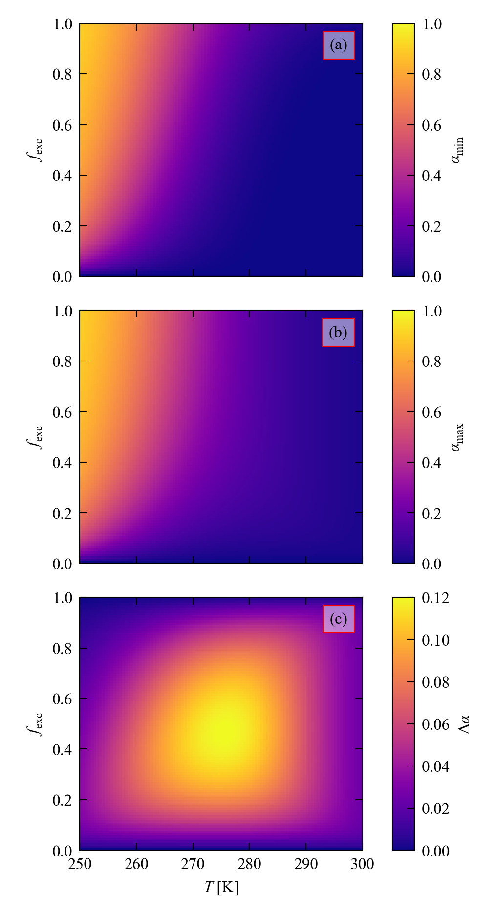
Figure S16 Numerical simulations to optimise the excitation and decay times, $t_{exc}$/$t_{dec}$, and measurement temperature $T$ for a fixed pump-probe cycle time of $t_{cyc}$ = 14 s. The kinetic parameters for the two-process JMAK model are listed in Table S14. (a) Minimum excited-state occupation, $α_{min}$, at $t = 0$, as a function of the fraction $f_{exc}$ of $t_{cyc}$ used for the excitation ($t_{exc}=f_{exc}×t_{cyc}$ and $t_{dec}=t_{cyc}-t_{exc}=(1-f_{exc})×t_{cyc}$). (b) Maximum ES occupation, $α_{max}$, at $t = t_{exc}$. (c) Difference $∆α=α_{max}-α_{min}$.

Section 5: Pump-multiprobe experimental data

Table S16 Summary of the 12 LED-pump-X-ray-probe datasets collected on 1. The maximum conversion percentages, $α_{max}$ or $α\left(t=t_{exc}\right),$ are the nitrito-(η¹-ONO) isomer occupancy achieved in each crystal after the irradiation period $t_{exc}$, and were determined from the single-crystal structure refinement. The variation in $α$ between experiments with identical $t_{exc}$ reflect the strong temperature dependence of the decay rate but also the large influence of the crystal size and shape on the photoconversion level. The shaded cells mark the experiments with the highest $α$ discussed in the text and used to generate molecular movies.
$t_{acq}$ [s] | Repeat | $T$ [K] | $t_{cyc}$ [s] | $t_{exc}$ [s] | $t_{dec}$ [s] | $α(t=t_{exc})$ [%]
8 | 1 | 260 | 170 | 55 | 115 | 21.0
8 | 2 | 265 | 170 | 55 | 115 | 33.7
8 | 3 | 270 | 170 | 55 | 115 | 16.5
4 | 1 | 265 | 108 | 35 | 73 | 21.3
4 | 2 | 270 | 108 | 35 | 73 | 18.8
4 | 3 | 272 | 108 | 35 | 73 | 21.3
4 | 4 | 274 | 108 | 35 | 73 | 20.7
1.6 | 1 | 280 | 35 | 14 | 21 | 10.7
0.8 | 1 | 280 | 22 | 8 | 14 | 11.8
0.4 | 1 | 282 | 14 | 5 | 9 | 8.7
0.4 | 2 | 283 | 14 | 5 | 9 | 10.4
0.4 | 3 | 284 | 14 | 5 | 9 | 8.0

Table S17 Single-crystal X-ray data for selected pump-multiprobe data collections. Crystal data for the structures with the highest and lowest excited-state population $α$ in each pump-multiprobe experiment are given. The average level of X-ray induced excitation across the experiments was ~ 4 %; where the lowest measured $α$ in each pair of entries are significantly above this level this implies the excited state had not fully decayed the selected during $t_{cyc}$.
$t_{acq}$ [s] | 8 | 8 | 8 | 8 | 8 | 8 | 4 | 4
Repeat | 3 | 3 | 2 | 2 | 1 | 1 | 1 | 1
$T$ [K] | 260 | 260 | 265 | 265 | 270 | 270 | 265 | 265
Experiment | 260K_8s_t5_excit | 260K_8s_t17_decay | 265K_8s_t5_excit | 265K_8s_t17_decay | 270K_8s_t5_excit | 270K_8s_t17_decay | 265K_4s_t6_excit | 265K_4s_t19_decay
$t_{exc}$ [s] | 55 | 55 | 55 | 55 | 55 | 55 | 35 | 35
ES conversion $α$ [%] | 21.0 | 9.1 | 33.7 | 5.1 | 16.5 | 3.3 | 21.3 | 7.3
Empirical formula | C₄₈H₇₃BN₄O₃Pd | C₄₈H₇₃BN₄O₃Pd | C₄₈H₇₃BN₄O₃Pd | C₄₈H₇₃BN₄O₃Pd | C₄₈H₇₃BN₄O₃Pd | C₄₈H₇₃BN₄O₃Pd | C₄₈H₇₃BN₄O₃Pd | C₄₈H₇₃BN₄O₃Pd
Formula weight [g mol⁻¹] | 871.31 | 871.31 | 871.31 | 871.31 | 871.31 | 871.31 | 871.31 | 871.31
Crystal system | monoclinic | monoclinic | monoclinic | monoclinic | monoclinic | monoclinic | monoclinic | monoclinic
Space group | P2₁/n | P2₁/n | P2₁/n | P2₁/n | P2₁/n | P2₁/n | P2₁/n | P2₁/n
a [Å] | 11.6748(6) | 11.6715(4) | 11.6547(3) | 11.6715(4) | 11.6667(3) | 11.6773(4) | 11.6550(4) | 11.6668(3)
b [Å] | 13.5924(7) | 13.5688(4) | 13.5866(4) | 13.5707(4) | 13.5838(4) | 13.5796(4) | 13.5702(4) | 13.5637(5)
c [Å] | 30.2436(15) | 30.2352(10) | 30.2126(8) | 30.1533(10) | 30.2270(9) | 30.2007(10) | 30.1920(9) | 30.1798(10)
$α$ [°] | 90 | 90 | 90 | 90 | 90 | 90 | 90 | 90
$β$ [°] | 93.022(5) | 93.267(3) | 93.407(3) | 93.711(3) | 93.269(3) | 93.408(3) | 93.362(3) | 93.535(3)
$γ$ [°] | 90 | 90 | 90 | 90 | 90 | 90 | 90 | 90
Volume [Å³] | 4792.6(4) | 4780.5(3) | 4775.6(2) | 4766.0(3) | 4782.5(2) | 4780.5(3) | 4767.0(3) | 4766.7(3)
Z | 4 | 4 | 4 | 4 | 4 | 4 | 4 | 4
$ρ_{calc}$ [g cm⁻³] | 1.208 | 1.211 | 1.212 | 1.214 | 1.210 | 1.211 | 1.214 | 1.214
$μ$ [mm⁻¹] | 0.201 | 0.202 | 0.202 | 0.202 | 0.201 | 0.202 | 0.202 | 0.202
F(000) | 1856.0 | 1856.0 | 1856.0 | 1856.0 | 1856.0 | 1856.0 | 1856.0 | 1856.0
Crystal size [mm³] | 0.1 × 0.1 × 0.05 | 0.1 × 0.1 × 0.05 | 0.1 × 0.1 × 0.05 | 0.1 × 0.1 × 0.05 | 0.1 × 0.1 × 0.05 | 0.1 × 0.1 × 0.05 | 0.1 × 0.1 × 0.05 | 0.1 × 0.1 × 0.05
Wavelength λ [Å] | 0.534 | 0.534 | 0.534 | 0.534 | 0.534 | 0.534 | 0.534 | 0.534
$2θ$ range [°] | 2.468 to 38.992 | 2.472 to 38.992 | 2.47 to 38.992 | 2.474 to 38.992 | 2.47 to 38.99 | 2.472 to 38.992 | 2.472 to 38.994 | 2.758 to 38.99
Reflections collected | 31360 | 34381 | 34211 | 34237 | 34353 | 34400 | 32582 | 32656
Independent reflections | 9653  [R_{int} = 0.0786, R_{sigma} = 0.1181] | 9740  [R_{int} = 0.0883, R_{sigma} = 0.1121] | 9727  [R_{int} = 0.0857, R_{sigma} = 0.1113] | 9700  [R_{int} = 0.1020, R_{sigma} = 0.1102] | 9742  [R_{int} = 0.0863, R_{sigma} = 0.1129] | 9737  [R_{int} = 0.0896, R_{sigma} = 0.1072] | 9716  [R_{int} = 0.0814, R_{sigma} = 0.1017] | 9718  [R_{int} = 0.0971, R_{sigma} = 0.1079]
Goodness of Fit on F² | 0.847 | 0.864 | 0.886 | 0.941 | 0.857 | 0.874 | 0.895 | 0.899
Final R indices $I≥2σ(I)$ | R₁ = 0.0576, wR₂ = 0.1227 | R₁ = 0.0576, wR₂ = 0.1235 | R₁ = 0.0563, wR₂ = 0.1120 | R₁ = 0.0596, wR₂ = 0.1218 | R₁ = 0.0571, wR₂ = 0.1200 | R₁ = 0.0581, wR₂ = 0.1258 | R₁ = 0.0543, wR₂ = 0.1188 | R₁ = 0.0560, wR₂ = 0.1215
Final R indices all data | R₁ = 0.1500, wR₂ = 0.1511 | R₁ = 0.1310, wR₂ = 0.1479 | R₁ = 0.1191, wR₂ = 0.1314 | R₁ = 0.1057, wR₂ = 0.1416 | R₁ = 0.1311, wR₂ = 0.1433 | R₁ = 0.1205, wR₂ = 0.1495 | R₁ = 0.1105, wR₂ = 0.1382 | R₁ = 0.0988, wR₂ = 0.1408
Largest diff. peak/hole | 0.31/-0.40 | 0.35/-0.31 | 0.46/-0.43 | 0.53/-0.53 | 0.35/-0.67 | 0.35/-0.62 | 0.49/-0.65 | 0.39/-0.65
Table S17 cont. Single-crystal X-ray data for selected pump-multiprobe data collections. Crystal data for the structures with the highest and lowest excited-state population $α$ in each pump-multiprobe experiment are given. The average level of X-ray induced excitation across the experiments was ~ 4 %; where the lowest measured $α$ in each pair of entries are significantly above this level this implies the excited state had not fully decayed during the selected $t_{cyc}$.
$t_{acq}$ [s] | 4 | 4 | 4 | 4 | 4 | 4 | 1.6 | 1.6
Repeat | 2 | 2 | 3 | 3 | 4 | 4 | 1 | 1
$T$ [K] | 270 | 270 | 272 | 272 | 274 | 274 | 280 | 280
Experiment | 270K_4s_t6_excit | 270K_4s_t19_decay | 272K_4s_t6_excit | 272K_4s_t19_decay | 274K_4s_t6_excit | 274K_4s_t19_decay | 280K_1.6s_t5_excit | 280K_1.6s_t13_decay
$t_{exc}$ [s] | 35 | 35 | 35 | 35 | 35 | 35 | 14 | 14
ES conversion, $α$ [%] | 18.8 | 3.2 | 21.3 | 4.2 | 20.7 | 3.8 | 10.7 | 2.5
Empirical formula | C₄₈H₇₃BN₄O₃Pd | C₄₈H₇₃BN₄O₃Pd | C₄₈H₇₃BN₄O₃Pd | C₄₈H₇₃BN₄O₃Pd | C₄₈H₇₃BN₄O₃Pd | C₄₈H₇₃BN₄O₃Pd | C₄₈H₇₃BN₄O₃Pd | C₄₈H₇₃BN₄O₃Pd
Formula weight [g mol⁻¹] | 871.31 | 871.31 | 871.31 | 871.31 | 871.31 | 871.31 | 871.31 | 871.31
Crystal system | monoclinic | monoclinic | monoclinic | monoclinic | monoclinic | monoclinic | monoclinic | monoclinic
Space group | P2₁/n | P2₁/n | P2₁/n | P2₁/n | P2₁/n | P2₁/n | P2₁/n | P2₁/n
a [Å] | 11.6864(4) | 11.6889(4) | 11.6632(4) | 11.6765(4) | 11.6703(5) | 11.6836(5) | 11.6850(4) | 11.6892(5)
b [Å] | 13.6030(4) | 13.5919(5) | 13.5810(4) | 13.5820(5) | 13.5825(5) | 13.5816(5) | 13.5977(5) | 13.5959(5)
c [Å] | 30.2776(10) | 30.2410(11) | 30.1872(10) | 30.1766(10) | 30.1953(11) | 30.1824(10) | 30.1995(10) | 30.1834(10)
$α$ [°] | 90 | 90 | 90 | 90 | 90 | 90 | 90 | 90
$β$ [°] | 93.416(3) | 93.595(3) | 93.304(3) | 93.521(3) | 93.343(3) | 93.541(3) | 93.262(3) | 93.352(3)
$γ$ [°] | 90 | 90 | 90 | 90 | 90 | 90 | 90 | 90
Volume [Å³] | 4804.7(3) | 4795.1(3) | 4773.6(3) | 4776.7(3) | 4778.2(3) | 4780.3(3) | 4790.6(3) | 4788.7(3)
Z | 4 | 4 | 4 | 4 | 4 | 4 | 4 | 4
$ρ_{calc}$ [g cm⁻³] | 1.205 | 1.207 | 1.212 | 1.212 | 1.211 | 1.211 | 1.208 | 1.209
$μ$ [mm⁻¹] | 0.201 | 0.201 | 0.202 | 0.202 | 0.202 | 0.202 | 0.201 | 0.201
F(000) | 1856.0 | 1856.0 | 1856.0 | 1856.0 | 1856.0 | 1856.0 | 1856.0 | 1856.0
Crystal size [mm³] | 0.1 × 0.1 × 0.05 | 0.1 × 0.1 × 0.05 | 0.1 × 0.1 × 0.05 | 0.1 × 0.1 × 0.05 | 0.1 × 0.1 × 0.05 | 0.1 × 0.1 × 0.05 | 0.1 × 0.1 × 0.05 | 0.1 × 0.1 × 0.05
Wavelength λ [Å] | 0.534 | 0.534 | 0.534 | 0.534 | 0.534 | 0.534 | 0.534 | 0.534
$2θ$ range [°] | 2.466 to 38.992 | 2.468 to 38.988 | 2.472 to 38.994 | 2.756 to 38.992 | 2.47 to 38.99 | 2.472 to 38.992 | 2.758 to 38.992 | 2.47 to 38.99
Reflections collected | 32734 | 32765 | 32772 | 32764 | 32550 | 32782 | 32888 | 32923
Independent reflections | 9775  [R_{int} = 0.0893, R_{sigma} = 0.1109] | 9761  [R_{int} = 0.0978, R_{sigma} = 0.1092] | 9681  [R_{int} = 0.1002, R_{sigma} = 0.1226] | 9676  [R_{int} = 0.1101, R_{sigma} = 0.1216] | 9741  [R_{int} = 0.1016, R_{sigma} = 0.1387] | 9738  [R_{int} = 0.1043, R_{sigma} = 0.1337] | 9603  [R_{int} = 0.0760, R_{sigma} = 0.0789] | 9599  [R_{int} = 0.0865, R_{sigma} = 0.0851]
Goodness of Fit on F² | 0.923 | 0.932 | 0.872 | 0.884 | 0.879 | 0.905 | 0.951 | 0.964
Final R indices $I≥2σ(I)$ | R₁ = 0.0551, wR₂ = 0.1142 | R₁ = 0.0569, wR₂ = 0.1211 | R₁ = 0.0605, wR₂ = 0.1320 | R₁ = 0.0611, wR₂ = 0.1269 | R₁ = 0.0606, wR₂ = 0.1200 | R₁ = 0.0596, wR₂ = 0.1177 | R₁ = 0.0539, wR₂ = 0.1207 | R₁ = 0.0552, wR₂ = 0.1263
Final R indices all data | R₁ = 0.1022, wR₂ = 0.1290 | R₁ = 0.0956, wR₂ = 0.1365 | R₁ = 0.1254, wR₂ = 0.1587 | R₁ = 0.1120, wR₂ = 0.1495 | R₁ = 0.1348, wR₂ = 0.1436 | R₁ = 0.1199, wR₂ = 0.1376 | R₁ = 0.0946, wR₂ = 0.1381 | R₁ = 0.0922, wR₂ = 0.1452
Largest diff. peak/hole | 0.33/-0.38 | 0.44/-0.42 | 0.48/-0.56 | 0.45/-0.54 | 0.42/-0.47 | 0.45/-0.41 | 0.43/-0.55 | 0.42/-0.60
Table S17 cont. Single-crystal X-ray data for selected pump-multiprobe data collections. Crystal data for the structures with the highest and lowest excited-state population $α$ in each pump-multiprobe experiment are given. The average level of X-ray induced excitation across the experiments was ~ 4 %; where the lowest measured $α$ in each pair of entries are significantly above this level this implies the excited state had not fully decayed during the selected $t_{cyc}$.
$t_{acq}$ [s] | 0.8 | 0.8 | 0.4 | 0.4 | 0.4 | 0.4 | 0.4 | 0.4
Repeat | 1 | 1 | 1 | 1 | 2 | 2 | 3 | 3
$T$ [K] | 280 | 280 | 282 | 282 | 283 | 283 | 284 | 284
Experiment | 280K_0.8s_t4_excit | 280K_0.8s_t11_decay | 282K_0.4s_t3_excit | 282K_0.4s_t9_decay | 283K_0.4s_t3_excit | 283K_0.4s_t9_decay | 284K_0.4s_t3_excit | 284K_0.4s_t9_decay
$t_{exc}$ [s] | 8 | 8 | 5 | 5 | 5 | 5 | 5 | 5
ES conversion, $α$ [%] | 11.8 | 4.4 | 8.7 | 3.6 | 10.4 | 3.4 | 8.0 | 3.8
Empirical formula | C₄₈H₇₃BN₄O₃Pd | C₄₈H₇₃BN₄O₃Pd | C₄₈H₇₃BN₄O₃Pd | C₄₈H₇₃BN₄O₃Pd | C₄₈H₇₃BN₄O₃Pd | C₄₈H₇₃BN₄O₃Pd | C₄₈H₇₃BN₄O₃Pd | C₄₈H₇₃BN₄O₃Pd
Formula weight [g mol⁻¹] | 871.31 | 871.31 | 871.31 | 871.31 | 871.31 | 871.31 | 871.31 | 871.31
Crystal system | monoclinic | monoclinic | monoclinic | monoclinic | monoclinic | monoclinic | monoclinic | monoclinic
Space group | P2₁/n | P2₁/n | P2₁/n | P2₁/n | P2₁/n | P2₁/n | P2₁/n | P2₁/n
a [Å] | 11.6799(4) | 11.6820(4) | 11.6826(7) | 11.6899(7) | 11.6995(5) | 11.6997(5) | 11.6885(5) | 11.6922(5)
b [Å] | 13.5938(5) | 13.5896(6) | 13.6088(7) | 13.6071(8) | 13.6308(5) | 13.6253(6) | 13.6052(7) | 13.6069(7)
c [Å] | 30.2110(10) | 30.1948(11) | 30.2346(15) | 30.2249(16) | 30.2963(12) | 30.2831(13) | 30.1939(12) | 30.1903(12)
$α$ [°] | 90 | 90 | 90 | 90 | 90 | 90 | 90 | 90
$β$ [°] | 93.319(3) | 93.408(3) | 93.228(5) | 93.276(5) | 93.208(4) | 93.260(4) | 93.246(4) | 93.272(4)
$γ$ [°] | 90 | 90 | 90 | 90 | 90 | 90 | 90 | 90
Volume [Å³] | 4788.7(3) | 4785.1(3) | 4799.3(4) | 4799.9(5) | 4823.9(3) | 4819.7(4) | 4793.9(4) | 4795.3(4)
Z | 4 | 4 | 4 | 4 | 4 | 4 | 4 | 4
$ρ_{calc}$ [g cm⁻³] | 1.209 | 1.209 | 1.206 | 1.206 | 1.200 | 1.201 | 1.207 | 1.207
$μ$ [mm⁻¹] | 0.201 | 0.201 | 0.201 | 0.201 | 0.200 | 0.200 | 0.201 | 0.201
F(000) | 1856.0 | 1856.0 | 1856.0 | 1856.0 | 1856.0 | 1856.0 | 1856.0 | 1856.0
Crystal size [mm³] | 0.1 × 0.1 × 0.05 | 0.1 × 0.1 × 0.05 | 0.1 × 0.1 × 0.05 | 0.1 × 0.1 × 0.05 | 0.1 × 0.1 × 0.05 | 0.1 × 0.1 × 0.05 | 0.1 × 0.1 × 0.05 | 0.1 × 0.1 × 0.05
Wavelength λ [Å] | 0.534 | 0.534 | 0.534 | 0.534 | 0.534 | 0.534 | 0.534 | 0.534
$2θ$ range [°] | 2.758 to 38.99 | 2.756 to 38.994 | 2.466 to 38.99 | 2.466 to 38.992 | 2.462 to 38.99 | 2.754 to 38.992 | 2.468 to 38.992 | 2.756 to 38.992
Reflections collected | 27786 | 27789 | 32702 | 32735 | 32844 | 32834 | 32732 | 32753
Independent reflections | 9400  [R_{int} = 0.0797, R_{sigma} = 0.1039] | 9394  [R_{int} = 0.0937, R_{sigma} = 0.1113] | 9721  [R_{int} = 0.0910, R_{sigma} = 0.1072] | 9726  [R_{int} = 0.0974, R_{sigma} = 0.1075] | 9783  [R_{int} = 0.0906, R_{sigma} = 0.1059] | 9778  [R_{int} = 0.0912, R_{sigma} = 0.1017] | 9616  [R_{int} = 0.0916, R_{sigma} = 0.0917] | 9615  [R_{int} = 0.0968, R_{sigma} = 0.0948]
Goodness of Fit on F² | 0.923 | 0.940 | 0.876 | 0.881 | 0.884 | 0.886 | 0.965 | 0.962
Final R indices $I≥2σ(I)$ | R₁ = 0.0584, wR₂ = 0.1167 | R₁ = 0.0623, wR₂ = 0.1283 | R₁ = 0.0567, wR₂ = 0.1152 | R₁ = 0.0573, wR₂ = 0.1181 | R₁ = 0.0609, wR₂ = 0.1345 | R₁ = 0.0599, wR₂ = 0.1310 | R₁ = 0.0628, wR₂ = 0.1415 | R₁ = 0.0627, wR₂ = 0.1412
Final R indices all data | R₁ = 0.1096, wR₂ = 0.1350 | R₁ = 0.1087, wR₂ = 0.1503 | R₁ = 0.1158, wR₂ = 0.1338 | R₁ = 0.1126, wR₂ = 0.1383 | R₁ = 0.1305, wR₂ = 0.1637 | R₁ = 0.1209, wR₂ = 0.1567 | R₁ = 0.1129, wR₂ = 0.1709 | R₁ = 0.1120, wR₂ = 0.1703
Largest diff. peak/hole | 0.36/-0.46 | 0.46/-0.49 | 0.34/-0.45 | 0.38/-0.39 | 0.60/-0.62 | 0.52/-0.48 | 0.44/-0.62 | 0.39/-0.55

Section 6: Pump-multiprobe data fitting

The pump-multiprobe datasets were analysed by fitting the excited-state populations as a function of time, $α(t)$, using numerical simulations based on a two-process JMAK model as described in Section 4 above. We also account for the small background excitation $α_{bg}$ as a fit parameter. For each dataset, we first estimate a decay rate constant $k_{dec}$ based on the Arrhenius parameterisation in Table S14, together with an $α_{bg}$ from the data, and use the excitation data ($t ≤ t_{exc}$) to fit an approximate excitation rate $k_{exc}$. We then refine all three parameters freely against the complete $α(t)$. This allows us to determine for each experiment an excitation and decay rate and a background excitation $α_{bg}$. (The Avrami exponents for the excitation and decay are both assumed to be unity.) The fit parameters for each of the experiments carried out in this work are listed in Table S18.
This fit also allows us to determine a maximum excitation level at $t= t_{exc}$ after accounting for any background excitation. It is of interest to compare this to the theoretical steady-state excitation level $α_{SS}$ that could be achieved with the fitted kinetic parameters - this comparison is shown in Table S19.

Table S18 Kinetic parameters obtained by fitting the excited-state populations as a function of $α(t)$ measured in each of the pump-multiprobe experiments on 1 carried out in this work: $α_{bg}$ - background ES population; $k_{exc}$ = excitation rate constant; $k_{dec}$ - decay rate constant; RMS - root-mean-square error on the fit. The data fits are shown in Figures S17-S28.
$t_{cyc}$ [s] | $t_{exc}$ [s] | $t_{dec}$ [s] | $T$ [K] | $α_{bg}$ [%] | $k_{exc}$ [s⁻¹] | $k_{dec}$ [s⁻¹] | RMS [%]
170 | 55 | 115 | 260 | 5.98 | 4.63 $×$ 10⁻³ | 1.43 $×$ 10⁻² | 0.43
170 | 55 | 115 | 265 | 3.25 | 1.57 $×$ 10⁻² | 2.74 $×$ 10⁻² | 0.45
170 | 55 | 115 | 270 | 3.71 | 8.34 $×$ 10⁻³ | 4.94 $×$ 10⁻² | 0.48
108 | 35 | 73 | 265 | 4.80 | 8.79 $×$ 10⁻³ | 2.65 $×$ 10⁻² | 0.57
108 | 35 | 73 | 270 | 2.30 | 1.19 $×$ 10⁻² | 4.70 $×$ 10⁻² | 0.35
108 | 35 | 73 | 272 | 3.97 | 1.56 $×$ 10⁻² | 6.44 $×$ 10⁻² | 0.62
108 | 35 | 73 | 274 | 3.84 | 1.78 $×$ 10⁻² | 7.86 $×$ 10⁻² | 0.43
35 | 14 | 21 | 280 | 2.95 | 2.12 $×$ 10⁻² | 2.38 $×$ 10⁻¹ | 0.30
22 | 8 | 14 | 280 | 2.73 | 2.38 $×$ 10⁻² | 1.83 $×$ 10⁻¹ | 0.44
14 | 5 | 9 | 282 | 1.31 | 2.17 $×$ 10⁻² | 1.77 $×$ 10⁻¹ | 0.41
14 | 5 | 9 | 283 | 0.45 | 3.24 $×$ 10⁻² | 1.68 $×$ 10⁻¹ | 0.39
14 | 5 | 9 | 284 | 2.71 | 1.94 $×$ 10⁻² | 2.42 $×$ 10⁻¹ | 0.57

Table S19 Maximum excited-state population $α_{max}$ obtained in each of the pump-multiprobe experiments on 1 listed in Table S16 based on the data fits shown in Figures S17-S28. Also shown are the predicted maximum steady-state populations attainable under continuous illumination using the same kinetic parameters, $α_{SS}$, and the ratios ${α_{max}}/{α_{SS}}$ as a percentage. Note that here $α_{max}$ refers to the maximum conversion determined after data fitting, and may differ from the largest measured ES populations ($α(t=t_{exc})$ in Tables S16 / S17) due mainly to the subtraction of the fitted background ES population $α_{bg}$.
$t_{cyc}$ [s] | $t_{exc}$ [s] | $t_{dec}$ [s] | $T$ [K] | $α_{max}$ [%] | $α_{SS}$ [%] | Ratio [%]
170 | 55 | 115 | 260 | 17.0 | 24.0 | 70.8
170 | 55 | 115 | 265 | 33.2 | 36.2 | 91.7
170 | 55 | 115 | 270 | 13.8 | 14.3 | 96.5
108 | 35 | 73 | 265 | 18.4 | 24.6 | 74.8
108 | 35 | 73 | 270 | 17.7 | 20.0 | 88.5
108 | 35 | 73 | 272 | 18.3 | 19.3 | 94.8
108 | 35 | 73 | 274 | 17.8 | 18.4 | 96.7
35 | 14 | 21 | 280 | 8.00 | 8.20 | 97.6
22 | 8 | 14 | 280 | 9.40 | 11.5 | 81.7
14 | 5 | 9 | 282 | 7.40 | 10.9 | 67.9
14 | 5 | 9 | 283 | 11.1 | 16.1 | 68.9
14 | 5 | 9 | 284 | 5.60 | 7.40 | 75.7

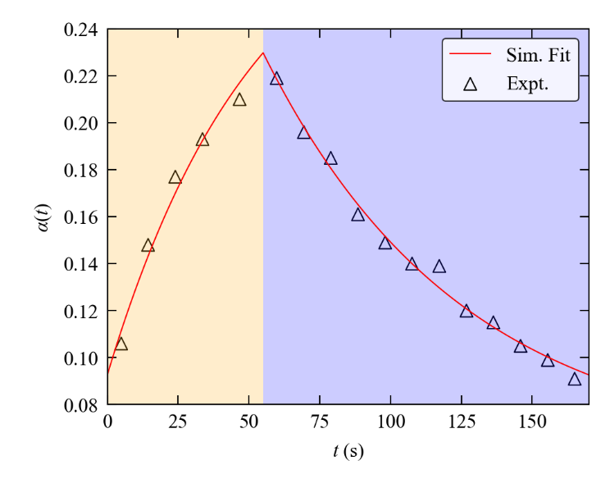
Figure S17 Data fitting for the pump-multiprobe experiment with 1 using the parameters $t_{cyc}$ = 170 s, $t_{exc}$ = 55 s, $t_{dec}$ = 115 s and $T$ = 260 K. The markers show the ES population as a function of time $α(t)$ obtained by solving and refining single-crystal structures from the pump-multiprobe diffraction datasets. The solid line shows the $α(t)$ predicted by numerical simulations using a two-process JMAK model with the fitted kinetic parameters listed in Table S18. The shaded yellow and blue regions of the plot mark the excitation and decay phases of the pump-multiprobe cycle, respectively.

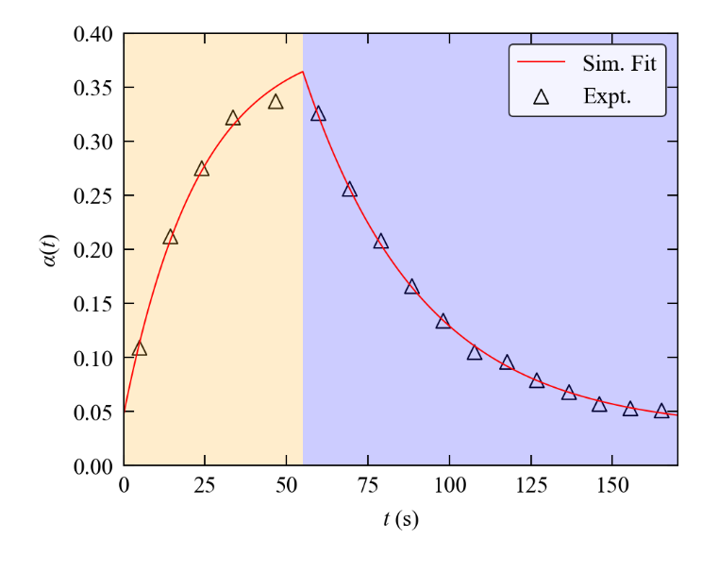
Figure S18 Data fitting for the pump-multiprobe experiment with 1 using the parameters $t_{cyc}$ = 170 s, $t_{exc}$ = 55 s, $t_{dec}$ = 115 s and $T$ = 265 K. The markers show the ES population as a function of time $α(t)$ obtained by solving and refining single-crystal structures from the pump-multiprobe diffraction datasets. The solid line shows the $α(t)$ predicted by numerical simulations using a two-process JMAK model with the fitted kinetic parameters listed in Table S18. The shaded yellow and blue regions of the plot mark the excitation and decay phases of the pump-multiprobe cycle, respectively.

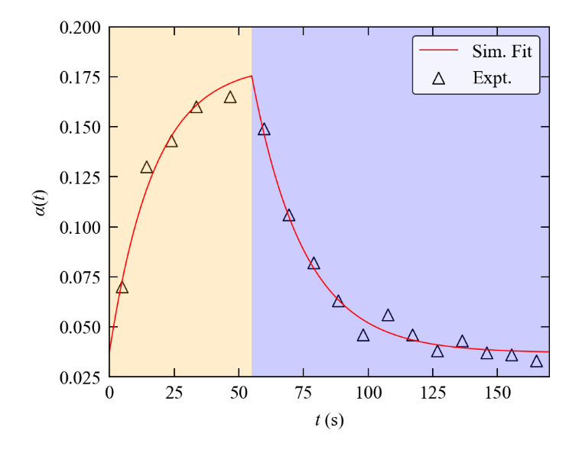
Figure S19 Data fitting for the pump-multiprobe experiment with 1 using the parameters $t_{cyc}$ = 170 s, $t_{exc}$ = 55 s, $t_{dec}$ = 115 s and $T$ = 270 K. The markers show the ES population as a function of time $α(t)$ obtained by solving and refining single-crystal structures from the pump-multiprobe diffraction datasets. The solid line shows the $α(t)$ predicted by numerical simulations using a two-process JMAK model with the fitted kinetic parameters listed in Table S18. The shaded yellow and blue regions of the plot mark the excitation and decay phases of the pump-multiprobe cycle, respectively.

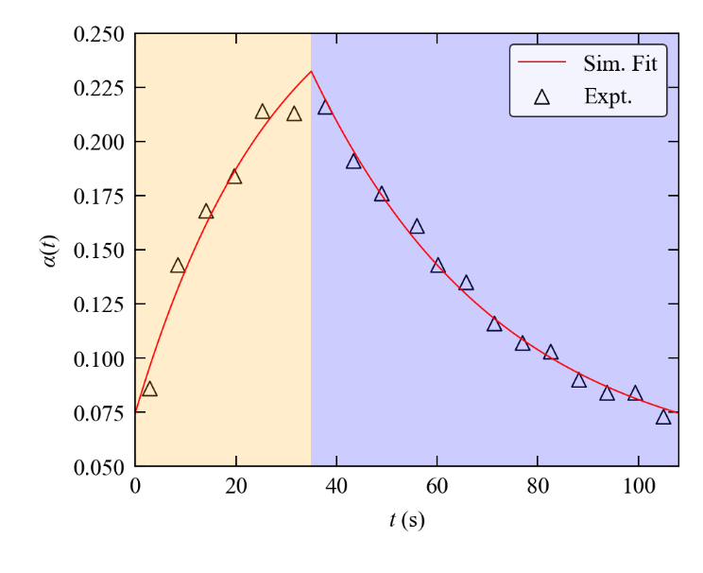
Figure S20 Data fitting for the pump-multiprobe experiment with 1 using the parameters $t_{cyc}$ = 108 s, $t_{exc}$ = 35 s, $t_{dec}$ = 73 s and $T$ = 265 K. The markers show the ES population as a function of time $α(t)$ obtained by solving and refining single-crystal structures from the pump-multiprobe diffraction datasets. The solid line shows the $α(t)$ predicted by numerical simulations using a two-process JMAK model with the fitted kinetic parameters listed in Table S18. The shaded yellow and blue regions of the plot mark the excitation and decay phases of the pump-multiprobe cycle, respectively.

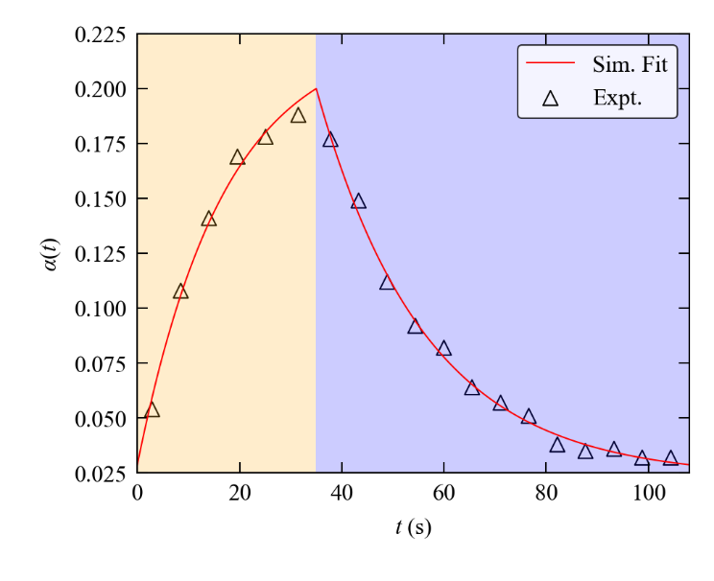
Figure S21 Data fitting for the pump-multiprobe experiment with 1 using the parameters $t_{cyc}$ = 108 s, $t_{exc}$ = 35 s, $t_{dec}$ = 73 s and $T$ = 270 K. The markers show the ES population as a function of time $α(t)$ obtained by solving and refining single-crystal structures from the pump-multiprobe diffraction datasets. The solid line shows the $α(t)$ predicted by numerical simulations using a two-process JMAK model with the fitted kinetic parameters listed in Table S18. The shaded yellow and blue regions of the plot mark the excitation and decay phases of the pump-multiprobe cycle, respectively.

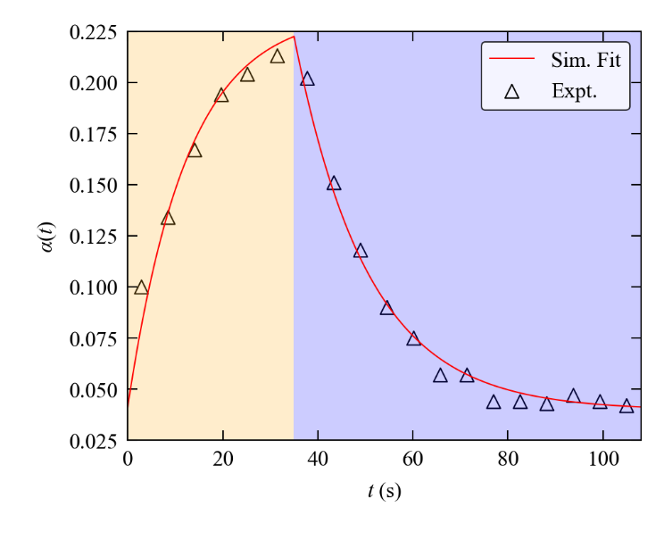
Figure S22 Data fitting for the pump-multiprobe experiment with 1 using the parameters $t_{cyc}$ = 108 s, $t_{exc}$ = 35 s, $t_{dec}$ = 73 s and $T$ = 272 K. The markers show the ES population as a function of time $α(t)$ obtained by solving and refining single-crystal structures from the pump-multiprobe diffraction datasets. The solid line shows the $α(t)$ predicted by numerical simulations using a two-process JMAK model with the fitted kinetic parameters listed in Table S18. The shaded yellow and blue regions of the plot mark the excitation and decay phases of the pump-multiprobe cycle, respectively.

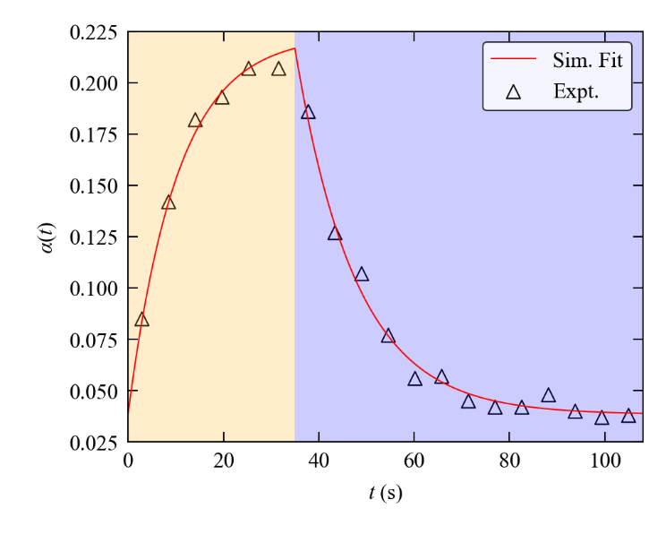
Figure S23 Data fitting for the pump-multiprobe experiment with 1 using the parameters $t_{cyc}$ = 108 s, $t_{exc}$ = 35 s, $t_{dec}$ = 73 s and $T$ = 274 K. The markers show the ES population as a function of time $α(t)$ obtained by solving and refining single-crystal structures from the pump-multiprobe diffraction datasets. The solid line shows the $α(t)$ predicted by numerical simulations using a two-process JMAK model with the fitted kinetic parameters listed in Table S18. The shaded yellow and blue regions of the plot mark the excitation and decay phases of the pump-multiprobe cycle, respectively.

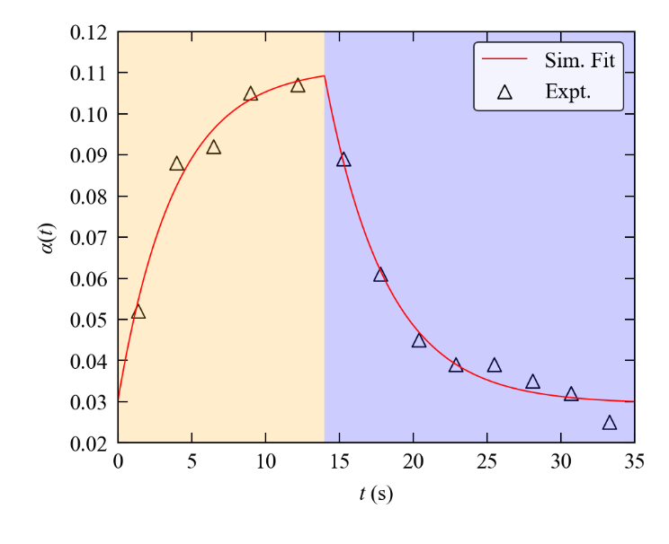
Figure S24 Data fitting for the pump-multiprobe experiment with 1 using the parameters $t_{cyc}$ = 35 s, $t_{exc}$ = 14 s, $t_{dec}$ = 21 s and $T$ = 280 K. The markers show the ES population as a function of time $α(t)$ obtained by solving and refining single-crystal structures from the pump-multiprobe diffraction datasets. The solid line shows the $α(t)$ predicted by numerical simulations using a two-process JMAK model with the fitted kinetic parameters listed in Table S18. The shaded yellow and blue regions of the plot mark the excitation and decay phases of the pump-multiprobe cycle, respectively.

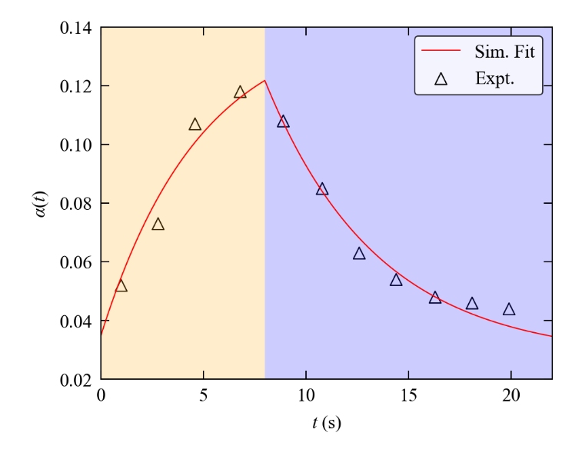
Figure S25 Data fitting for the pump-multiprobe experiment with 1 using the parameters $t_{cyc}$ = 22 s, $t_{exc}$ = 8 s, $t_{dec}$ = 14 s and $T$ = 280 K. The markers show the ES population as a function of time $α(t)$ obtained by solving and refining single-crystal structures from the pump-multiprobe diffraction datasets. The solid line shows the $α(t)$ predicted by numerical simulations using a two-process JMAK model with the fitted kinetic parameters listed in Table S18. The shaded yellow and blue regions of the plot mark the excitation and decay phases of the pump-multiprobe cycle, respectively.

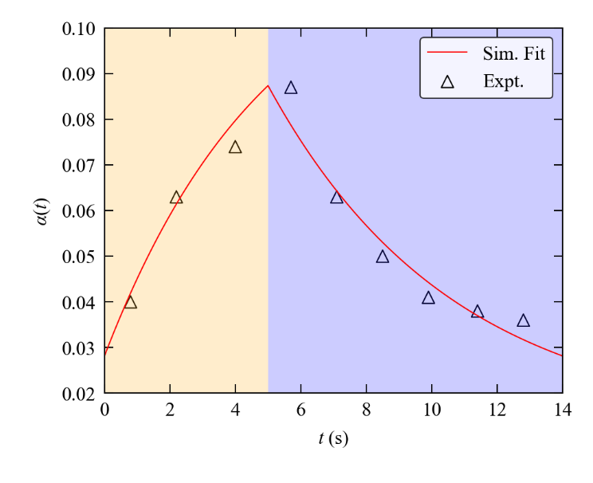
Figure S26 Data fitting for the pump-multiprobe experiment with 1 using the parameters $t_{cyc}$ = 14 s, $t_{exc}$ = 5 s, $t_{dec}$ = 9 s and $T$ = 282 K. The markers show the ES population as a function of time $α(t)$ obtained by solving and refining single-crystal structures from the pump-multiprobe diffraction datasets. The solid line shows the $α(t)$ predicted by numerical simulations using a two-process JMAK model with the fitted kinetic parameters listed in Table S18. The shaded yellow and blue regions of the plot mark the excitation and decay phases of the pump-multiprobe cycle, respectively.

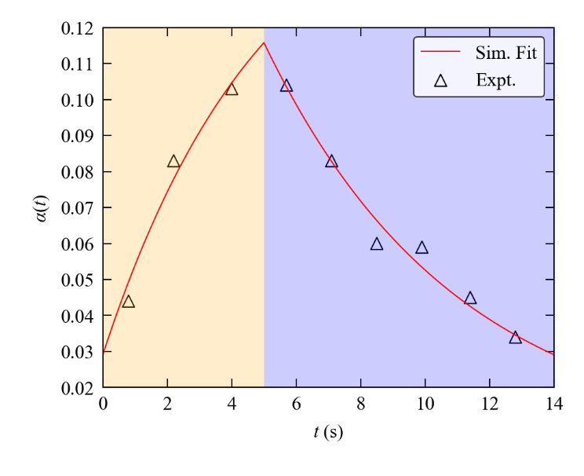
Figure S27 Data fitting for the pump-multiprobe experiment with 1 using the parameters $t_{cyc}$ = 14 s, $t_{exc}$ = 5 s, $t_{dec}$ = 9 s and $T$ = 283 K. The markers show the ES population as a function of time $α(t)$ obtained by solving and refining single-crystal structures from the pump-multiprobe diffraction datasets. The solid line shows the $α(t)$ predicted by numerical simulations using a two-process JMAK model with the fitted kinetic parameters listed in Table S18. The shaded yellow and blue regions of the plot mark the excitation and decay phases of the pump-multiprobe cycle, respectively.

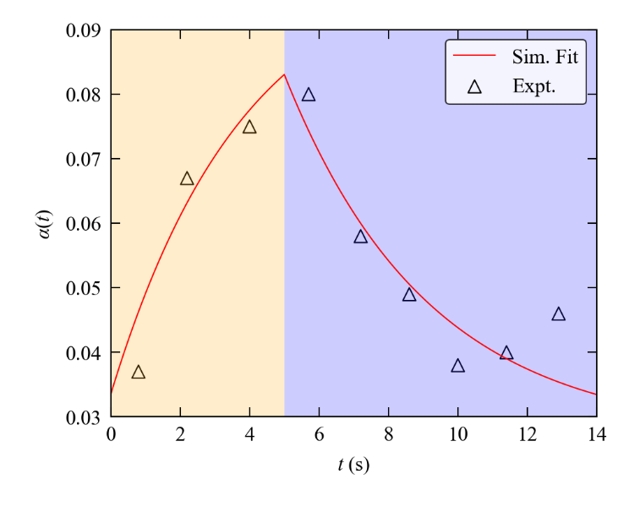
Figure S28 Data fitting for the pump-multiprobe experiment with 1 using the parameters $t_{cyc}$ = 14 s, $t_{exc}$ = 5 s, $t_{dec}$ = 9 s and $T$ = 284 K. The markers show the ES population as a function of time $α(t)$ obtained by solving and refining single-crystal structures from the pump-multiprobe diffraction datasets. The solid line shows the $α(t)$ predicted by numerical simulations using a two-process JMAK model with the fitted kinetic parameters listed in Table S18. The shaded yellow and blue regions of the plot mark the excitation and decay phases of the pump-multiprobe cycle, respectively.

Section 7: Time-resolved molecular movies

Molecular movies generated for the pump-multiprobe experiments with the largest maximum excited-state populations, under each of the timing regimes tested, are provided as follows.
- 8s_Animation.gif - molecular movie for the experiment at $t_{acq}$ = 8 s
- 4s_Animation.gif - molecular movie for the experiment at $t_{acq}$ = 4 s
- 1-6s_Animation.gif - molecular movie for the experiment at $t_{acq}$ = 1.6 s
- 0-8s_Animation.gif - molecular movie for the experiment at $t_{acq}$ = 0.8 s
- 0-4s_Animation.gif - molecular movie for the experiment at $t_{acq}$ = 0.4 s

Section 8: Supplementary Methods

(i) Pump-multiprobe synchronisation

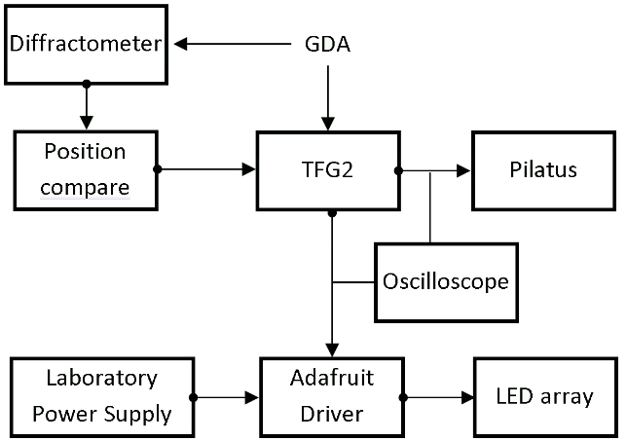

Figure S29 Schematic diagram outlining the communication connections between the diffractometer, LED pump array, Pilatus detector, TFG2 function generator and GDA software to enable the timing synchronisation in the pump-multiprobe experiments.

(ii) Timepix experiments

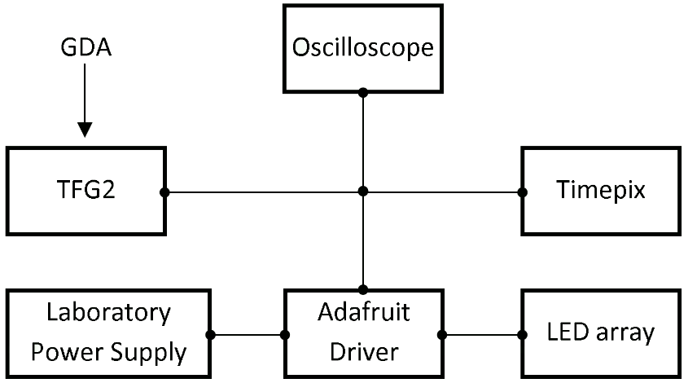

Figure S30 Schematic diagram outlining the communication connections between the diffractometer, LED pump array, Timepix3 detector, TFG2 function generator and GDA software to enable the timing synchronisation in the Timepix experiments.

References

1. Hatcher, L.E. Raising the (metastable) bar: 100% photo-switching in [Pd(Bu4dien)(η¹-NO₂)]⁺ approaches ambient temperature. CrystEngComm 18, 4180-4187 (2016).
2. Hatcher, L.E. et al. Monitoring photo-induced population dynamics in metastable linkage isomer crystals: a crystallographic kinetic study of [Pd(Bu₄dien)NO₂]BPh₄. Phys. Chem. Chem. Phys. 20, 5874-5886 (2018).
3. Avrami, M. Kinetics of Phase Change. III. Granulation, Phase Change, and Microstructure. J. Chem. Phys. 9, 177-184 (1941).
4. Avrami, M. Kinetics of Phase Change. II. Transformation-Time Relations for Random Distribution of Nuclei. J. Chem. Phys. 8, 212-224 (1940).
5. Avrami, M. Kinetics of Phase Change. I. General Theory. J. Chem. Phys. 7, 1103-1112 (1939).

