Supplementary Material

Supplementary Tables
Table S1 Characterization of datasets used in this study
Dataset | Normal | NSCLC | Stage | T | N | M | Smoking | Survival data
TCGA_LUAD | 59 | 515 | Y | Y | Y | Y | Y | Y
TCGA_LUSC | 51 | 502 | Y | Y | Y | Y | Y | Y
GSE41271 | 0 | 275 | Y | N | N | N | Y | Y
GSE30219 | 0 | 293 | N | Y | Y | Y | N | Y
GSE32665 | 92 | 87 | N | N | N | N | N | N
GSE19188 | 65 | 91 | N | N | N | N | N | N
LUAD: lung adenocarcinoma; LUSC: Squamous cell carcinoma; TCGA: The Cancer Gene Atlas; T: Invasion depth; N: Lymph node metastasis; M: Distant metastasis

Table S2 Primers used in this study
Primer name | Primer sequence 5′ to 3′
F_YTHDC2 | CAAAACATGCTGTTAGGAGCCT
R_YTHDC2 | CCACTTGTCTTGCTCATTTCCC
F_CDH1 | CGAGAGCTACACGTTCACGG
R_CDH1 | GGGTGTCGAGGGAAAAATAGG
F_CDH2 | AGCCAACCTTAACTGAGGAGT
R_CDH2 | GGCAAGTTGATTGGAGGGATG
F_GAPDH | CTGGGCTACACTGAGCACC
R_GAPDH | AAGTGGTCGTTGAGGGCAATG

Table S3 Clinical-pathological analysis of copy number values in lung cancer
Factor |  | LUAD |  | LUSC
 |  | Case | Copy Number | Case | Copy Number
Gender
 | Male | 235 | -0.104±0.307 | 369 | -0.306±0.235
 | Female | 274 | -0.053±0.307 | 129 | -0.298±0.254
Age
 | <60 | 135 | -0.106±0.266 | 90 | -0.341±0.223
 | ≥60 | 355 | -0.065±0.326 | 399 | -0.294±0.243
Invasion depth
 | T1 | 168 | 0.279±0.022 | 292 | 0.232±0.014
 | T2 | 276 | 0.327±0.020 | 71 | 0.232±0.028
 | T3 | 44 | 0.278±0.042 | 23 | 0.268±0.056
 | T4 | 19 | 0.336±0.077 | 498 | 0.240±0.011
Lymph node metastasis
 | N0 | 327 | 0.321±0.018 | 316 | 0.244±0.014
 | N1 | 95 | 0.312±0.032 | 131 | 0.244±0.021
 | N2 | 74 | 0.248±0.029 | 40 | 0.201±0.032
 | N3 | 2 | 0.265±0.188 | 5 | 0.234±0.105
Distant metastasis
 | M0 | 344 | -0.081±0.291 | 408 | -0.300±0.242
 | M1 | 25 | -0.097±0.270 | 7 | -0.468±0.186
Pathological stage
 | I | 273 | 0.319±0.019 | 242 | 0.250±0.016
 | II | 121 | 0.307±0.028 | 161 | 0.236±0.019
 | III | 83 | 0.271±0.030 | 84 | 0.221±0.024
 | IV | 25 | 0.270±0.054 | 7 | 0.186±0.070
LUAD: lung adenocarcinoma; LUSC: Squamous cell carcinoma;

Supplementary Figures
Figure S1. The gene expression profile across all tumor samples (T) and normal tissues (N) (dot plot). Each dot represents expression level of samples. Red dots represent tumor samples and green dots represent normal tissues. Cancer names in black indicates that there is no significant difference between tumor and normal tissues; whereas, cancer names in red or green indicate that YTHDC2 expression either was significantly increased or decreased in tumor tissues compared with normal tissues, respectively.

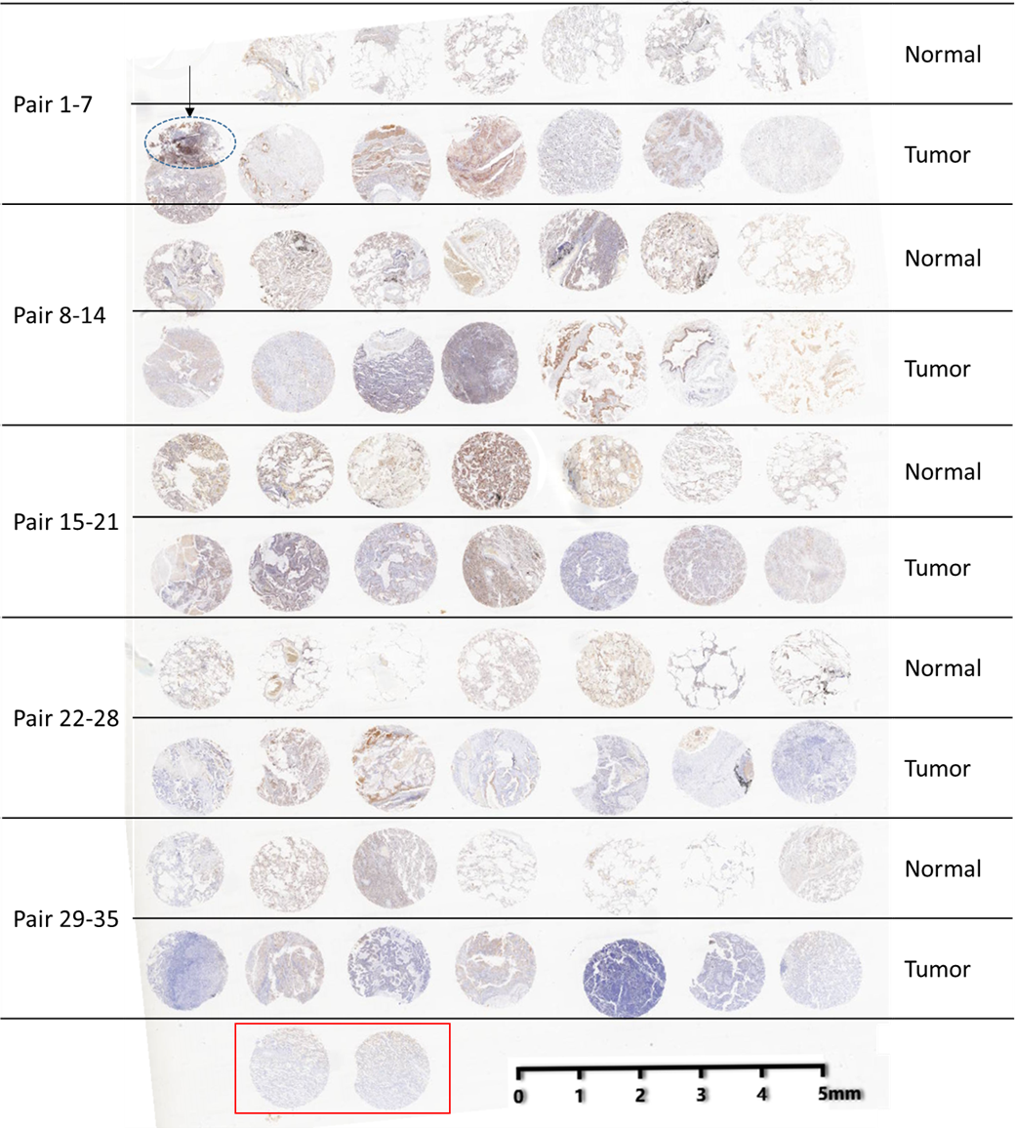
Figure S2. Overview of IHC staining of the lung cancer tissue array (LAC-1402). The tissues in the red box are the mark point of the chip

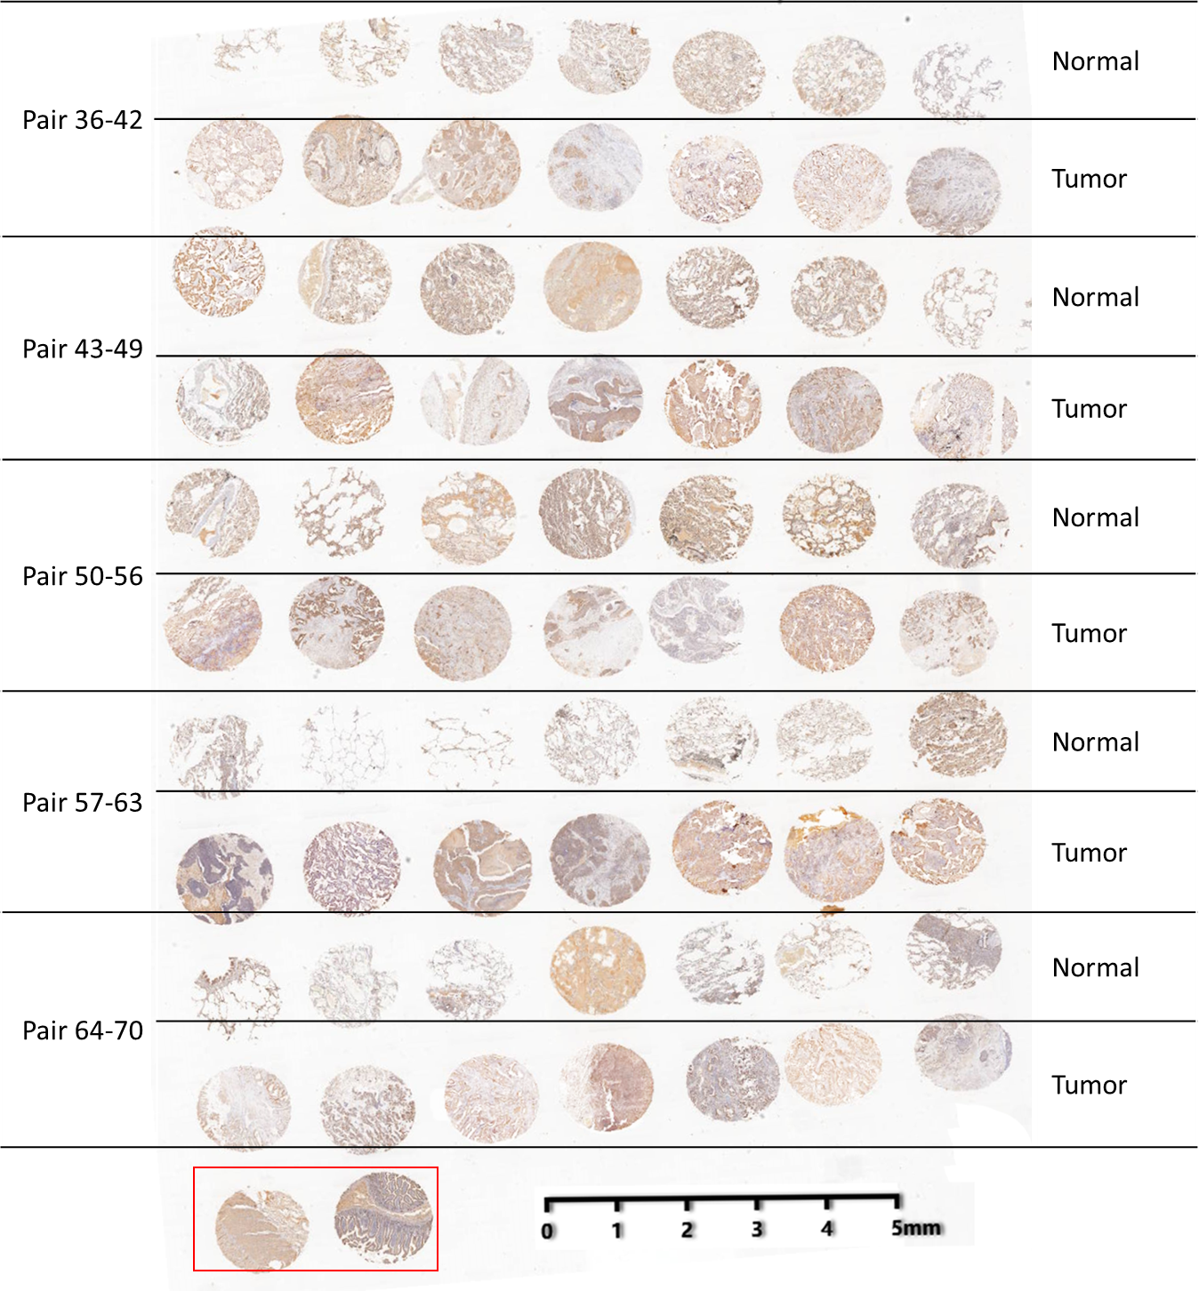
Figure S3. Overview of IHC staining of the lung cancer tissue array (LAC-1403). The tissues in the red box are the mark point of the chip

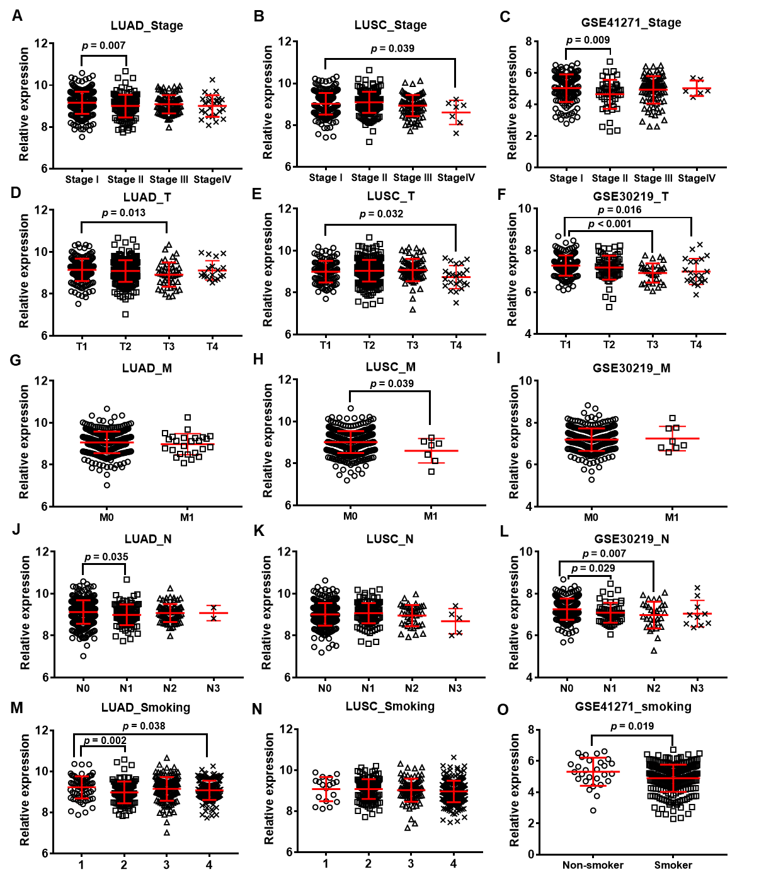
Figure S4. Associations between YTHDC2 mRNA expression and pathological features. Correlation between YTHDC2 mRNA expression and pathological stage in TCGA LUAD (A), TCGA LUSC (B), and GSE41271 (C) cohorts. Correlation between YTHDC2 mRNA expression and pathological T stages in TCGA LUAD (D), TCGA LUSC (E), and GSE30219 (F) cohorts. Correlation between YTHDC2 mRNA expression and pathological M stages in TCGA LUAD (G), TCGA LUSC (H), and GSE30219 (I) cohorts. Correlation between YTHDC2 mRNA expression and pathological N stages in TCGA LUAD (J), TCGA LUSC (K), and GSE30219 (L) cohorts. Correlation between YTHDC2 mRNA expression and smoking histories in TCGA LUAD (J), TCGA LUSC (K), and GSE30219 (L) cohorts. LUAD: lung adenocarcinoma; LUSC: Squamous cell carcinoma; TCGA: The Cancer Gene Atlas.
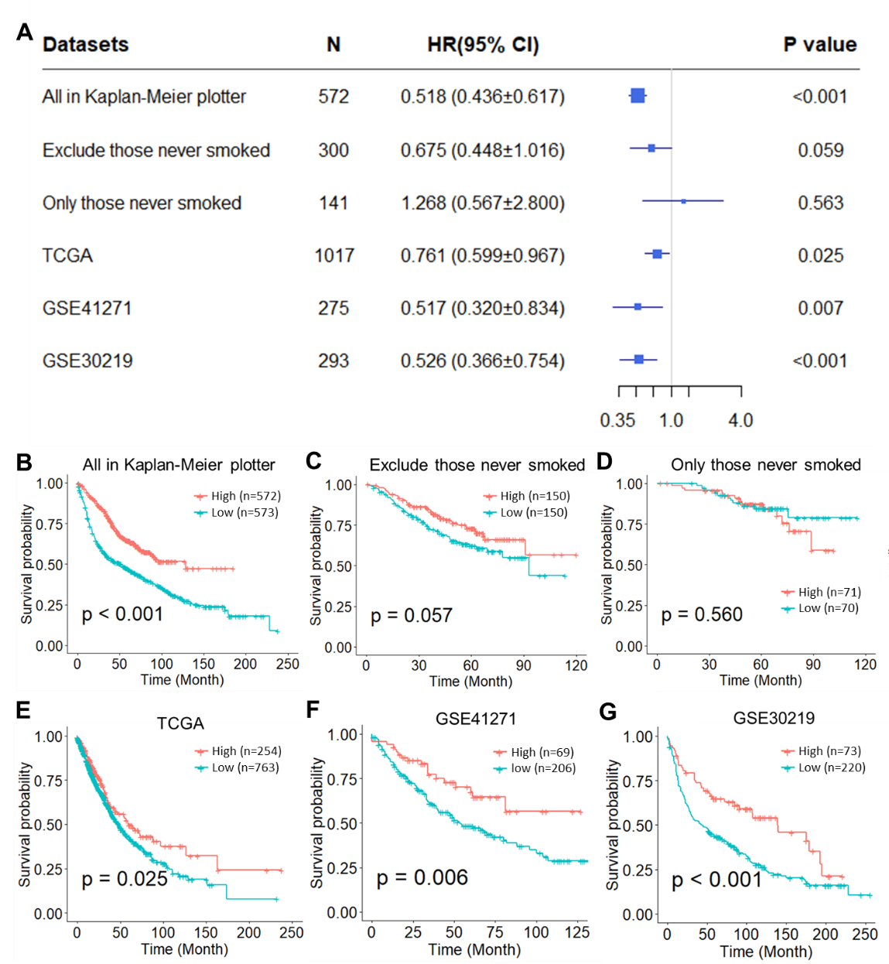
Figure S5. Survival analysis of YTHDC2 in lung cancer patients. (A) Univariate Cox model analysis of the prognostic effect of YTHDC2 expression based on lung cancer datasets. Kaplan-Meier analysis and survival curve were performed based on the Kaplan-Meier plotter datasets of (B) all lung cancer patients, (C) exclude those lung cancer patients who never smoked, and (D) only those lung cancer patients who never smoked, in addition to datasets from (E) TCGA, (F) GSE41271, and (G) GSE30219. The endpoint was overall survival (OS). The mRNA expression level of YTHDC2 was divided into two groups based on their upper quartiles. TCGA: The Cancer Gene Atlas.

Figure S6. Kaplan-Meier analysis of YTHDC2 copy numbers in lung cancer patients in TCGA_LUAD (A) and TCGA_LUSC (B) datasets. LUAD: lung adenocarcinoma; LUSC: Squamous cell carcinoma; TCGA: The Cancer Gene Atlas.

