Supplementary Material
Title: Transcriptomics of Type 2 Diabetic and Healthy Human Neutrophils
Authors: Sarah E. Kleinstein, Jamison McCorrison, Alaa Ahmed, Hatice Hasturk, Thomas E. Van Dyke, Marcelo Freire.
Supplementary Tables: 4
Supplementary Figures: 4

Supplementary Tables:
Supplementary Table S1. Over-represented KEGG pathways.
Pathway Name | p-value | p-value (FDR) | p-value (Bonferroni)
Sphingolipid metabolism | 2.52E-04 | 0.02 | 0.02
Ether lipid metabolism | 0.004 | 0.14 | 0.28
Phospholipase D signaling pathway | 0.02 | 0.24 | 1
Fc gamma R-mediated phagocytosis | 0.02 | 0.24 | 1
Glycerophospholipid metabolism | 0.02 | 0.24 | 1
Colorectal cancer | 0.03 | 0.24 | 1
Sphingolipid signaling pathway | 0.03 | 0.24 | 1
Viral carcinogenesis | 0.03 | 0.24 | 1
Tuberculosis | 0.03 | 0.24 | 1
Transcriptional misregulation in cancer | 0.03 | 0.24 | 1
Fluid shear stress and atherosclerosis | 0.04 | 0.24 | 1
Complement and coagulation cascades | 0.05 | 0.24 | 1
MicroRNAs in cancer | 0.05 | 0.24 | 1
Uncorrected p < 0.05 (before rounding) considered over-represented; Bonferroni or FDR-corrected p-value < 0.05 considered statistically significant. FDR, false discovery rate.
Supplementary Table S2. Top 5 statistically significant over-represented diseases.
Disease | No. Genes (DE/All) | p-value | FDR-adjusted p-value
Citrullinemia | 1 / 1 | 0.003 | 0.03
Paget's disease of bone and related disorders | 1 / 2 | 0.006 | 0.03
Endometriosis | 1 / 3 | 0.009 | 0.03
Epidermolysis bullosa, junctional | 1 / 4 | 0.01 | 0.03
Avascular necrosis of the femoral head /  Osteonecrosis of the femoral head | 1 / 4 | 0.01 | 0.03
Uncorrected p < 0.05 considered over-represented; FDR-corrected p-value < 0.05 considered statistically significant. DE, differentially expressed; FDR, false discovery rate.

Supplementary Table S3. Average cytokine levels (pg/mL) by matched RvE1 treatment of T2D (N = 3) and healthy (N = 3) neutrophils in cell culture.
Cytokine | Mean Healthy (0 nM RvE1) | Mean T2D (0 nM RvE1) | p-value | Mean Healthy (1 nM RvE1) | Mean T2D (1 nM RvE1) | p-value | Mean Healthy (10 nM RvE1) | Mean T2D (10 nM RvE1) | p-value | Mean Healthy (100 nM RvE1) | Mean T2D (100 nM RvE1) | p-value
MIP-1α | 10 | 11.2 | 0.67 | 11.2 | 15.7 | 0.19 | 18.0 | 21.5 | 0.80 | 34.2 | 22.5 | 0.71
IL-4 | 155 | 155 | - | 155 | 157.2 | 0.37 | 155 | 155 | - | 155 | 155 | -
IL-8 | 394.2 | 310.4 | 0.68 | 416.4 | 322.7 | 0.61 | 385.9 | 334.2 | 0.79 | 554.8 | 338.7 | 0.23
MIP-1β | 80.4 | 74 | 0.79 | 83.5 | 82.2 | 0.96 | 115.5 | 93.7 | 0.56 | 239.9 | 137.4 | 0.52
P-Selectin | 1219 | 1737 | 0.47 | 1219 | 1937 | 0.35 | 1090 | 1578 | 0.37 | 1511 | 1751 | 0.76
sICAM-1 | 555.8 | 493.1 | 0.61 | 469.3 | 481.2 | 0.79 | 469.3 | 445.6 | 0.50 | 516.9 | 445.6 | -
TNF-α | 15 | 20.3 | 0.52 | 15 | 17.6 | 0.64 | 22.9 | 21.7 | 0.74 | 24.6 | 19.3 | 0.68
IL-1α | 6.3 | 6.2 | 0.86 | 6.7 | 6.2 | 0.73 | 6.1 | 6.2 | 0.95 | 10.8 | 6.2 | 0.15
p-values calculated by unpaired t-tests, where possible. Significance threshold: p < 0.05. RvE1, resolvin E1; T2D, type 2 diabetes.

Supplementary Table S4. Average cytokine levels (pg/mL) by differing RvE1 treatment of T2D (N = 3) and healthy (N = 3) neutrophils in cell culture.
Cytokine | Mean Healthy (0 nM RvE1) | Mean Healthy (100 nM RvE1) | p-value | Mean T2D (0 nM RvE1) | Mean T2D (100 nM RvE1) | p-value | Mean Healthy (0 nM RvE1) | Mean T2D (100 nM RvE1) | p-value
MIP-1α | 10 | 34.2 | 0.39 | 11.2 | 22.5 | 0.46 | 10 | 22.5 | 0.42
IL-4 | 155 | 155 | - | 155 | 155 | - | 155 | 155 | -
IL-8 | 394.2 | 554.8 | 0.47 | 310.4 | 338.7 | 0.84 | 394.2 | 338.7 | 0.79
MIP-1β | 80.4 | 239.9 | 0.29 | 74 | 137.4 | 0.38 | 80.4 | 137.4 | 0.43
P-Selectin | 1219 | 1511 | 0.38 | 1737 | 1751 | 0.99 | 1219 | 1751 | 0.47
sICAM-1 | 555.8 | 516.9 | 0.88 | 493.1 | 445.6 | 0.42 | 555.8 | 445.6 | 0.67
TNF-α | 15 | 24.6 | 0.33 | 20.3 | 19.3 | 0.93 | 15 | 19.3 | 0.71
IL-1α | 6.3 | 10.8 | 0.14 | 6.2 | 6.2 | 0.95 | 6.3 | 6.2 | 0.94
p-values calculated by unpaired t-tests, where possible. Significance threshold: p < 0.05. RvE1, resolvin E1; T2D, type 2 diabetes.

Supplementary Figures:
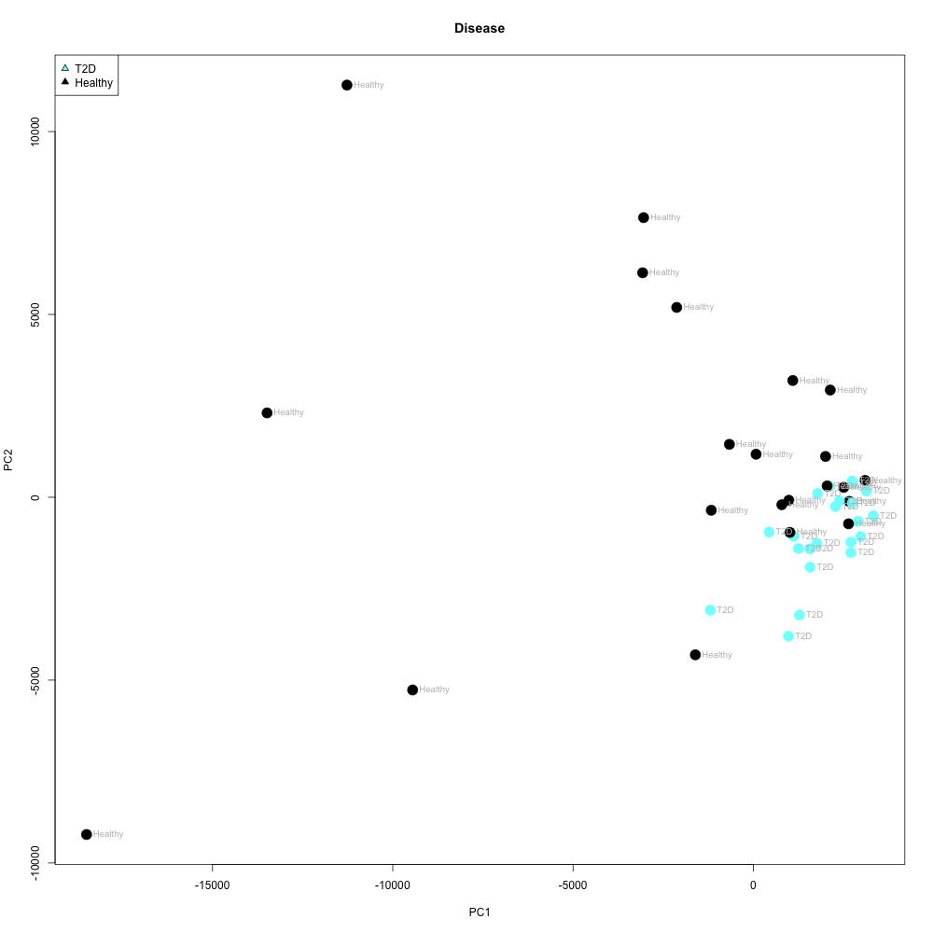
Supplementary Figure S1. Principal component analysis (PCA) plot of type 2 diabetic and healthy subjects. EIGENSTRAT PCA plot of the two main axes of variation (PC1, x-axis; PC2, y-axis) for gene expression results, color-coded by disease: blue = type 2 diabetic; black = healthy. PC1, principal component 1; PC2, principal component 2.

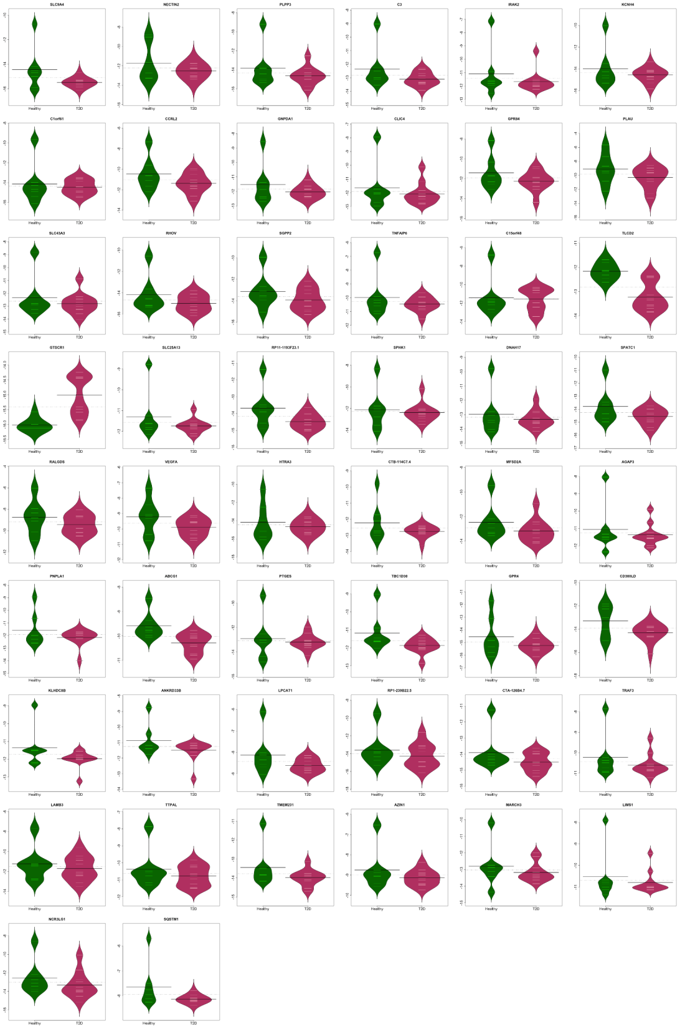
Supplementary Figure S2. Neutrophil gene expression in type 2 diabetic versus healthy subjects for all 50 significant genes. Bean plots of the ln-transformed relative abundance of neutrophil gene expression (line at mean) of all 50 significant (FDR-corrected p < 0.05) differentially expressed genes between T2D and healthy subjects. T2D, type 2 diabetes.

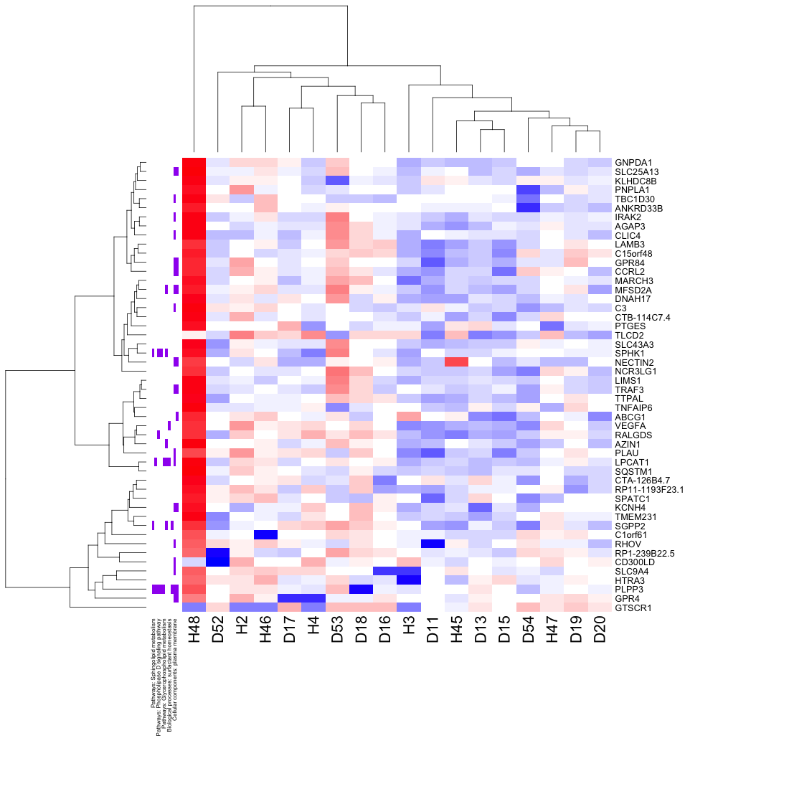
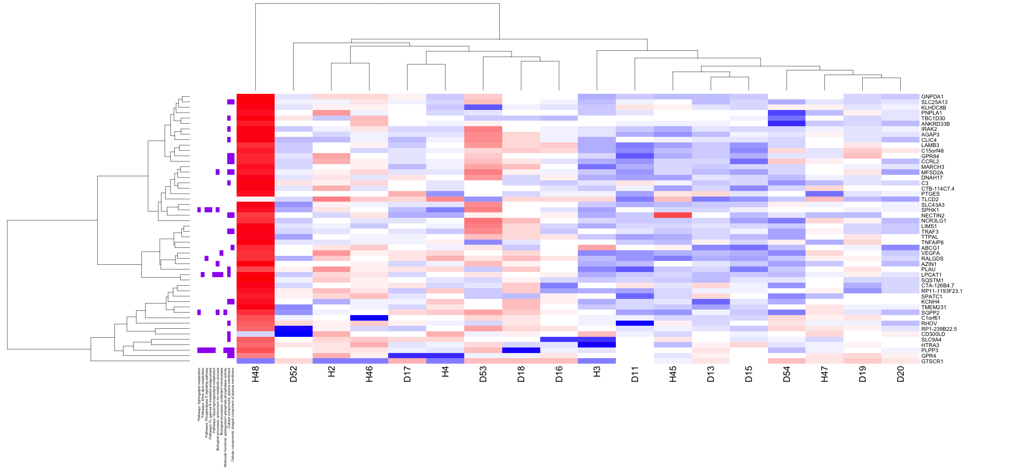
Supplementary Figure S3. Top 50 significant neutrophil genes differentially expressed in type 2 diabetic and healthy subjects by top biological pathways. RNA-seq transcript expression of T2D (D; N = 11) vs. healthy (H; N =7) subject neutrophils. Heatmap of T2D and healthy gene expression by over-represented KEGG and Gene Ontology (GO) pathways (L to R: sphingolipid metabolism, ether lipid metabolism, phospholipase D signaling pathway, Fc gamma R-mediated phagocytosis, glycerophospholipid metabolism, ammonium ion metabolic process, surfactant homeostasis, sphingosine-1-phosphate-phosphatase activity, plasma membrane, integral component of plasma membrane) across all 50 statistically significant differentially expressed genes (FDR-corrected p < 0.05). Blue indicates decreased and red indicates increased gene expression.

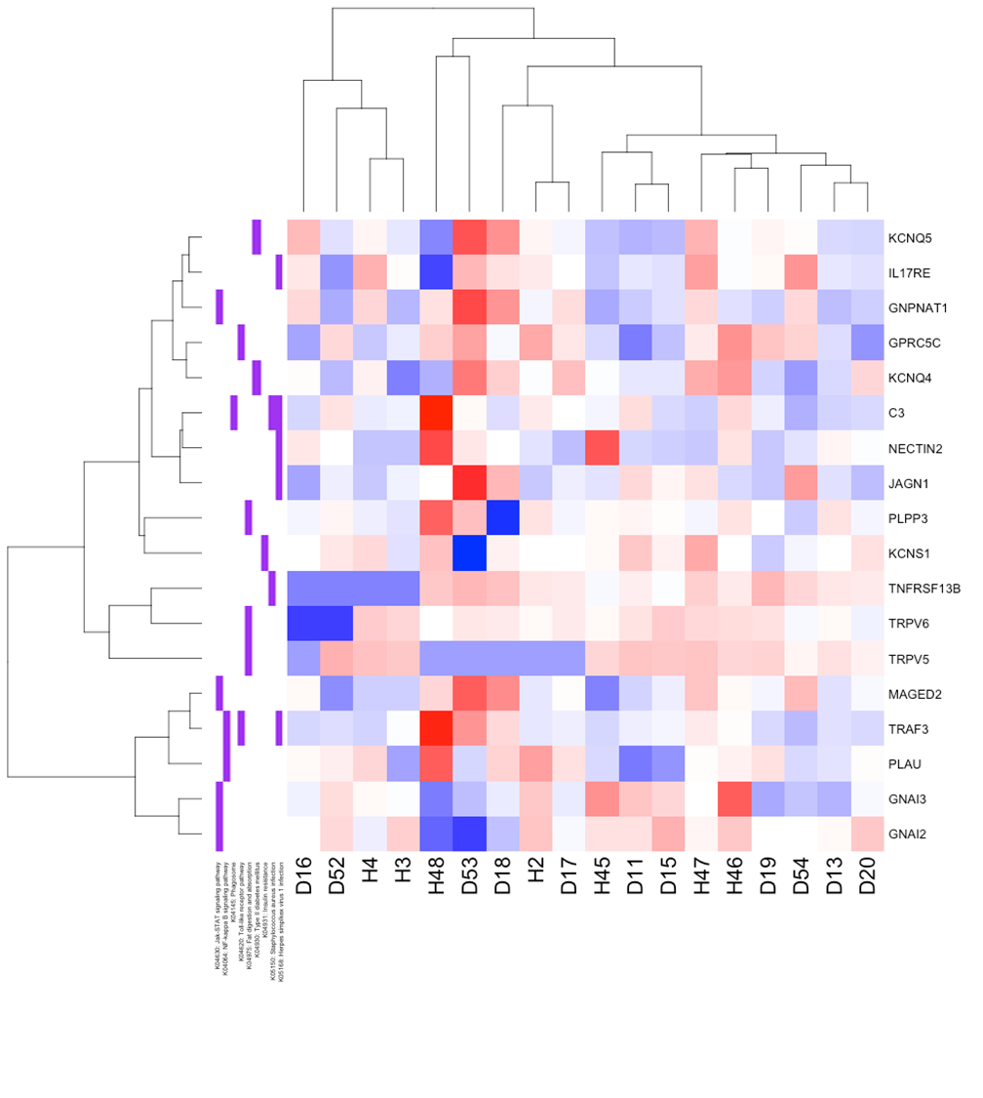
Supplementary Figure S4. Neutrophil gene expression of type 2 diabetic and healthy subjects by biologically relevant KEGG pathways. RNA-seq transcript expression of T2D (D; N = 11) vs. healthy (H; N = 7) subject neutrophils. Heatmap of T2D and healthy gene expression by biologically relevant KEGG pathways (L to R: Jak-STAT signaling pathway, NFκB signaling pathway, Phagosome, Toll-like receptor pathway, Fat digestion and absorption, Type II diabetes mellitus, Insulin resistance, Staphylococcus aureus infection, Herpes simplex virus 1 infection) and all differentially expressed genes in those pathways. Blue indicates decreased and red indicates increased gene expression.

