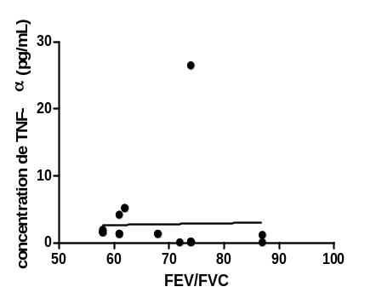Fig 3 f: Correlation between TNF-α and FEV/FVC; r = 0.588, p = 0.007
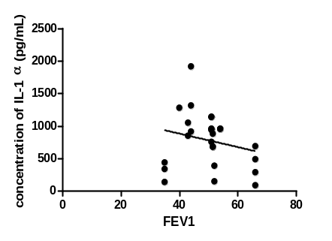Fig 3 a: Correlation between FEV1 and IL-1α; r = -0.286, p = 0,047

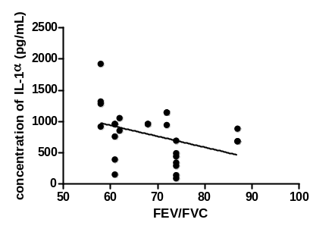
Fig 3 c: Correlation between FEV/FVC and IL-1α: r = -0.552, p = 0.003

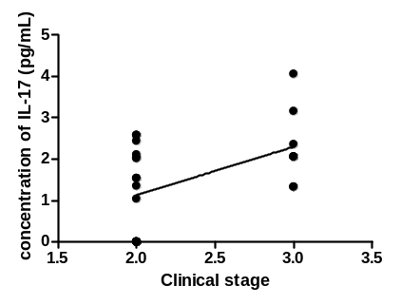
Fig 3 d: Correlation between clinical stage and IL-17; r = 0.489, p = 0.013
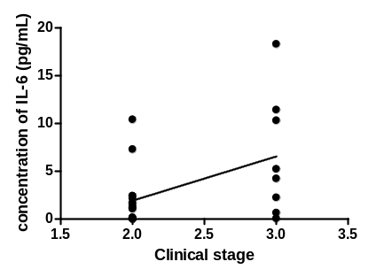
Fig 3 e: Correlation between IL-6 and clinical stage; r = 0.401, p = 0.047
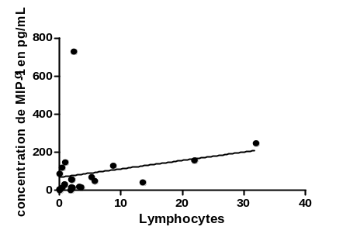
Fig 3 g: Correlation between MIP-1α and lymphocytes; r = 0.4294, p = 0.0461

Legend:
FEV1 = forced expiratory volume in the first second
FVC = forced vital capacity
IL= interleukin
MIP = macrophage inflammatory protein
r = correlation test
Figure 3: Significant correlations in the patients with post-TB airflow obstruction

