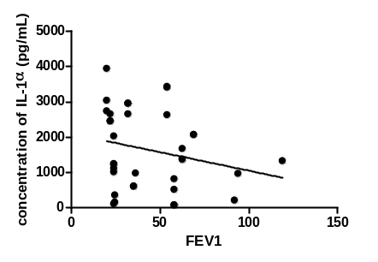 Fig 2 b: Correlation between FEV1 and IL-1α; r = -0.314, p = 0.046
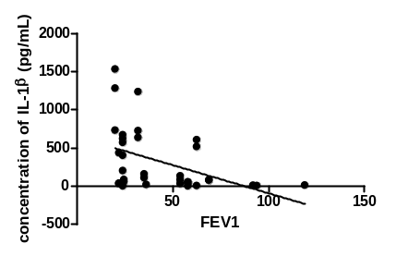 Fig 2c: Correlation between FEV1 and IL-1β; r = -0.536, p = 0.0009
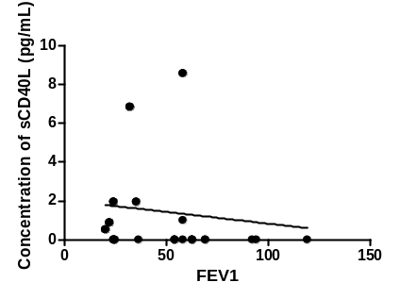Fig 2 a: Correlation between FEV1 and sCD40L; r = -0.342, p = 0.044

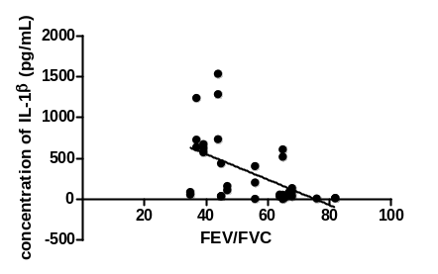Fig 2 f: Correlation between IL-1β and FEV/FVC; r = -0.621, p < 0.0001
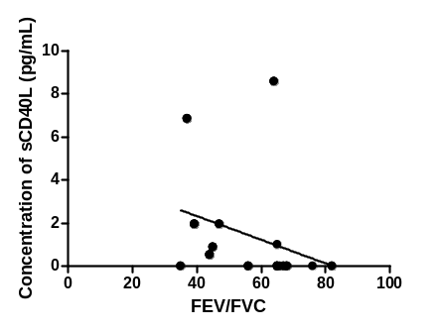Fig 2 d: Correlation between sCD40L and FEV/FVC; r = -0.571, p = 0.003
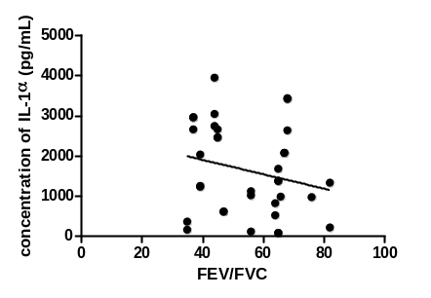Fig 2 e: Correlation between IL-1α and FEV/FVC; r = -0.227, p = 0.039

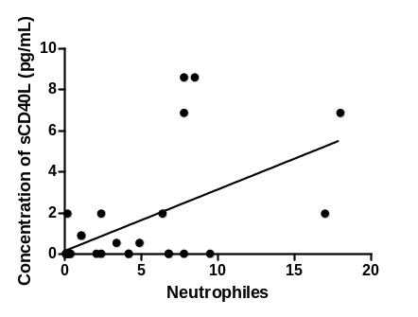Fig 2 i: Correlation between sCD40L and neutrophils ; r = 0.531, p = 0.004
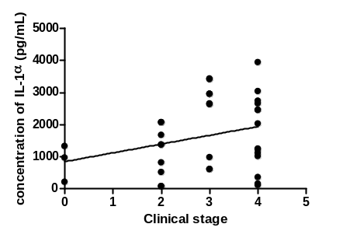Fig 2 g: Correlation between IL-1α and clinical stage; r = 0.295, p = 0.045
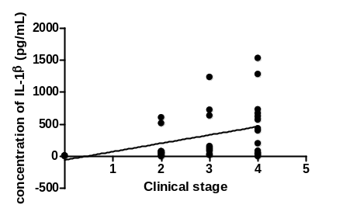Fig 2 h: Correlation between clinical stage and IL-1β; r = 0.384, p = 0.022

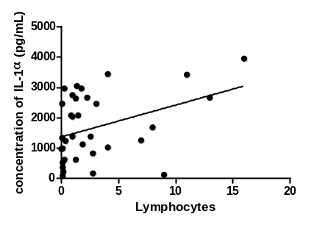Fig 2 k: Correlation between IL-1α and lymphocytes; r = 0.383, p = 0.025
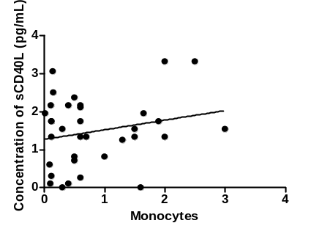Fig 2l: Correlation between sCD40L and monocytes; r = 0.334, p = 0.047
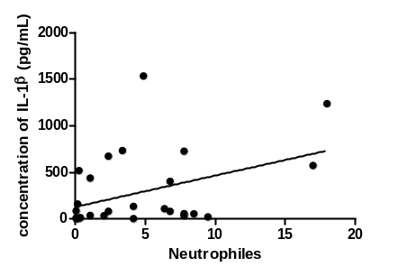Fig 2 j: Correlation between IL-1β and neutrophils; r = 0.406, p = 0.036

Figure 2: Significant correlations in the COPD patients with history of smoking
Legend:
FEV1: forced expiratory volume in the first second
FVC: forced vital capacity
IL: interleukin
sCD40L: soluble cluster differentiation 40 ligand

