Chromatographic analyses, virtual screening and pharmacokinetics of yellow Malaysian rambutan (Nephelium lappaceum L.) fruit epicarp extracts reveal potential antibacterial compounds

Authors: Ali Asghar¹, Yong Chiang Tan¹, Mohammad Zahoor², Syafiq Asnawi³, Yoon Yen Yow¹, Ezzat Khan⁴ and Chandrajit Lahiri^{1*}
Addresses:
¹ Department of Biological Sciences, Sunway University, Petaling Jaya, Malaysia
² Department of Biochemistry, University of Malakand, Chakdara, Pakistan
³ Jeffrey Cheah School of Medicine and Health Science, Monash University Malaysia, Petaling Jaya, Malaysia
⁴ Department of Chemistry, University of Bahrain, Sakhir, Bahrain.

Correspondence: *Chandrajit Lahiri, E-mail: chandrajitl@sunway.edu.my
Phone: +60 3-7491 8622 Fax: +6 03 5638 7177

Co-Authors: Ali Asghar, E-mail: ali.a13@imail.sunway.edu.my
Yong Chiang Tan, E-mail: yong.t38@imail.sunway.edu.my
Mohammad Zahoor, E-mail: mohammadzahoorus@yahoo.com
Syafiq Asnawi, E-mail: syafiq.asnawi@monash.edu
Yoon-Yen Yow, E-mail: yoonyeny@sunway.edu.my
Ezzat Khan, E-mail: ezkhan@uob.edu.bh

SUPPLEMENTARY MATERIALS:

Table S1. Antibacterial activity of N. lappaceum sequential extracts based on disc diffusion method
Microorganisms |  | Visible inhibition produced by the extracts
 | Chloroform | Ethyl acetate | Acetone | Ethanol | Methanol | Aqueous | DMSO
B. subtilis | - | - | - | - | - | - | -
MRSA | - | - | - | - | - | - | -
S. pyogenes | - | - | - | - | - | - | -
P. aeruginosa | - | - | - | - | - | - | -
K. pneumonia | - | - | - | - | - | - | -
S. enterica | - | - | - | - | - | - | -
‘‘-’’, no inhibition zone

Table S2. Percentage of antibacterial activity of sequential extracts by broth dilution method
Rambutan | Gram positive bacteria |  |  | Gram negative bacteria
 | % Viable bacteria
Extracts | MRSA | B. subtilis | S. pyogenes | P. aeruginosa | S. enterica | K. pneumonia
CF | 60% | 95% | 65% | 70% | 90% | 95%
ET | 70 | 65 | 65 | 70 | 90 | 80
MT | 80 | 60 | 55 | 60 | 90 | 80
WT | 90 | 95 | 85 | 80 | 95 | 90
CF; Chloroform, EA; ethyl acetate, AC; acetone, ET; ethanol, MT; methanol, WT; water

Exploration of other chemical determinants through Liquid Chromatography–Mass Spectrometry (LC-MS) Analysis
Table S3. Identified compounds existing in N. lappaceum ethyl acetate extract identified by LC-MS analysis
No | m/z | Identified compounds | Molecular Formula | RT (Min.) | Mass | Score (DB) | Antibacterial activity  reports
1 | 104.1066 | 2-Amino-3-methyl-1-butanol | C₅ H₁₃ N O | 1.517 | 103.0992 | 95.45 | Not reported
2 | 122.0806 | Tromethamine | C₄ H₁₁ N O₃ | 1.5 | 121.0731 | 90.86 | 38
3 | 139.0387 | p-Salicylic acid | C₇ H₆ O₃ | 9.772 | 138.0315 | 86.19 | 39
4 | 157.0494 | Iretol | C₇ H₈ O₄ | 9.771 | 156.0422 | 86.71 | Not reported
5 | 175.0599 | 6,7-dihydroxy-4-oxo-2-heptenoic acid | C₇ H₁₀ O₅ | 15.388 | 174.0527 | 99.23 | Not reported
6 | 195.0867 | Quebrachitol | C₇ H₁₄ O₆ | 1.604 | 194.0794 | 99.12 | 40
7 | 217.0681 | D-Glucoside | C₇ H₁₄ O₆ | 1.588 | 194.079 | 86.27 | 41
8 | 219.0267 | L-Galactose | C₆ H₁₂ O₆ | 1.546 | 180.0641 | 87.34 | Not reported
9 | 226.1289 | Ethyl beta-D-glucopyranoside | C₈ H₁₆ O₆ | 2.196 | 208.0948 | 96.07 | Not reported
10 | 233.0436 | Caffeine | C₈ H₁₀ N₄ O₂ | 1.593 | 194.0808 | 88.04 | 42
11 | 247.0934 | 5,6-Dihydrouridine | C₉ H₁₄ N₂ O₆ | 1.737 | 246.086 | 95.81 | Not reported
12 | 253.1284 | 2,3-Butanediol glucoside | C₁₀ H₂₀ O₇ | 2.548 | 252.121 | 96.45 | 43
13 | 279.1554 | Mycosporine | C₁₁ H₁₉ N O₆ | 3.449 | 261.1216 | 99.21 | Not reported
14 | 284.1347 | 1-(3-Carboxypropyl)-3,7-dimethylxanthine | C₁₁ H₁₄ N₄ O₄ | 2.801 | 266.101 | 96.71 | Not reported
15 | 291.0862 | Oritin-4beta-ol | C₁₅ H₁₄ O₆ | 10.143 | 290.0788 | 96.06 | Not reported
16 | 303.0151 | Ellagic acid | C₁₄ H₆ O₈ | 11.033 | 302.0077 | 92.82 | 44
17 | 303.0425 | 2'-Hydroxyfurano [2'',3'':4',3’] chalcone | C₁₇ H₁₂ O₃ | 11.37 | 264.0795 | 87.51 | Not reported
18 | 315.0714 | Salicyl phenolic glucuronide | C₁₃ H₁₄ O₉ | 9.404 | 314.0645 | 94.36 | Not reported
19 | 316.2846 | (4OH,8Z, t18:1) sphingosine | C₁₈ H₃₇ N O₃ | 14.897 | 315.2773 | 98.48 | Not reported
20 | 318.3004 | Phytosphingosine | C₁₈ H₃₉ N O₃ | 15.37 | 317.2931 | 99.41 | 45
21 | 321.0246 | Niflumic Acid | C₁₃ H₉ F₃ N₂ O₂ | 9.864 | 282.0617 | 90.14 | 46
22 | 339.1233 | (-)-Glyceollin I | C₂₀ H₁₈ O₅ | 16.008 | 338.1161 | 96.26 | 47
23 | 365.1559 | Kinetin Riboside | C₁₅ H₁₇ N₅ O₅ | 8.704 | 347.1223 | 95.94 | Not reported
24 | 369.1334 | Aurmillone | C₂₁ H₂₀ O₆ | 16.218 | 368.1263 | 98.52 | Not reported
25 | 386.1596 | Papaverrubine B | C₂₁ H₂₃ N O₆ | 9.795 | 385.1525 | 99.08 | Not reported
26 | 415.212 | Eplerenone | C₂₄ H₃₀ O₆ | 16.63 | 414.2048 | 98.7 | 48
27 | 420.1864 | Benzyl O-[arabinofuranosyl-(1->6)-glucoside] | C₁₈ H₂₆ O₁₀ | 9.77 | 402.1527 | 97.76 | Not reported
28 | 435.0926 | Avicularin | C₂₀ H₁₈ O₁  ₁ | 11.242 | 434.0856 | 96.85 | 49
29 | 437.3414 | Demethyl phylloquinone | C₃₀ H₄₄ O₂ | 16.163 | 436.3343 | 92.02 | Not reported
30 | 449.1082 | 6-Hydroxyluteolin 5-rhamnoside | C₂₁ H₂₀ O₁₁ | 11.369 | 448.101 | 98.51 | Not reported
31 | 455.3518 | Bryononic acid | C₃₀ H₄₆ O₃ | 14.871 | 454.3448 | 99.16 | 50
32 | 465.1033 | 8-Hydroxyluteolin 8-glucoside | C₂₁ H₂₀ O₁₂ | 10.908 | 464.0959 | 99.07 | Not reported
33 | 565.3885 | 3beta-Acetoxy-11alpha-methoxy-12-ursen-28-oic acid | C₃₄ H₅₄ O₅ | 15.436 | 542.3995 | 87.71 | Not reported
34 | 579.1496 | Apigenin 7-(3''-p-coumaroylglucoside) | C₃₀ H₂₆ O₁₂ | 9.851 | 578.1415 | 88.85 | Not reported
35 | 593.2761 | Pheophorbide a | C₃₅ H₃₆ N₄ O₅ | 22.878 | 592.2689 | 99.21 | 51
36 | 611.1398 | Isoorientin 6''-O-caffeate | C₃₀ H₂₆ O₁₄ | 12.092 | 610.1328 | 97.43 | Not reported
37 | 611.1602 | Robinetin 3-rutinoside | C₂₇ H₃₀ O₁₆ | 10.634 | 610.1528 | 98.45 | 52
38 | 619.4206 | 19-Methoxypomolic acid 3-arabinoside | C₃₆ H₅₈ O₈ | 15.458 | 618.4135 | 98.04 | Not reported
39 | 629.4043 | Zizyphine A | C₃₃ H₄₉ N₅ O₆ | 15.351 | 611.3704 | 89.69 | Not reported
40 | 652.1142 | Punicacortein A | C₂₇ H₂₂ O₁₈ | 9.86 | 634.0802 | 99.1 | Not reported
41 | 700.2812 | Bruceoside A | C₃₂ H₄₂ O₁₆ | 10.401 | 682.2469 | 95.47 | Not reported
42 | 751.462 | Oleanolic acid 3-[glucosyl-(1->4)-xyloside] | C₄₁ H₆₆ O₁₂ | 14.874 | 750.4547 | 99.01 | Not reported
43 | 757.4516 | beta-Hederin | C₄₁ H₆₆ O₁₁ | 15.346 | 734.4612 | 87.4 | Not reported
44 | 775.4626 | Hebevinoside VI | C₄₁ H₆₈ O₁₂ | 15.387 | 752.4731 | 94.26 | Not reported
45 | 783.0668 | Emblicanin A | C₃₄ H₂₂ O₂₂ | 9.678 | 782.0598 | 97.26 | 53
46 | 785.0833 | Pedunculagin | C₃₄ H₂₄ O₂₂ | 10.438 | 784.0757 | 98.63 | 54
47 | 793.4741 | Sanguisorbin E | C₄₃ H₆₈ O₁₃ | 15.443 | 792.4665 | 99 | Not reported
48 | 804.1241 | Tercatain | C₃₄ H₂₆ O₂₂ | 10.393 | 786.0905 | 97.33 | 55
49 | 823.0995 | 1,3,4,5-Tetra-O-galloylquinic acid | C₃₅ H₂₈ O₂₂ | 10.781 | 800.1101 | 90.85 | Not reported
50 | 826.1326 | Reduced flavine adenine dinucleotide (FADH2) | C₂₇ H₃₅ N₉ O₁₅ P₂ | 9.346 | 787.1699 | 83.43 | Not reported
51 | 883.5037 | Pitheduloside B | C₄₆ H₇₄ O₁₆ | 14.87 | 882.4964 | 97.93 | 56
52 | 907.5043 | 3-O-(Rhaa1-4(Rhaa1-2) Glcb) -(25R)-spirost-5-en-3beta-ol | C₄₆ H₇₆ O₁₆ | 15.368 | 884.515 | 96.24 | Not reported
53 | 970.1146 | Geraniin | C₄₁ H₂₈ O₂₇ | 9.676 | 952.0808 | 98.43 | 57
54 | 972.1301 | Chebulagic acid | C₄₁ H₃₀ O₂₇ | 10.431 | 954.0955 | 94.85 | 55

Table S4. Identified compounds existing in N. lappaceum acetone extract identified by LC-MS analysis
No | m/z | Identified compounds | Molecular Formula | RT (Min.) | Mass | Score (DB) | Antibacterial activity  report
1 | 175.0597 | 6,7-dihydroxy-4-oxo-2-heptenoic acid | C₇ H₁₀ O₅ | 15.395 | 174.0525 | 98.44 | Not reported
2 | 195.0865 | Quebrachitol | C₇ H₁₄ O₆ | 1.602 | 194.0792 | 99.65 | 40
3 | 198.0973 | L-Galactose | C₆ H₁₂ O₆ | 1.561 | 180.0632 | 94.41 | Not reported
4 | 226.1288 | Ethyl beta-D-glucopyranoside | C₈ H₁₆ O₆ | 2.208 | 208.0949 | 96.24 | Not reported
5 | 267.1717 | Falcarinol | C₁₇ H₂₄ O | 18.571 | 244.1825 | 86.46 | 58
6 | 279.108 | 1-O-(4-hydroxy-2-methylene-butanoyl)-beta-D-glucopyranose | C₁₁ H₁₈ O₈ | 15.478 | 278.1009 | 95.32 | Not reported
7 | 279.1556 | Mycosporine | C₁₁ H₁₉ N O₆ | 3.478 | 261.1219 | 93.66 | Not reported
8 | 284.1343 | 1-(3-Carboxypropyl)-3,7-dimethylxanthine | C₁₁ H₁₄ N₄ O₄ | 2.814 | 266.1008 | 92.11 | Not reported
9 | 291.0861 | Oritin-4beta-ol | C₁₅ H₁₄ O₆ | 10.148 | 290.0789 | 97.34 | Not reported
10 | 303.0144 | Ellagic acid | C₁₄ H₆ O₈ | 11.041 | 302.0071 | 97.6 | 44
11 | 369.1334 | Glycyrrhisoflavanone | C₂₁ H₂₀ O₆ | 16.226 | 368.1263 | 93.19 | Not reported
12 | 386.1598 | Papaverrubine B | C₂₁ H₂₃ N O₆ | 9.801 | 385.1529 | 94.16 | Not reported
13 | 415.2117 | Eplerenone | C₂₄ H₃₀ O₆ | 16.629 | 414.2046 | 97.52 | 48
14 | 420.1858 | Ile His Glu | C₁₇ H₂₇ N₅ O₆ | 9.776 | 397.1966 | 94.94 | Not reported
15 | 430.2437 | 5-(2,3-Dihydroxy-3-methylbutyl)-4-(3,4-epoxy-4-methylpentanoyl)-3,4-dihydroxy-2-isopentanoyl-2-cyclopenten-1-one | C₂₁ H₃₂ O₈ | 11.011 | 412.2096 | 92.06 | Not reported
16 | 437.3415 | Demethylphylloquinone | C₃₀ H₄₄ O₂ | 15.442 | 436.3342 | 99.08 | Not reported
17 | 439.3573 | Ganoderol A | C₃₀ H₄₆ O₂ | 17.197 | 438.35 | 98.68 | Not reported
18 | 449.1077 | 6-Hydroxyluteolin 5-rhamnoside | C₂₁ H₂₀ O₁₁ | 11.364 | 448.1008 | 96.89 | Not reported
19 | 455.352 | Bryononic acid | C₃₀ H₄₆ O₃ | 16.158 | 454.3447 | 99.82 | 50
20 | 465.103 | 8-Hydroxyluteolin 8-glucoside | C₂₁ H₂₀ O₁₂ | 10.901 | 464.0957 | 99.06 | Not reported
21 | 565.3882 | 3beta-Acetoxy-11alpha-methoxy-12-ursen-28-oic acid | C₃₄ H₅₄ O₅ | 15.445 | 542.3987 | 93.93 | Not reported
22 | 583.3988 | OH-Diaponeurosporene glucoside ester | C₃₆ H₅₄ O₆ | 15.467 | 582.3915 | 95.54 | Not reported
23 | 587.3936 | (3b,16a,21b,22a)-12-Oleanene-3,16,21,23,28-pentol-22-angeloyloxy-23-al | C₃₅ H₅₄ O₇ | 16.153 | 586.3866 | 98.4 | Not reported
24 | 593.2756 | Pheophorbide a | C₃₅ H₃₆ N₄ O₅ | 22.885 | 592.2687 | 97.71 | 51
25 | 611.1397 | Isoorientin 6''-O-caffeate | C₃₀ H₂₆ O₁₄ | 12.087 | 610.1325 | 98.66 | Not reported
26 | 619.4202 | 19-Methoxypomolic acid 3-arabinoside | C₃₆ H₅₈ O₈ | 15.472 | 618.4129 | 99.13 | Not reported
27 | 627.3866 | Hederagenin 3-O-arabinoside | C₃₅ H₅₆ O₈ | 16.13 | 604.398 | 84.9 | Not reported
28 | 629.4039 | Zizyphine A | C₃₃ H₄₉ N₅ O₆ | 15.349 | 611.3702 | 90.78 | Not reported
29 | 652.1135 | Punicacortein A | C₂₇ H₂₂ O₁₈ | 9.866 | 634.08 | 96.87 | Not reported
30 | 700.2808 | Bruceoside A | C₃₂ H₄₂ O₁₆ | 10.404 | 682.2462 | 92.84 | Not reported
31 | 751.4624 | Oleanolic acid 3-[glucosyl-(1->4)-xyloside] | C₄₁ H₆₆ O₁₂ | 15.441 | 750.4551 | 99.81 | Not reported
32 | 757.4517 | Gambierol | C₄₃ H₆₄ O₁₁ | 15.343 | 756.4438 | 94.87 | Not reported
33 | 775.4617 | Melilotoside B | C₄₁ H₆₈ O₁₂ | 15.382 | 752.4725 | 96.45 | Not reported
34 | 779.4568 | Momordin Ia | C₄₂ H₆₆ O₁₃ | 16.199 | 778.4497 | 99.4 | Not reported
35 | 783.0681 | Emblicanin A | C₃₄ H₂₂ O₂₂ | 9.959 | 782.0606 | 99.34 | 53
36 | 785.081 | Pedunculagin | C₃₄ H₂₄ O₂₂ | 10.437 | 784.0744 | 91.32 | 54
37 | 793.4733 | Sanguisorbin E | C₄₃ H₆₈ O₁₃ | 15.448 | 792.4658 | 99.52 | Not reported
38 | 804.1255 | Tercatain | C₃₄ H₂₆ O₂₂ | 10.396 | 786.0909 | 93.46 | 55
39 | 817.472 | Hebevinoside III | C₄₃ H₇₀ O₁₃ | 16.296 | 794.4827 | 95.75 | Not reported
40 | 865.196 | Epicatechin-(4beta->6)-epicatechin-(2beta->7,4beta->8)-epicatechin | C₄₅ H₃₆ O₁₈ | 10.275 | 864.189 | 92.64 | Not reported
41 | 907.5038 | 3-O-(Rhaa1-4(Rhaa1-2) Glcb) -(25R)-spirost-5-en-3beta-ol | C₄₆ H₇₆ O₁₆ | 15.365 | 884.5145 | 97.89 | Not reported
42 | 970.1154 | Geraniin | C₄₁ H₂₈ O₂₇ | 9.962 | 952.0812 | 99.07 | 57
43 | 1227.6122 | Eleutheroside M | C₅₉ H₉₆ O₂₅ | 15.357 | 1204.6233 | 97.12 | Not reported
44 | 1231.7826 | Lienomycin | C₆₇ H₁₀₇ N O₁₈ | 16.127 | 1213.749 | 98.32 | Not reported

LC-MS data of Metlin-Unmatched Compounds from N. lappaceum Sequential Extract.
Table S5. Molecular Formula of Metlin-Unmatched Compounds from N. lappaceum Ethyl Acetate Extract.
NO | Molecular Formula | RT (Mint) | m/z | Mass
 | C₈ H₄ O₃ | 19.801 | 149.0234 | 148.0161
 | C₉ H₁₉ N O | 15.301 | 158.1536 | 157.1463
 | C₆ H₂ N₂ O₃ S | 1.361 | 182.9851 | 181.9787
 | C₆ H₈ N₃ O₅ | 1.541 | 203.0525 | 202.0455
 | C₅ H₈ N₆ O₄ | 1.582 | 217.068 | 216.0608
 | C₁₀ H₈ N₄ O₂ | 16.292 | 217.0717 | 216.0645
 | C₁₃ H₂₅ N O₂ | 14.934 | 228.1957 | 227.1879
 | C₉ H₁₁ Cl N O₄ | 1.761 | 233.0457 | 232.038
 | C₁₆ H₃₄ O₃ | 21.544 | 275.2581 | 274.2508
 | C₁₇ H₃₆ O₃ | 22.188 | 289.2739 | 288.2662
 | C₁₃ H₁₈ O₈ | 15.353 | 303.1075 | 302.1
 | C₁₈ H₃₈ O₃ | 23.093 | 303.2898 | 302.2822
 | C₁₃ H₂₀ O₉ | 15.481 | 321.1182 | 320.1109
 | C₁₃ H₃₇ N₉ O | 21.458 | 336.3184 | 335.3114
 | C₁₉ H₄₀ O₄ | 22.189 | 350.3266 | 332.2926
 | C₂₂ H₄₁ N _{O}2 | 21.887 | 352.3236 | 351.316
 | C₂₁ H₄₀ O₂ S | 20.935 | 357.283 | 356.2756
 | C₁₈ H₄₃ N₄ O₃ | 23.131 | 364.3421 | 363.3343
 | C₁₀ H₂₂ N₉ O₄ S₂ | 1.563 | 397.1318 | 396.1235
 | C₁₉ H₁₄ O₁₂ | 10.481 | 435.056 | 434.0489
 | C₂₅ H₅₁ N₄ O₂ | 18.669 | 440.4094 | 439.4018
 | C₂₉ H₂₂ N₂ S₂ | 21.043 | 463.1321 | 462.1229
 | C₂₁ H₂₀ O₈ S₂ | 9.874 | 465.0662 | 464.0601
 | C₂₇ H₅₅ N₄ O₂ | 20.443 | 468.4415 | 467.4315
 | C₂₀ H₁₆ O₁₄ | 9.698 | 481.0608 | 480.0541
 | C₃₂ H₂₈ N₂ S₃ | 22.245 | 554.1757 | 536.1411
 | C₄₀ H₁₇ N₃ | 22.245 | 557.1766 | 539.1411
 | C₂₁ H₂₄ N₁₀ S₅ | 1.736 | 577.085 | 576.0787
 | C₃₆ H₅₆ O₇ | 15.47 | 601.4096 | 600.4023
 | C₃₅ H₃₇ N₃ S₄ | 23.432 | 628.1946 | 627.1868
 | C₃₁ H₁₅ N₁₅ O | 23.433 | 631.1941 | 613.1587
 | C₃₂ H₅₂ N₁₅ O | 24.263 | 663.4548 | 662.4478
 | C₂₆ H₁₉ N₈ O₁₄ | 9.671 | 668.1093 | 667.102
 | C₃₇ H₃₉ N₃ S₅ | 24.274 | 686.1835 | 685.175
 | C₄₀ H₅₆ N₇ O₅ | 15.442 | 715.4415 | 714.4343

Table S6. Molecular Formula of Metlin-Unmatrched Compounds from N. lappaceum Acetone Extract.
NO | Molecular Formula | RT (Mint) | m/z | Mass
 | C₈ H₄ O₃ | 19.8 | 149.0232 | 148.0159
 | C₉ H₁₉ N O | 15.304 | 158.1536 | 157.1463
 | C₁₁ H Cl N | 1.363 | 182.9848 | 181.979
 | C₆ H₈ N₃ O₅ | 1.549 | 203.0526 | 202.0458
 | C₇ H₄ N₄ O₃ | 2.235 | 210.0627 | 192.0284
 | C₁₀ H₇ N₅ O₃ | 1.639 | 246.0613 | 245.0548
 | C₁₆ H₃₄ O₃ | 21.538 | 275.2587 | 274.2511
 | C₁₇ H₃₆ O₃ | 22.165 | 289.2743 | 288.2666
 | C₂₃ H₂₀ N₁₂ O₈ | 1.554 | 297.0845 | 592.1539
 | C₁₈ H₃₈ O₃ | 23.078 | 303.2896 | 302.2817
 | C₁₄ H₁₆ N₄ O₅ | 15.473 | 321.1189 | 320.1116
 | C₁₉ H₄₀ O₄ | 22.17 | 350.3267 | 332.2924
 | C₂₁ H₄₀ O₂ S | 20.937 | 357.282 | 356.2749
 | C₂₀ H₂₀ N O₂ S₂ | 22.24 | 371.102 | 370.0942
 | C₁₀ H₁₈ N₆ O₁₀ | 1.535 | 383.1152 | 382.108
 | C₁₁ H₂₀ N₆ O₁₀ | 1.579 | 397.1316 | 396.1243
 | C₁₂ H₂₀ N₁₃ S₂ | 1.612 | 411.1479 | 410.1404
 | C₁₉ H₁₄ O₁₂ | 10.478 | 435.0565 | 434.0492
 | C₁₇ H₂₂ O₁₂ | 9.408 | 436.1455 | 418.1116
 | C₂₂ H₁₆ N₄ O₄ S₂ | 9.864 | 465.0672 | 464.0608
 | C₂₀ H₁₆ O₁₄ | 9.695 | 481.0615 | 480.0546
 | C₃₂ H₂₈ N₂ S₃ | 22.24 | 554.1762 | 536.1417
 | C₃₆ H₅₆ O₇ | 15.451 | 601.4104 | 600.403
 | C₃₇ H₃₉ O S₄ | 23.43 | 628.1959 | 627.1878
 | C₂₇ H₂₅ N O₁₉ | 9.689 | 668.109 | 667.102
 | C₃₀ H₂₉ N O₁₉ | 10.177 | 708.1399 | 707.1328

Table S7. Validation of DnaK Protein Models:
Species | Swiss Model |  |  |  |  | SAVES v5.0
Species | QMean Z-score | MolProbity Score | Ramachandran Favoured (%) | Ramachandran Outliers (%) |  | VERIFY 3D (%) | ERRAT (Quality Factor) | PROCHECK Ramachandran Core (%) | PROCHECK Ramachandran Disallowed (%)
P. aeruginosa | 0.28 | 2.43 | 97.95 | 0.63 |  | 90.74 | 85.1852 | 96.1 | 0.4
S. aureus | 0.46 | 2.56 | 98.36 | 0.16 |  | 89.02 | 87.9159 | 95.8 | 0.0

Table S8. Druggable Pockets Predicted via P2Rank
Protein | Score | Residues
P. aeruginosa DnaK | 33.6991 | 8, 10, 11, 12, 13, 37, 39, 55, 58, 65, 67, 68, 70, 171, 194, 196, 197, 199, 229, 230, 233, 260, 263, 264, 267, 270, 271, 274, 341, 342, 343, 345, 367, 368, 371
S. aureus DnaK | 32.7680 | 8, 10, 11, 12, 13, 14, 15, 35, 145, 168, 170, 171, 173, 199, 200, 237, 240, 241, 311, 312, 313, 315, 337, 338

Table S9. Virtual Screening and Pharmacological Screening Results
MOLECULE | VIRTUAL SCREENING |  |  |  | PHARMACOLOGICAL SCREENING
MOLECULE |  |  |  |  | ABSORPTION |  |  | METABOLISM |  |  |  |  |  |  | DRUG-LIKENESS |  |  |  |  |  | Abbot Bioavailability Score
MOLECULE | Binding Energy (kcal/mol)
MOLECULE | P. aeruginosa DnaK | S. aureus DnaK | Average | Standard Deviation | GI absorption | BBB permeant | PGP Substrate |  | CYP1A2 inhibitor | CYP2C19 inhibitor | CYP2C9 inhibitor | CYP2D6 inhibitor | CYP3A4 inhibitor |  | Lipinski #violations | Ghose #violations | Veber #violations | Egan #violations | Muegge #violations
Stigmasterol | -8.73 | -10.54 | -9.635 | 0.905 | Low | No | No |  | No | No | Yes | No | No |  | 1 | 3 | 0 | 1 | 2 |  | 0.55
Demethyl phylloquinone | -9.05 | -9.71 | -9.38 | 0.33 | Low | No | Yes |  | Yes | No | No | No | No |  | 1 | 3 | 1 | 1 | 1 |  | 0.55
Zizyphine A | -9.49 | -8.59 | -9.04 | 0.45 | High | No | Yes |  | No | No | No | No | Yes |  | 2 | 3 | 1 | 0 | 1 |  | 0.17
6-Hydroxyluteolin 5-rhamnoside | -7.35 | -10.64 | -8.995 | 1.645 | Low | No | No |  | No | No | No | No | No |  | 2 | 0 | 1 | 1 | 3 |  | 0.17
Silane, [[(3alpha,5beta,20S)-pregn-11-ene-3,11,17,20-tetrayl] tetrakis(oxy)] tetrakis [trimethyl] | -9.21 | -8.57 | -8.89 | 0.32 | Low | No | No |  | No | No | No | No | No |  | 2 | 4 | 0 | 1 | 2 |  | 0.17
Epigallocatechin gallate | -7.68 | -9.76 | -8.72 | 1.04 | Low | No | No |  | No | No | No | No | No |  | 2 | 0 | 1 | 1 | 3 |  | 0.17
Papaverrubine B | -8.13 | -9.21 | -8.67 | 0.54 | High | Yes | Yes |  | No | No | No | Yes | Yes |  | 0 | 0 | 0 | 0 | 0 |  | 0.55
OH-Diaponeurosporene glucoside ester | -7.72 | -9.48 | -8.6 | 0.88 | Low | No | Yes |  | No | No | No | No | Yes |  | 1 | 4 | 1 | 1 | 1 |  | 0.55
Isoorientin 6''-O-caffeate | -8.21 | -8.97 | -8.59 | 0.38 | Low | No | No |  | No | No | No | No | No |  | 3 | 2 | 1 | 1 | 4 |  | 0.17
Phytosphingosine | -8.73 | -8.33 | -8.53 | 0.2 | High | No | Yes |  | No | No | No | Yes | No |  | 0 | 0 | 1 | 0 | 1 |  | 0.55
Apigenin 7-(3''-p-coumaroylglucoside) | -8.04 | -8.98 | -8.51 | 0.47 | Low | No | No |  | No | No | Yes | No | No |  | 3 | 2 | 1 | 1 | 3 |  | 0.17
Aurmillone | -8.07 | -8.94 | -8.505 | 0.435 | High | No | No |  | No | No | Yes | No | Yes |  | 0 | 0 | 0 | 0 | 0 |  | 0.55
Ganoderol A | -8.8 | -8.09 | -8.445 | 0.355 | Low | No | No |  | No | No | No | No | No |  | 1 | 3 | 0 | 1 | 1 |  | 0.55
Robinetin 3-rutinoside | -8.04 | -8.83 | -8.435 | 0.395 | Low | No | Yes |  | No | No | No | No | No |  | 3 | 4 | 1 | 1 | 4 |  | 0.17
Alpha-Tocopherol | -7.91 | -8.68 | -8.295 | 0.385 | Low | No | Yes |  | No | No | No | No | No |  | 1 | 3 | 1 | 1 | 1 |  | 0.55
2,2-Bis[4-[(4,6-dichloro-1,3,5-triazin-2-yl) oxy] phenyl]-1,1,1,3,3,3-hexafluoropropane | -8.48 | -8.06 | -8.27 | 0.21 | Low | No | Yes |  | Yes | No | No | No | No |  | 2 | 2 | 0 | 1 | 3 |  | 0.17
Catechin | -7.83 | -8.58 | -8.205 | 0.375 | High | No | Yes |  | No | No | No | No | No |  | 0 | 0 | 0 | 0 | 0 |  | 0.55
Quercetin | -8.17 | -8.16 | -8.165 | 0.005 | High | No | No |  | Yes | No | No | Yes | Yes |  | 0 | 0 | 0 | 0 | 0 |  | 0.55
8-Hydroxyluteolin 8-glucoside | -6.39 | -9.83 | -8.11 | 1.72 | Low | No | No |  | No | No | No | No | No |  | 2 | 1 | 1 | 1 | 3 |  | 0.17
(4OH,8Z, t18:1) sphingosine | -8.16 | -7.89 | -8.025 | 0.135 | High | No | Yes |  | No | No | No | Yes | No |  | 0 | 0 | 1 | 0 | 0 |  | 0.55
Bryononic acid | -6.87 | -9.18 | -8.025 | 1.155 | Low | No | No |  | No | No | No | No | No |  | 1 | 3 | 0 | 1 | 1 |  | 0.85
Eplerenone | -7.8 | -8.16 | -7.98 | 0.18 | High | No | No |  | No | No | No | No | No |  | 0 | 0 | 0 | 0 | 0 |  | 0.55
Card-20(22)-enolide, 3-[(6-deoxy-3,4-O-methylenehexopyranos-2-ulos-1-yl)oxy]-5,11,14-trihydroxy-12-oxo-, (3.beta.,5.alpha.,11.alpha.)- | -8.78 | -7.11 | -7.945 | 0.835 | Low | No | Yes |  | No | No | No | No | No |  | 2 | 3 | 1 | 1 | 2 |  | 0.17
beta-Hederin | -7.54 | -8.31 | -7.925 | 0.385 | Low | No | Yes |  | No | No | No | No | No |  | 3 | 3 | 1 | 1 | 4 |  | 0.11
Glycyrrhisoflavanone | -7.67 | -7.9 | -7.785 | 0.115 | High | No | Yes |  | Yes | Yes | Yes | Yes | Yes |  | 0 | 0 | 0 | 0 | 0 |  | 0.55
Avicularin | -6.49 | -9.02 | -7.755 | 1.265 | Low | No | No |  | No | No | No | No | No |  | 2 | 0 | 1 | 1 | 3 |  | 0.17
2'-Hydroxyfurano [2'',3'':4',3’] chalcone | -7.63 | -7.72 | -7.675 | 0.045 | High | Yes | No |  | Yes | Yes | Yes | No | No |  | 0 | 0 | 0 | 0 | 0 |  | 0.55
Chlorogenic acid | -7.85 | -7.47 | -7.66 | 0.19 | Low | No | No |  | No | No | No | No | No |  | 1 | 1 | 1 | 1 | 2 |  | 0.11
(-)-Glyceollin I | -7.51 | -7.7 | -7.605 | 0.095 | High | Yes | Yes |  | Yes | Yes | No | Yes | Yes |  | 0 | 0 | 0 | 0 | 0 |  | 0.55
5H-Cyclopropa (3,4) benz(1,2-e) azulen-5-one, 1,1a-à,1b-á,4,4a,7a-à,7b,8,9,9a-decahydro-7b-à,9-á,9a-à-trihydroxy-3-hydroxymethyl-1,1,6,8-à-tetramethyl-4a-methoxy-, 9,9a-didecanoate | -7.77 | -7.22 | -7.495 | 0.275 | Low | No | Yes |  | No | No | No | No | Yes |  | 2 | 4 | 1 | 1 | 3 |  | 0.17
Kinetin Riboside | -6.8 | -8.05 | -7.425 | 0.625 | Low | No | No |  | No | No | No | No | No |  | 0 | 1 | 0 | 1 | 0 |  | 0.55
Ellagic acid | -6.68 | -8.14 | -7.41 | 0.73 | High | No | No |  | Yes | No | No | No | No |  | 0 | 0 | 1 | 1 | 0 |  | 0.55
Curlone | -7.11 | -7.57 | -7.34 | 0.23 | High | Yes | No |  | No | Yes | Yes | No | No |  | 0 | 0 | 0 | 0 | 1 |  | 0.55
Mycosporine | -7.78 | -6.87 | -7.325 | 0.455 | Low | No | No |  | No | No | No | No | No |  | 0 | 1 | 0 | 0 | 1 |  | 0.55
5-(2,3-Dihydroxy-3-methylbutyl)-4-(3,4-epoxy-4-methylpentanoyl)-3,4-dihydroxy-2-isopentanoyl-2-cyclopenten-1-one | -6.95 | -7.63 | -7.29 | 0.34 | Low | No | Yes |  | No | No | No | No | No |  | 0 | 0 | 1 | 1 | 0 |  | 0.56
Oritin-4beta-ol | -7.08 | -7.3 | -7.19 | 0.11 | High | No | No |  | No | No | No | No | No |  | 0 | 0 | 0 | 0 | 0 |  | 0.55
(3b,16a,21b,22a)-12-Oleanene-3,16,21,23,28-pentol-22-angeloyloxy-23-al | -6.29 | -8.01 | -7.15 | 0.86 | Low | No | Yes |  | No | No | No | No | Yes |  | 1 | 3 | 0 | 0 | 1 |  | 0.55
Momordin Ia | -7.17 | -7.1 | -7.135 | 0.035 | Low | No | Yes |  | No | No | No | No | No |  | 3 | 3 | 1 | 1 | 4 |  | 0.11
1,3,4,5-Tetra-O-galloylquinic acid | -5.96 | -8.25 | -7.105 | 1.145 | Low | No | Yes |  | No | No | No | No | No |  | 3 | 3 | 2 | 1 | 4 |  | 0.11
5,6-Dihydrouridine | -6.71 | -7.38 | -7.045 | 0.335 | Low | No | No |  | No | No | No | No | No |  | 0 | 1 | 0 | 0 | 1 |  | 0.55
Ar-tumerone | -6.7 | -7.23 | -6.965 | 0.265 | High | Yes | No |  | No | No | No | No | No |  | 0 | 0 | 0 | 0 | 1 |  | 0.55
Phenol, 2,4-bis(1,1-dimethylethyl) | -6.89 | -6.75 | -6.82 | 0.07 | High | Yes | No |  | No | No | No | Yes | No |  | 0 | 0 | 0 | 0 | 2 |  | 0.55
3,7,11-Tridecatrienenitrile, 4,8,12-trimethyl | -6.49 | -7.05 | -6.77 | 0.28 | High | Yes | No |  | Yes | No | Yes | No | No |  | 0 | 0 | 0 | 0 | 2 |  | 0.55
Benzyl O-[arabinofuranosyl-(1->6)-glucoside] | -5.85 | -7.64 | -6.745 | 0.895 | Low | No | No |  | No | No | No | No | No |  | 1 | 1 | 1 | 1 | 3 |  | 0.55
Ile His Glu | -5.35 | -8.03 | -6.69 | 1.34 | Low | No | No |  | No | No | No | No | No |  | 2 | 1 | 2 | 1 | 3 |  | 0.17
1-O-(4-hydroxy-2-methylene-butanoyl)-beta-D-glucopyranose | -6.77 | -6.57 | -6.67 | 0.1 | Low | No | Yes |  | No | No | No | No | No |  | 0 | 1 | 0 | 1 | 0 |  | 0.55
Sanguisorbin E | -7.98 | -5.17 | -6.575 | 1.405 | Low | No | Yes |  | No | No | No | No | No |  | 3 | 3 | 1 | 1 | 4 |  | 0.17
Pheophorbide a | -6.98 | -6.02 | -6.5 | 0.48 | Low | No | Yes |  | No | No | Yes | No | No |  | 1 | 3 | 0 | 1 | 0 |  | 0.56
19-Methoxypomolic acid 3-arabinoside | -6.2 | -6.68 | -6.44 | 0.24 | Low | No | Yes |  | No | No | No | No | No |  | 1 | 3 | 0 | 0 | 1 |  | 0.55
Emblicanin A | -6.74 | -6.13 | -6.435 | 0.305 | Low | No | Yes |  | No | No | No | No | No |  | 3 | 3 | 1 | 1 | 4 |  | 0.11
Melilotoside B | -4.98 | -7.83 | -6.405 | 1.425 | Low | No | Yes |  | No | No | No | No | No |  | 3 | 3 | 1 | 1 | 4 |  | 0.17
3beta-Acetoxy-11alpha-methoxy-12-ursen-28-oic acid | -6.71 | -6.1 | -6.405 | 0.305 | Low | No | No |  | No | No | No | No | No |  | 2 | 4 | 0 | 1 | 1 |  | 0.17
2-Amino-3-methyl-1-butanol | -6.42 | -6.37 | -6.395 | 0.025 | High | No | No |  | No | No | No | No | No |  | 0 | 2 | 0 | 0 | 1 |  |  | 0.55
Gambierol | -7.19 | -5.46 | -6.325 | 0.865 | Low | No | Yes |  | No | No | No | No | No |  | 2 | 3 | 0 | 1 | 3 |  |  | 0.17
1-(3-Carboxypropyl)-3,7-dimethylxanthine | -6.16 | -6.31 | -6.235 | 0.075 | High | No | No |  | No | No | No | No | No |  | 0 | 1 | 0 | 0 | 0 |  |  | 0.56
2,3-Butanediol glucoside | -6.67 | -5.72 | -6.195 | 0.475 | Low | No | Yes |  | No | No | No | No | No |  | 0 | 1 | 0 | 0 | 1 |  |  | 0.55
Tromethamine | -5.97 | -6.42 | -6.195 | 0.225 | Low | No | No |  | No | No | No | No | No |  | 0 | 4 | 0 | 0 | 3 |  |  | 0.55
Bruceoside A | -6.28 | -6 | -6.14 | 0.14 | Low | No | No |  | No | No | No | No | No |  | 3 | 4 | 1 | 1 | 4 |  |  | 0.17
Tercatain | -6.64 | -5.6 | -6.12 | 0.52 | Low | No | Yes |  | No | No | No | No | No |  | 3 | 3 | 1 | 1 | 4 |  |  | 0.17
1,3-Dioxolane, 2-pentadecyl | -6.08 | -6.09 | -6.085 | 0.005 | High | No | No |  | Yes | No | No | No | No |  | 0 | 1 | 1 | 0 | 1 |  |  | 0.55
Falcarinol | -6.27 | -5.84 | -6.055 | 0.215 | High | Yes | No |  | Yes | No | Yes | No | No |  | 1 | 0 | 0 | 0 | 2 |  |  | 0.55
Vitamin C | -6.31 | -5.78 | -6.045 | 0.265 | High | No | No |  | No | No | No | No | No |  | 0 | 2 | 0 | 0 | 1 |  |  | 0.56
Iretol | -6.51 | -5.54 | -6.025 | 0.485 | High | No | No |  | No | No | No | No | Yes |  | 0 | 3 | 0 | 0 | 1 |  |  | 0.55
L-Galactose | -6.38 | -5.51 | -5.945 | 0.435 | Low | No | Yes |  | No | No | No | No | No |  | 0 | 2 | 0 | 0 | 2 |  |  | 0.55
Hederagenin 3-O-arabinoside | -6.74 | -5.1 | -5.92 | 0.82 | Low | No | Yes |  | No | No | No | No | No |  | 1 | 3 | 0 | 1 | 1 |  |  | 0.56
Salicyl phenolic glucuronide | -6.07 | -5.76 | -5.915 | 0.155 | Low | No | No |  | No | No | No | No | No |  | 0 | 1 | 1 | 1 | 1 |  |  | 0.11
3-O-(Rhaa1-4(Rhaa1-2) Glcb) -(25R)-spirost-5-en-3beta-ol | -5.49 | -6.32 | -5.905 | 0.415 | Low | No | Yes |  | No | No | No | No | No |  | 3 | 3 | 1 | 1 | 5 |  |  | 0.17
Niflumic Acid | -5.99 | -5.71 | -5.85 | 0.14 | High | Yes | No |  | No | No | No | No | No |  | 0 | 0 | 0 | 0 | 0 |  |  | 0.85
n-Hexadecanoic acid | -5.86 | -5.63 | -5.745 | 0.115 | High | Yes | No |  | Yes | No | Yes | No | No |  | 1 | 0 | 1 | 0 | 1 |  |  | 0.85
Hebevinoside VI | -6.24 | -5.23 | -5.735 | 0.505 | Low | No | Yes |  | No | No | No | No | No |  | 3 | 3 | 1 | 1 | 4 |  |  | 0.17
Ethyl beta-D-glucopyranoside | -6.02 | -5.4 | -5.71 | 0.31 | High | No | Yes |  | No | No | No | No | No |  | 0 | 1 | 0 | 0 | 1 |  |  | 0.55
Phenol, 2-methoxy-3-(2-propenyl) | -5.87 | -5.52 | -5.695 | 0.175 | High | Yes | No |  | Yes | No | No | No | No |  | 0 | 0 | 0 | 0 | 1 |  |  | 0.55
Hebevinoside III | -7.02 | -4.28 | -5.65 | 1.37 | Low | No | Yes |  | No | No | No | No | No |  | 3 | 3 | 2 | 1 | 4 |  |  | 0.17
Quebrachitol | -5.98 | -5.19 | -5.585 | 0.395 | Low | No | Yes |  | No | No | No | No | No |  | 0 | 1 | 0 | 0 | 2 |  |  | 0.55
Oleanolic acid 3-[glucosyl-(1->4)-xyloside] | -6.79 | -4.37 | -5.58 | 1.21 | Low | No | Yes |  | No | No | No | No | No |  | 3 | 3 | 1 | 1 | 4 |  |  | 0.11
Punicacortein A | -5.82 | -4.94 | -5.38 | 0.44 | Low | No | Yes |  | No | No | No | No | No |  | 3 | 3 | 1 | 1 | 4 |  |  | 0.17
Reduced flavine adenine dinucleotide (FADH2) | -4 | -6.59 | -5.295 | 1.295 | Low | No | Yes |  | No | No | No | No | No |  | 3 | 4 | 2 | 1 | 5 |  |  | 0.11
Epicatechin-(4beta->6)-epicatechin-(2beta->7,4beta->8)-epicatechin | -5.4 | -5.14 | -5.27 | 0.13 | Low | No | Yes |  | No | No | Yes | No | No |  | 3 | 3 | 1 | 1 | 5 |  |  | 0.17
6,7-dihydroxy-4-oxo-2-heptenoic acid | -5.04 | -5.14 | -5.09 | 0.05 | High | No | No |  | No | No | No | No | No |  | 0 | 2 | 0 | 0 | 1 |  |  | 0.56
Pitheduloside B | -6.63 | -3.47 | -5.05 | 1.58 | Low | No | Yes |  | No | No | No | No | No |  | 3 | 3 | 1 | 1 | 5 |  |  | 0.11
p-Salicylic acid | -5.04 | -4.98 | -5.01 | 0.03 | High | Yes | No |  | No | No | No | No | No |  | 0 | 3 | 0 | 0 | 1 |  |  | 0.85
Caffeine | -4.58 | -4.66 | -4.62 | 0.04 | High | No | No |  | No | No | No | No | No |  | 0 | 1 | 0 | 0 | 1 |  |  | 0.55
2-Methoxy-1,3-dioxolane | -4.93 | -4.31 | -4.62 | 0.31 | High | No | No |  | No | No | No | No | No |  | 0 | 3 | 0 | 0 | 2 |  |  | 0.55
D-Glucoside | -4.59 | -4.52 | -4.555 | 0.035 | Low | No | Yes |  | No | No | No | No | Yes |  | 2 | 3 | 1 | 1 | 3 |  |  | 0.11
Geraniin | -6.46 | -2.11 | -4.285 | 2.175 | Low | No | Yes |  | No | No | No | No | No |  | 3 | 4 | 1 | 1 | 5 |  |  | 0.17
Malic acid | -3.97 | -3.91 | -3.94 | 0.03 | High | No | No |  | No | No | No | No | No |  | 0 | 4 | 0 | 0 | 2 |  |  | 0.56
3-Methyl-1,2-diazirine | -3.6 | -3.43 | -3.515 | 0.085 | Low | No | No |  | No | No | No | No | No |  | 0 | 4 | 0 | 0 | 2 |  |  | 0.55
Pedunculagin | -3.74 | -1.05 | -2.395 | 1.345 | Low | No | Yes |  | No | No | No | No | No |  | 3 | 3 | 1 | 1 | 4 |  |  | 0.17
Chebulagic acid | -3.85 | 5.52 | 0.835 | 4.685 | Low | No | Yes |  | No | No | No | No | No |  | 3 | 3 | 1 | 1 | 5 |  |  | 0.11
Eleutheroside M | 2.18 | 12.62 | 7.4 | 5.22 | Low | No | Yes |  | No | No | No | No | No |  | 3 | 4 | 2 | 1 | 5 |  |  | 0.17
Lienomycin | 201.78 | 206.25 | 204.015 | 2.235 | Low | No | Yes |  | No | No | No | No | No |  | 3 | 3 | 2 | 1 | 5 |  |  | 0.17
Note. #violations refer to number of violations in drug-likeness rules. The predicted pharmacological properties were colour coded, from green (preferred) to red (unfavoured).

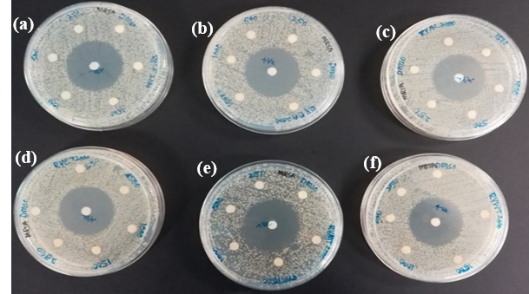
Figure S1. Antibacterial activity of N. lappaceum sequential crude extracts by disc diffusion
Positive control: Gentamicin, Solvent control; DMSO, EA: Ethyl acetate; AC: Acetone
(a) K. pneumonia (b) S. enterica (c) P. aeruginosa (d) MRSA (e) B. subtilis (f) S. pogenes

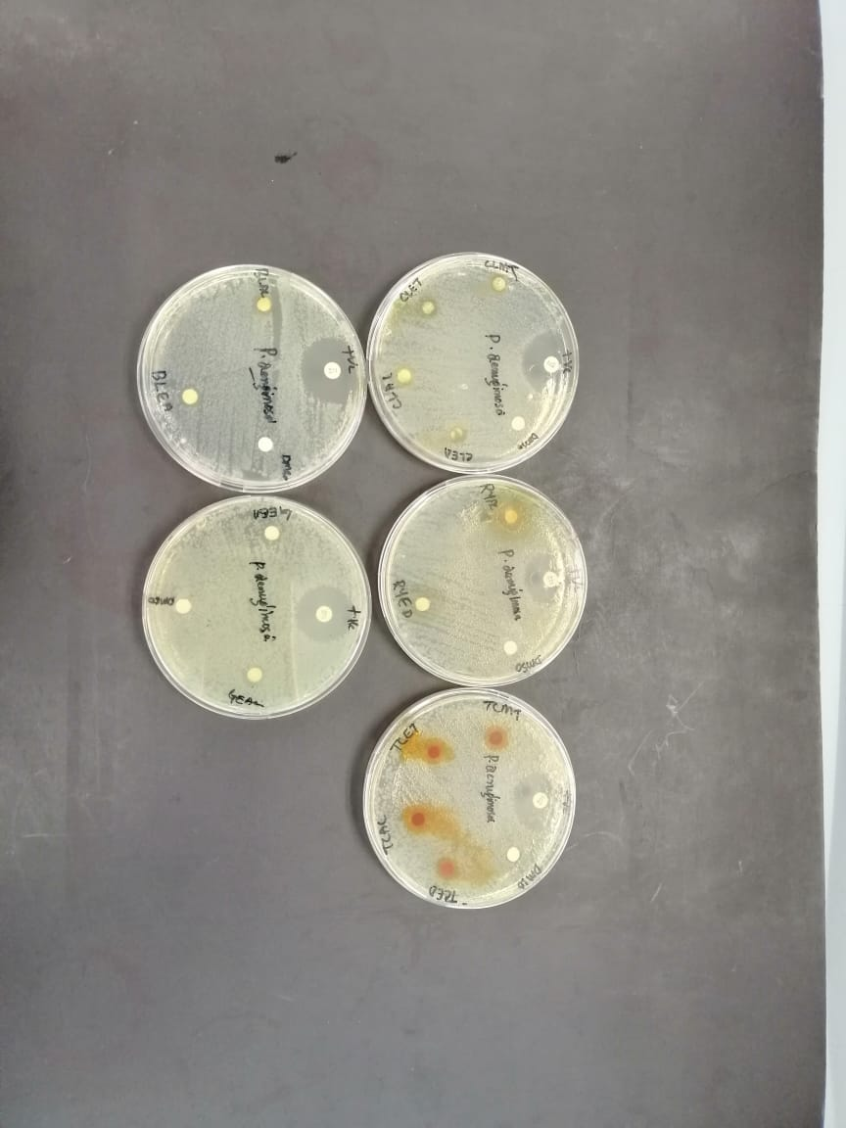
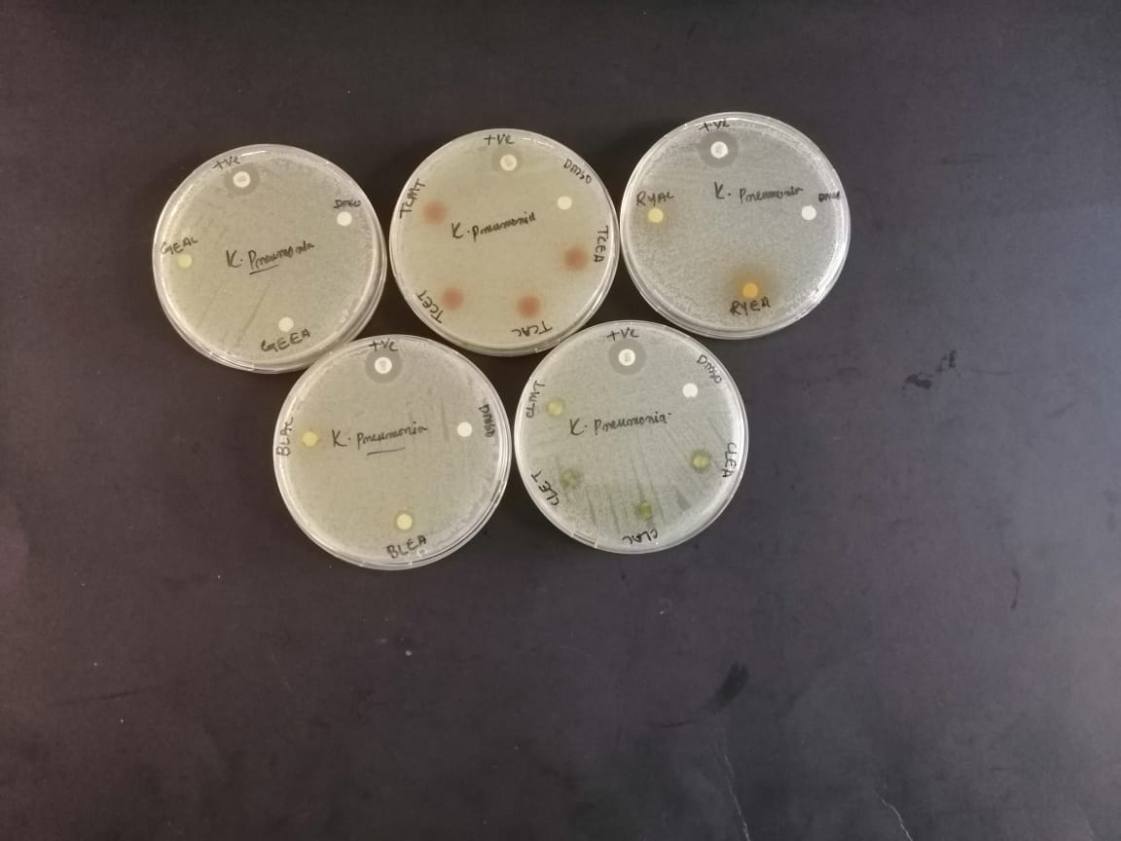
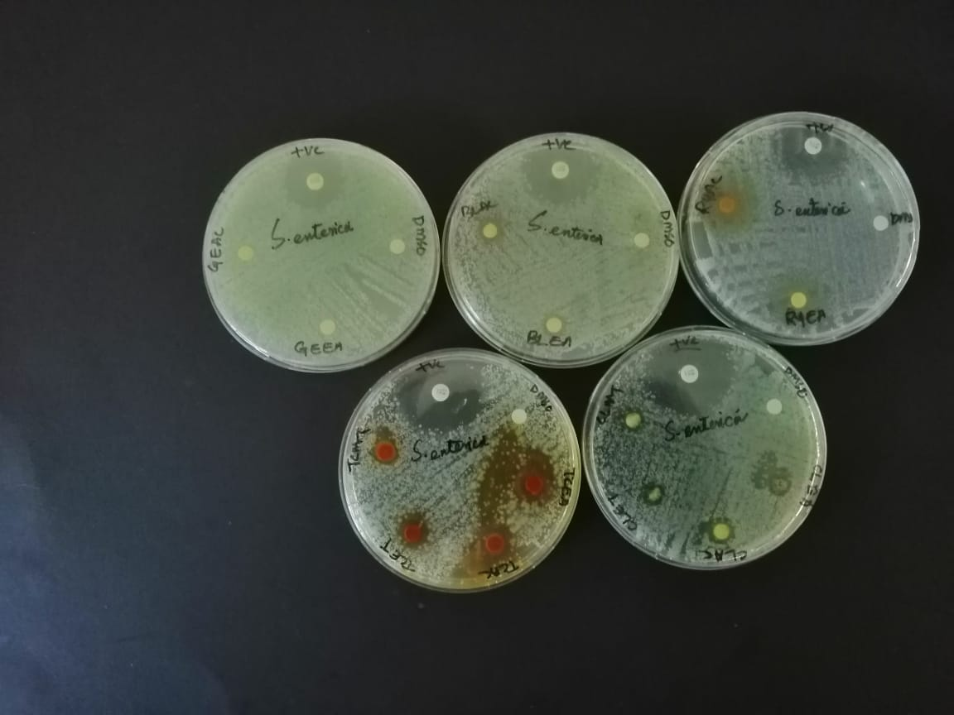
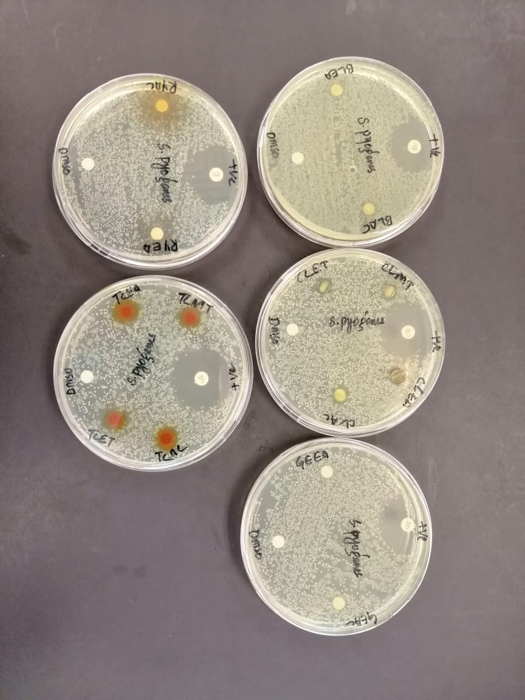
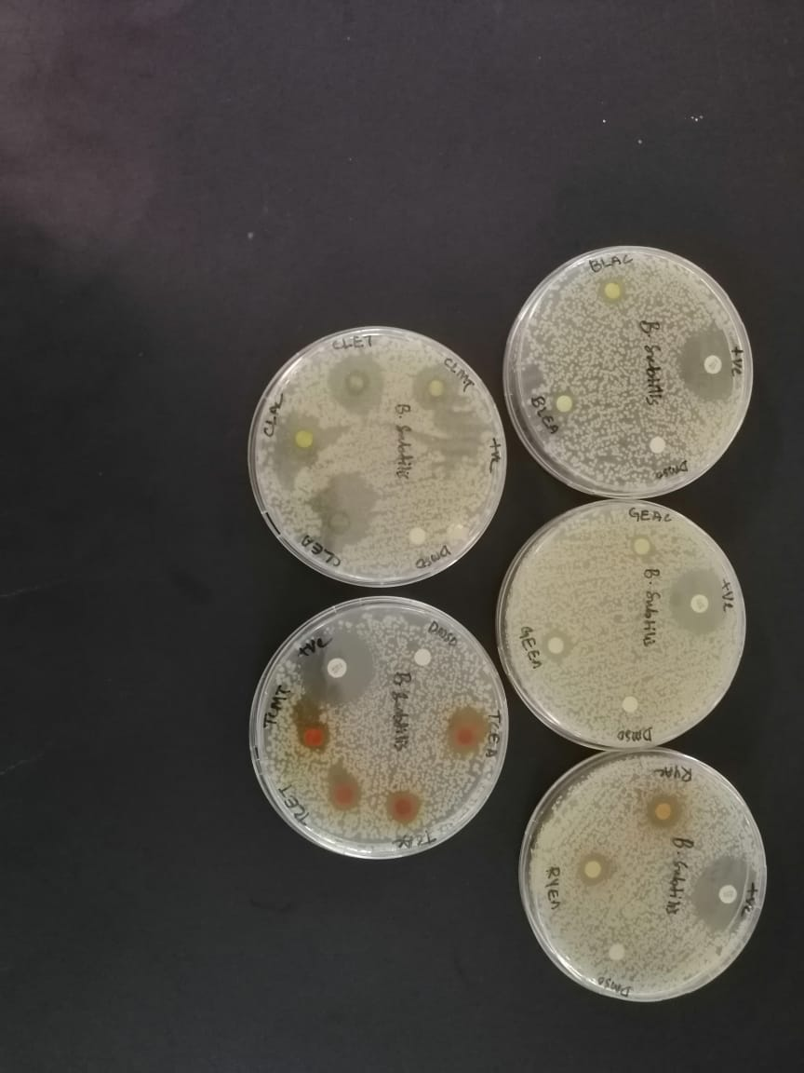
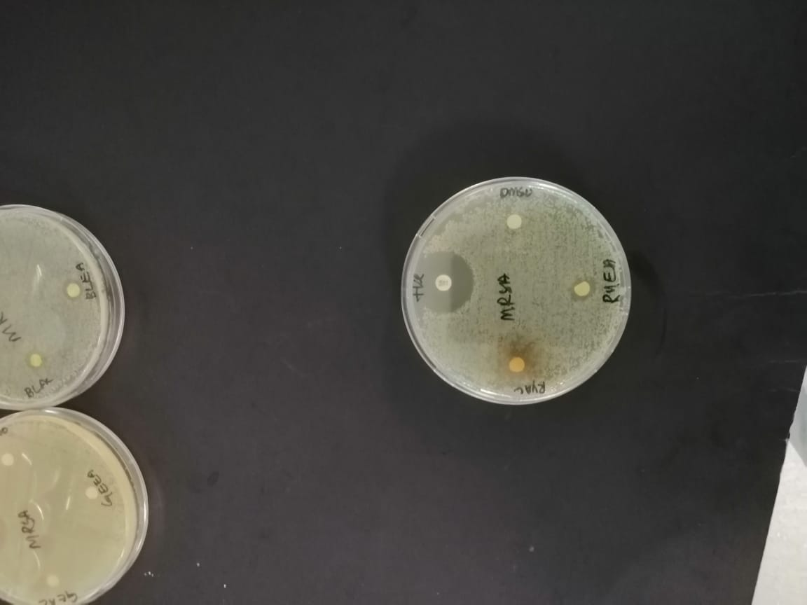
Figure S2. Antibacterial activity of N. lappaceum direct crude extracts by disc diffusion
(A)
(B)
(C)
(D)
(E)
(F)

Positive control: Gentamicin, Solvent control; DMSO, EA: Ethyl acetate; AC: Acetone
S. pogenes (A), B. subtilis (B), MRSA (C), P. aeruginosa (D), K. pneumonia (E), S. enterica (F).

Potential in-vitro antibacterial activities of yellow rambutan fruit epicarp extracts.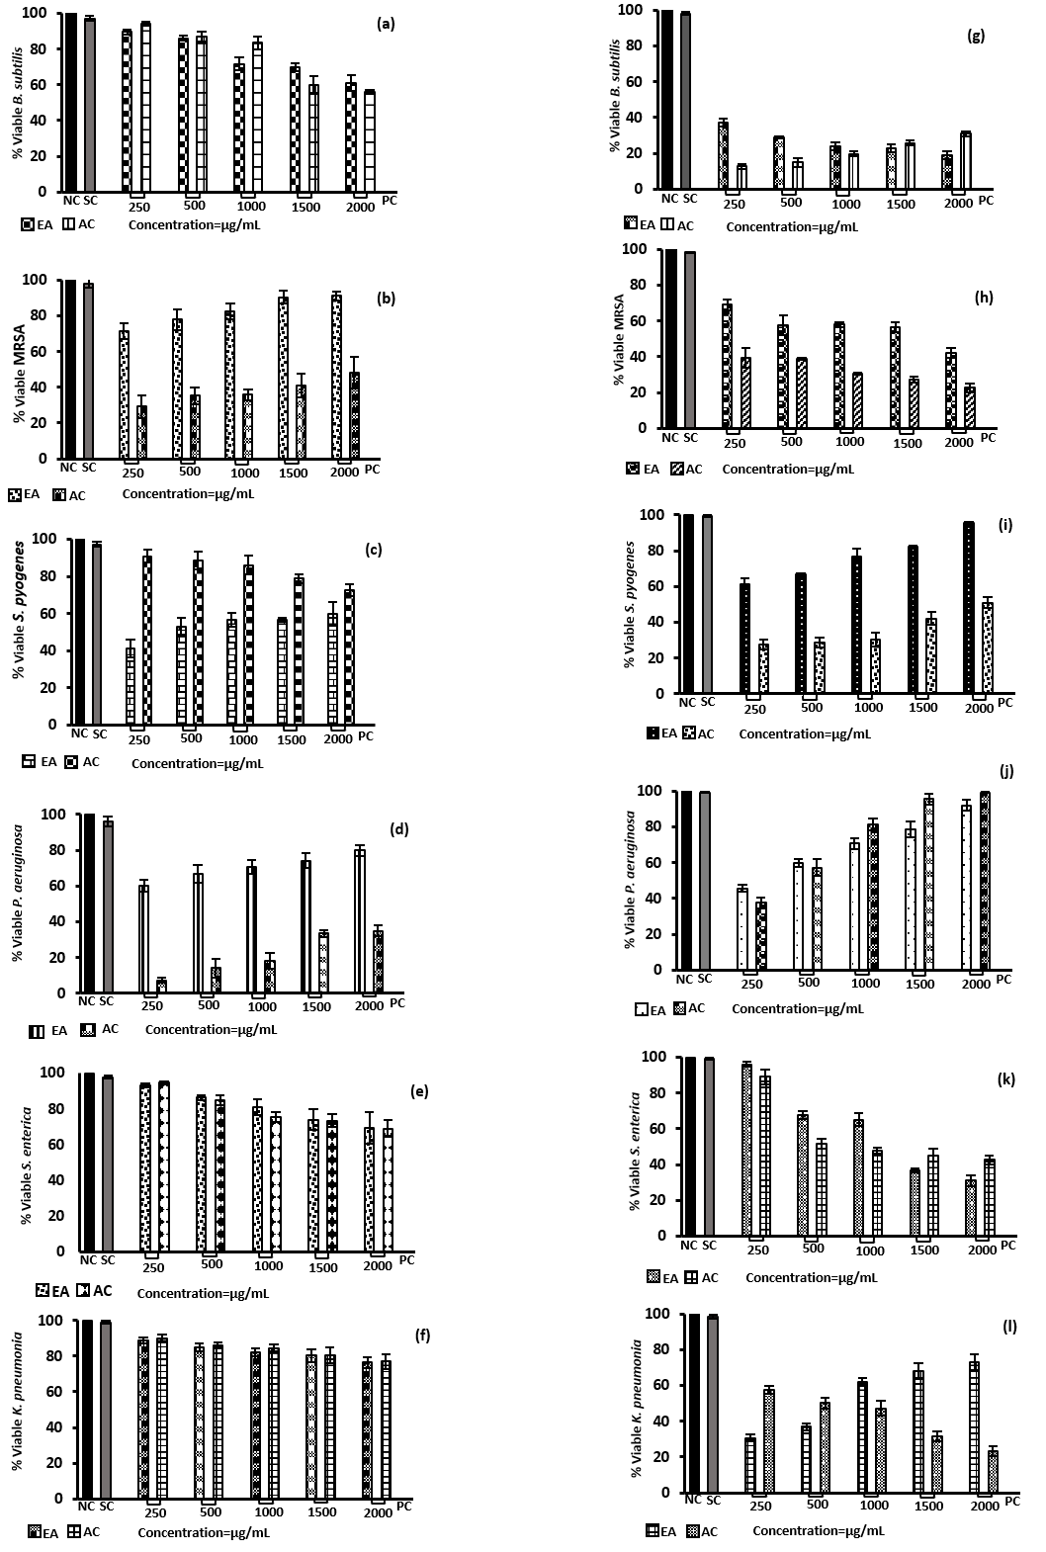EA; ethyl acetate extract, AC; acetone extract, SC; solvent control (<1%DMSO), NC; negative control, (only bacterial) PS; Positive control (Gentamicin, 10µg/mL)
(See figure on above page)
Figure S3. Percentages of antibacterial activity of N. lappaceum sequential and direct crude extracts of ethyl acetate and acetone by broth dilution assay. The crude (sequential; a-f, and direct; g-l) fractions were screened against gram-positive and gram-negative pathogens. (a, g) B. subtilis. (b, h) MRSA. (c, i) S. pyogenes. (d, j) P. aeruginosa. (e, k) S. enterica. (f, l) K. pneumoniae. The results are demonstrative of some experiments achieved in triplicate and expressed as the mean ± standard error.

HPLC analysis of N. lappaceum sequential extracts:
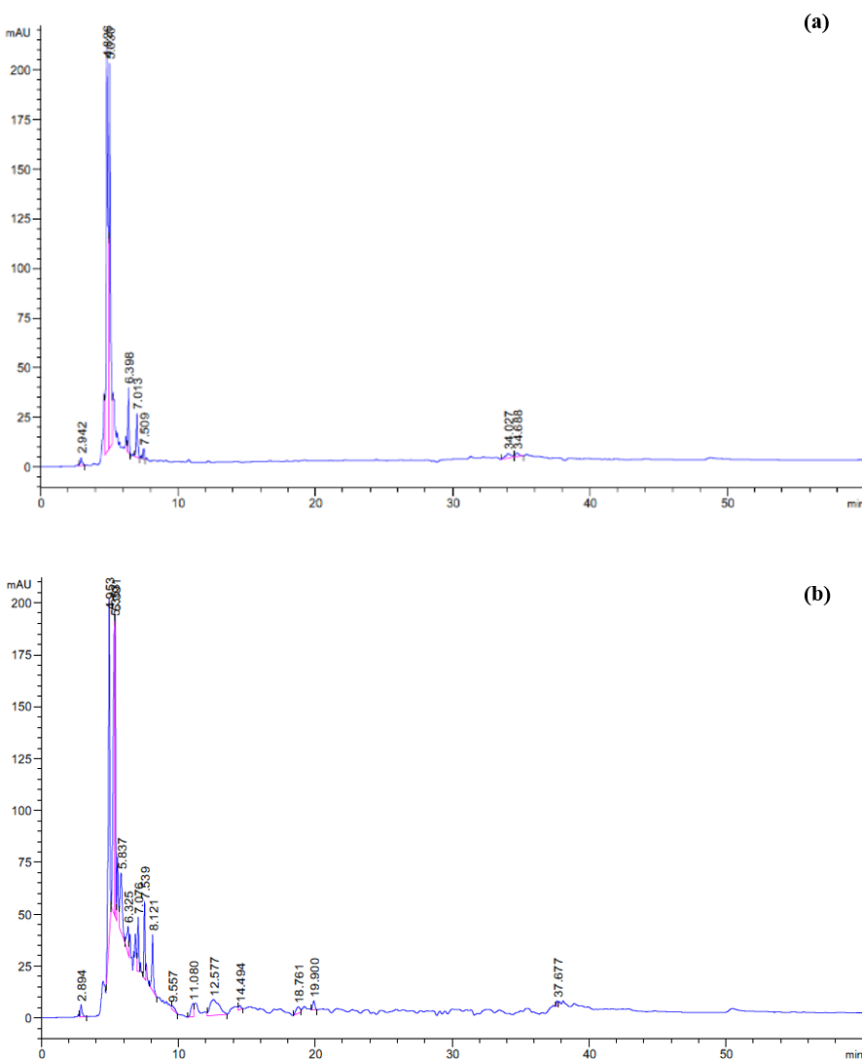
Figure S4. HPLC-UV chromatogram of sequential fraction for (a) ethyl acetate (b) acetone.

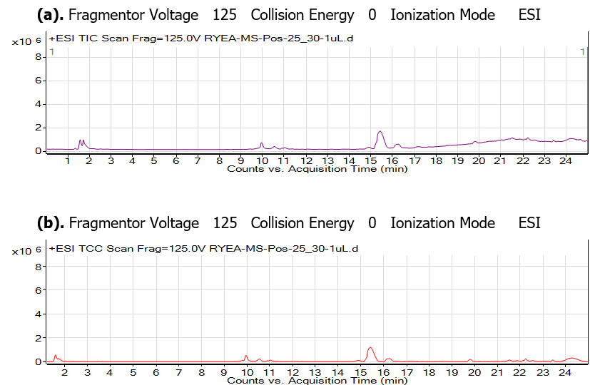
LC-MS analysis of N. lappaceum sequential extracts:

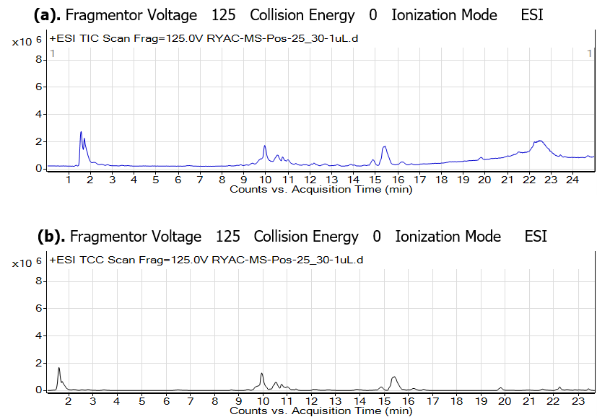
Figure S5. N. lappaceum ethyl acetate extract was subjected to LCMS qualitative analysis using positive ion mode. a) Total ion current (TIC) chromatogram and b) Total compound chromatogram (TCC).
Figure S6. N. lappaceum acetone extract was subjected to LCMS qualitative analysis using positive ion mode. a) Total ion current (TIC) chromatogram and b) Total compound chromatogram (TCC).
GC-MS analysis of N. lappaceum sequential and direct extracts:
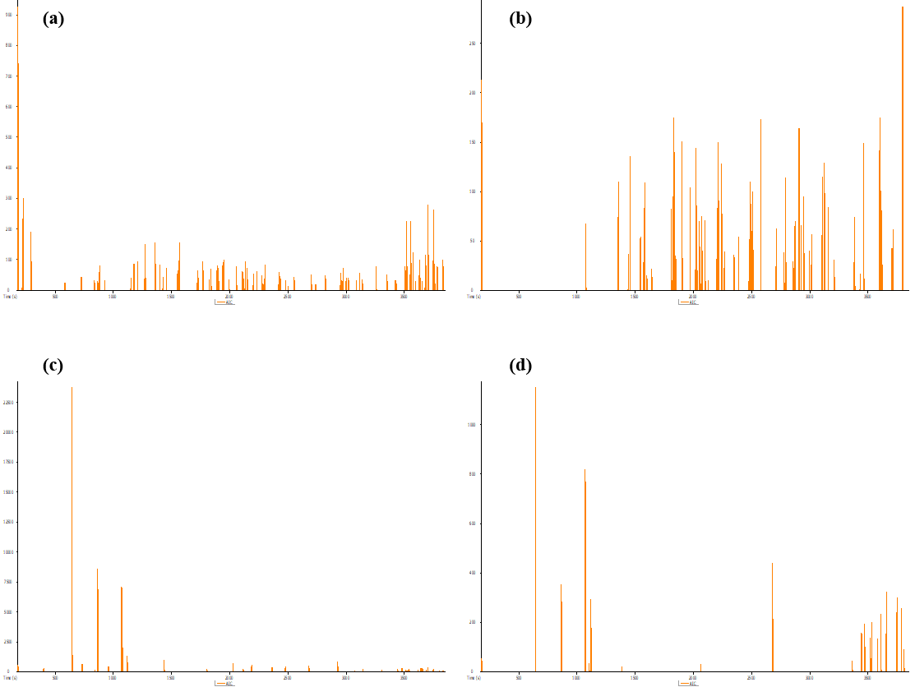
Figure S7: GC-MS chromatogram of sequential and direct extracts of N. lappaceum. Compounds were identified based on % peak area. (a) sequential ethyl acetate fraction. (b) sequential acetone fraction. (c) direct ethyl acetate fraction. (b) direct acetone fraction.

Druggable Pocket Prediction
A.  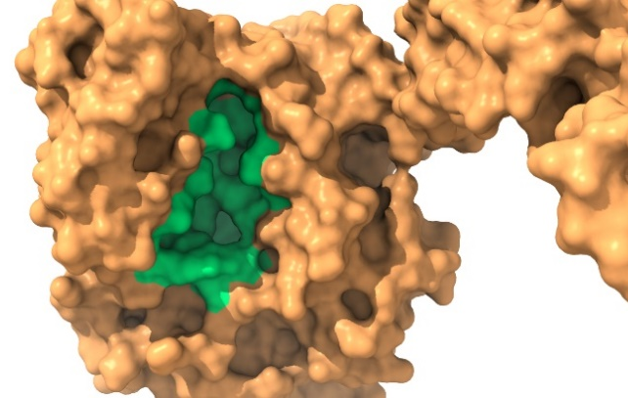 | B.  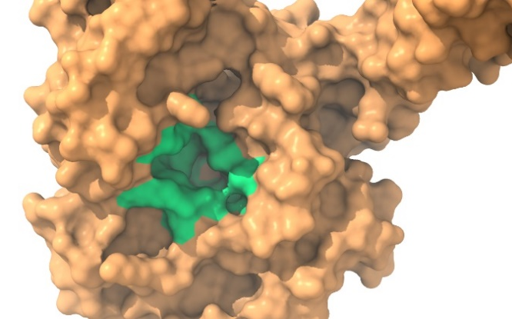
C.
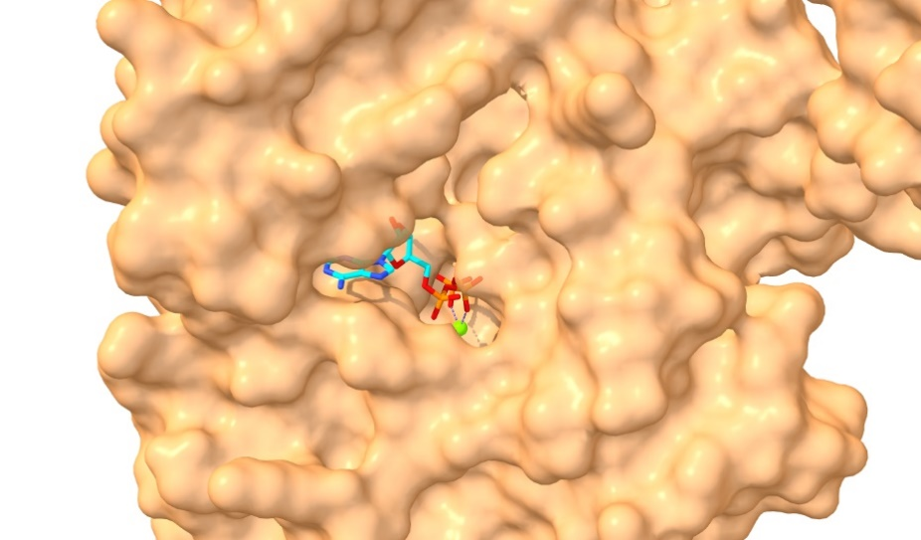
Figure S8. Visualization of P2Rank predicted docking pocket (green) of A. Pseudomonas aeruginosa and B. Staphylococcus aureus DnaK proteins via ChimeraX. C. ATP-bound (cyan coloured) structure of E. coli DnaK protein (brown) deposited in PDB (PDB ID: 4JNE, Chain: A) visualized for comparison to the predicted pocket.

MD Simulation: Energy Minimization and Equilibration
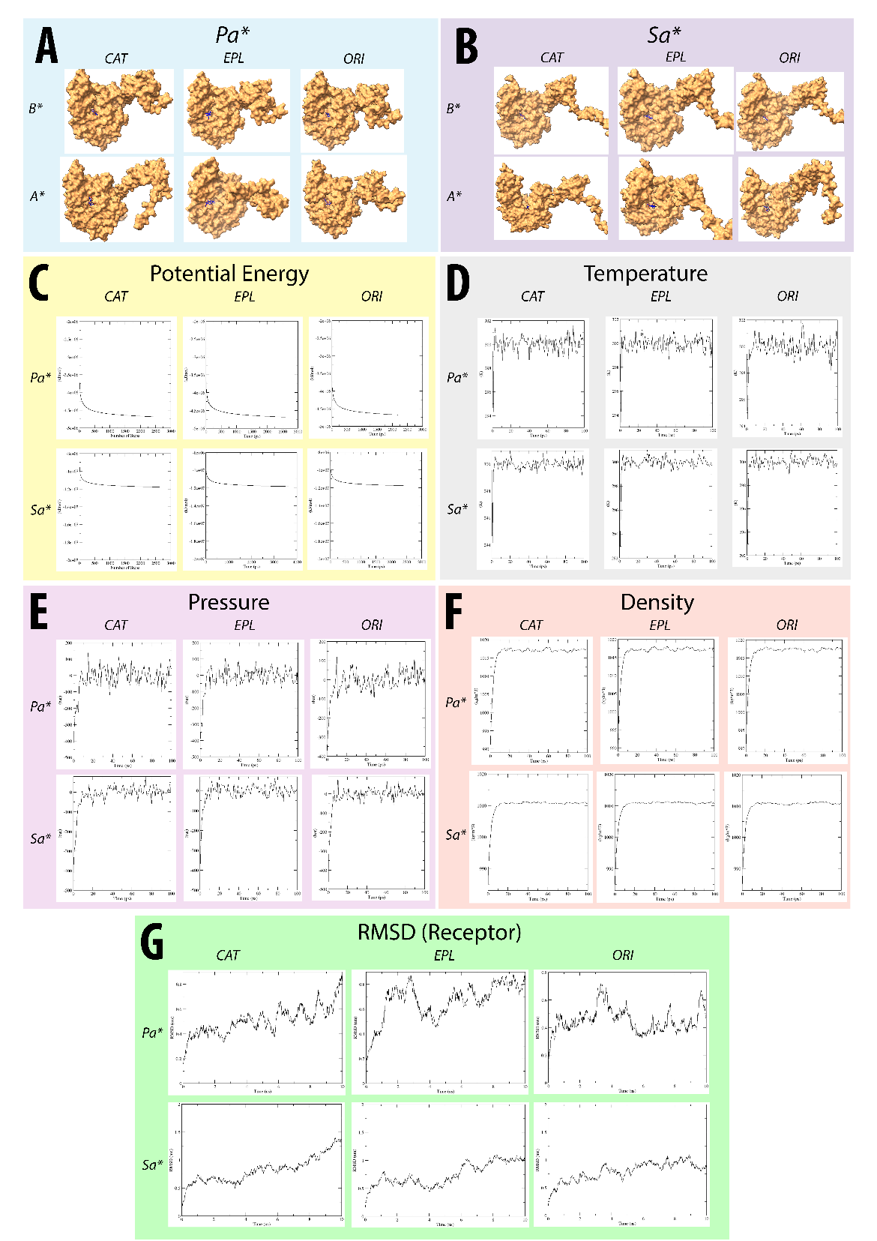
Figure S9. Energy minimization, NVT/NPT equilibration, and MD simulation for DnaK-ligand complexes. A. Full view of DnaK-ligand complexes before and after simulation. Convergence of energies, for instance, B. potential energies during steepest descent energy minimization, C. temperature during NVT equilibration, as well as D. pressure and E. densities during NPT equilibration, were visualized to ensure the stabilization of systems before simulations. G. Total RMSD of DnaK protein over the course of MD were also computed. Note. B* - Before MD, A* - After MD, Pa* - P. aeruginosa, Sa* - S. aureus, CAT – Catechin, EPL – Eplerenone, ORI – Oritin-4-beta-ol.

