Supplementary section
Figure S1. FTIR spectra of (1) and its ligand
Figure S2. FTIR spectra of (2) and its ligand
Figure S3. Simulated and experimental PXRD patterns of (1)

Figure S4. Simulated and experimental PXRD patterns of (2)

Table S1: Experimental bond lengths (Å) and angles (^{ο}) in (1) and (2)
Bond lengths of (1) |  | Bond lengths of (2)
Experimental | Theoretical | Experimental | Theoretical
Ca1–N 2.561(2) | 2.74766 | Ca1–O1 2.5049(15) | -
Ca1–N1¹ 2.561(2) | 2.74806 | Ca1–O2 2.3753(15) | 2.36775
Ca1–O8 2.4446(15) | 2.41309 | Ca1–O3 2.3706(15) | 2.36421
Ca1–O8¹ 2.4445(15) | 2.30391 | Ca1– O101¹ 2.3725(16) | 2.35928
Ca1–O11 2.6891(17) | 3.10462 | Ca1– N107² 2.6142(18) | 2.60094
Ca1–O11¹ 2.6890(17) | 3.1052 | Ca1– O109² 2.4140(15) | 2.4068
Ca1–O13 2.3177(16) | 2.2874 | Ca1– O110 2.4044(16) | 2.40939
Ca1–O13¹ 2.3177(16) | 2.2873 | Ca2– O1 2.5411(16) | 2.54318
 |  | Ca2– O4 2.4784(16) | 2.48034
 |  | Ca2– O5 2.3750(17) | 2.38055
 |  | Ca2–O6 2.3396(17) | 2.3472
 |  | Ca2– O201 2.2724(17) | 2.28263
 |  | Ca2– N207³ 2.5694(18) | 2.55898
 |  | Ca2–O210³ 2.3658(15) | 2.35651
Bond angles of (1) |  | Bond angles of (2)
N1¹–Ca1–N1 173.79(8) | 165.37 | O1–Ca1–O2 72.07(6) | -
N1¹–Ca1–O11¹ 58.40(5) | 53.3585 | O1–Ca1–O3 149.00(5) | 148.6150
N1–Ca1–O11¹ 115.51(5) | 112.0141 | O1–Ca1–O110 88.40(5) | 88.5039
O8¹–Ca1–O8 68.95(7) | 63.3202 | O1–Ca1–O101 100.50(5) | 100.6616
N1–Ca1–O11 58.40(5) | 53.3585 | O1–Ca1–NIO7 130.26(6) | 129.8239
O8¹–Ca1–N1 122.58(5) | 129.8532 | O1–Ca1–O109 68.99(5) | 70.2349
O8¹–Ca1–N11 63.30(5) | 63.3202 | O2–Ca1–O3 77.75(6) | 77.8153
O8–Ca1–O11 115.35(5) | 113.2579 | O2–Ca1–O110 91.45(6) | 91.2683
O8–Ca1–O11¹ 173.40(5) | 163.5680 | O2–Ca1–O101 93.56(6) | 93.5176
O11¹–Ca1–O11 60.87(7) | 58.8311 | O1–Ca2–O4 70.34(5) | 70.3902
O13–Ca1–N1¹ 81.47(6) | 82.2498 | O1–Ca2–O5 92.98(5) | 93.1078
O13¹–Ca1–N11 97.19(6) | 96.5513 | O1–Ca2–O6 146.70(6) | 146.6870
O13¹–Ca1–N1 81.48(6) | 81.0888 | O1–Ca2–O201 79.22(5) | 79.2661
O13–Ca1–N1 97.19(6) | 96.0505 | O1–Ca2–N207 130.25(6) | 129.9013
O13¹–Ca1–O8 111.94(6) | 112.3713 | O1–Ca2–O210 71.74(5) | 72.3944
O13–Ca1–O8 88.66(5) | 885.3018 | O4–Ca2–O5 76.04(5) | 76.2092
O13–Ca1–O11 73.74(5) | 79.6905 | O4–Ca2–O6 77.50(6) | 77.4116
O13¹–Ca1–O11 85.05(5) | 85.3018 | O4–Ca2–O201 97.47(5) | 97.0565
O13¹–Ca1–O11¹ 73.74(5) | 74.2219
O13–Ca1–O13¹ 155.47(8) | 158.7818

Symmetry codes: (1): ¹3/2-x,3/2-y,+z (2): +x,1-y,-1/2+z; 2 +x,1-y,1/2+z; +x,+y,1+z; +x,2-y,1/2+z; +x,2-y,-1/2+z

Table S2: Selected hydrogen bonding parameters of (1)
Compound | D$-$H$∙∙∙∙$A | D$-$H (Å) | D$∙∙∙∙$A (Å) | H$∙∙∙∙$A (Å) | D$-$H$∙∙∙∙$A (^{ο})
(1) | O11–H11···O8¹ | 0.846(18) | 2.573(2) | 1.728(19) | 176(3)
 | O13–H13A···O9² | 0.845(17) | 2.834(2) | 1.989(2) | 160(3)
 | O13–H13B···O9¹ | 0.838(17) | 2.724(2) | 1.886(17) | 176(3)

Table S3: Showing the π···π interactions distances in (1)
Compound |  | π···π (Å)
(1) | i1···i2 | 4.082(8)

Table S4: Selected hydrogen bonding parameters of (2)
Compound | D$-$H$∙∙∙∙$A | D$-$H (Å) | D$∙∙∙∙$A (Å) | H$∙∙∙∙$A (Å) | D$-$H$∙∙∙∙$A (^{ο})
(2) | C105‒H105···O202 | 0.950(3) | 3.458(4) | 2.508(5) | 133.7
 | O1–H1B···O209 | 0.881(6) | 2.652(2) | 1.787(9) | 167(3)
 | O1–H1A···O109 | 0.880(6) | 2.787(2) | 2.33(3) | 113(2)
 | O1–H1A···O4 | 0.880(6) | 3.081(2) | 2.232(11) | 162(3)
 | O2–H2A···O101 | 0.85 | 2.969(2) | 2.13 | 168.1
 | O2–H2B···O210 | 0.84 | 2.764(2) | 1.95 | 164.9
 | O3–H3A···O102 | 0.89 | 2.771(2) | 1.88 | 178.1
 | O3–H3B···O102 | 0.89 | 2.690(2) | 1.81 | 172.9
 | O4–H4A···O109 | 0.88 | 2.778(2) | 1.93 | 164.4
 | O4–H4B···O5 | 0.88 | 2.911(2) | 2.14 | 145.8
 | O5–H5A···O209 | 0.85 | 2.605(2) | 1.83 | 149.9
 | O5–H5B···O110 | 0.87 | 2.769(2) | 2.00 | 145.9
 | O6–H6B···O202 | 0.87 | 2.685(2) | 1.84 | 160.4
 | O6–H6A···O201 | 0.89 | 2.827(2) | 1.95 | 168.2

Table S5: Showing the π···π interactions distances in (2)
Compound |  | π···π (Å)
(2) | i1···i2 | 3.647(8)
 | i9···i10 | 3.711(7)

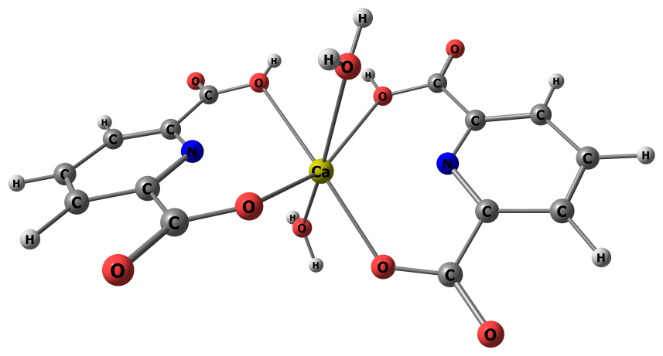
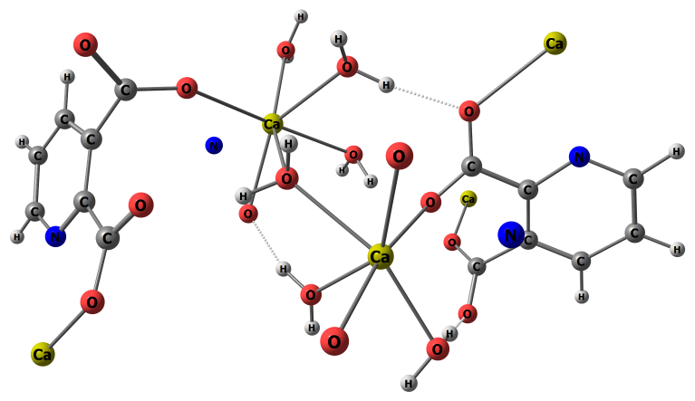
(a)
(b)

Figure S5. Optimised structure of (a) Ca(H(2,6-pyr))₂(H₂O)₂ (1) and (b) [Ca₂(2,3-pyr)₂(H₂O)₆]_{n} (2)

