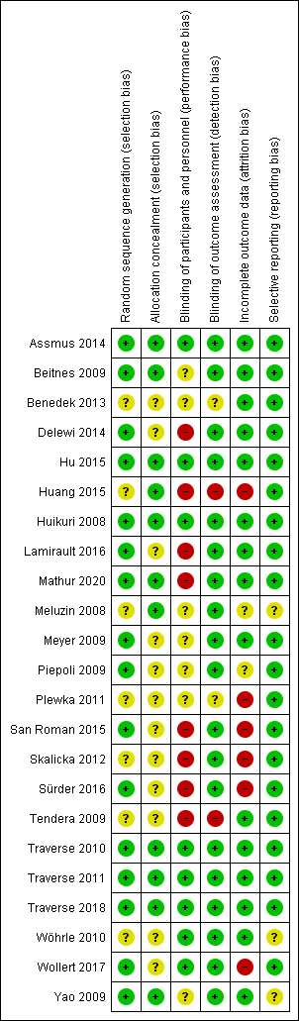
Fig. 1: Risk of bias assessment of the enrolled studies
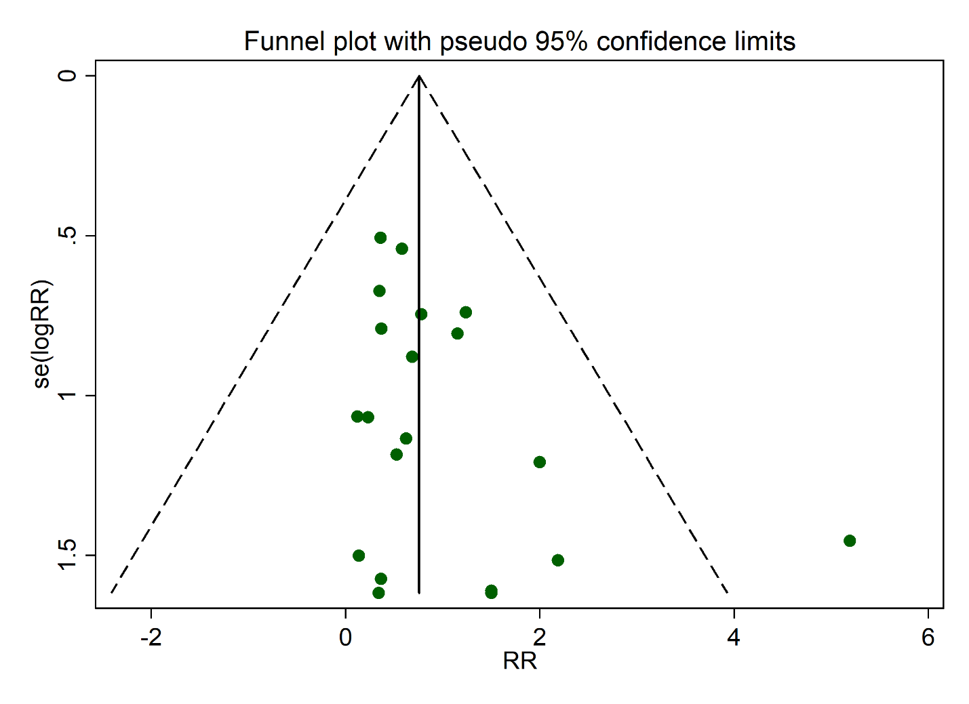
Fig. 2: Funnel plot of hospitalization for CHF
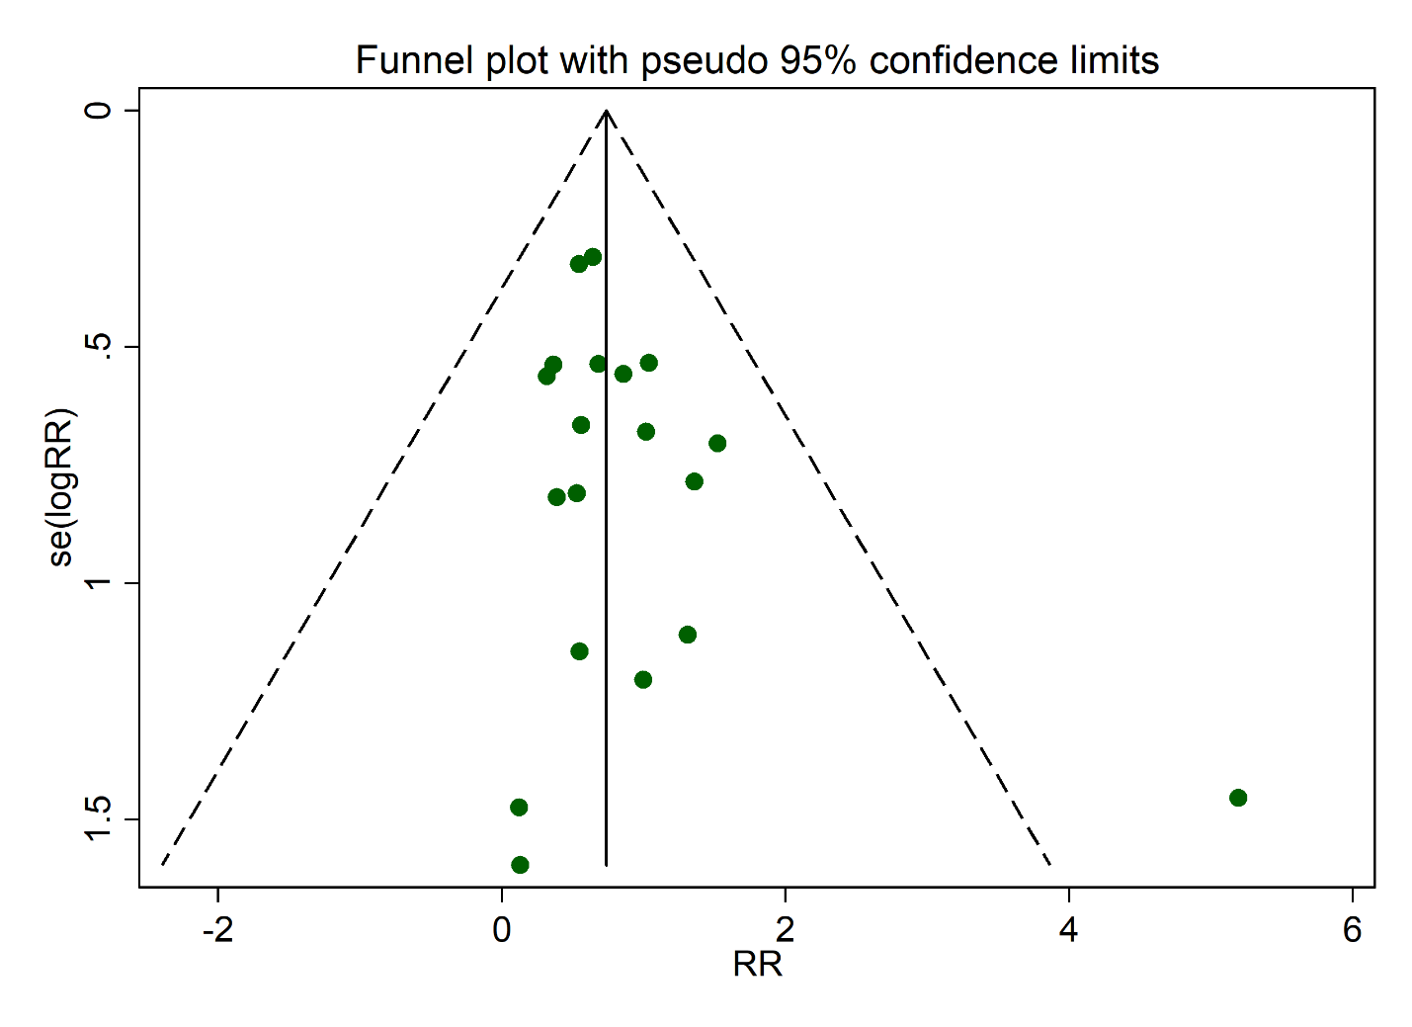
Fig. 3: Funnel plot of composite endpoints

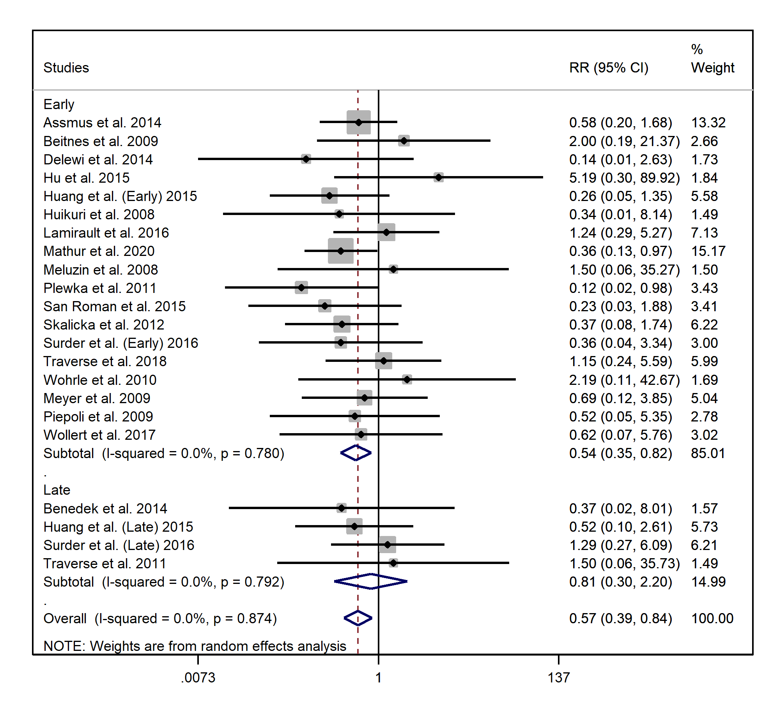
Fig. 4: Relative risk of hospitalization for CHF in early and late injection group
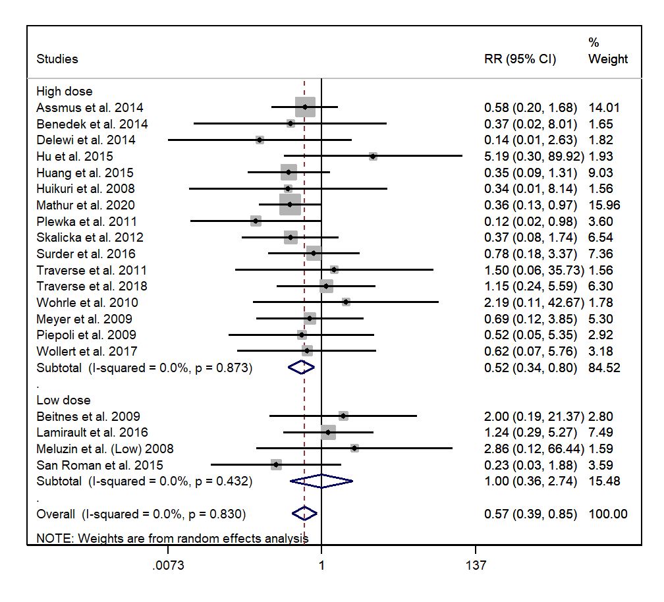
Fig. 5: Relative risk of hospitalization for CHF in low and high dose group
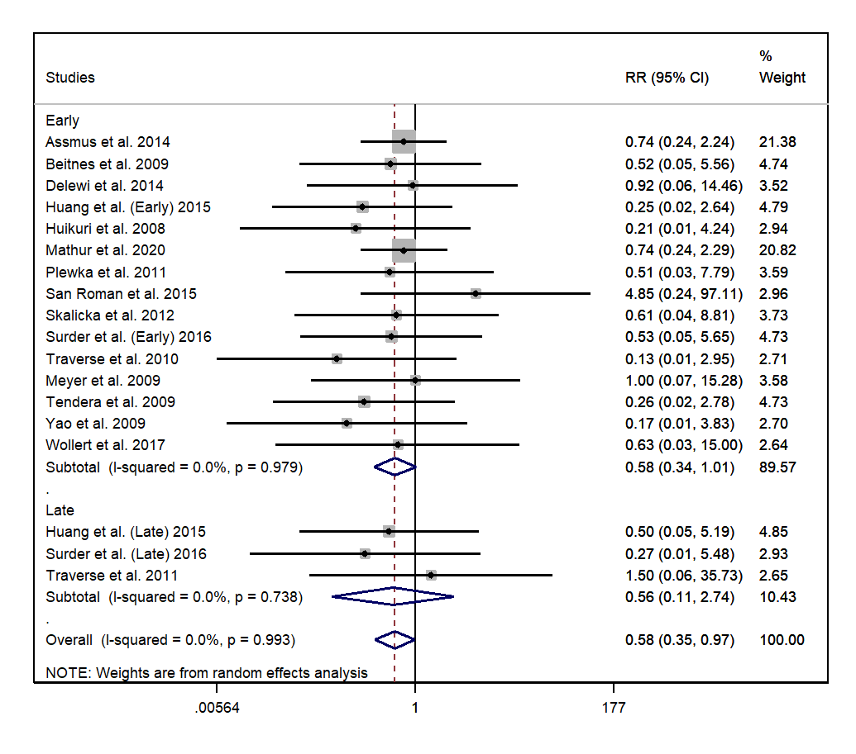
Fig. 6: Relative risk of myocardial reinfarction in early and late injection
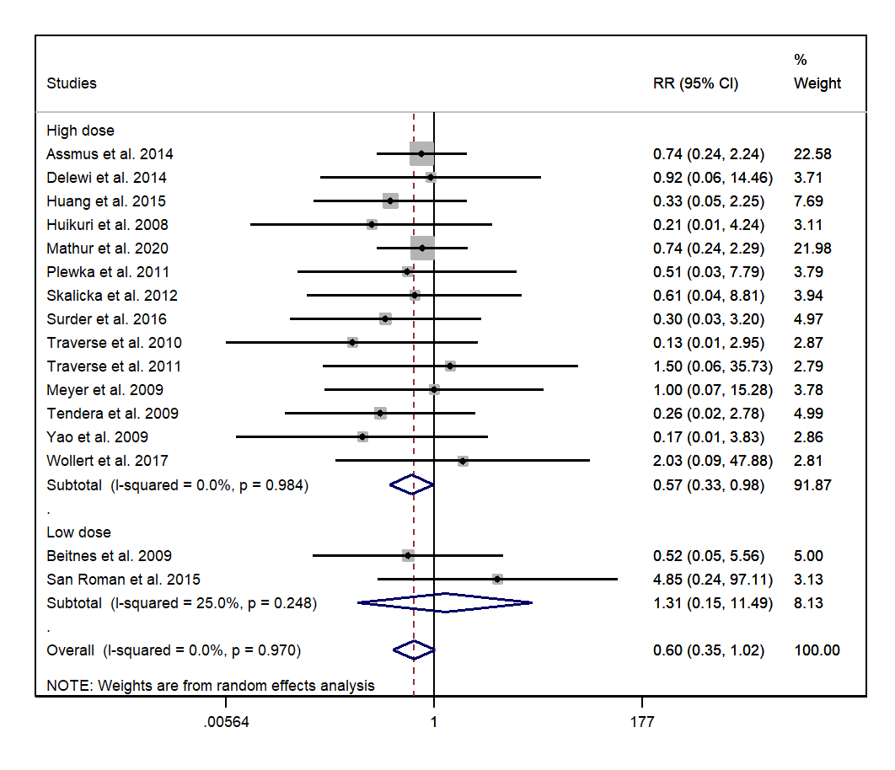
Fig. 7: Relative risk of myocardial reinfarction in high and low dose of injection
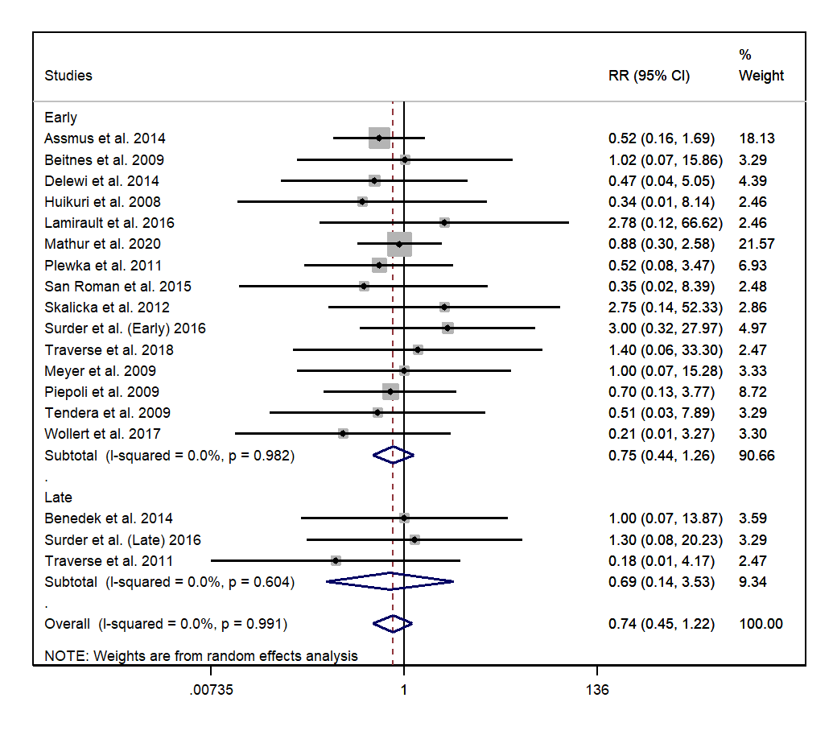
Fig. 8: Relative risk of cardiac-related mortality in early and late injection
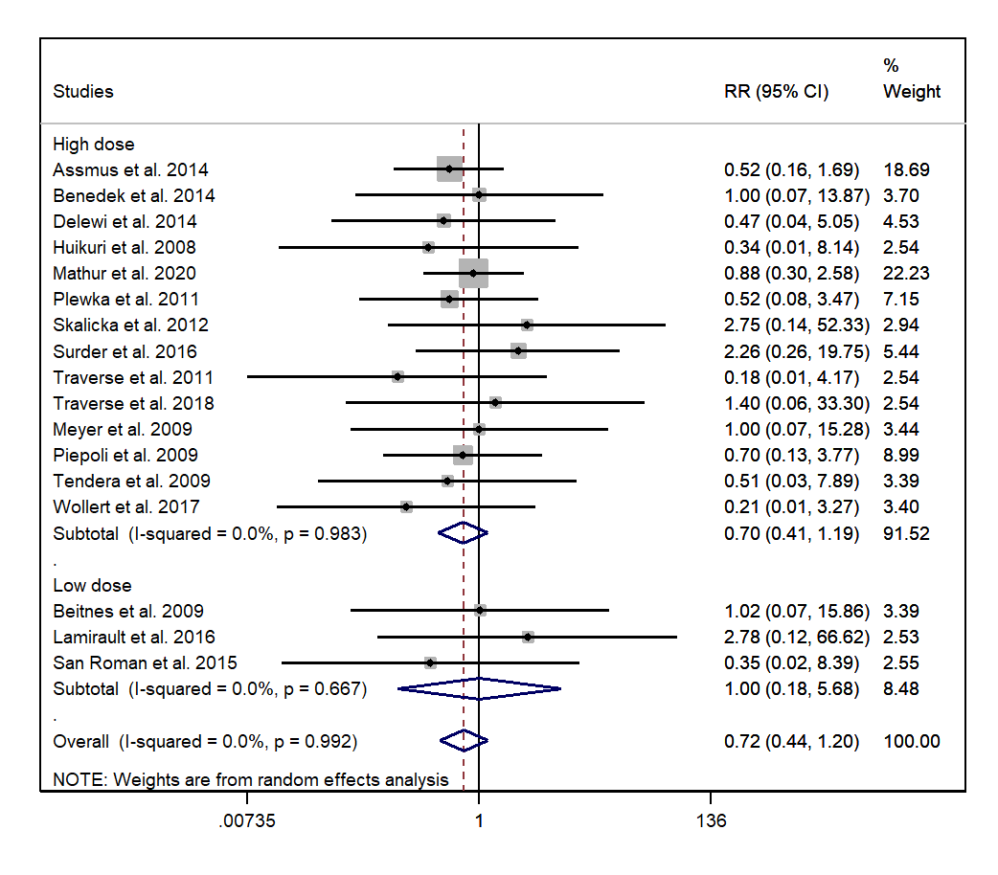
Fig. 9: Relative risk of cardiac-related mortality in high and low dose injection
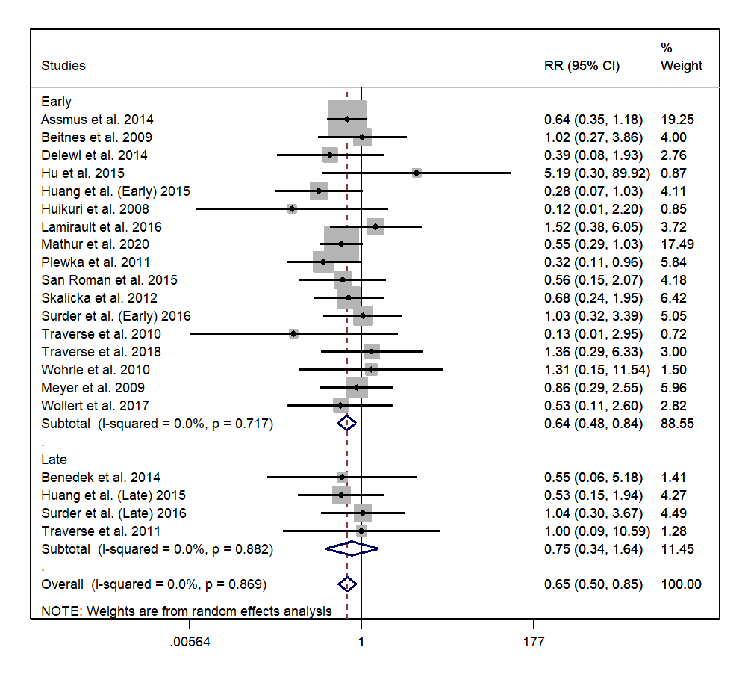
Fig. 10: Relative risk of composite endpoints in early and late group
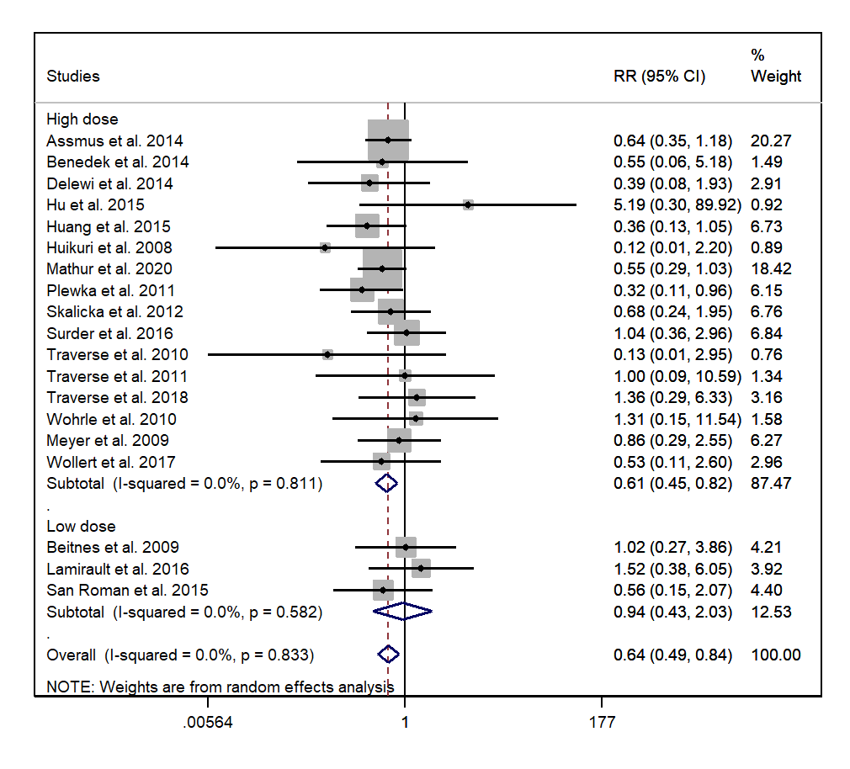
Fig. 11: Relative risk of composite endpoint in high and low dose group
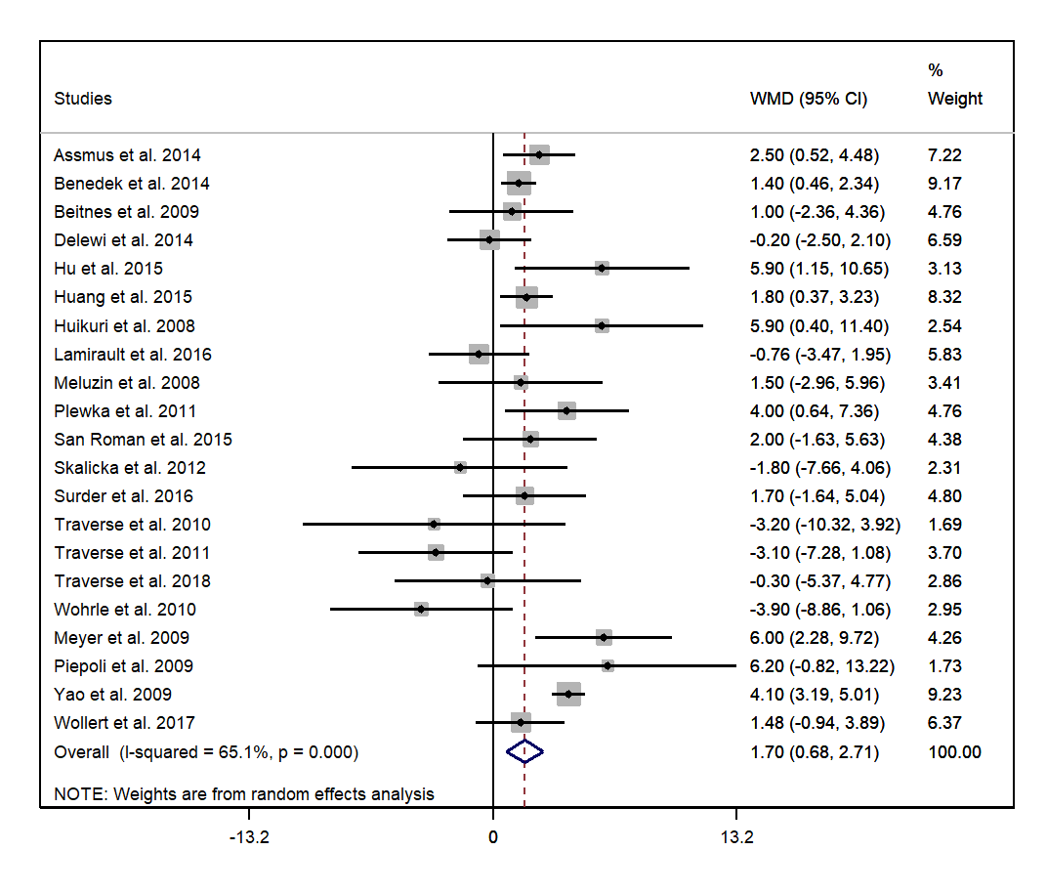
Fig. 12: Forest plot of LVEF improvement compared between control and intervention group

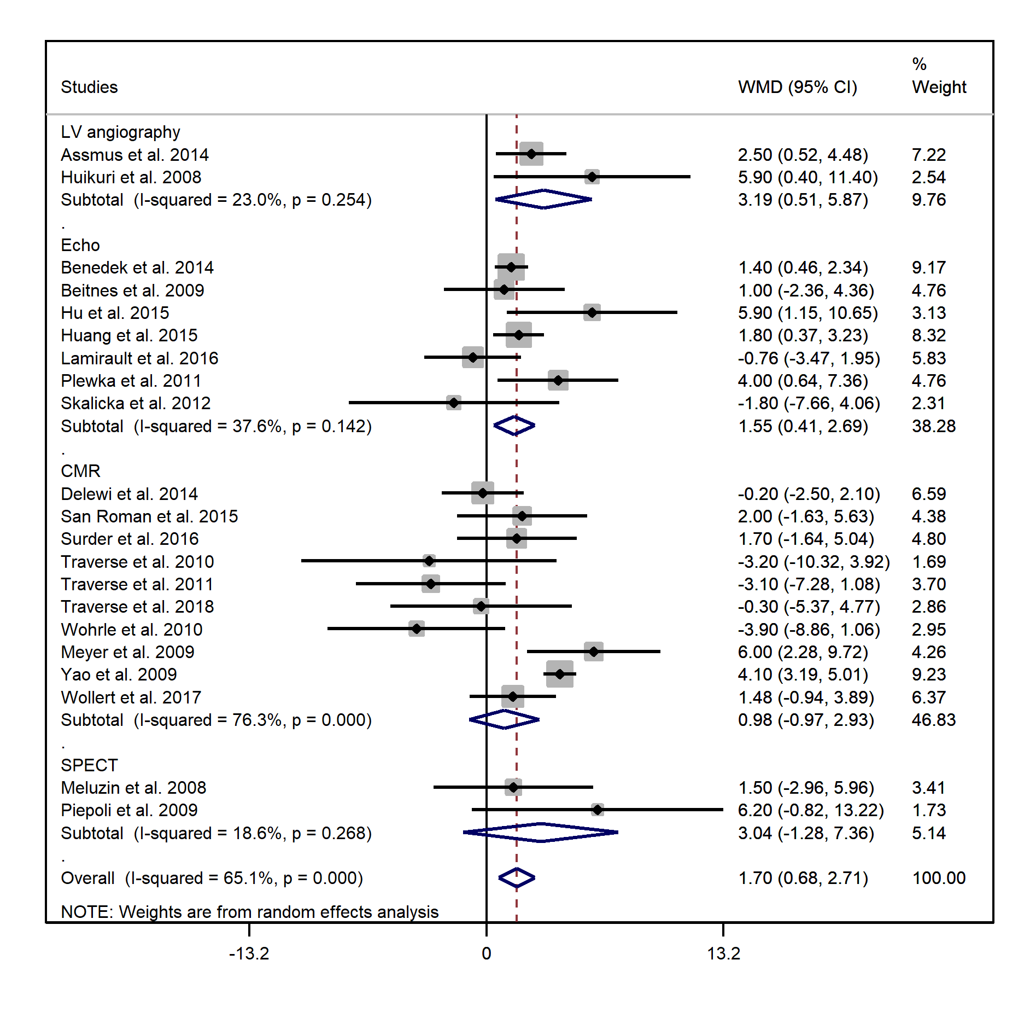
Fig. 13: Forrest plot of subgroup analysis of LVEF improvement measured by each modality
Fig. 14: Forest plot of changes in LVEDV values for all modalities
Fig. 15: Forest plot of subgroup analysis of changes in LVEDV based on each modality
Fig. 16: Forest plot of changes in LVESV before excluding the study with low correlation with others
Fig. 17: Forest plot of changes in LVESV after excluding the study with low correlation with others
Fig. 18: Forest plot of subgroup analysis changes in LVESV after excluding the study with low correlation with others

