Supplemental Figure 1
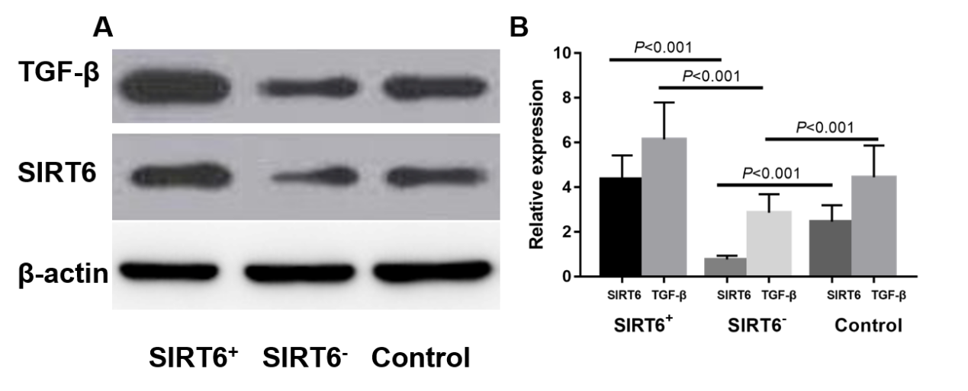
A: The SIRT6 and TGF-β expression in SIRT6 transduced and knocked out SW900 cell lines using Western blot;
B: The SIRT6 and TGF-β expression in SIRT6 transduced and knocked out SW900 cell lines using qRT-PCR.

