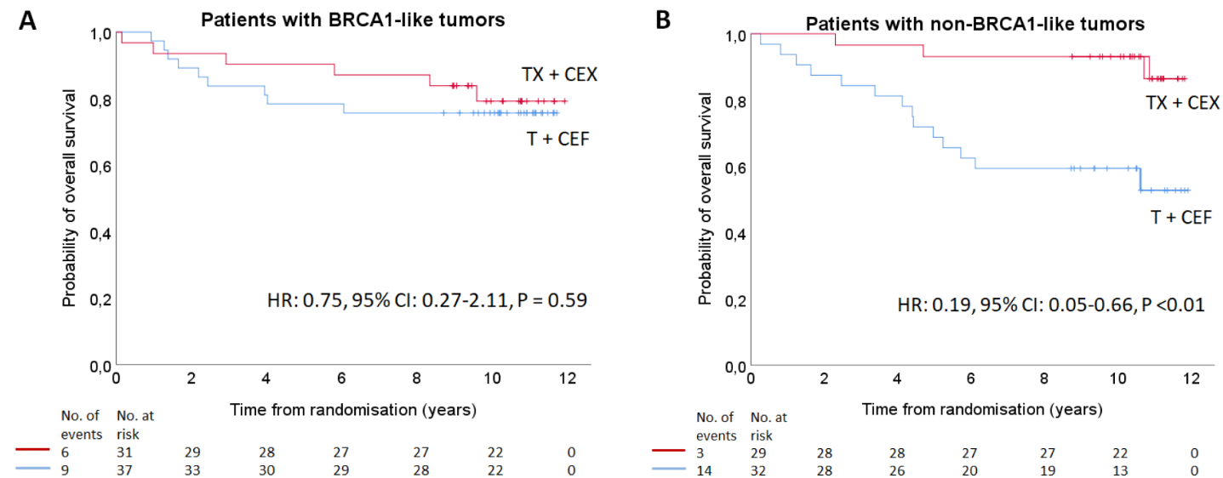

Additional file 3: Supplemental Figure 1. Overall survival for TNBC patients by BRCA1-like status and adjuvant treatment

Kaplan-Meier curves of OS for TNBC patients with BRCA1-like (A) and non-BRCA1-like tumors (B) according to treatment.
Patients had been randomly assigned between adjuvant TX+CEX or T+CEF. Number of events and patients at risk are reported below the figure. Unadjusted hazard ratios are derived from Cox regression models. Similar results were obtained when HRs were adjusted for clinico-pathological variables.
HR: hazard ratio; CI: confidence interval; TX+CEX: 3 cycles of capecitabine plus docetaxel 3-weekly, followed by 3 cycles of cyclophosphamide, epirubicin and capecitabine, 3-weekly; T+CEF: 3 cycles of docetaxel 3-weekly, followed by 3 cycles of cyclophosphamide, epirubicin, and fluorouracil, 3-weekly.

