CASC15 mediated upregulation of SERPINE1 by sponging miR-30c-5p correlates with poor prognosis and immune infiltration of gastric cancer

Jun Xie¹, Kai Liu ¹, Feng Yan^{1*}
¹ Department of Gastrointestinal Surgery, Zhongshan Hospital, Xiamen University, No. 201-209 Hubin South Road, Xiamen, 361004 People’s Republic of China
*Address of correspondence: Feng Yan, M.D., No. 201-209, Hubin South Road, Siming District, Xiamen, Fujian, China. E-mail: yanfeng@xmzsh.com

(Supplementary Table S1 and Supplementary Fig.1)

Supplementary table S1

82 prognostic mRNAs significantly associated with survival in gastric cancer
Gene | KM | HR | HR.95L | HR.95H | CoxPvalue
PCOLCE2 | 8.84E-05 | 1.41411174 | 1.10655336 | 1.8071537 | 0.0056208
CD36 | 0.0370385 | 1.31568056 | 1.10706472 | 1.56360808 | 0.00184146
CNTN1 | 0.00178668 | 1.30633031 | 1.11463967 | 1.53098704 | 0.00096542
LOX | 0.00208486 | 1.28365929 | 1.0996926 | 1.49840161 | 0.00155577
SPARC | 0.00994944 | 1.27234549 | 1.09358073 | 1.48033245 | 0.00182078
FAP | 0.03527669 | 1.27017683 | 1.05416574 | 1.53045116 | 0.01191679
CSRNP1 | 0.00259415 | 1.26864672 | 1.02482992 | 1.57046985 | 0.02887398
ABCA8 | 0.02104521 | 1.2679301 | 1.05122478 | 1.52930825 | 0.01305168
VCAN | 0.00302282 | 1.26735995 | 1.09425073 | 1.46785485 | 0.00156707
ZFP36 | 0.04249999 | 1.26572138 | 1.06108637 | 1.50982112 | 0.00881992
CDH11 | 0.04274297 | 1.25985502 | 1.06557257 | 1.48956037 | 0.00686737
SERPINE1 | 7.56E-05 | 1.2576172 | 1.12649147 | 1.40400621 | 4.50E-05
RGS2 | 0.00458792 | 1.25759663 | 1.09455831 | 1.44492008 | 0.00121508
SLC22A17 | 0.00514371 | 1.25100892 | 1.05713242 | 1.48044209 | 0.0091433
ADAMTS12 | 0.03640687 | 1.25013965 | 1.04800762 | 1.49125742 | 0.0130989
GPX3 | 0.04728533 | 1.24519551 | 1.10074224 | 1.40860576 | 0.00049098
SNCG | 0.00534861 | 1.2432555 | 1.09042013 | 1.41751257 | 0.00114033
PER1 | 0.03854897 | 1.24208199 | 1.05870523 | 1.45722117 | 0.00781638
GAMT | 0.02317821 | 1.23528168 | 1.08572441 | 1.4054403 | 0.00133155
KLF9 | 0.01991113 | 1.23061109 | 1.04682595 | 1.44666231 | 0.01192055
INAFM2 | 0.01842289 | 1.22954097 | 1.031986 | 1.46491425 | 0.02076243
COL5A2 | 0.01245289 | 1.21698022 | 1.04762284 | 1.4137157 | 0.01021472
OLFML2B | 0.01135643 | 1.21640662 | 1.06014179 | 1.39570487 | 0.00523087
BEX4 | 0.01331241 | 1.21472374 | 1.05316008 | 1.40107263 | 0.00755677
PDGFRB | 0.00929631 | 1.21336303 | 1.03396692 | 1.42388485 | 0.01782862
CTHRC1 | 0.00565747 | 1.20020317 | 1.06038811 | 1.35845324 | 0.00387902
COL4A5 | 0.00186764 | 1.19223209 | 1.01366436 | 1.40225642 | 0.03367808
INHBA | 0.024478 | 1.18869295 | 1.02773067 | 1.374865 | 0.01988968
MFAP2 | 0.01452305 | 1.18387298 | 1.03635559 | 1.35238836 | 0.01292273
NPTX1 | 0.02242792 | 1.1819015 | 1.0186013 | 1.37138167 | 0.02760191
CAV1 | 0.0437917 | 1.18174192 | 1.04336539 | 1.33847066 | 0.00858736
CIDEC | 0.0401144 | 1.178723 | 1.02293965 | 1.35823058 | 0.02299231
DCN | 0.02544197 | 1.16089529 | 1.02540372 | 1.31429002 | 0.01846556
FNDC1 | 0.01248248 | 1.15917325 | 1.04641947 | 1.28407648 | 0.0046692
CST2 | 0.03378802 | 1.15804724 | 1.03677003 | 1.29351098 | 0.0093296
COL1A2 | 0.04602493 | 1.15704438 | 1.02355195 | 1.307947 | 0.01969301
AADAC | 0.022214 | 1.15455399 | 1.0440169 | 1.27679438 | 0.00512809
COL8A1 | 0.04817897 | 1.14694232 | 1.01451416 | 1.2966568 | 0.02851259
MSRB3 | 0.02227424 | 1.14646033 | 1.02061992 | 1.28781662 | 0.02122142
FN1 | 0.04179344 | 1.13908642 | 1.02412911 | 1.26694755 | 0.01642968
FABP4 | 0.01959327 | 1.13762317 | 1.02509028 | 1.26250975 | 0.01525548
APOD | 0.00709242 | 1.13580529 | 1.0539319 | 1.22403891 | 0.00084969
PPP1R14A | 0.02115669 | 1.13217372 | 1.0094826 | 1.26977655 | 0.03390206
PDK4 | 0.00083575 | 1.1271455 | 1.02560424 | 1.23873998 | 0.01296095
AGT | 0.03292202 | 1.12066503 | 1.01049443 | 1.24284715 | 0.0309517
COL10A1 | 0.04566079 | 1.11749583 | 1.01644718 | 1.22859009 | 0.02160047
ASCL2 | 0.04063768 | 0.90746456 | 0.83306813 | 0.9885049 | 0.02608945
CLRN3 | 0.00105475 | 0.90508807 | 0.82282575 | 0.9955746 | 0.04024831
TRIM31 | 0.03482549 | 0.89876295 | 0.80998139 | 0.99727581 | 0.04428643
PLEKHS1 | 0.01570919 | 0.88151041 | 0.78310429 | 0.99228241 | 0.03677564
POF1B | 0.01577382 | 0.87536816 | 0.77328578 | 0.99092656 | 0.03537499
EPS8L3 | 0.0135524 | 0.87438951 | 0.7726994 | 0.98946241 | 0.03334539
FAM83H | 0.00341727 | 0.84315722 | 0.72373539 | 0.98228456 | 0.02857175
SLCO4A1 | 0.03438488 | 0.83782693 | 0.73026219 | 0.96123553 | 0.01160622
TNFAIP2 | 0.00859908 | 0.82955939 | 0.71989555 | 0.95592866 | 0.00979451
SLC1A5 | 0.03156206 | 0.8269305 | 0.70424168 | 0.97099343 | 0.0203843
LRFN4 | 0.03692424 | 0.82539845 | 0.69544914 | 0.97962964 | 0.02813271
ASF1B | 0.03898292 | 0.82491975 | 0.69453953 | 0.97977518 | 0.02832605
BATF2 | 0.03024558 | 0.82268799 | 0.71254263 | 0.94985971 | 0.00778165
PKMYT1 | 0.03368262 | 0.8158217 | 0.66910025 | 0.99471648 | 0.04418475
PRR15L | 0.03710448 | 0.8130583 | 0.71409428 | 0.92573744 | 0.00177654
FAM111B | 0.03790487 | 0.81016084 | 0.65728723 | 0.99859021 | 0.04847426
STIL | 0.00970741 | 0.79947928 | 0.64250495 | 0.99480497 | 0.04478514
FCHO1 | 0.02778693 | 0.79869872 | 0.64318764 | 0.99180955 | 0.04191121
LRP8 | 0.02817951 | 0.79388666 | 0.63162532 | 0.9978321 | 0.04786471
NFE2L3 | 0.01027767 | 0.78853513 | 0.65552752 | 0.94853019 | 0.01171591
NDC1 | 0.00779352 | 0.78744118 | 0.62417222 | 0.99341753 | 0.04383446
CDC25A | 0.01557225 | 0.78509092 | 0.62701725 | 0.98301564 | 0.03491864
EFNA4 | 0.00521562 | 0.78400945 | 0.63574623 | 0.96684935 | 0.02289532
UHRF1 | 0.0462768 | 0.7729087 | 0.62638817 | 0.95370233 | 0.0163062
CLSPN | 0.00677432 | 0.77224659 | 0.60355297 | 0.98809023 | 0.03985577
MLEC | 0.00699022 | 0.77020172 | 0.60496951 | 0.98056296 | 0.03406672
FEN1 | 0.0044596 | 0.76834622 | 0.61509895 | 0.9597739 | 0.02024898
RAD54L | 0.0114631 | 0.76266937 | 0.60308578 | 0.96448065 | 0.02370383
EZH2 | 0.00601741 | 0.752275 | 0.59834877 | 0.94579901 | 0.01480746
DDIAS | 0.0189078 | 0.74839934 | 0.5724682 | 0.9783977 | 0.03403206
PVT1 | 0.00608982 | 0.7482921 | 0.58540221 | 0.95650659 | 0.02061391
TMC6 | 0.02373846 | 0.74496811 | 0.58258494 | 0.95261212 | 0.01892688
LMNB2 | 0.03064367 | 0.73993887 | 0.59491809 | 0.92031077 | 0.00680804
BRI3BP | 0.02838432 | 0.73387546 | 0.59456786 | 0.90582292 | 0.00396531
MASTL | 0.04289152 | 0.71757778 | 0.53161365 | 0.96859415 | 0.03012363
SLC52A3 | 0.00155978 | 0.7116865 | 0.5933554 | 0.853616 | 0.00024649

Supplementary Fig.1
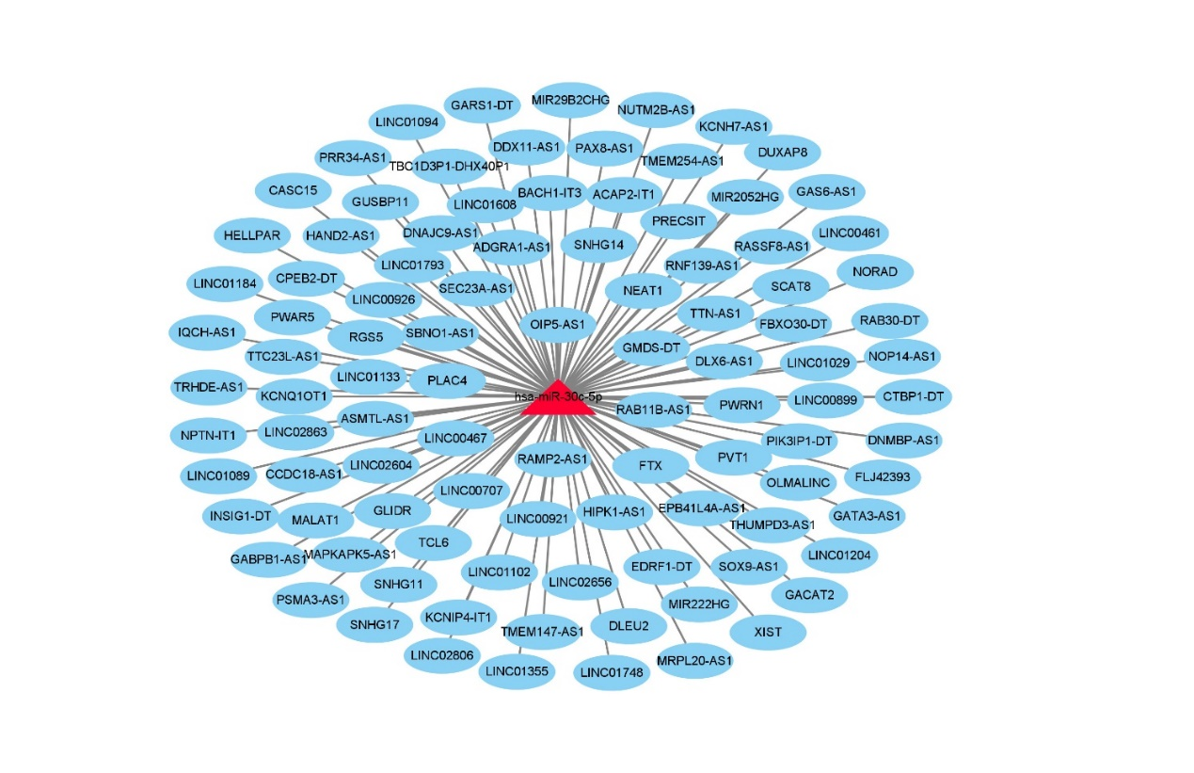Supplementary Fig.1 Identification of potential upstream lncRNAs of miR-30c-5p in STAD.

