Graphical Abstract

CAGE TEST FOR FLIES REPELLENCY

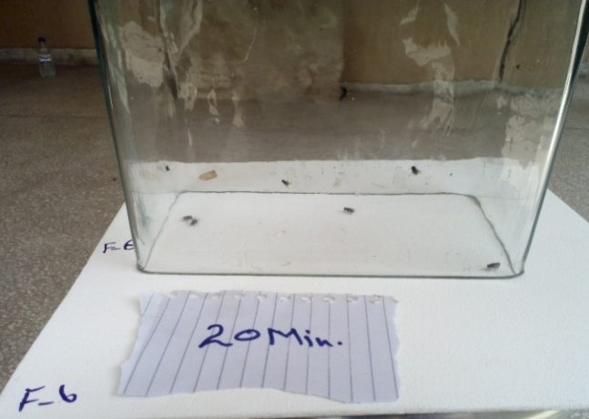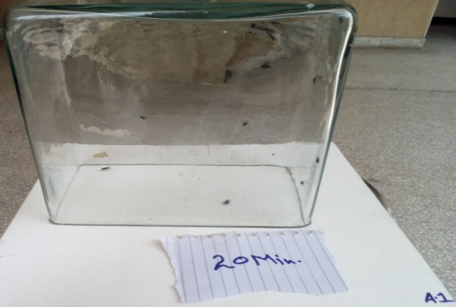

Without Additive
With Additive

