Can we predict the burden of wasting in crisis-affected countries? Findings from Somalia and South Sudan
ADDITIONAL FILE 1

Francesco Checchi¹*
Séverine Frison¹
Abdihamid Warsame¹
Kiross Tefera Abebe², UNICEF South Sudan
Jasinta Achen³, UNICEF Somalia
Eric Alain Ategbo², UNICEF South Sudan
Mohamed Ag Ayoya³, UNICEF Somalia
Ismail Kassim², UNICEF South Sudan
Biram Ndiaye³ UNICEF Somalia
Mara Nyawo⁴ UNICEF ESARO

1 Department of Infectious Disease Epidemiology, Faculty of Epidemiology and Population Health, London School of Hygiene and Tropical Medicine
2 United Nations Children’s Fund, South Sudan Country Office
3 United Nations Children’s Fund, Somalia Country Office
4 United Nations Children’s Fund, East and Southern Africa Regional Office

* Corresponding author: Francesco.checchi@lshtm.ac.uk

Causal framework for wasting
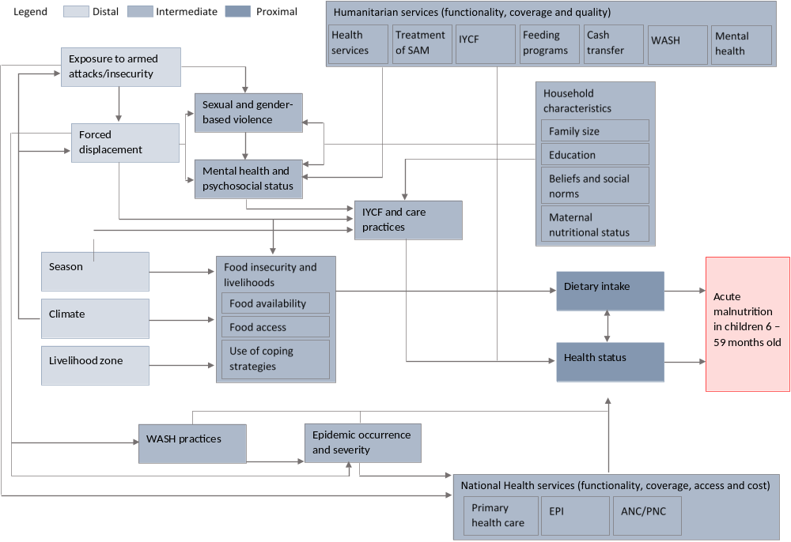
Figure S5. Causal framework for wasting among children, used to identify potential predictors.

Predictive accuracy of additional Somalia models
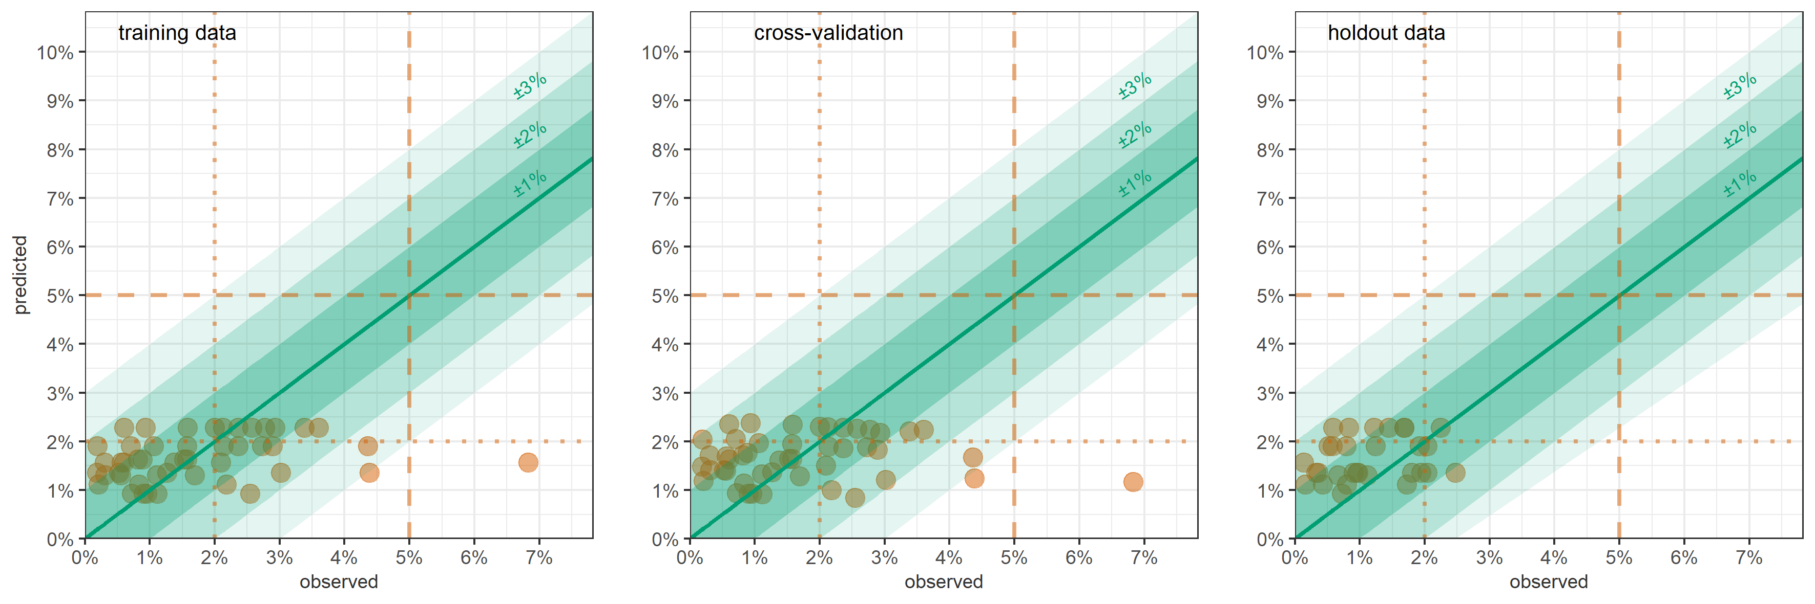
Figure S6. GLM-predicted versus observed severe wasting (MUAC + oedema) prevalence, Somalia, by district-month, on training data, LOOCV and holdout data. Shaded channels indicate different absolute deviance of predictions. Vertical dotted lines denote commonly used severe wasting prevalence thresholds.

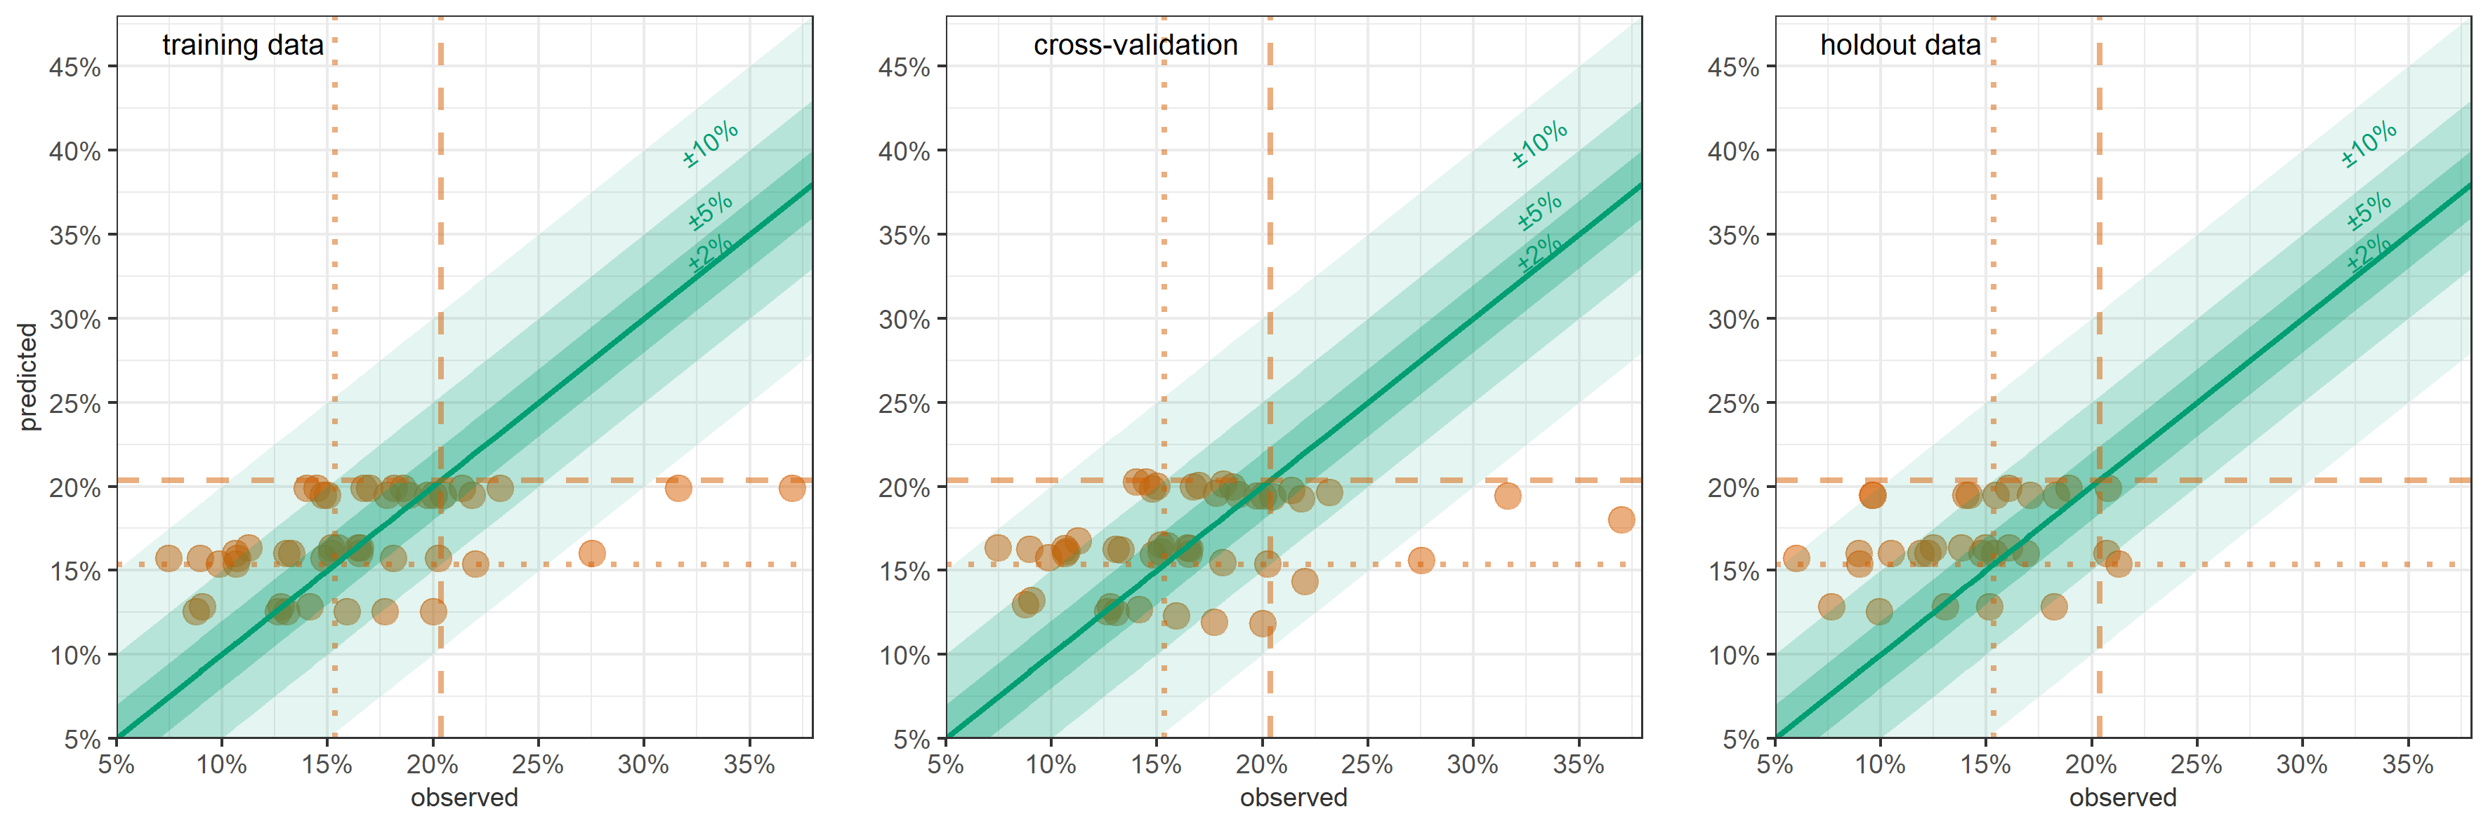
Figure S7. GLM-predicted versus observed wasting (WFH + oedema) prevalence, Somalia, by district-month, on training data, LOOCV and holdout data. Shaded channels indicate different absolute deviance of predictions. Vertical dotted lines denote commonly used wasting prevalence thresholds.

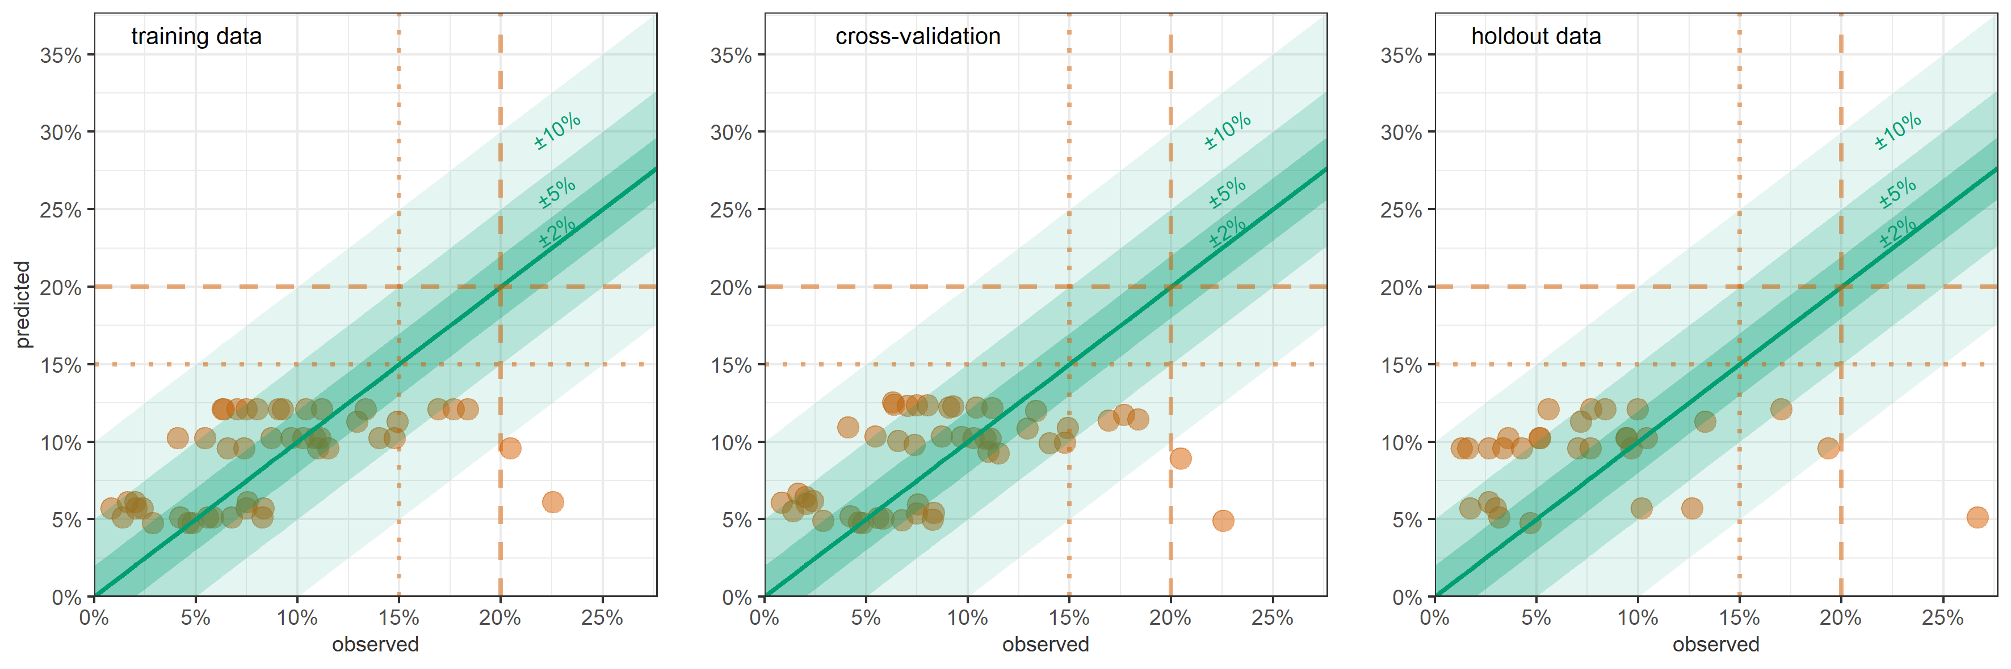
Figure S8. GLM-predicted versus observed wasting (MUAC + oedema) prevalence, Somalia, by district-month, on training data, LOOCV and holdout data. Shaded channels indicate different absolute deviance of predictions. Vertical dotted lines denote commonly used wasting prevalence thresholds.

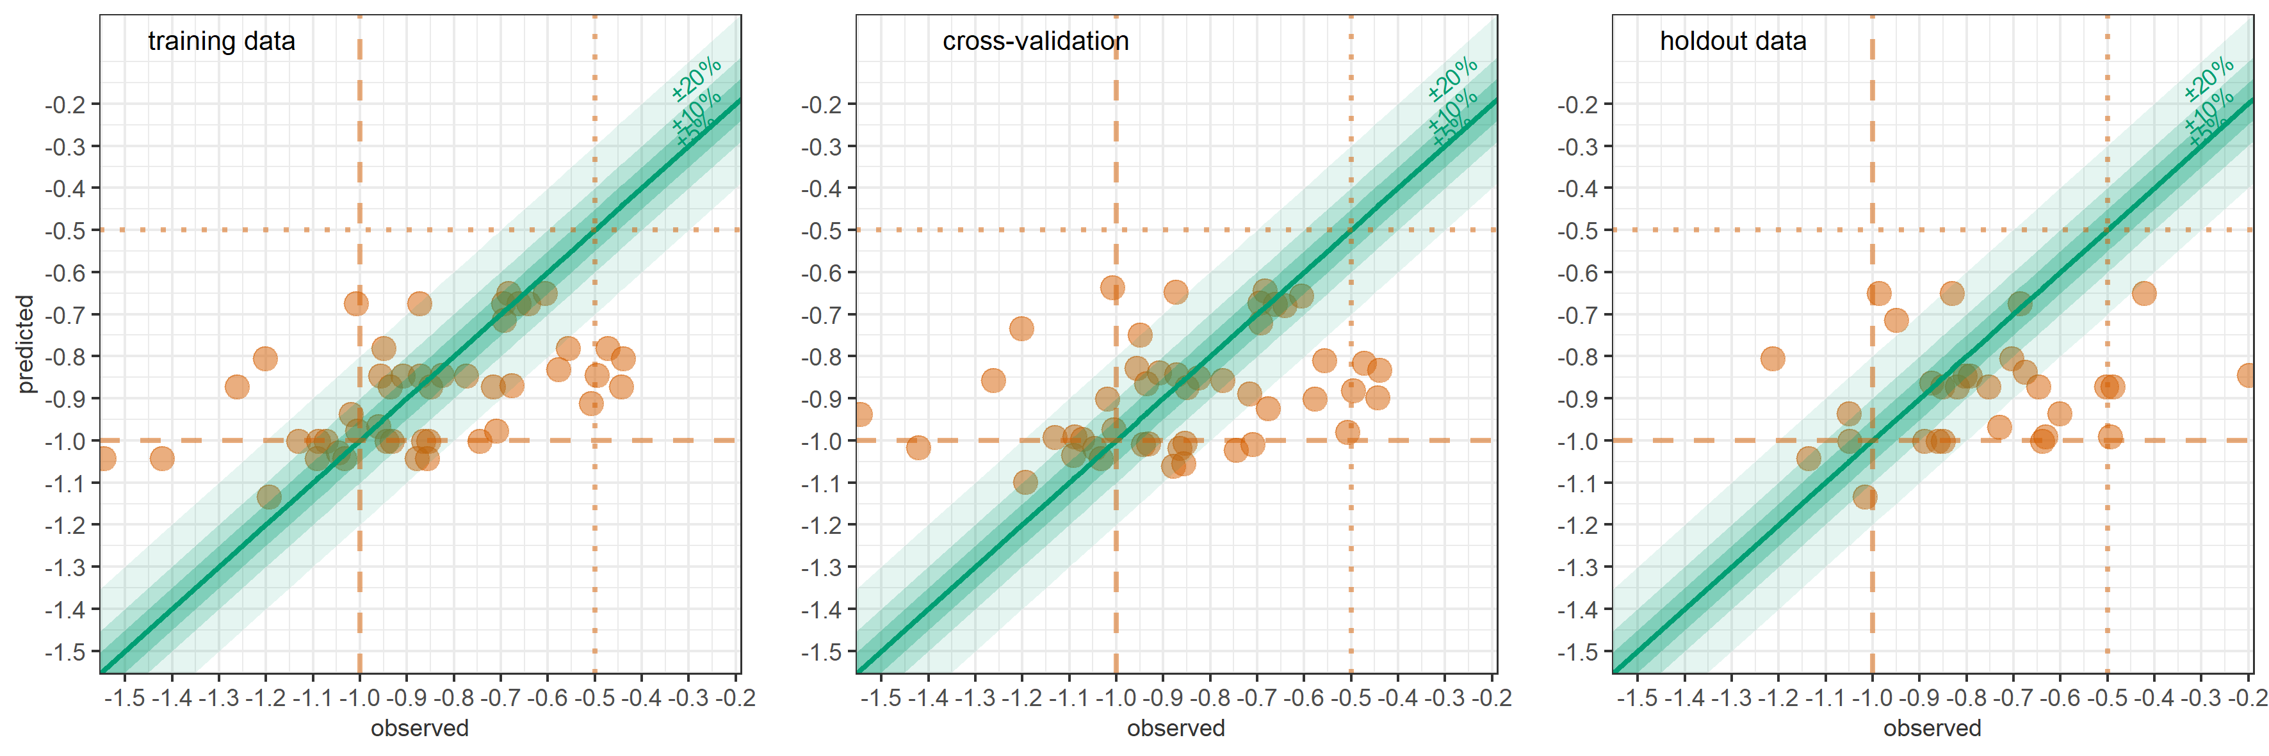
Figure S9. GLM-predicted versus observed mean WFH, Somalia, by district-month, on training data, LOOCV and holdout data. Shaded channels indicate different absolute deviance of predictions. Vertical dotted lines denote potentially useful thresholds.

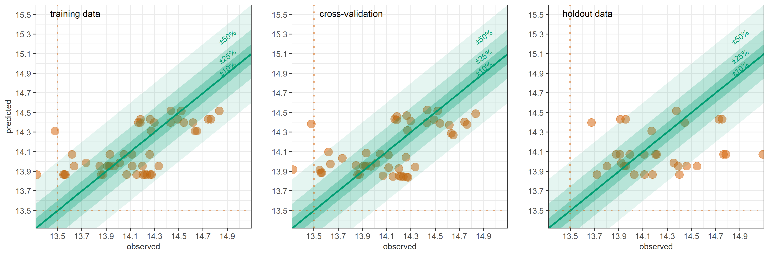
Figure S10. GLM-predicted versus observed mean MUAC, Somalia, by district-month, on training data, LOOCV and holdout data. Shaded channels indicate different absolute deviance of predictions. Vertical dotted lines denote potentially useful thresholds.

Table S7. Performance of random forest models in Somalia, by wasting outcome.
Statistic |  | Binary:  Wasting (WFH + oedema) |  | Continuous:  WFH
Estimation performance
Mean square error | training data | 0.00060 |  | 0.01057
Mean square error | LOOCV | 0.00303 |  | 0.05244
Mean square error | holdout data | 0.00265 |  | 0.06680
Relative bias | LOOCV | -5.7% |  | +7.6%
Relative bias | holdout data | 15.6% |  | +29.9%
Relative precision of 95%CI | LOOCV | ±21.8% |  | ±18.2%
Relative precision of 95%CI | holdout data | ±16.8% |  | ±12.4%
Coverage of 95%CI | LOOCV | 48.9% |  | 57.4%
Coverage of 95%CI | holdout data | 63.3% |  | 33.3%
Coverage of 80%CI | LOOCV | 25.5% |  | 46.8%
Coverage of 80%CI | holdout data | 53.3% |  | 30.0%
Classification performance by wasting prevalence threshold (n = denominator of percentage)
Sensitivity  (lower threshold) | LOOCV | ≥15% | 66.7% (33) | n/a
Sensitivity  (lower threshold) | holdout data | ≥15% | 72.2% (18)
Sensitivity  (upper threshold) | LOOCV | ≥20% | 11.1% (18)
Sensitivity  (upper threshold) | holdout data | ≥20% | 42.9% (7)
Specificity  (lower threshold) | LOOCV | <15% | 50.0% (14)
Specificity  (lower threshold) | holdout data | <15% | 33.3% (12)
Specificity  (upper threshold) | LOOCV | <20% | 93.1% (29)
Specificity  (upper threshold) | holdout data | <20% | 91.3% (23)
Most important predictors | lag | Importance | p-value | Importance | p-value
Measles incidence rate | previous 0-2mths | 0.0002 | 0.050 | 0.006 | 0.010
Measles incidence rate | previous 1-3mths | 0.0003 | 0.040 | 0.006 | 0.010
Cholera incidence rate | previous 0-2mths | not among most important predictors |  | 0.003 | 0.020
Cholera incidence rate | previous 1-3mths |  |  | 0.001 | 0.099
Water price | previous 3-5mths | 0.0002 | 0.208 | 0.003 | 0.198
Water price | previous 1-3mths | 0.0002 | 0.139 | 0.001 | 0.594
Water price | previous 0-2mths | 0.0001 | 0.653 | 0.001 | 0.554
Terms of trade | previous 4-6mths | 0.0001 | 0.495 | 0.001 | 0.188
Terms of trade | previous 3-5mths | 0.0001 | 0.644 | 0.001 | 0.426
Terms of trade | previous 2-4mths | 0.0001 | 0.337 | 0.001 | 0.455
NDVI | previous 0-5mths | 0.0002 | 0.069 | 0.002 | 0.178

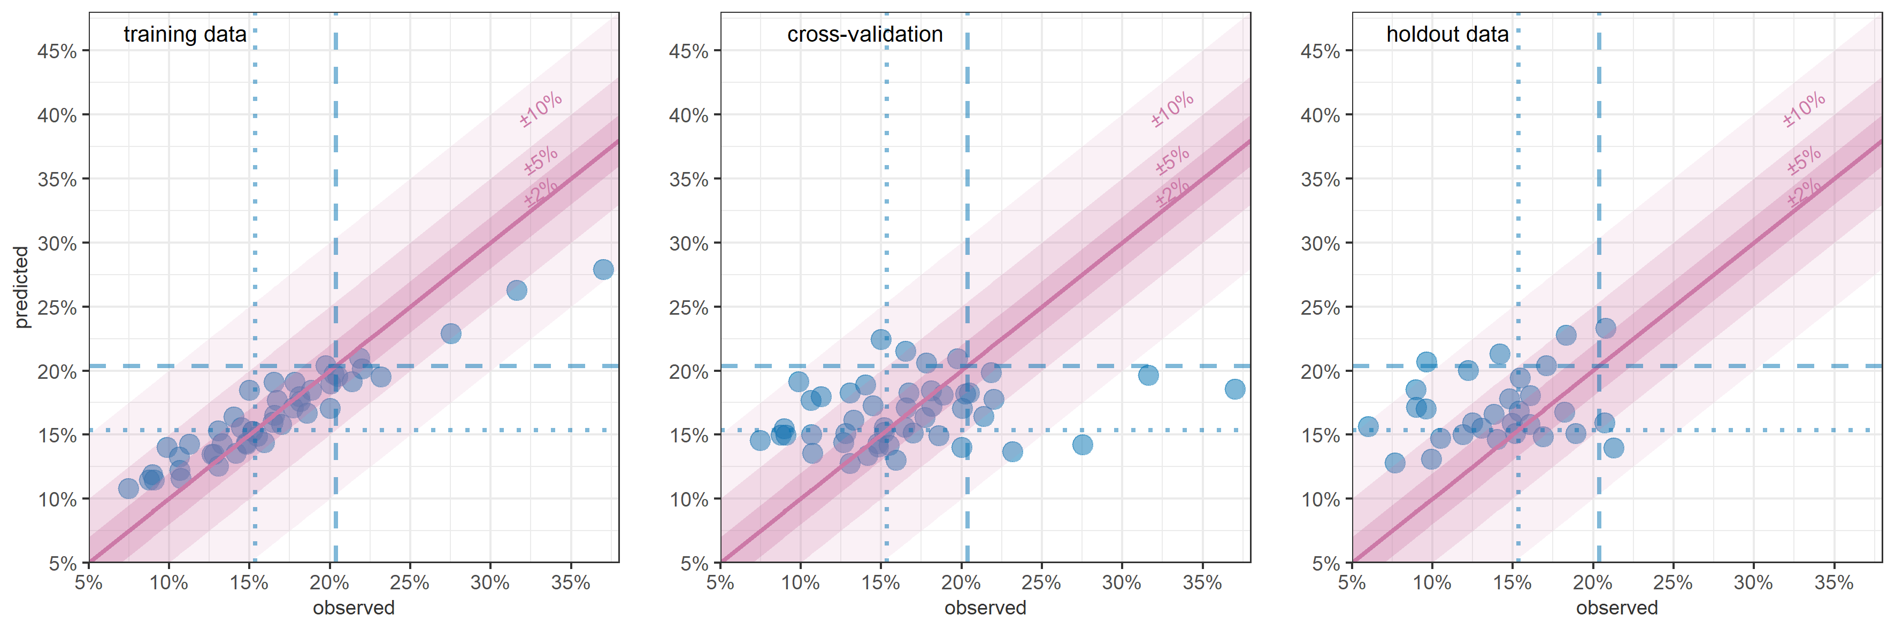
Figure S11. RF-predicted versus observed wasting (WFH + oedema) prevalence, Somalia, by district-month, on training data, LOOCV and holdout data. Shaded channels indicate different absolute deviance of predictions. Vertical dotted lines denote commonly used wasting prevalence thresholds.

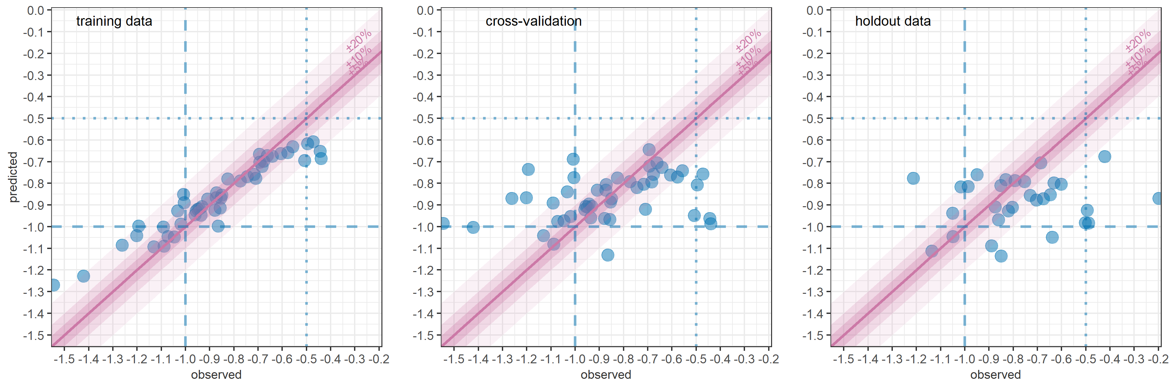
Figure S12. RF-predicted versus observed mean WFH, Somalia, by district-month, on training data, LOOCV and holdout data. Shaded channels indicate different absolute deviance of predictions. Vertical dotted lines denote potentially useful thresholds.

Predictive accuracy of additional South Sudan models
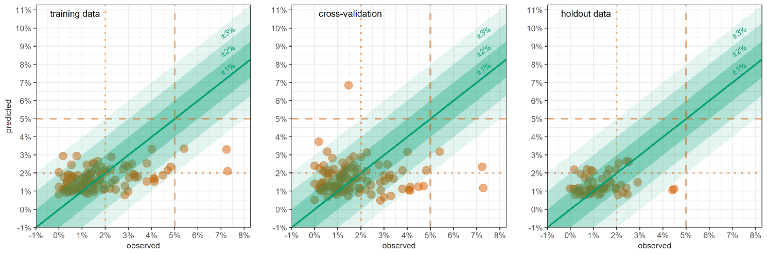
Figure S13. GLM-predicted versus observed severe wasting (MUAC + oedema) prevalence, South Sudan, by district-month, on training data, LOOCV and holdout data. Shaded channels indicate different absolute deviance of predictions. Vertical dotted lines denote commonly used severe wasting prevalence thresholds.

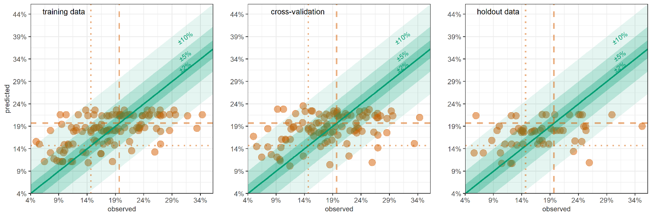
Figure S14. GLM-predicted versus observed wasting (WFH + oedema) prevalence, South Sudan, by district-month, on training data, LOOCV and holdout data. Shaded channels indicate different absolute deviance of predictions. Vertical dotted lines denote commonly used wasting prevalence thresholds.

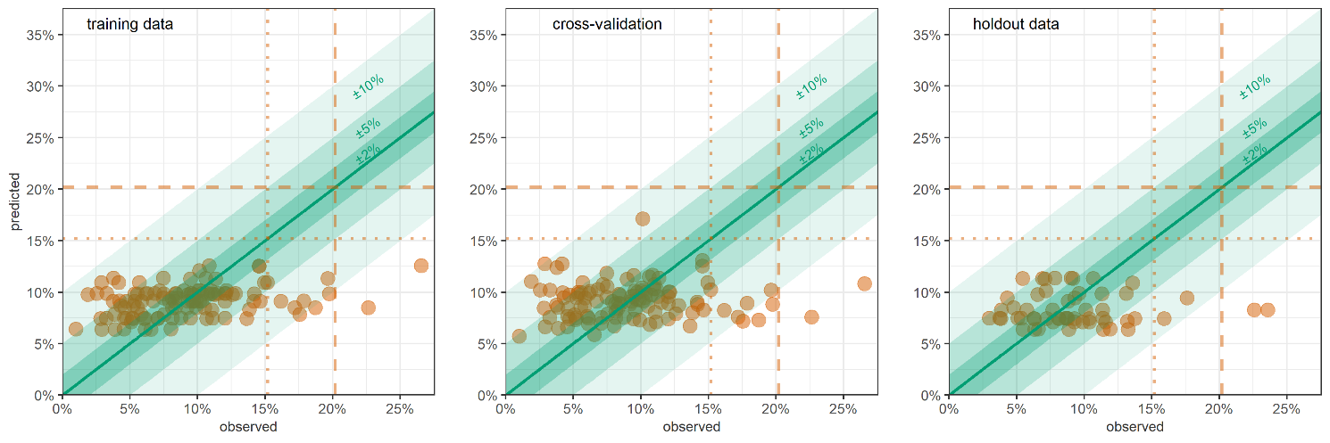
Figure S15. GLM-predicted versus observed wasting (MUAC + oedema) prevalence, South Sudan, by district-month, on training data, LOOCV and holdout data. Shaded channels indicate different absolute deviance of predictions. Vertical dotted lines denote commonly used wasting prevalence thresholds.

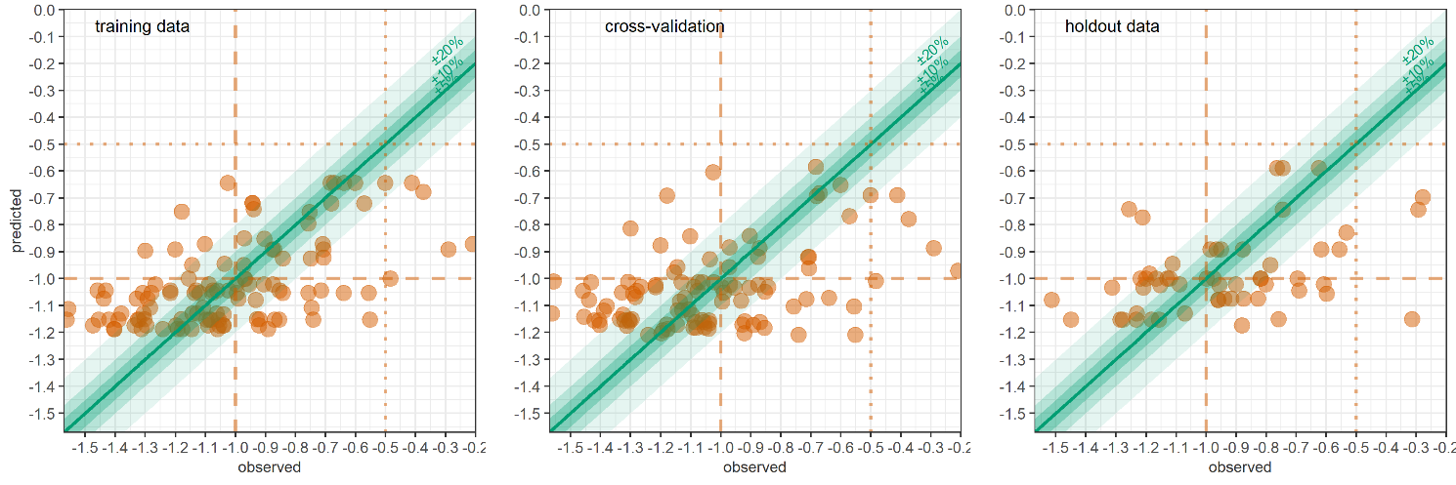
Figure S16. GLM-predicted versus observed mean WFH, South Sudan, by district-month, on training data, LOOCV and holdout data. Shaded channels indicate different absolute deviance of predictions. Vertical dotted lines denote potentially useful thresholds.

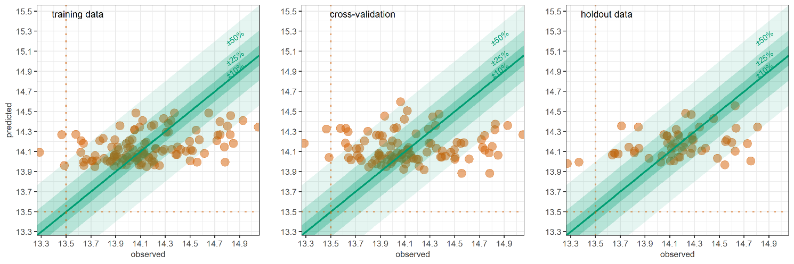
Figure S17. GLM-predicted versus observed mean MUAC, South Sudan, by district-month, on training data, LOOCV and holdout data. Shaded channels indicate different absolute deviance of predictions. Vertical dotted lines denote potentially useful thresholds.

Table S8. Performance of random forest models in South Sudan, by wasting outcome.
Statistic |  | Binary:  Wasting (WFH + oedema) |  |  | Continuous:  WFH
Estimation performance
Mean square error | training data | 0.00067 |  |  | 0.01225
Mean square error | LOOCV | 0.00367 |  |  | 0.07329
Mean square error | holdout data | 0.00348 |  |  | 0.07153
Relative bias | LOOCV | -8.9% |  |  | +2.8%
Relative bias | holdout data | +2.5% |  |  | +20.9%
Relative precision of 95%CI | LOOCV | ±19.3% |  |  | ±16.8%
Relative precision of 95%CI | holdout data | ±11.8% |  |  | ±9.6%
Coverage of 95%CI | LOOCV | 41.7% |  |  | 35.7%
Coverage of 95%CI | holdout data | 51.8% |  |  | 46.4%
Coverage of 80%CI | LOOCV | 27.8% |  |  | 27.8%
Coverage of 80%CI | holdout data | 35.7% |  |  | 32.1%
Classification performance by wasting prevalence threshold (n = denominator of percentage)
Sensitivity  (lower threshold) | LOOCV | ≥15% | 94.3% (88) |  | n/a
Sensitivity  (lower threshold) | holdout data | ≥15% | 97.6% (42)
Sensitivity  (upper threshold) | LOOCV | ≥20% | 11.3% (71)
Sensitivity  (upper threshold) | holdout data | ≥20% | 35.7% (28)
Specificity  (lower threshold) | LOOCV | <15% | 29.6% (27)
Specificity  (lower threshold) | holdout data | <15% | 7.1% (14)
Specificity  (upper threshold) | LOOCV | <20% | 88.6% (44)
Specificity  (upper threshold) | holdout data | <20% | 89.3% (28)
Most important predictors | lag | Importance | p-value |  | Importance | p-value
Main livelihood type | n/a | 0.0002 | 0.010 |  | 0.0083 | 0.010
Terms of trade | previous 4-6mths | 0.0002 |  | 0.089 | 0.0037 | 0.129
Terms of trade | previous 3-5mths | 0.0001 |  | 0.505 | 0.0048 | 0.089
Number of measles vaccine doses administered per population | previous 2-4mths | 0.0003 | 0.069 |  | 0.0053 | 0.109
Number of measles vaccine doses administered per population | previous 3-5mths | 0.0001 | 0.356 |  | 0.0037 | 0.208
Number of measles vaccine doses administered per population | previous 0-2mths | 0.0001 | 0.218 |  | 0.0038 | 0.178
Rate of insecurity events | previous 4-6mths | 0.0002 | 0.119
Rate of insecurity events | previous 3-5mths | 0.0001 | 0.446
Rate of insecurity events | previous 2-4mths | 0.0001 | 0.495
Total rainfall | previous 0-5mths | 0.0004 | 0.010 |  | 0.0073 | 0.010
Proportion of the population that is internally displaced | n/a |  |  |  | 0.0020 | 0.139

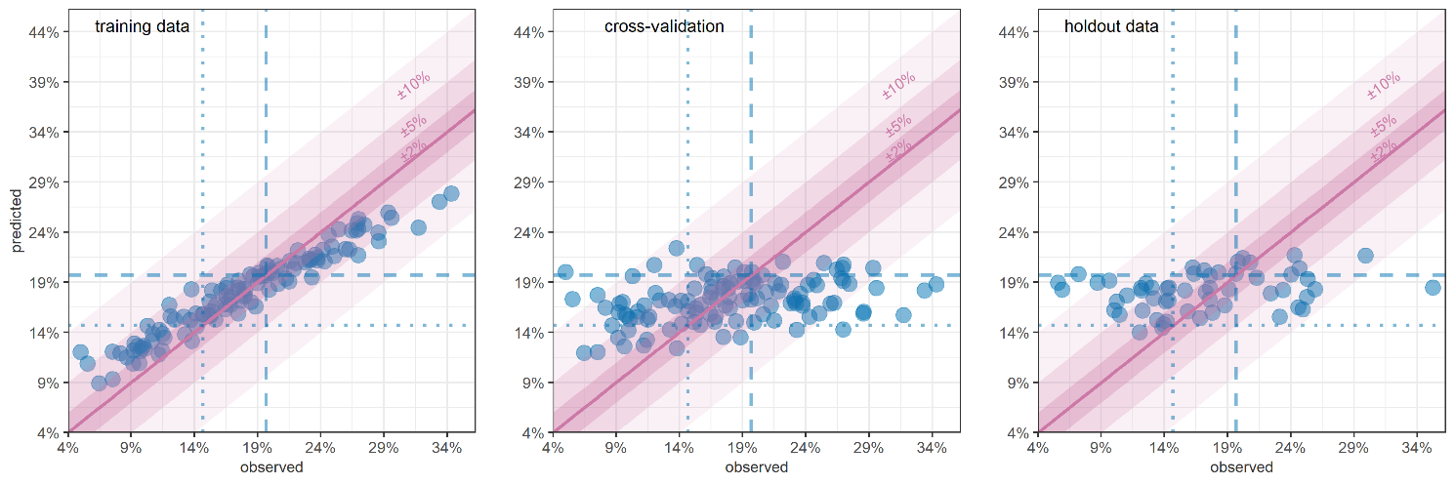
Figure S18. RF-predicted versus observed wasting (WFH + oedema) prevalence, South Sudan, by district-month, on training data, LOOCV and holdout data. Shaded channels indicate different absolute deviance of predictions. Vertical dotted lines denote commonly used wasting prevalence thresholds.

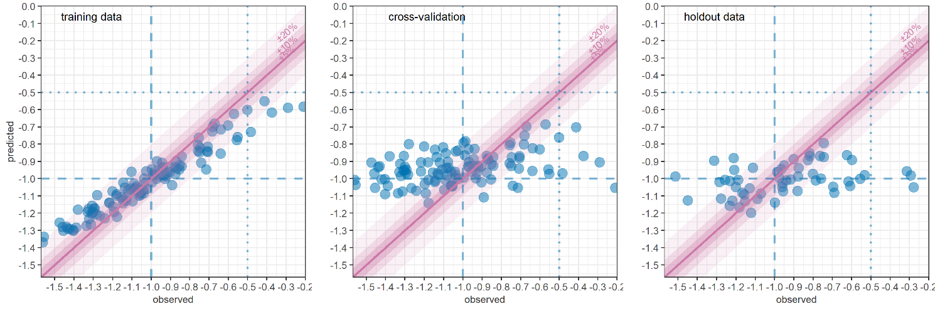
Figure S19. RF-predicted versus observed mean WFH, South Sudan, by district-month, on training data, LOOCV and holdout data. Shaded channels indicate different absolute deviance of predictions. Vertical dotted lines denote potentially useful thresholds.

