Supplementary information:

Figure S1:

Supplementary figure S1: Patient selection for this analysis in DPV. Patients were followed in 2020, had type 1 diabetes and were up to 18 years old. Due to different lockdown conditions, we limited this analysis to patients followed in Germany (not Austria, Luxemburg and Switzerland).
Figure S2

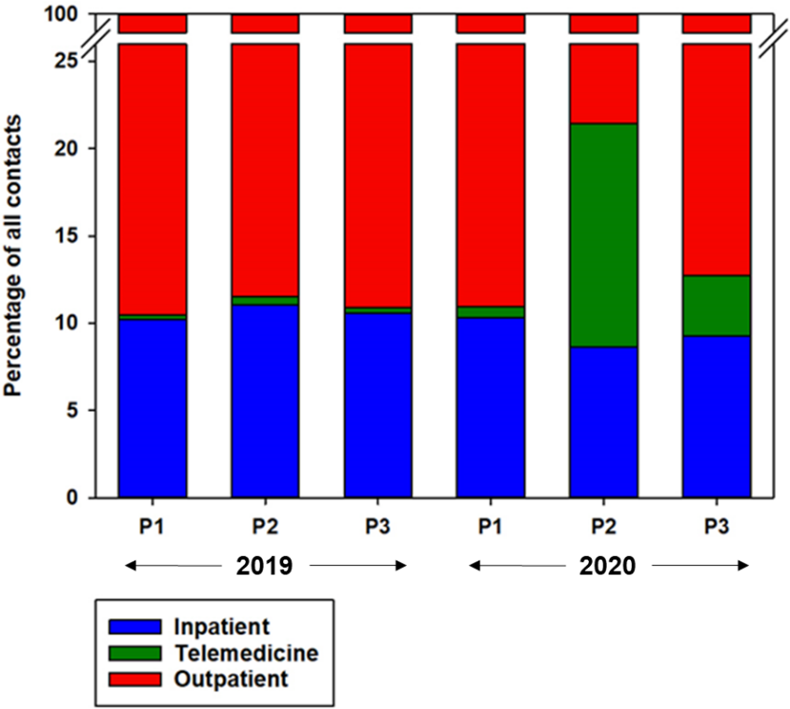

Supplementary figure S2. Proportion of inpatient, telemedicine and outpatient contacts of all contacts for 3 Periods in 2019 and 2020. P1 = first period from 01 Jan to 12 Mar; P2 = second period from 13 Mar to 13 May; P3 = third period from 14 Mar to 31 December. The proportion on telemedicine contacts was significantly higher in P2 and P3 in 2020 compared to all other periods (p<0.001), detailed numbers are given in table S1.

Supplementary table S1. Percentage of telemedicine, outpatient and inpatient contacts of all contacts for 3 identical periods in 2019 and 2020.
Data corresponding to figure S2.

Type of contact | 01 Jan – 12 Mar (P1) |  |  | 13 Mar – 13 May (P2) |  |  | 14 May – 31 Dec (P3)
 | 2019 | 2020 | p-value | 2019 | 2020 | p-value | 2019 | 2020 | p-value
Telemedicine | 0.3 | 0.6 | <0.001 | 0.5 | 12.8 | <0.001 | 0.3 | 3.5 | <0.001
Outpatient | 89.5 | 89.0 | 0.584 | 88.5 | 78.6 | <0.001 | 89.1 | 87.3 | <0.001
Inpatient | 10.2 | 10.3 | 0.997 | 11.0 | 8.6 | <0.001 | 10.5 | 9.2 | <0.001

