Table 1. Base structure and results of L₁ assays for aminoalcohol (AO) derivatives against T. muris. Cytotoxicity data were reported in a previous study [21]. Abbreviations: Bn: Benzyl, Boc: tert-butoxycarbonyl, CC₅₀: cytotoxic concentration 50, Dec: n-decyl, Et: Ethyl, Hex: n-hexyl, IC₅₀: inhibitory concentration 50, N: length of the alkylside-chain, R: radical, SI: selectivity index. SI = CC₅₀ (Caco-2 or HepG2)/IC_{50.}
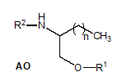 | Compound |  |  | T. muris  L₁  assay |  | Cytotoxicity |  | Selectivity Indexes
Compound identification | N | R¹ | R² | % dead larvae (100 µM) | IC₅₀ µM | Caco 2 CC₅₀ (µM) | HepG2 CC₅₀ (µM) | SI Caco2 | SI HepG2
AO1 | 9 | H | H | 65.09 | - | - | - | - | -
AO2 | 13 | H | H | 78.36 | - | - | - | - | -
AO3 | 15 | H | H | 36.47 | - | - | - | - | -
AO4 | 15 | H | Et | 85.29 | - | - | - | - | -
AO5 | 17 | H | Et | 97.04 | 25.6 | 13.01±0.27 | 9.13±0.56 | < 1.0 | < 1.0
AO6 | 13 | H | Bu | 74.44 | - | - | - | - | -
AO7 | 13 | H | Hex | 53.25 | - | - | - | - | -
AO8 | 13 | H | Dec | 23.66 | - | - | - | - | -
AO9 | 13 | H | Boc | 29.63 | - | - | - | - | -
AO10 | 9 | Bn | H | 61.27 | - | - | - | - | -
AO11 | 13 | Bn | H | 97.83 | 17.5 | >20 | 6.48±0.18 | >1.1 | < 1.0
AO12 | 15 | Bn | H | 25.55 | - | - | - | - | -
AO13 | 17 | Bn | H | 27.23 | - | - | - | - | -
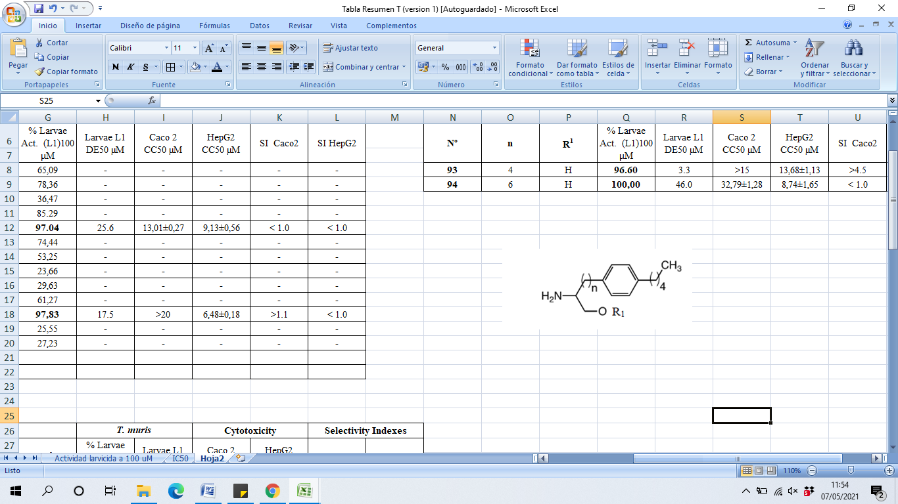 | Compound |  |  | T. muris  L₁  assay |  | Cytotoxicity |  | Selectivity Indexes
Compound identification | N | R¹ |  | % dead larvae (100 µM) | IC₅₀ µM | Caco 2 CC50 (µM) | HepG2 CC50 (µM) | SI Caco2 | SI HepG2
AO14 | 4 | H |  | 96.60 | 3.3 | >15 | 13.68±1.13 | >4.5 | 4.1
AO15 | 6 | H |  | 100.00 | 46.0 | 32.79±1.28 | 8.74±1.65 | < 1.0 | < 1.0

Table 2. Base structure and results of L₁ assays for diamine (AA) derivatives against T. muris. Cytotoxicity data were reported in a previous study [21]. Abbreviations: Bn: Benzyl, Boc: tert-butoxycarbonyl, Bu: n-Butyl, CC₅₀: cytotoxic concentration 50, Dec: n-decyl, Et: Ethyl, Hex: n-hexyl, IC₅₀: inhibitory concentration 50, N: length of the alkylside-chain, R: radical, SI: selectivity index. SI = CC₅₀ (Caco-2 or HepG2)/IC₅₀
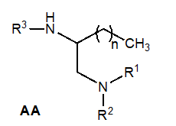 | Compound |  |  | T. muris  L₁  assay |  | Cytotoxicity |  | Selectivity Indexes
Compound identification | N | R¹/R² | R³ | % dead larvae (100 µM) | IC₅₀ (µM) | Caco 2 CC₅₀ (µM) | HepG2 CC₅₀ (µM) | SI Caco2 | SI HepG2
AA16 | 13 | H/H | H | 0.00 | - | - | - | - | -
AA17 | 17 | H/H | H | 9.80
AA18 | 9 | H/H | Boc | 93.55 | 21.9 | 30.24±1.56 | 25.20±0.33 | 1.4 | 1.1
AA19 | 13 | H/H | Boc | 32.47 | - | - | - | - | -
AA20 | 15 | H/H | Boc | 20.79 | - | - | - | - | -
AA21 | 17 | H/H | Boc | 23.86 | - | - | - | - | -
AA22 | 13 | Et/Et | H | 75.02 | - | - | - | - | -
AA23 | 13 | H/Et | Boc | 87.49 | - | - | - | - | -
AA24 | 13 | Et/Et | Boc | 61.85 | - | - | - | - | -
AA25 | 13 | H/Bu | Boc | 28.98 | - | - | - | - | -
AA26 | 13 | H/Hex | Boc | 12.91 | - | - | - | - | -

Table 3. Base structure and results of L₁ assays for benzimidazole (BZ) derivatives against T. muris. Cytotoxicity data were reported in previous study [19]. Abbreviations: CC₅₀: cytotoxic concentration 50, IC₅₀: inhibitory concentration 50, Me: methyl, R: radical, SI: selectivity index. SI = CC₅₀ (Caco-2 or HepG2)/IC_{50.}
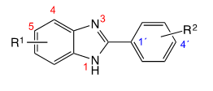 | Compound |  | T. muris  L₁  assay |  | Cytotoxicity |  | Selectivity Indexes
Compound identification | R¹ | R² | % dead larvae (100 µM) | IC₅₀ (µM) | Caco 2 CC₅₀ (µM) | HepG2 CC₅₀ (µM) | SI Caco2 | SI HepG2
BZ1 | Me | 4´-OMe | 100.00 | 15.92 | 11.60±3.42 | 18.75±1.92 | < 1 | 1.18
BZ2 | Me | 4´-Cl | 91.29 | 21.94 | 28.06±1.35 | 27.11±1.69 | 1.28 | 1.23
BZ3 | Me | 2´,6´-diMe | 73.90 | - | 9.14±2.32 | > 25 | - | -
BZ4 | Me | 3´-NO₂,4´-OMe | 40.67 | - | 9.07±2.35 | > 25 | - | -
BZ5 | Cl | 4´-OMe | 71.85 | - | 37.38±3.38 | 36.03±3.02 | - | -
BZ6 | Cl | 4´-Cl | 90.80 | 4.17 | 22.58±1.69 | 17.54±0.91 | 5.41 | 4.21
BZ7 | Cl | 4´- NO₂ | 54.74 | - | 19.14±2.05 | 21.73±1.65 | - | -
BZ8 | Cl | 2´,6´-diMe | 46.82 | - | 23.28±2.47 | 30.22±3.35 | - | -
BZ9 | Cl | 3´-NO₂,4´-OMe | 52.43 | - | 67.31±15.31 | 53.43±16.61 | - | -
BZ10 | Cl | 3´-NH₂,4´-OMe | 62.06 | - | 34.70±4.32 | 44.91±5.94 | - | -
BZ11 | NO₂ | 4´-OMe | 53.37 |  | 14.37±3.69 | 22.98±19.57 | - | -
BZ12 | NO₂ | 4´-Cl | 95.00 | 8.89 | 12.29±1.09 | 14.64±0.83 | 1.38 | 1.65
BZ13 | NO₂ | 2´,6´-diMe | 99.40 | 18.53 | 16.78±9.16 | > 12.5 | < 1 | < 1
BZ14 | NO₂ | 3´-NO₂,4´-OMe | 55.24 | - | 13.38±3.02 | 13.64±4.85 | - | -
BZ15 | NH₂ | 4´-OMe | 42.26 | - | > 25 | > 50 | - | -

Table 4. Results of anthelmintic activity for selected compounds (AO14, BZ12 and BZ6) against T. muris and H. polygyrus adults at 10 µM. Abbreviations: IC₅₀: inhibitory concentration 50, SI: selectivity index. SI = CC₅₀ (Caco-2 or HepG2)/IC₅₀
T. muris adults | AO14 | BZ6 | BZ12
% Efficacy at 10 µM | 21.2 | 17.2 | 81.7
IC₅₀ (µM) | - | - | 8.1
IC₅₀ r (µM) | - | - | 0.8
SI Caco2 | - | - | 1.5
SI HepG2 | - | - | 1.8
H. polygyrus adults | AO14 | BZ6 | BZ12
% Efficacy at 10 µM | 22.2 | 100 | 53.3
IC₅₀ (µM) | - | 5.3 | -
IC₅₀ r (µM) | - | 0.8 | -
SI Caco2 | - | 4.3 | -
SI HepG2 | - | 3.1 | -

