Journal: Applied Microbiology and Biotechnology
Title: Immunoinformatics Approaches for Developing Multi-Epitope Subunit Vaccines to Combat Acinetobacter baumannii
Fei zhu ^{1,2,3,4,5, #}, Shiyang Ma ^{1,2,3,4,5, #}, Mingjun Rao ^{1,2,3,4,5}, Peipei Zhang ^{1,2,3,4,5}, Wenzhong Peng ^{1,2,3,4,5}, Yanhui Cui ^{1,2,3,4,5}, Hang Yang ^{1,2,3,4,5}, Caixia Tan ⁶, Jie Chen ^{1,2,3,4,5, *}, Pinhua Pan ^{1,2,3,4,5, *}
¹ Department of Respiratory Medicine, National Key Clinical Specialty, Branch of National Clinical Research Center for Respiratory Disease, Xiangya Hospital, Central South University, Changsha, Hunan, China, 410008
² Center of Respiratory Medicine, Xiangya Hospital, Central South University, Changsha, Hunan, China. 410008
³ Clinical Research Center for Respiratory Diseases in Hunan Province, Changsha, Hunan, China. 410008
⁴ Hunan Engineering Research Center for Intelligent Diagnosis and Treatment of Respiratory Disease, Changsha, Hunan, China. 410008
⁵ National Clinical Research Center for Geriatric Disorders，Xiangya Hospital, Changsha, Hunan, P.R. China, 410008
⁶ Department of Infection Control Center of Xiangya Hospital, Central South University, Changsha, Hunan, China. 410008
# These authors contributed equally to this work.
* Correspondence: chenjie869@163.com (Jie Chen), 0731-89753028; pinhuapan668@csu.edu.cn (Pinhua Pan), 0731-89753029.

Table S1. CTL epitopes selected
Protein | Supertype | Start Position | Epitope Sequence | Score | Immunogenicity | Antigenicity | Allergic | Toxicity | IC50 | RANK% | MHC alles | Similarity with human protein
OmpA | A1 | 269 | HTDNTGPRK | 1.046 | 0.09127 | 1.6471 | - | - | 321.25 | 0.97 | HLA-A*11:01 | 0
OmpA | B7 | 18 | AAANAGVTV | 0.9721 | 0.13371 | 1.1461 | - | - | 50.88 | 0.12 | HLA-C*12:03 | 0
 |  |  |  |  |  |  |  |  | 56.24 | 0.19 | HLA-C*16:01 | 0
 |  |  |  |  |  |  |  |  | 86.93 | 0.19 | HLA-C*03:03 | 0
 |  |  |  |  |  |  |  |  | 86.93 | 0.19 | HLA-C*03:04 | 0
 |  |  |  |  |  |  |  |  | 235.88 | 0.54 | HLA-C*03:02 | 0
 |  |  |  |  |  |  |  |  | 309.11 | 0.18 | HLA-C*17:01 | 0
 |  |  |  |  |  |  |  |  | 363.83 | 0.22 | HLA-C*15:02 | 0
 |  |  |  |  |  |  |  |  | 466.12 | 0.33 | HLA-C*12:02 | 0
Omp33-36 | A2 | 16 | GAHAYQFEV | 1.0009 | 0.09453 | 1.7241 | - | - | 114.03 | 0.87 | HLA-A*02:06 | 0
 |  |  |  |  |  |  |  |  | 164.35 | 0.46 | HLA-C*16:01 | 0
 |  |  |  |  |  |  |  |  | 217.64 | 0.38 | HLA-C*12:03 | 0
 |  |  |  |  |  |  |  |  | 286.15 | 0.18 | HLA-C*15:02 | 0
Omp33-36 | A2 | 100 | YVPTPYLPV | 0.9688 | 0.00534 | 1.5876 | - | - | 16.4 | 0.15 | HLA-A*02:06 | 0
 |  |  |  |  |  |  |  |  | 21.24 | 0.14 | HLA-A*68:02 | 0
 |  |  |  |  |  |  |  |  | 47.78 | 0.75 | HLA-A*02:03 | 0
 |  |  |  |  |  |  |  |  | 107.78 | 0.8 | HLA-A*02:01 | 0
Omp33-36 | A2 | 140 | AMLLPNFLM | 0.8631 | 0.06067 | 1.7425 | - | - | 128.75 | 0.96 | HLA-A*02:06 | 0
 |  |  |  |  |  |  |  |  | 374.01 | 0.3 | HLA-A*32:01 | 0
 |  |  |  |  |  |  |  |  | 72.03 | 0.56 | HLA-A*02:01 | 0
OmpW | A1 | 308 | FTAGFTYDF | 1.5173 | 0.20718 | 1.267 | - | - | 12.38 | 0.06 | HLA-C*03:02 | 0
 |  |  |  |  |  |  |  |  | 40.2 | 0.14 | HLA-C*16:01 | 0
 |  |  |  |  |  |  |  |  | 45.9 | 0.11 | HLA-C*12:03 | 0
 |  |  |  |  |  |  |  |  | 59.64 | 0.06 | HLA-C*12:02 | 0
 |  |  |  |  |  |  |  |  | 68.23 | 0.16 | HLA-A*29:02 | 0
 |  |  |  |  |  |  |  |  | 81.82 | 0.14 | HLA-B*35:01 | 0
 |  |  |  |  |  |  |  |  | 84.41 | 0.05 | HLA-C*02:02 | 0
 |  |  |  |  |  |  |  |  | 84.41 | 0.05 | HLA-C*02:09 | 0
 |  |  |  |  |  |  |  |  | 106.74 | 0.61 | HLA-B*15:25 | 0
 |  |  |  |  |  |  |  |  | 129.57 | 0.23 | HLA-C*03:03 | 0
 |  |  |  |  |  |  |  |  | 129.57 | 0.23 | HLA-C*03:04 | 0
 |  |  |  |  |  |  |  |  | 155.61 | 0.07 | HLA-A*26:01 | 0
 |  |  |  |  |  |  |  |  | 164.47 | 0.44 | HLA-B*58:01 | 0
 |  |  |  |  |  |  |  |  | 189.67 | 0.75 | HLA-A*68:02 | 0
 |  |  |  |  |  |  |  |  | 206.41 | 0.19 | HLA-A*32:01 | 0
 |  |  |  |  |  |  |  |  | 252.95 | 0.72 | HLA-B*15:01 | 0
 |  |  |  |  |  |  |  |  | 293.55 | 1.8 | HLA-A*02:06 | 0
 |  |  |  |  |  |  |  |  | 318.46 | 0.35 | HLA-B*15:02 | 0
 |  |  |  |  |  |  |  |  | 318.95 | 0.69 | HLA-C*14:02 | 0
 |  |  |  |  |  |  |  |  | 357.17 | 0.48 | HLA-A*23:01 | 0
 |  |  |  |  |  |  |  |  | 442.32 | 0.25 | HLA-C*17:01 | 0
OmpW | A2 | 160 | FIGGIPPKV | 1.1644 | 0.0289 | 1.4031 | - | - | 22.79 | 0.22 | HLA-A*02:06 | 0
 |  |  |  |  |  |  |  |  | 24.17 | 0.21 | HLA-A*02:01 | 0
 |  |  |  |  |  |  |  |  | 493.01 | 1.5 | HLA-A*68:02 | 0

Table S2 HTL epitopes screened
Protein | OmpA |  |  | Omp33-36 |  | OmpW
MHC Allele | DRB1_0401 | DRB3_0101 | DRB1_1501 | DRB3_0202 | DRB3_0202 | DRB1_0401 | DRB1_0404 | DRB1_1501
Start Position | 130 |  | 66 | 233 | 235 | 114 |  | 234
Epitope Sequence | YKYDFDGVNRGTRGT |  | GIELTPWLGFEAEYN | VGATFVGNDGEADIK | ATFVGNDGEADIKGN | KPEVAGEATIQGLEQ |  | KSGVNKFRPYLGVGL
Core Sequence | YDFDGVNRG |  | LTPWLGFEA | FVGNDGEAD | FVGNDGEAD | VAGEATIQG |  | VNKFRPYLG
EL-Score | 0.871095 | 0.36301 | 0.812456 | 0.826383 | 0.707369 | 0.782894 | 0.864158 | 0.495036
%Rank_EL | 0.22 | 1.52 | 0.48 | 0.11 | 0.26 | 0.51 | 0.37 | 1.71
Score_BA | 0.550607 | 0.432203 | 0.628625 | 0.476464 | 0.453156 | 0.429614 | 0.434445 | 0.69569
IC50(nM) | 129.33 | 465.65 | 55.6 | 288.46 | 371.2 | 478.88 | 454.49 | 26.91
%Rank_BA | 2.24 | 4.99 | 1.2 | 2.94 | 3.58 | 11.2 | 14.7 | 0.31
Antigenicity | 1.3463 |  | 0.9127 | 0.9694 | 1.0696 | 0.7934 |  | 0.7925
Allergic | - |  | - | - | - | - |  | -
Toxicity | - |  | - | - | - | - |  | -
γ-INFpred | + |  | + | + | + | + |  | +
IL-4pred | + |  | + | + | + | + |  | +
Similarty with human protein | 0 |  | 0 | 0 | 0 | 0 |  | 0

Table S3. LBL epitopes screened
Protein | Start Position | Epitope Sequence | Score | Antigenicity | Allergic | Toxicity | Similarity with human protein
OmpA | 142 | RGTSEEGTLGNAGVGA | 0.94 | 1.8663 | - | - | 0
OmpA | 83 | KGDVDGASAGAEYKQK | 0.86 | 1.9423 | - | - | 0
OmpA | 42 | NGGKDGNLTNAPELQD | 0.82 | 1.5997 | - | - | 0
Omp33-36 | 259 | YPNATARIEGHTDNTG | 0.8 | 1.1391 | - | - | 0
Omp33-36 | 110 | ASATYNHTDVDGKNNF | 0.89 | 1.1803 | - | - | 0
Omp33-36 | 116 | HTDVDGKNNFSKDDNG | 0.88 | 1.6333 | - | - | 0
Omp33-36 | 87 | NYHIGTYGVKGEAYVP | 0.83 | 1.0537 | - | - | 0
OmpW | 278 | DGKAGAALDRKESSGN | 0.87 | 1.8311 | - | - | 0
OmpW | 234 | KSGVNKFRPYLGVGL | 0.84 | 0.7925 | - | - | 0

Table S4. Refined complex of Vaccine 1 and receptor analysis
 | HLA-A11:01 | HLA-DRB1-0401 | TLR2 | TLR4 | BCR
HADDOCK score | -193.9 +/- 5.3 | -172.2 +/- 1.5 | -148.5 +/- 1.4 | -222.1 +/- 3.8 | -217.3 +/- 1.4
RMSD | 0.6 +/- 0.4 | 0.7 +/- 0.4 | 0.6 +/- 0.4 | 0.6 +/- 0.4 | 0.7 +/- 0.4
van der Waals energy | -99.7 +/- 3.1 | -101.5 +/- 1.3 | -82.9 +/- 3.9 | -122.1 +/- 2.7 | -115.4 +/- 4.8
Electrostatic energy | -497.1 +/- 24.6 | -302.2 +/- 17.1 | -447.2 +/- 24.5 | -384.4 +/- 47.8 | -394.6 +/- 16.7
Desolation energy | 5.2 +/- 4.5 | -10.2 +/- 2.1 | 23.9 +/- 0.4 | -23.2 +/- 5.1 | -22.9 +/- 5.6
Restraint’s violation energy | 0.0 +/- 0.0 | 0.0 +/- 0.0 | 0.0 +/- 0.0 | 0.0 +/- 0.0 | 0.0 +/- 0.0
Buried Surface Area | 3319.0 +/- 31.4 | 3074.6 +/- 22.2 | 2800.2 +/- 15.0 | 3396.4 +/- 87.5 | 3495.0 +/- 61.4
ΔG (kcal mol-1) | -15.2 | -11.2 | -14.1 | -14.9 | -15.5
Kd (M) at 25.0 ℃ | 7.2E-12 | 6.5E-09 | 4.70E-11 | 1.2E-11 | 4.2E-12

Table S5. Refined complex of Vaccine 2 and receptor analysis

 | HLA-A11:01 | HLA-DRB1-0401 | TLR2 | TLR4 | BCR
HADDOCK score | -137.4 +/- 1.6 | -184.2 +/- 4.6 | -146.5 +/- 1.9 | -163.2 +/- 3.1 | -149.6 +/- 3.6
RMSD | 0.6 +/- 0.4 | 0.7 +/- 0.4 | 0.6 +/- 0.4 | 0.6 +/- 0.3 | 0.7 +/- 0.4
van der Waals energy | -83.3 +/- 3.5 | -95.2 +/- 3.5 | -80.4 +/- 4.1 | -79.3 +/- 4.9 | -82.0 +/- 3.9
Electrostatic energy | -321.3 +/- 15.6 | -394.4 +/- 19.9 | -439.6 +/- 27.4 | -386.1 +/- 37.1 | -236.3 +/- 27.1
Desolation energy | 10.1 +/- 1.6 | -10.2 +/- 2.3 | 21.8 +/- 1.8 | -6.6 +/- 2.5 | -20.4 +/- 2.8
Restraint’s violation energy | 0.0 +/- 0.0 | 0.0 +/- 0.0 | 0.0 +/- 0.0 | 0.0 +/- 0.0 | 0.0 +/- 0.0
Buried Surface Area | 2544.1 +/- 35.4 | 2826.0 +/- 26.8 | 2748.5 +/- 50.9 | 2173.0 +/- 19.0 | 2402.2 +/- 29.3
ΔG (kcal mol-1) | -12.7 | -10.7 | -15.1 | -12.9 | -10.7
Kd (M) at 25.0 ℃ | 5.0E-10 | 1.5E-08 | 8.9E-12 | 3.5E-10 | 1.4E-08

(a)
(b)
Figure S1. (a)secondary structure of vaccine 1 and (b) vaccine 2

(a)
(b)
(c)
(d)
Figure S2. Cell population per state simulated by C-ImmSim for vaccine 1, Act=active, Intern=internalized the Ag, Pres II = presenting on MHC II,
Dup = in the mitotic cycle, Anergic = anergic, Resting = not active. (a)(b) Immune Simulation for Vaccine 1 (c)(d) Immune Simulation for Vaccine 2

(a) | (b)

(c) | (d)
(e) | (f)

Figure S3. Docked complex of vaccine construct and receptor and the interacting part along with the interacting residue, in the figure, vaccine construct is highlighted (a)Vaccine 1 and HLADRB0401 (b) Vaccine 1 and BCR (c) Vaccine 2 and TLR4 (d) Vaccine 2 and HLADRB0401（e）Vaccine 2 and BCR (f) Vaccine 2 and TLR 4

Figure S4. Population coverage analysis results

（a）413
(b)R2
(c)R4
(d)BCR
(e)
(f)

(g)R2

(h)
(i)
Figure S5. Molecular dynamic simulation (a) Vaccine 1 and HLADRB0401 complex (b)Vaccine 1 and TLR2 complex (c)Vaccine 1 and TLR4 complex (d)Vaccine 1 and BCR complex (f)Vaccine 2 and HLADRB0401 complex (g)Vaccine 2 and TLR2 complex (h)Vaccine 2 and TLR4 complex (i)Vaccine 2 and BCR complex

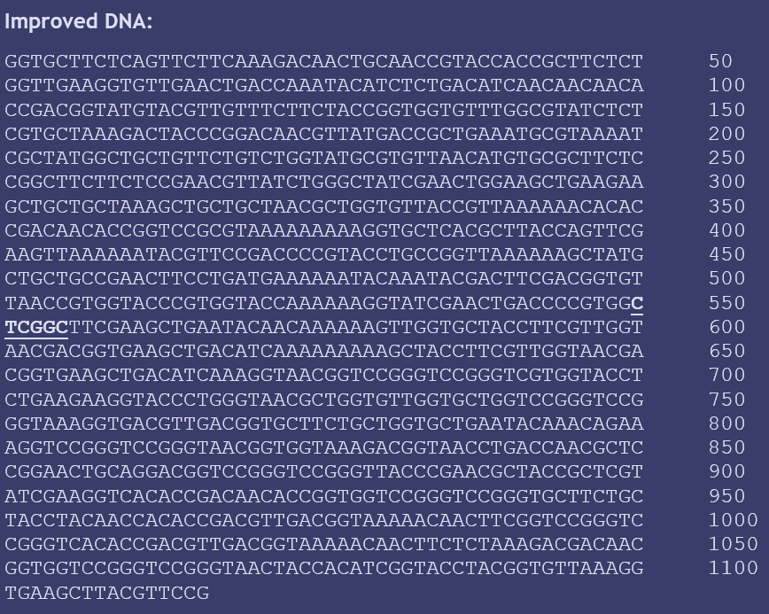 | 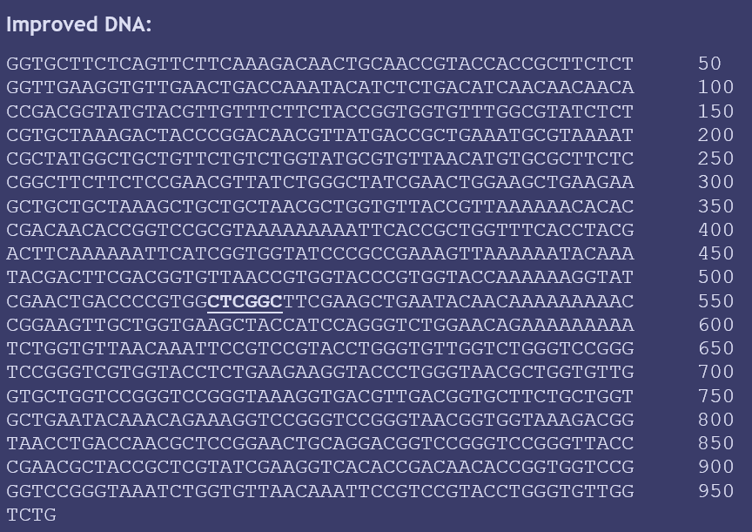
(e) | (f)

Figure S6. Nucleotide sequences of vaccine 1(a) and vaccine 2(b).

