EXTENDED DATA

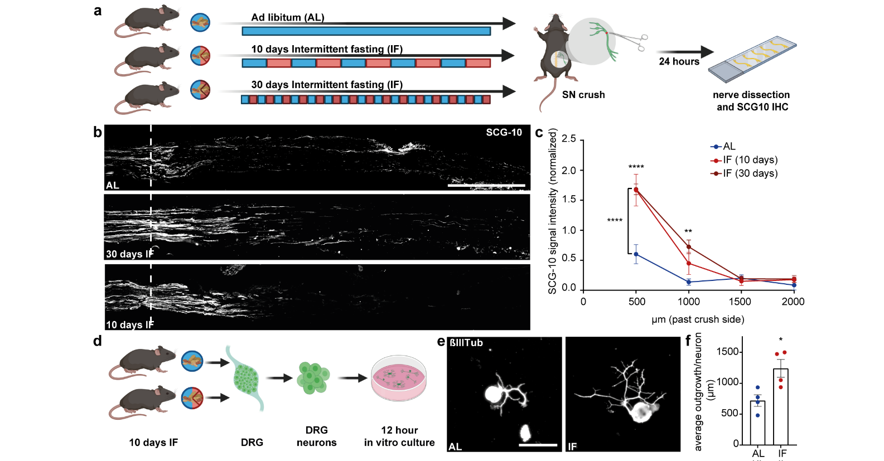
Extended data Fig. 1. Intermittent fasting promotes axonal regeneration and DRG neurite outgrowth
a. Schematic of the experimental design.
b. Micrographs showing representative longitudinal sections of sciatic nerves stained with SCG-10 24h after SNC. Scale bar: 1000 µm. The dashed line indicates the crush site.
c. Quantification of SCG-10 intensity at the indicated distances and normalized to the intensity before the crush site (N=5-6 nerves per group from 3 mice per group with a bilateral sciatic nerve crush; ****p<0.0001, **p<0.01, *p<0.05, two-way-ANOVA with Tukey test, mean±SEM).
d. Schematic of the experimental design.
e. Representative images of DRG neurons relative to d immunostained with ßIII-Tubulin (ßIIITub).
f. Quantification of immunostained neurite outgrowth (N=4 animals per group, 4 technical replicates each; *p<0.05, Student’s unpaired t-test, Scale bar: 100 µm).

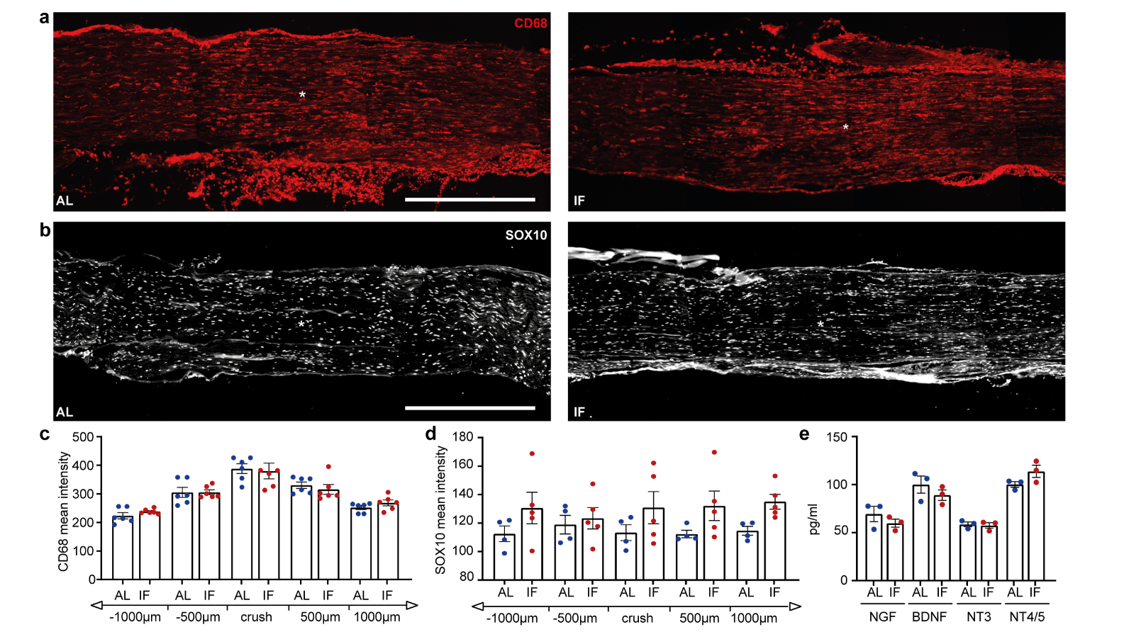Extended data Fig. 2. Assessment of macrophages, Schwann cells and neurotrophic factors in the nerve and DRG in IF vs AL following sciatic injury
a-b. Representative images of nerves dissected from 10 days AL or IF treated animals at 3 days post sciatic injury. Sections were immunostained for a) CD68 (macrophage marker, red) or b) SOX10 (Schwann cell marker, white). Scale bar 500 µm. Asterisk indicates the crush site.
c. Quantification of CD68 (red) was conducted by intensity measurements 1000 µm proximal and distal to the crush site (N=4-5 nerves per group from 3 mice each).
d. Quantification of SOX10 (white) was conducted by intensity measurements 1000 µm proximal and distal to the crush site (N=5 nerves per group from 3 mice each)
e. ELISA measurements of NGF, BDNF, NT3 and NT4/5 from DRG tissue following 10 days IF or AL (N=3 mice per group). Samples were collected on the refed day.

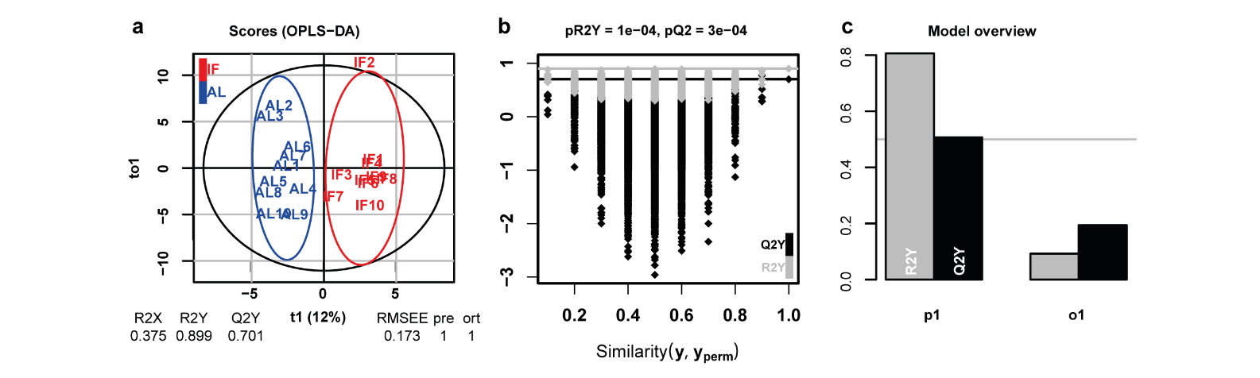

Extended data Fig. 3. O-PLS-DA model discriminating AL and IF groups using GC-MS-based metabolic profiles
a. Score plot of the O-PLS-DA model of the IF group vs AL group. The number of components and the cumulative R²_{X}, R²_{Y} and Q²_{Y} are indicated below the plot.
b. Significance diagnostic of the OPLS-DA: the R2Y and Q2Y of the model are compared with the corresponding values obtained after random permutation (1000) of the y response.
c. Model overview: Inertia bar plot.

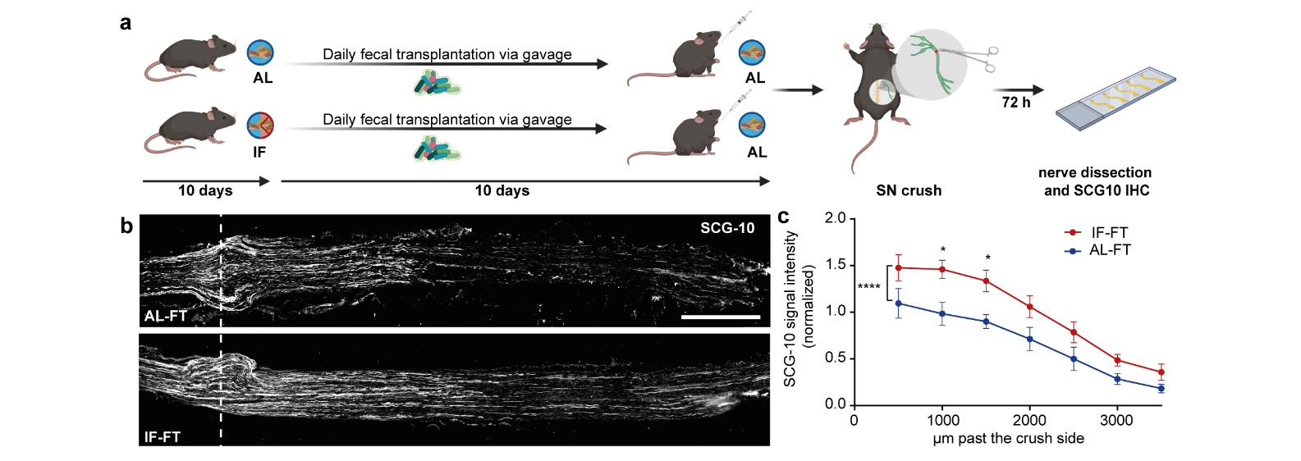
Extended data Fig. 4. Faecal transplantation from IF mice promotes axonal regeneration
a. Schematic showing the experimental design.
b. Micrographs of representative longitudinal sections of sciatic nerves after faecal transplantation from AL and IF treated mice, 3 days post sciatic nerve crush, immunostained with SCG-10. Scale bar: 1000 µm. The dashed line indicates the crush site.
c. Quantification of SCG-10 intensity at the indicated distances and normalized to the intensity before the crush-site revealed increased regeneration in IF-FT mice compared to AL-FT (N=7-8 nerves from 4 mice per group; ****p<0.0001, *p<0.05, two-way-ANOVA with Tukeys test, mean±SEM).

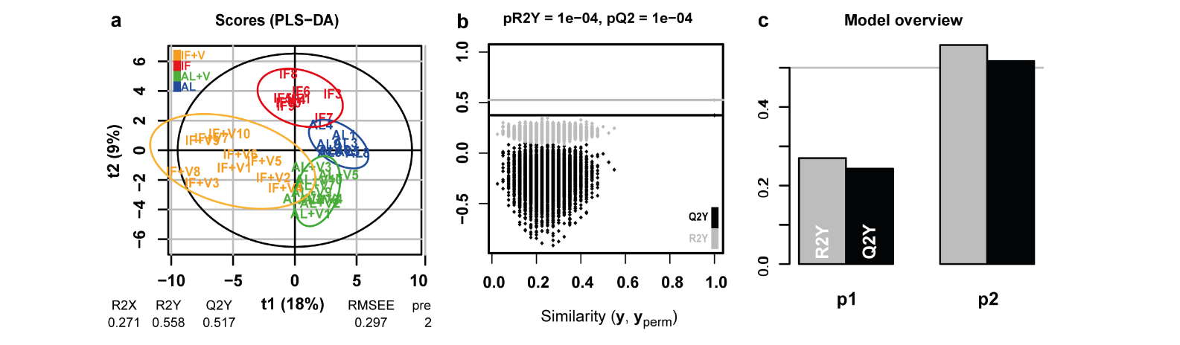
Extended data Fig. 5. O-PLS-DA model discriminating IF, AL, IF+V and AL+V groups based on GC-MS metabolic profiles
a. Score plot of the PLS-DA model discriminating IF, AL, IF+V and AL+V.
b. Permutation testing of the PLS-DA model: the R²_{Y} and Q²_{Y} of the original model are compared with the corresponding values obtained after random permutation of the group classes (n = 1000 iterations).
c. Model overview: Inertia bar plot.
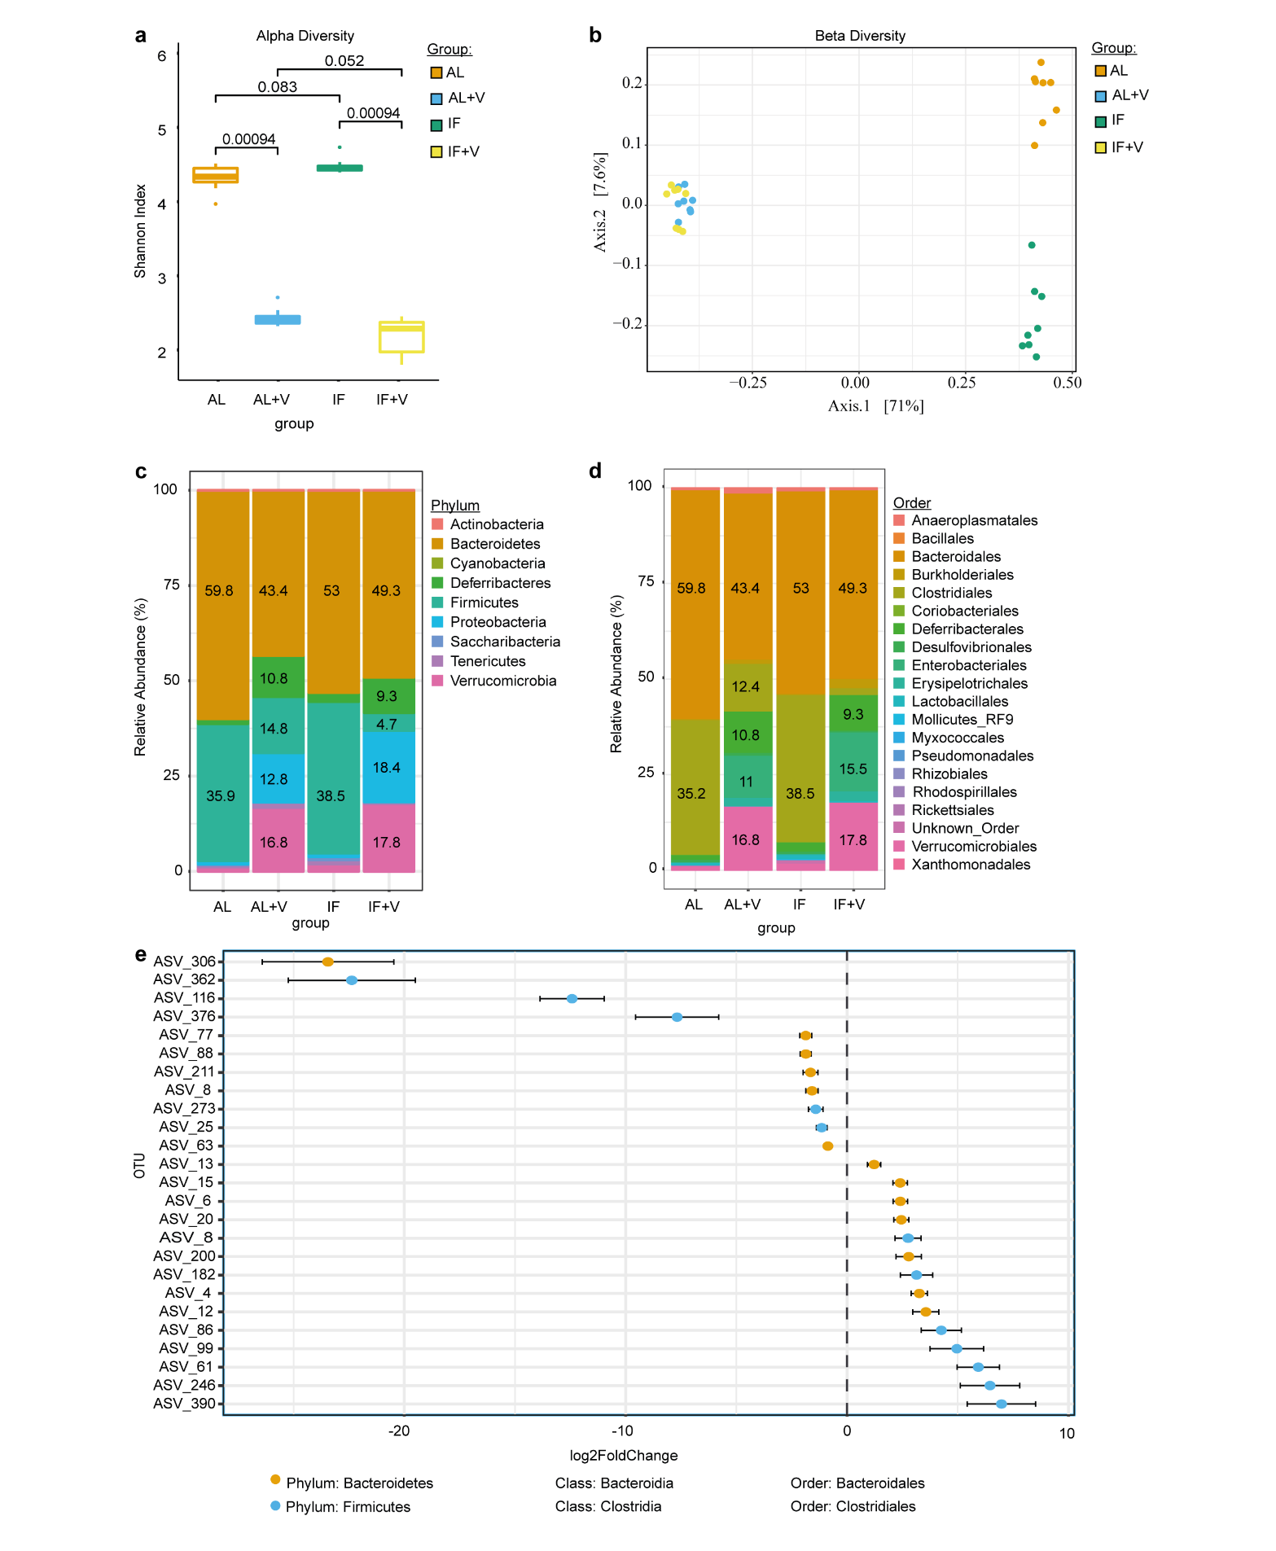
Extended data Fig. 6. 16S rDNA amplicon sequencing reveals increased number of Clostridiales following intermittent fasting
a. Shannon index reveals significant differences in Alpha diversity between vancomycin vs non-vancomycin treated groups (16S sequencing was carried out from cecum of AL, AL+vancomyin, IF, IF+vancomycin treated animals (N=8), Mann Whitney U test).
b. Beta diversity reveals differences in microbiota composition between IF and AL groups
c-d. Relative abundance (%) of bacterial phyla (c) and bacterial order (d) between AL, AL+ vancomycin, IF and IF+ vancomycin.
e. Plot showing that the top 25 bacterial Amplicon sequence variants (ASVs) that are statistically different (p<0.05, FDR corrected, plotted as log2FoldChange) between IF and AL belong to either Bacteroidetes or Firmicutes phyla, Bacteroida or Clostridia classes and Bacteroidales or Clostridiales orders.

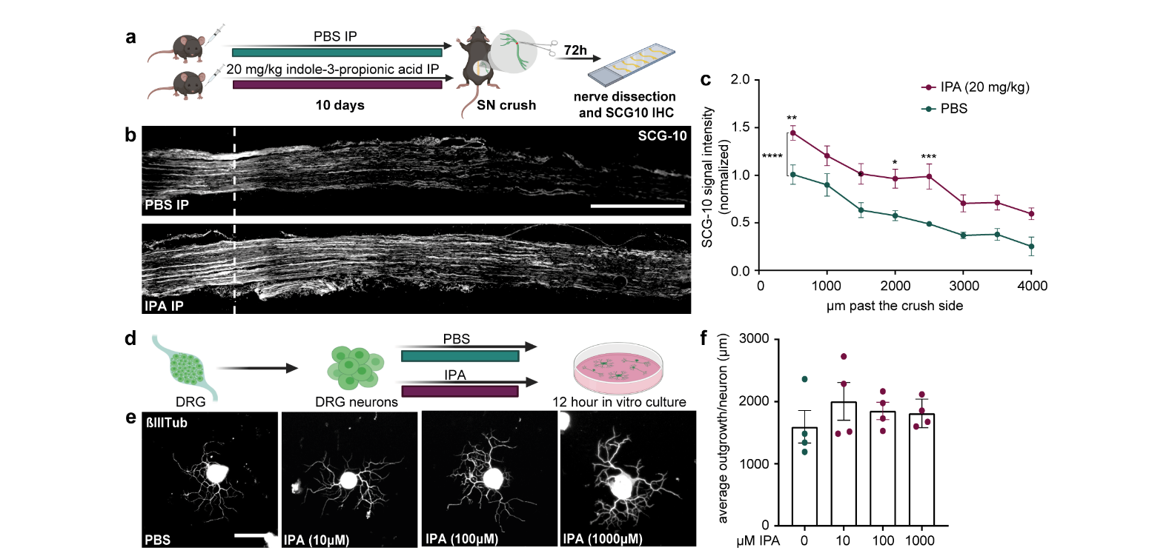
Extended data Fig. 7. Indole-3-proprionate-dependent axonal regeneration
a. Schematic of the experimental design.
b. Micrographs of representative longitudinal sections of sciatic nerves immunostained with SCG-10. Scale bar: 1000 µm. The dashed line indicates the crush site.
c. Quantification of SCG-10 intensity at the indicated distances and normalized to the intensity before the crush-site. (N=7 nerves from 4 mice per group with a bilateral sciatic nerve crush; *p<0.05. **p<0.01, ***p<0.001, ****p<0.0001, two-way-ANOVA with Sidak test, mean±SEM).
d-f. IPA treatment of DRG cell cultures does not affect neurite outgrowth. DRG neurons were treated with 10μM, 100μM and 1000μM IPA (schematic in d).
e. Representative images of DRG neurons immunostained with ßIII-Tub. Scale bar: 50 µm.
f. Quantification of ßIII-Tubulin (ßIIITub) immunostained neurite outgrowth by measuring the length of neurites (N=4 replicates per group; one-way ANOVA, Dunnett's multiple comparisons test, mean±SEM).

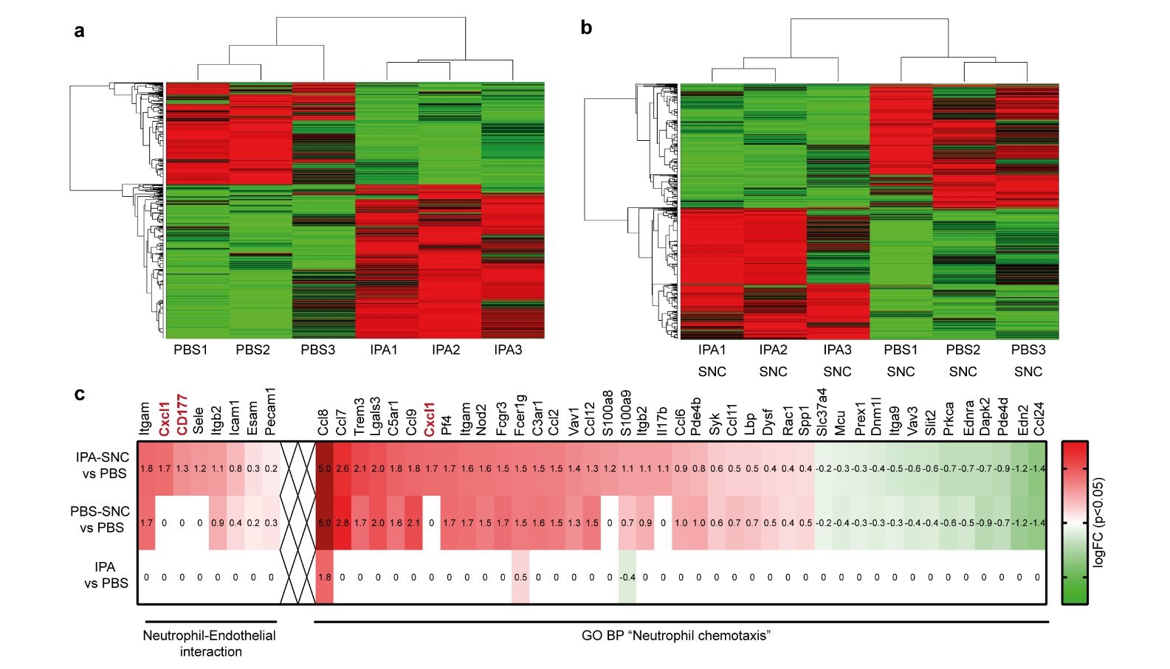
Extended data Fig. 8. RNA sequencing from DRG following IPA treatment and injury
a-b. Shown are heatmaps of differentially regulated genes (FPKMs, P<0.05) following 10 days IPA vs PBS treatment as, preceding (a) and 3 days following SN crush (b). Green: downregulated, red: upregulated.
c. Heatmap showing the logarithmic expression fold change (logFC (P<0.05)) of all genes belonging to “Neutrophil-Endothelial interaction” or “BP Neutrophil chemotaxis” GO class for the comparisons IPA-SNCvsPBS, PBS-SNCvsPBS and IPAvsPBS.

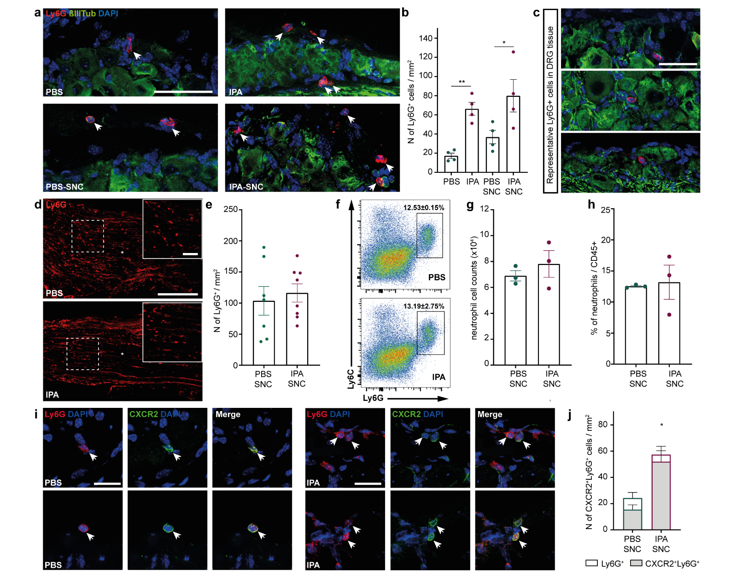
Extended data Fig. 9. Increased number of neutrophils in the DRG following IPA treatment
a. Representative image of a DRG stained for Ly6G (red), ßIIITubulin (ßIIITub, green) and DAPI (blue). Scale bar: 100 µm. Arrows indicate Ly6G+ cells.
b. Quantitative analysis of neutrophils, shown as number of neutrophils per 1 mm² (N=4 mice per group; *p<0.05, **p<0.01, one-way ANOVA, multiple comparison testing: corrected by FDR with Benjamini and Hochberg, if not indicated otherwise p-value compares to PBS group, mean±SEM).
c. Representative images of Ly6G+ cells in DRG tissue. Scale bar: 50 µm.
d. Images of the sciatic nerve crush site, immunostained for Ly6G (red) after IPA and PBS treatment. Asterisk indicates the crush site. Scale bar: 250 µm. Magnified image scale bar: 50 µm.
e. Quantitative analysis showing the number of neutrophils 1000 µm proximal and distal to the crush site.
f. FACS analysis of the nerve crush site following 10 days of IPA treatment and 3 days SNC.
g+h. Bar graphs showing Ly6G+ cell counts (g) and percentage of Ly6G+ cells of the total CD45⁺ cells (h) in nerve crush site 3 days following SNC (N=3 mice per group).
i. Representative images of CXCR2+Ly6G+ cells in DRG tissue. Scale bar: 20 µm. Arrows indicate CXCR2+Ly6G+ cells.
j. Quantitative analysis of CXCR2+Ly6G+ cells in DRG tissue (N=4 mice per group; *p<0.05, Student t-test, p-value compares CXCR2+Ly6G+ groups, mean±SEM).

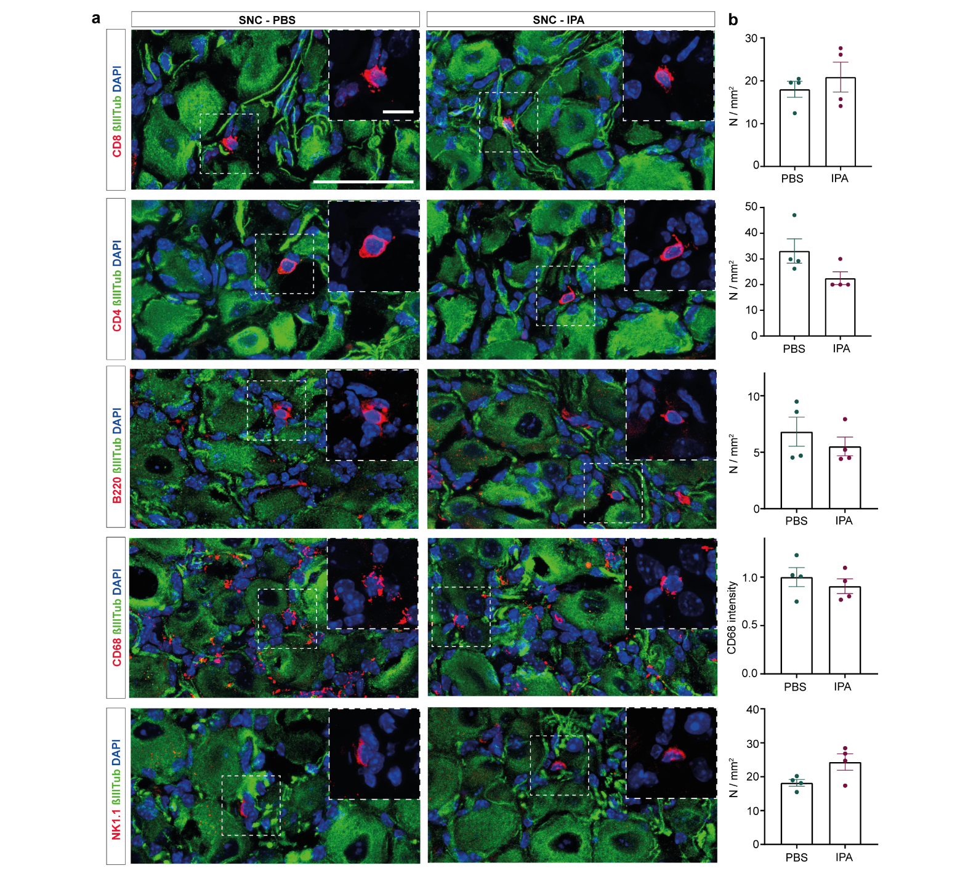
Extended data Fig.10. Immune cell quantification following IPA and PBS treatment including 3 days after SNC
a. CD8, CD4, B220, CD68 and NK1.1 (red) coimmunostained with βIIITubulin (green) and DAPI (blue) in DRG sections from IPA and PBS treated groups 3 days after SNC. Scale bar: 50 µm. Scale bar in magnification: 10 µm.
b. Quantification of CD8 T-cells, CD4 T-cells, B-cells (B220), Macrophages (CD68) and NK cells (NK1.1) number in IPA and PBS treated DRGDRG 3 days after SNC (N=4, Student’s unpaired t-test).

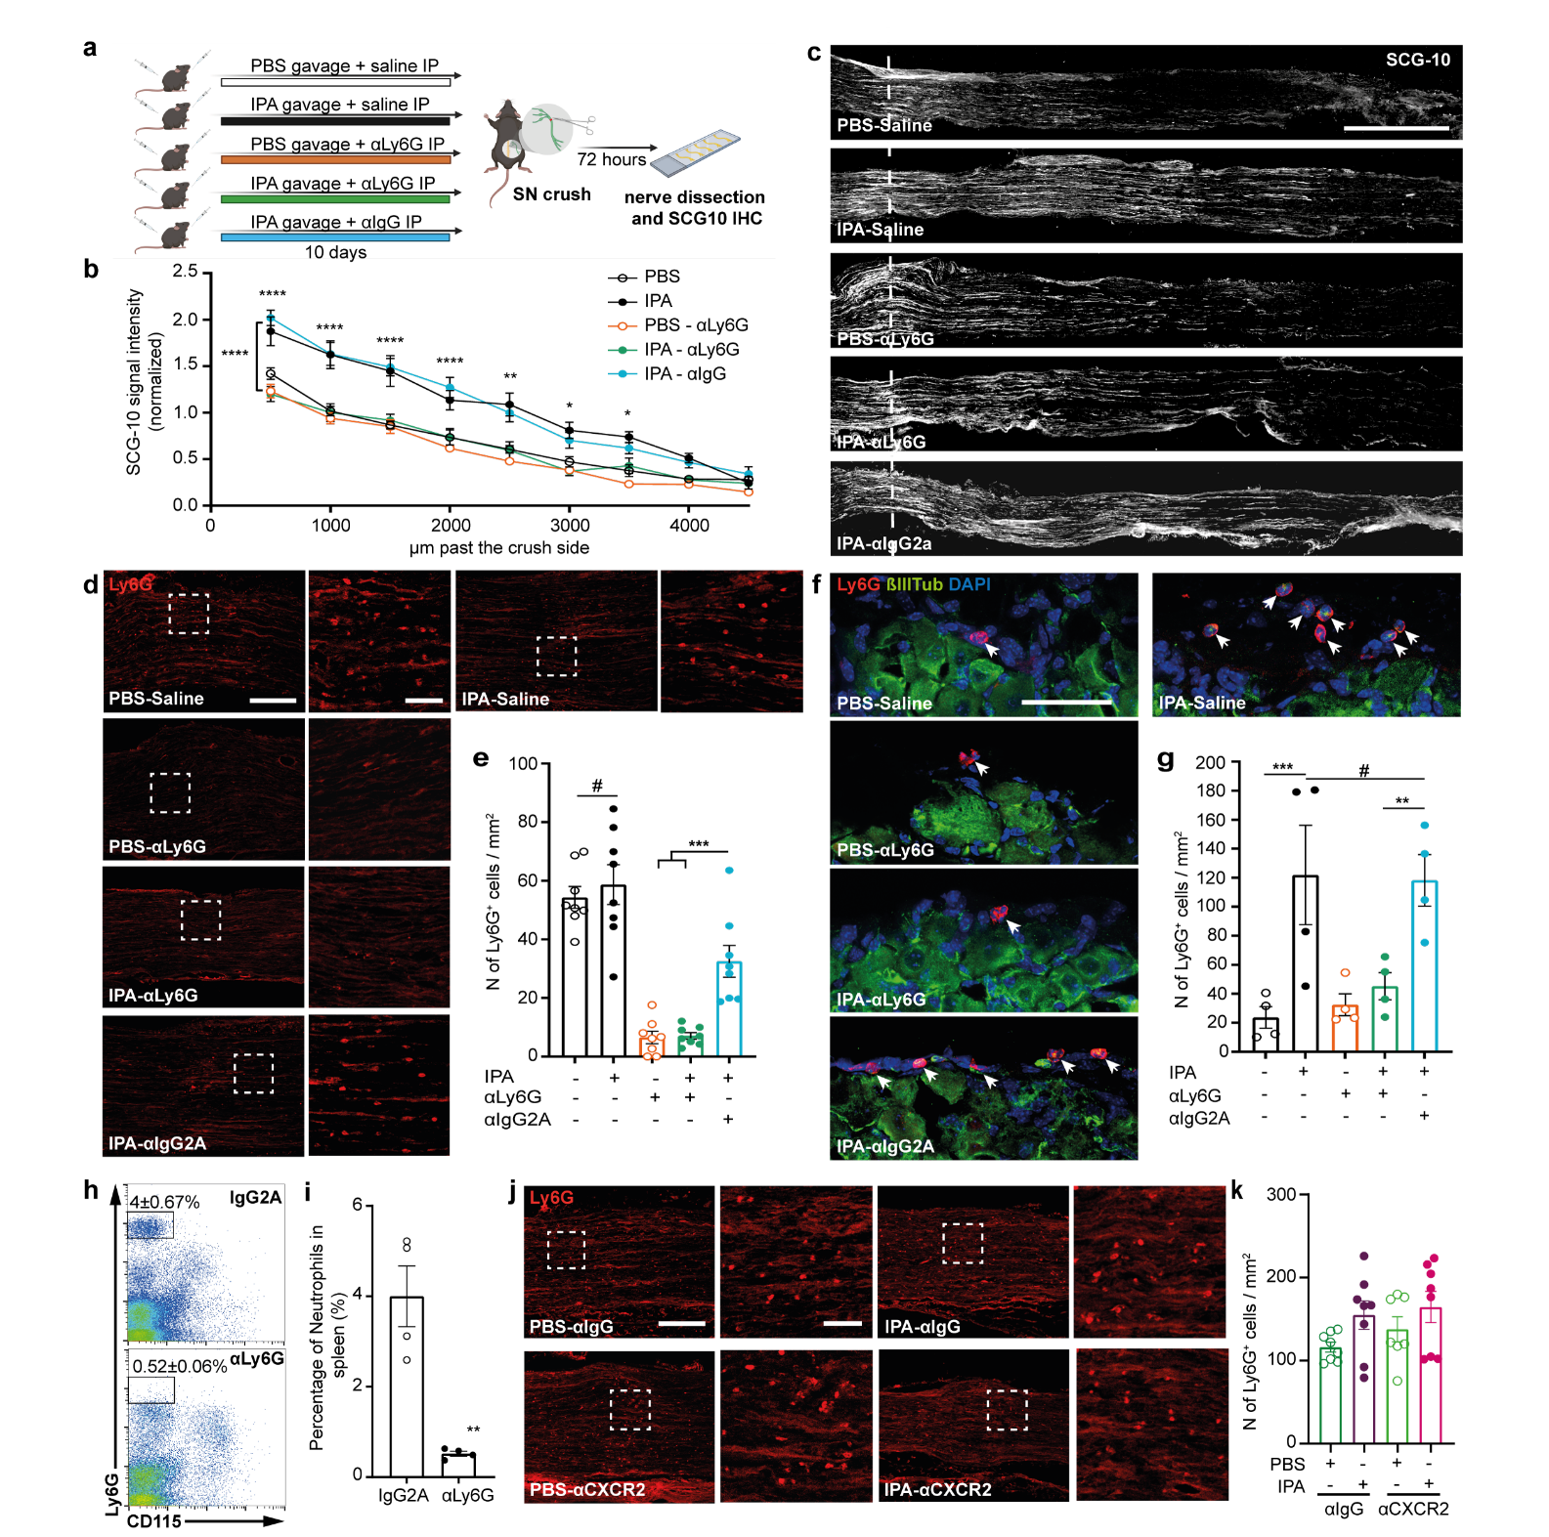

Extended data Fig. 11. Reduced regeneration following neutrophil depletion and loss of neutrophils in DRG tissue following chemotaxis inhibition
- Schematic of the experimental design.
- Quantification of SCG-10 intensity at the indicated distances and normalized to the intensity before the crush site. (N=7 nerves from 4 mice per group with a bilateral sciatic nerve crush; *p<0.05. **p<0.01, ***p<0.001, ****p<0.0001, two-way-ANOVA with Sidak test, mean±SEM).
- Micrographs of representative longitudinal sections of sciatic nerves immunostained with SCG-10. Scale bar: 1000 µm. The dashed line indicates the crush site.
- Ly6G immunostaining in sciatic nerve sections (crush site) of mice treated with IPA or PBS and anti-Ly6G or anti-IgG monoclonal antibody 3 days after SNC. Scale bar: 250 µm. Scale bar in magnification: 50 µm.
- Quantification of the number of Ly6G+ cells in the sciatic nerve crush site of mice treated with IPA or PBS and anti-Ly6G or anti-IgG monoclonal antibody 3 days after SNC (N=8, nerves from 4 mice per group with a bilateral sciatic nerve crush; ***p<0.001, #=n.s., two-way-ANOVA with Sidak test, mean±SEM).
- Ly6G immunostaining in sciatic DRG sections of mice treated with IPA or PBS and anti-Ly6G or anti-IgG monoclonal antibody 3 days after SNC. Scale bar: 50 µm. Arrows indicate Ly6G+ cells.
- Quantification of the number of Ly6G+ cells in sciatic DRG sections of mice treated with IPA or PBS and anti-Ly6G or anti-IgG monoclonal antibody 3 days after SNC (N=4, ;. **p<0.01, ***p<0.001, #=n.s., two-way-ANOVA with Sidak test, mean±SEM).
- Representative flow cytometry plots showing Ly6G+ neutrophil depletion following anti-Ly6G monoclonal antibody vs control IgG.
- Quantification of the percentage of neutrophils of the total CD45⁺ cells in spleen following control IgG or anti-Ly6G monoclonal antibody treatment (N=4, **p<0.01, Student’s unpaired t-test).
- Ly6G immunostaining in sciatic nerve sections (crush site) of mice treated with IPA or PBS and anti-CXCR2 or anti-IgG monoclonal antibody 3 days after SNC. Scale bar: 250 µm. Scale bar in magnification: 50 µm.
- Quantification of the number of Ly6G+ cells in the sciatic nerve crush site of mice treated with IPA or PBS and anti-CXCR2 or anti-IgG monoclonal antibody 3 days after SNC (N=8, nerves from 4 mice per group with a bilateral sciatic nerve crush; mean±SEM).

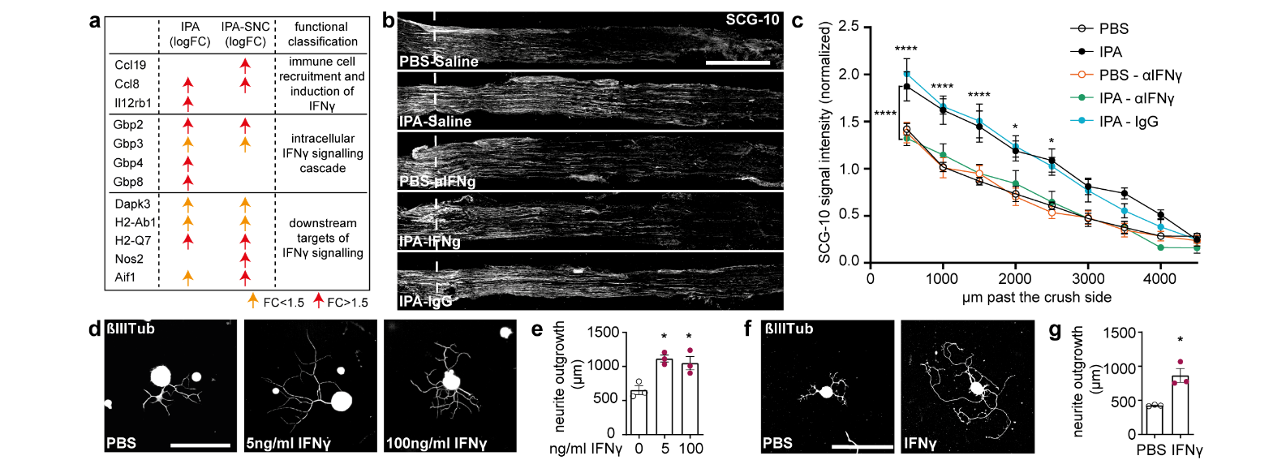
Extended data Fig. 12. IFNy is required for IPA-dependent axonal regeneration after SNC
- Table showing IPA dependently upregulated genes assigned to GO BP “cellular response to interferon gamma” before and after injury.
b-c. Mice were treated for 10 days with either IPA or PBS (by gavage) and injected (IP) with anti-IFNγ/ anti-IgG/PBS (IFNγ neutralisation). Axonal regeneration was assessed at 3 days post sciatic nerve crush.
b. Micrographs of representative longitudinal sections of sciatic nerves for all groups immunostained with SCG-10 following. Scale bar: 1000µm. The dashed line indicates the crush site.
c. Quantification of SCG-10 intensity at the indicated distances and normalized to the intensity before the crush site (N=7-8 nerves per group from 4 mice per group with a bilateral sciatic nerve crush; *p<0.05, ****p<0.0001, by two-way-ANOVA with Tukey test, comparing IPA-αIFNγ and IPA-αIgG, mean±SEM).
d. DRG neurons were treated with 5ng/ml or 100ng/ml of IFNγ in vitro and neurite outgrowth was assessed. Representative images of DRG neurons for each treatment, immunostained with ßIII-Tubulin (ßIIITub). Cultured for 12 hours. Scale bar: 100 μm.
e. Quantification of DRG neurite outgrowth (N=3 technical replicates per group; *p<0.05, one-way ANOVA with Dunnett’s multiple comparisons test, mean±SEM)).
f-g. Ex vivo culture of DRG neurons 48 hours after IFNγ i.p. injection.
f. Representative images of DRG neuron for each treatment, immunostained with ßIII-Tubulin (ßIIITub, white). Scale bar: 100μm.
g. Quantification of DRG neurite outgrowth (N=3 technical replicates per group, *p<0.05, Student’s t-test, mean±SEM)

