Supplementary information
Identification of a porcine TLR2-targeting peptide ligands using a cell-based phage display combined with high-throughput sequencing

Su-Bin An^{1,€}, Seo-Ho Oh^{1,2,€}, Jun-Yeong Lee^{1,3}, Kwang-Hwan Choi¹, Chang-Kyu Lee¹, Yun-Jaie Choi¹ and Sang-Kee Kang^{1,2,}*

¹ Department of Agricultural Biotechnology and the Research Institute of Agriculture and Life Science, Seoul National University, Seoul 08826, Republic of Korea
² Institute of Green-Bio Science & Technology, Graduate School of International Agricultural Technology, Seoul National University, Pyeongchang-gun, 25354, Republic of Korea
³ Mount Desert Island Biological Laboratory, Bar Harbor, ME 04609, USA

€ First-authors with equal contributions
* Correspondence: Sang-Kee Kang, Institute of Green-Bio Science and Technology, Seoul National University, 1447 Pyeongchang-daero, 25354, Pyeongchang, Republic of Korea
E-mail: kangsk01@snu.ac.kr

Supplementary Figures
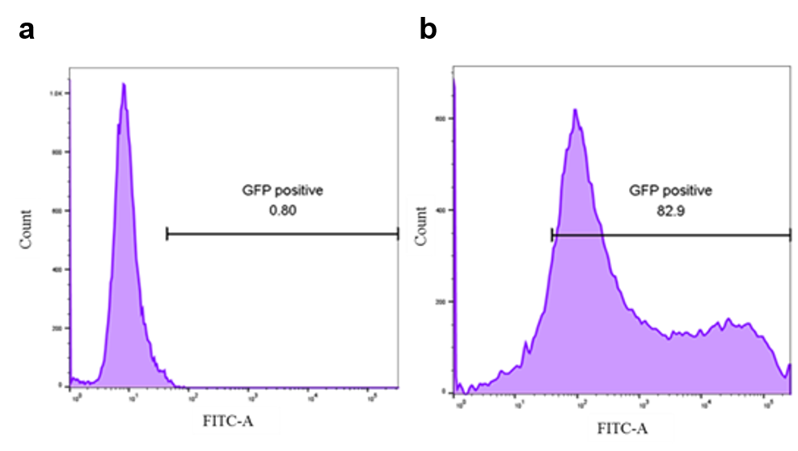
Supplementary Figure S1. Flow cytometry analysis of IPEC-J2 cells transduced with pTLR2-eGFP-carrying lentiviruses. IPEC-J2 cells were transduced with pTLR2-eGFP carrying lentiviruses and incubated for 48 hours in the presence of 8 μg/ml polybrene. The transduction efficiency was analyzed using flow cytometry. (a) Wild-type IPEC-J2 cells, (b) TLR2-overexpressing IPEC-J2 cells.

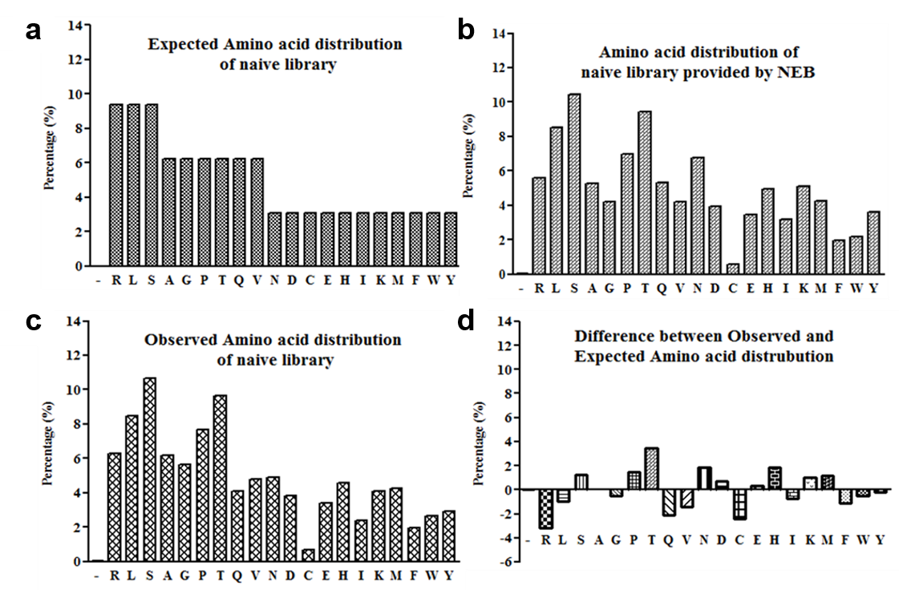
Supplementary Figure S2. Analysis of the amino acid distribution of the Ph.D.C7C-library. The average amino acid composition (%) of all unique sequenced peptides is indicated. (a) The theoretical amino acid composition based on the (NNK)7 inserts. (b) The amino acid composition provided by the manufacturer. (c) The observed amino acid distribution after Illumina sequencing. (d) The difference between the observed and the theoretical composition; '-' indicates a stop codon.

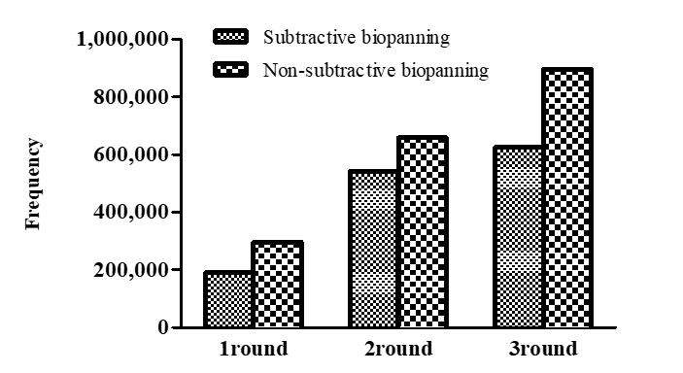Supplementary Figure S3. The frequency of false positives during three rounds of biopanning. The non-target sequences and the sequences already reported were screened by SAROTUP and PepBank, respectively.

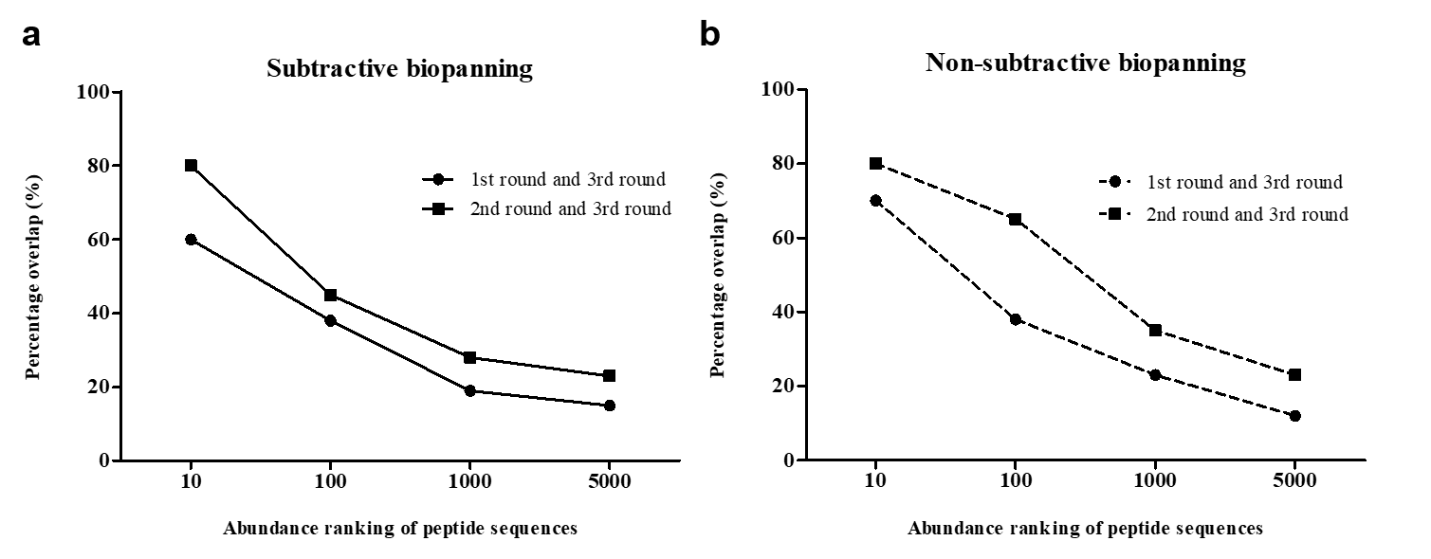Supplementary Figure S4. Percentage of overlap of the abundant peptides. Obtained sequences from rounds 1 and 2 are compared with those of the third round, and the overlapping sequences are indicated as a percentage. (a) Subtractive biopanning. (b) Non-subtractive biopanning.

Supplementary Table
Supplementary Table S1. Primers used for amplification of porcine TLR2 gene.
Primers | DNA Sequence (5’ to 3’) | Restriction enzyme site
1F | AGCTTTGTTTAAACGCCACCATGCCATGTGCTTT | PmeⅠ
1R | ACATGCATGCTCACAGGCTGAGTT | SphⅠ
2F | ACATGCATGCCTGGCCCTTCCTAC | SphⅠ
2R | CGCGACGCGTAAGGACTTGATCGCAG | MluⅠ

