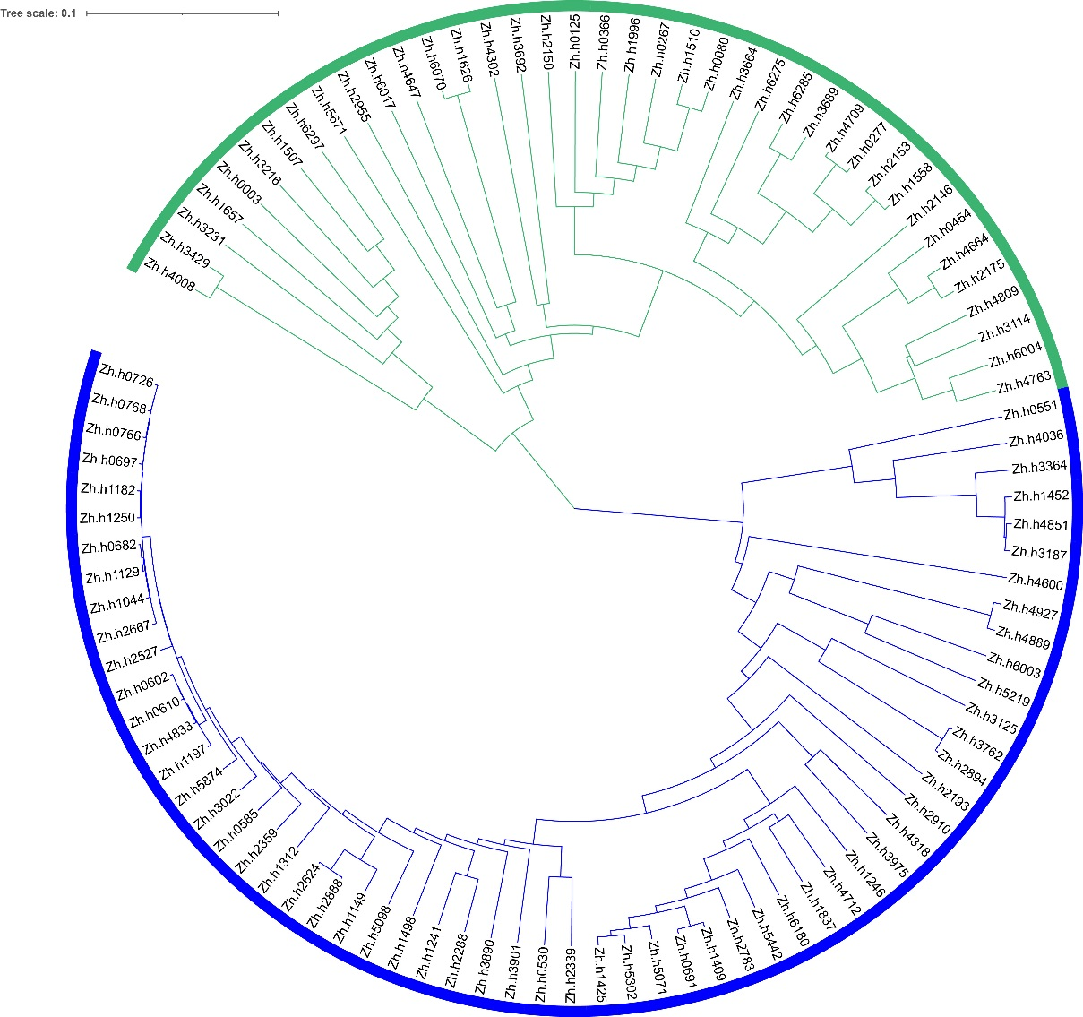
Figure S1 Dendrogram of the peanut panel based on genotypic data

Figure S2 Frequency distribution of relative kinship coefficient in 99 peanut accessions. Only kinship values ranged from 0 to 0.5 were shown.

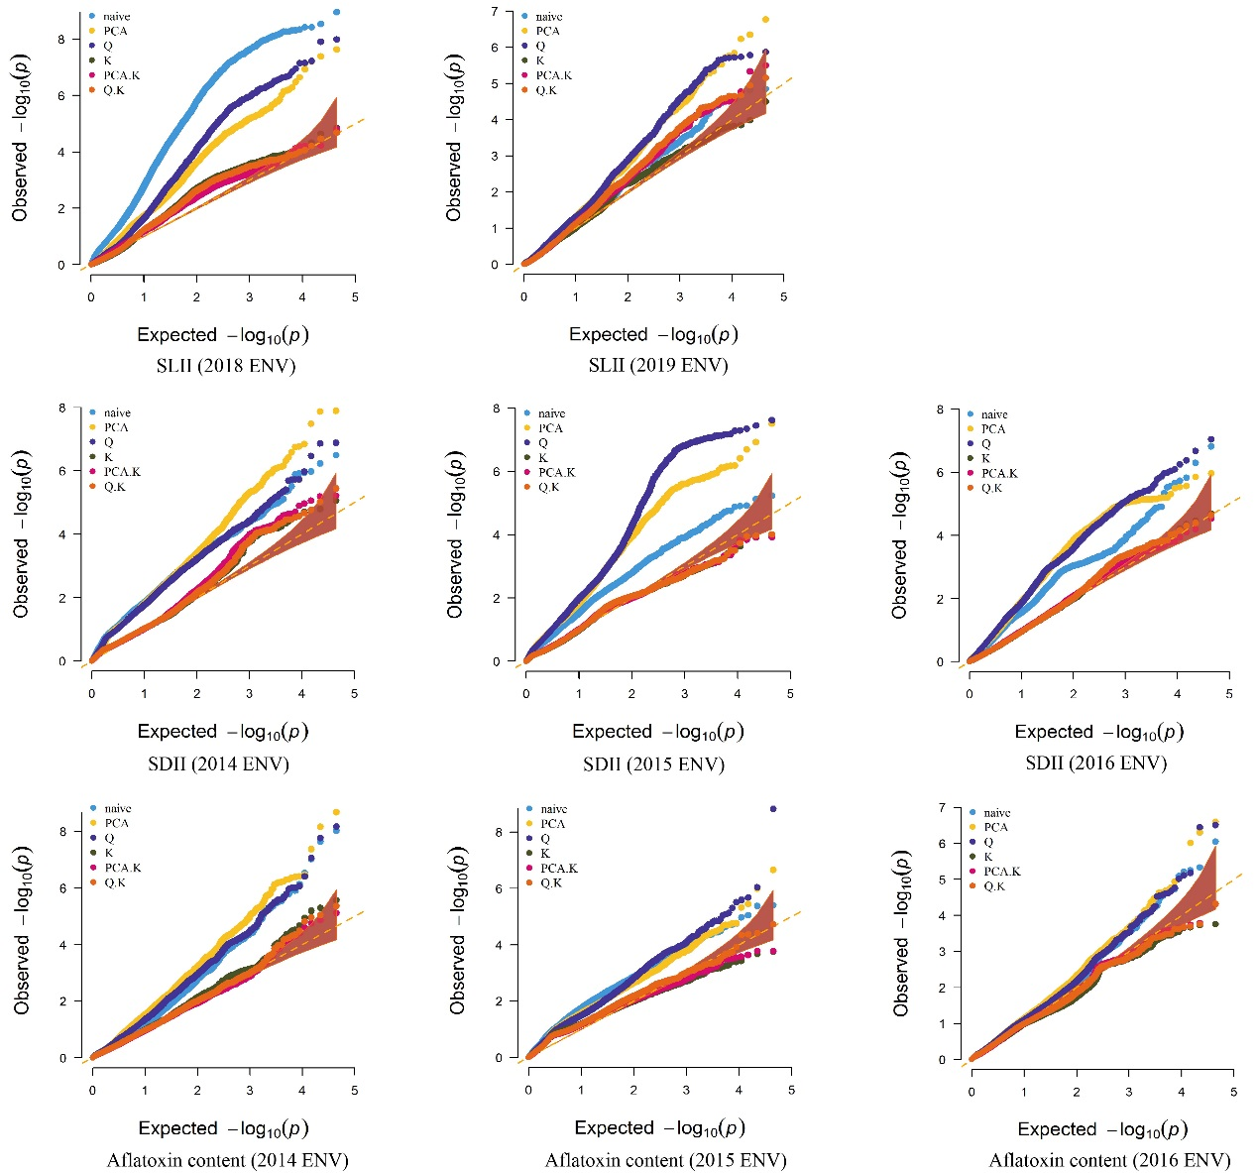
Figure S3 QQ plot for three resistances. ENV environment.

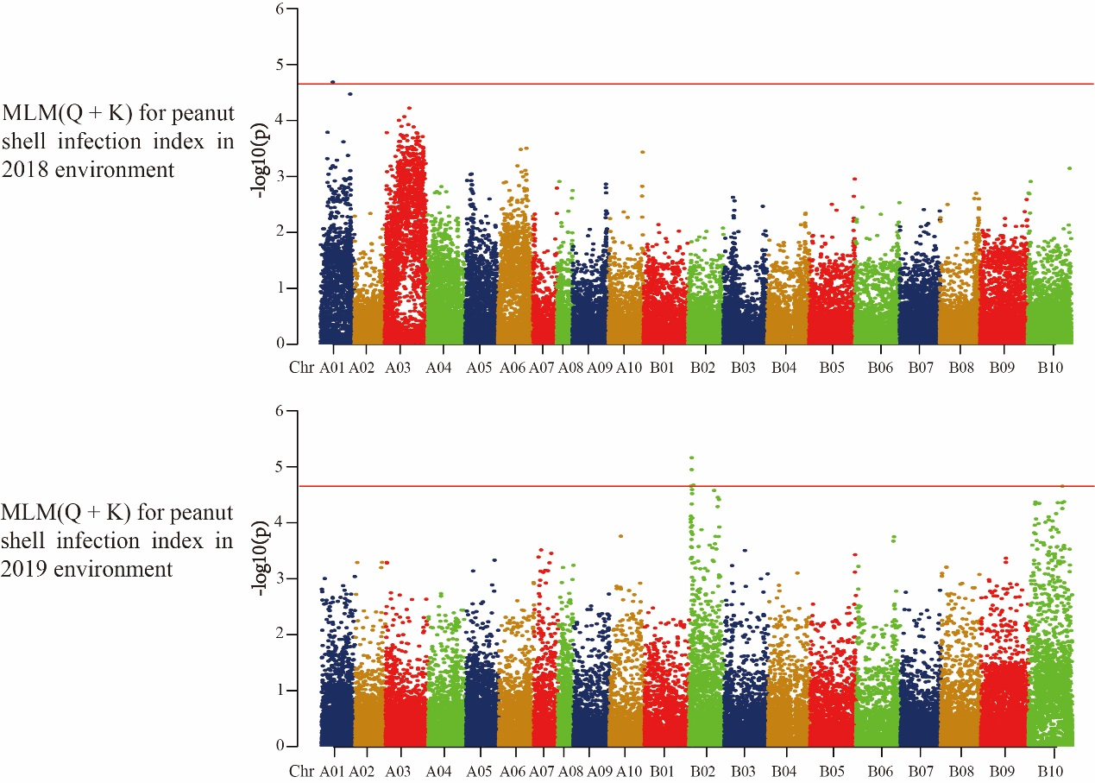
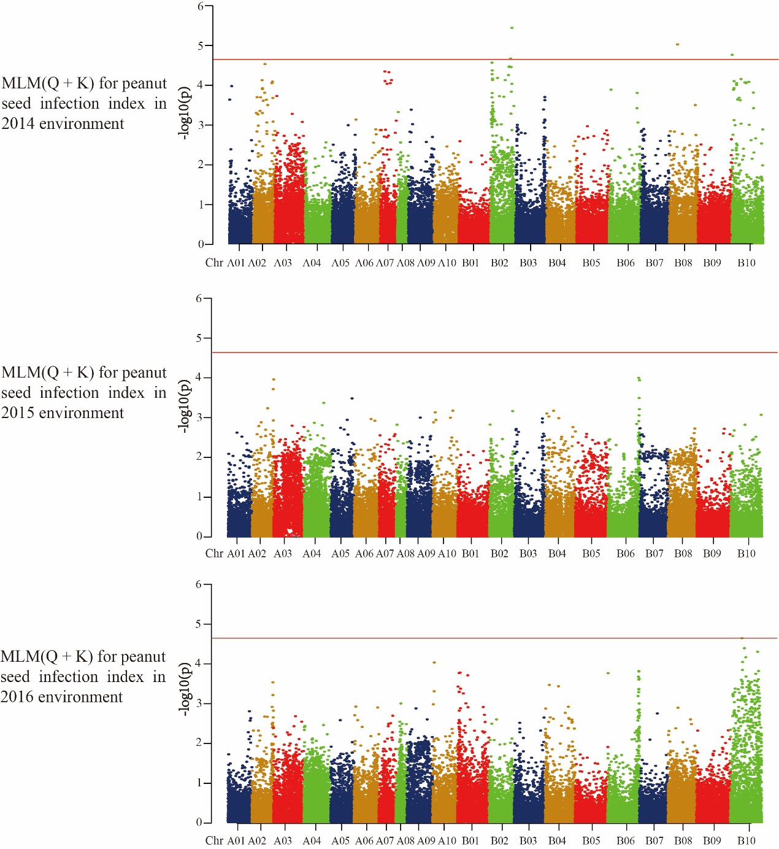
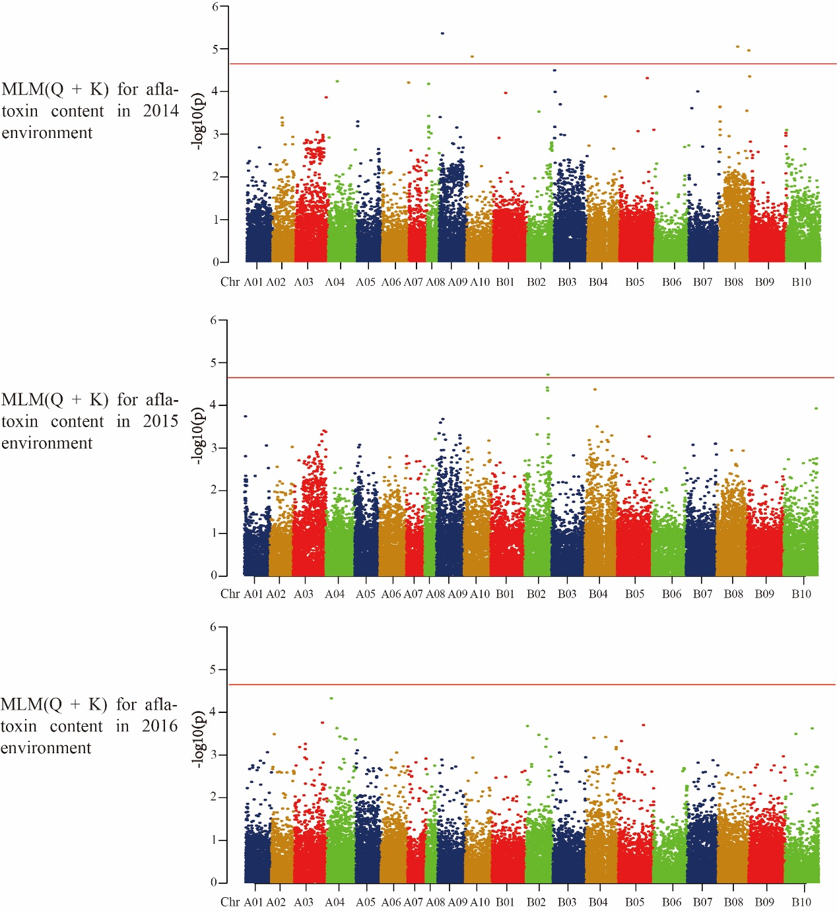
Figure S4 Genome-wide association for shell infection index (SLII), seed infection index (SDII) and aflatoxin content in peanut associations

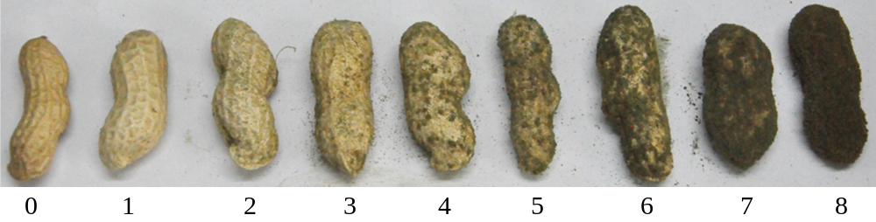
Figure S5 0-8 scale for resistance screening of peanut pod

