Supplementary Information for
Automated target-driven molecular machine-based engineering process for SARS-CoV-2 monitoring

Zhenqiang Fan,ª Minhao Xie,^{a,c} Jianbin Pan*^{,b} Kai Zhang,*^{,a}

ªNHC Key Laboratory of Nuclear Medicine, Jiangsu Key Laboratory of Molecular Nuclear Medicine, Jiangsu Institute of Nuclear Medicine, Wuxi, Jiangsu, China 214063

^{b}State Key Laboratory of Analytical Chemistry for Life Science and Collaborative Innovation Center of Chemistry for Life Sciences, School of Chemistry and Chemical Engineering, Nanjing University, Nanjing 210023, China

^{c}Department of Radiopharmaceuticals, School of Pharmacy, Nanjing Medical University, Nanjing 211166, China

* Corresponding authors. Fax: +86-510-85508775; Tel: +86-510-85508775
E-mail addresses: jbpan@nju.edu.cn (J. Pan), zhangkai@jsinm.org (K. Zhang)

Materials and Methods

  - Materials and chemical reagents

The oligonucleotides, modified DNA probes, tris-borate-EDTA (TBE) buffer for polyacrylamide gel electrophoresis (PAGE) experiment to verify DNA hybridization, phosphate buffer saline (PBS, pH = 7.1) for ECL tests were obtained from Sangon Biotech Co. Ltd. (Shanghai). Tris (4, 4’-dicarboxylic acid-2, 2’-bipyridine) ruthenium dichloride (Ru(dcbpy)₃²⁺) was obtained through Suna Tech Inc (Suzhou, China). Polyethyleneimine (PEI), N-(3-(Dimethylamino)propyl)-N-ethyl-carbodiimide hydrochloride (EDC), N-hydroxysuccinimide (NHS), tris(2-carboxyethyl) phosphonate hydrochloride (TCEP), and various analytical grade reagents were purchased from Aladdin Biochemical Technology Co. MXene-Ti₃C₂ of single layer/few layers was obtained from XFNANO (Nanjing, China). Ultrapure water with a resistance greater than 18 MΩ was obtained from the Milli-Q purification system (Branstead) for the experimental procedure. The DNA sequences used in this strategy were depicted in Table S1. The nicking endonuclease was Nb.BbvCI and related buffer were got from New England Biolabs (USA). This work has received approval for research ethics from Medical Ethics Committee of Jiangsu Institute of Nuclear Medicine and a proof/certificate of approval is available upon request.

  - Instrument parameters and test conditions

Transmission electron microscopy (TEM) images were taken by 1400 PLUS (Nippon Electron). X-ray photoelectron spectroscopy (XPS) data were obtained from Thermo Fisher K-Alpha. ECL test data were obtained by an ECL-6B instrument built by the State Key Laboratory of Analytical Chemistry for Life Sciences, Nanjing University, with voltage parameters from 0 to 1.3 V and a scan rate of 0.1 V/s. ECL tests were performed using a three-electrode system consisting of a 3 mm diameter glassy carbon electrode (GCE), an Ag/AgCl reference electrode, and a Pt counter electrode in PBS (0.1 M, pH 7.4). UV-visible absorption data were obtained by Spectra Max M5e (Molecular Devices Co. Ltd). Cyclic voltammetry (CV) with a scan rate of 100 mV/s and electrochemical impedance spectroscopy (EIS) with a frequency ranged from 100 kHz to 0.1 Hz were obtained in PBS buffer (0.1 M, pH = 7.4) containing [Fe(CN)₆]^{3-/4-} (5 mM).

  - Synthesis of Ti₃C₂/PEI-Ru@Au nanocomposite

Ti₃C₂/PEI-Ru@Au nanocomposite was explicitly synthesized according to the following method. First, 8 mg of Ru(dcbpy)₃²⁺ powder was dissolved in 4 mL ultrapure water. Then, 24 mg of EDC and 4 mg of NHS were added to the above solution and kept stirring for 15 min. Immediately afterward, 1 mL of Ti₃C₂ solution (5 mg mL⁻¹) and 5 mL PEI solution (mass fraction of 1%) was added to the above reaction solution and continuously stirred for 2 h. Finally, 500 μL HAuCl₄ (0.1 M) and 500 μL NaBH₄ (0.1 M) were added to the above solution and the reaction was continued for 1.5 h. Finally, the reaction solution was centrifuged twice and dissolved into 10 mL ultrapure water for further use.

  - Fabrication of automated molecular machine and their assembly on electrodes

The construction of the automated molecular machine followed the following procedure. The GCE was polished with alumina powder of 0.05 μm diameter size and repeatedly sonicated in ethanol and aqueous solution prior to modification.

The synthesis of the automated molecular machine followed the following method. Six single-stranded DNA (H-T1, P-T2, S-S’-T3, T4, H, P’) with a final concentration of 1 μM and TCEP (with the final concentration of 10 μM) were mixed and heated to 95 ℃ for ten min. Subsequently, the mixed solution was rapidly cooled to 4 °C and placed in the refrigerator for further use. Then the inverted tetrahedral probe scaffold DNA automaton was successfully synthesized.

10 μL Ti₃C₂/PEI-Ru@Au nanocomposite solution was dipped on the spotless GCE. Then the modified GCE was immersed into the automated molecular machine solution overnight to facilitate the full reaction of the inverted tetrahedral probes with the Au particles of Ti₃C₂/PEI-Ru@Au nanocomposite to form Au-S bonds. In to obtain the best sensitivity and assay performances, we optimized the tetrahedral concentrations. Because the inverted tetrahedra labelled the Fc probes which could quench the ECL signal, it could be concluded that the most suitable tetrahedral concentration for the reaction is obtained when the best quenching effect was achieved. We obtained the optimal tetrahedral concentration by obtaining the relationship between the ECL signal and the tetrahedral concentration as depicted in Fig. S1. It could be seen that when the tetrahedral concentration reached 1 μM, the ECL intensity no longer changed. Therefore a concentration of 1 μM was considered as the optimal concentration. By incubation with inverted DNA tetrahedra the at optimal concentration, the sensor construction containing modifications of Ti₃C₂/PEI-Ru@Au nanocomposite and automated molecular machine was achieved.

Fig. S1. Optimization of the concentration of inverted DNA tetrahedron used in our method for SARS-CoV-2 monitoring.

  - Monitoring process

The automated molecular machine was immersed in a reaction containing different concentrations of target DNA for 1 h, followed by a reaction in a nicking buffer containing 10 U mL⁻¹ for 2 h. The gene targets are highly specific sequences on the RNA-dependent RNA polymerase (RdRp) selected from the SARS-CoV-2 gene library. The sequences were retrieved from the GISAID database with library code of SARS-CoV-2 NC_045512, which exhibits a role in distinguishing SARS-CoV-2 from SARS-CoV (Qiu et al 2020). It is particularly important to note that the modified electrodes need to be rinsed with 0.1 M PBS solution after each modification. The final ECL signals were obtained in PBS solution (0.1 M, pH = 7.4) with a scanning voltage ranged from 0 to 1.3 V.

Fig. S2. EDX elemental mapping to illustrate the elemental distribution of Ti₃C₂/PEI-Ru@Au nanocomposite. The electron image (A), the overlap image (B) and Ti (C), C (D), Ru (E), N (F), O (G), Au (H) elements.

The EDS spectra as depicted in Fig S3 showed that Ti₃C₂/PEI-Ru@Au contains the characteristic elements Ti and C of Ti₃C₂, the characteristic element Ru of Ru(dcbpy)₃²⁺, and the basic element Au for Au nanoparticles, indicating the synthesis of the composite.
Fig. S3. EDS spectra of Ti₃C₂/PEI-Ru@Au nanocomposite.

To verify the successful assembly of the sensor, we characterized the inverted tetrahedral backbone as depicted in Fig. S4. Lane 1-4 were four single strands DNA (H-T1, P-T2, S’-S-T3, T4), respectively. The dsDNA including H-T1·P-T2, H-T1·S’-S-T3, H-T1·T4 and S’-S-T3·T4 were in lane 5-8. The triple-stranded DNA formed by H-T1, P-T2, S’-S-T3 was in lane 9, and the inverted DNA tetrahedral skeleton was at lane 10. It could be seen that the swimming speeds were gradually slowing down as the inverted DNA tetrahedra were assembled, which also verified the synthesis of inverted DNA tetrahedra.
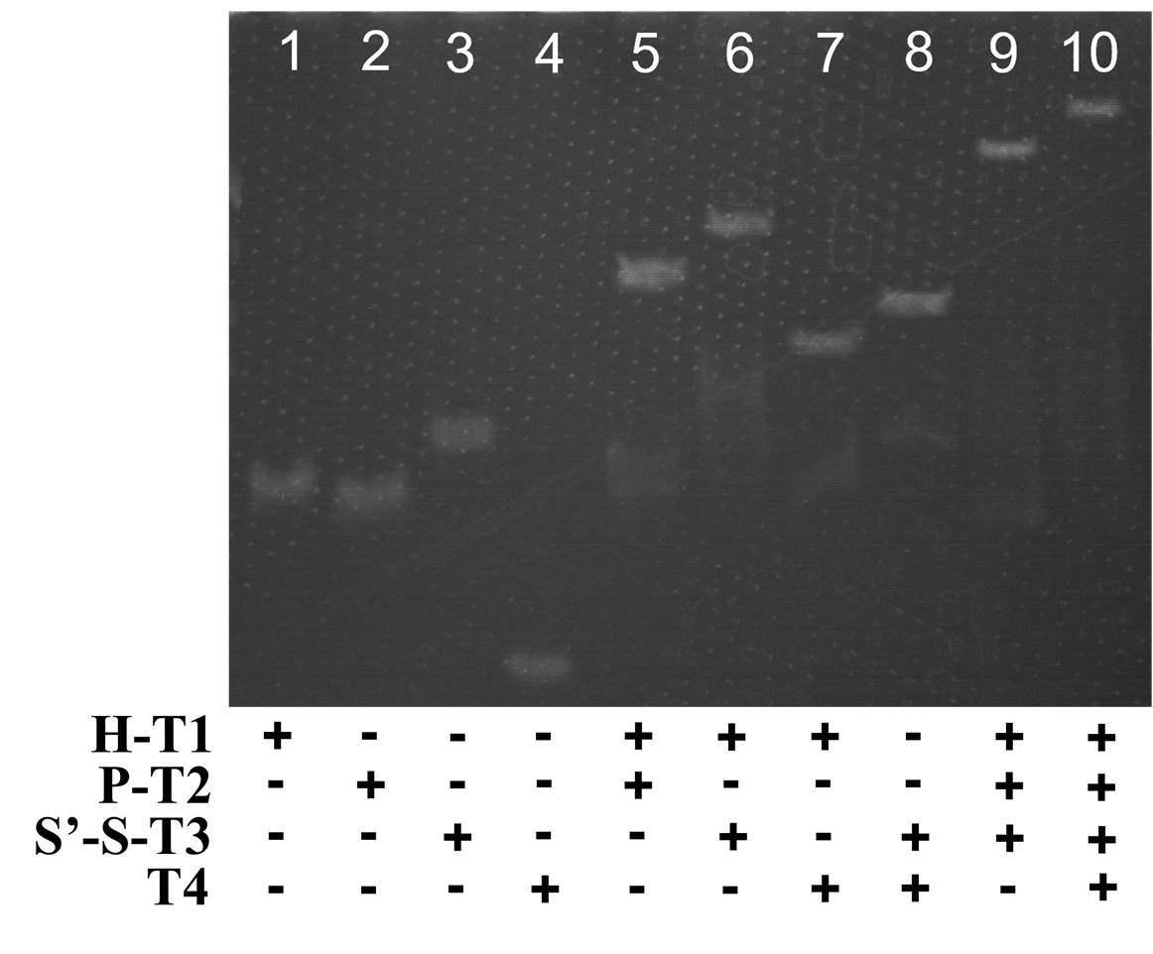
Fig. S4. PAGE image to illustrate the synthesis of the inverted DNA tetrahedron.

Fig. S5. PAGE characterizations for the step-by-step reactions on inverted DNA tetrahedra.

Fig. S6. Schematic diagram of the electrode modification process (A), EIS (B), and CV (C) characterizations for (a) Bare GCE, (b) GCE/Ti₃C₂/PEI-Ru@Au, (c) GCE/Ti₃C₂/PEI-Ru@Au/DA, (d) GCE/Ti₃C₂/PEI-Ru@Au/DA/Nicking.

Table S1. The sequences of the oligonucleotides used in the strategy. The part highlighted in yellow represents the restriction site of Nb.BbvCI, where the cleavage between CC and TCAGC. The part in italics is the sequences of the hairpin stem. Bolded sequences for the synthesis of inverted tetrahedral probes. The base pairs of different colors correspond to the individual oligonucleotide domains shown in the scheme.
note | sequence (5’-3’)
T | CAG GTG GAA CCT CAT CAG GAG ATG C
H’ | GCA TCT CCT GAT GAG GTT CCA CCT G
H-T1 | ATA AAT GGA GCA GGT GGA ACC TCA TTT TTT TCT TTC CTA AGT AAA TAC AGC TTG CAA ATT GAG CCG CCA T
P’ | TC CAC CTG CTC CAT TTA TTC CTC A
P-T2 | TGT GCT GAG GAA TAA ATG GAG TTT TTT ATA CAC CAG GCT AAT GCA AGC TGT ATA GTT GCG AGG GTC C
S’-S-T3 | Fc-CGT GGT CTA CAG TCA CTA TTC CTC AGC ACC ACG TTT TTT AGC CTG GTG TAT AAC GAC ACT ACG TGT CAT GGC GGC TCA A
T4 | SH-ACT TAG GAA AGA GCC ACG TAG TGT CGA AGG ACC CTC GCA A
Bat SARS-related CoV isolate bat-SL-CoVZC45 (M1) | CAGGTGGAACATCATCCGGTGATGC
BM48-31/BGR/2008 (M2) | CAGGCGGTACATTTTCAGGAGATGC
SARS-CoV | CCAGGTGGAACATCATCCGGTGATGC

Table S2. Comparisons of our strategy with other viral DNA target detecting methods.
Method | Linear range | LOD | Ref.
Colorimetric | 20 to 1000 nM | 1.53 nM | (Teengam et al 2017)
Colorimetric | 4 nM to 1 μM | 1 nM | (Yeasmin et al 2020)
Fluorescence | 2 to 200 pM | 3.1 pM | (Zhu et al 2018)
Fluorescence | 0.1 to 150 nM | 81 pM | (Chen et al 2016)
Electrochemistry | 3.2 pM to 320 nM | 2.3 pM | (Hong et al 2017)
Electrochemistry | 10 fM to 10 pM | 10 fM | (Wan et al 2015)
ECL | 0.05 pM to 50 nM | 39.81 fM | (Wu et al 2019)
ECL | 1 pM to 1 nM | 0.68 pM | This work

Table S3. Target determination in 20-fold and 50-fold real human saliva dilution environments.
Sample | Target |  | Recovery (%) | RSD (%, n=3)
Sample | Spiked | Detected | Recovery (%) | RSD (%, n=3)
Human saliva (20-fold) | 5 pM | 5.13 pM | 102.6 | 3.1
Human saliva (20-fold) | 50 pM | 48.2pM | 96.4 | 2.6
Human saliva (20-fold) | 0.5 nM | 0.524 nM | 104.8 | 3.2
Human saliva (20-fold) | 5 nM | 4.85 nM | 97.0 | 4.3
Human saliva (50-fold) | 5 pM | 4.95 pM | 99.0 | 2.7
Human saliva (50-fold) | 50 pM | 52.4 pM | 104.8 | 2.5
Human saliva (50-fold) | 0.5 nM | 0.482 nM | 96.4 | 4.2
Human saliva (50-fold) | 5 nM | 5.21 nM | 104.2 | 3.8

References

Chen J, Ji X, Tinnefeld P et al (2016) Multifunctional dumbbell-shaped DNA-templated selective formation of fluorescent silver nanoclusters or copper nanoparticles for sensitive detection of biomolecules. ACS Appl. Mater. Interfaces 8(3): 1786-1794. https://doi.org/10.1021/acsami.5b09678
Hong N, Cheng L, Wei B et al (2017) An electrochemical DNA sensor without electrode pre-modification. Biosens. Bioelectron. 91: 110-114. https://doi.org/https://doi.org/10.1016/j.bios.2016.10.008
Qiu G, Gai Z, Tao Y et al (2020) Dual-functional plasmonic photothermal biosensors for highly accurate severe acute respiratory syndrome coronavirus 2 detection. ACS Nano 14(5): 5268-5277. https://doi.org/10.1021/acsnano.0c02439
Teengam P, Siangproh W, Tuantranont A et al (2017) Multiplex paper-based colorimetric DNA sensor using pyrrolidinyl peptide nucleic acid-induced agnps aggregation for detecting mers-cov, mtb, and hpv oligonucleotides. Anal. Chem. 89(10): 5428-5435. https://doi.org/10.1021/acs.analchem.7b00255
Wan Y, Wang P, Su Y et al (2015) Nanoprobe-initiated enzymatic polymerization for highly sensitive electrochemical DNA detection. ACS Appl. Mater. Interfaces 7(46): 25618-25623. https://doi.org/10.1021/acsami.5b08817
Wu Z, Luo F, Wen W et al (2019) Enrichment–stowage–cycle strategy for ultrasensitive electrochemiluminescent detection of HIV-DNA with wide dynamic range. Anal. Chem. 91(19): 12238-12245. https://doi.org/10.1021/acs.analchem.9b01969
Yeasmin S, Ammanath G, Ali Y et al (2020) Colorimetric urinalysis for on-site detection of metabolic biomarkers. ACS Appl. Mater. Interfaces 12(28): 31270-31281. https://doi.org/10.1021/acsami.0c09179
Zhu Z, Yuan P, Li S et al (2018) Plasmon-enhanced fluorescence in coupled nanostructures and applications in DNA detection. ACS Applied Bio Materials 1(1): 118-124. https://doi.org/10.1021/acsabm.8b00032

