Supplementary information

A record from an active asteroid preserved in a carbonaceous chondrite

Xin Yang^{1,2,3}*, Romy D. Hanna⁴, Andrew M. Davis^{1,3,5}, April I. Neander⁶, Philipp R. Heck^{1,2,3}

¹Department of the Geophysical Sciences, The University of Chicago, Chicago, IL 60637, USA
²Robert A. Pritzker Center for Meteoritics and Polar Studies, Negaunee Integrative Research Center, Field Museum of Natural History, Chicago, IL, USA
³Chicago Center for Cosmochemistry, The University of Chicago, Chicago, IL 60637, USA.
⁴Jackson School of Geosciences, University of Texas, Austin, TX 78712, USA
⁵Enrico Fermi Institute, The University of Chicago, Chicago, IL 60637, USA.
⁶Department of Organismal Biology and Anatomy, The University of Chicago, Chicago, IL 60637, USA.

Supplementary Figs. 1–6
Supplementary Table 1

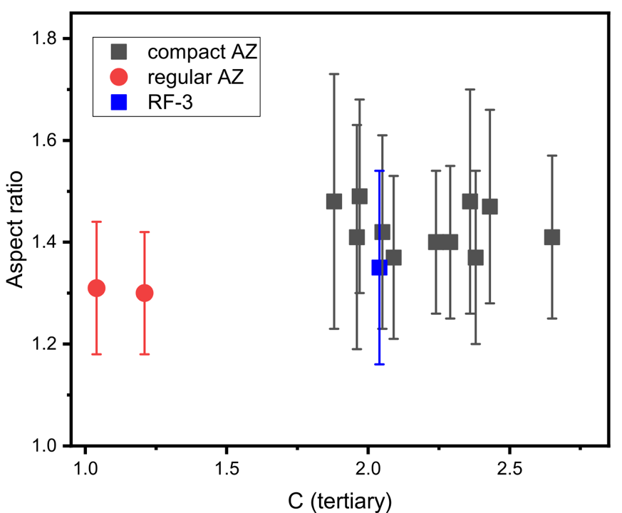
Supplementary Fig. 1. 3D aspect ratios of fitted ellipsoids of chondrules in AZ fragments versus C parameters. Two groups, regular AZ and compact AZ, are clearly separated, with RF-3 in the compact group. Error bars are one standard deviation (n=22–85).

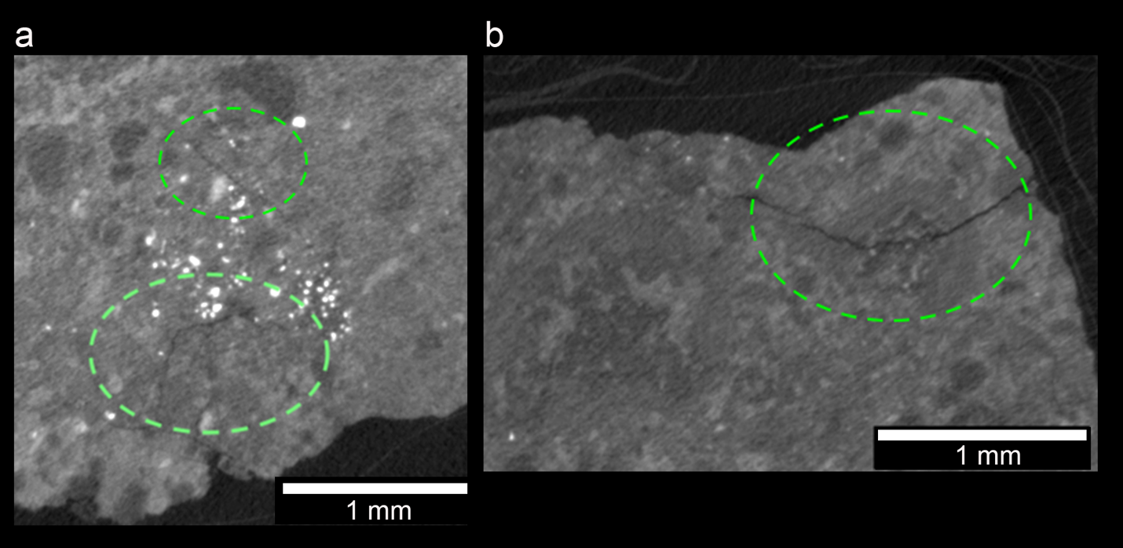
Supplementary Fig. 2. μCT images of one regular AZ fragment RF-1. Fractures are indicated by green ellipses in a and b.
Supplementary Fig. 3. Pressure profiles for bodies with varying sizes. The left panel shows that the maximum pressure (center pressure) within a spherical body increases quadratically with the radius. The right panel displays that the local pressure within a body with a radius of 100 km increases quadratically with the depth below the surface.
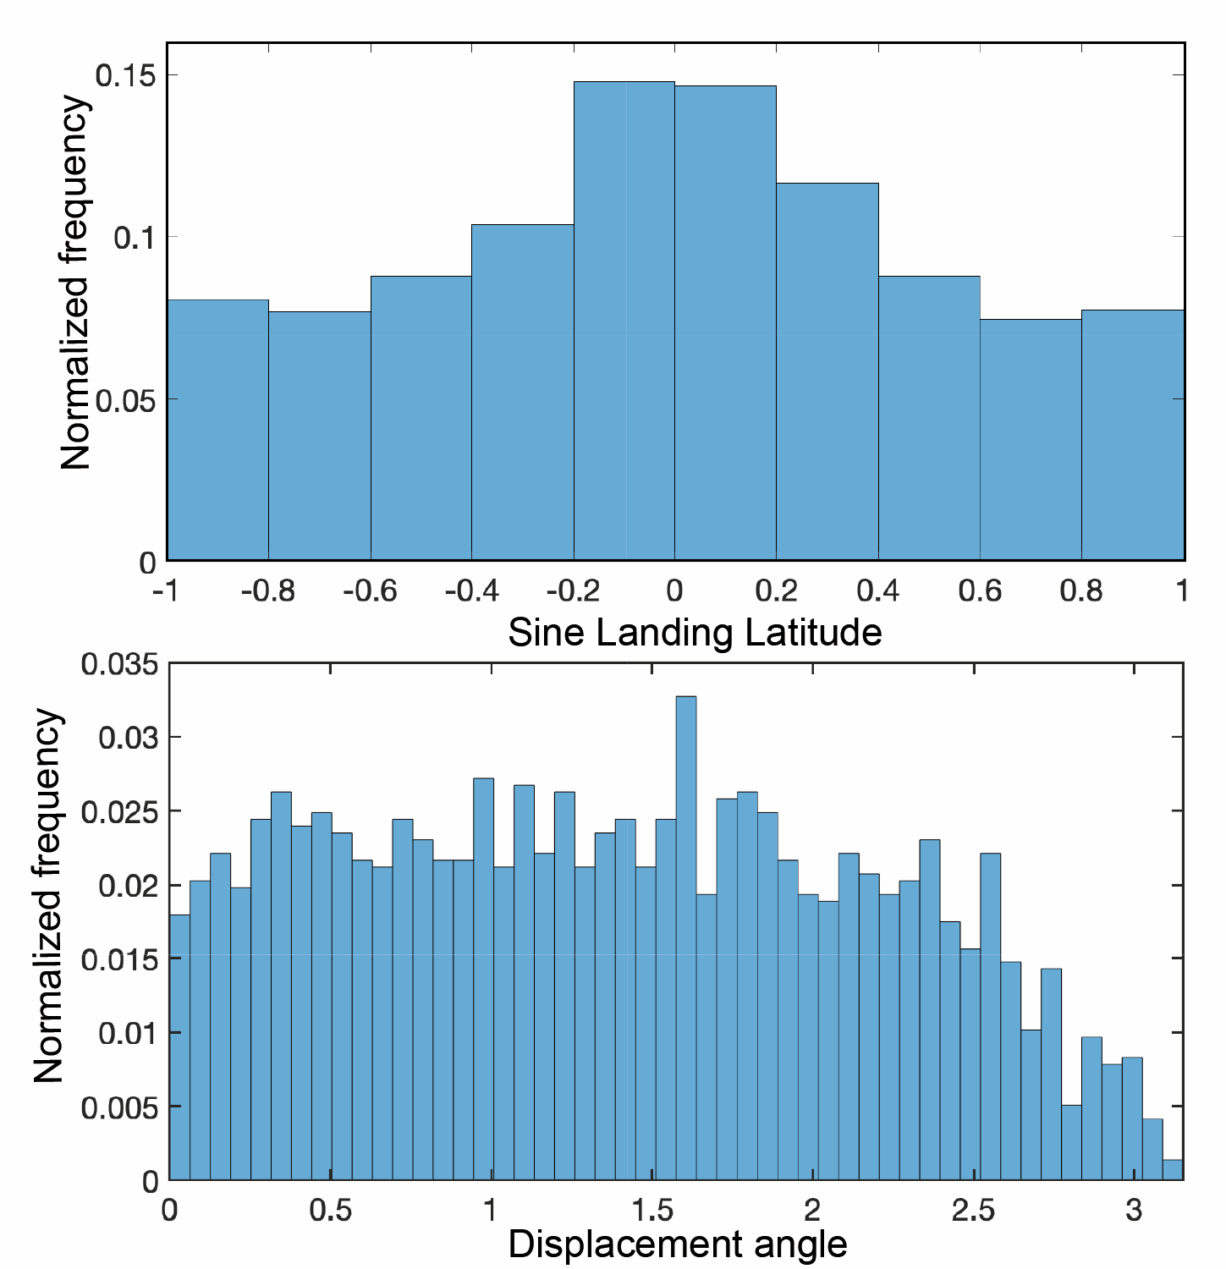
Supplementary Fig. 4. Distributions of absolute locations (upper panel) and of displacement angles (lower panel) for redeposition onto a Bennu-like asteroid. The center body has the same size and bulk density as that of Bennu (490 m in diameter and 1.26 g cm^{–3} in bulk density).

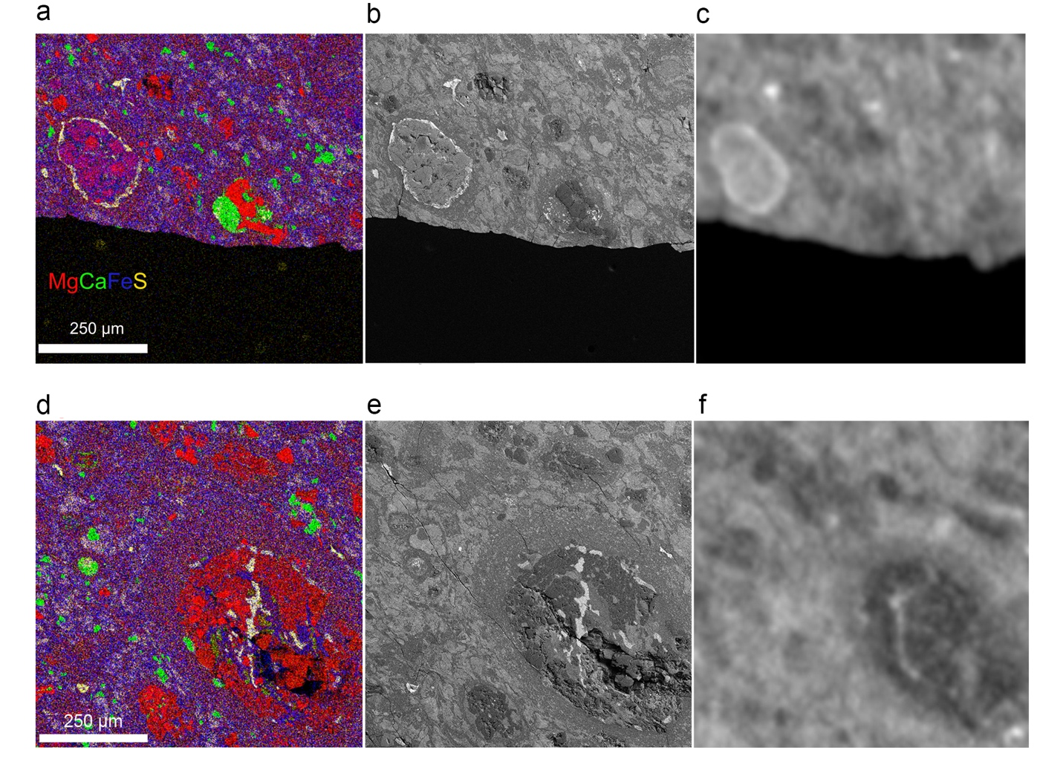
Supplementary Fig. 5. EDS, BSE, and μCT images of CF-10. a, EDS map from CF-10 shows a sulfide rim surrounding a chondrule. b, BSE image of the same area as a with bright sulfide chondrule rim. c, μCT cross-section of approximately the same position as a with a light-toned chondrule on the left. d, EDS map of CF-10 shows sulfide veins (yellow) in a chondrule (lower right). e, BSE image of the same area as d and bright veins in the chondrule. f, μCT data of approximately the same position as d with a dark-toned object (chondrule) in the lower right.

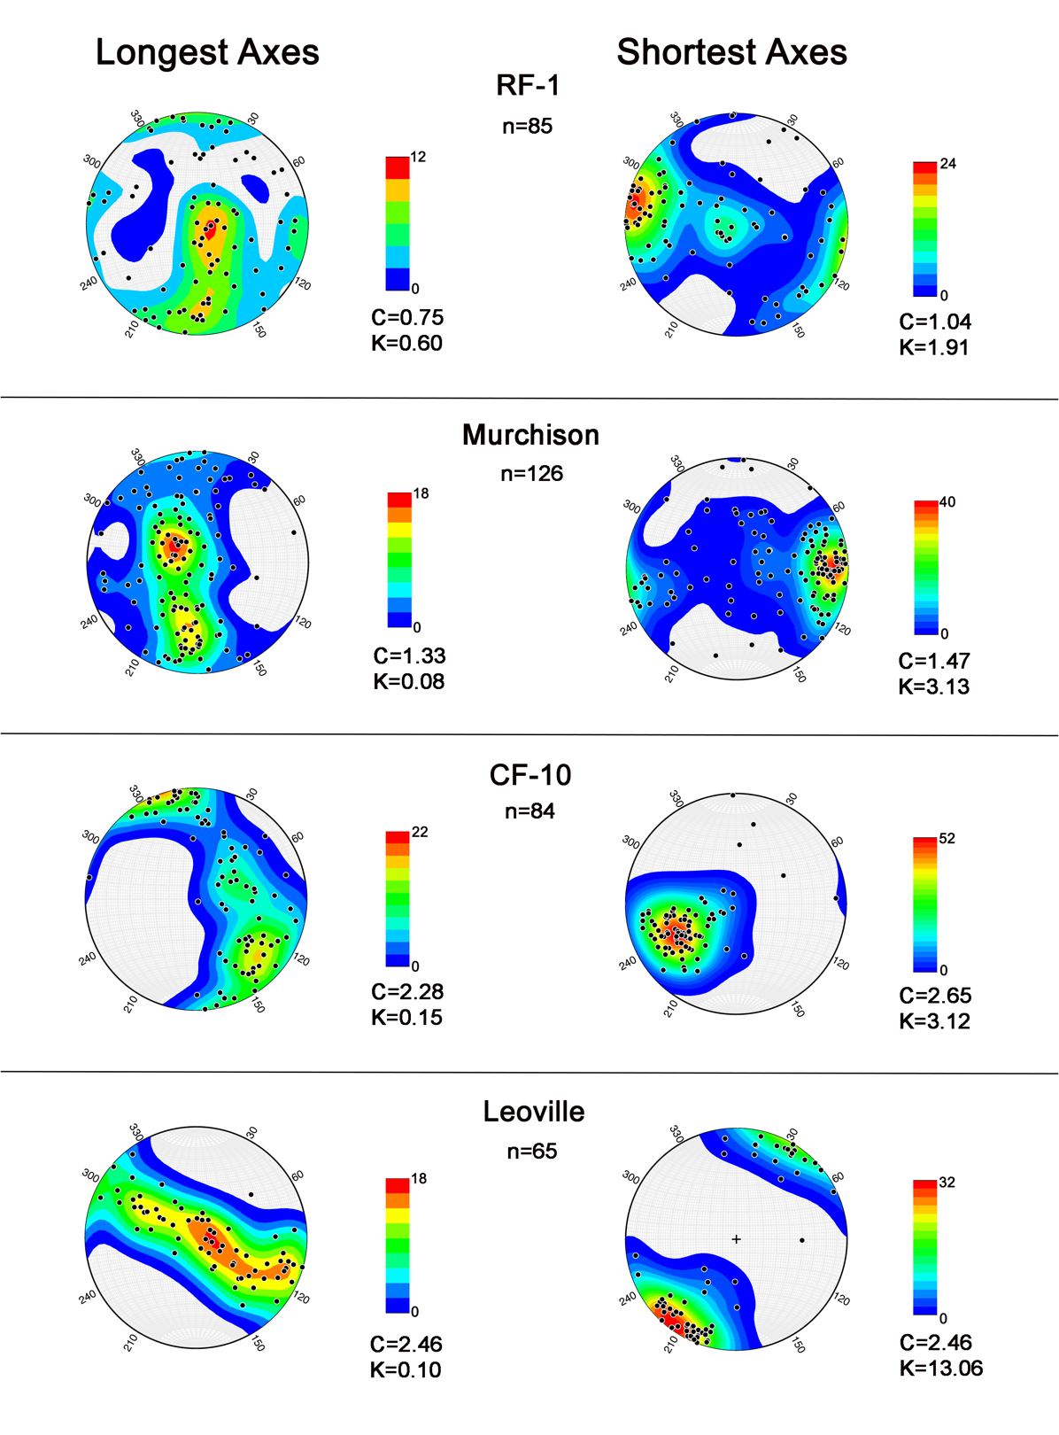
Supplementary Fig. 6. Chondrule ellipsoid orientations. n is the number of best-fitted ellipsoids and the color bar represents the density contour values. For compact fragment CF-10 and Leoville, girdling of longest axes and clustering of shortest axes show a moderately strong foliation. A weak fabric is suggested by the contour for Murchison, and no fabric is evident in RF-1.

Supplementary Table 1. Parameters of μCT scanned fragments and chondrule best-fit ellipsoids.
 | Compact AZ |  |  |  |  |  |  |  |  |  |  |  |  | Regular AZ |  |  | Reference
 | CF1 | CF2 | CF3 | CF4 | CF5 | CF6 | CF7 | CF8 | CF9 | CF10 | CF11 | RF3 | RF1 |  | RF2 | Murchison |  | Leoville
Mass (g) | 0.079 | 0.027 | 0.163 | 0.122 | 0.062 | 0.109 | 0.098 | 0.185 | 0.213 | 0.591 | 0.594 | 0.088 | 0.730 |  | 0.123 | 1.171 |  | 1.706
Density (g cm^{–3}) | 2.72 | 2.75 | 2.72 | 2.73 | 2.75 | 2.72 | 2.71 | 2.72 | 2.72 | 2.73 | 2.71 | 2.55 | 2.41 |  | 2.44
Aspect ratio* (δ§) | 1.40 (0.15) | 1.48 (0.22) | 1.40 (0.14) | 1.48 (0.25) | 1.49 (0.19) | 1.37 (0.17) | 1.41 (0.22) | 1.42 (0.19) | 1.47 (0.19) | 1.41 (0.16) | 1.37 (0.16) | 1.35 (0.19) | 1.31 (0.13) |  | 1.30 (0.12) | 1.30 (0.15) |  | 1.50 (0.18)
Elongation† (δ§) | 1.14 (0.08) | 1.18 (0.10) | 1.13 (0.08) | 1.18 (0.12) | 1.19 (0.10) | 1.14 (0.10) | 1.15 (0.10) | 1.13 (0.07) | 1.17 (0.13) | 1.13 (0.10) | 1.12 (0.08) | 1.13 (0.09) | 1.13 (0.08) |  | 1.12 (0.06) | 1.12 (0.08) |  | 1.18 (0.11)
Flatness‡ (δ§) | 1.23 (0.12) | 1.26 (0.14) | 1.25 (0.11) | 1.25 (0.17) | 1.26 (0.15) | 1.20 (0.12) | 1.23 (0.14) | 1.25 (0.15) | 1.26 (0.14) | 1.25 (0.12) | 1.22 (0.14) | 1.19 (0.15) | 1.16 (0.11) |  | 1.16 (0.12) | 1.16 (0.11) |  | 1.28 (0.14)
C_{longest} | 1.98 | 2.53 | 1.81 | 1.62 | 1.98 | 2.08 | 2.04 | 1.44 | 2.45 | 2.28 | 2.19 | 1.67 | 0.75 |  | 1.38 | 1.33 |  | 2.46
K_{longest} | 0.19 | 0.23 | 0.09 | 0.33 | 0.22 | 0.12 | 0.12 | 0.20 | 0.40 | 0.15 | 0.15 | 0.28 | 0.60 |  | 0.90 | 0.08 |  | 0.10
C_{shortest} | 2.29 | 2.36 | 2.24 | 1.88 | 1.97 | 2.38 | 1.96 | 2.05 | 2.43 | 2.65 | 2.09 | 2.04 | 1.04 |  | 1.21 | 1.47 |  | 2.46
K_{shortest} | 4.91 | 1.97 | 4.26 | 4.22 | 7.04 | 2.31 | 7.21 | 6.73 | 18.17 | 3.12 | 6.53 | 3.07 | 1.91 |  | 1.82 | 3.13 |  | 13.06
Longest axis length (μm) (δ§) | 146 (51) | 142 (54) | 184 (72) | 146 (62) | 167 (74) | 148 (50) | 150 (49) | 158 (51) | 186 (68) | 183 (88) | 210 (74) | 149 (43) | 196 (68) |  | 161 (47) | 348 (190) |  | 478 (216)
Secondary axis length (μm) (δ§) | 128 (44) | 121 (44) | 164 (66) | 123 (47) | 141 (63) | 130 (44) | 131 (44) | 139 (42) | 159 (55) | 161 (68) | 187 (64) | 132 (38) | 174 (59) |  | 145 (44) | 310 (166) |  | 408 (189)
Shortest axis length (μm) (δ§) | 104 (34) | 95 (29) | 131 (49) | 98 (35) | 110 (40) | 109 (36) | 108 (37) | 111 (31) | 126 (40) | 129 (53) | 153 (51) | 112 (33) | 152 (55) |  | 125 (38) | 266 (134) |  | 315 (131)
n | 23 | 22 | 28 | 47 | 25 | 43 | 41 | 45 | 68 | 84 | 63 | 36 | 85 |  | 24 | 126 |  | 65
* Longest axis length/shortest axis length.
† Longest axis length/secondary axis length.
‡ Secondary axis length/shortest axis length.
§1σ standard deviation

