SUPPLEMENTARY INFORMATION
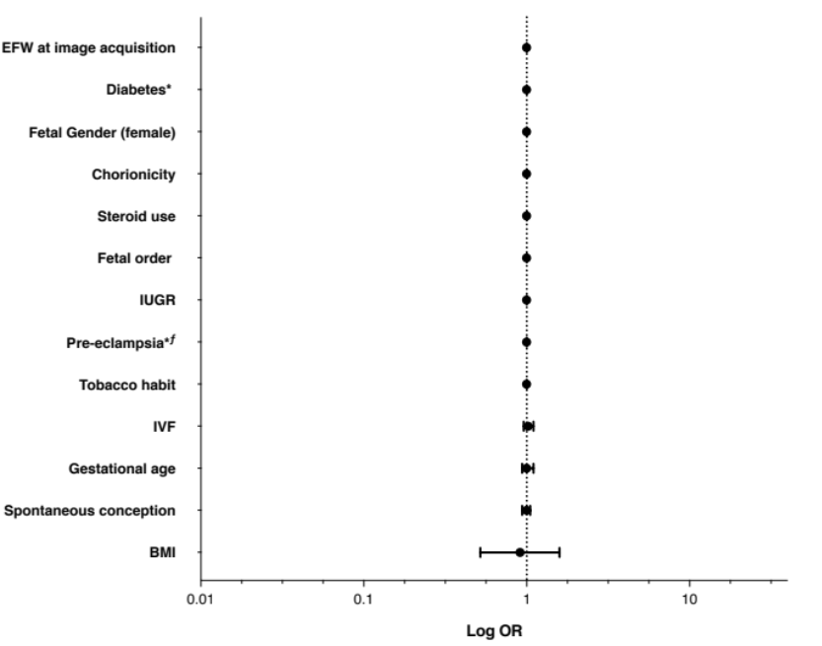
Figure S1. Individual risk for increased risk of neonatal respiratory morbidity according to QuantusFLM® results in Group 1 (26.0 – 29.6 weeks). All p values and confidence intervals were calculated with robust bias-corrected logistic regression. *Adjusted for gestational age at the time of image acquisition. ^{ƒ} Adjusted for steroid use. EFW: estimated fetal weight, BMI: body mass index, IUGR: intrauterine growth restriction, IVF: in vitro fertilization, GA: gestational age.
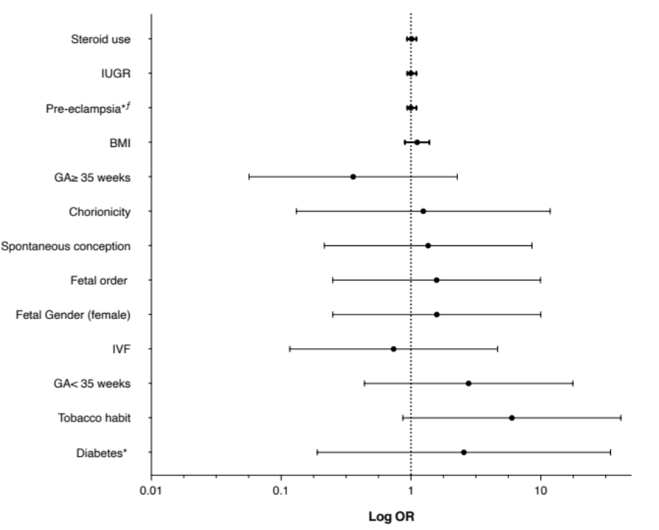
Figure S2. Individual risk for increased risk of neonatal respiratory morbidity according to QuantusFLM® results in Group 3 (34.0 – 38.6 weeks). All p values and confidence intervals were calculated with robust bias-corrected logistic regression. *Adjusted for gestational age at the time of image acquisition. ^{ƒ} Adjusted for steroid use. EFW: estimated fetal weight, BMI: body mass index, IUGR: intrauterine growth restriction, IVF: in vitro fertilization, GA: gestational age.

