Supplementary Data
Extracting Metal-organic Frameworks (MOFs) from End-of-Life (EoL) Solar Panels for Wastewater remediation
Huu Khue Pham,^{a,b} Ying Sim,^{a,b} Michaël Carboni,^{c} Daniel Meyer,^{b,c} Nripan Mathews ^{a,b,d,*}
ªEnergy Research Institute at Nanyang Technological University (ERI@N), Research Techno Plaza, X-Frontier Block Level 5, 50 Nanyang Drive, Singapore 637553, Singapore
^{b}Singapore-CEA Alliance for Research in Circular Economy (SCARCE), School of Chemical and Biomedical Engineering, 62 Nanyang Drive, Singapore 637459, Singapore
^{c}ICSM, CEA, Univ Montpellier, CNRS, ENSCM, BP 17171, 30207 Bagnols-sur-Cèze Cedex, France
^{d}School of Materials Science and Engineering, Nanyang Technological University, 50 Nanyang Avenue, Singapore 639798, Singapore
Keywords: Solar cells, Upcycling, Metal-Organic Framework, Dye Adsorption

INDEX
No. |  |  |  |  | Pg
1 |  | Experimental Procedures |  |  | 2
2 |  | Results and discussion |  |  | 4

- Experimental Procedures
Materials
Sodium hydroxide (NaOH) pellets were purchased from HCS Scientific & Chemical Pte Ltd, Singapore. Ethylene Glycol (EG), nitric acid (HNO₃,70%), hydrochloric acid (HCl, 37%), methylene blue and methyl orange were purchased from Sigma Aldrich, Singapore. N,N-dimethylformamide (DMF) was purchased from Fisher Scientific. All the chemicals were used as received without further purification.
Backsheet was detached from End-of-life (EoL) solar panel (SolarGy Pte Ltd, Singapore). Polycrystalline silicon solar cells of dimension 156 by 156 mm were purchased and used for leaching without further manipulation. Ultrapure water was accessed from Millipore Sigma™ Direct-Q™ 3 Tap purification system.
Characterisation Techniques
Metal concentrations in the leachate were determined by inductively-coupled plasma optical emission spectrometry (ICP-OES) (Perkin Elmer Optimus 8000). The wavelengths for metal detection were Al 396.153 and Ag 328.068. The morphologies of the MOF samples were observed using field emission scanning electron microscope (FE-SEM) (JEOL JSM-7600F) after being spray coated with platinum for 20 seconds. The crystalline structure of the precipitated solids from dissolved backsheet and MOF samples were analysed using X-ray diffractometer (XRD) (PANalytical X'Pert Pro) with Cu Kα X-rays as target at the scanning range of 5-60° and scan rate of 1.60°/min. Fourier transform infrared spectroscopy (FT-IR) were recorded using PerkinElmer Frontier with KBr pellet pressing method at wavelength of 4000-400 cm⁻¹. Thermogravimetric analysis (TGA) of the MOF samples was done using the TA Instruments Q500 from 25 to 800 °C at 10 °C/min heating rate under nitrogen atmosphere. Nitrogen adsorption/desorption isotherms were measured at 77 K using Micromeritics ASAP 2020 after being degassed at 200 °C for 12 hours. MB and MO dye concentrations were determined using UV-vis spectrophotometer (Shimadzu UV-2700) between 800 and 400 nm wavelength at medium scan speed with 1 nm sampling interval and 1 nm slit with. The absorbance of MB and MO were recorded at 664 and 464 nm, respectively.
Solar panel backsheet dissolution
Solar panel was first treated in suitable organic solvent to soften the adhesion, allowing manual peeling to detach the backsheet. 5 g of the detached backsheet was cut into pieces of 1-2 cm in length and dissolved in NaOH solution (2.8 g in 50 mL ethylene glycol) at 180 °C for 18 hours. The mixture was allowed to cool before dropwise addition of 50 mL water to dissolve the solids. The undissolved solids were separated by filtration and the dissolved backsheet solution was obtained.
Precipitation of terephthalic acid
5 mL of HNO3 (70 %) was added in excess to 20 mL dissolved backsheet solution, and the precipitated solids were collected through centrifugation at 5,000 rpm for 10 minutes. The obtained solids were washed three times with water and ethanol and were left in the oven at 75 °C overnight to dry. 0.318 g of precipitated terephthalic acid was dissolved in NaOH solution (0.153 g in 10.6 mL ultrapure water) to form disodium terephthalate. The XRD peaks of the precipitated solids matched closely to that of commercially purchased terephthalate acid. The NMR peak at 8.04 ppm corresponds to the hydrogen from the benzene ring of terephthalic acid. Through weighing the precipitated solid, the concentration of terephthalate in the dissolved solution could be calculated to be ~30 g/L. The concentration is important in the synthesis process, where the amount of terephthalic acid used for MOF-2 and MOF-3 samples are to be determined.
In the basic hydrolysis process of PET, the polymer was dissolved to form disodium tererphthalate and ethylene glycol. The tererphthalate salt was then precipitated out under acidic condition as terepthalic acid (insoluble in water) was formed (Figure S1). Under ideal conditions where 100 % of PET is converted to terepthalic acid, 100 g of PET would form 86.5 g of terepthalic acid. In this current process, using 5 g of solar panel backsheet produced 3.3 g of terepthalic acid in the end. Hence, an efficiency of 76.3 % has been achieved in the attempt to convert solar panel backsheet.
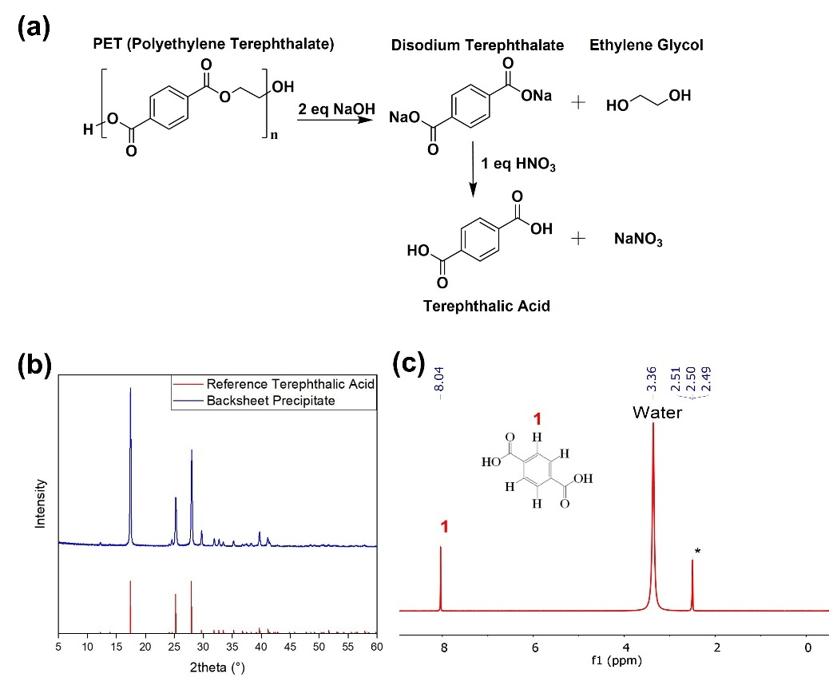
Figure S1. (a) Reactions occurred when dissolving PET and forming terephthalic acid; (b) XRD Pattern and (c) NMR Pattern of precipitated powder from dissolved backsheet
Dye Adsorption
The dyes employed in the study are cationic methylene blue (MB) and anionic methyl orange (MO) (Figure S2).
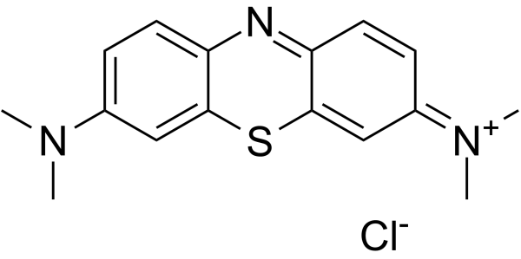  Methylene blue (MB) | 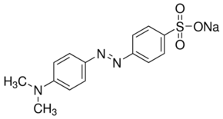  Methyl Orange (MO)
Figure S2. Molecular structures of methylene blue (MB) and methyl orange (MO).
The amount of dye absorbed by the MOFs at equilibrium, $q_{e}$ (mg/g), is calculated by the equation:
$$q_{e}=\frac{V(C_{o}-C_{e})}{m} (1)$$
where V is the volume of the dye solution (L), m is the weight of absorbent (g), while $C_{o}$ and $C_{e}$are initial and equilibrium dye concentrations (mg/L), respectively.

- Results and Discussion
Figure S3. MIL-53 (Al) structure. The aluminium atoms (blue) were covalently bonded to 4 organic ligands via the oxygen atoms (red) and 2 other aluminium atoms.
Adsorption Kinetics
The percentage dye removed, R, at a particular time interval is calculated by:
$$R \left(\%\right)=\frac{100(C_{o}-C_{t})}{C_{o}} (2)$$
where $C_{t}$ represents the dye concentration at that time interval (mg/L).
Fitting the absorption data into pseudo first order and pseudo second order kinetic model showed the mechanism in which the adsorbents remove the dyes.
The pseudo first order follows the equation:
$\ln\left(q_{e}-q_{t}\right)=lnq_{e}-k_{1}t (3)$
while pseudo second order follows:
$$\frac{t}{q_{t}}=\frac{1}{k_{2}q_{e}^{2}}+\frac{t}{q_{e}} (4)$$
where qt (mg/g) represents the amount of dye absorbed at time t (min), $k_{1}$ (1/min) and $k_{2}$ (gmg⁻¹min⁻¹) represents the rate constant for pseudo-first-order and pseudo-second-order adsorption kinetics, respectively.
Adsorption Kinetics Isotherms
The different adsorption models are important in explaining the mechanisms in which the adsorptions take place. Two most widely used models, the Langmuir and Freundlich adsorption isotherms were used in this work to describe the adsorption.
Langmuir adsorption isotherm assumed homogeneous sites in the adsorbent, which suggests a monolayer adsorption is taking place. To Langmuir adsorption equation is expressed in linear form as seen below:
$$\frac{1}{q_{e}}=\frac{1}{K_{a}q_{max}} \frac{1}{C_{e}} +\frac{1}{q_{max}} (5)$$
where $C_{e}$ is the equilibrium dye concentration (mg/L), $q_{max}$ is the maximum adsorption capacity (mg/g) and $K_{a}$ is the Langmuir constant (L/mg). Through plotting the graphs of $C_{e}$/$q_{e}$ against $C_{e}$, $K_{a}$ and $q_{max}$ can be obtained from the slope and intercept of the plot.
Freundlich adsorption isotherm, on the other hand, assumed a heterogeneous adsorption with unequal adsorption sites. The model can be expressed in linear form as:
$lnq_{e}=lnK_{f}+\frac{1}{n}lnC_{e} (6)$
where $K_{f}$ and $n$ are Freundlich absorbent constants. These parameters can be obtained from the slope and intercept from plotting the graph of $lnq_{e}$ against $lnC_{e}$

