SUPPLEMENTARY MATERIAL

Title: Physical activity and 4-year changes in body weight in 52,498 non-obese people: The Lifelines Cohort

Oyuntugs Byambasukh,^{1,3} Petra Vinke¹, Daan Kromhout¹, Gerjan Navis², Eva Corpeleijn¹
¹Department of Epidemiology, University Medical Center Groningen, University of Groningen, Groningen, the Netherlands, ²Department of Internal Medicine, University Medical Center Groningen, University of Groningen, Groningen, the Netherlands, ³Department of Internal Medicine, Mongolian National University of Medical Sciences, Ulaanbaatar, Mongolia

Correspondence details:
Oyuntugs Byambasukh
Unit of Lifestyle Medicine in Obesity and Diabetes
Department of Epidemiology (FA40)
University Medical Center Groningen
University of Groningen
P.O. Box 30 001, 9700 RB Groningen, The Netherlands
Tel: +31(0)641152211, E-Mail: o.byambasukh@umcg.nl, oyuntugs@mnums.edu.mn

Contents:
Supplementary method: |  | Page
Method 1. | Anthropometry and laboratory tests
Method 2. | Definitions of covariates

Supplementary tables: |  | Page
Table S1. | General characteristics of the study population, by age
Table S2. | Role of lifestyle related confounders in the association between physical activity and changes in body weight
Table S3 | Non-occupational MPA and 4-year changes in body weight
Table S4 | Moderate-to-vigorous physical activity and changes in body weight, according to age
Table S5 | MET values for physical activities in this study

Supplementary figures: |  | Page
Figure S1. | Flowchart of the study population
Figure S2. | Level of daily-life physical activity according to sex
Figure S3. | 4-year changes in body weight, according to 6 category of age
Figure S4. | 4-year changes in body weight and creatinine excretion – a marker of muscle mass, according to age

1. Anthropometry and laboratory measurements
Body height, waist circumference, and blood pressure were measured by a permanent staff of well-trained assistants using a standardized protocol. Height was measured with a stadiometer placing the heels against the rod and the head in Frankfort Plane position. Waist circumference was measured in standing position with a tape measure all around the body, at the level midway between the lower rib margin and the iliac crest. Body mass index (BMI) was calculated as weight (kg) divided by height squared (m²).[1][2]
The blood samples were collected in the fasting state, between 8.00 and 10.00 a.m. and analyzed on the day of collection at the Department of Laboratory Medicine of the University Medical Center Groningen, the Netherlands. Participants were requested to fast for at least 12 hours prior to the blood draw. Fasting plasma glucose (FPG) was measured by the hexokinase method.. Serum levels of total and HDL cholesterol were measured using an enzymatic colorimetric method, triglycerides using a colorimetric UV method on a Roche Modular P chemistry analyzer (Roche, Basel, Switzerland).[1][2]

2. Definition of lifestyle confounders and diseases
Education level: Education was categorized as low (no education, primary education, lower or preparatory vocational education and lower general secondary education), medium (intermediate vocational education or apprenticeship, higher general senior secondary education or pre-university secondary education) and high (higher vocational education and university).
Current smoking: Smoking status was categorized as non-smokers and smokers. Non-smokers were those who had not smoked during the last month and had also never smoked for longer than a year.
Daily caloric intake and alcohol intake: From the Food Frequency Questionnaire, daily caloric intake and alcohol intake were calculated and presented as kilocalories a day (kcal/day) and grams of alcohol a day (gr/day). The calculation was based on intake frequency and the average number of units consumed on a day (divided the number of alcoholic drinks/week by 7). In the Netherlands a standard unit contains 9.9 grams of alcohol. For each type of alcoholic beverage, respondents indicated whether they consumed it never (0%), sometimes (30%), often (70%) or always (100%).[1][2]
The Lifelines Diet Score: Based on food groups derived from the food frequency questionnaire, diet quality was scored by The Lifelines Diet Score (LLDS). The LLDS is based on the international scientific evidence on diet and chronic disease relations from prospective cohort analyses and randomized controlled trials, summarized by the Dutch Health Council and underlying the 2015 Dutch dietary guidelines. The LLDS ranks the relative intake of nine food groups for which there is strong international peer-reviewed scientific evidence of positive health effects (vegetables, fruit, whole grain products, legumes & nuts, fish, oils & soft margarines, unsweetened dairy, coffee and tea) and three food groups for which there is strong international peer-reviewed scientific evidence of negative health effects (red & processed meat, butter & hard margarines and sugar-sweetened beverages). For each of the food groups, quintiles of consumption in grams/1000 kcal are determined and awarded zero to four points. For the positive food groups, higher scores are awarded to higher quintiles of consumption, whereas intake for negative food groups is scored inversely. The sum of these components leads to a LLDS between zero and 48.[3]
References:
- Stolk RP, Rosmalen JGM, Postma DS, de Boer RA, Navis G, Slaets JPJ, et al. Universal risk factors for multifactorial diseases: LifeLines: a three-generation population-based study. Eur J Epidemiol. 2008;23: 67±74. doi: 10.1007/s10654-007-9204-4 PMID: 18075776.
- Scholtens S, Smidt N, Swertz MA, Bakker SJL, Dotinga A, Vonk JM, et al. Cohort Profile: LifeLines, a three-generation cohort study and biobank. Int J Epidemiol. 2015; 44: 1172±1180. doi: 10.1093/ije/dyu229 PMID: 25502107.
- Vinke PC, Corpeleijn E, Dekker LH, Jacobs DR, Navis G, Kromhout D: Development of the food-based Lifelines Diet Score (LLDS) and its application in 129,369 Lifelines participants. Eur J Clin Nutr 2018;72:1111–1119.
Table S1. General characteristics of the study population, by age
Characteristics | <35 | 35-55 | >55 | P-value
Men
Number (%) | 5,530 (24.2) | 13,027 (57.1) | 4,270 (18.7) | -
Age (years) | 29 (26-32) | 45 (41-49) | 62 (59-66) | -
Education: Low, (%, n) | 13.9 (769) | 24.7 (3224) | 38.3 (1637) | <0.001
Current smoking, (%, n) | 27.9 (1544) | 20.0 (2605) | 12.8 (546) | <0.001
Alcohol use, (gr/day) | 7.6 (3.2-15.8) | 6.7 (2.6-13.9) | 8.2 (3.0-17.0) | <0.001
Lifelines Diet score | 20.8 ± 5.4 | 22.8 ± 5.4 | 25.2 ± 5.5 | <0.001
Energy intake (kcal/day) | 2507.3 ± 653.4 | 2440.6 ± 614.8 | 2173.0 ± 534.5 | <0.001
Body weight (kg) | 82.5 ± 10.6 | 86.1 ± 9.8 | 83.4 ± 9.0 | <0.001
BMI (kg/m²) | 24.2 ± 2.6 | 25.5 ± 2.4 | 25.7 ± 2.2 | <0.001
Waist circumference (cm) | 87.6 ± 8.2 | 93.1 ± 7.6 | 95.2 ± 7.4 | <0.001
Total cholesterol (mmol/L) | 4.6 ± 0.9 | 5.3 ± 0.9 | 5.5 ± 0.9 | <0.001
HDL-cholesterol | 1.3 ± 0.3 | 1.3 ± 0.3 | 1.4 ± 0.3 | <0.001
Triglycerides (mmol/L) | 1.0 (0.7-1.4) | 1.2 (0.8-1.6 | 1.1 (0.8-1.5) | <0.001
Plasma glucose (mmol/L) | 4.9 ± 0.4 | 5.0 ± 0.5 | 5.2 ± 0.5 | <0.001
Non-occupational MVPA
No MVPA, (%, n) | 12.2 (676) | 14.6 (1902) | 10.7 (457) | <0.001
MVPA (min/week) | 225.5 (80-420) | 180 (60-360) | 270 (120-495) | <0.001
Non-Occupational VPA
No VPA, (%, n) | 35.7 (1976) | 48.1 (6263) | 52.6 (2245) | <0.001
VPA (min/week) | 90 (0-270) | 40 (0-180) | 0 (0-180) | <0.001
Occupational MVPA (min/week) | 270.1 (60-520) | 220.1 (72-380) | 76 (60-395) | <0.001
Women
Number (%) | 6,046 (20.4) | 18,201 (61.3) | 5,424 (18.3) | -
Age (years) | 27 (22-32) | 45 (41-49) | 61 (58-65) | -
Education: Low, (%, n) | 11.8 (713) | 23.1 (4199) | 55.5 (3012) | <0.001
Current smoking, (%, n) | 23.4 (1412) | 17.9 (3250) | 10 (544) | <0.001
Alcohol use, (gr/day) | 2.6 (0.7-6.4) | 2.8 (0.7-7.1) | 3.6 (0.8-9.9) | <0.001
Lifelines Diet score | 22.7 ± 5.9 | 25.4 ± 5.8 | 28.2 ± 5.5 | <0.001
Energy intake (kcal/day) | 1859.5 ± 464.6 | 1890.7 ± 460.5 | 1766.3 ± 417.4 | <0.001
Body weight (kg) | 68.2 ± 9.4 | 70.4 ± 8.9 | 69.5 ± 8.3 | <0.001
BMI (kg/m²) | 23.3 ± 2.8 | 24.3 ± 2.7 | 25.0 ± 2.6 | <0.001
Waist circumference (cm) | 79.3 ± 8.7 | 83.3 ± 8.5 | 86.4 ± 8.5 | <0.001
Total cholesterol (mmol/L) | 4.4 ± 0.8 | 5.1 ± 0.9 | 5.9 ± 1.0 | <0.001
HDL-cholesterol | 1.6 ± 0.3 | 1.7 ±0.4 | 1.8 ± 0.4 | <0.001
Triglycerides (mmol/L) | 0.8 (0.6-1.1) | 0.8 (0.6-1.1) | 1.0 (0.8-1.3) | <0.001
Plasma glucose (mmol/L) | 4.6 ± 0.4 | 4.8 ± 0.4 | 4.9 ± 0.5 | <0.001
Non-occupational MVPA
No MVPA, (%, n) | 7.4 (447) | 9.6 (1748) | 7.4 (402) | <0.001
MVPA (min/week) | 210 (90-380) | 190(80-360) | 270 (120-480) | <0.001
Non-occupational VPA
No VPA, (%, n) | 44.8 (2710) | 57.2 (10416) | 47.9 (2597) | <0.001
VPA (min/week) | 45 (0-150) | 0 (0-100) | 30 (0-120) | <0.001
Occupational MVPA (min/week) | 120 (40-320) | 115.3 (60-280) | 36 (70-285) | <0.001
Data are presented as mean ± SD or median (25th to 75th percentile) and number (percentages, %). Abbreviations: BMI=body mass index, BP=blood pressure, HDL-C=high-density lipoprotein cholesterol, HbA1c=hemoglobin-A1c, MVPA=moderate-to-vigorous physical activity, VPA=vigorous physical activity, T=tertile.
Table S2. Role of lifestyle confounders in the association between physical activity and changes in body weight
PA | Unstandardized beta coefficients kg body weight
PA | Basic model |  | Model 1A |  | Model 1B
PA | B (95%CI) | P | B (95%CI) | P | B (95%CI) | P
Men
Moderate-to-vigorous PA
T0 | 0 (Reference) | - | 0 (Reference) | - | 0 (Reference) | -
T1 | -0.140 (-0.349; 0.069) | 0.19 | -0.097 (-0.306; 0.112) | 0.37 | -0.092 (-0.301; 0.117) | 0.39
T2 | -0.026(-0.235; 0.183) | 0.81 | 0.043 (-0.167; 0.252) | 0.69 | 0.038 (-0.171; 0.248) | 0.72
T3 | 0.024 (-0.187; 0.235) | 0.82 | 0.120 (-0.092; 0.333) | 0.27 | 0.099 (-0.113; 0.311) | 0.36
Vigorous PA
T0 | 0 (Reference) | - | 0 (Reference) | - | 0 (Reference) | -
T1 | -0.254 (-0.423; -0.085) | 0.03 | -0.223 (-0.392;-0.054) | 0.01 | -0.228 (-0.397;-0.059) | 0.008
T2 | -0.192 (-0.376; -0.008) | 0.04 | -0.144 (-0.329; 0.040) | 0.13 | -0.154 (-0.338; 0.030) | 0.10
T3 | -0.197 (-0.377; -0.018) | 0.03 | -0.131 (-0.312; 0.049) | 0.15 | -0.147 (-0.327; 0.032) | 0.11
Women
Moderate-to-vigorous PA
T0 | 0 (Reference) | - | 0 (Reference) | - | 0 (Reference) | -
T1 | -0.323 (-0.547; -0.099) | 0.005 | -0.260 (-0.485; -0.035) | 0.023 | -0.298 (-0.523; -0.073) | 0.009
T2 | -0.420 (-0.645; -0.195) | 0.000 | -0.339 (-0.565; -0.113) | 0.003 | -0.380 (-0.606; -0.154) | 0.001
T3 | -0.525 (-0.750; -0.300) | 0.000 | -0.425 (-0.652; -0.198) | 0.000 | -0.475 (-0.701; -0.249) | 0.000
Vigorous PA
T0 | 0 (Reference) | - | 0 (Reference) | - | 0 (Reference) | -
T1 | -0.266 (-0.435; -0.097) | 0.002 | -0.243 (-0.412; -0.074) | 0.005 | -0.238 (-0.407; -0.068) | 0.006
T2 | -0.345 (-0.512; -0.178) | 0.000 | -0.321 (-0.489; -0.154) | 0.000 | -0.315 (-0.483; -0.148) | 0.000
T3 | -0.382 (-0.552; -0.212) | 0.000 | -0.346 (-0.517; -0.175) | 0.000 | -0.348 (-0.518; -0.177) | 0.000
Regression analysis. Determinants are dummy exposure variables for physical activities for comparison between the reference group (No-MVPA, and No-VPA, T0) and tertiles of MVPA and VPA (T1-3). Data are expressed as unstandardized beta coefficient with 95% confidence interval (95% CI). PA=physical activity, T=tertile.
Basic model=age and education.
Model 1A = Basic model + diet score.
Model 1B = Basic model + smoking and alcohol use.

Table S3. Non-occupational MPA and 4-year changes in body weight
Physical activity |  | Unstandardized beta coefficients kg body weight
 |  | Basic model |  | Model 1 |  | Model 2
 |  | B (95%CI) | P-value | B (95%CI) | P-value | B (95%CI) | P-value
Men
 | MPA-T0 | 0 (Reference) | - | 0 (Reference) | - | 0 (Reference) | -
 | MPA-T1 | -0.26 (-0.48; -0.03) | 0.02 | -0.05 (-0.37; 0.07) | 0.19 | -0.11 (-0.33; 0.11) | 0.32
 | MPA-T2 | -0.02 (-0.25; 0.21) | 0.85 | 0.10 (-0.13; 0.34) | 0.38 | 0.13 (-0.10; 0.36) | 0.27
 | MPA-T3 | 0.18 (-0.05; 0.41) | 0.13 | 0.32 (0.09; 0.55) | 0.007 | 0.34 (0.11; 0.56) | 0.004
Women
 | MPA-T0 | 0 (Reference) | - | 0 (Reference) | - | 0 (Reference) | -
 | MPA-T1 | -0.39 (-0.62; -0.15) | 0.001 | -0.29 (-0.53; -0.05) | 0.018 | -0.28 (-0.52; -0.04) | 0.022
 | MPA-T2 | -0.43 (-0.67; -0.20) | 0.000 | -0.31 (-0.55; -0.07) | 0.011 | -0.30 (-0.54; -0.06) | 0.014
 | MPA-T3 | -0.50 (-0.73; -0.27) | 0.000 | -0.36 (-0.60; -0.13) | 0.003 | -0.36 (-0.59; -0.12) | 0.003
Regression analysis. Determinants are dummy exposure variables for physical activities for comparison between the reference group (No-MPA, T0) and tertiles of MPA (T1-3). Data are expressed as unstandardized beta coefficient with 95% confidence interval (95% CI). MPA=moderate physical activity, T=tertile.
Basic model=age and education.
Model 1 = Basic model + diet, smoking and alcohol use.
Model 2 = Model 1 + 24-hour urinary creatinine excretion

Table S4. Moderate-to-vigorous physical activity and changes in body weight, according to age
PA | Unstandardized beta coefficients kg body weight
PA | <35 years |  | 35-55 years |  | >55 years
PA | B (95%CI) | P-value | B (95%CI) | P-value | B (95%CI) | P-value
Men
T0 | 0 (Reference) | - | 0 (Reference) | - | 0 (Reference) | -
T1 | -0.255 (-0.477; 0.033) | 0.02 | -0.151(-0.374; 0.072) | 0.19 | -0.113 (-0.334; 0.109) | 0.32
T2 | -0.024 (-0.253; 0.208) | 0.85 | 0.104 (-0.128; 0.336) | 0.38 | -0.130 (-0.100; 0.360) | 0.27
T3 | 0.177 (-0.051; 0.405) | 0.13 | 0.316 (0.086; 0.546) | 0.01 | 0.337 (0.109; 0.565) | 0.01
Women
T0 | 0 (Reference) | - | 0 (Reference) | - | 0 (Reference) | -
T1 | -0.386 (-0.624; -0.148) | 0.001 | -0.289 (-0.529; -0.049) | 0.018 | -0.278 (-0.517; -0.039) | 0.022
T2 | -0.433 (-0.670; -0.196) | 0.000 | -0.310 (-0.550; -0.071) | 0.011 | -0.298 (-0.535; -0.060) | 0.014
T3 | -0.500 (-0.733; -0.267) | 0.000 | -0.361 (-0.597; -0.125) | 0.003 | -0.355 (-0.590; -0.120) | 0.003
Regression analysis. Determinants are dummy exposure variables for physical activities for comparison between the reference group (No-MVPA, T0) and tertiles of MVPA (T1-3). Data are expressed as unstandardized beta coefficient with 95% confidence interval (95% CI). PA=physical activity, T=tertile.
Analysis was adjusted for age, education. diet score, smoking and alcohol use.

Table S5. MET values for physical activities in this study
Codes  (Ainsworth’s  compendium in 2011*) | Physical activity | MET
17250 | Walking | 3.5
02010 | Bicycling (stationary, general) | 7.0
 | Bicycling (leisure, commuting) | 5.0
06040 | Odd jobs | 3.0
08245 | Gardening | 3.8
05040 | Light household work | 2.5
05020 | Intense household work | 3.5
11600 | Light activities at work | 3.0
11630 | Intense activities at work | 4.5
02120 | Aqua aerobics | 5.3
03015 | Aerobics | 7.3
15010 | Archery | 4.3
15030 | Badminton | 5.5
15120 | Boxing | 7.8
15255 | Golf | 4.8
15350 | Hockey | 7.8
15370 | Horse riding | 5.5
15675 | Tennis | 7.3
19160 | Snowboarding | 5.3
Note: More METs for various sports are described in the manual of Wendel-Vos et al [Wendel-Vos, W., and J. Schuit. "SQUASH: Short QUestionnaire to ASses Health enhancing physical activity." Centrum voor Preventie en Zorgonderzoek Rijksinstituut voor Volksgezondheid en Milieu (2004)]. *Ainsworth, Barbara E., et al. "2011 Compendium of Physical Activities: a second update of codes and MET values." Medicine & science in sports & exercise 43.8 (2011): 1575-1581.

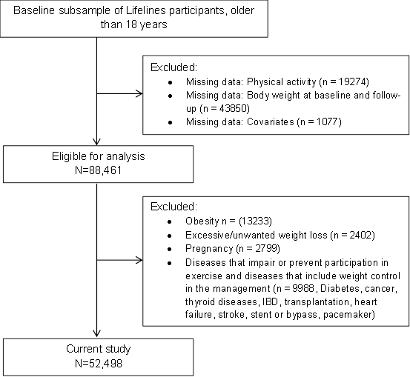
Figure S1. Flowchart of the study population.

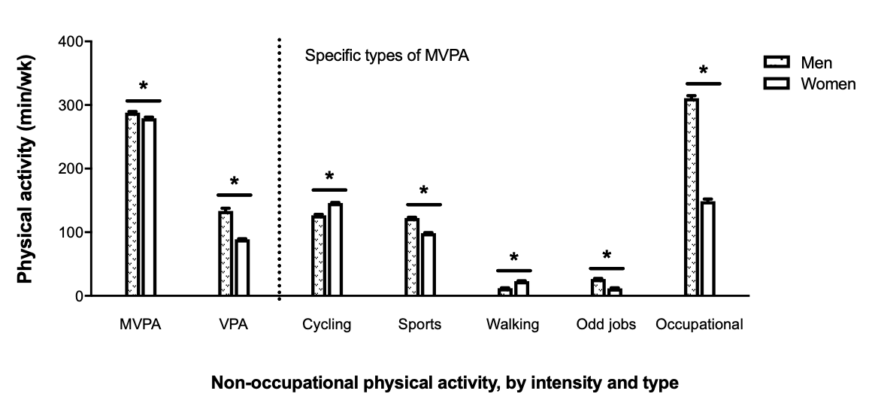
Figure S2. Level of daily-life physical activity according to sex.
MVPA (min/week) are expressed as adjusted means (adjusted for age, gender, education) for total and domain-specific physical activities. *indicates significant difference between men and women at p value < 0.05. MVPA=moderate-to-vigorous physical activity.

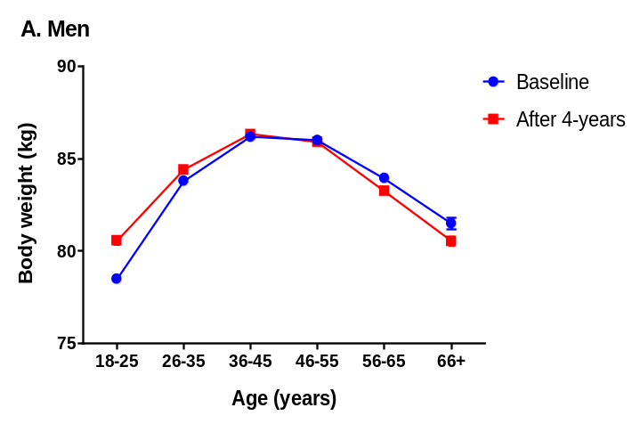
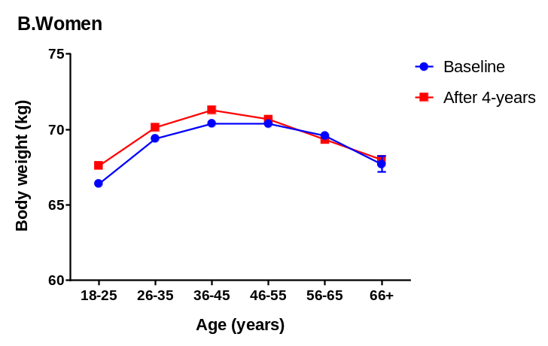
Figure S3. 4-year changes in body weight, according to 6 categories of age

Men  A. Body weight | Women  C. Body weight
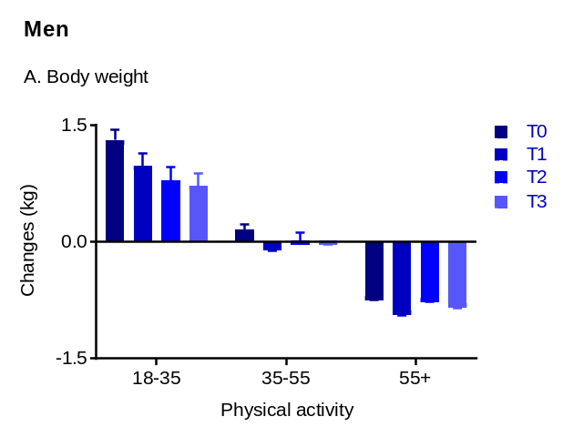 | 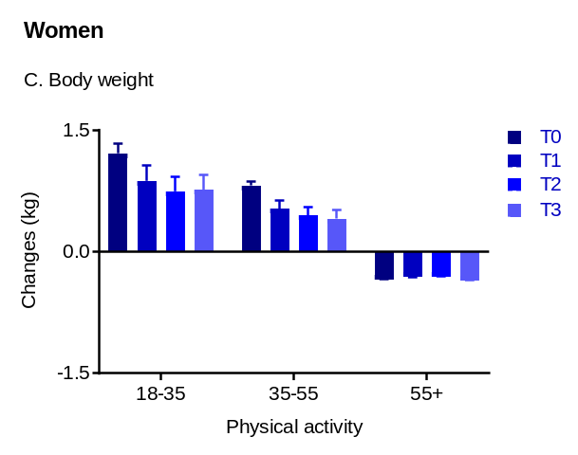
B. Creatinine excretion | D. Creatinine excretion
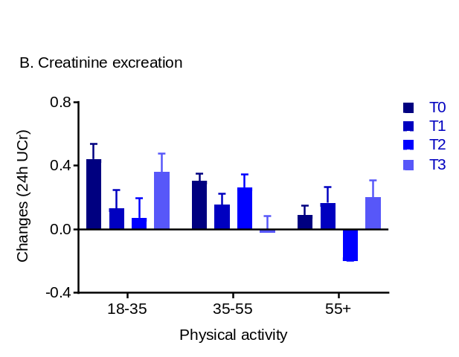 | 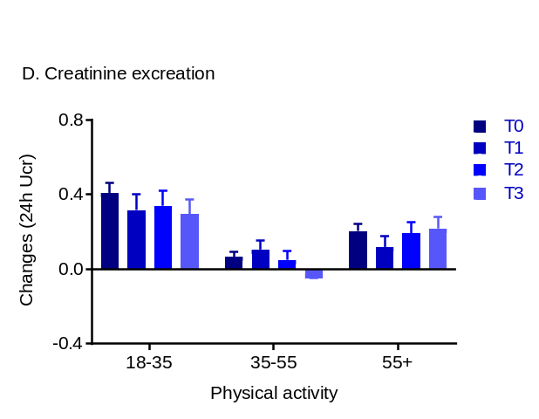

Figure S4. 4-year changes in body weight and creatinine excretion – a marker of muscle mass, according to age

