ANALYSIS OF SOME PHYTOCHEMICALS AS POTENTIAL ANTICANCER AGENTS TARGETING THE RECEPTOR PROTEIN ASSOCIATED WITH CANCER
Rishabh Sen, Subarna Ghosh*, Anindita Datta
Serampore College, Department of Zoology, Serampore-712201
Email: rishabhsen21@gmail.com
PHYTOCOMPOUND AND SOURCES | PHYTOCOMPOUND TYPE | TYPES OF CANCER PREVENTED | MECHANISM OF ACTION | REFERENCES
Apigenin  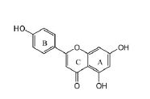  (Found in celery, parsley, chamomile; Matricaria recutita) | Flavonoid | Colorectal cancer | Induces apoptosis | Seo et al., (2015)
Curcumin  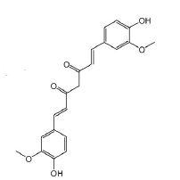  (Found in the plants Curcuma longa) | Polyphenol | Colon, Breast, Lung, Prostate, Esophagus, Liver and Skin cancer | Upregulates and downregulates the expressions of different genes and their  Products | Vallianou et al., (2015)
Crocetin  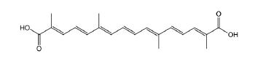  (Found in plants Crocus sativus, Gardenia jasminoides) | Carotenoid | Cardiac hypertrophy | Act on GATA binding protein 4 and MEK-ERK1/2 pathway, induces apoptosis and blocks proliferating activities of cancer cells. | Cai J et al., (2009); Bakshi et al.,(2009)
Cyanidin  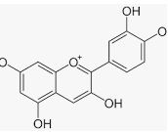  (Found in red berries Ardisia crenata) | Anthocyanin | Colon cancer | They suppress the expressions of iNOS and mitogen induced pathway, induces apoptosis. | Serra D et al., (2013)
EGCG  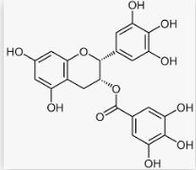  (Mainly found in green tea, Very small amounts can be found in apples, avocados, blackberries etc.) | Polyphenol | Prostate cancer, Bladder cancer, Lung cancer | Blocks cancer activation and progression pathways and induces apoptosis | Singh et al., (2011)
Fisetin  (Found in apple, kiwi, peach, cucumber, red grapes, etc.)  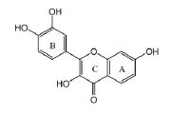 | Flavonoid | Lung cancer, promyelocytic leukemia | It causes cell cycle arrest, viz. MAPK, NF- kB, JAK/STAT, PI3K/Akt, Wnt, and mTOR pathways | Adan A, and Baran Y. (2015)
Genistein  (Found in soyabean, lupin, fava beans)  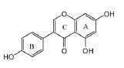 | Isoflavonoid | Ovarian camcer | Inhibition of WNT/β-catenin and Akt signaling pathway | Radhakrishnan et al., (2014)
Gingerol  (Found in Zingiber officinale)  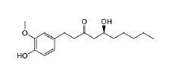 | Polyphenol | Cancers of ovary, cervix, colon, rectum, liver, urinary  bladder, oral cavity, neuroblastoma, and leukemia | Focuses on the Erk1/2/JNK/AP-1 signalling and initiates caspase-dependent apoptosis | Joo et al., 2016
Lycopene  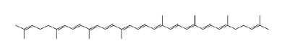  (Found in tomatoes, carrots, red cabbages etc.) | Carotenoid | Prostate, colon and gastric cancer | Targets PI3K/Akt pathway, hinders Erk and Bcl-2 signalling | Kim et al., (2015)
Rosmarinic acid  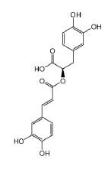  (Found in rosemary plant; Rosmarinus officinalis) | Polyphenol | Colon cancer, breast cancer, leukemia, lung cancer, ovary cancer | Decreases COX-2 activity and Erk phosphorylation, targets PKA/CREB/MITF pathway and NF-kB activation | Hossan et al. (2014); Tal et al. (2012)
Calcitriol  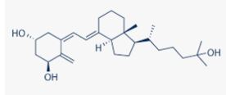  (Found in mushrooms) | Vitamin D3 | Prostate cancer | Hinders prostaglandins, COX-2, NF-kB and VEGF signalling and blockss angiogenesis | Sylvester PW and Ayoub NM (2013)
Docetaxel  (Found in the plant Taxus baccata)  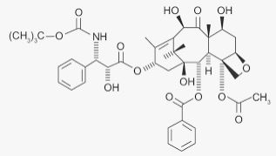 | Taxane | Breast, pancreas, prostate and lung cancers therapies. | Repress microtubule functioning bringing about cell cycle capture | Iqbal J et al. (2017)
Resveratrol  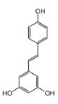  (Found in peanuts, pistachios, grapes, red and white wine, blue berries, cocoa and dark chocolate) | Polyphenol | Breast, colorectal, liver, pancreatic, prostate cancer and lung carcinoma | Up-regulating p53 and Bcl-2 protein and down regulating MMPs, NFkB, AP-1, Bcl-2, cyclins, CDKs, cytokines,and COX-2 proteins and hinder angiogenesis of cancer cells, blocking VEGF protein activity by decreasing MAP kinase phosphorylation. | Patel KR et al. (2010)
Podophyllotoxin  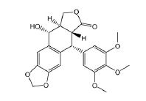  (Found in the Ameriacan mayapple; Podophyllum peltatum and Sinopodophyllum hexandrun Royle) | Polyphenol | Osteosarcoma, NSCLC cervical, nasopharyngeal, colon, breast,  prostate, and testicular cancer | Preventing DNA synthesis by forming a complex with topoisomerase II and DNA | Cao et al. (2010)
Chrysin  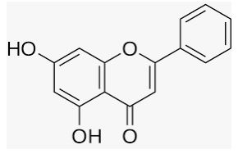  (Found in passion flowers; Passiflora caerulea and Passiflora incarnate) | Flavonoid | Colorectal, lung cancer | Promotes apoptosis, capture cell cycle at G2/M stage, expandes ROS formation | Iqbal J et al. (2017)
Colchicine  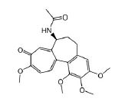  (Derived from the bulb-like corns of the autumn crocus plant; Colchicum autumnale) | Alkaloid | Gastric, liver cancer | Initiates apoptosis, upregulates dual specificity phosphatase 1 (DUSP1) quality in gastric cancer. | Kuo MC et al., (2015)
Thymoquinone  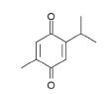  (Found in plant Nigella sativa) | Quinone | Breast cancer, gastric cancer | Promotes apoptosis by restraining STAT-3 phosphorylation, diminishing expression of VEGF and enacts anticancer immune response by expanding INF-γ level. | Odeh et al., 2018;  Zhu et al., 2016
β-elemene  (Found in plant Curcuma wenyujin)  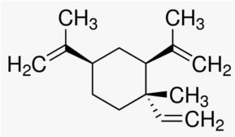 | Sesquiterpene | Melanoma | Initiates apoptosis and cell death, hinder the expression of VEGF, downregulates Akt phosphorylation and CD34 expression, blocks PI3K/Akt/mTOR, MAPK and pathway, lessening angiogenesis. | Chen et al., 2011

TABLE-1. DIFFERENT TYPES OF PHYTOCHEMCALS WITH THEIR STRUCTURES AND THE TYPES OF
CANCERS AFFECTED WITH MOLECULAR ACTIONS ARE REPRESENTED
Abbreviations: GATA, Globin transcription factor; MEK, Mitogen-activated protein kinase; ERK, extracellular signal-regulated protein kinase; iNOS, inducible Nitric Oxide Synthase; MAPK, Mitogen-activated protein kinases; NF-κB, nuclear factor κ light chain-enhancer of activated B cells; JAK/STAT, Janus kinase/signal transducers and activators of transcription; PI3K, phosphoinositide 3-kinase; AKT, serine-threonine–specific protein kinase; Wnt, Wingless-related integration site; mTOR, mechanistic target of rapamycin kinase; JNKs, c-Jun NH₂-terminal kinases; AP-1, Activator protein 1; Bcl-2, B-cell lymphoma 2; COX2, cyclooxygenase 2; PKA, protein kinase A; CREB, cAMP response element-binding protein; MITF, Melanocyte Inducing Transcription Factor; VEGF, Vascular endothelial growth factor; p53, tumor protein p53; CDKs, Cyclin-dependent kinases; ROS, Reactive oxygen species; DUSP1, Dual specificity phosphatase 1; STAT-3, Signal transducer and activator of transcription 3; IFN-γ, Interferon gamma; CD34, Protein Coding gene.

