Supplementary Information
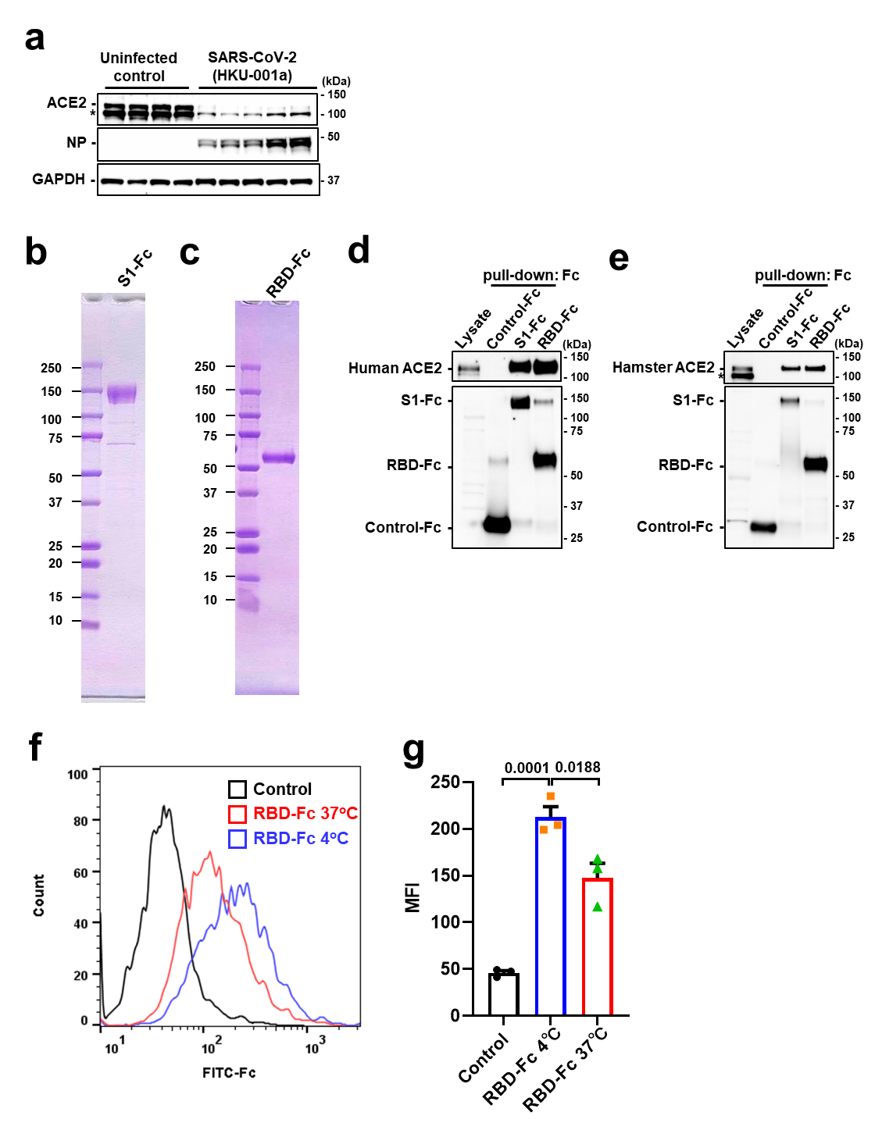
Extended Data Figure 1. Downregulation of ACE2 expression by SARS-CoV-2 (HKU-001a) and recombinant Spike proteins
a, Protein expression of ACE2 in hamster lungs at 4 days after intranasal infection of SARS-CoV-2 (Hong Kong strain, HKU-001a). Representative Western Blot is shown. b-c, Preparation of recombinant Spike proteins. SDS-PAGE of purified Spike proteins S1-Fc (b) and RBD-Fc (c) are shown. d-e, Binding of recombinant S1-Fc or RBD-Fc protein to human ACE2 and hamster ACE2 in pull-down assays. Western Blot of human ACE2 (d, top), hamster ACE2 (e, top) and respective Fc protein (d, e, bottom) are shown. Total lysates are shown as controls. *; non-specific band. f-g, Decreased cell-surface expression of ACE2 after binding to Spike RBD-Fc protein at 37 °C compared to 4 °C in Vero E6 cells. ACE2 surface expression was detected at 3 h of incubation with RBD-Fc using Fc-specific antibody to directly detect surface-bound Spike-Fc and to avoid masking of the ACE2 epitope. Representative FACS histograms (f) and quantification of mean fluorescence intensity (g) are shown including a background control with an isotype-matched antibody (n = 3 per group). FSC/SSC plot was gated for live and healthy Vero E6 cells. One-way ANOVA with Sidak’s multiple comparisons test. Numbers above square brackets show P values.

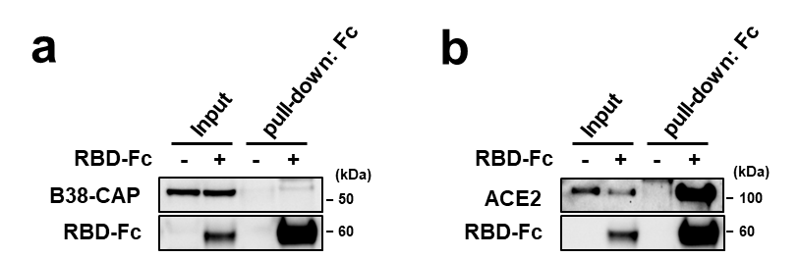
Extended Data Figure 2. B38-CAP does not bind to Spike RBD.
a-b, In vitro binding of recombinant RBD-Fc protein to recombinant soluble human ACE2 protein but not B38-CAP in pull-down assays. Western Blot of B38-CAP (a) and soluble human ACE2 (b) are shown.

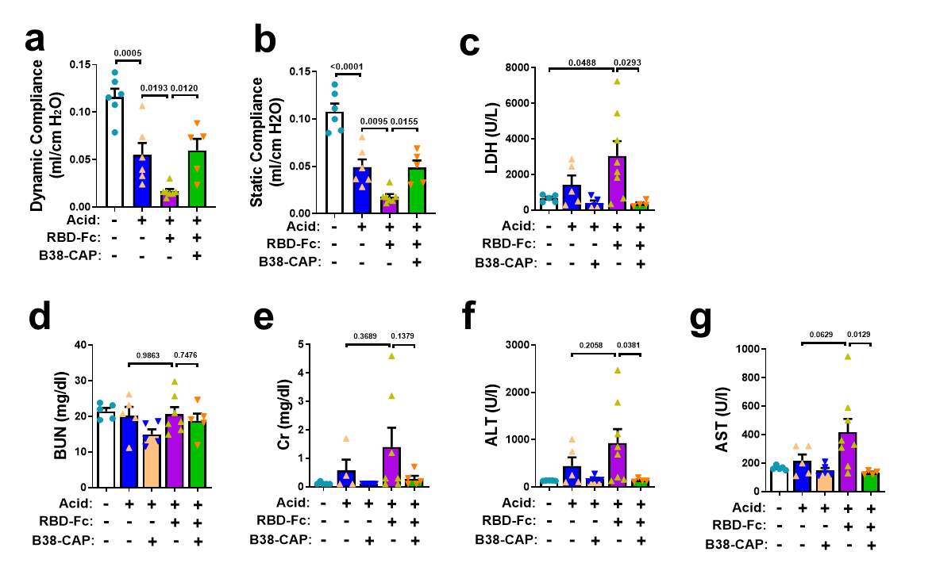Extended Data Figure 3. Effects of B38-CAP on lung functions and serum markers of tissue injury and liver and kidney functions.
a-b, Lung function measurements at 17 hours after acid instillation. Measurements of dynamic (a) and static (b) compliance are shown (n = 5-7 hamsters per group). c, Tissue injury assessment with measurements of LDH in the blood. d-e, Kidney function assessment with measurements of BUN (d) and Creatinine (Cr) (e) in the blood. f-g, Liver function test with measurements of alanine aminotransferase (ALT) (f) and aspartate aminotransferase (AST) (g) in the blood. n = 5-7 hamsters per group. All values are means ± SEM. One-way ANOVA with Sidak’s multiple comparisons test. Numbers above square brackets show P values.
species | genes | 5'-Sense-3' | 5'-Antisense-3'
Hamster | IL-6 | GGACAATGACTATGTGTTGTTAGAA | AGGCAAATTTCCCAATTGTATCCAG
Hamster | TNF-α | TGAGCCATCGTGCCAATG | AGCCCGTCTGCTGGTATCAC
Hamster | CXCL10 | CTCTACTAAGAGCTGGTCC | CTAACACACTTTAAGGTGGG
Hamster | β-actin | TGTACCCAGGCATTGCTGAC | TCATCGTACTCCTGCTTGCTGA
Mouse | IL-6 | CAACGATGATGCACTTGCAGA | CTCCAGGTAGCTATGGTACTCCAGA
Mouse | TNF-α | GCCTCTTCTCATTCCTGCTTG | CTGATGAGAGGGAGGCCATT
Mouse | Cxcl10 | GCCGTCATTTTCTGCCTCAT | GCTTCCCTATGGCCCTCATT
Mouse | Cxcl2 | GCGCTGTCAATGCCTGAAGA | TTTGACCGCCCTTGAGAGTG
Mouse | IFN-γ | CGGCACAGTCATTGAAAGCCTA | GTTGCTGATGGCCTGATTGTC
Mouse | 18S | AAACGGCTACCACATCCAAG | CCTCCAATGGATCCTCGTTA
Extended Data Table 1. qRT-PCR primers for cyto

