Supplementary Information

Jia-Wei Wang et al.

Experimental Section
Materials
CuBCP,¹ CuBCP',¹ BIH,² CoTSPc (deprotonated and protonated),³ CoTCPc,^{4,5} and pbcp ligand⁶ were prepared following the previously reported methods. Milli-Q ultrapure water (> 18 MΩ) was utilized unless otherwise stated. [Cu(CH₃CN)₄]PF₆ (97%, Innochem), bis[(2-diphenyl-phosphino)phenyl]ether (DPEphos; 97%, Innochem), 9,9-dimethyl-4,5-bis(diphenylphosphino)xanthene (xantphos; 97%, Innochem), 2,9-dimethyl-4,7-diphenyl-1,10-phenanthroline (bathocuproine, bcp; 97%, Innochem), CoPc (97%, β-form, Aldrich), CoTAPc (95%, Jilin Chinese Academy of Sciences-Yanshen Technology Co., Ltd.), CH₃CN (Superdry, >99.5%, Acros), NMP (Superdry, >99.5%, Acros), TEA (Superdry, >99.5%, Energy Chemical Co., Ltd.), phenol (99.5%, Aladdin), 2,2,2-trifluoroethanol (TFE, 99.5%, Aladdin), CO₂ (99.999%), N₂ (99.999%), ¹³CO₂ (99.9%) and other chemicals were commercially available and used without further purification.

Characterization
¹H NMR and ¹H-¹H 2D NMR correlation spectroscopy (COSY) spectra were obtained on a Bruker advance III instrument (400 MHz). Electrochemical measurements were carried out using an electrochemical workstation (CHI 620E). All potentials were referenced against ferrocenium/ferrocene (Fc⁺/Fc) as an internal standard. Unless otherwise stated, all potentials were footnoted as vs. normal hydrogen electrode (NHE) by adding 0.64 V based on the potentials vs. Fc⁺/Fc. The irradiation experiments were carried out with a blue LED light (Zolix, MLED4). Gas chromatographic analysis was conducted on an Agilent 7820A gas chromatography equipped with a thermal conductivity detector (TCD) and a TDX-01 packed column, where the oven temperature was held constant at 60 °C, the inlet and detector temperature were set at 80 °C and 200 °C, respectively. The isotopic labeling experiment was conducted under ¹³CO₂ atmosphere and the gas in the headspace was analyzed by a quantitative mass spectrometer attached Agilent 7890A gas chromatography. The liquid phase of the reaction system was analyzed by an ion chromatograph (Metrohm, 930 Compact IC Flex, Supp 5 anion column, Na₂CO₃/NaHCO₃ aqueous eluent) to detect the presence of formate. UV–vis spectra were collected on a Shimadzu UV-3600 spectrophotometer. The emission experiments were conducted on a modular fluorescent life and steady-state fluorescence spectrometer (FLSP1000, Edinburgh Instruments LTD.). The TA spectroscopy was carried out on a laser flash photolysis instrument (LP980, Edinburgh Instruments LTD.). All experiments were operated at room temperature (24~25 °C) unless otherwise stated.

Synthesis of CoTDMAPc
CoTAPc (0.79 mmol, 0.5 g) and iodomethane (3 mL) were stirred at room temperature in DMF (20 mL) for 24 h. After the reaction, diethyl ether was added to the mixture. The precipitate was collected by centrifugation with ethanol for five times and water for five times, respectively. The final product was dried in oven at 373 K as a blue-green solid. MALDI-TOF: CoTDMAPc (measured: 743.249; simulated: 743.251).

Synthesis of CuPBCP/CuPBCP'
The synthesis follows a similar procedure for preparing heteroleptic Cu(I) PSs.⁷ In a 50 mL Schlenk tube, [Cu(CH₃CN)₄]PF₆ (186 mg, 0.5 mmol) and DPEphos (279 mg, 0.5 mmol) or xantphos (289 mg, 0.5 mmol) are dissolved in 10 mL dry DCM at room temperature under N₂ and darkness. The resulting solution is stirred at 40 °C for 2 h. The reaction mixture is then added with the pbcp ligand (180 mg, 0.5 mmol) under N₂ flow. The resulting mixture is then heated at 45 °C for 2 h. The reaction mixture was then allowed to cool to room temperature and the solvent was evaporated under reduced pressure. Then a minimal volume of dry DCM (ca. 5 mL) was added to dissolve most the orange residue, which was filtrated via a 0.45 μM nylon membrane, followed by the addition of excess xantphos (ca. 70 mg) into the filtrate to prevent the formation of [Cu(pbcp)₂]⁺. Finally, excess dry hexane (50 mL) was added to precipitate CuPBCP/CuPBCP' as yellow powder (46%/55% yield). It should be noted that the presence of trace water will make the product oily. The yellow prism crystals were obtained by the gaseous diffusion of ether into dry CH₃CN solutions of the Cu(I) PSs. Q-TOF ESI-MS(+): [Cu(xantphos)(pbcp)]⁺ (measured: 1003.2767; simulated: 1003.2756); [Cu(DPEphos)(pbcp)]⁺ (measured: 963.2444; simulated: 963.2437).

DFT Calculation on CoPc complexes
Cobalt phthalocyanine with varied substituents have been optimized by Perdew-Burke-Ernzerhof hybrid functional (PBE0)⁸ method and def2-SVP basis set with ultrafine integration grids and Grimme’s DFT-D3(BJ) empirical dispersion correction⁹ by Gaussian 09 package.¹⁰ Harmonic vibrational frequency was performed at the same level to guarantee that there is no imaginary frequency in the molecules, i.e. they locate on the minima of potential energy surface. The Hirshfeld population¹¹ was gained from Gaussian, while the electron density at cobalt center were yielded from Multiwfn 3.8¹² whose input files were extracted from Gaussian format checkpoint.

X-ray Crystallography
Single-crystal X-ray diffraction data were collected at 150 K on an Agilent Technologies Supernova system with Cu/Kα (λ = 1.54178 Å) radiation. The empirical absorption corrections were applied using spherical harmonics, implemented in SCALE3 ABSPACK scaling algorithm. The structure was solved using direct method and refined by the full-matrix least-squares method on F², which yielded the positions of all non-hydrogen atoms. These were refined first isotropically and then anisotropically. All the hydrogen atoms of the ligand were placed in calculated positions with fixed isotropic thermal parameters and included in the structure factor calculations in the final stage of full-matrix least-squares refinement. All the calculations were performed using the SHELX-97 program.¹³ CCDC number: CuPBCP (2092595) and CuPBCP' (2043973).

Determination of Binding Constant
Binding isotherms for the NMR titration were calculated from a global proton shift analysis using Bindfit with the shift differences (δ - δ₀) taken to obtain a binding isotherm.¹⁴ The fitting is based on the shift difference between the host-only data and the data at varying guest concentrations. The Equations used for these analyses are available in the review by Thordarson.¹⁵ Nelder-Mead (Simplex) method was used as the optimal search algorithm. The error of binding constant, the root mean square and the covariance of the fit (variance of the residuals divided by the variance in the data) were used to conclude the models that best describe the binding between CuPBCP and CoTCPc. Specific discussion on the choices of the models is included in the table captions. It should be noted that the non-cooperative mode means that each of the multiple binding process does not interfere with each other, in which the second binding constant (K₁₂ or K₂₁) will be equivalent to the first binding constant (K₁₁). For the choices of protons in binding fits, we observed that most protons at the pbcp ligand in CuPBCP underwent significant relaxation with the addition of CoTCPc and thus disappeared, presumably due to the coordinative interaction with paramagnetic Co(II) center. We thus only utilized the shifted but not vanished protons G, H, J1-J4 and K1-K4 of CuPBCP for binding fits, which still afforded reliable binding constants that are consistent with our previous works on coordinative interaction.¹⁶

Cyclic Voltammetry
Cyclic voltammetry was performed in a 25 mL gas-tight three-neck flask with a three-electrode system, where a 3 mm glassy carbon disc electrode, a platinum wire auxiliary electrode, and a platinum wire pseudo-reference electrode were placed in a 0.1 M tetrabutylammonium hexafluorophosphate (TBAPF₆) NMP solution (8.0 mL) or NMP/TEA (v:v = 5:1; 9.6 mL). Prior to experiments, the working electrode was polished in turn with 0.3 and 0.05 μm Al₂O₃ slurry for 3 min to obtain a mirror surface, then sonicated in water for ~60 seconds to remove debris, and finally rinsed with water. The solution was bubbled with N₂/CO₂ for 15 min prior to each experiment. Scan rate is 100 mV/s.

Photocatalytic Experiments
The photocatalytic reduction of CO₂ to CO was conducted in a 17 mL home-made reactor upon successive addition of catalyst, proton source, a CH₃CN solution containing Cu PS, corresponding diphosphine ligand and BIH, and finally TEA, under 1 atm CO₂ atmosphere at 293±2 K. Phenol was placed in a N₂-saturated Schlenk flask and molten at 70 °C prior to use. After the reaction system purged with CO₂ for 10 min, the photocatalytic reaction was initiated by irradiation under an LED light. The generated gases in the headspace were analyzed by a gas chromatography, and the possible products in the solution were analyzed by an ion chromatograph.

Determination of Φ for CO Production
A reported method¹⁷ was used to determine Φ. A typical experiment employed a mixture of CoTCPc (0.05 mM), CuBCP (0.5 mM), xantphos (1.0 mM), phenol (5.0 v%), and BIH (50 mM) in 4.0 mL CH₃CN/TEA (v:v = 5:1) for evaluation. The temperature was kept at 25 °C. The light source is an LED light set-up (λ = 425 ± 5 nm, light intensity = 40 mW·cm⁻², irradiated area is 1.5 cm²). The photon flux is determined to be 2.39 × 10⁻⁷ einstein s⁻¹.¹⁸ Under these conditions, the light entering the reaction solution was considered to be fully absorbed by PS without scattering, suggesting the evaluated Φ is a lower limit. The 5 min of light irradiation is consistent with the total number of photons n_{p} = 7.18 × 10⁻⁵ einstein.
The Φ with BIH as the two-electron reductant was evaluated by the Equation¹⁹ for two-electron reduction of CO₂.
Φ = n(CO) / n_{p} (S1)
A typical Φ of 63.5% was determined by the measured n(CO) = 45.6 μmol by GC-TCD after 5 min of irradiation.

Determination of Quenching Rate (k_{q})
A reported method¹⁹ was followed to calculate the k_{q}, where the fluorescence intensity of photo-excited Cu(I) PS in the presence of quencher was measured and fitted to the Stern-Volmer Equation,
$\frac{I_{0}}{I}=1+K[Q]=1+k_{q}τ_{0}[Q]$ (S2)
In this Equation, I₀ and I are the fluorescence intensity values in the absence and presence of the quencher, K is the Stern-Volmer constant for dynamic quenching, k_{q} is the apparent rate of bimolecular quenching, τ₀ is the lifetime of the excited state without quencher, and [Q] is the concentration of the quencher.
In the time-resolved fluorescent quenching experiments, the calculation Equation should be
$\frac{τ_{0}}{τ}=1+k_{q}'τ_{0}[Q]$ (S3)
Here k_{q}' is the dynamic quenching rate.

Determination of Second-Order Reaction Rate (k_{r}) for the Excited States
A reported method²⁰ was followed to calculate the k_{r}, where the lifetime of reduced Cu(I) PS in the presence of quencher was measured and fitted to the following Equation S4,
$\frac{τ_{1}}{τ}=1+k_{r}τ_{1}[Q]$ (S4)
In this Equation, τ₁ and τ are the lifetimes in the absence and presence of the quencher, and [Q] is the concentration of the quencher.

Extended X-ray Absorption Fine Structure (EXAFS) Analysis
Athena software²¹ was used for data processing. The energy scale for each scan was normalized using copper metal standard. Data in energy space were pre-edge corrected, normalized, deglitched (if necessary), and background corrected. The processed data were next converted to the photoelectron wave vector (k) space and weighted by k². The electron wave number is defined as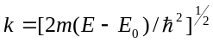. E₀ is the energy origin or the threshold energy. K-space data were truncated near the zero crossings k = 2 to 11.674 Å⁻¹ for the CuBCP and CuPBCP ground states and k = 2 to 9 Å⁻¹ for the reconstructed excited states in the Cu EXAFS Fourier transformation. The k-space data were transferred into the Artemis Software for curve fitting. In order to fit the data, the Fourier peaks were isolated separately, grouped together, or the entire (unfiltered) spectrum was used. The individual Fourier peaks were isolated by applying a Hanning window to the first and last 15% of the chosen range, leaving the middle 70% untouched. Curve fitting was performed using ab initio-calculated phases and amplitudes from the FEFF8²² program from the University of Washington. Ab initio-calculated phases and amplitudes were used in the EXAFS Equation (Equation S5),
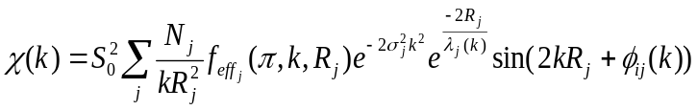 | (S5)
where N_{j} is the number of atoms in the j^{th} shell; R_{j} the mean distance between the absorbing atom and the atoms in the j^{th} shell; 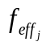(π,k, R_{j} ) is the ab initio amplitude function for shell j, and the Debye-Waller term 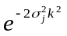accounts for damping due to static and thermal disorder in absorber-backscatterer distances. The mean free path term 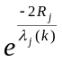 reflects losses due to inelastic scattering, where λ_{j}(k), is the electron mean free path. The oscillations in the EXAFS spectrum are reflected in the sinusoidal term 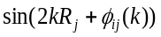, where 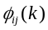is the ab initio phase function for shell j. This sinusoidal term shows the direct relation between the frequency of the EXAFS oscillations in k-space and the absorber-backscatterer distance. S₀² is an amplitude reduction factor.
The EXAFS equation²³ (Equation S5) was used to fit the experimental Fourier isolated data (q-space) as well as unfiltered data (k-space) and Fourier transformed data (R-space) using N, S₀², E₀, R, and σ² as variable parameters (Supplementary Table 11). N refers to the number of coordination atoms around Cu for each shell. The quality of fit was evaluated by R-factor and the reduced Chi² value. The deviation in E₀ ought to be less than or equal to 10 eV. R-factor less than 2% denotes that the fit is good enough. R-factor between 2 and 5% denotes that the fit is correct within a consistently broad model. The reduced Chi² value is used to compare fits as more absorber-backscatter shells are included to fit the data. A smaller reduced Chi² value implies a better fit. Similar results were obtained from fits in k, q, and R-spaces.

Steady-State and Time-Resolved XAS Measurements
Steady-state and time-resolved X-ray absorption spectra were collected at 11 ID-D²⁴ beamlines at the Advanced Photon Source using undulator radiation at electron energy 8.98 keV in solvent grade acetonitrile. The samples were circulated through a stainless-steel nozzle into a free-flowing cylindrical jet inside an airtight aluminum chamber, and continuously degassed with nitrogen. This sample handling technique ensures proper sample recovery such that the subsequent laser pulse can hit a “fresh” sample position.
Cooled running water from a chiller was additionally circulated around the jacketed sample flask to prevent heating damage of the complexes by radiation. The X-ray fluorescence signals were collected with two avalanche photodiodes (APDs) positioned at 90˚ on both sides of the liquid jet, and a combination of Z-1 filters and soller slits with conical geometry were used to reduce the background from elastically scattered X-rays.
The experiments were carried out using the 24-bunch timing mode of APS (in top up mode with a constant 102 mA ring current) which consists of a train of X-rays separated by 153 ns. This mode easily allows for gateable detectors that selects X-ray pulses. This timing mode was suitable for this type of experiments in which the separation between adjacent X-ray pulses is long enough for the Avalanche Photodiode (APD) detector to resolve individual X-ray pulses.
The time-resolved experiments were carried out by pumping the samples at 400 nm wavelength using a regenerative amplified laser with 10 kHz repetition rate 5 ps-FWHM pulse length and laser power of 630 mW at the sample. The X-ray and laser beam was spatially overlapped with an X-ray spot size of 100 µm (V) × 450 µm (H) and laser spot size of 170 µm (V) × 550 µm (H). With a liquid flow speed of around 4.5 m s⁻¹, the pumped laser volume was calculated to move out of the FWHM laser pulse region in around 20 µs. This temporal range ensured that the excited state volume was probed more at the center and less at the edges where the excitation fraction would be less, due to movement of the sample. Beamline 11 ID-D has an automated data digitization system which allows for all X-ray pulses after laser excitation to be collected. Such a system, together with the larger X-ray beam spot size, was very useful for our experiments, as multiple X-ray pulses after laser excitation were averaged to monitor the dynamics for the formation and decay of triplet states for the CuBCP and CuPBCP as PSs in the nano-microsecond time regime.
The delay between the pump and X-ray pulses was adjusted by a programmable delay line (PDL-100A-20NS, Colby Instruments). A Cu metal foil was placed between two ionization chambers downstream to the X-ray beam, and its transmission recorded with each scan for energy calibration.

Ground and Excited-State DFT Calculations
The DFT optimization calculations were performed using the ORCA (Version 4.2.0) program package developed by Neese²⁵ and co-workers. The geometry optimizations of the ground state structures were carried out using the BP86 exchange-correlation functional^{26,27} in combination with the triple zeta valance polarization functions (def2-TZVP),²⁸ and the atom-pairwise dispersion correction with the Becke-Johnson damping scheme (D3BJ).^{29,30} The ground state structures for the complexes in solution were furthermore optimized at the BP86 level with the def2-TZVP triple-zeta basis sets, the atom-pairwise dispersion correction D3BJ and after considering solvent effect of acetonitrile by the PCM³¹ method.
The excited-state geometries were by contrast optimized using the B3LYP^{32,33} as functional with the def2-TZVP triple-zeta²⁸ basis sets and once again with the Becke-Johnson damping scheme (D3BJ)^{29,30} and the PCM³¹ method. The RI^{34,35} and RIJCOSX³⁶ approximations were used to accelerate Coulomb and exchange integrals for the ground and excited state calculations respectively. The default GRID settings were further employed for the self-consistent field iterations and for the final energy evaluation. The calculated structures were confirmed to be minima based on a check of the energies and the absence of imaginary frequencies from frequency calculations carried out on the optimized geometries.

Supporting Figures
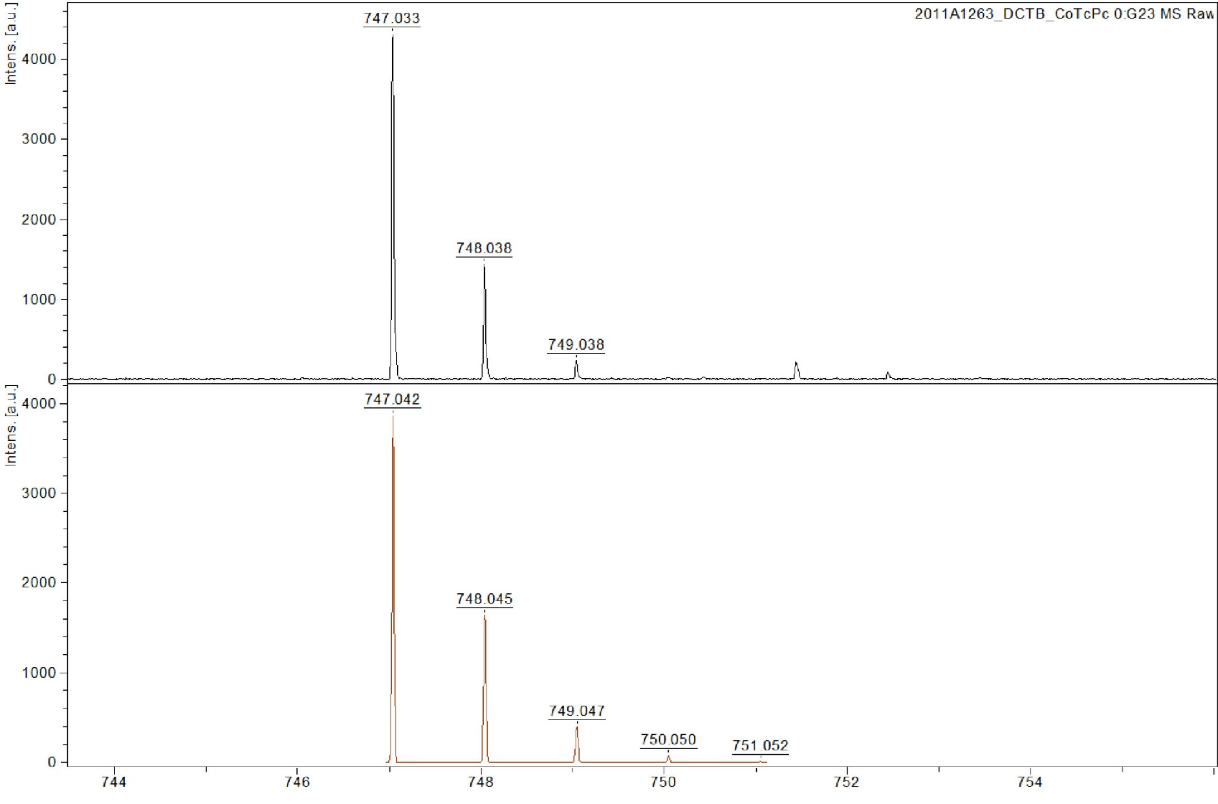
Supplementary Figure 1. MALDI-TOF HR MS spectrum of CoTCPc dissolved in NMP.

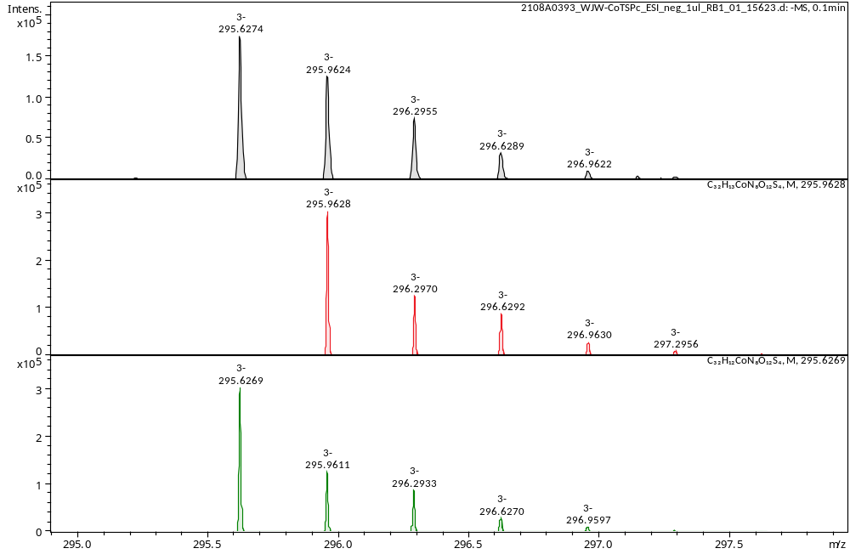
Supplementary Figure 2. MALDI-TOF HR MS spectrum of CoTSPc dissolved in NMP.

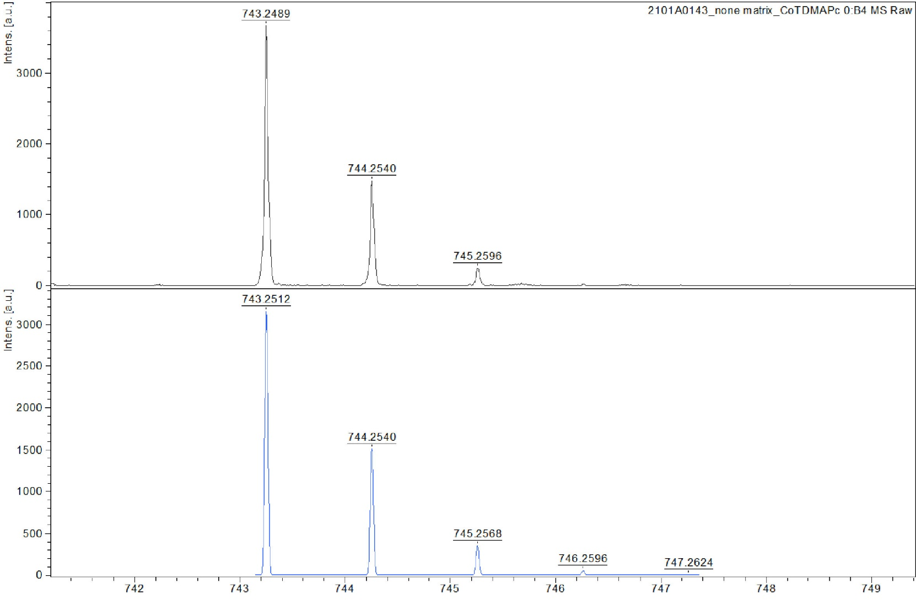
Supplementary Figure 3. MALDI-TOF HR MS spectrum of CoTDMAPc dissolved in NMP.

Supplementary Figure 4. UV-vis spectra of 25 μM CoPc derivatives in NMP.
Supplementary Figure 5. CVs of 0.5 mM CoTCPc in 0.1 M nBu₄NPF₆ NMP/TEA (v:v = 5:1) solution under N₂ (deep red), CO₂ (medium red) or CO₂ (pale red) with 5 v% phenol at a scan rate of 0.1 V s⁻¹.

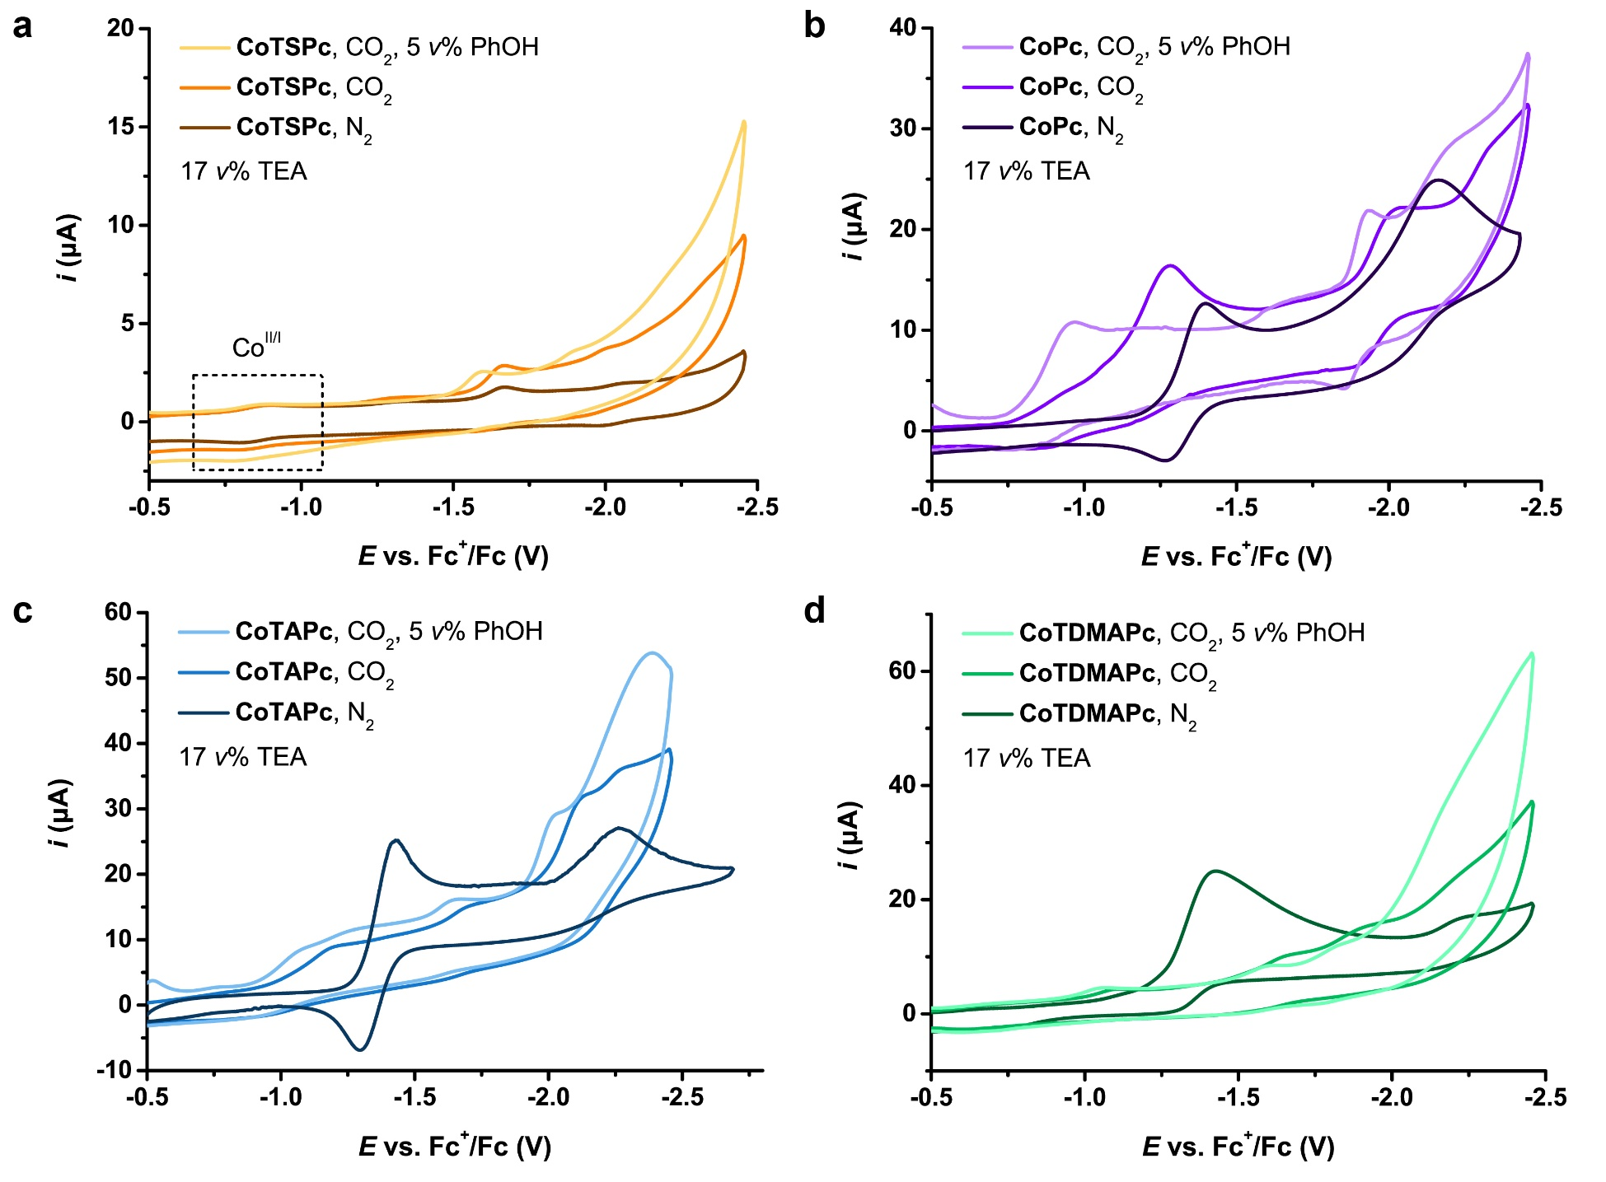
Supplementary Figure 6. CVs of (a) 0.1 mM CoTSPc (limited solubility), (b) 0.5 mM CoPc, (c) 0.5 mM CoTAPc or (d) 0.5 mM CoTDMAPc in 0.1 M nBu₄NPF₆ NMP/TEA (v:v = 5:1) solution under N₂ (deep color), CO₂ (medium color) or CO₂ (pale color) with 5 v% phenol (PhOH) at a scan rate of 0.1 V s⁻¹.
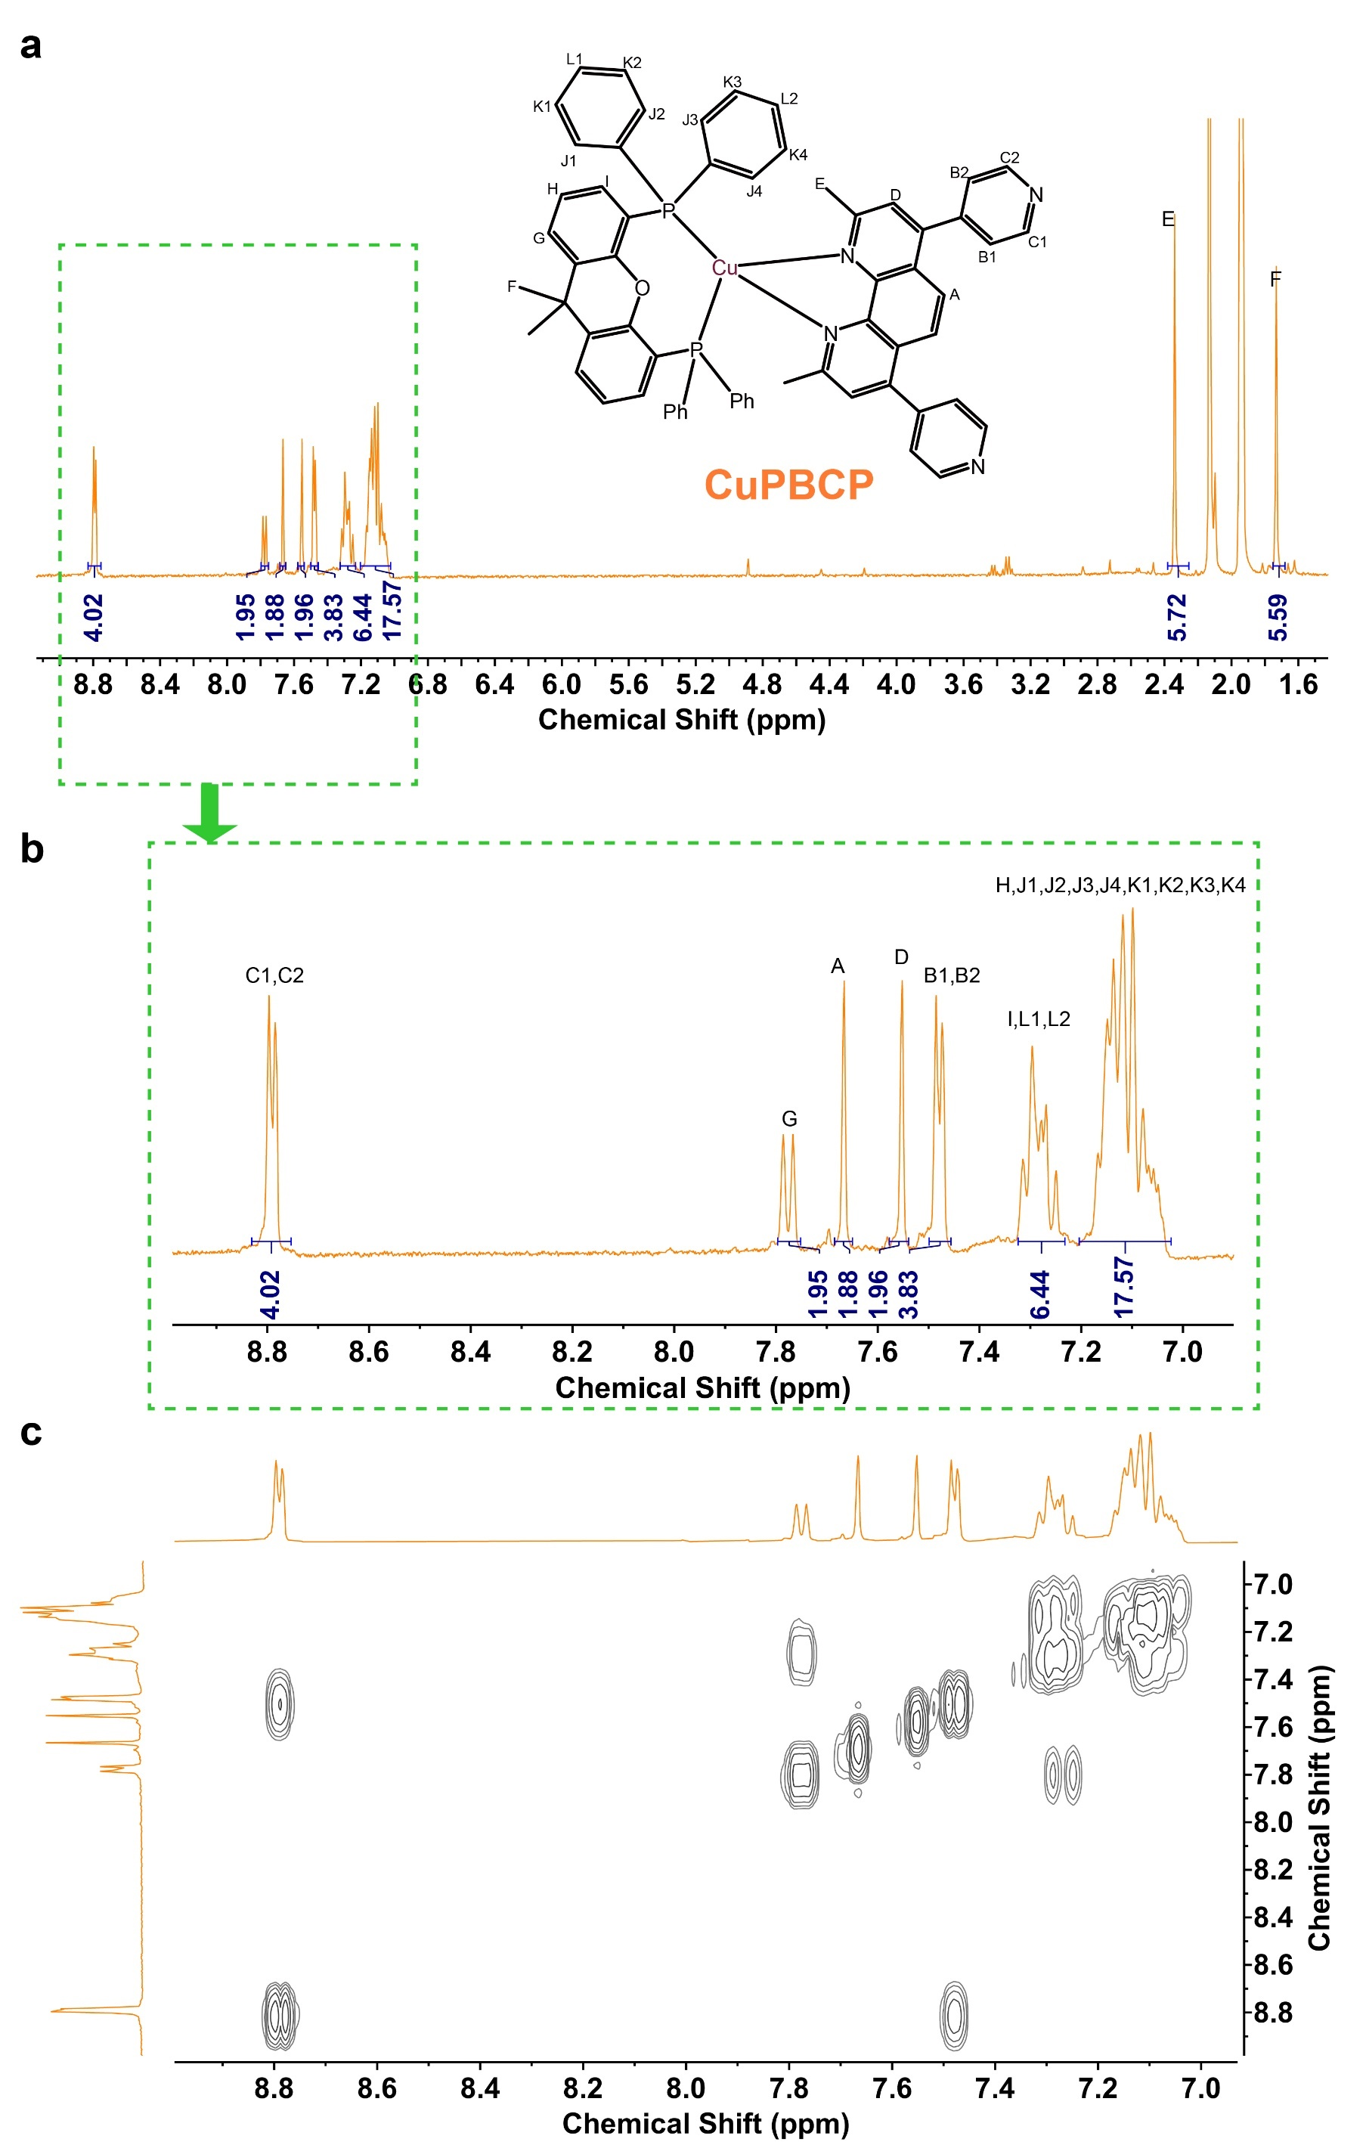
Supplementary Figure 7. (a,b) ¹H and (c) 2D COSY NMR spectra of CuPBCP in CD₃CN with proton assignments. 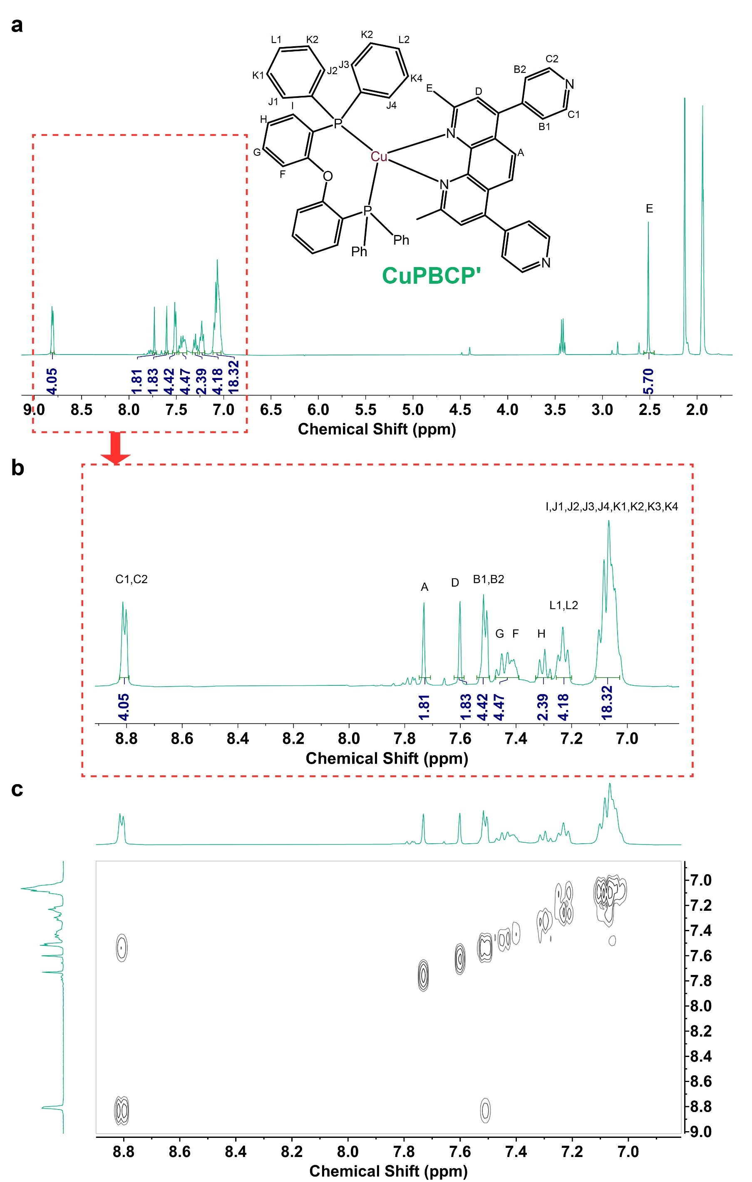
Supplementary Figure 8. (a,b) ¹H and (c) 2D COSY NMR spectra of CuPBCP' in CD₃CN with proton assignments.

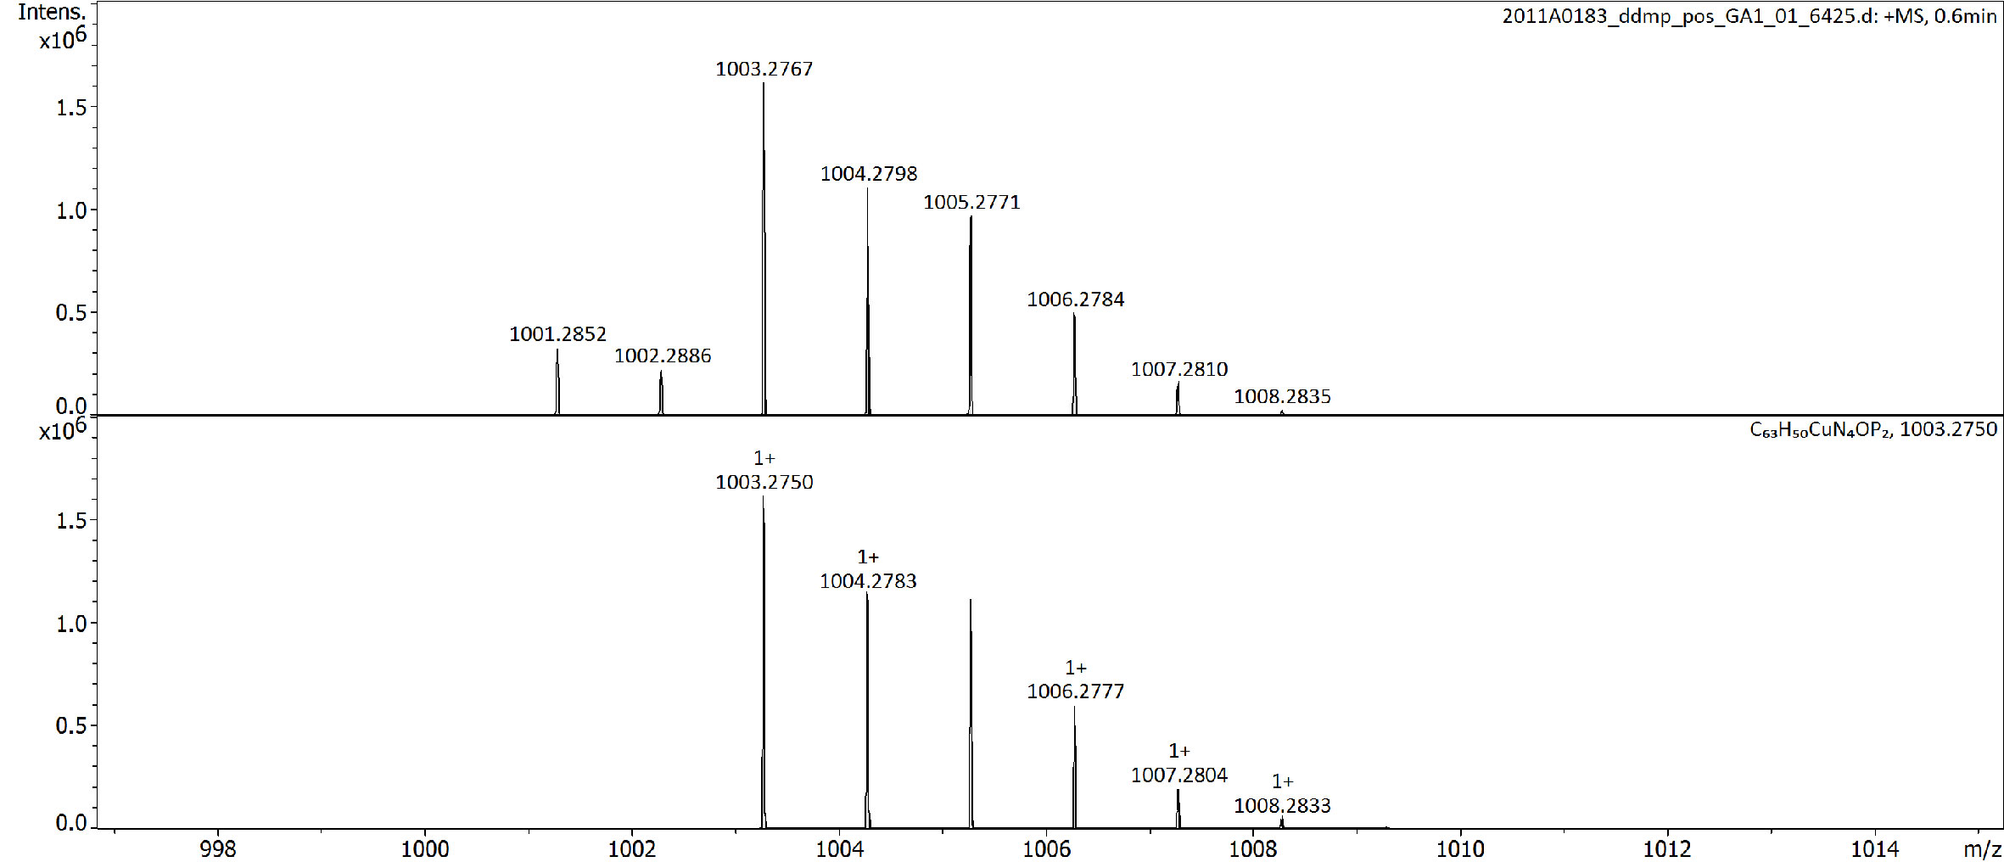
Supplementary Figure 9. Q-TOF HR MS spectrum of CuPBCP dissolved in CH₃CN.

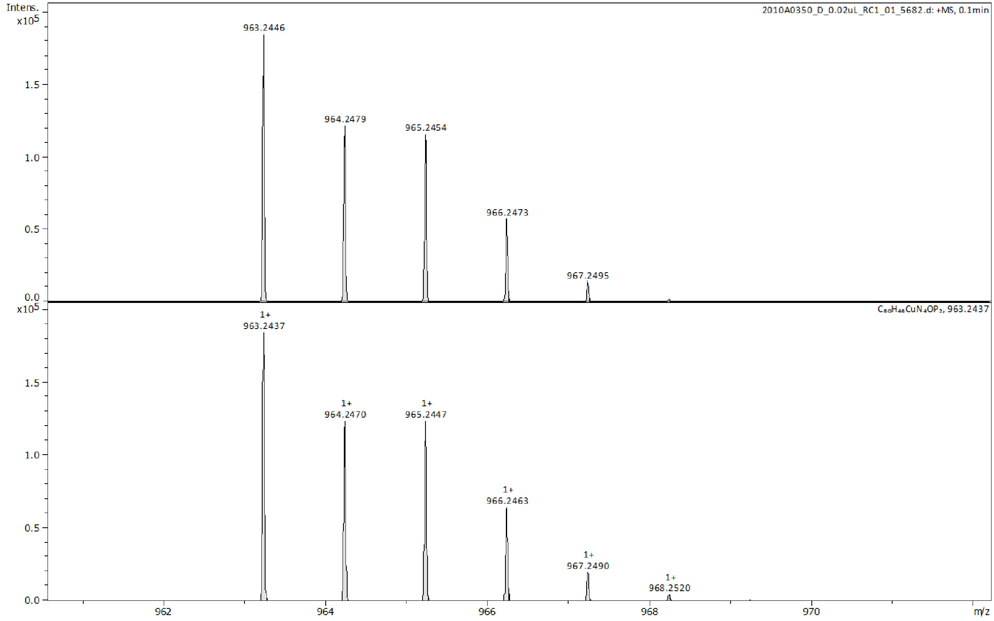
Supplementary Figure 10. Q-TOF HR MS spectrum of CuPBCP' dissolved in CH₃CN.

Supplementary Figure 11. Crystal structure of the cation of CuPBCP. Counter anions and solvent molecules are omitted for clarity. Possibility = 50%.

Supplementary Figure 12. Crystal structure of the cation of CuPBCP'. Counter anions and solvent molecules are omitted for clarity. Possibility = 50%.

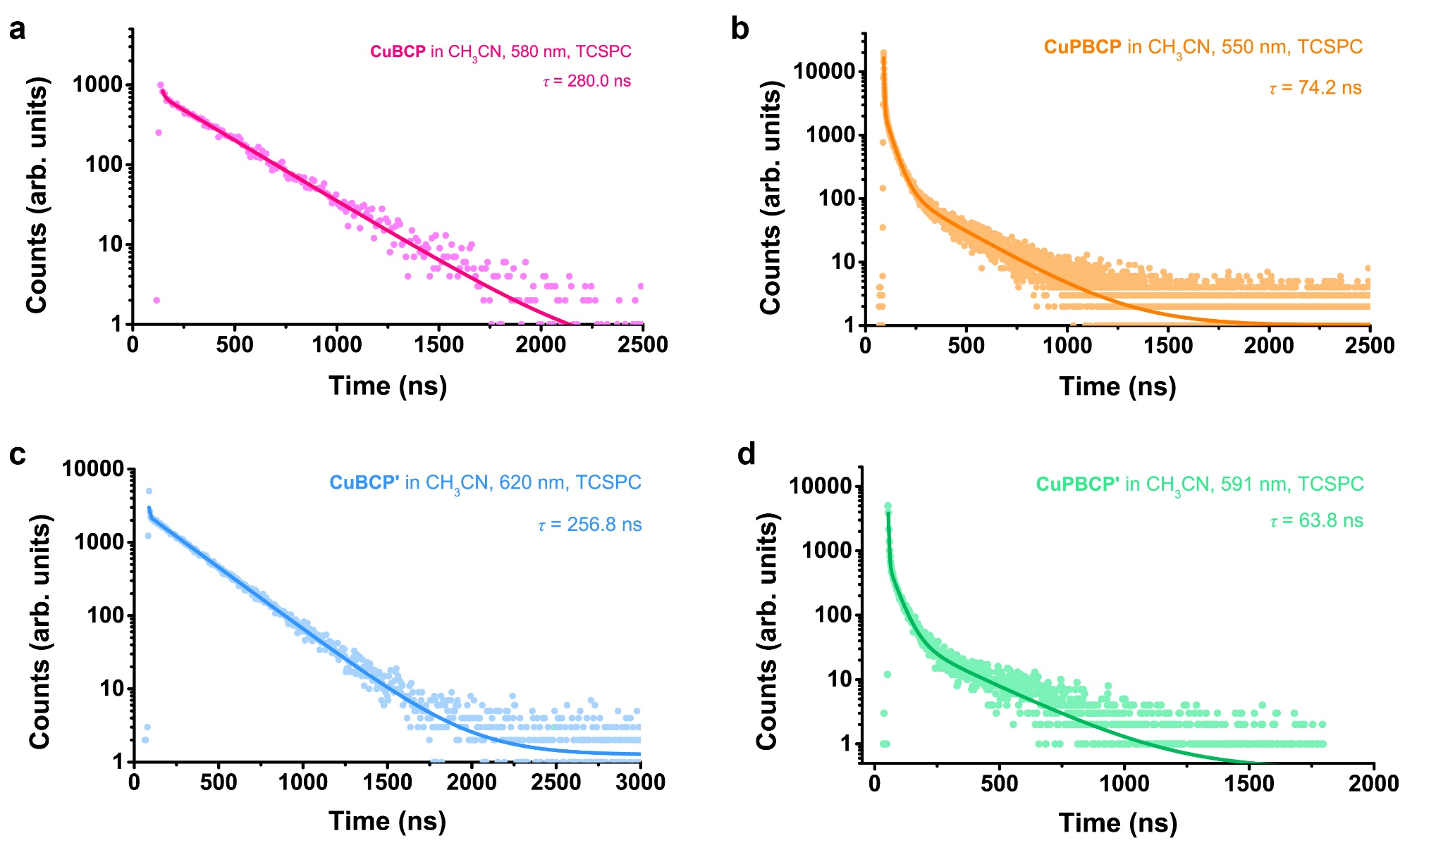
Supplementary Figure 13. Excited-state lifetime measurements of Cu(I) PSs, including (a) CuBCP (pink), (b) CuBCP' (azure), (c) CuPBCP (orange) and (d) CuPBCP' (turquoise). Deaerated 50 μM CH₃CN solutions of Cu(I) PSs were used.

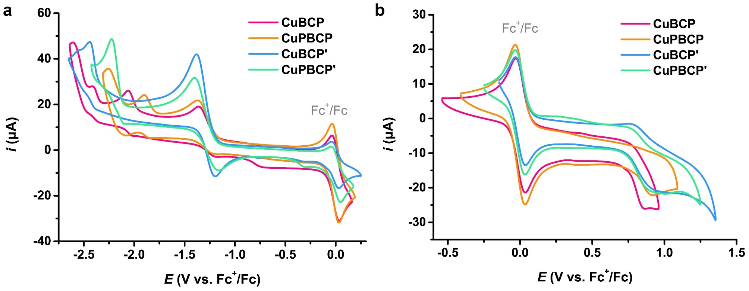
Supplementary Figure 14. (a) Reduction and (b) oxidation CVs of 0.5 mM CuBCP (pink), CuPBCP (orange), CuBCP’ (azure) or CuPBCP’ (turquoise) in 0.1 M nBu₄NPF₆ CH₃CN solution under N₂ with 1.0 mM Fc as the internal reference.

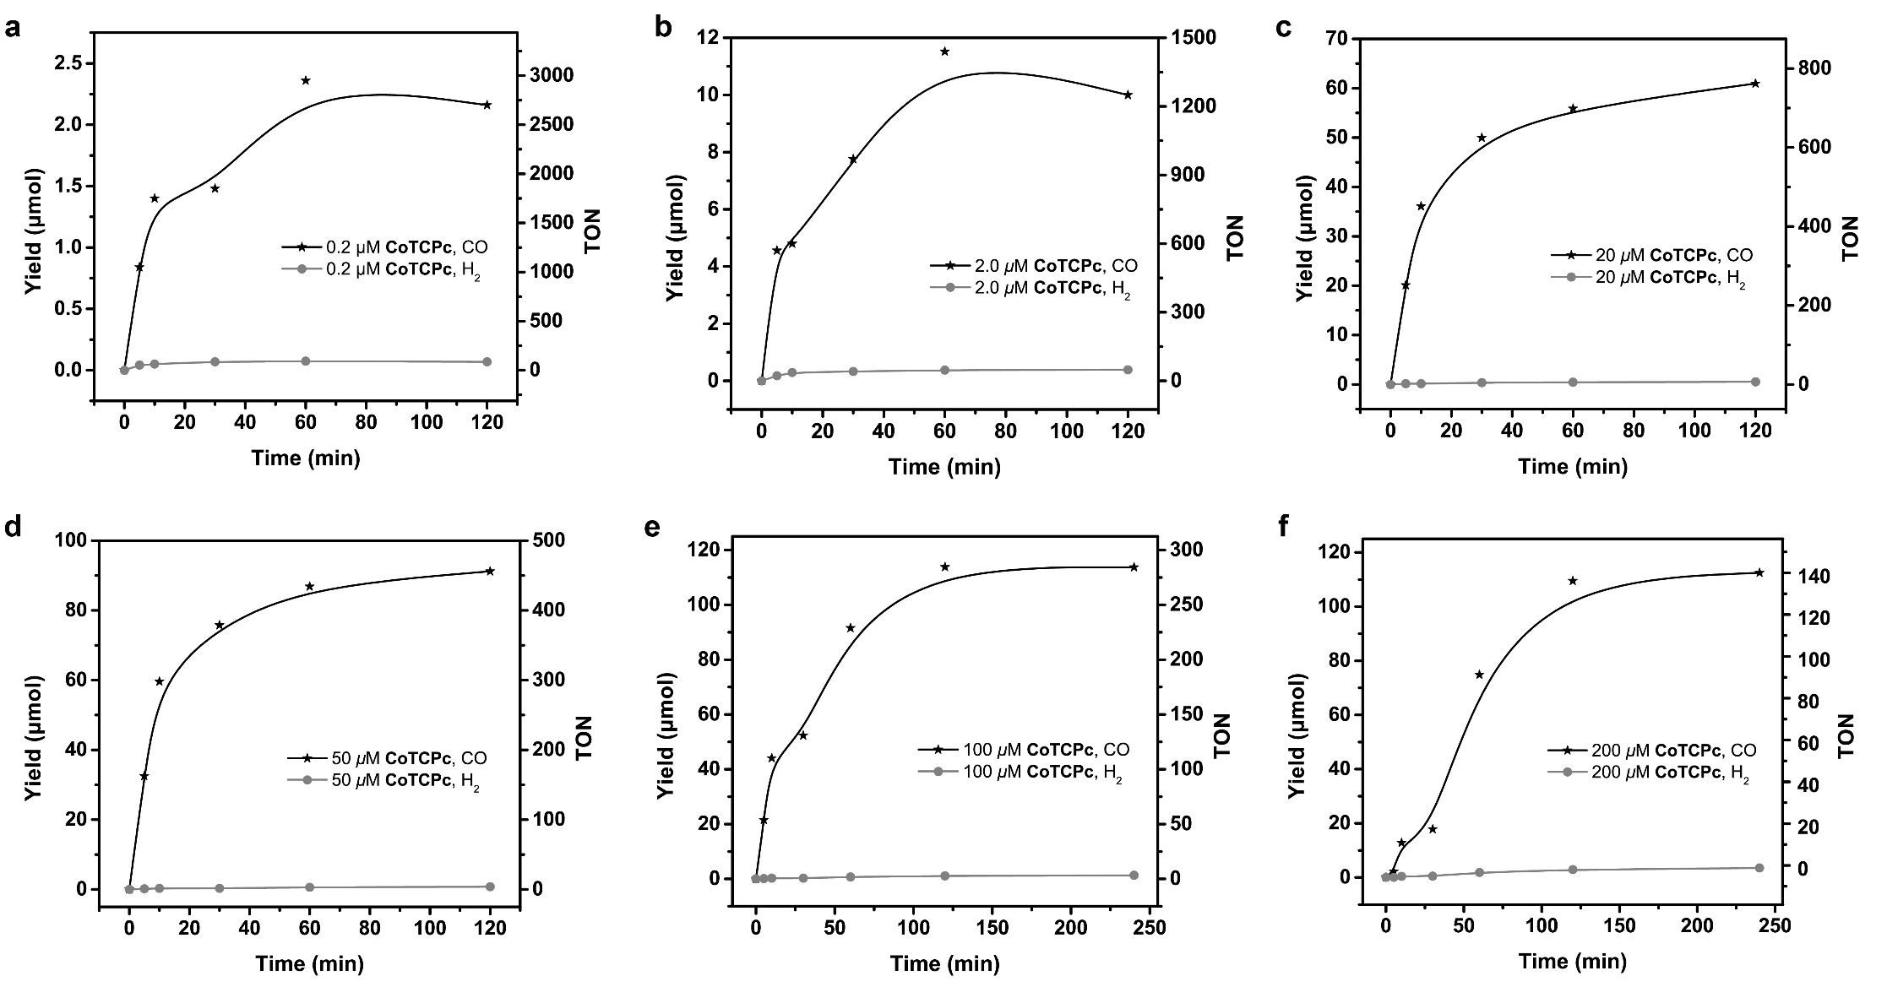
Supplementary Figure 15. Time profiles and TONs of photocatalytic CO and H₂ yields from a mixture of CuBCP (0.5 mM), xantphos ligand (1.0 mM), phenol (5.0 v%), and BIH (20 mM) in 4 mL CH₃CN/TEA (v:v = 5:1) within 1 h of 450-nm LED irradiation under 1 atm CO₂ with the concentration of CoTCPc as (a) 0.2 μM, (b) 2.0 μM, (c) 20 μM, (d) 50 μM, (e) 100 μM or (f) 200 μM.
Supplementary Figure 16. UV-vis spectra of 50 μM CuBCP (magenta), 10 μM CoTCPc (red) and 10 μM BIH (volet) in CH₃CN.

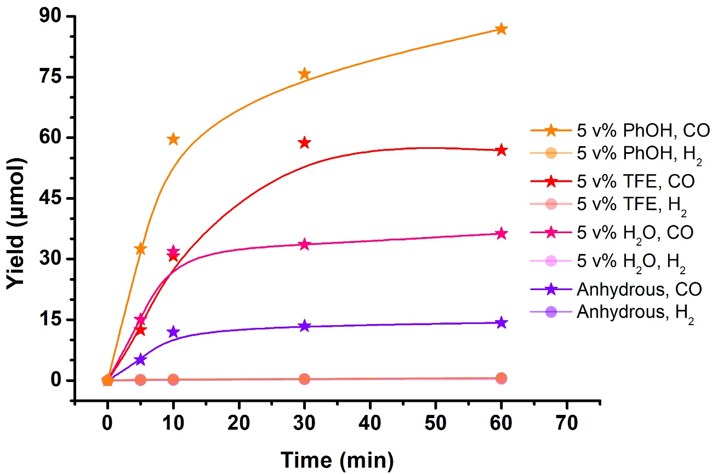
Supplementary Figure 17. Time profiles of photocatalytic CO and H₂ yields from a mixture of CuBCP (0.5 mM), xantphos ligand (1.0 mM), CoTCPc (0.05 mM), and BIH (20 mM) in 4 mL CH₃CN/TEA (v:v = 5:1) under 1 atm CO₂ without proton souce (violet) or with 5.0 v% of phenol (PhOH, orange), TFE (red) or H₂O (pink).
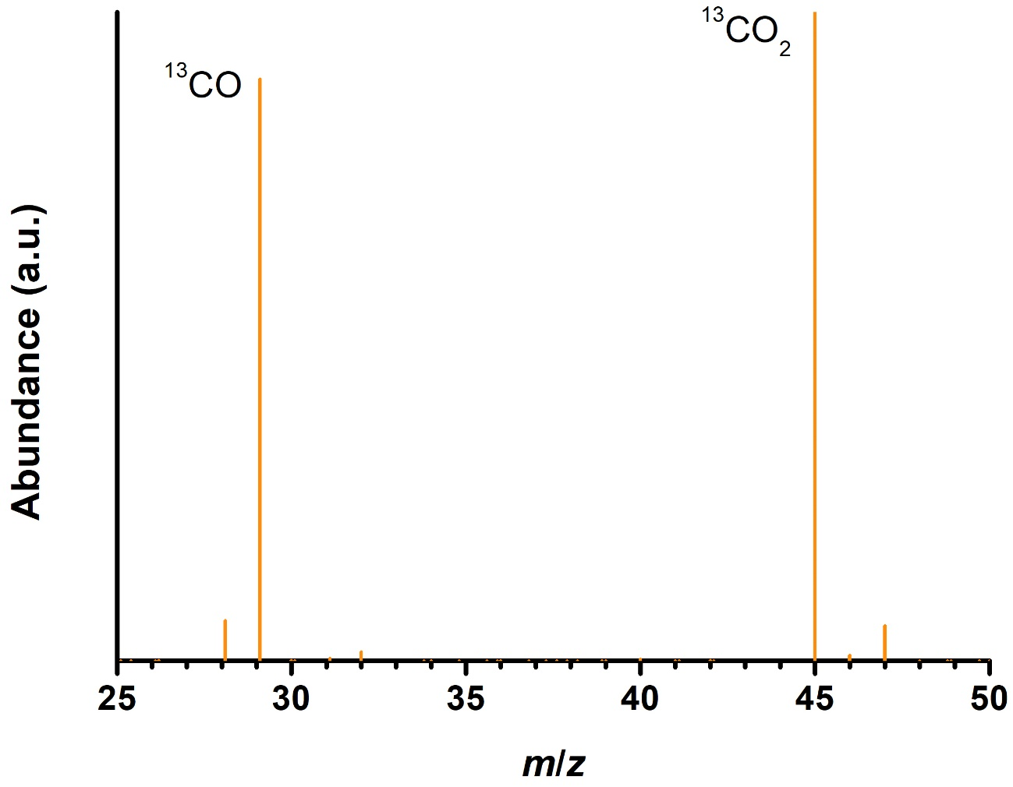
Supplementary Figure 18. Mass spectra analyses via gas chromatography on the generated gas from a mixture of CuBCP (0.5 mM), xantphos ligand (1.0 mM), CoTCPc (0.05 mM), phenol (5.0 v%), and BIH (20 mM) in 4 mL CH₃CN/TEA (v:v = 5:1) within 1 h of 450-nm LED irradiation under 1 atm CO₂.

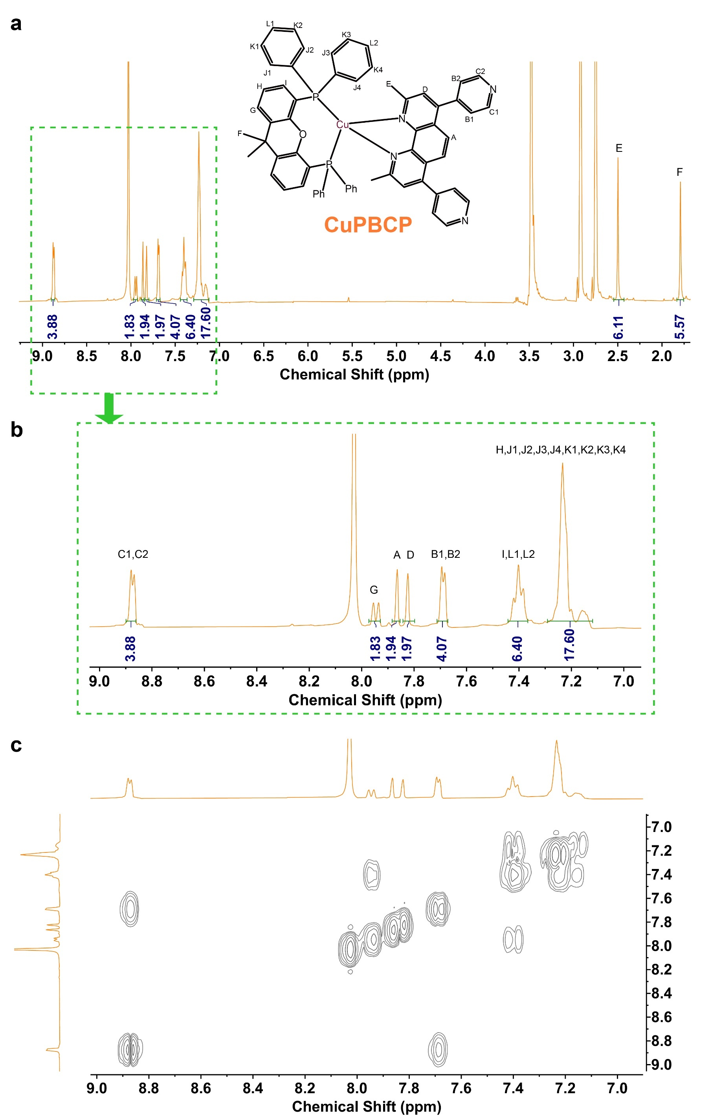
Supplementary Figure 19. (a,b) ¹H and (c) 2D COSY NMR spectra of CuPBCP in d₇-DMF with proton assignments.

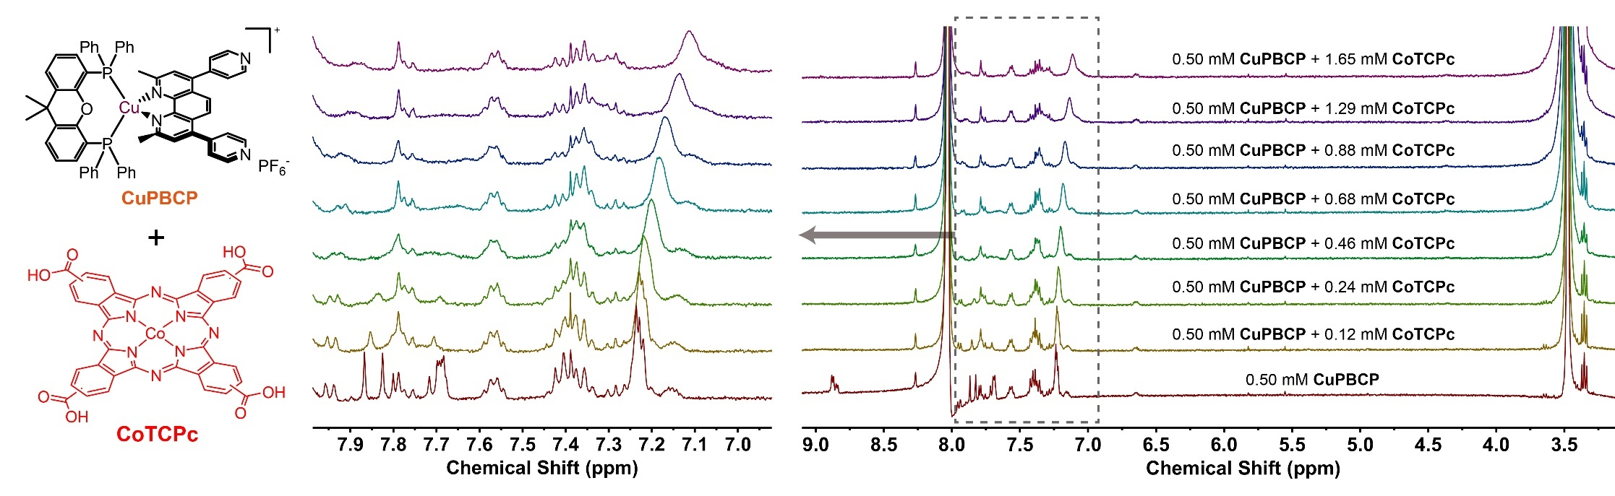
Supplementary Figure 20. ¹H NMR titration of CoTCPc into a 0.50 mM DMF-d₇ solution of CuPBCP.

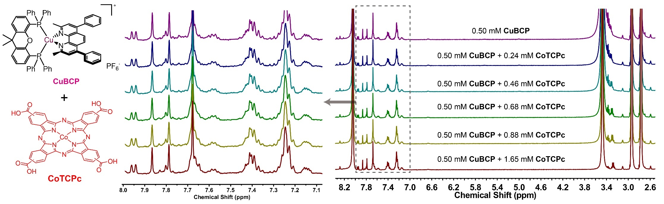
Supplementary Figure 21. ¹H NMR titration of CoTCPc into a 0.50 mM DMF-d₇ solution of CuBCP. The magnified area clearly show that no shift of the aromatic proton signals took place when increasing concentration of CoTCPc was added in the solution of CuBCP, indicative of no interaction.

Supplementary Figure 22. UV-vis spectra of 10 μM CH₃CN solution of CoTCPc in the absence (red) or presence (crimson) of 16.7 v% TEA. The enhanced absorbance and narrowed peak of the Q band indicate the diminished staking of CoTCPc, consistent with the coordination of TEA to isolate each molecule.

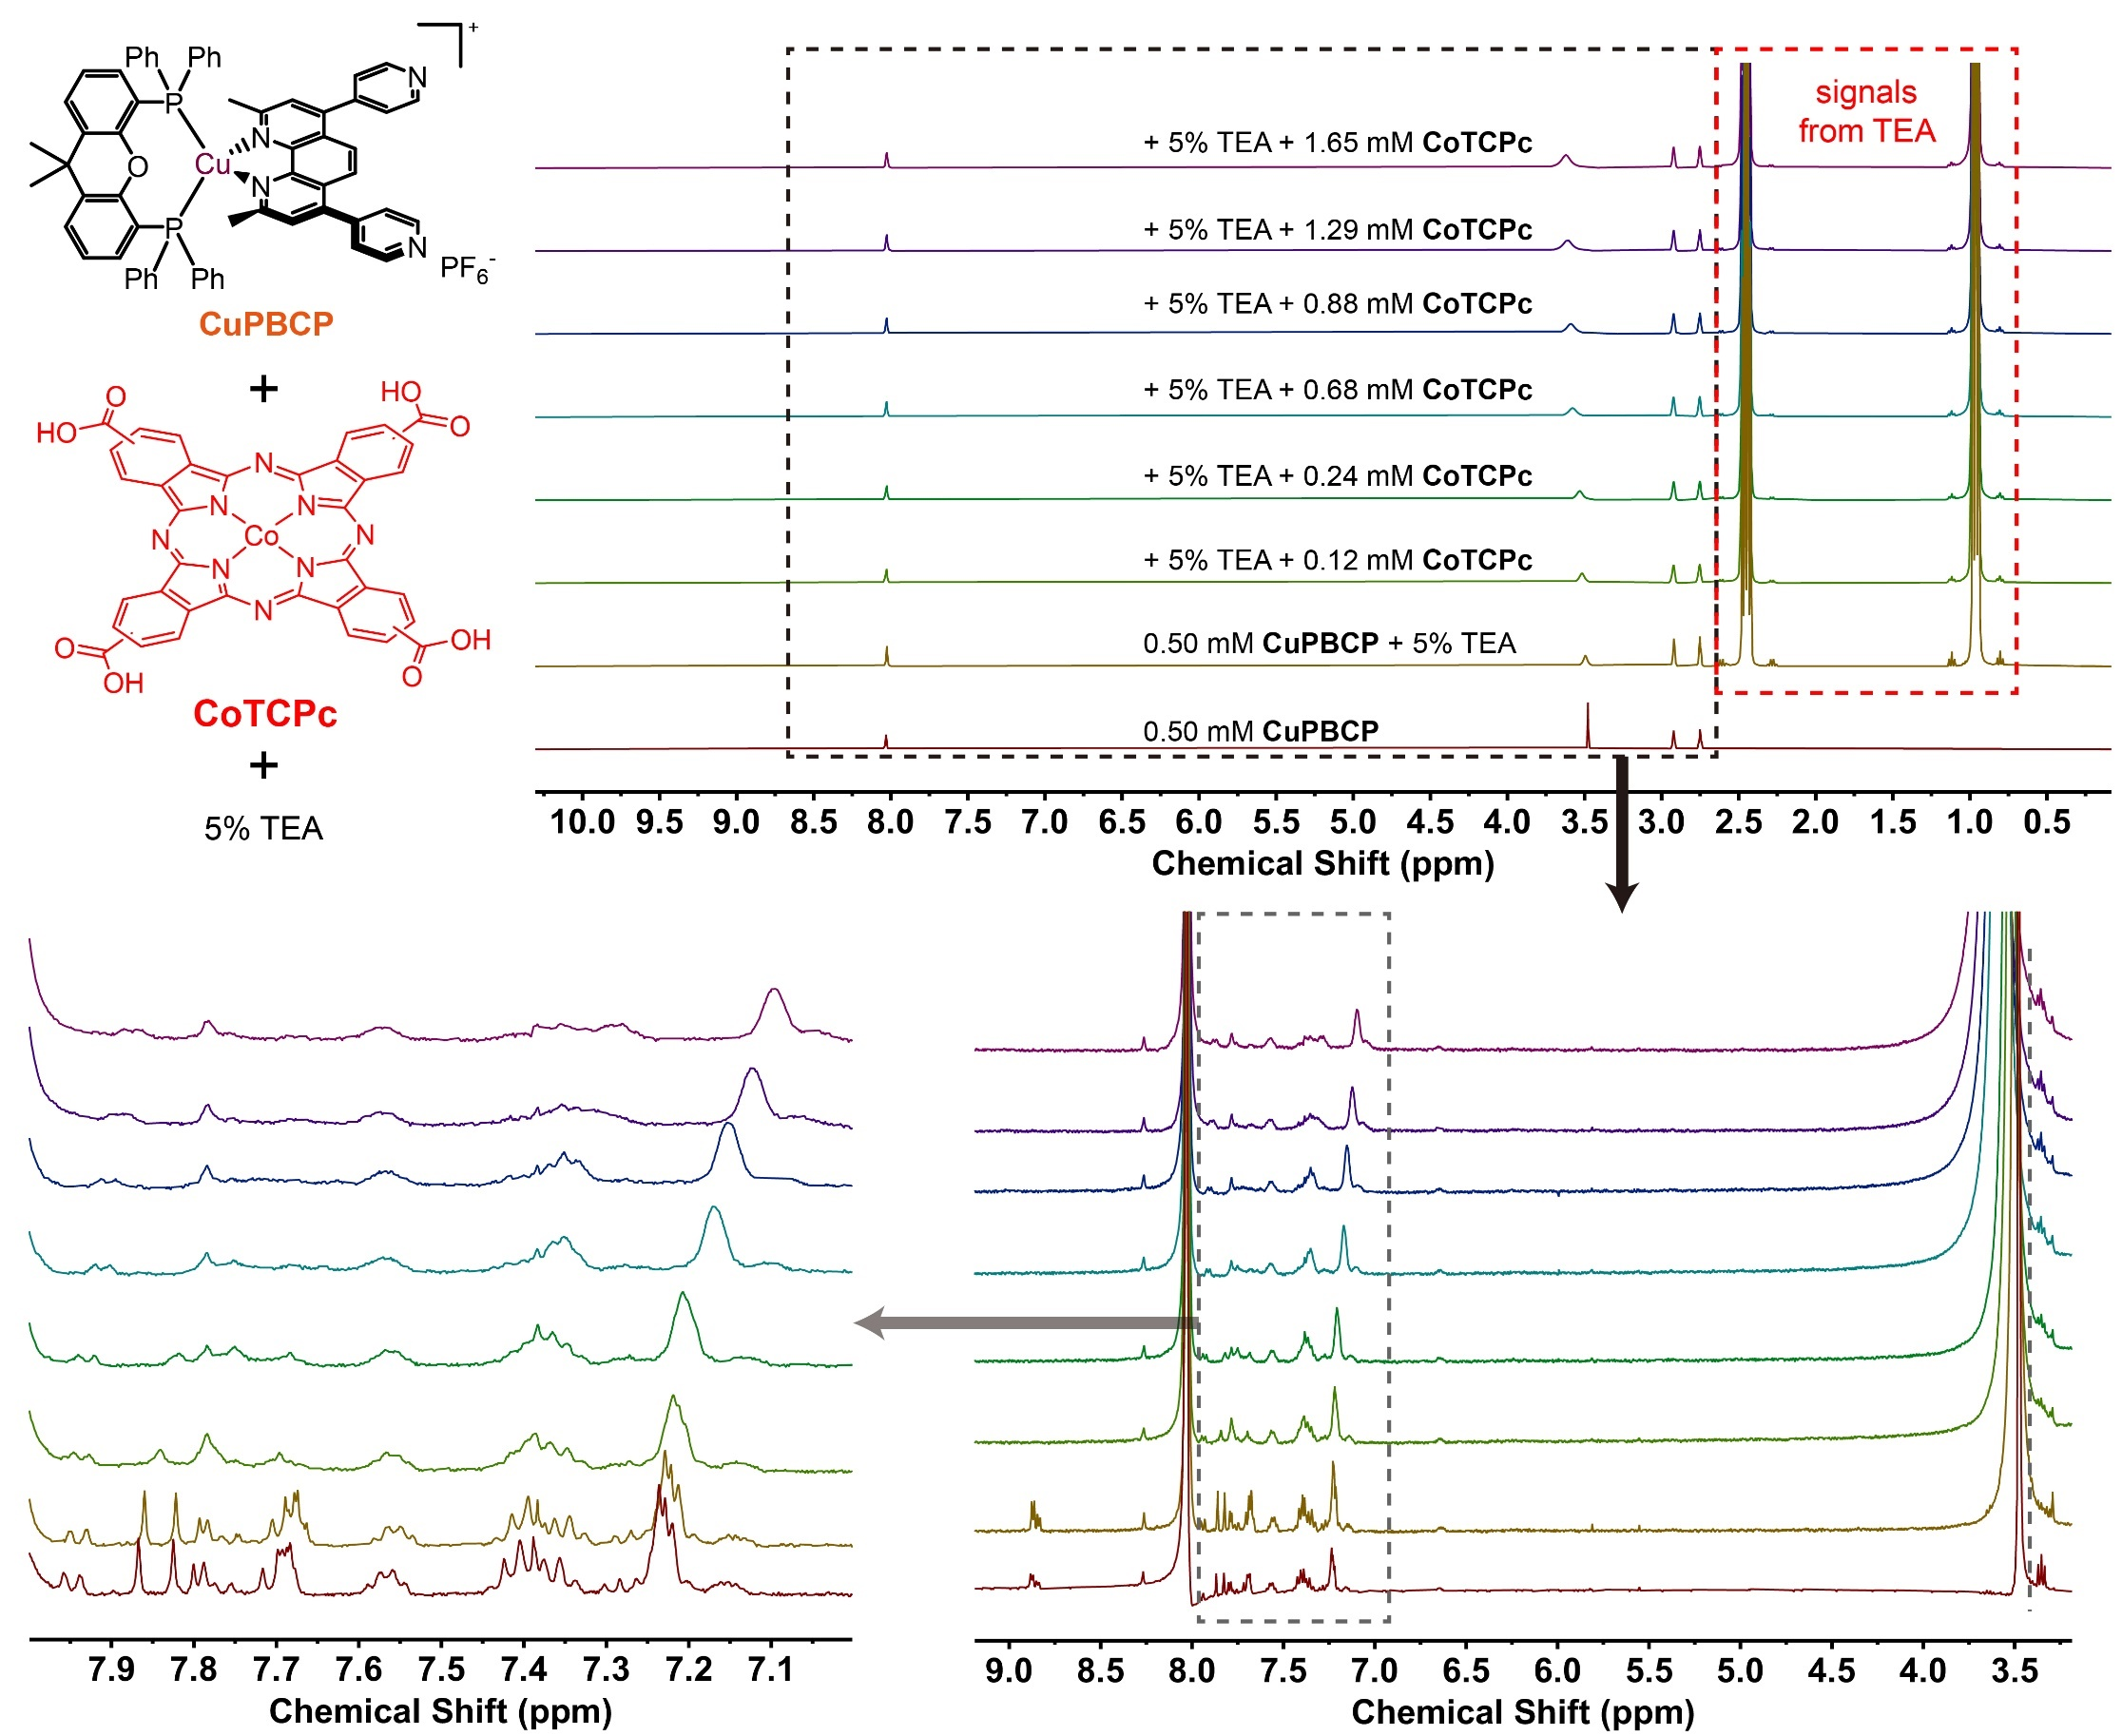
Supplementary Figure 23. ¹H NMR titration of CoTCPc into a 0.50 mM DMF-d₇ solution of CuPBCP in the absence of presence of 5 v% TEA. It should be noted that the addition of TEA volume ratio higher than 5% will enhance the difficulties of shimming during NMR titration, and 5 v% is already excessive to the concentration of guest/host.

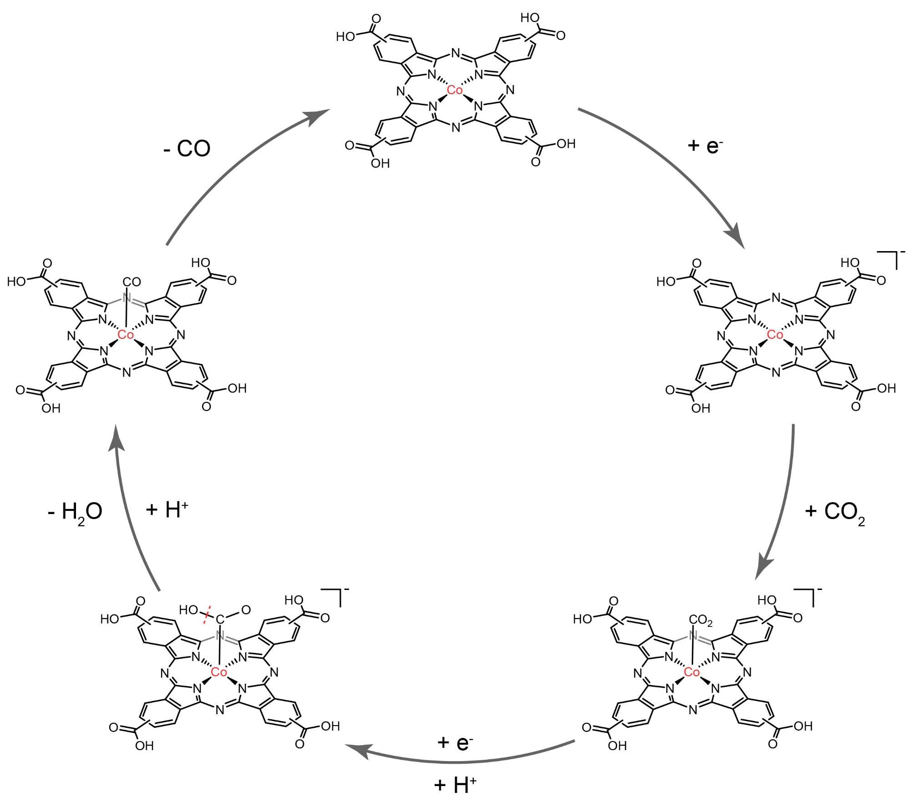
Supplementary Figure 24. Proposed catalytic mechanism of CoTCPc for CO₂ reduction.

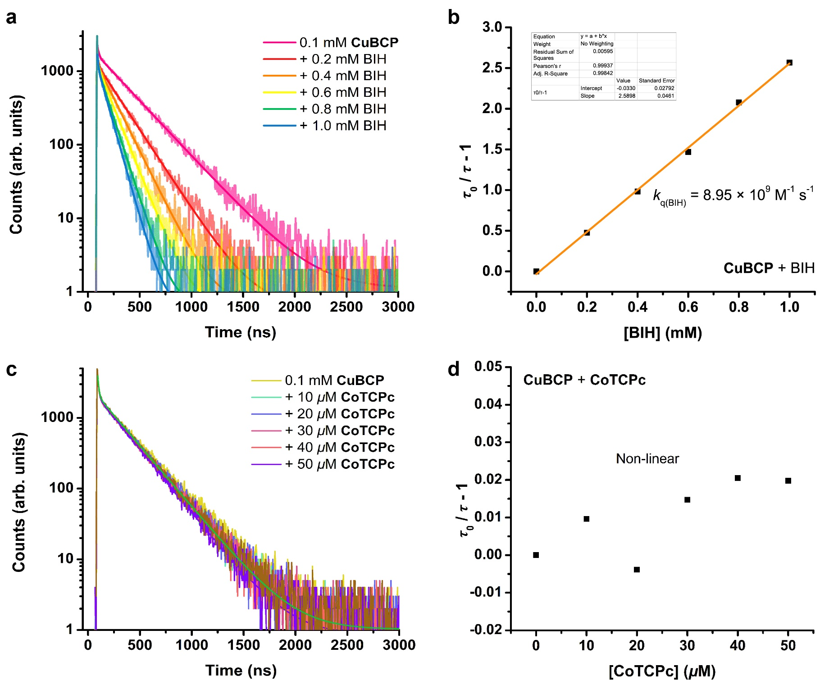
Supplementary Figure 25. Transient fluorescent spectra of a CH₃CN solution containing 0.1 mM CuBCP, in the absence and presence of varying concentrations of quencher (a) BIH or (c) CoTCPc, respectively. Ratio of lifetimes versus (b) [BIH] with linear fitting or (d) [CoTCPc].
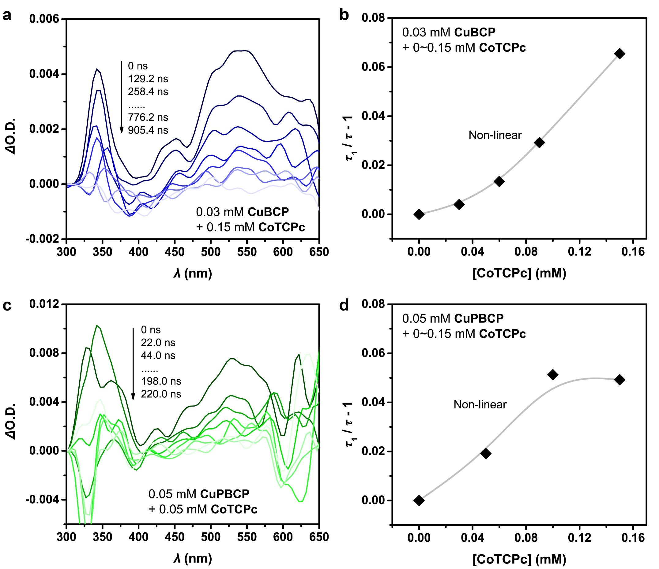
Supplementary Figure 26. Nanosecond TA spectroscopic results of (a,b) CuBCP and (c,d) CuPBCP. (a) TA spectra of 0.03 mM CuBCP with 0.15 mM CoTCPc. (b) Plot of (τ₁ / τ - 1) versus [CoTCPc] with linear fitting for the CuBCP system. or (c) 0.03 mM CuPBCP with 0.05 mM CoTCPc. (d) Plot of (τ₁ / τ - 1) versus [CoTCPc] with linear fitting for the CuPBCP system.

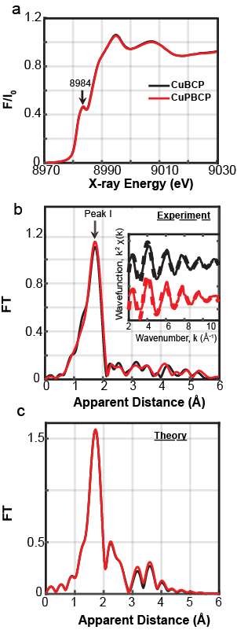
Supplementary Figure 27. (a) Normalized Cu K-edge XANES of CuBCP (black) and CuPBCP (red). (b) Fourier transforms of k²-weighted Cu EXAFS for CuBCP (black) and CuPBCP (red). (c) Simulated EXAFS spectra for CuBCP (black) and CuPBCP (red) using atomic coordinates obtained from DFT simulations.

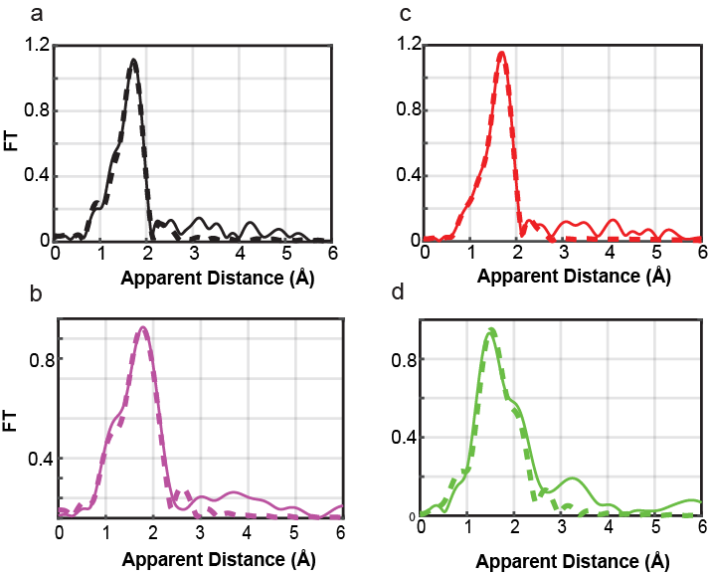
Supplementary Figure 28. Fourier transforms of k²-weighted Cu EXAFS for (a) ground-state CuBCP (solid black line) and its corresponding fit (Fit 2, Supplementary Table 9, dotted black line), (b) reconstructed excited-state CuBCP (solid magenta line) and its corresponding fit (Fit 5, Supplementary Table 9, dashed red line), (c) ground-state CuPBCP (solid red line) and its corresponding fit (Fit 4, Supplementary Table 9, dashed green line) and (d) reconstructed excited-state CuPBCP (solid green line) and its corresponding fit (Fit 6, Supplementary Table 9, dashed blue line).

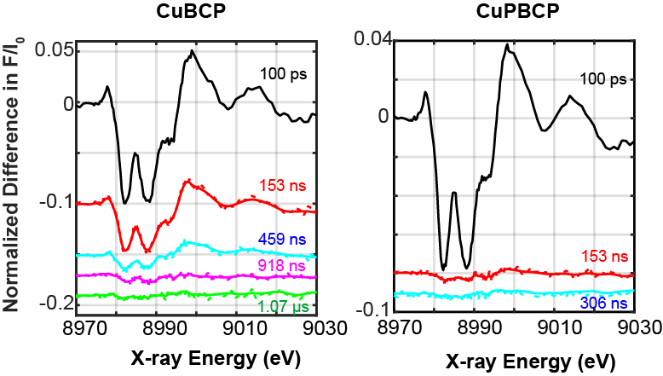
Supplementary Figure 29. Stacked spectra between laser and X-ray pulses for (a) 0.8 mM CuBCP in CH₃CN, at a series of time delays between 100 ps to 1.07 µs and (b) 0.8 mM CuPBCP in CH₃CN between 100 ps to 306 ns. The dotted lines represent the raw data and the solid lines represent smoothened spectra, respectively.

Supporting Tables

Supplementary Table 1. Elemental analysis results of Cu PSs and several CoPc derivatives.
Complexes | Calculated formula | Calculated value (%) |  |  | Measured value (%)
Complexes | Calculated formula | C | H | N | C | H | N
CuBCP | CuC_{65.5}H₅₃F₆N₂P₃OCl (CuBCP·0.5CH₂Cl₂) | 66.11 | 4.49 | 2.35 | 66.45 | 4.44 | 2.18
CuPBCP | CuC₆₃H₅₀F₆N₂P₃OCl (CuPBCP) | 65.82 | 4.38 | 4.87 | 66.01 | 4.42 | 4.96
CuBCP' | CuC₆₂H₄₉F₆N₂P₃O_{1.5} (CuBCP'·0.5H₂O) | 66.70 | 4.42 | 2.51 | 67.24 | 4.37 | 2.53
CuPBCP' | CuC₆₀H₄₆F₆N₄P₃O (CuPBCP') | 64.95 | 4.18 | 5.05 | 65.14 | 4.41 | 5.07
CoTCPc | CoC₃₆H₂₈Cl₂N₈Na₂O₁₄ (CoTCPc·6H₂O·2NaCl) | 44.46 | 2.90 | 11.52 | 44.42 | 3.02 | 11.86
CoTSPc | CoC₃₂H₁₄Cl₂N₈NaO₁₃S₄ (CoTSPc⁴⁻·H₂O·NaCl) | 36.39 | 1.34 | 10.61 | 36.82 | 1.31 | 10.84
CoTDMAPc | C₄₅H₄₇CoI₅N₁₃Na₅O₂ (CoTDMAPc·NMP·H₂O·5NaI) | 33.56 | 2.94 | 11.31 | 33.75 | 2.85 | 11.01

Supplementary Table 2. ¹H NMR results and proton assignments of Cu(I) PSs.
Entry | Compounds | Solvent | Assignments
1 | CuBCP | CD₃CN | ¹H-NMR (CD₃CN, 400 MHz, 25 °C): $δ$ [ppm] =7.77 (d, J = 7.8 Hz, 2H), 7.73 (s, 2H), 7.59 (t, J = 6.5 Hz, 6H), 7.53 (d, J = 8.9 Hz, 6H), 7.33-7.23 (m, 6H), 7.21-7.03 (m, 18H), 2.33 (s, 6H), 1.74 (s, 6H).
2* | CuPBCP | CD₃CN | ¹H-NMR (CD₃CN, 400 MHz, 25 °C): $δ$ [ppm] = 8.82 (dd, 4H, J = 4.4, 1.6, py-H), 7.80 (dd, 2H, J = 7.9, 1.3 Ar-H), 7.69 (s, 2H, phen-H), 7.58 (s, 2H, phen-H), 7.51 (dd, 4H, J = 4.4, 1.6 py-H), 7.35-7.27 (m, 6H, Ar-H), 7.20-7.06 (m, 18H, Ar-H), 2.37 (s, 6H, CH₃), 1.76 (s, 6H, CH₃).
3 | CuBCP' | CD₃CN | ¹H-NMR (CD₃CN, 400 MHz, 25 °C): $δ$ [ppm] =7.79 (s, 2H), 7.61 (d, J = 7.0 Hz, 6H), 7.59-7.53 (m, 6H), 7.43 (dd, J = 17.6, 9.9 Hz, 4H), 7.29 (t, J = 7.4 Hz, 2H), 7.23 (t, J = 6.9 Hz, 4H), 7.13-7.02 (m, 18H), 2.50 (s, 6H).
4* | CuPBCP' | CD₃CN | ¹H-NMR (CD₃CN, 400 MHz, 25 °C): $δ$ [ppm] = 8.81 (d, J = 4.5 Hz, 4H, py-H), 7.73 (s, 2H, phen-H), 7.60 (s, 2H, phen-H), 7.51 (d, J = 4.6 Hz, 4H, py-H), 7.44 (dd, J = 16.8, 8.2 Hz, 4H, Ar-H), 7.30 (t, J = 7.5 Hz, 2H, Ar-H), 7.23 (t, J = 6.8 Hz, 4H, Ar-H), 7.13-6.98 (m, 18H, Ar-H), 2.51 (s, 6H, CH₃).
5 | CuBCP | d₇-DMF | ¹H-NMR (d₇-DMF, 400 MHz, 25 °C): $δ$ [ppm] = 7.93 (d, J = 7.6 Hz, 2H), 7.85 (s, 2H), 7.77 (s, 2H), 7.70-7.61 (m, 10H), 7.39 (t, J = 7.6 Hz, 6H), 7.28-7.18 (m, 16H), 7.16-7.10 (m, 2H), 2.47 (s, 6H), 1.79 (s, 6H).
6* | CuPBCP | d₇-DMF | ¹H-NMR (d₇-DMF,, 400 MHz, 25 °C): $δ$ [ppm] = 8.88 (d, J = 4.6 Hz, 4H, py-H), 7.95 (d, J = 7.8 Hz, 2H, Ar-H), 7.87 (s, 2H, phen-H), 7.83 (s, 2H, phen-H), 7.69 (d, J = 4.5 Hz, 4H, py-H), 7.40 (t, J = 7.2 Hz, 6H, Ar-H), 7.29-7.12 (m, 18H, Ar-H), 2.50 (s, 6H, CH₃), 1.79 (s, 6H, CH₃).
*More detailed assignments have been made with the references of ¹H-¹H 2D NMR correlation spectroscopy (COSY) spectra (Figures S7, S8, and S19).

Supplementary Table 3. Crystallographic data for CuPBCP and CuPBCP'.
Complex | CuPBCP | CuPBCP'·(C₂H₅)₂O·H₂O
Formula | C₆₃H₅₀CuF₆N₄OP₃ | C₆₄H₅₆CuF₆N₄O₃P₃
CCDC number | 2092595 | 2043973
Formula weight | 1149.52 | 1199.57
Crystal system | triclinic | monoclinic
Space group | P-1 | Cc
Z | 2 | 4
a / Å | 11.0218(2) | 24.1468(17)
b / Å | 13.2401(3) | 10.3466(7)
c / Å | 24.7771(9) | 23.3639(16)
α / ° | 97.109(2) | 90
β / ° | 97.344(2) | 102.528(3)
γ / ° | 97.8986(16) | 90
V / Å³ | 3515.07(16) | 5698.2(7)
ρ_{calcd} / g m⁻³ | 1.086 | 1.398
μ / mm⁻¹ | 1.524 | 0.538
Crystal size / mm | 0.25 × 0.18 × 0.12 | 0.18 × 0.15 × 0.12
2Θ range for data collection / ° | 6.81 / 145.86 | 3.456 / 54.36
Reflns collected / Independent | 25680 / 13644 | 41445 / 12330
R_{int} | 0.0361 | 0.0543
Parameters refined | 711 | 737
F(000) | 1184.0 | 2480.0
GOF on F² | 1.020 | 1.115
Final R indices [I > 2sigma(I)] | R₁ª = 0.0650  wR₂^{b} = 0.1736 | R₁ª = 0.0967  wR₂^{b} = 0.2593
R indices (all data) | R₁ = 0.0720  wR₂ = 0.1804 | R₁ = 0.1123  wR₂ = 0.2781
Largest diff. peak and hole / e Å⁻³ | 1.79 / -0.45 | 0.88 / -2.03
ªR₁ = ∑||F₀| - |F_{c}||/∑F₀. ^{b}wR₂ = {[∑(F₀²-F_{c}²)/∑w (F₀²)²]}^{1/2}, w = 1/[s²(F_{o}²) + (0.2000P)² + 0.0000P]; where P = (F_{o}² + 2F_{c}²)/3

Supplementary Table 4. Measured geometrical, photophysical and redox properties of Cu(I) PSs in deareated CH₃CN.ª
Cu PS | Dihedral angle (°) | λ_{em} (nm) | λ_{ab} (nm) | ε₄₅₀ (M⁻¹ cm⁻²) | Φ_{em}^{b} | τ^{b} (ns) | E_{red} (V) | E_{ox} (V) | Isosbestic  point (nm) | E₀₋₀ (V) | E_{q, red} (V) | E_{q, ox} (V)
CuBCP | 95.0 | 580 | 388 | 766 | 0.58% | 280.0 ns  τ₁ = 12.4 ns, 2%  τ₂ = 285.4 ns, 98% | -1.36 | 0.86 | 460 | 2.70 | 1.34 | -1.84
CuPBCP | 94.2 | 550 | 395 | 885 | 0.23% | 74.2 ns  τ₁ = 2.8 ns, 28%  τ₂ = 38.6 ns, 50%  τ₃ = 240.5 ns, 22% | -1.37 | 0.92 | 430 | 2.88 | 1.51 | -1.96
CuBCP' | 91.3 | 620 | 393 | 608 | 0.60% | 256.8 ns  τ₁ = 2.9 ns, 2%  τ₂ = 257.9 ns, 98% | -1.38 | 0.95 | 469 | 2.64 | 1.26 | -1.69
CuPBCP' | 89.3 | 591 | 385 | 809 | 0.44% | 63.8 ns  τ₁ = 3.1 ns, 34%  τ₂ = 32.2 ns, 44%  τ₃ = 220.4 ns, 22% | -1.40 | 0.92, 0.99 | 475 | 2.61 | 1.21 | -1.69
[a] Potentials are versus Fc^{+/0}.
[b] Excitation wavelength is 450 nm.

Supplementary Table 5. Photocatalytic CO₂ reduction to CO by CuBCP/CoTCPc in the absence of certain component.*
Entry | Conditions | n(CO) (μmol) | n(H₂) (μmol)
1 | No CoTCPc | N.D. | 1.20±0.40
2 | No CuBCP | N.D. | N.D.
3 | Under N₂ instead of CO₂ | N.D. | N.D.
4 | No irradiation | N.D. | N.D.
5 | No BIH | 0.60±0.10 | 1.10±0.20
*Standard condition: CuBCP (0.5 mM), xantphos ligand (1.0 mM), CoTCPc (0.05 mM), phenol (5.0 v%), and BIH (20 mM) in 4 mL CH₃CN/TEA (v:v = 5:1) within 1 h of 450-nm LED irradiation under 1 atm CO₂.

Supplementary Table 6. Bindfit results for CuPBCP/CoTCPc.
Host:Guest Model | Flavor | Applicable? Y/N | K (M⁻¹) | K error (%) | Total root mean square | Total covariance | Optimal model*
1:1 | None | N | N.A.
1:2 | None | Y | K₁₁ = 7069  K₁₂ = 754 | ±76.8  ±12.4 | 0.00106 | 0.00105
1:2 | Non-cooperative | Y | K₁₁ = 3795 | ±3.1 | 0.00107 | 0.00106 | √
2:1 | None | N | N.A.
2:1 | Non-cooperative | Y | K₁₁ = 911 | ±8.5 | 0.00109 | 0.00111
*Three models are applicable with the fitted data. Considering the K errors to be within ±10%, the non-cooperative 1:2 and non-cooperative 2:1 models are more reasonable. By comparison, with the smaller total root mean square, total covariance and K error, the non-cooperative 1:2 binding model should be the optimal model to afford the 1:1 binding constant (K₁₁) of 3795±118 M⁻¹.

Supplementary Table 7. Bindfit results for CuPBCP/CoTCPc/TEA.
Host:Guest Model | Flavor | Applicable? Y/N | K (M⁻¹) | K error (%) | Total root mean square | Total covariance | Optimal model*
1:1 | None | N | N.A.
1:2 | None | Y | K₁₁ = 210638  K₁₂ = 196 | ±1498.3  ±9.6 | 0.00118 | 0.00100
1:2 | Non-cooperative | Y | K₁₁ = 1611 | ±2.8 | 0.00120 | 0.00103 | √
2:1 | None | N | N.A.
2:1 | Non-cooperative | Y | K₁₁ = 530 | ±11.7 | 0.00119 | 0.00102
*Three models are applicable with the fitted data. Considering the K errors to be within ±10%, the non-cooperative 1:2 model is considered as the optimal model to afford the 1:1 binding constant (K₁₁) of 1611±45 M⁻¹.

Supplementary Table 8. The optimized structures and Gibbs free energies of *COOH and *CO intermediates from the CoPc families. The white, gray, blue, red, yellow and pink colors denote H, C, N, O, S and Co atoms.
Complexes | *COOH species | ΔG(*COOH) (eV) | *CO species | ΔG(*CO) (eV)
CoTSPc | 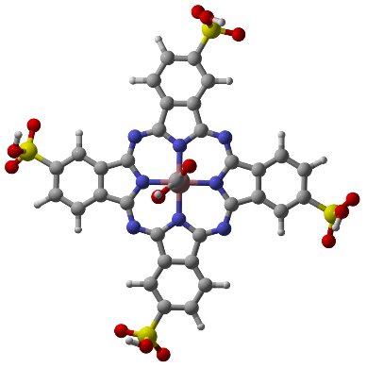  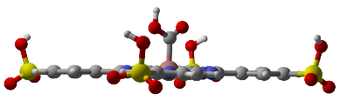 | 1.123817 | 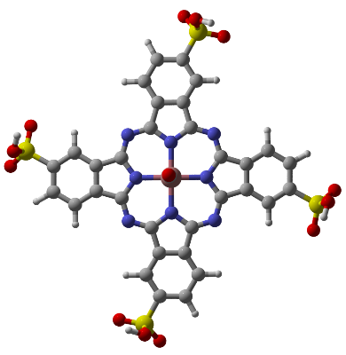  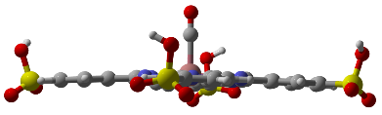 | -0.11355
CoTCPc | 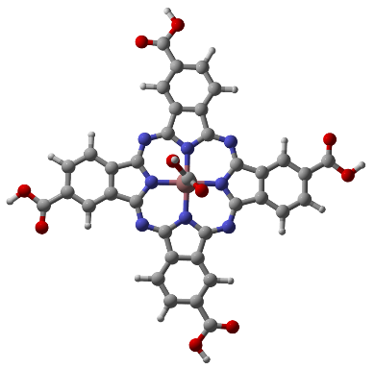  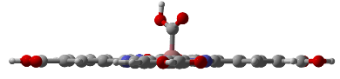 | 1.126483 | 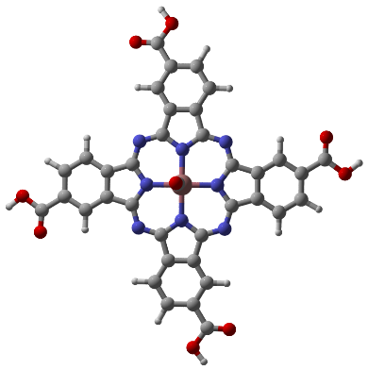  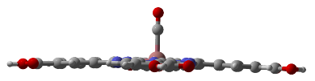 | -0.11021
CoPc | 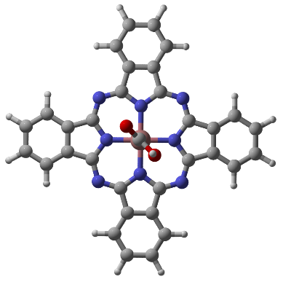  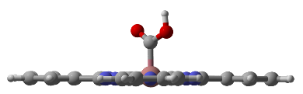 | 1.129477 | 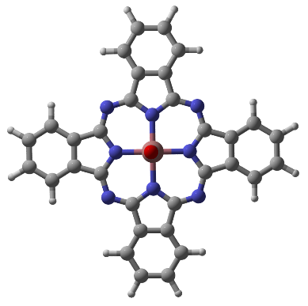  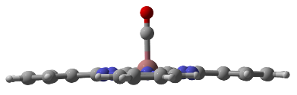 | -0.11377
CoTAPc | 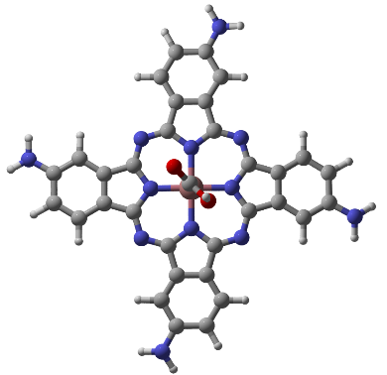  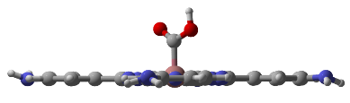 | 1.111136 | 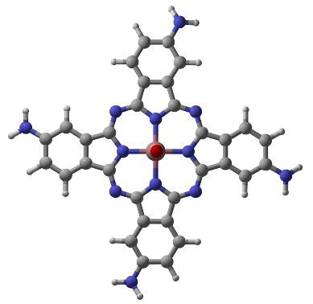  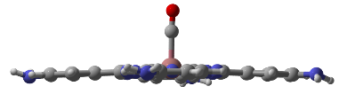 | -0.13034
CoTDMAPc | 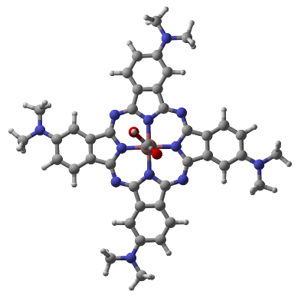  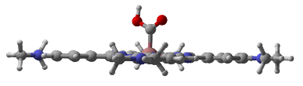 | 1.10349 | 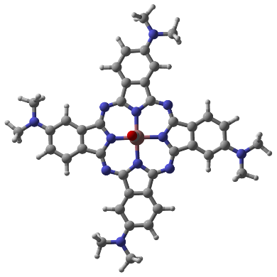  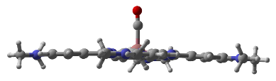 | -0.18819
Supplementary Table 9. Overview of the applied EXAFS fit parameters.
Sample | Fit | Shell, N | R, Å | E₀ | ss.²  (10⁻³) | R-factor | Reduced  Chi-square
CuBCP | 1 | Cu-N/P, 4 | 2.11 | 11.0 | 5.2 | 0.0262 | 711
CuBCP | 2 | Cu-N, 2  Cu-P, 2 | 2.08  2.30 | 3.8 | 4.4  8.9 | 0.0026 | 112
CuPBCP | 3 | Cu-N/P, 4 | 2.12 | 11.8 | 4.8 | 0.0325 | 1971
CuPBCP | 4 | Cu-N, 2  Cu-P, 2 | 2.09  2.30 | 4.2 | 4.5  7.6 | 0.0006 | 48
Reconstructed CuBCP | 5 | Cu-N, 2  Cu-P, 2 | 2.01  2.39 | 5.9 | 9.6  5.7 | 0.0076 | 20
Reconstructed CuPBCP | 6 | Cu-N, 2  Cu-P, 2 | 1.99  2.43 | 5.8 | 1.4  11.1 | 0.0273 | 215
*The fit was carried out between 1/1.3 - 3 Å, in apparent distance scale for the ground and reconstructed laser on states. The reconstructed excited states of CuBCP and CuPBCP correspond to the subtraction of the EXAFS data of the “Laser on” states from the ground/ “Laser off” states. CuBCP and CuPBCP show a proportion of excited states of ~35% and 27%, respectively, as described in the main text. 65% and 73% of the ground-state EXAFS spectra were subtracted accordingly from the “Laser on” states of CuBCP and CuPBCP, respectively, to gain their reconstructed excited states.

Supplementary Table 10. Stick figures of XRD and DFT calculated structures calculated in gas phase.
XRD stick figures | DFT stick figures
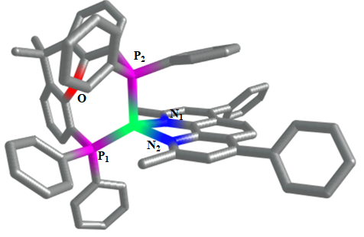  CuBCP | 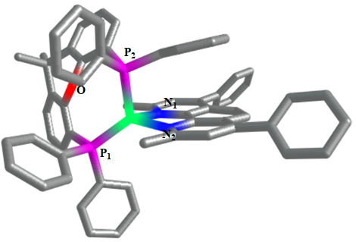  CuBCP
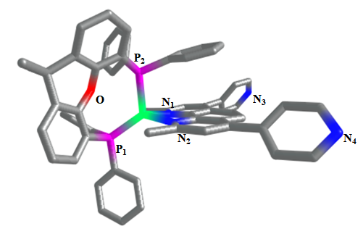  CuPBCP | 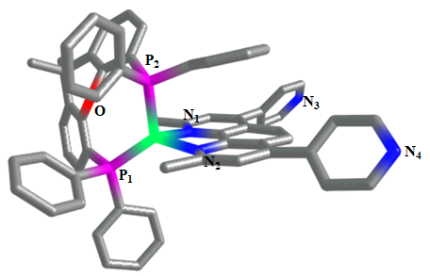  CuPBCP

Supplementary Table 11. Comparison of the solid-state XRD measurements with DFT optimized coordinates using the BP-86 functional and def2-TZVP triple-zeta basis sets, together with atom-pairwise Grimme dispersion correction with D3BJ in gas phase.

Heteroleptic [(P^P)  Cu(N^N)]PF₆ | XRD  CuBCP | XRD  CuPBCP | DFT  ground-state  CuBCP | DFT  ground-state  CuPBCP
Cu-N₁ | 2.06416 | 2.10718 | 2.06540 | 2.06662
Cu-N₂ | 2.09832 | 2.08182 | 2.06857 | 2.07029
Cu-P₁ | 2.24247 | 2.24416 | 2.22856 | 2.23100
Cu-P₂ | 2.30480 | 2.30179 | 2.26153 | 2.26250
Cu-O | 3.20538 | 3.20754 | 3.16865 | 3.16493
Cu-N₃ | N.A. | 9.13659 | N.A. | 9.15401
Cu-N₄ | N.A. | 9.15058 | N.A. | 9.13441
N₁-Cu-N₂ | 80.423 | 79.917 | 81.209 | 81.149
P₁-Cu-P₂ | 119.680 | 119.357 | 119.183 | 119.242
Torsional Angle | 85.0063° | 85.7550° | 86.3227° | 86.2064°

Supplementary Table 12. Stick figures of CuBCP’s and CuPBCP’s ground- and excited-state structures in solution.
Ground-state DFT stick figures | Excited-state DFT stick figures
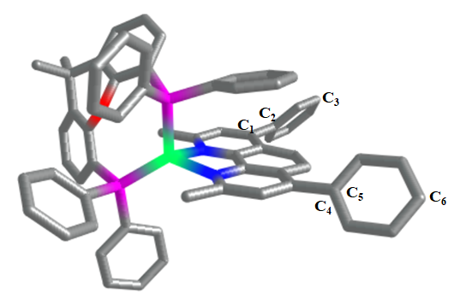  CuBCP  C₁-C₂-C₃: 178.247°  C₄-C₅-C₆: 178.066° | 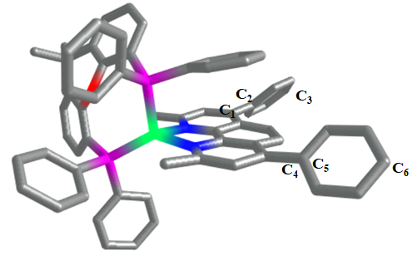  CuBCP  C₁-C₂-C₃: 178.130°  ΔC₁-C₂-C₃: -0.117°  C₄-C₅-C₆: 177.906°  ΔC₄-C₅-C₆: -0.160°
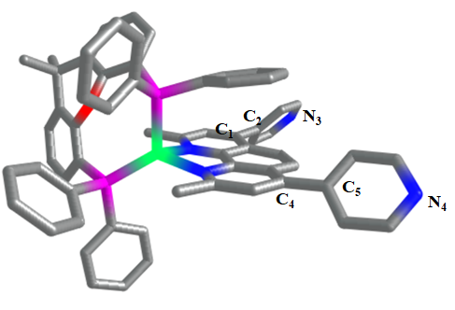  CuPBCP  C₁-C₂-N₃: 178.370°  C₄-C₅-N₄: 178.109° | 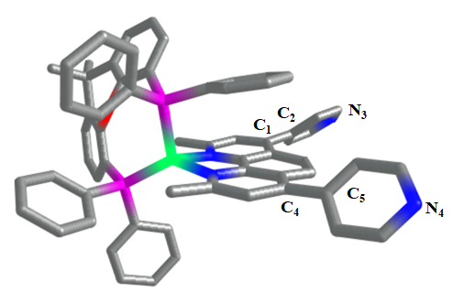  CuPBCP  C₁-C₂-N₃: 177.641°  ΔC₁-C₂-N₃: -0.729°  C₁-C₂-N₃: 177.880°  ΔC₁-C₂-N₃:-0.229°

Reference:
1. DiSalle, B. F. & Bernhard, S. Orchestrated photocatalytic water reduction using surface-adsorbing iridium photosensitizers. J. Am. Chem. Soc. 133, 11819-11821 (2011).
2. Zhu, X. Q., Zhang, M. T., Yu, A., Wang, C. H. & Cheng, J. P. Hydride, hydrogen atom, proton, and electron transfer driving forces of various five-membered heterocyclic organic hydrides and their reaction intermediates in acetonitrile. J. Am. Chem. Soc. 130, 2501-2516 (2008).
3. Weber, J. H. & Busch, D. H. Complexes derived from strong field ligands. Xix. Magnetic properties of transition metal derivatives of 4,4',4",4'''-tetrasulfophthalocyanine. Inorg. Chem. 4, 469-471 (1965).
4. Kobayashi, N. & Nishiyama, Y. Catalytic electroreduction of molecular oxygen using iron or cobalt 4,4',4",4'"-tetracarboxyphthalocyanine. J. Phys. Chem. 89, 1167-1170 (1985).
5. Kumar, A., Prajapati, P. K., Aathira, M. S., Bansiwal, A., Boukherroub, R. & Jain, S. L. Highly improved photoreduction of carbon dioxide to methanol using cobalt phthalocyanine grafted to graphitic carbon nitride as photocatalyst under visible light irradiation. J. Colloid Interface Sci. 543, 201-213 (2019).
6. Li, C., et al. A phenanthroline derivative as exciton blocking material for organic solar cells. Dyes Pigm. 97, 258-261 (2013).
7. Luo, S. P., et al. Photocatalytic water reduction with copper-based photosensitizers: A noble-metal-free system. Angew. Chem. Int. Ed. 52, 419-423 (2013).
8. Adamo, C. & Barone, V. Toward reliable density functional methods without adjustable parameters: The PBE0 model. J. Chem. Phys. 110, 6158-6170 (1999).
9. Goerigk, L. & Grimme, S. Efficient and accurate double-hybrid-meta-gga density functionals-evaluation with the extended gmtkn30 database for general main group thermochemistry, kinetics, and noncovalent interactions. J. Chem. Theory Comput. 7, 291-309 (2011).
10. Frisch, M. J., et al. Gaussian 09, Revision C.01 (Gaussian, Inc., 2009)
11. Hirshfeld, F. L. Bonded-atom fragments for describing molecular charge densities. Theor. Chim. Acta 44, 129-138 (1977).
12. Lu, T. & Chen, F. Multiwfn: A multifunctional wavefunction analyzer. J. Comput. Chem. 33, 580-592 (2012).
13. Sheldrick, G. M. A short history of SHELX. Acta Crystallogr., Sect. A: Found. Crystallogr. 64, 112-122 (2008).
14. Bindfit. (ed^(eds). v0.5 edn.
15. Thordarson, P. Determining association constants from titration experiments in supramolecular chemistry. Chem. Soc. Rev. 40, 1305-1323 (2011).
16. Wang, J. W., Jiang, L., Huang, H. H., Han, Z. & Ouyang, G. Rapid electron transfer via dynamic coordinative interaction boosts quantum efficiency for photocatalytic CO₂ reduction. Nat. Commun. 12, 4276 (2021).
17. Li, H., Li, F., Zhang, B., Zhou, X., Yu, F. & Sun, L. Visible light-driven water oxidation promoted by host-guest interaction between photosensitizer and catalyst with a high quantum efficiency. J. Am. Chem. Soc. 137, 4332-4335 (2015).
18. Kuhn, H., Braslavsky, S. & Schmidt, R. Chemical actinometry (IUPAC technical report). Pure Appl. Chem. 76, 2105-2146 (2004).
19. Thoi, V. S., Kornienko, N., Margarit, C. G., Yang, P. & Chang, C. J. Visible-light photoredox catalysis: Selective reduction of carbon dioxide to carbon monoxide by a nickel N-heterocyclic carbene-isoquinoline complex. J. Am. Chem. Soc. 135, 14413-14424 (2013).
20. Wang, P., et al. A broadband and strong visible-light-absorbing photosensitizer boosts hydrogen evolution. Nat. Commun. 10, 3155 (2019).
21. Ravel, B. & Newville, M. Athena, artemis, hephaestus: Data analysis for X-ray absorption spectroscopy using ifeffit. J. Synchrot. Radiat. 12, 537-541 (2005).
22. Rehr, J. J., Albers, R. C. & Zabinsky, S. I. High-order multiple scattering calculations of X-ray-absorption fine structure. Phys. Rev. Lett. 69, 3397-3400 (1992).
23. Koningsberger, D. C. & Prins, R. X-ray absorption: Principles, applications, techniques of EXAFS, SEXAFS and XANES. John Wiley & Sons (1988).
24. Chen, L. X. & Zhang, X. Photochemical processes revealed by X-ray transient absorption spectroscopy. J. Phys. Chem. Lett. 4, 4000-4013 (2013).
25. Neese, F. The ORCA program system. Wiley Interdisciplinary Reviews: Computational Molecular Science 2, 73-78 (2012).
26. Perdew, J. P. Density-functional approximation for the correlation energy of the inhomogeneous electron gas. Phys. Rev. B 33, 8822-8824 (1986).
27. Becke, A. D. Density-functional exchange-energy approximation with correct asymptotic behavior. Phys. Rev. A Gen. Phys. 38, 3098-3100 (1988).
28. Weigend, F. & Ahlrichs, R. Balanced basis sets of split valence, triple zeta valence and quadruple zeta valence quality for h to rn: Design and assessment of accuracy. Phys. Chem. Chem. Phys. 7, 3297-3305 (2005).
29. Grimme, S., Ehrlich, S. & Goerigk, L. Effect of the damping function in dispersion corrected density functional theory. J. Comput. Chem. 32, 1456-1465 (2011).
30. Grimme, S., Antony, J., Ehrlich, S. & Krieg, H. A consistent and accurate ab initio parametrization of density functional dispersion correction (DFT-D) for the 94 elements h-pu. J Chem Phys 132, 154104 (2010).
31. Mennucci, B. & Tomasi, J. Continuum solvation models: A new approach to the problem of solute’s charge distribution and cavity boundaries. J. Chem. Phys. 106, 5151-5158 (1997).
32. Stephens, P. J., Devlin, F. J., Chabalowski, C. F. & Frisch, M. J. Ab initio calculation of vibrational absorption and circular dichroism spectra using density functional force fields. J. Phys. Chem. 98, 11623-11627 (1994).
33. Becke, A. D. Density‐functional thermochemistry. iii. The role of exact exchange. J. Chem. Phys. 98, 5648-5652 (1993).
34. Eichkorn, K., Treutler, O., Öhm, H., Häser, M. & Ahlrichs, R. J. C. P. Auxiliary basis sets to approximate coulomb potentials. Chem. Phys. 242, 652 (1995).
35. Weigend, F. Accurate coulomb-fitting basis sets for H to R_{n}. Phys. Chem. Chem. Phys. 8, 1057-1065 (2006).
36. Kossmann, S. & Neese, F. Efficient structure optimization with second-order many-body perturbation theory: The rijcosx-mp2 method. J. Chem. Theory Comput. 6, 2325-2338 (2010).

Appendix I: DFT calculation data on CoPc and its derivatives
The Hirshfeld atomic charges (e) of studied molecules. The number denotes the atomic labels.
Molecules | Atoms | Charge | Atoms | Charge
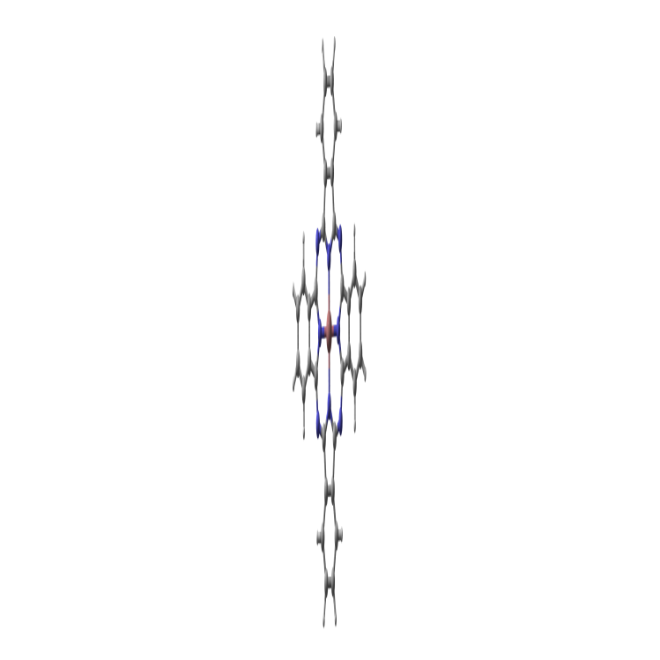  CoPc | C1 | -0.0282 | C29 | -0.0223
 | C2 | -0.0352 | C30 | -0.0282
 | C3 | -0.0351 | C31 | -0.0352
 | C4 | -0.0282 | C32 | -0.0352
 | C5 | -0.0223 | C33 | -0.0282
 | C6 | 0.1020 | C34 | -0.0223
 | N7 | -0.1533 | C35 | 0.1019
 | C8 | 0.1020 | N36 | -0.1178
 | C9 | -0.0223 | N37 | -0.1532
 | C10 | -0.0282 | C38 | 0.1020
 | C11 | -0.0352 | N39 | -0.1178
 | C12 | -0.0351 | C40 | -0.0223
 | C13 | -0.0282 | H41 | 0.0493
 | C14 | -0.0223 | H42 | 0.0446
 | C15 | 0.1020 | H43 | 0.0446
 | N16 | -0.1179 | H44 | 0.0493
 | N17 | -0.1531 | H45 | 0.0492
 | C18 | 0.1019 | H46 | 0.0446
 | C19 | -0.0223 | H47 | 0.0446
 | C20 | -0.0282 | H48 | 0.0492
 | C21 | -0.0352 | H49 | 0.0492
 | C22 | -0.0352 | H50 | 0.0446
 | C23 | -0.0282 | H51 | 0.0446
 | C24 | -0.0223 | H52 | 0.0492
 | C25 | 0.1019 | H53 | 0.0492
 | N26 | -0.1178 | H54 | 0.0446
 | N27 | -0.1532 | H55 | 0.0446
 | C28 | 0.1019 | H56 | 0.0492
 |  |  | Co57 | 0.2038
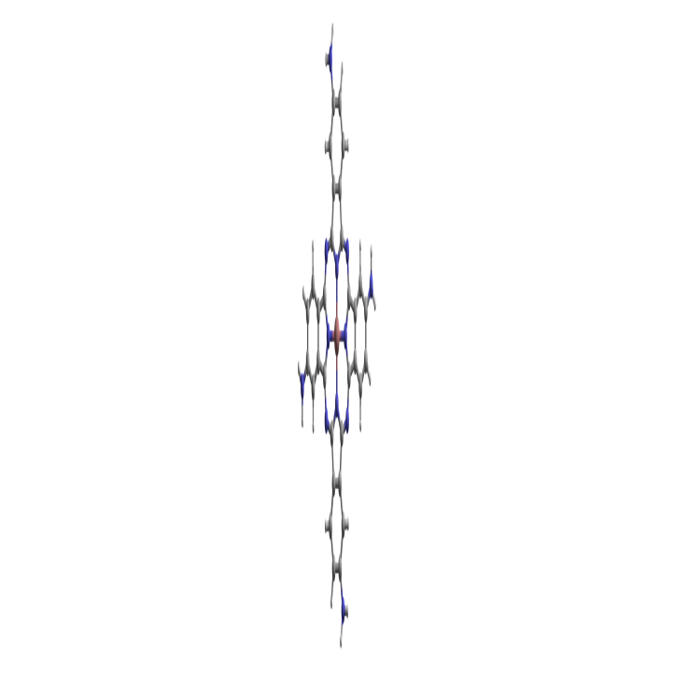  CoTAPc | C1 | -0.0294 | C34 | -0.0223
 | C2 | -0.0659 | C35 | 0.0982
 | C3 | 0.0510 | N36 | -0.1220
 | C4 | -0.0634 | N37 | -0.1607
 | C5 | -0.0223 | C38 | 0.0974
 | C6 | 0.0982 | N39 | -0.1220
 | N7 | -0.1607 | C40 | -0.0421
 | C8 | 0.0974 | H41 | 0.0472
 | C9 | -0.0421 | H42 | 0.0358
 | C10 | -0.0294 | H43 | 0.0405
 | C11 | -0.0659 | H44 | 0.0472
 | C12 | 0.0510 | H45 | 0.0358
 | C13 | -0.0634 | H46 | 0.0405
 | C14 | -0.0223 | H47 | 0.0472
 | C15 | 0.0982 | H48 | 0.0358
 | N16 | -0.1220 | H49 | 0.0405
 | N17 | -0.1607 | H50 | 0.0472
 | C18 | 0.0974 | H51 | 0.0358
 | C19 | -0.0421 | H52 | 0.0405
 | C20 | -0.0294 | Co53 | 0.1971
 | C21 | -0.0659 | N54 | -0.1614
 | C22 | 0.0510 | H55 | 0.1232
 | C23 | -0.0634 | H56 | 0.1247
 | C24 | -0.0223 | N57 | -0.1614
 | C25 | 0.0982 | H58 | -0.0294
 | N26 | -0.1220 | H59 | -0.0659
 | N27 | -0.1607 | N60 | 0.0510
 | C28 | 0.0974 | H61 | -0.0634
 | C29 | -0.0421 | H62 | -0.0223
 | C30 | -0.0294 | N63 | 0.0982
 | C31 | -0.0659 | H64 | -0.1607
 | C32 | 0.0510 | H65 | 0.0974
 | C33 | -0.0634
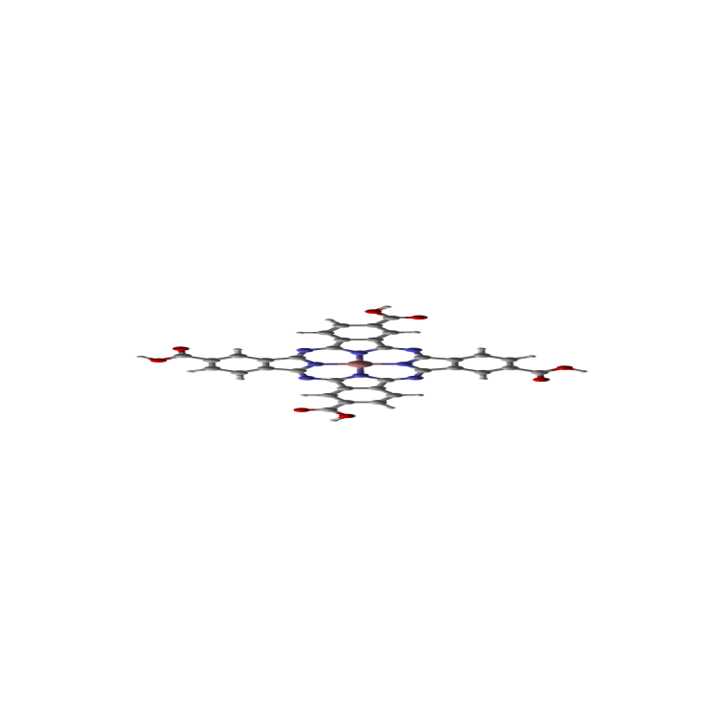  CoTCPc | C1 | -0.0236 | C35 | 0.1056
 | C2 | -0.0255 | N36 | -0.1151
 | C3 | -0.0168 | N37 | -0.1482
 | C4 | -0.0110 | C38 | 0.1046
 | C5 | -0.0200 | N39 | -0.1151
 | C6 | 0.1056 | C40 | -0.0134
 | N7 | -0.1482 | H41 | 0.0545
 | C8 | 0.1046 | H42 | 0.0478
 | C9 | -0.0134 | H43 | 0.0557
 | C10 | -0.0236 | H44 | 0.0545
 | C11 | -0.0255 | H45 | 0.0478
 | C12 | -0.0168 | H46 | 0.0557
 | C13 | -0.0110 | H47 | 0.0545
 | C14 | -0.0200 | H48 | 0.0478
 | C15 | 0.1056 | H49 | 0.0557
 | N16 | -0.1151 | H50 | 0.0545
 | N17 | -0.1482 | H51 | 0.0478
 | C18 | 0.1046 | H52 | 0.0557
 | C19 | -0.0134 | Co53 | 0.2084
 | C20 | -0.0236 | C54 | 0.2095
 | C21 | -0.0255 | O55 | -0.2781
 | C22 | -0.0168 | O56 | -0.1666
 | C23 | -0.0110 | H57 | 0.1885
 | C24 | -0.0200 | C58 | 0.2095
 | C25 | 0.1056 | O59 | -0.2781
 | N26 | -0.1151 | O60 | -0.1666
 | N27 | -0.1482 | H61 | 0.1885
 | C28 | 0.1046 | C62 | 0.2095
 | C29 | -0.0134 | O63 | -0.2781
 | C30 | -0.0236 | O64 | -0.1666
 | C31 | -0.0255 | H65 | 0.1885
 | C32 | -0.0168 | C66 | 0.2095
 | C33 | -0.0110 | O67 | -0.2781
 | C34 | -0.0200 | O68 | -0.1666
 |  |  | H69 | 0.1885
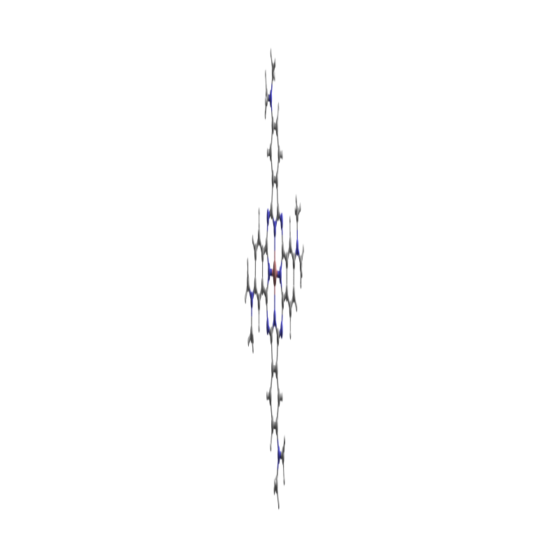  CoTDMAPc | C1 | -0.0317 | H46 | 0.0373
 | C2 | -0.0683 | H47 | 0.0457
 | C3 | 0.0460 | H48 | 0.0330
 | C4 | -0.0652 | H49 | 0.0373
 | C5 | -0.0241 | H50 | 0.0457
 | C6 | 0.0977 | H51 | 0.0330
 | N7 | -0.1616 | H52 | 0.0373
 | C8 | 0.0966 | Co53 | 0.1959
 | C9 | -0.0436 | N54 | -0.0419
 | C10 | -0.0317 | N55 | -0.0419
 | C11 | -0.0683 | N56 | -0.0419
 | C12 | 0.0460 | N57 | -0.0419
 | C13 | -0.0652 | C58 | -0.0316
 | C14 | -0.0241 | H59 | 0.0420
 | C15 | 0.0977 | H60 | 0.0327
 | N16 | -0.1224 | H61 | 0.0327
 | N17 | -0.1616 | C62 | -0.0315
 | C18 | 0.0966 | H63 | 0.0340
 | C19 | -0.0436 | H64 | 0.0413
 | C20 | -0.0317 | H65 | 0.0340
 | C21 | -0.0683 | C66 | -0.0316
 | C22 | 0.0460 | H67 | 0.0420
 | C23 | -0.0652 | H68 | 0.0327
 | C24 | -0.0241 | H69 | 0.0326
 | C25 | 0.0977 | C70 | -0.0317
 | N26 | -0.1224 | H71 | -0.0683
 | N27 | -0.1616 | H72 | 0.0460
 | C28 | 0.0966 | H73 | -0.0652
 | C29 | -0.0436 | C74 | -0.0241
 | C30 | -0.0317 | H75 | 0.0977
 | C31 | -0.0683 | H76 | -0.1616
 | C32 | 0.0460 | H77 | 0.0966
 | C33 | -0.0652 | C78 | -0.0436
 | C34 | -0.0241 | H79 | -0.0317
 | C35 | 0.0977 | H80 | -0.0683
 | N36 | -0.1224 | H81 | 0.0460
 | N37 | -0.1616 | C82 | -0.0652
 | C38 | 0.0966 | H83 | -0.0241
 | N39 | -0.1224 | H84 | 0.0977
 | C40 | -0.0436 | H85 | -0.1224
 | H41 | 0.0457 | C86 | -0.1616
 | H42 | 0.0330 | H87 | 0.0966
 | H43 | 0.0373 | H88 | -0.0436
 | H44 | 0.0457 | H89 | -0.0317
 | H45 | 0.0330
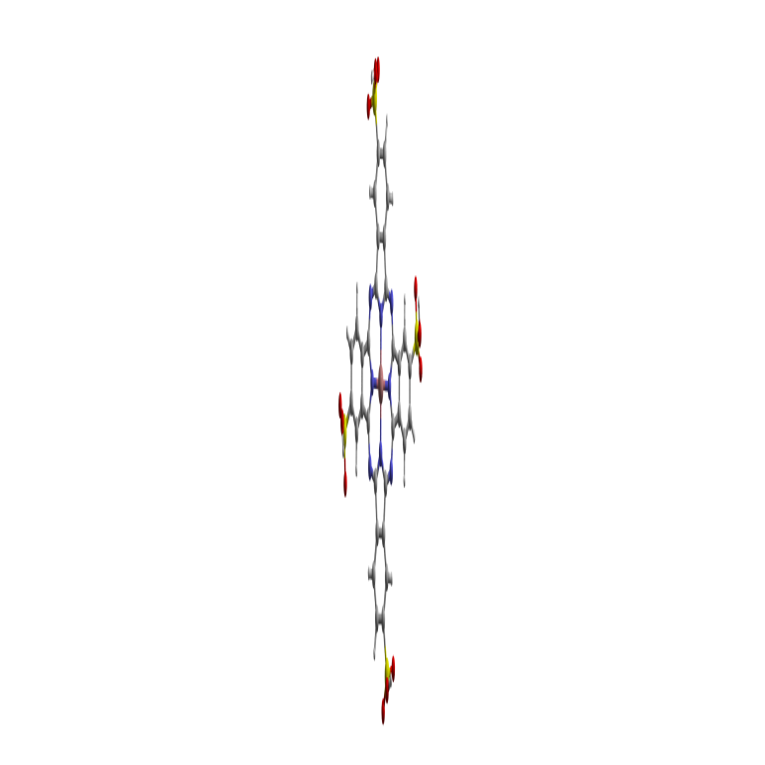  CoTSPc | C1 | -0.0146 | N37 | -0.1458
 | C2 | -0.0174 | C38 | 0.1068
 | C3 | -0.0239 | N39 | -0.1137
 | C4 | -0.0172 | C40 | -0.0110
 | C5 | -0.0164 | H41 | 0.0592
 | C6 | 0.1070 | H42 | 0.0596
 | N7 | -0.1458 | H43 | 0.0573
 | C8 | 0.1068 | H44 | 0.0592
 | C9 | -0.0110 | H45 | 0.0596
 | C10 | -0.0146 | H46 | 0.0573
 | C11 | -0.0174 | H47 | 0.0592
 | C12 | -0.0239 | H48 | 0.0596
 | C13 | -0.0172 | H49 | 0.0573
 | C14 | -0.0164 | H50 | 0.0592
 | C15 | 0.1070 | H51 | 0.0596
 | N16 | -0.1137 | H52 | 0.0573
 | N17 | -0.1458 | Co53 | 0.2122
 | C18 | 0.1068 | S54 | 0.5453
 | C19 | -0.0110 | O55 | -0.3119
 | C20 | -0.0146 | O56 | -0.2953
 | C21 | -0.0174 | S57 | 0.5453
 | C22 | -0.0239 | O58 | -0.3119
 | C23 | -0.0172 | O59 | -0.2953
 | C24 | -0.0164 | S60 | 0.5453
 | C25 | 0.1070 | O61 | -0.3119
 | N26 | -0.1137 | O62 | -0.2953
 | N27 | -0.1458 | S63 | 0.5453
 | C28 | 0.1068 | O64 | -0.3119
 | C29 | -0.0110 | O65 | -0.2953
 | C30 | -0.0146 | O66 | -0.2095
 | C31 | -0.0174 | H67 | 0.1886
 | C32 | -0.0239 | O68 | -0.2095
 | C33 | -0.0172 | H69 | 0.1886
 | C34 | -0.0164 | O70 | -0.0146
 | C35 | 0.1070 | H71 | -0.0174
 | N36 | -0.1137 | O72 | -0.0239
 |  |  | H73 | -0.0172

Appendix II: DFT optimized coordinates of CuBCP and CuPBCP in the ground state using the BP86 functional and the atom-pairwise Grimme dispersion correction with the Becke-Johnson damping scheme (D3BJ).

CuBCP - ground state:
Cu 6.19407390151465 11.33976968151509 5.49160968333885
P 4.38127148632952 11.75134286268871 4.26245004578418
P 7.71239011254823 12.98664718217361 5.80308266707333
O 6.45783249316850 13.61418261855334 3.30121296717779
N 7.39035701626705 9.71557181898222 5.04800647744349
N 6.27457222199436 10.48324719282593 7.37280220055931
C 4.74341394014226 12.16811623301850 2.51079965427434
C 4.08789120920097 11.56374935226785 1.42770855336803
H 3.26735528454702 10.87163845328859 1.61388249071285
C 4.50610177857821 11.81542623199546 0.12102764259034
H 3.99324183083241 11.33443355671841 -0.71160346267897
C 5.58109091731734 12.67332291325509 -0.12859435837028
H 5.89843688808451 12.84797801135940 -1.15580006520257
C 6.24764176531402 13.31133117281508 0.92259695950475
C 5.80420198075829 13.03862110945507 2.22164419494776
C 8.60711021509081 13.52295609085497 4.30379353399114
C 9.99634100087134 13.67692073623327 4.19097966586548
H 10.62967466086083 13.52099427809139 5.06397437302637
C 10.56710970909626 13.99501962542137 2.95804805595207
H 11.64885179773639 14.10418772826225 2.87541101624456
C 9.76506296996280 14.17207523700969 1.82610629623002
H 10.23445318033534 14.41116150192444 0.87296610400648
C 8.37234315970399 14.06237452169094 1.90754961037509
C 7.83030486020682 13.74836566379800 3.15767363595622
C 7.39756420672884 14.30840444148621 0.75519258109038
C 8.07381562185106 14.18199540959793 -0.61302439535907
H 8.47999946513057 13.17418469983090 -0.77661491935379
H 8.89203794277441 14.90706246344362 -0.70980875296481
H 7.36058539222001 14.40498372448306 -1.41742875806063
C 6.82124319478793 15.74286908456361 0.90729333934463
H 6.07632225870538 15.93405439083741 0.12244885633612
H 7.62848115654972 16.48329746933885 0.81860041612859
H 6.33817590273217 15.87766371432853 1.88395518977019
C 3.24617947018549 10.32889000423899 4.13719448249563
C 3.76883955911912 9.05515079041112 4.40672119565939
H 4.81094282347803 8.96264267503704 4.71964143019207
C 2.95947686013717 7.92376934030055 4.28780400896574
H 3.37107378161456 6.93615916895774 4.49933427633973
C 1.62102778682640 8.05965266278223 3.91094057276085
H 0.98680308527485 7.17672950893653 3.82407558879087
C 1.09068937448522 9.32834298916553 3.65343946735418
H 0.04466974704296 9.43515194513473 3.36408314974124
C 1.89864212057078 10.45999766125024 3.76376784701319
H 1.48327137638350 11.44915222310524 3.56585014217952
C 3.29581171687257 13.12171271428971 4.80150598617170
C 2.45361003937404 12.92503003413840 5.90955366868844
H 2.37305012195615 11.93451912032688 6.36074885111273
C 1.70224576537075 13.98219844421505 6.42199433593558
H 1.04640838505246 13.81471310124127 7.27732674755865
C 1.78410968194583 15.24971113935847 5.83645237273979
H 1.19677092377991 16.07630060767266 6.23736031403486
C 2.60941559350447 15.44839406769302 4.72748841324719
H 2.66967522021301 16.43128400475634 4.25894453604500
C 3.36090215373337 14.39141291878890 4.21028115592953
H 4.00236413347946 14.55831930824490 3.34623277874116
C 7.19636268172033 14.56900367788008 6.54869994988303
C 5.82990924793863 14.85639469038418 6.64364900698119
H 5.10193176699868 14.12733347714659 6.29234093249218
C 5.40319504816940 16.07984937153003 7.16607267879818
H 4.33575990135990 16.29411505919746 7.22689583915165
C 6.34181083085884 17.01805527338259 7.59916337002472
H 6.01032362068240 17.97248868600038 8.00959325724499
C 7.71021679080838 16.73792752917963 7.50122653986376
H 8.44392033988312 17.47339257505804 7.83305639698403
C 8.13815186486453 15.52114110314236 6.97296130999994
H 9.20530449833321 15.30765020013160 6.89063093345134
C 8.97711679440191 12.30849288302650 6.92245594451229
C 9.88720092133140 11.34489837168471 6.45169141146754
H 9.94678618626372 11.12565274416195 5.38434835933014
C 10.70691375233374 10.65309593159390 7.34189489352994
H 11.41215910428771 9.91545310261366 6.95762987377752
C 10.61471162963309 10.89195363232662 8.71534570626575
H 11.25915861208765 10.34930629051596 9.40781332282208
C 9.69903031648506 11.83211312423551 9.19420939953067
H 9.61600696245298 12.01978487484484 10.26549155500176
C 8.88729449209647 12.53806676847465 8.30563165402804
H 8.17614764723012 13.27100743618495 8.68780350070163
C 7.94674098712161 9.37952446873216 3.87212399729946
C 8.92265222340838 8.37175017948002 3.79271738715483
H 9.37732842229956 8.15501611596145 2.82629702926018
C 9.35525737183606 7.68537532271332 4.92254917821263
C 8.75077470123578 8.01756497596332 6.16919242512839
C 7.78056872456250 9.05574203054915 6.17671286200104
C 7.53342043460502 10.14754263088753 2.65792716632519
H 6.44049693588674 10.16487659406541 2.55398079306845
H 7.97138210031224 9.72112059721662 1.74821728444284
H 7.86373947828877 11.19401398576047 2.74086096475982
C 5.75702183593146 10.94677179518655 8.51849403709262
C 6.15529985457698 10.42611015076200 9.76287421834993
H 5.73997447271532 10.86161246042550 10.67239727602157
C 7.09629144129156 9.40982020353794 9.85798926689951
C 7.62590411994870 8.88589813100648 8.64114622219138
C 7.19953911669308 9.48217455347558 7.42549016537547
C 4.78080320928567 12.07586806374316 8.44260692369285
H 4.39086061602853 12.17266778570910 7.42457444636528
H 5.27026185365655 13.02751801089882 8.70180216119595
H 3.94644276522284 11.93373939908006 9.14249400888908
C 9.05641991823819 7.35350516512572 7.39792435528794
H 9.72383395383874 6.49352628606031 7.37343476881169
C 8.52252019290161 7.77365313324945 8.58323452493251
H 8.76190231949232 7.24775422247170 9.50587686238161
C 10.41734496965326 6.66459664643803 4.80006086680839
C 10.30187602828113 5.64493636809568 3.84079620288181
H 9.40279126997671 5.58945378574815 3.22490416617076
C 11.30941072825219 4.69162933580636 3.69436803151607
H 11.19926154098410 3.89667149674930 2.95578071669742
C 12.45420636635556 4.75202173232051 4.49307868198163
H 13.24391569596394 4.00913690273551 4.37473792054559
C 12.58576571463724 5.76971636677390 5.44156668023234
H 13.48383833591579 5.83091643561227 6.05732296868959
C 11.57337272861292 6.71574866088553 5.59867382666267
H 11.69002546724692 7.52023521657227 6.32673324777413
C 7.52834752676180 8.92717656242451 11.18551400040751
C 6.57338608718498 8.59572906456652 12.16175206622313
H 5.51232061143420 8.64732032750736 11.91169367188730
C 6.97237224434580 8.17373169270613 13.42988836218286
H 6.22034353109867 7.90597045418691 14.17274046054826
C 8.33083925282934 8.08955970172486 13.74590463361303
H 8.64289817088620 7.76268345824042 14.73794911952156
C 9.28884847728590 8.42766194924573 12.78618721894103
H 10.35027115937391 8.37589757991175 13.03219864903611
C 8.89248975177824 8.83878866064038 11.51398381457652
H 9.63847603919915 9.12377893419495 10.77228671132004

CuPBCP - ground state:
Cu 6.19319641918515 11.33944461256316 5.48660326851596
P 4.37945684459323 11.75100466239125 4.25440591639471
P 7.70922343520119 12.98808972463782 5.80684232707927
O 6.45855025071019 13.61704230773308 3.30510345096700
N 7.39350105547990 9.71769704419578 5.03927481045234
N 6.27759623675138 10.47732748143003 7.36696120392737
C 4.74536068179106 12.17441360402978 2.50575186644072
C 4.09078985760369 11.57469886407761 1.41942206724909
H 3.26976001689359 10.88212076050098 1.60153553998493
C 4.51042533262360 11.83235464084873 0.11438194092235
H 3.99828228107386 11.35543782634058 -0.72099155466541
C 5.58587895209614 12.69120586410831 -0.13009096886822
H 5.90428286419910 12.87047710523033 -1.15614342148467
C 6.25141234815422 13.32459677148270 0.92457207845950
C 5.80638904991802 13.04627448693814 2.22183212558849
C 8.60655178557337 13.52511084340133 4.31005221372063
C 9.99580428900153 13.68154683794380 4.20041459910794
H 10.62809339067909 13.52542993389237 5.07410521994399
C 10.56797411957664 14.00424642586785 2.96932639042710
H 11.64960032415534 14.11576164288365 2.88882766839816
C 9.76739251160846 14.18376136303473 1.83671605172264
H 10.23804283665866 14.42691480570290 0.88525052943132
C 8.37461544850348 14.07225541585091 1.91538872034061
C 7.83100266851255 13.75304120527285 3.16349311207893
C 7.40148371006768 14.32245418950609 0.76249641683613
C 8.07968108408004 14.20125632998457 -0.60521158867218
H 8.48627700672852 13.19415887774086 -0.77213133232124
H 8.89787005628986 14.92681831812713 -0.69844525616153
H 7.36763104127133 14.42723923567959 -1.40978459601064
C 6.82460636704873 15.75619947617377 0.91941126730575
H 6.08164365488685 15.95046366159416 0.13352847160325
H 7.63181704741861 16.49718076937204 0.83553840204535
H 6.33911087014345 15.88696145715290 1.89540717209790
C 3.24795469104351 10.32665893291108 4.12424849357243
C 3.77201232406854 9.05233832678448 4.38824650521814
H 4.81420242230964 8.95935501627540 4.70062193012536
C 2.96410999377279 7.92047075452533 4.26445034539722
H 3.37664641305475 6.93232368648967 4.47154931715092
C 1.62554278069023 8.05647618387992 3.88804464070406
H 0.99238290763508 7.17323108105828 3.79725677014041
C 1.09377051363139 9.32563017383547 3.63597538448775
H 0.04768788708539 9.43241335192590 3.34699264175251
C 1.90025197663284 10.45780277449826 3.75124901805358
H 1.48358283038455 11.44722895146050 3.55754359177533
C 3.29239191692686 13.11750707755127 4.79869066191779
C 2.45064956168957 12.91523015261496 5.90607681252956
H 2.37206866705641 11.92303853918703 6.35402721460969
C 1.69575529204105 13.96881713125322 6.42072306937052
H 1.03961623270823 13.79733255548831 7.27501362372301
C 1.77374951569670 15.23783432165541 5.83786685694771
H 1.18313430541964 16.06143909205629 6.24006079701309
C 2.59880329046443 15.44189464696787 4.72970129770819
H 2.65559729595185 16.42595691568464 4.26325938422937
C 3.35405626572105 14.38862315335068 4.21034600205011
H 3.99510518625565 14.55932011051886 3.34672083038033
C 7.18469889118642 14.56712481376350 6.55195549622384
C 5.81704849740065 14.84840700809152 6.64788459148236
H 5.09178993818243 14.11696453199595 6.29592279481321
C 5.38557170740220 16.06979219873775 7.17123120836525
H 4.31735250991535 16.27970228860670 7.23284695529012
C 6.32050605753738 17.01193980388079 7.60371066420719
H 5.98523782786763 17.96474186712183 8.01478375986847
C 7.69005718232285 16.73820043454651 7.50392514592407
H 8.42079685458242 17.47697957819558 7.83480391201085
C 8.12293585713170 15.52353679244418 6.97489591990741
H 9.19103079102905 15.31555920698315 6.89070739841020
C 8.97222185540470 12.31328129862645 6.93044029865726
C 9.88647081271213 11.35157489011419 6.46349197496788
H 9.94659510813231 11.12882371027621 5.39689046743685
C 10.71335118093805 10.67105396862206 7.35584914442939
H 11.42496418456928 9.93773891636915 6.97494869168514
C 10.62474635495479 10.91944005132293 8.72795469430960
H 11.27883118718189 10.38959411234767 9.42132882653109
C 9.70419193703874 11.85670221705782 9.20320122439302
H 9.62627400797294 12.05456782969486 10.27304468748068
C 8.88460100655864 12.55092966122754 8.31239335199160
H 8.17224476963827 13.28434546913119 8.69142130122680
C 7.94641146140570 9.38457067768135 3.86090732523055
C 8.91876056671881 8.37257781262759 3.77692936537493
H 9.36577431746185 8.15060534687353 2.80813646694139
C 9.35271612215937 7.68870036725111 4.90637348203437
C 8.76001245844789 8.02195850194513 6.15662260739606
C 7.78667175656637 9.05735297749409 6.16627035118229
C 7.53209073572178 10.15529308855226 2.64955925283420
H 6.43918750870462 10.17247380740883 2.54514514342141
H 7.97108637515029 9.73321617637266 1.73844795181059
H 7.86089864689461 11.20191248124684 2.73729095746739
C 5.75980187174093 10.93906696580511 8.51316845413653
C 6.16111404306956 10.41701698739143 9.75699271846856
H 5.74215570778201 10.84548454059138 10.66814187230730
C 7.10723559880731 9.40638636979318 9.84539493127851
C 7.64150632018188 8.88686781573416 8.63046172726446
C 7.20723501498403 9.48074746554899 7.41643154540103
C 4.77840429799487 12.06300419693428 8.43986612152135
H 4.38268867770300 12.15654358430681 7.42371583194289
H 5.26573107752662 13.01707857369216 8.69429945021745
H 3.94870047665370 11.91931543632080 9.14488564064081
C 9.08160256574569 7.36582533259892 7.38555932143966
H 9.75971295877044 6.51411757392872 7.36235784088334
C 8.55094751167294 7.78503824783525 8.57243796321905
H 8.80493801026948 7.26593904784776 9.49499478896072
C 10.41247606565249 6.66508628008635 4.77908852651831
C 10.29113888377973 5.62255858998026 3.85004625205701
H 9.39295425169622 5.52736266479039 3.23812379495809
C 11.32460816970131 4.69050376297151 3.73858544919661
H 11.24318333401867 3.86209878836145 3.02939337151391
N 12.45060974575499 4.73655216389844 4.46562848308123
C 12.56773684659880 5.74237290526140 5.34502775184911
H 13.49641329744285 5.77251654432280 5.92134214367998
C 11.58849239812129 6.71723302750268 5.54239944000294
H 11.75121374205866 7.52009670766035 6.26294085160961
C 7.54423837267465 8.92530627970436 11.17264730581948
C 6.60799924218985 8.56182725956890 12.15082691064936
H 5.53954080195553 8.58033602319071 11.93060037074779
C 7.06353084672543 8.14720853207474 13.40394461480720
H 6.34993919253551 7.84860647111946 14.17663154398624
N 8.36011372081954 8.08390942096654 13.74150428678389
C 9.25165785550185 8.44195314778575 12.80508775446100
H 10.30382136523001 8.39418336547368 13.09971530033557
C 8.90200025333794 8.86026699065627 11.52058167382087
H 9.66898190369162 9.15742357402025 10.80582025141941

Appendix III: DFT optimized coordinates of CuBCP and CuPBCP in the ground state using the BP86 functional, the PCM method assuming solvent effects of acetonitrile, and the atom-pairwise Grimme dispersion correction with the Becke-Johnson damping scheme (D3BJ).

CuBCP - ground state:
Cu 6.19108689626378 11.34005303322046 5.49473453988362
P 4.37872590643634 11.75217788786902 4.26715438518565
P 7.71149787312079 12.98510521116816 5.80118400434029
O 6.45355631485203 13.60786429088622 3.29768026246737
N 7.38807317548113 9.71847787140871 5.04750135716375
N 6.27173660082518 10.48153288451048 7.37350612112790
C 4.73492256264133 12.16457986738080 2.51345387566862
C 4.07249637577526 11.56267553260923 1.43294123836822
H 3.24810439952433 10.87518153650947 1.61998575208753
C 4.48774977182053 11.81174806203492 0.12383666470774
H 3.97004757886970 11.33206384555581 -0.70694964780649
C 5.56782636052278 12.66352787854720 -0.12998470330094
H 5.88304148775652 12.83644405618481 -1.15829850347594
C 6.24016947415573 13.29882105714395 0.91975937678416
C 5.79812375824398 13.03096344195538 2.22015737701655
C 8.60316706807022 13.52457533423682 4.30060437879577
C 9.99232134513678 13.68233881124481 4.18778560838739
H 10.62739744075537 13.53166996865437 5.06037215430261
C 10.56232671207165 13.99830318006075 2.95295303585298
H 11.64431639935274 14.10787485982233 2.86991422760527
C 9.75985099178097 14.16808620924671 1.81903450932699
H 10.22840393047989 14.40540318960775 0.86489638691201
C 8.36701579607097 14.05328240296002 1.90140813756852
C 7.82579431155395 13.74353350321511 3.15301599319459
C 7.39433705221090 14.28919985994563 0.74525943676527
C 8.07345367831483 14.14477838941876 -0.61993107343923
H 8.47457216834817 13.13244618161513 -0.76849208367116
H 8.89618708445874 14.86447456435383 -0.71829314827062
H 7.36027722544108 14.35990575894101 -1.42656386004612
C 6.82193572253782 15.72697213932588 0.88097171914094
H 6.08203896860793 15.91058737897719 0.08922992995685
H 7.63450849014112 16.46137333226901 0.78710418333013
H 6.33343429407715 15.87266528231014 1.85384918926557
C 3.24412643808209 10.32748166855114 4.14750996444803
C 3.77524011345520 9.05373557578922 4.40292914265004
H 4.82227690274087 8.95973201537562 4.69873191325382
C 2.96811379642328 7.91916903339389 4.29014796395853
H 3.38781541145752 6.93237894445239 4.49024358210263
C 1.62256117078371 8.05279640474547 3.93361753402818
H 0.98995757048083 7.16789190147284 3.85120478150114
C 1.08454275401702 9.32195294778245 3.68932911505898
H 0.03447691474010 9.42749049652504 3.41350004831282
C 1.89127862407312 10.45622561168186 3.79337734681301
H 1.46902805051161 11.44369763295075 3.60204107179275
C 3.29910308317752 13.12783727990954 4.80416610155853
C 2.47577751573150 12.94547491112807 5.92900963023737
H 2.40111657008702 11.96251817779671 6.39703317727413
C 1.74198818413467 14.01307947466764 6.44719144143210
H 1.10743998643787 13.85781877082375 7.32088298285660
C 1.82224930625488 15.27617860940122 5.84993715988234
H 1.25587127984814 16.11273262544985 6.26074314747574
C 2.62679686970027 15.45972656147341 4.72213155996540
H 2.68909539923192 16.43919449397961 4.24617606356418
C 3.36088673305619 14.39218776448214 4.19978857172782
H 3.98758367449485 14.54978888096358 3.32309866512878
C 7.20109035546260 14.57304849088766 6.54421556795445
C 5.83602500329974 14.86757736064067 6.63969534758184
H 5.10417519969610 14.13971047419724 6.29370466576674
C 5.41515035245976 16.09543481367957 7.15871640245069
H 4.34901529518965 16.31627174500287 7.22217054502366
C 6.35923948864285 17.03117400340505 7.58851824956623
H 6.03211856061721 17.98867428947766 7.99599124021264
C 7.72717649346910 16.74273754516068 7.49170302547345
H 8.46562982093420 17.47427440915834 7.82271325959914
C 8.14845624065443 15.52084729373891 6.96706213028025
H 9.21482853732495 15.30127065234343 6.88799952018934
C 8.97261483106685 12.30529968657379 6.92252373428487
C 9.88792859819852 11.34606557745286 6.45245543913140
H 9.96384261261131 11.13733840869055 5.38402704368368
C 10.69140748940504 10.63898204729609 7.34665612798975
H 11.39597471710690 9.89924424209173 6.96492840498103
C 10.57780996829210 10.85957049836620 8.72238689334693
H 11.20143489763056 10.29641652092561 9.41775902495809
C 9.65860794658717 11.79868572396849 9.19920368061256
H 9.55429045565728 11.96951891802163 10.27168306988838
C 8.86242069610165 12.51902712752480 8.30727621227097
H 8.14247674904464 13.24244519795548 8.69141304447323
C 7.94492988196772 9.38619309850229 3.87106268761083
C 8.92485176342341 8.38220965780143 3.78840442893500
H 9.37646455693438 8.17019700309748 2.81981972911458
C 9.35932943361044 7.69835372641117 4.91812167860963
C 8.75154668592095 8.02181613007919 6.16522784129690
C 7.77763164629496 9.05633526834814 6.17472014503839
C 7.53002229297487 10.15234538534501 2.65705162464772
H 6.43699247856793 10.16349176594633 2.55260842910625
H 7.97465358663449 9.72889140689090 1.74955171549295
H 7.85413097897570 11.20031168470564 2.74442490245929
C 5.75323121899699 10.94386671402650 8.51926450839456
C 6.14441335349240 10.41564351206948 9.76341285176230
H 5.72337756587181 10.84915587858486 10.67083482777212
C 7.08295328526671 9.39760133139441 9.85482142786005
C 7.61748810432152 8.87710758705097 8.63849915605699
C 7.19425358487338 9.47793611678311 7.42394070979756
C 4.78648688000801 12.07974249436677 8.44846661629742
H 4.40950176165664 12.19334301722412 7.42754190136227
H 5.28362717463408 13.02054811375311 8.73165054132429
H 3.94463248969931 11.93245719529798 9.13770072088533
C 9.05859991384819 7.35604504769429 7.39262201494615
H 9.73549529428192 6.50344797245610 7.37238656674428
C 8.51894810687454 7.76883327092560 8.57835327219551
H 8.76565926794538 7.24076532255586 9.49766652035802
C 10.43267823964364 6.68824536062793 4.79468504878984
C 10.33188456464165 5.67380481156862 3.82735198899483
H 9.43855371274763 5.61585468402545 3.20333102621733
C 11.35208471386754 4.73259686248440 3.67825217642356
H 11.25420292473705 3.94278949684036 2.93176255659679
C 12.49398716995595 4.80037443643601 4.48308360970521
H 13.29345022613799 4.06754984726054 4.36281416168120
C 12.60948233648794 5.81420658707639 5.43962549476188
H 13.50345457804087 5.88261276785013 6.06116246119250
C 11.58497865946159 6.74857857551557 5.59866786064332
H 11.69187001688959 7.54854347157143 6.33303678931440
C 7.51059997181483 8.91201972031411 11.18397589915149
C 6.55014470127252 8.59161440262063 12.15967162399262
H 5.48991047821125 8.65878350645039 11.90971447220028
C 6.94337918581323 8.16898004105615 13.43075095735211
H 6.18663943784119 7.91197589476021 14.17325320494888
C 8.30182547233811 8.07261466916461 13.74991530453551
H 8.60967335615406 7.74509220372439 14.74360124489967
C 9.26480220113863 8.40085190222024 12.79001437310627
H 10.32618149235375 8.34051036844932 13.03556058696034
C 8.87358960497596 8.81344974759174 11.51547488701139
H 9.62644877432584 9.08778832853375 10.77709403351333

CuPBCP - ground state:
Cu 6.19056921475358 11.33880022716705 5.48972065370891
P 4.37695077823355 11.75114448420441 4.26047450207833
P 7.70795647518649 12.98579938335849 5.80544976066144
O 6.45304134110340 13.61023483267049 3.30165994246042
N 7.39173823888119 9.72050331529960 5.03771317788942
N 6.27401997166165 10.47444858936701 7.36651814297669
C 4.73587985773007 12.16985577181235 2.50934019044722
C 4.07423434367018 11.57237776278816 1.42595525283994
H 3.24955164171792 10.88432277243076 1.60948987994149
C 4.49064755549354 11.82704860196674 0.11834425205375
H 3.97363678152497 11.35096852912024 -0.71491126811146
C 5.57099050790080 12.67984009317249 -0.13085036012430
H 5.88710981239609 12.85696151451305 -1.15814661583130
C 6.24255360451133 13.31079145845823 0.92203799411506
C 5.79916947817872 13.03766255004756 2.22080968114126
C 8.60132859346505 13.52710904411677 4.30710952664466
C 9.99041762639945 13.68732450663695 4.19733756170507
H 10.62442948950198 13.53570081199359 5.07049825888714
C 10.56175821271919 14.00782700457554 2.96430781237330
H 11.64366151247907 14.11940229893455 2.88332404132743
C 9.76074442240237 14.17980129693800 1.82970447356150
H 10.23051497650914 14.42083619417936 0.87711751135872
C 8.36790463670259 14.06273144934363 1.90934709168718
C 7.82520516024073 13.74817205360424 3.15906344124950
C 7.39691267416224 14.30178938089646 0.75243756397552
C 8.07822239141369 14.16139364409799 -0.61208843659543
H 8.47989039575081 13.14959782920798 -0.76276683963210
H 8.90086211188429 14.88162092741841 -0.70731295317116
H 7.36617829419023 14.37847166415846 -1.41917348703732
C 6.82399917084046 15.73902461479991 0.89167810306853
H 6.08603305600380 15.92512736168216 0.09874063871225
H 7.63665162752506 16.47388843690216 0.80227031863162
H 6.33302241784157 15.88128487553440 1.86381731514278
C 3.24598526893853 10.32450119547118 4.13593642389328
C 3.77859359075374 9.05076304479353 4.38806649354103
H 4.82531427296247 8.95665865858045 4.68471650377754
C 2.97332301377472 7.91539638885345 4.27070309353635
H 3.39424108319014 6.92865156917485 4.46833164349576
C 1.62811286239926 8.04826440129195 3.91268553088792
H 0.99692047100971 7.16272336536748 3.82661966484845
C 1.08863463347690 9.31736798106308 3.67145342336641
H 0.03886389377524 9.42225859964096 3.39433283549307
C 1.89348095904224 10.45252220492784 3.78013866371002
H 1.47022395992699 11.43993439589153 3.59089056565191
C 3.29579596118996 13.12336263552236 4.80198061064398
C 2.47284858106525 12.93632238501506 5.92628062815986
H 2.40010976711565 11.95207899751856 6.39187591636836
C 1.73646264084951 14.00108448077320 6.44661879837269
H 1.10213162001712 13.84248878056536 7.31984459770716
C 1.81366193044376 15.26551902534314 5.85181804006214
H 1.24508706232437 16.09978185053554 6.26421967350619
C 2.61777645176860 15.45349079617133 4.72443505163289
H 2.67747578757422 16.43402956560516 4.25040029789297
C 3.35470469799450 14.38894664931073 4.20001779704414
H 3.98081157946829 14.54968784121010 3.32347229842945
C 7.19063546150478 14.57062800082936 6.54904467510440
C 5.82467998516892 14.86073534086875 6.64472025116688
H 5.09483892404223 14.13152639400875 6.29744195084672
C 5.40015202789465 16.08665324369555 7.16530824337725
H 4.33341195658866 16.30424761450669 7.22912101255892
C 6.34144621611921 17.02476770558605 7.59598661239801
H 6.01139916822981 17.98077381481028 8.00456850155076
C 7.71024943379818 16.74082535774966 7.49849775802420
H 8.44650430774950 17.47429161418020 7.83005037108423
C 8.13531316650021 15.52087368535674 6.97255001785865
H 9.20238352802527 15.30500100141578 6.89295513483656
C 8.96716414008860 12.30762557338225 6.92990797030531
C 9.88716824509461 11.35161876709604 6.46202350829121
H 9.96661783727721 11.14330968254884 5.39376714497721
C 10.69350572525959 10.65000945928818 7.35804485689164
H 11.40355668125031 9.91439098851913 6.97849498550659
C 10.57809160648086 10.87275592858504 8.73338008433463
H 11.20582472162662 10.31549754450284 9.42981368084729
C 9.65390581776277 11.80814861837437 9.20789751721923
H 9.54922788226130 11.98222163343218 10.27982757297190
C 8.85460037227032 12.52297699934256 8.31418004581898
H 8.13208715971446 13.24467782206912 8.69667259856138
C 7.94682560241293 9.39314372751785 3.85922996826404
C 8.92580259281558 8.38755988356890 3.77213911509187
H 9.37277935649207 8.17293453707977 2.80214450878132
C 9.36066237392819 7.70677592758784 4.90188542495840
C 8.76255322808050 8.02778176125642 6.15234978892545
C 7.78416663477312 9.05801471176278 6.16339436371273
C 7.52962321328995 10.16103168045941 2.64792971722695
H 6.43642142048444 10.17165756864908 2.54563630493700
H 7.97315726862909 9.73999590769876 1.73892083680251
H 7.85354026456378 11.20885643488181 2.73774243580420
C 5.75522950983265 10.93522380731456 8.51252492613398
C 6.14939776607891 10.40597555195864 9.75626238315850
H 5.72582110547119 10.83307042956530 10.66535337887744
C 7.09311048678283 9.39381918799582 9.83994964655384
C 7.63267673729891 8.87682975885780 8.62629791197621
C 7.20149042427142 9.47555467347508 7.41363111944081
C 4.78302184260035 12.06559615247572 8.44468311050448
H 4.40475572729780 12.17945823189830 7.42434125451132
H 5.27613876550583 13.00780713046256 8.73022861211379
H 3.94283734176470 11.91239793609633 9.13456018943588
C 9.08406929969849 7.36826116214629 7.37916836392329
H 9.77050450133684 6.52327381630300 7.36034295814681
C 8.54640189901326 7.77891450038593 8.56633423559409
H 8.80583173015944 7.25564360552545 9.48480923046994
C 10.43436558396212 6.69800838928150 4.77328365016595
C 10.33627633301676 5.66820629738696 3.82690400414679
H 9.44936590080659 5.57261872597571 3.19967288189832
C 11.38089051195605 4.75136007039375 3.71132447003433
H 11.31365543880853 3.93605251577968 2.98600904973454
N 12.50169310316122 4.79903286742337 4.45408049797504
C 12.59476474268061 5.79658427953465 5.35195179423282
H 13.51341544213651 5.83454949779096 5.94291386754839
C 11.60104480307033 6.75481256025291 5.55023425234861
H 11.75007722525276 7.54688559154862 6.28466982019197
C 7.52596886374371 8.91287617238574 11.16891292884035
C 6.58351173127873 8.57305476594932 12.15041953277107
H 5.51546792197994 8.61399342339044 11.93394586201849
C 7.02947560352112 8.16060115111603 13.40598443655084
H 6.30663380213615 7.88341491262072 14.17771960411258
N 8.32857949287668 8.07545422128849 13.74626064361305
C 9.22741715555720 8.41273422500583 12.80325428291301
H 10.28018851976725 8.35059781860974 13.09116660339557
C 8.88225650530944 8.82801493289686 11.51778884718181
H 9.65895039965030 9.10372061227086 10.80600201029096

Appendix IV: DFT optimized coordinates of CuBCP and CuOBCO in the excited state using the B3LYP functional, the PCM method assuming solvent effects of acetonitrile, and the atom-pairwise Grimme dispersion correction with the Becke-Johnson damping scheme (D3BJ).

CuBCP - excited state:
Cu 6.14987715104097 11.26723483029526 5.55807803955590
P 4.38882091370741 11.73806062466126 4.14374129013960
P 7.62857806595300 13.07079287758812 5.87734768899177
O 6.42288618169321 13.61990846735489 3.28092827219976
N 7.29389893447026 9.62124383942365 5.05101313679094
N 6.32973419911234 10.50576725418553 7.41161605827988
C 4.75608742091429 12.17593919110142 2.40442151624437
C 4.11704394250264 11.59214371843415 1.29867618383123
H 3.29873694934746 10.89364620766352 1.44870283791062
C 4.55805150190387 11.88687162158838 0.00512407653468
H 4.06338385469546 11.42963790648548 -0.84874071335836
C 5.63991338625999 12.75354341506944 -0.20214852273671
H 5.97150029757954 12.95336826007823 -1.21692089577124
C 6.28997503162479 13.36655496295654 0.87886977977858
C 5.81285230354804 13.06266825958611 2.15827823228604
C 8.53720218621700 13.57371764201406 4.36555613857098
C 9.92940556011090 13.76897868066279 4.31300733100856
H 10.53278921568539 13.62789862543736 5.20438923455672
C 10.53766885655852 14.12598071380667 3.10739334419151
H 11.61526819435417 14.27192083818054 3.07177798632703
C 9.77543415196798 14.29186543934626 1.94243834262829
H 10.27686554806575 14.55948002941450 1.01723375608460
C 8.38265645277500 14.13282958151973 1.96268021367294
C 7.80178722474771 13.78591454381618 3.18922243194358
C 7.45167489782622 14.36716135779665 0.76117724285143
C 8.19457278540304 14.22962893827358 -0.58062182786577
H 8.61859955249538 13.22582029494667 -0.70375087935262
H 9.00604434345854 14.96179267419776 -0.64940287519905
H 7.51326882916692 14.42594425957059 -1.41554607937397
C 6.86354587514114 15.80908841094511 0.87690757697718
H 6.16737406361225 15.99389253463461 0.04964120259365
H 7.67517998562746 16.54577460010847 0.83211539737546
H 6.32305573289939 15.94299750767274 1.82108904351382
C 3.30763897303906 10.26582883080865 4.04246512950282
C 3.87216449729144 8.99421515393201 4.25017931097941
H 4.92504448778390 8.90215159852859 4.50775508437292
C 3.07916790938190 7.84735161055351 4.13706880263922
H 3.52290480937890 6.86708079727015 4.30057126940175
C 1.71945704236778 7.96278863957971 3.82379703209752
H 1.10268597627508 7.07006902398617 3.73910189637634
C 1.15081052291247 9.22858172350878 3.62405813925746
H 0.09426392634985 9.32136151600093 3.37995151749641
C 1.93875565998323 10.37728958388551 3.73385502082295
H 1.49190513657701 11.35630084566370 3.57809479494533
C 3.30109214135243 13.07833937623088 4.74501985397518
C 2.55864928151253 12.86526440043343 5.92370847779338
H 2.56012701004406 11.88783192456888 6.40147149828339
C 1.80405960331224 13.90196214377157 6.47722212095670
H 1.23637089881733 13.72739407923235 7.38898806845219
C 1.78235746401463 15.16135206104789 5.86254157038295
H 1.20165402635988 15.97127004470716 6.29939276939372
C 2.50698017620672 15.37381157458129 4.68358480569529
H 2.48713816078746 16.34692777457361 4.19687194318472
C 3.26446231272078 14.33917078139556 4.12536726546202
H 3.82180665754047 14.51873964404729 3.21120276750102
C 7.10344373919241 14.66258071061440 6.60659378522528
C 5.74123123868358 14.99513416400727 6.63456068975864
H 5.00354778313058 14.28915171115047 6.27139987001943
C 5.33199349076973 16.24005721398557 7.12527619121140
H 4.27344808714092 16.49010601273261 7.13918762999784
C 6.28191185194288 17.15478973694615 7.59292091593960
H 5.96318046943559 18.12196551427743 7.97667458322287
C 7.64570382190985 16.82737146444392 7.56401407216744
H 8.38711255314817 17.53845786386505 7.92331164088772
C 8.05871788471791 15.58845320337042 7.06841455282473
H 9.11833495909868 15.34321558945451 7.04202223857030
C 8.88567997335509 12.34434908363550 6.97890838906619
C 9.76336260482234 11.36502085618084 6.47077022119436
H 9.77403104394393 11.13763467666986 5.40795368417542
C 10.60946566545685 10.66228045189961 7.33016520363331
H 11.27598551609328 9.90506877106318 6.92328287087383
C 10.57566163518323 10.90866983820615 8.70744405956471
H 11.22506843671706 10.34866268705511 9.37702176782270
C 9.69296211621359 11.86703006559265 9.22171993106400
H 9.65051810421031 12.05152226071258 10.29332531075205
C 8.85091264733539 12.58113482952730 8.36625192103912
H 8.16302400455275 13.31261207705063 8.78107433140244
C 7.82098445856857 9.23605327349572 3.85621488678001
C 8.78828253158516 8.23900909255379 3.76546308746713
H 9.20633579774336 8.00619168709625 2.79045295509323
C 9.26965051399785 7.56370157096275 4.91512510957385
C 8.69562865849075 7.91679021233582 6.16702458358914
C 7.72384498917954 8.96958007497358 6.20509557640970
C 7.34932072758712 9.95394619325681 2.62342321062670
H 6.26605946662467 9.84365489542080 2.49097177256592
H 7.84770624199178 9.56642036288256 1.73016304466751
H 7.55895402460962 11.02768842619692 2.69971597381424
C 5.83404282525657 10.98791211136479 8.58287233251930
C 6.16890999576571 10.41742337246836 9.80537035439018
H 5.75925664900688 10.85808005358376 10.71037629505733
C 7.12544495071914 9.37267360970527 9.89838356692301
C 7.63056116986941 8.84106120386106 8.67900127494863
C 7.21532905389697 9.43191436799881 7.44392504586775
C 4.97080082978373 12.21627700953286 8.53024191430259
H 4.45142809392737 12.29523776783057 7.57254166090171
H 5.58471018087813 13.11849927829902 8.64997568668392
H 4.23007123274473 12.21127341633469 9.33762913785377
C 9.00453542651010 7.26479920142704 7.40267105171295
H 9.65276432402901 6.39404306690688 7.39122993877970
C 8.48580625450353 7.69701333453717 8.59845961179547
H 8.71222457234361 7.14409438360082 9.50503428725643
C 10.34034709356029 6.55701220597937 4.76910396361724
C 10.27775523413677 5.59849107271270 3.73304411497244
H 9.40989332279213 5.58030178519268 3.07620749807884
C 11.29740257146249 4.65937643718095 3.55992227604361
H 11.21971307614210 3.92048663312884 2.76347380011006
C 12.41475643752673 4.66387675040470 4.40725098246768
H 13.21237383191396 3.93587659285396 4.26817397467177
C 12.50092159460920 5.62016565399595 5.42810643342370
H 13.37354592108756 5.64667900240271 6.07923671711174
C 11.47775694704769 6.55468048247507 5.60809821040214
H 11.57467937419469 7.31042996881047 6.38453225370115
C 7.58643265862244 8.93653706226682 11.22679752881924
C 6.66596208505422 8.79462166437340 12.29241643156937
H 5.60594787552948 8.95704393615075 12.10646491344740
C 7.09409397346527 8.41972195002134 13.56725199370442
H 6.36481564479375 8.30010745346094 14.36704121914588
C 8.45520611057203 8.19267427935131 13.81892920514128
H 8.78900455215713 7.90369230949017 14.81370706655808
C 9.38325437654321 8.34939425815186 12.77992867257593
H 10.44475982893358 8.19573951804888 12.96886333123541
C 8.95690475790994 8.71672467434618 11.50197107509266
H 9.68986087080203 8.87148432300845 10.71558441796166

CuPBCP – excited state:
Cu 6.18194638184136 11.27749887716117 5.54125347892553
P 4.40910762677141 11.73389396363141 4.13730393574406
P 7.64396407785601 13.10577674978655 5.85172336649645
O 6.41460079386598 13.63214742486159 3.25917807277440
N 7.28661303084316 9.61564806698816 5.05628507782167
N 6.35722663945390 10.53072029300657 7.41376168914739
C 4.75841319805347 12.16933974386182 2.39678020898690
C 4.11687701833576 11.57504913069678 1.29799935731935
H 3.30593879070675 10.86985504532704 1.45636408186958
C 4.54677302151814 11.87044950271691 0.00095559645491
H 4.05084090508990 11.40630286452234 -0.84834443425830
C 5.61968712153295 12.74603145706310 -0.21598440593026
H 5.94255056086807 12.94528377836371 -1.23373815082897
C 6.27187852402489 13.36871654159119 0.85845015720287
C 5.80483866918106 13.06552871902472 2.14134515991508
C 8.53479707713051 13.61096529141094 4.33266407709659
C 9.92448660430099 13.82370460152310 4.27523160879070
H 10.53259919258932 13.69395812944107 5.16514178849048
C 10.52283482183663 14.18358607458527 3.06585954963249
H 11.59822825021785 14.34314175481733 3.02507571148774
C 9.75360027568497 14.33444369751220 1.90331924541902
H 10.24818493693598 14.60403847344546 0.97505701308531
C 8.36290042854918 14.15887722091793 1.92927056030689
C 7.79123655675362 13.81090905267900 3.15962545733780
C 7.42490539810660 14.37820617194023 0.73027876260556
C 8.16345118993080 14.23841413555773 -0.61366875435354
H 8.59542343725263 13.23748380328266 -0.73235997415027
H 8.96823758517836 14.97710212385056 -0.69048903093818
H 7.47704473447471 14.42413449475380 -1.44675883474773
C 6.82569536038613 15.81603358008584 0.84020582956205
H 6.12494181263952 15.99069699685025 0.01465190195205
H 7.63169565361676 16.55834780620110 0.78789366621447
H 6.28826884985422 15.95131697447298 1.78589874586130
C 3.33504062764912 10.25631503298097 4.06148903015728
C 3.90167488832718 8.98510193161228 4.26557263646385
H 4.95753735901910 8.89189560357232 4.50856509460015
C 3.10517912568309 7.83923394753558 4.17016173026631
H 3.55011653529683 6.85918626007978 4.33131825846223
C 1.74095431834772 7.95525607220989 3.87776009748732
H 1.12182526306111 7.06304069993472 3.80654115016214
C 1.17057855489780 9.22094384100630 3.68204517876879
H 0.11047625100513 9.31420616798838 3.45408186346883
C 1.96091384830898 10.36914491208950 3.77570518927039
H 1.51286273399219 11.34806062495045 3.62333173552113
C 3.32915419104654 13.06586873717647 4.76347486925782
C 2.64341224387570 12.85387018096662 5.97658042324688
H 2.69597932444328 11.88721833483079 6.47210071592512
C 1.88855950634189 13.88139116857753 6.54544137276542
H 1.36743746673997 13.71003482116710 7.48498386602627
C 1.80940189405240 15.12892479617835 5.91110635477194
H 1.22836790759992 15.93226442354111 6.35951924940920
C 2.47666918967397 15.33888341763699 4.69820394813216
H 2.41037385202528 16.30239039979584 4.19683330846231
C 3.23564641160828 14.31384875973632 4.12418282542032
H 3.74692100952266 14.49026982068390 3.18276826854272
C 7.13179825065500 14.68778279118658 6.60776548132979
C 5.78077144166963 15.06355975199291 6.57500378674041
H 5.04164533437953 14.39803461469353 6.14382355392600
C 5.38439180324655 16.30459197125978 7.08476040123531
H 4.33502690424592 16.58897009805655 7.05101039488722
C 6.33591634054742 17.17294160973486 7.63129469294060
H 6.02716057010913 18.13716743335647 8.03003416883807
C 7.68871931735232 16.80316418616802 7.66086445587961
H 8.43187663975110 17.47873475222238 8.07993097855366
C 8.08993152531723 15.56774917112760 7.14711949018409
H 9.14149636334288 15.29035069509977 7.16627957264182
C 8.90148908796119 12.35252061427545 6.93205173632442
C 9.78311213591208 11.38974968256495 6.39894246326658
H 9.79853286799552 11.19207767111560 5.33019384076003
C 10.62725031432300 10.66403354949766 7.24096663594731
H 11.29787756243136 9.92122150715076 6.81491854895943
C 10.58836258992599 10.87128037826352 8.62461789139538
H 11.23735069010547 10.29373357034242 9.27961424871116
C 9.70190550807449 11.81339668589530 9.16325200935841
H 9.65696976952714 11.96946968962024 10.23928137171806
C 8.86077971634647 12.54894984608374 8.32613418934355
H 8.16743428405797 13.26403932590381 8.76020803805566
C 7.80593185597127 9.21727672146800 3.85583841106819
C 8.76466988298737 8.21798105638536 3.77151491190576
H 9.17563445287157 7.97760665994278 2.79550066203347
C 9.26001373995922 7.55218239014174 4.92596449735521
C 8.69024924616984 7.92040969193873 6.18235756987054
C 7.72421319494217 8.97195458343813 6.20995703250100
C 7.33123026418346 9.93057566551503 2.62210603245662
H 6.24864998564536 9.81502012118294 2.48723593345469
H 7.83198752455130 9.54264329216580 1.73041109244311
H 7.53631493992361 11.00584833602844 2.69480846436589
C 5.85694381566805 11.02297918905143 8.56534187168965
C 6.19425283773558 10.46267073421278 9.80287827686389
H 5.79163577238783 10.91633070730690 10.70436932563996
C 7.12014742596781 9.40688938502656 9.89758370404272
C 7.63157005773125 8.85826615221252 8.68843452319311
C 7.22289987553630 9.44533903772877 7.45132945285185
C 4.95445093438672 12.22284512375436 8.50076997495692
H 4.86372292305048 12.58662269286354 7.47705565089170
H 5.33926108344838 13.03582423701740 9.12772028983100
H 3.95114595178465 11.96884401237337 8.86709037631792
C 8.99500511788670 7.27398517636380 7.42437823939995
H 9.63264334477139 6.39608461334615 7.41903708724785
C 8.48457024844090 7.71372119381249 8.62019858290665
H 8.71485670844939 7.16676631689317 9.52904343967383
C 10.33021554029566 6.55952407254246 4.77485862656700
C 10.34731944286645 5.67174885564208 3.67285072051357
H 9.53410410685807 5.67438582486124 2.95020765660107
C 11.39402688478634 4.76514874787526 3.52564804163838
H 11.39585346891664 4.07110444115913 2.68334180032382
N 12.44211566857039 4.67445702179237 4.37685279905257
C 12.43802598571210 5.53561813565559 5.42016974509762
H 13.29273465388254 5.47807053320976 6.09616115524933
C 11.43287708982998 6.47115770168371 5.65701786469306
H 11.52951164840185 7.14952247247442 6.50037597502228
C 7.54988305908245 8.94758274245275 11.23209101204163
C 6.61451070920108 8.76963721946262 12.27194977084926
H 5.55201863288942 8.91860377239045 12.09204095291116
C 7.05530263937388 8.37397189879809 13.53442519662016
H 6.33477377227559 8.22138257835770 14.33914927083728
N 8.35268898692741 8.15654110467577 13.84357854648599
C 9.24887034409132 8.34344805448668 12.85101667808153
H 10.29657256998234 8.18097945223592 13.10814507023424
C 8.90485366803280 8.73095773118525 11.55565199561572
H 9.68518889839532 8.89192745709383 10.81815508572377

