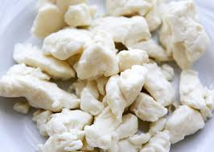
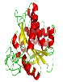
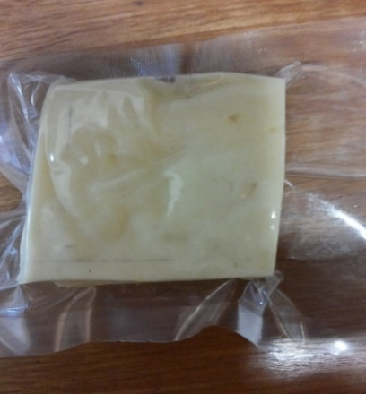
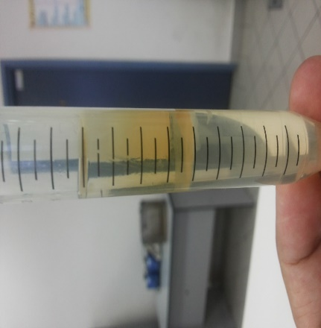
P. candidum PCA 1/TT031 protease
Cheddar curds
Ideal Cheddar cheese

Optimizing the Acceleration of Cheddar Cheese Ripening Using Response Surface Methodology by Microbial Protease Without Altering Its Quality Features

GRAPHIC ABSTRACT

