Supplementary materials
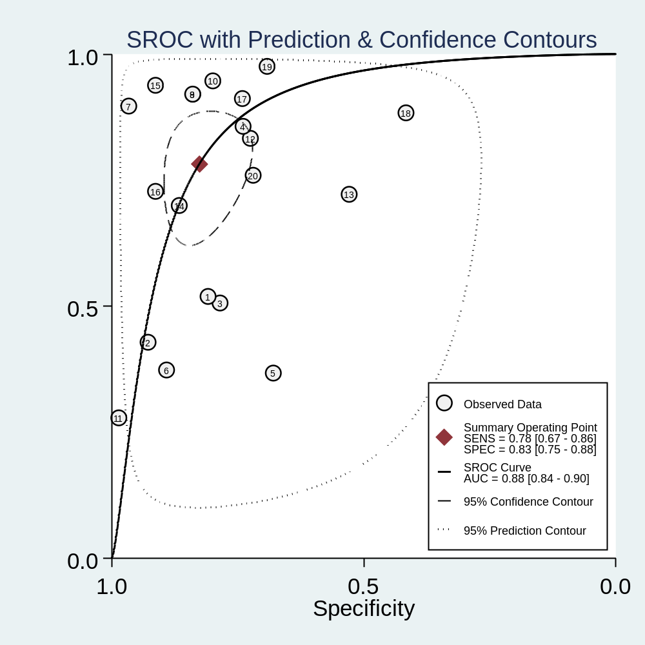
Figure S1 SROC curve for 20 sets of single miRNAs
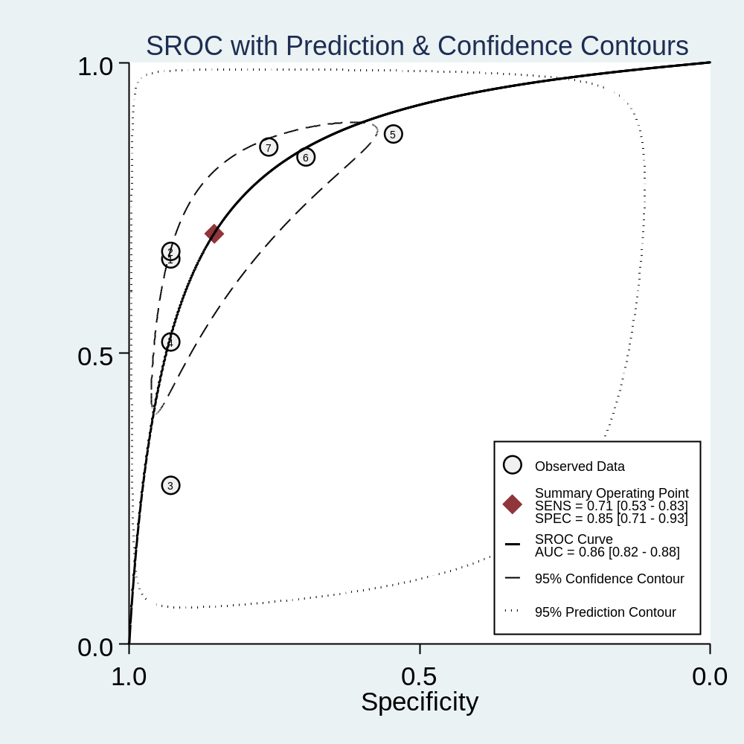
Figure S2 SROC curve for 7 sets of combined miRNAs

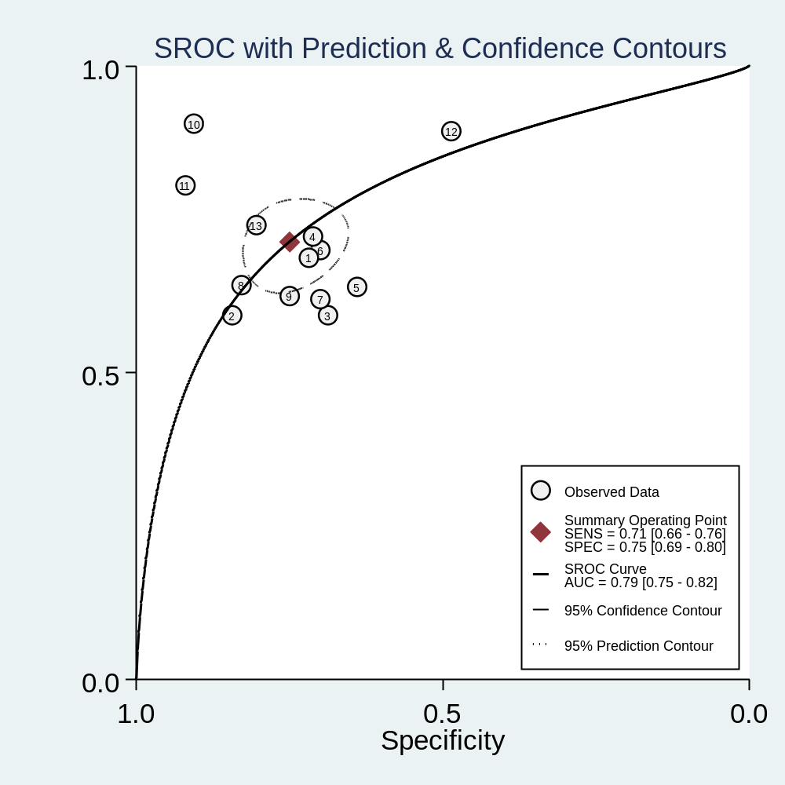
Figure S3 SROC curve for 13 sets of single lncRNAs
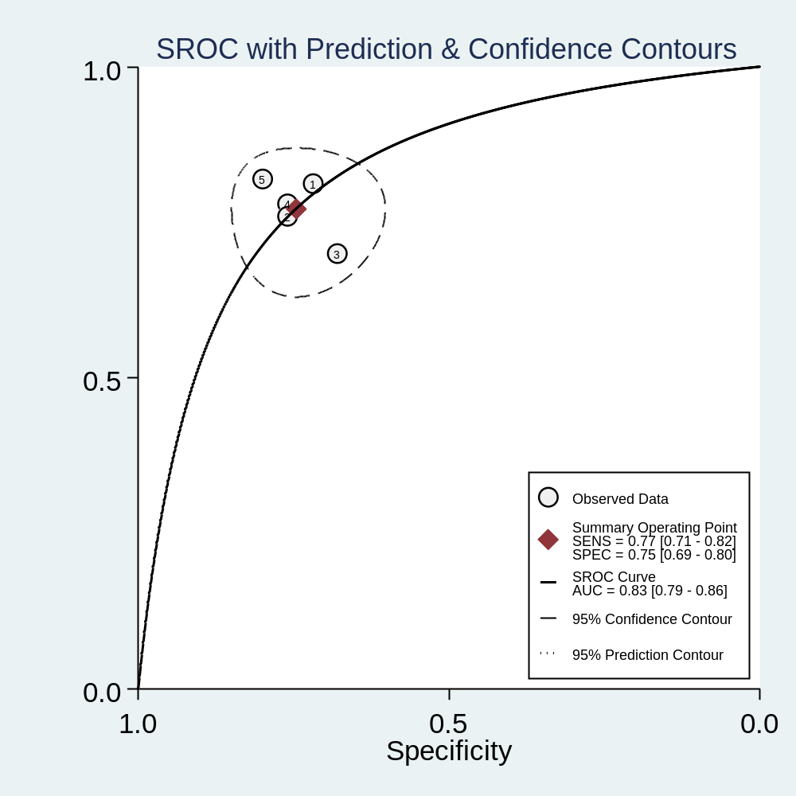 Figure S4 SROC curve for 5 sets of combined lncRNAs

Figure S5 Forest plots after excluding the 13th、17th、19tn、25th sets of miRNAs

Figure S6 Diagrams of miRNAs: (a)Goodness-of-fit, (b)Bivariate normality, (c)Influence analysis, (d)Outlier ditection. Goodness-of-fit and Bivariate normality showed that random effects model is suitable. Influence analysis showed studies weight more than others, and Outlier diection is responsible for heterogeneity.
Figure S7 Forest plots after excluding the 15th、16th、17th sets of lncRNAs

Figure S8 Diagrams of lncRNAs: (a)Goodness-of-fit, (b)Bivariate normality, (c)Influence analysis, (d)Outlier ditection.

