Additional File 3: Preferred Reporting Items for Systematic reviews and Meta-Analyses (PRISMA) Flow Chart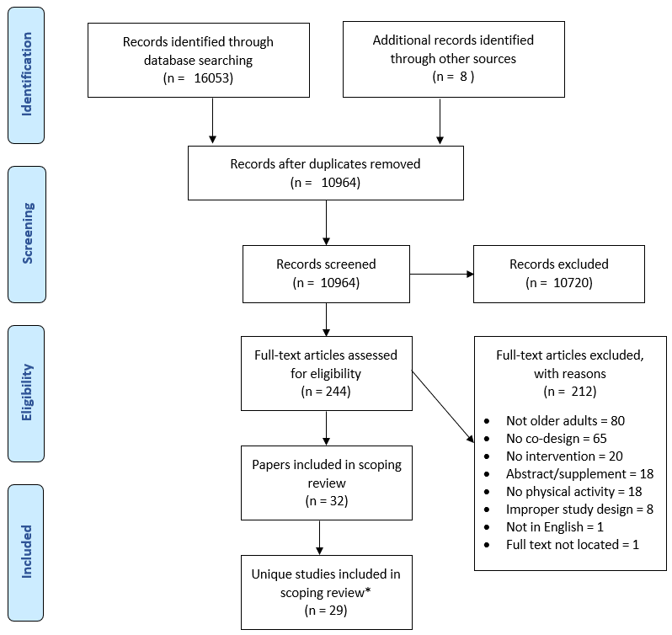

Reference: Moher D, Liberati A, Tetzlaff J, Altman DG, The PRISMA Group (2009). Preferred Reporting Items for Systematic Reviews and Meta Analyses: The PRISMA Statement. PLoS Med 6(7): e1000097. doi:10.1371/journal.pmed1000097 (37). *Three studies had secondary publications including a protocol paper and two qualitative papers associated with randomized controlled trials, leaving 29 unique studies.

