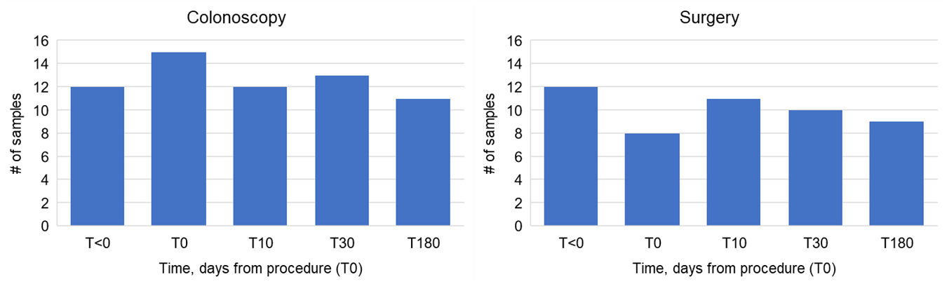
Supplemental Figure 1. Number of fecal samples included in comparisons among sample groups by patients that underwent A) colonoscopy and B) surgery, after sample normalization by rarefaction.

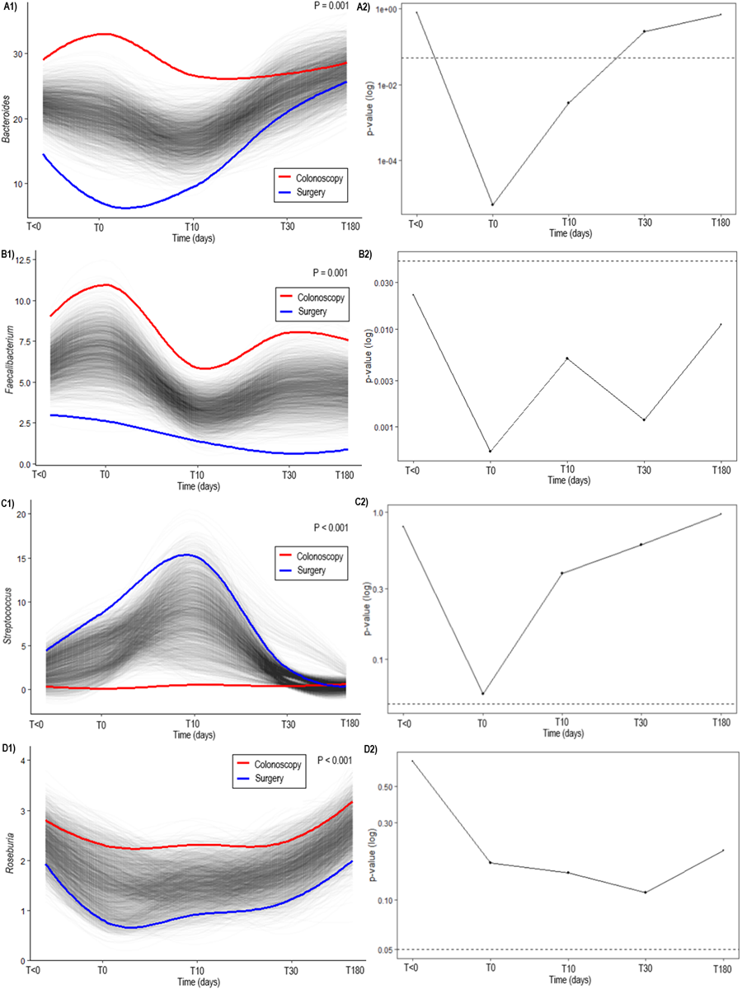
Supplemental Figure 2. Permuted spline tests for statistical significance in longitudinal microbial data shows differences between patients undergoing colonoscopy and surgery in relative abundance of A) Bacteroides, B) Faecalibacterium, C) Streptococcus, and D) Roseburia.

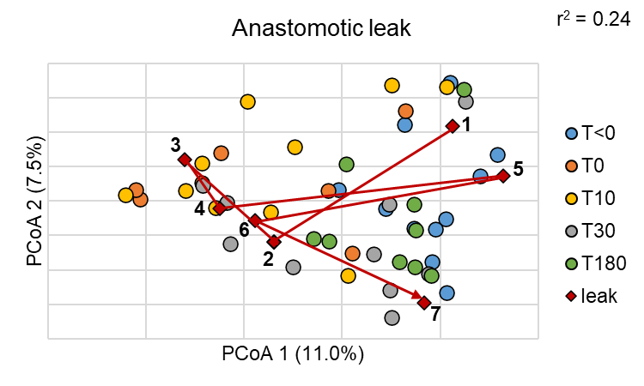
Supplemental Figure 3. Principle coordinate analysis of Bray-Curtis distances among samples collected over study course in patients that underwent surgery, including patient who had postoperative anastomotic leak (red). Samples 1 (T<0), 2 (T0), 3 (T1), 4 (T29), 5 (T153), 6 (T154), and 7 (T335) are shown.

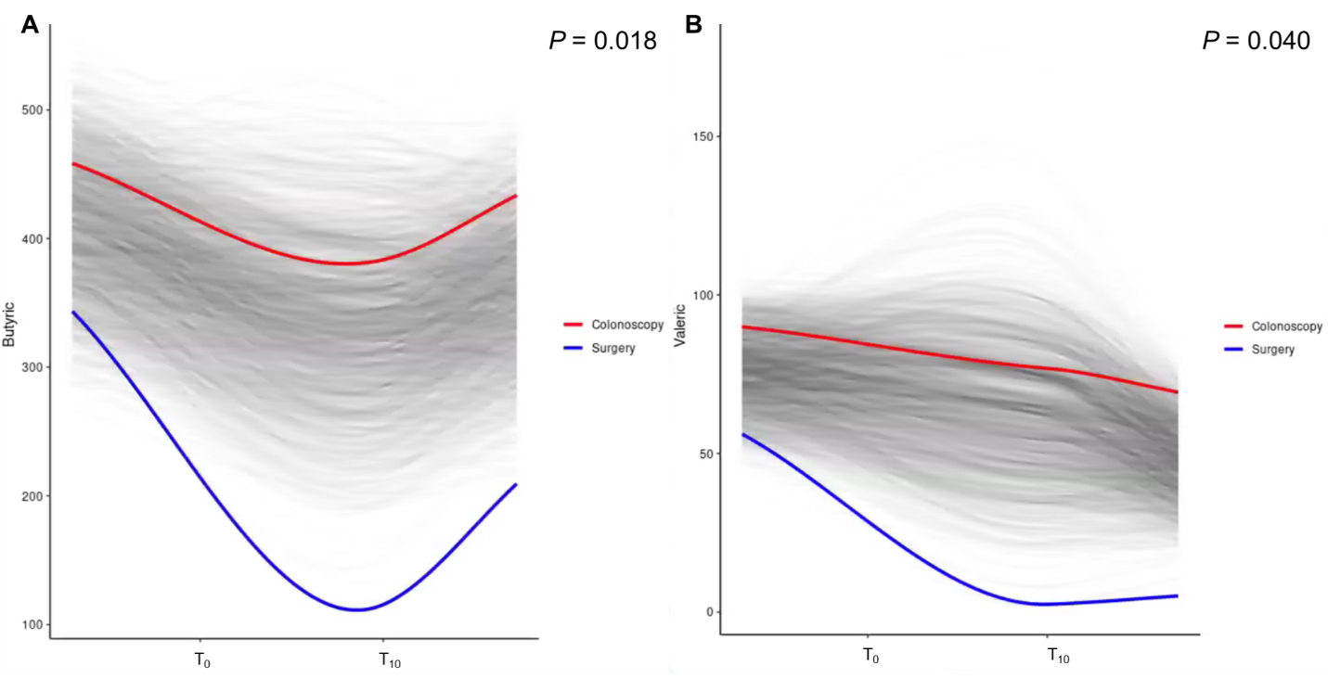 Supplemental Figure 4. Longitudinal analysis of SCFA concentrations. A) Butyric acid and B) valeric acid analyzed using SplinectomeR.

Supplemental Figure 5. (A) Fecal IgA concentrations and (B) Percent Fecal IgA concentrations relative to total protein prior to and acutely (T10) following colonoscopy or surgery.

Supplemental Figure 6. Fecal calprotectin concentrations prior to and acutely (T10) following colonoscopy or surgery.
Supplemental Table 1. Computational parameters and curve fit for SCFA analysis.
Compound | Quant Ion (m/z) | Expected RT (min) | Cal Curve | R²
Acetic Acid | 43.0185 | 5.339 | Y = 0.004861 * x + 1.976720 | 0.9939
Propionic Acid | 73.0286 | 5.966 | Y = 0.005784 * x + 0.9972377 | 0.9972
Isobutyric Acid | 73.0289 | 6.200 | Y = 0.009044 * x + 0.016972 | 0.9990
Butyric Acid | 55.0180 | 6.715 | Y = 0.005401 * x - 0.428140 | 0.9918
Isovaleric Acid | 60.0210 | 7.107 | Y = 0.025248 * x + 0.028839 | 0.9983
Valeric Acid | 60.0210 | 7.795 | Y = 0.026160 * x – 0.007053 | 0.9982
2-Ethylbutyric Acid | 88.0523 | 8.060
4-Methylvaleric Acid | 57.0703 | 8.503 | Y = 0.012271 * x – 0.011853 | 0.9956

Supplemental Table 2. Shannon indices (mean ± standard deviation) of fecal communities from patients undergoing colonoscopy and surgery. Time represented as days from procedure (T0). Samples sharing the same letter did not vary significantly by Tukey's post-hoc test (P<0.001).
Time (days) | Colonoscopy | Surgery
T<0 | 3.8 ± 0.3 A | 3.6 ± 0.4 A
T0 | 3.2 ± 0.4 AB | 3.4 ± 0.4 AB
T10 | 3.4 ± 0.7 AB | 2.8 ± 1.1 B
T30 | 3.7 ± 0.3 A | 3.1 ± 0.4 AB
T180 | 3.8 ± 0.4 A | 3.4 ± 0.3 AB

Supplemental Table 3. Spearman correlations relating SCFA concentrations to relative abundances of predominant genera. Values in parentheses are Spearman’s rho; P-values. Samples from all time points were used for each treatment group. No significant correlations were observed with 4-methylvaleric acid.
SCFA | Colonoscopy | Surgery
Acetic | Alistipes (-0.381; 0.039)  Collinsella (0.363; 0.049) | Parabacteroides (0.420; 0.038)  Blautia (0.742; < 0.0001)  Streptococcus (-0.564; 0.004)
Propionic | Faecalibacterium (-0.385; 0.037) | Bacteroides (0.402; 0.047)  Parabacteroides (0.657; < 0.0001)  Blautia (0.552; 0.005)  Streptococcus (-0.435; 0.031)
Isobutyric | Faecalibacterium (-0.426; 0.020)  Alistipes (0.482; 0.008)  Akkermansia (0.478; 0.008) | Parabacteroides (0.417; 0.039)  Blautia (0.440; 0.029)
Butyric | Roseburia (0.373; 0.043)  Collinsella (0.402; 0.028) | Parabacteroides (0.424; 0.036)  Blautia (0.608; 0.002)  Streptococcus (-0.488; 0.014)  Roseburia (0.49; 0.014)
Isovaleric | Faecalibacterium (-0.389; 0.034)  Alistipes (0.470; 0.009)  Akkermansia (0.526; 0.003) | Parabacteroides (0.441; 0.028)
Valeric | Faecalibacterium (-0.417; 0.023)  Alistipes (0.408; 0.026)  Akkermansia (0.423; 0.021) | Bacteroides (0.468; 0.019)  Parabacteroides (0.537; 0.006)  Blautia (0.586; 0.002)  Streptococcus (-0.508; 0.010)  Roseburia (0.460; 0.022)

