APPENDIX
Fig. 1. Comparison of the three measurements of LMR, NLR and PLR.

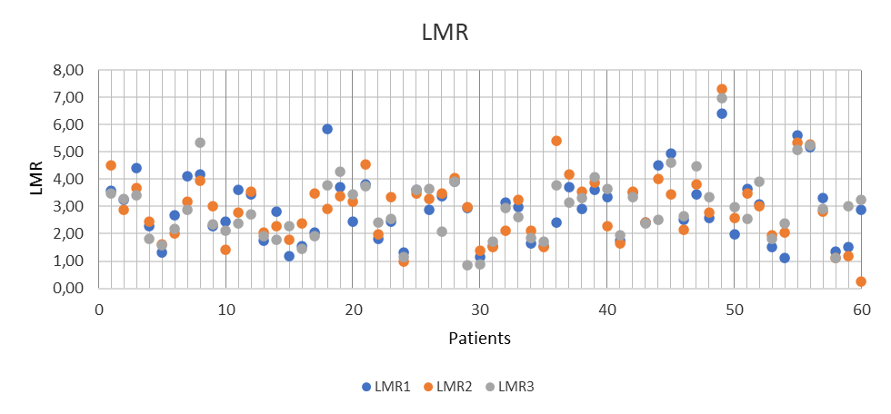
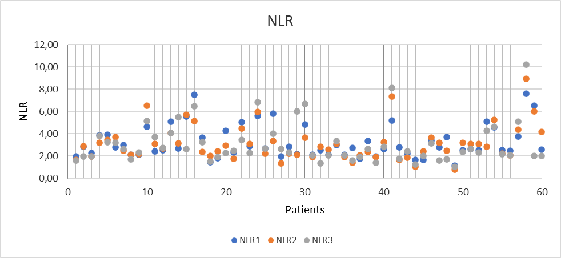
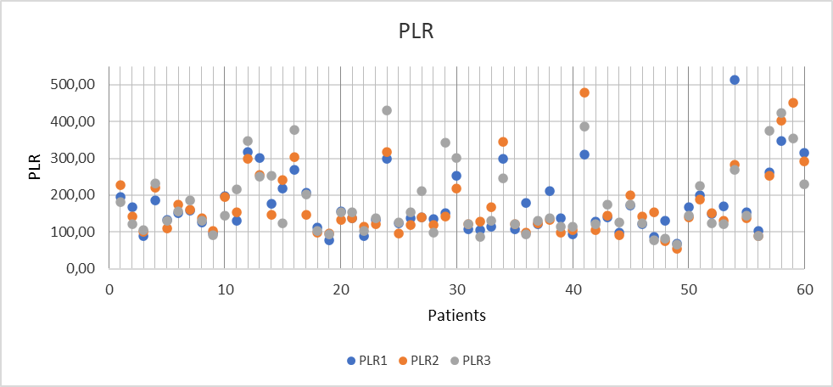
Figure 1
LMR- lymphocyte-to-monocyte ratio
NLR- neutrophil-to-lymphocyte ratio
PLR- platelet-to-lymphocyte ratio

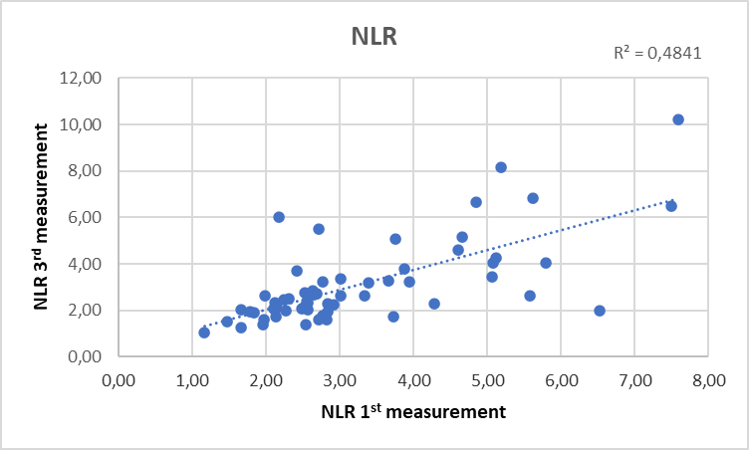
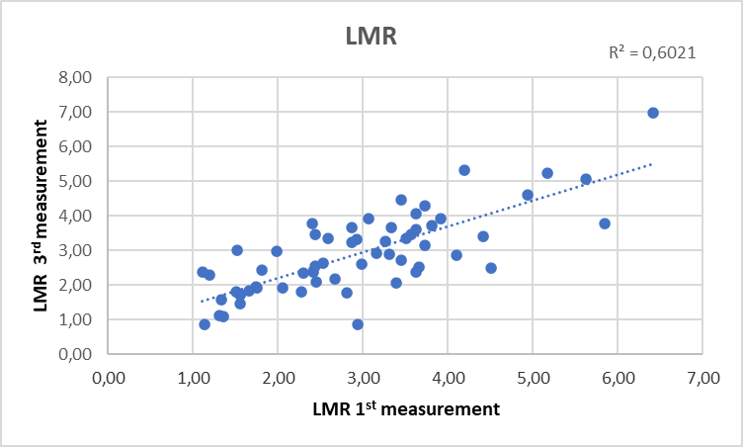
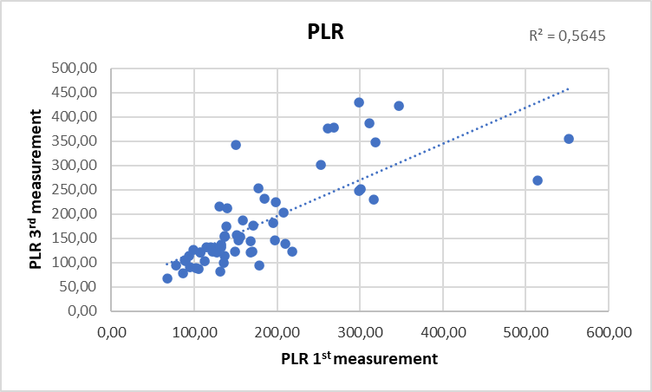
Fig. 2. The coefficient of determination of LMR, NLR and PLR
LMR- lymphocyte-to-monocyte ratio
NLR- neutrophil-to-lymphocyte ratio
PLR- platelet-to-lymphocyte ratio
R² – coefficient of determination

