AN EFFICIENT ONE POT MULTICOMPONENT SYNTHESIS OF DIHYDRO PYRAZOLYL BITHIAZOLE DERIVATIVESAS POTENTIAL ANTICANCER AGENTS AND THEIR MOLECULAR DOCKING STUDIES
Anjaneyulu V¹. Krishnaiah Vaarla². Rajesh Kumar Kesharwani³.
Panaganti Leelavathi¹.

Anjaneyulu V
anjaneyuluv2000@gmail.com

Krishnaiah Vaarla
Krishnaiahvaarla@gmail.com

RajeshKumar Kesharwani
raajiiit06@gmail.com

Panaganti Leelavathi
leelaou@gmail.com

¹Department of Chemistry, University College of Science, Osmania University, Hyderabad,Telangana, India.
²National Institute of Technology- Warangal, Warangal, Telangana, India.

³Department of Computer application, Nehru Gram Bharati (Deemed to be University), Prayagraj, India.

Supporting Information
S.No. | Table of Contents | Page No.
1 | Fig S1.¹H NMR spectrum of compound (4a) in DMSO-d₆. | S3
2 | Fig S2.¹H NMR spectrum of compound (4b) in DMSO-d₆. | S3
3 | Fig S3.¹H NMR spectrum of compound (4c) in DMSO-d₆. | S4
4 | Fig S4.¹H NMR spectrum of compound (4d) in DMSO-d₆. | S4
5 | Fig S5.¹H NMR spectrum of compound (4e) in DMSO-d₆. | S5
6 | Fig S6.¹H NMR spectrum of compound (4f) in DMSO-d₆. | S5
7 | Fig S7.¹H NMR spectrum of compound (4g) in DMSO-d₆. | S6
8 | Fig S8.¹H NMR spectrum of compound (4h) in DMSO-d₆. | S6
9 | Fig S9.¹H NMR spectrum of compound (4i) in DMSO-d₆. | S7
10 | Fig S10.¹H NMR spectrum of compound (4j) in DMSO-d₆. | S7
11 | Fig S11.¹H NMR spectrum of compound (4k) in DMSO-d₆. | S8
12 | Fig S12.¹³C NMR spectrum of compound (4a) in DMSO-d₆. | S8
13 | Fig S13.¹³C NMR spectrum of compound (4b) in DMSO-d₆+CDCl₃. | S9
14 | Fig S14.¹³C NMR spectrum of compound (4c) in DMSO-d₆+CDCl₃. | S9
15 | Fig S15.¹³C NMR spectrum of compound (4d) in DMSO-d₆+CDCl₃. | S10
16 | Fig S16.¹³C NMR spectrum of compound (4e) in DMSO-d₆+CDCl₃. | S10
17 | Fig S17.¹³C NMR spectrum of compound (4f) in DMSO-d₆+CDCl₃. | S11
18 | Fig S18.¹³C NMR spectrum of compound (4g) in DMSO-d₆+CDCl₃. | S11
19 | Fig S19.¹³C NMR spectrum of compound (4h) in DMSO-d₆+CDCl₃. | S12
20 | Fig S20.¹³C NMR spectrum of compound (4i) in DMSO-d₆+CDCl₃. | S12
21 | Fig S21.¹³C NMR spectrum of compound (4j) in DMSO-d₆. | S13
22 | Fig S22.¹³C NMR spectrum of compound (4k) in DMSO-d₆+CDCl₃. | S13
23 | Fig S23. Mass spectrum of compound (4a). | S14
24 | Fig S24. Mass spectrum of compound (4b). | S14
25 | Fig S25. Mass spectrum of compound (4c). | S15
26 | Fig S26. Mass spectrum of compound (4d). | S15
27 | Fig S27. Mass spectrum of compound (4e). | S16
28 | Fig S28. Mass spectrum of compound (4f). | S16
29 | Fig S29. Mass spectrum of compound (4g). | S17
30 | Fig S30. Mass spectrum of compound (4h). | S17
31  32 | Fig S31. Mass spectrum of compound (4i).  Fig S32. Mass spectrum of compound (4j). | S18  S18
33 | Fig S33. Mass spectrum of compound (4k). | S19

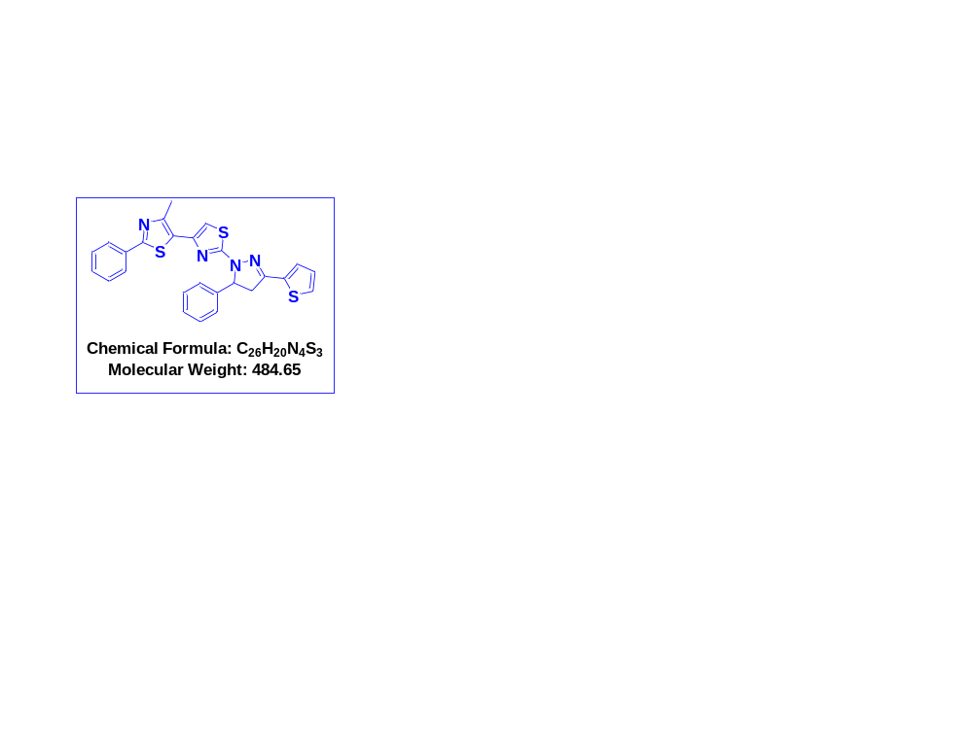
Fig S1.¹H NMR spectrum of compound (4a) in DMSO-d₆.

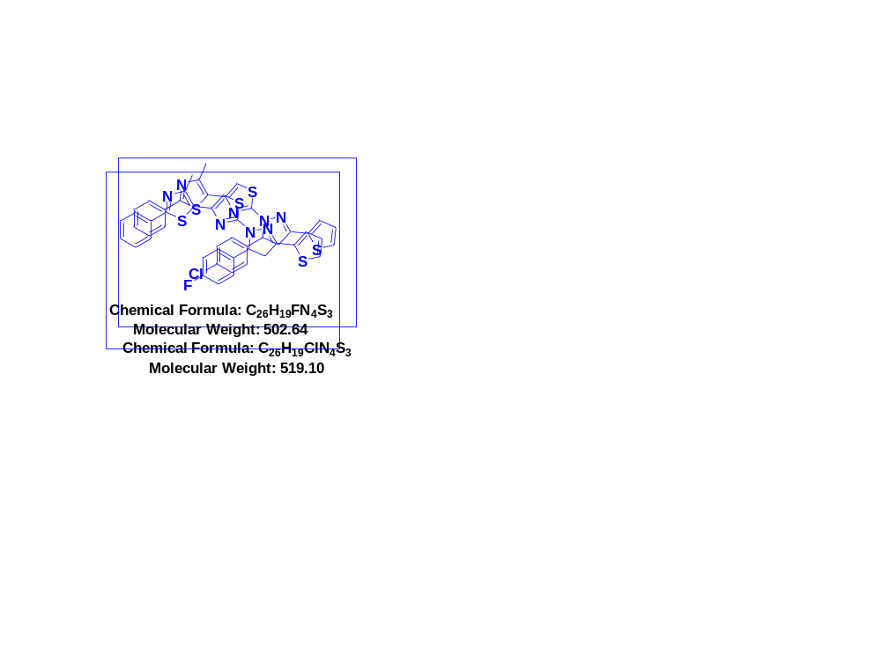
Fig S2.¹H NMR spectrum of compound (4b) in DMSO-d₆.
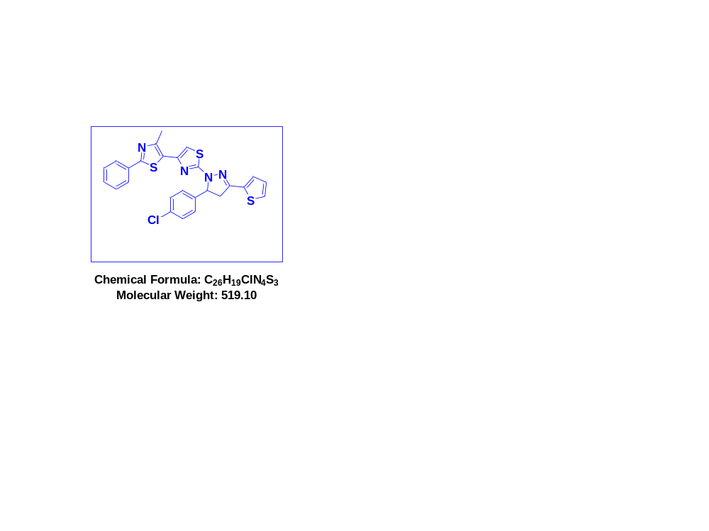
Fig S3.¹H NMR spectrum of compound (4c) in DMSO-d₆.

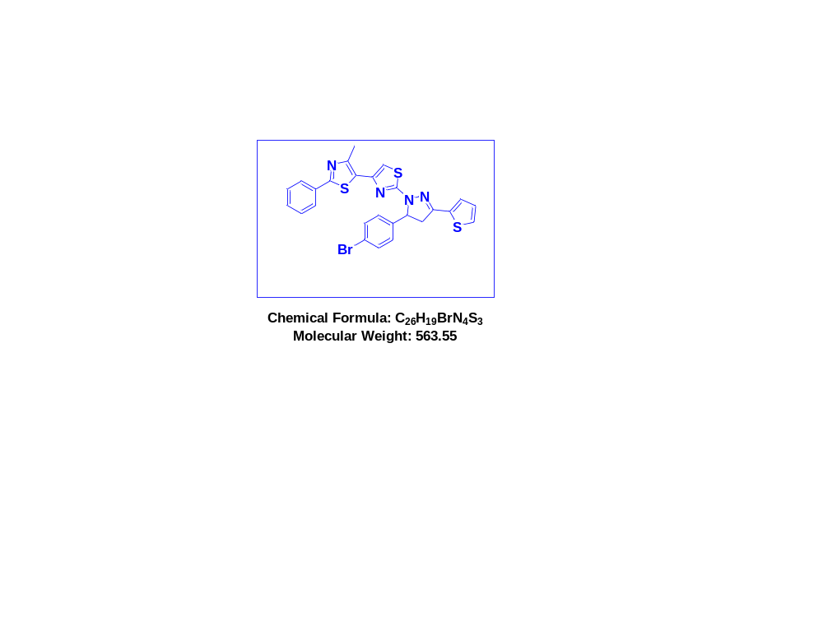
Fig S4.¹H NMR spectrum of compound (4d) in DMSO-d₆.
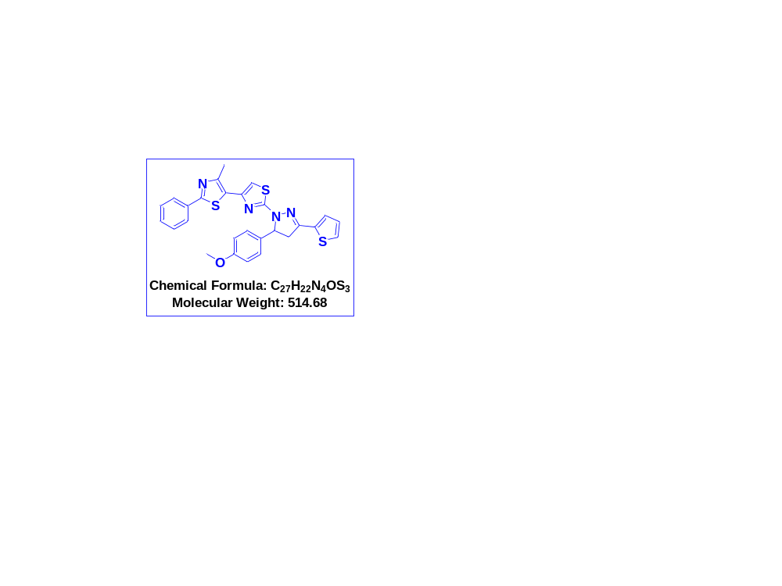
Fig S5.¹H NMR spectrum of compound (4e) in DMSO-d₆.

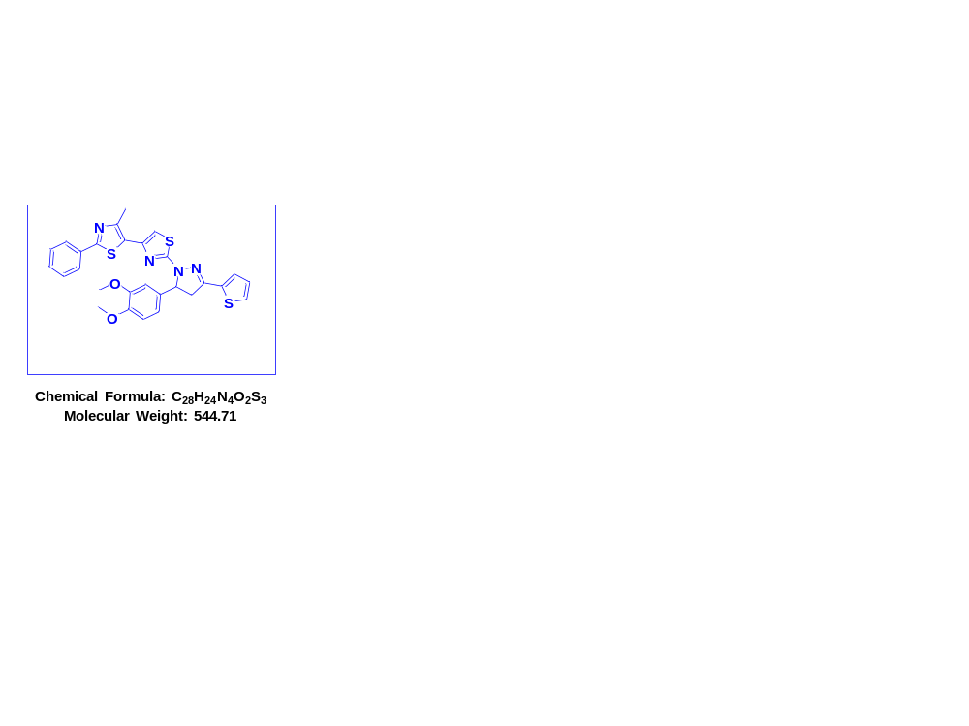
Fig S6.¹H NMR spectrum of compound (4f) in DMSO-d₆.

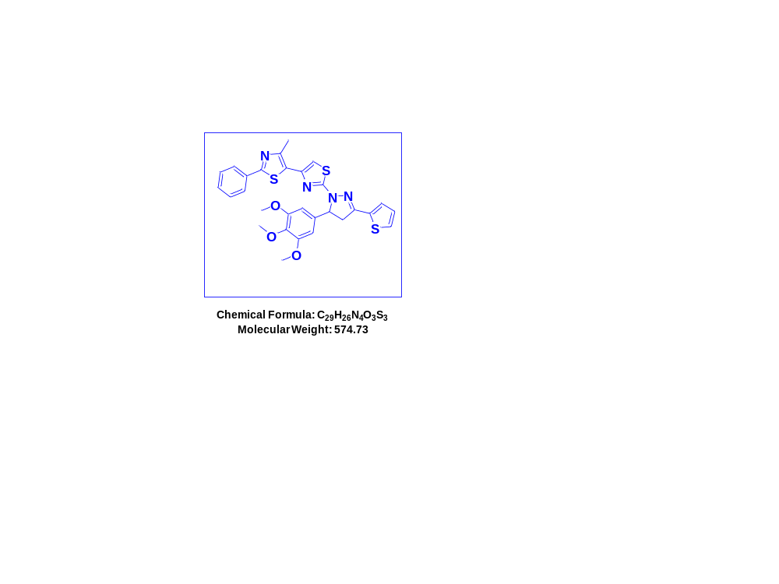
Fig S7.¹H NMR spectrum of compound (4g) in DMSO-d₆.

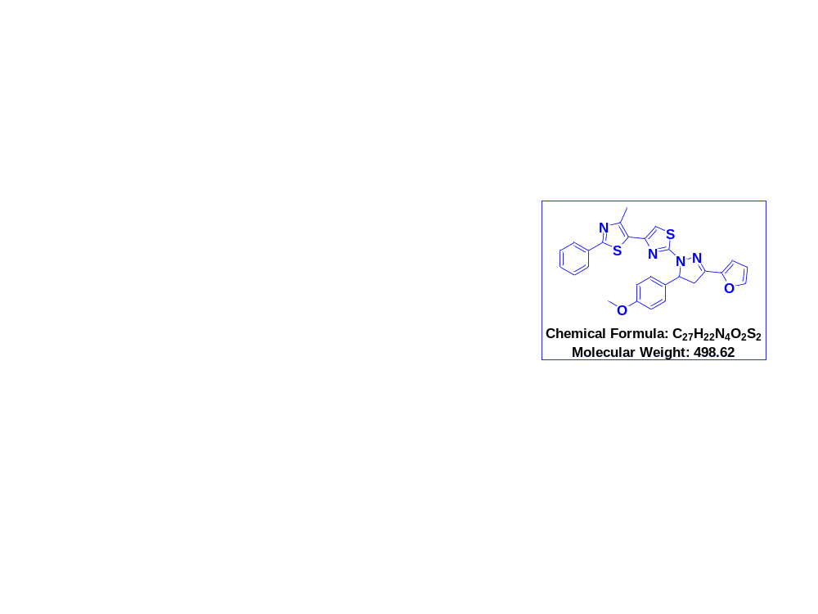
Fig S8.¹H NMR spectrum of compound (4h) in DMSO-d₆.

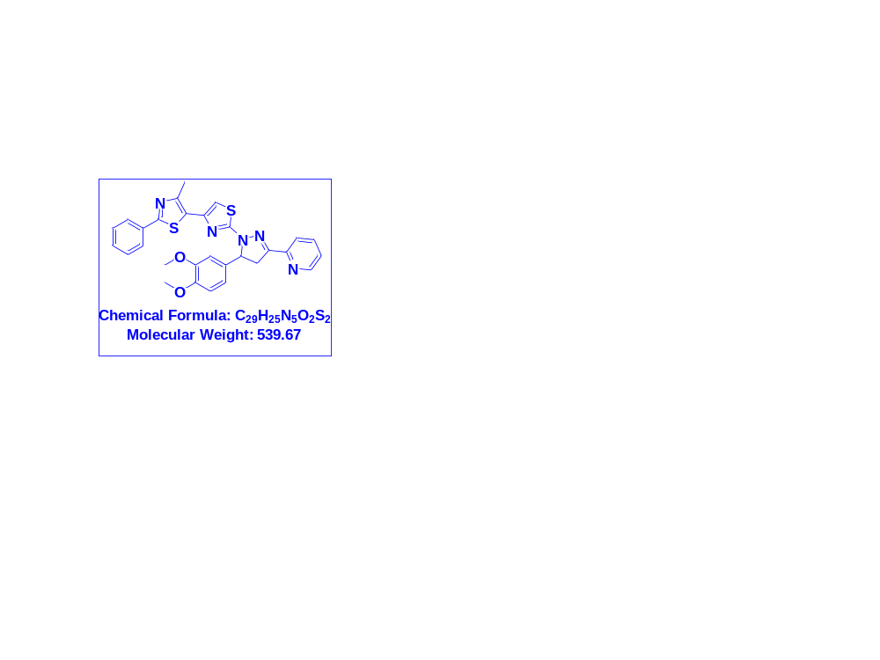
Fig S9.¹H NMR spectrum of compound (4i) in DMSO-d₆.

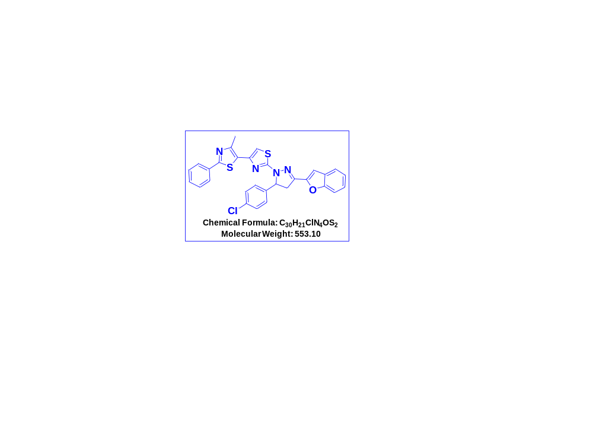
Fig S10.¹H NMR spectrum of compound (4j) in DMSO-d₆.
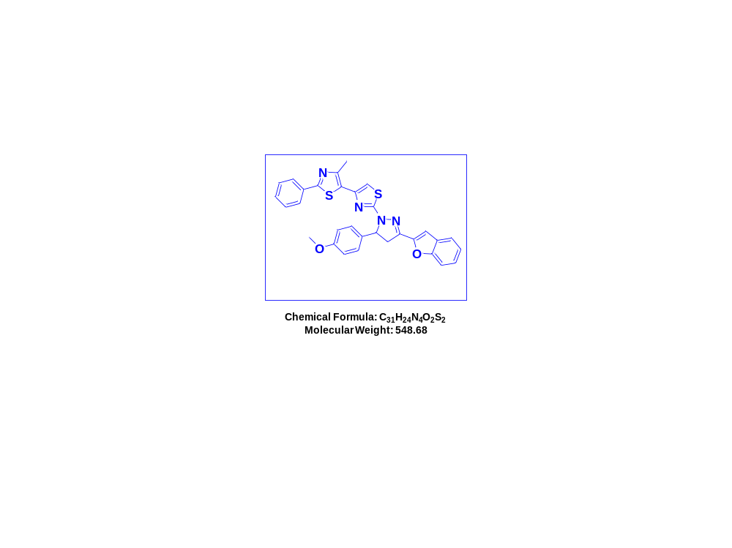
Fig S11.¹H NMR spectrum of compound (4k) in DMSO-d₆.

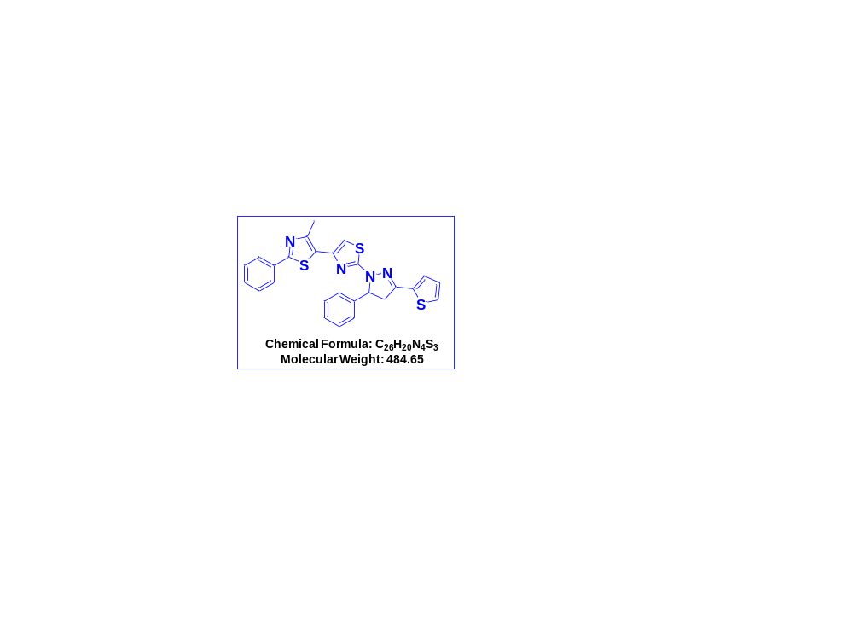
Fig S12.¹³C NMR spectrum of compound (4a) in DMSO-d₆.
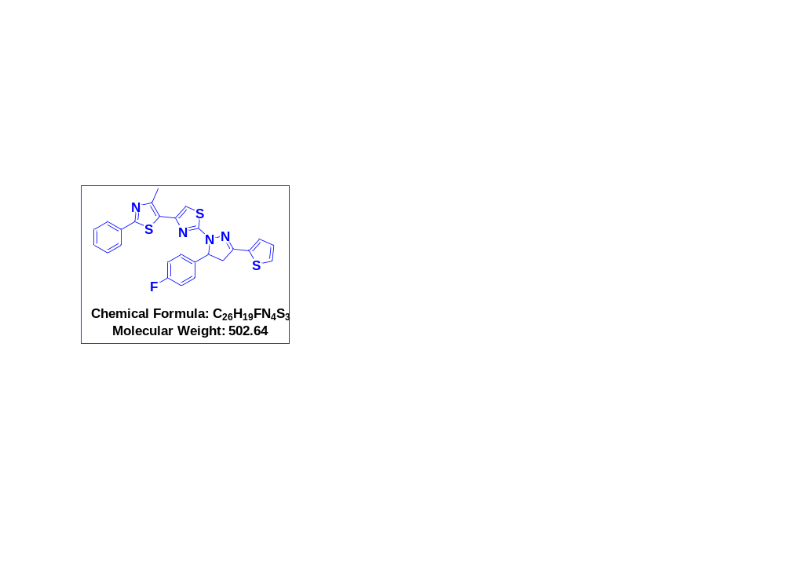
Fig S13.¹³C NMR spectrum of compound (4b) in DMSO-d₆+CDCl₃.

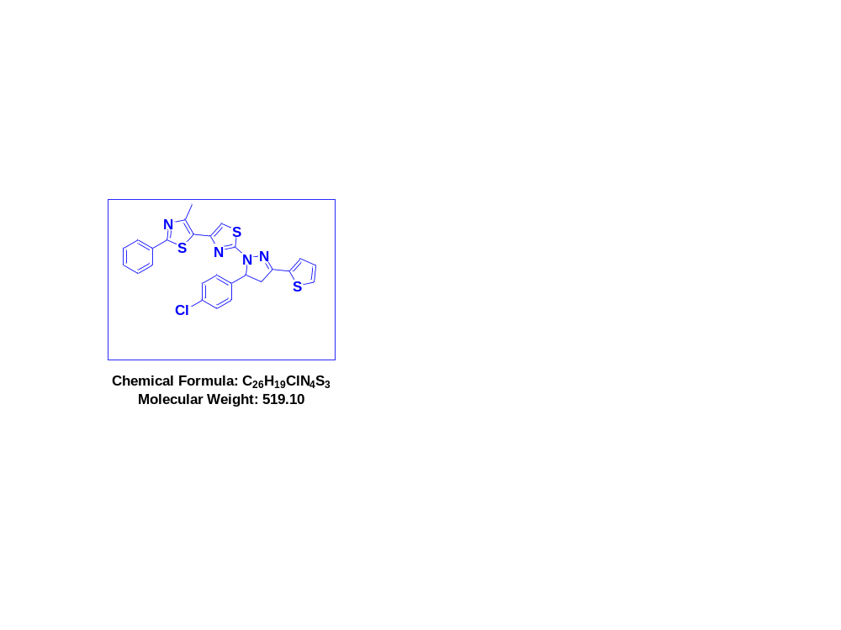
Fig S14.¹³C NMR spectrum of compound (4c) in DMSO-d₆+CDCl₃.

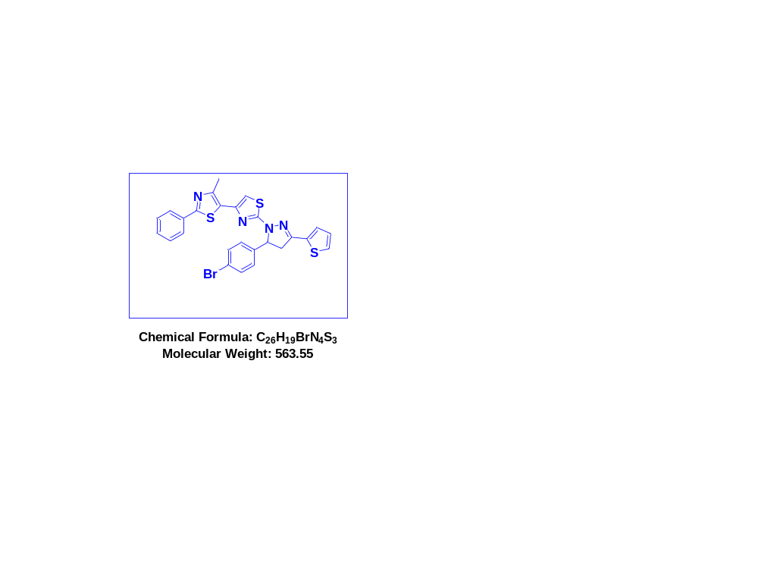.
Fig S15.¹³C NMR spectrum of compound (4d) in DMSO-d₆+CDCl₃.

Fig S16.¹³C NMR spectrum of compound (4e) in DMSO-d₆+CDCl₃.
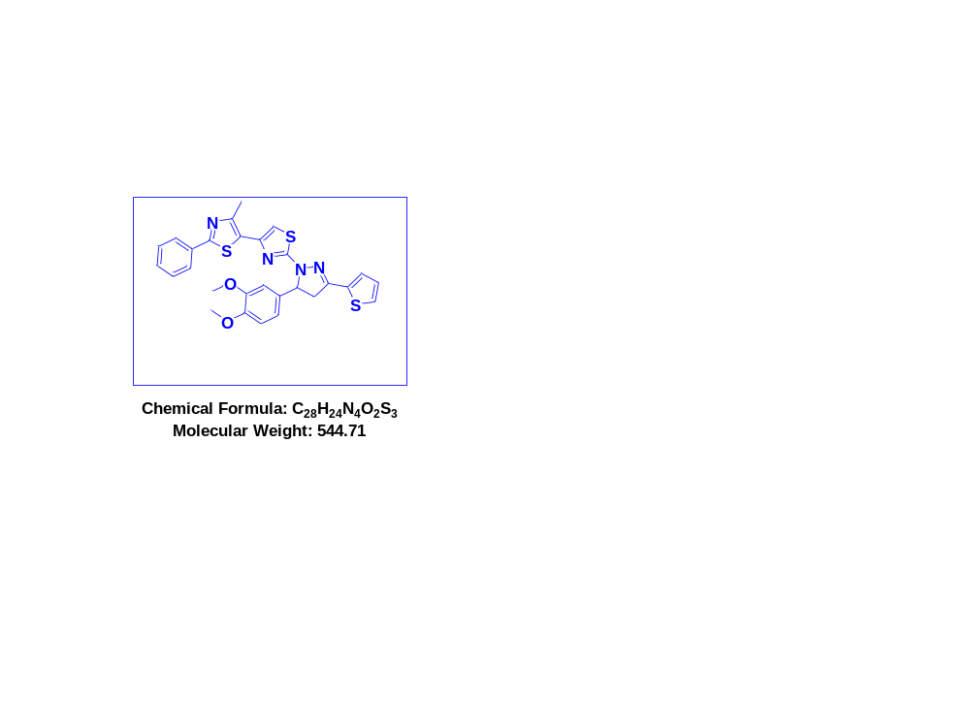.
Fig S17.¹³C NMR spectrum of compound (4f) in DMSO-d₆+CDCl₃.

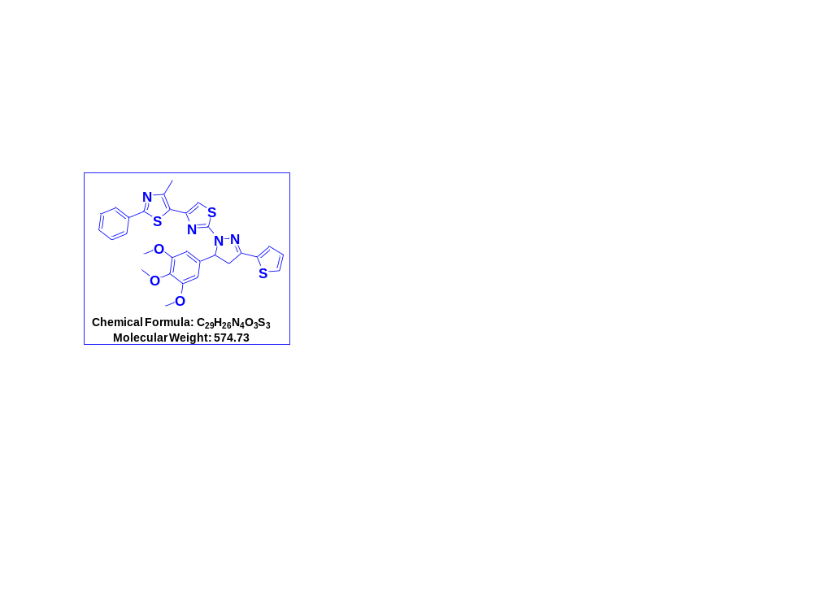
Fig S18.¹³C NMR spectrum of compound (4g) in DMSO-d₆+CDCl₃.
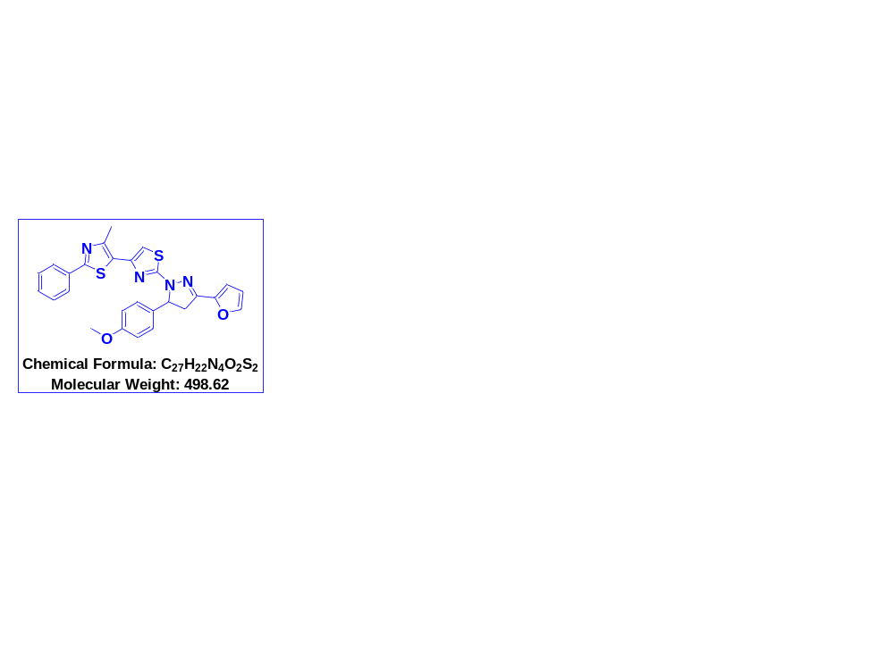.
Fig S19.¹³C NMR spectrum of compound (4h) in DMSO-d₆+CDCl₃.

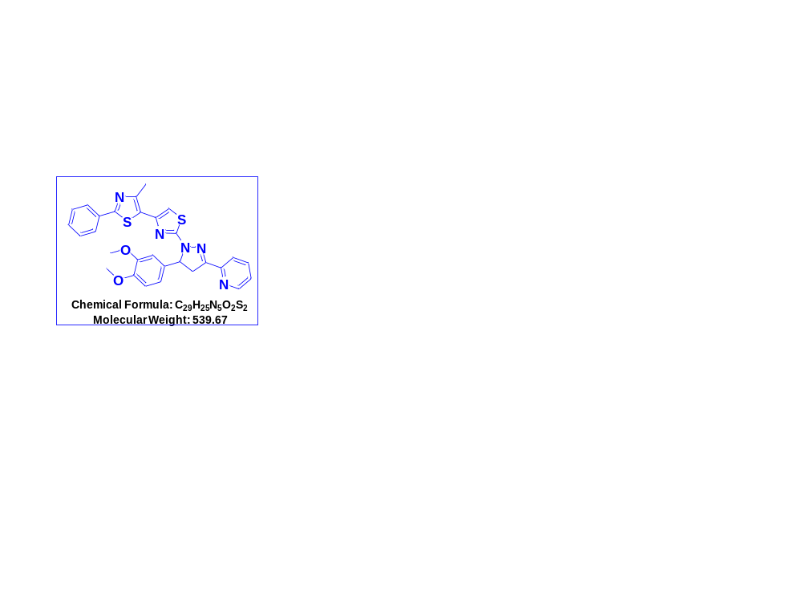
Fig S20.¹³C NMR spectrum of compound (4i) in DMSO-d₆+CDCl₃.
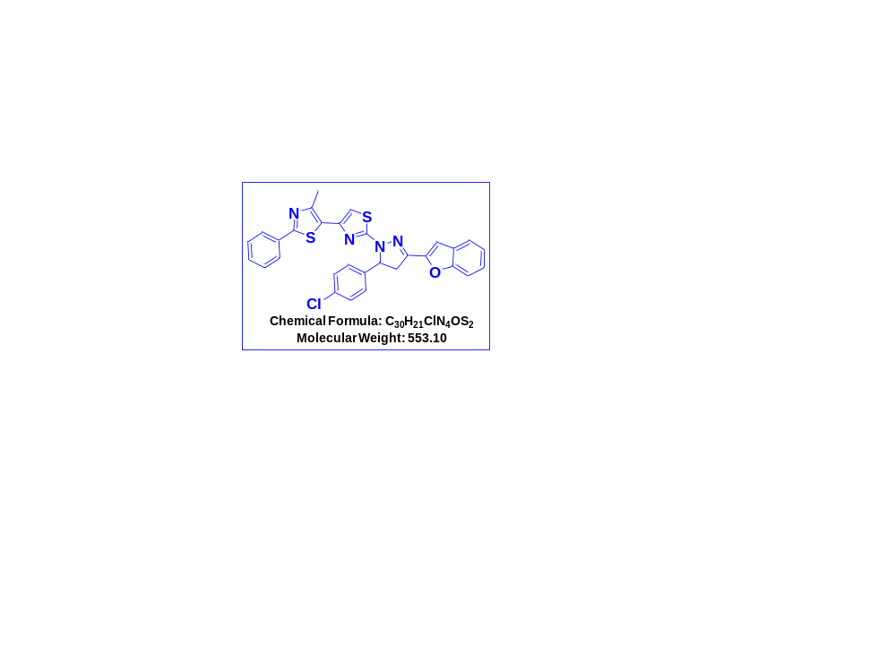
Fig S21.¹³C NMR spectrum of compound (4j) in DMSO-d₆.

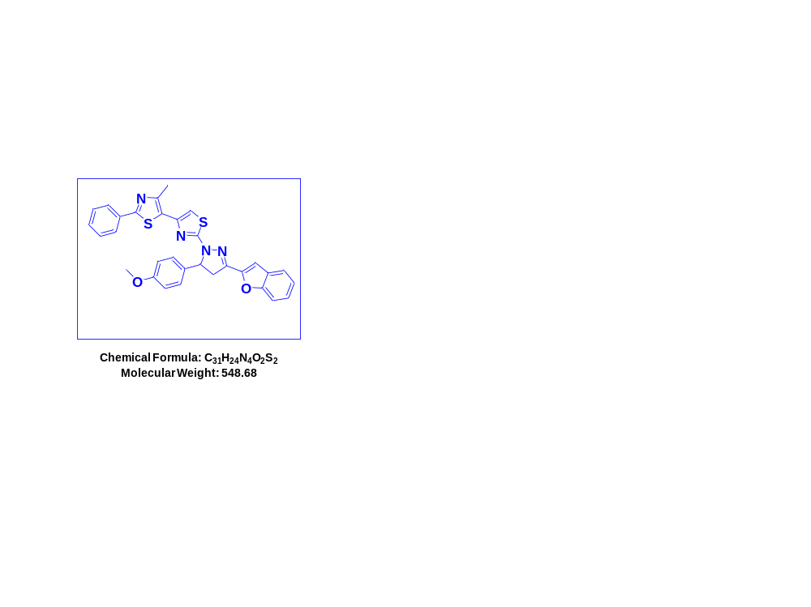
Fig S22.¹³C NMR spectrum of compound (4k) in DMSO-d₆+CDCl₃.

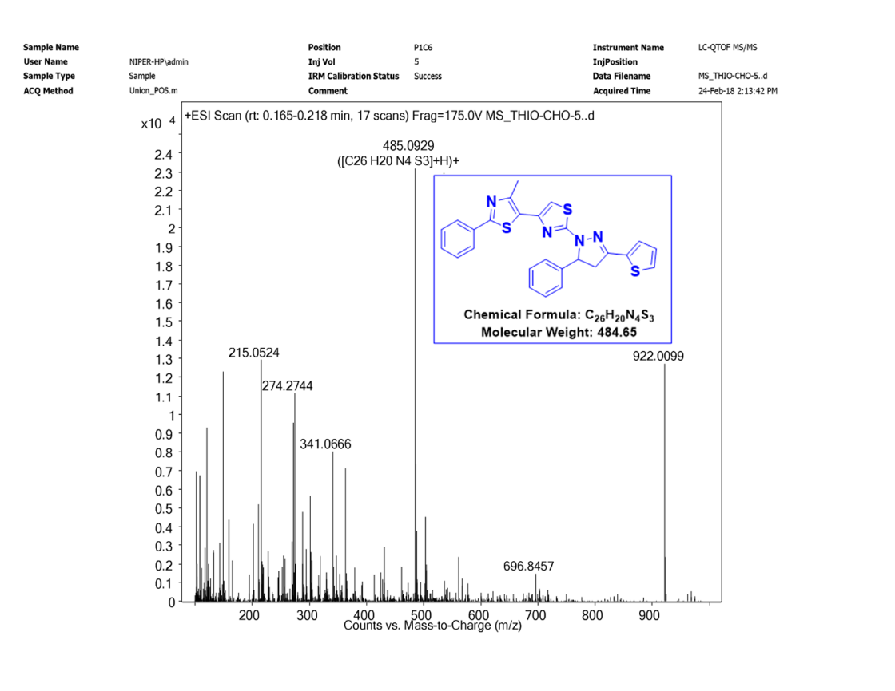
Fig S23. Mass spectrum of compound (4a).

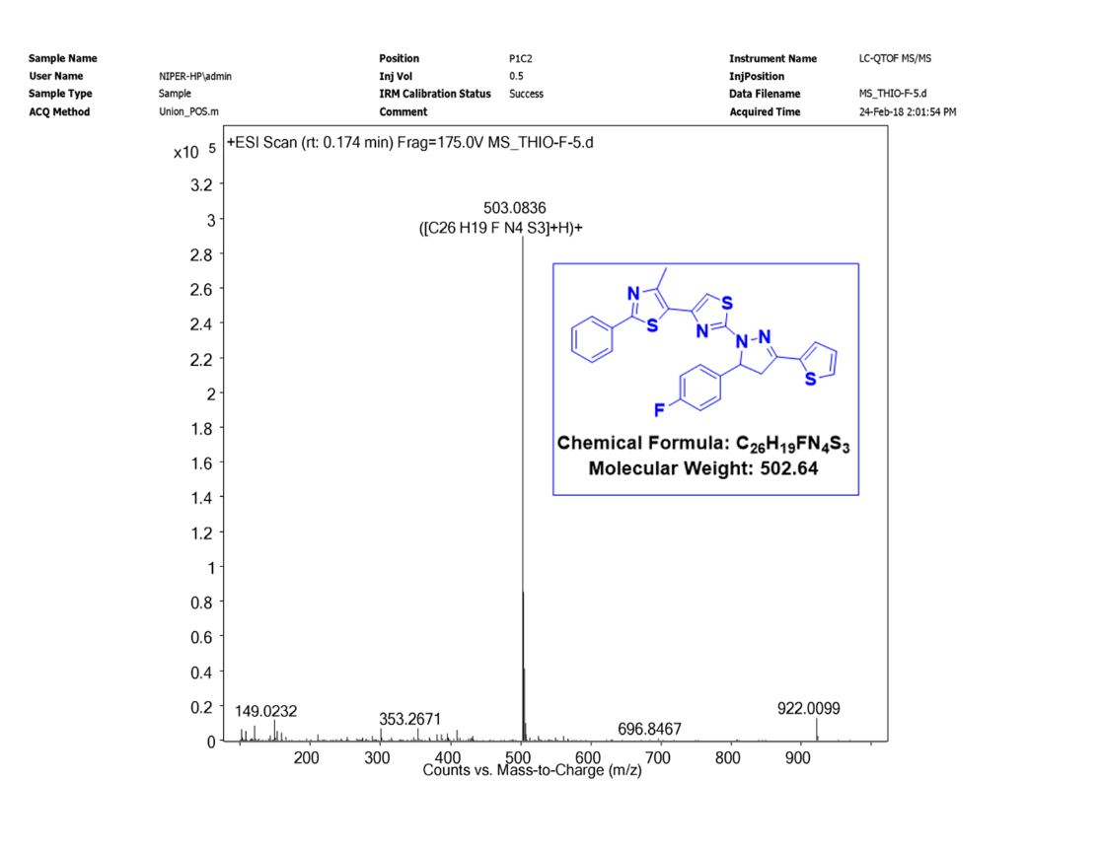
Fig S24. Mass spectrum of compound (4b).
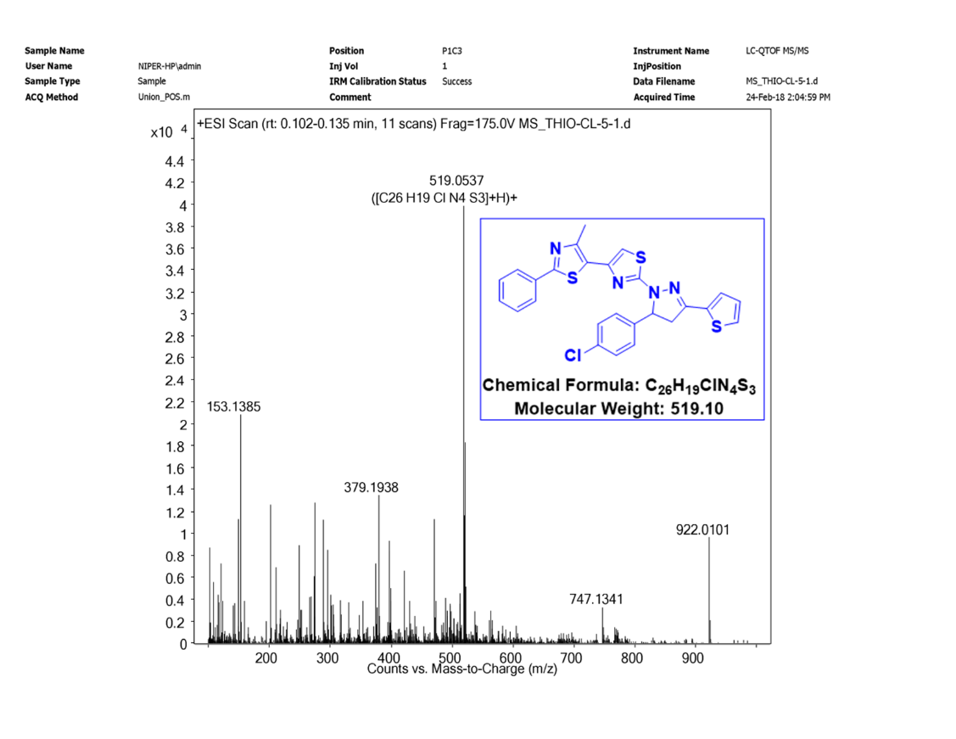
Fig S25.Mass spectrum of compound (4c).

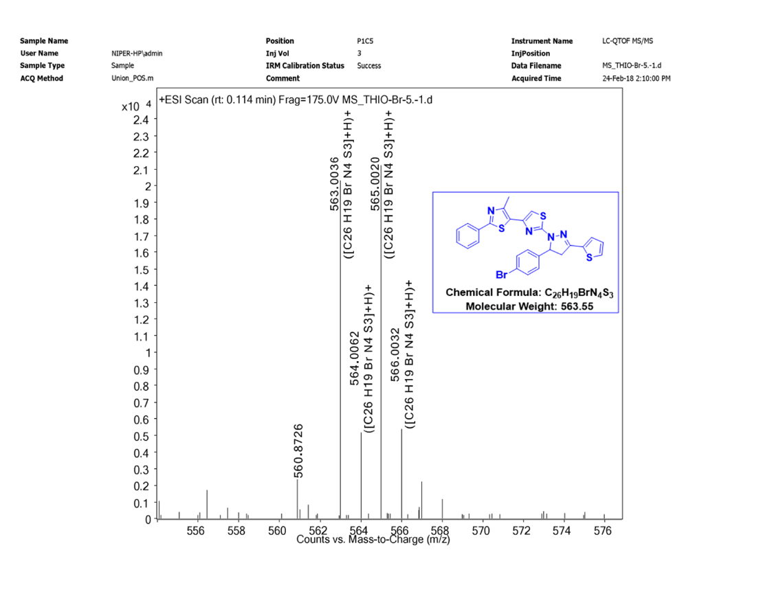
Fig S26. Mass spectrum of compound (4d).
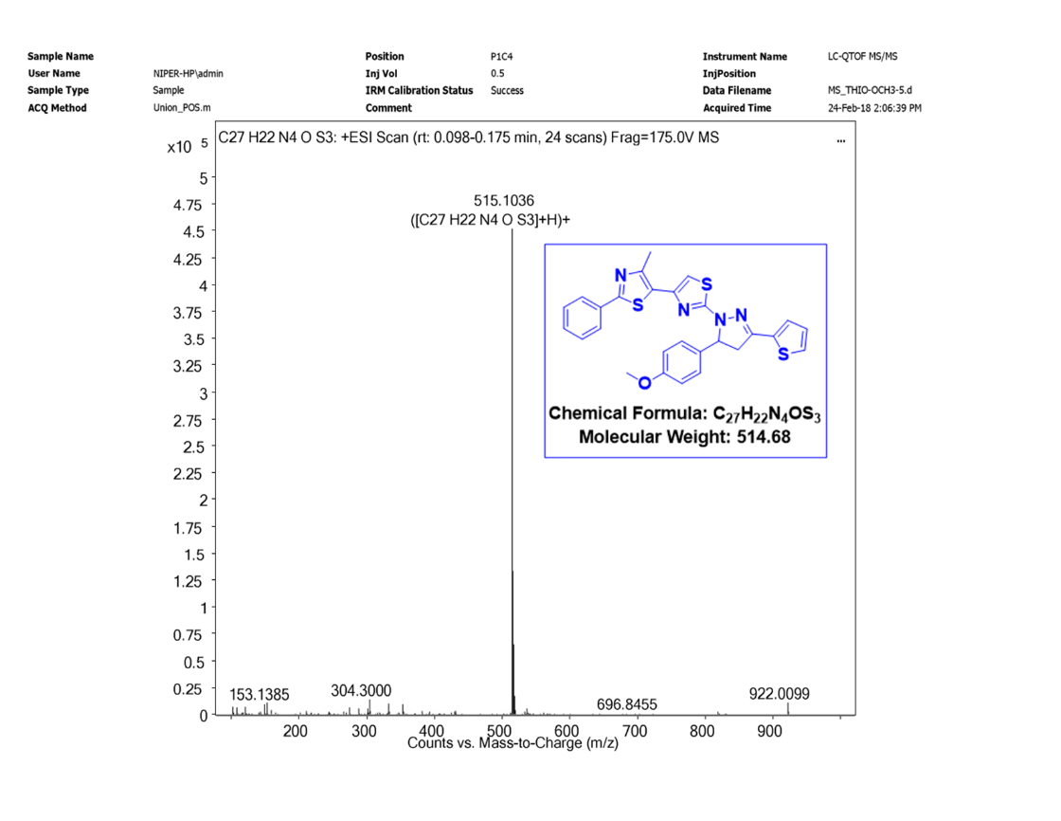
Fig S27. Mass spectrum of compound (4e).

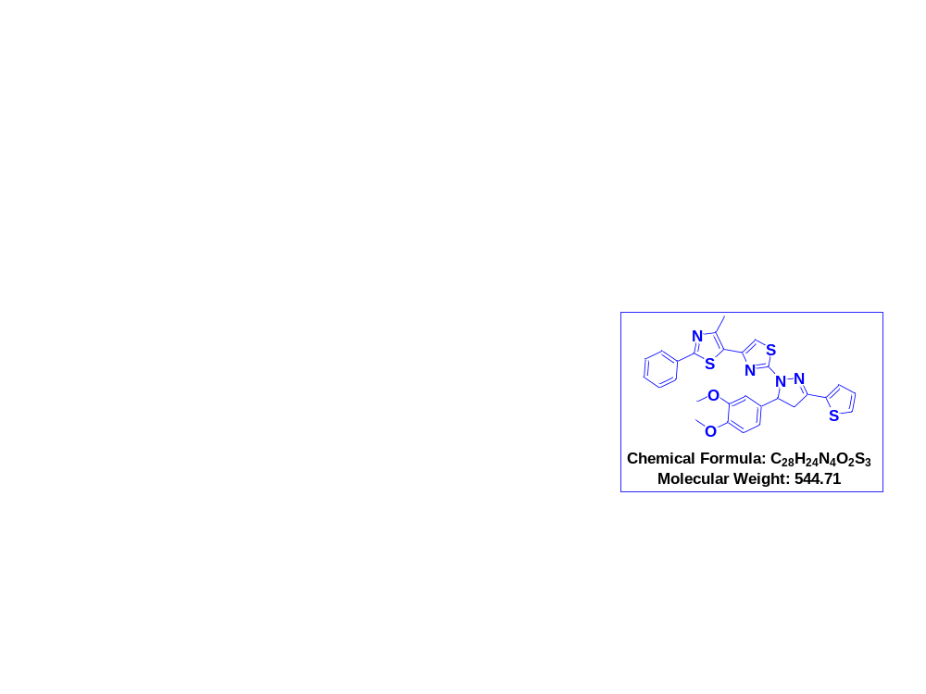.
Fig S28. Mass spectrum of compound (4f).
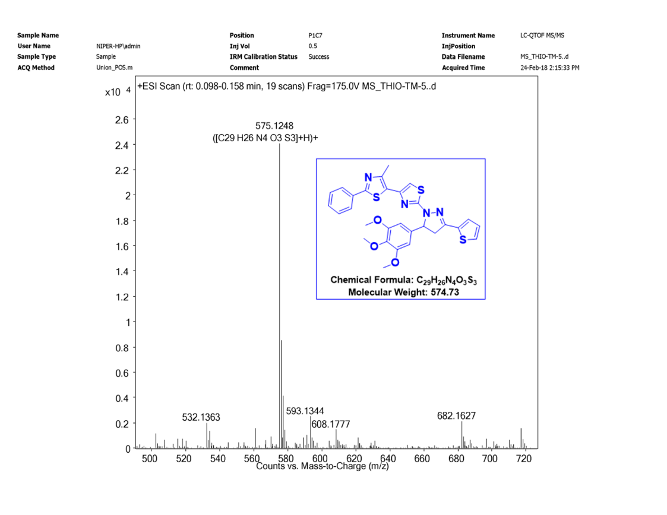
Fig S29. Mass spectrum of compound (4g).

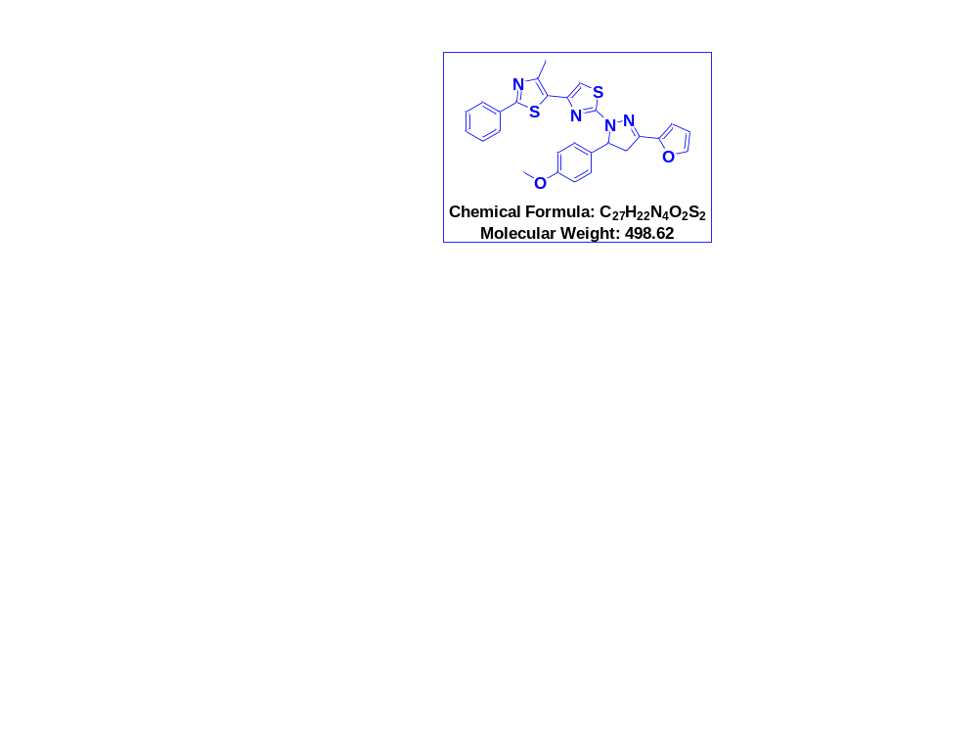
Fig S30. Mass spectrum of compound (4h).
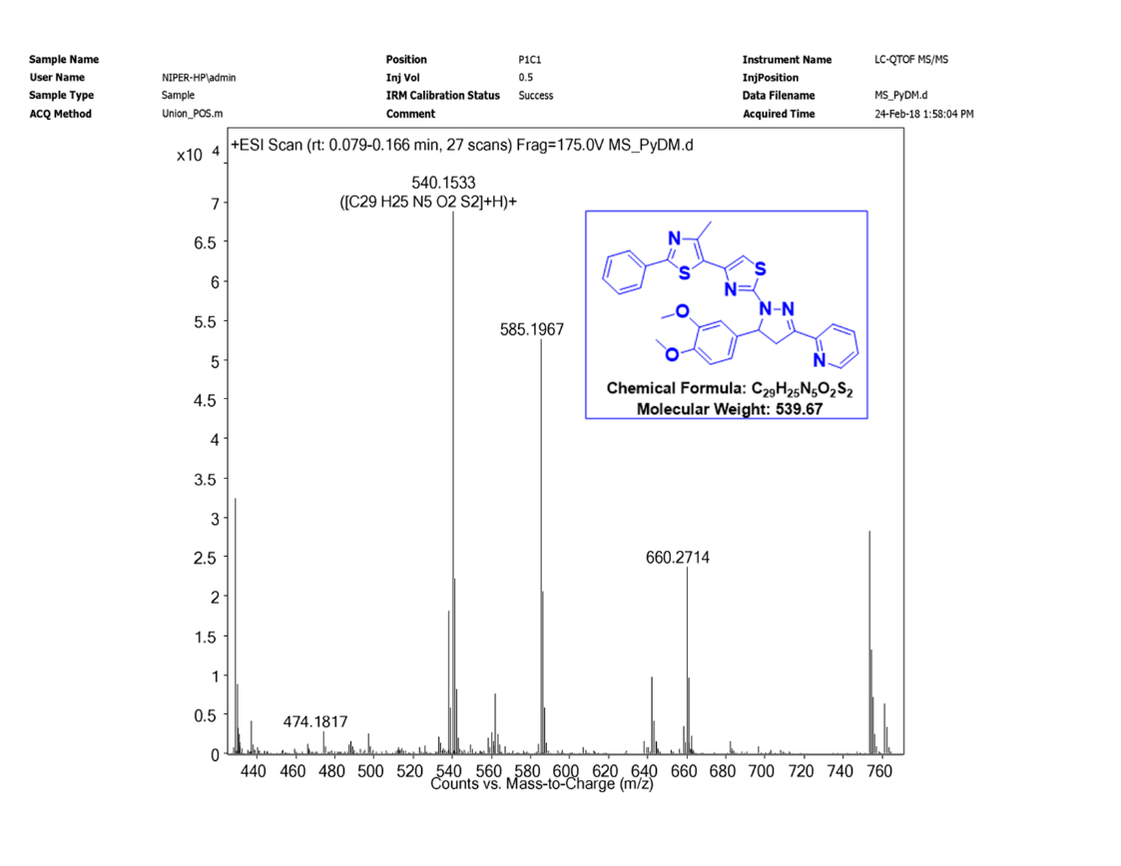
Fig S31. Mass spectrum of compound (4i).

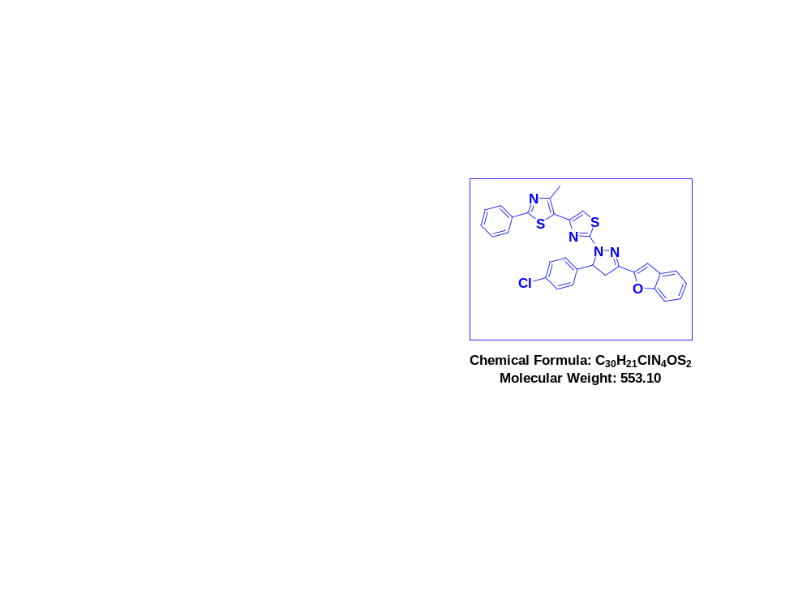
Fig S32. Mass spectrum of compound (4j).

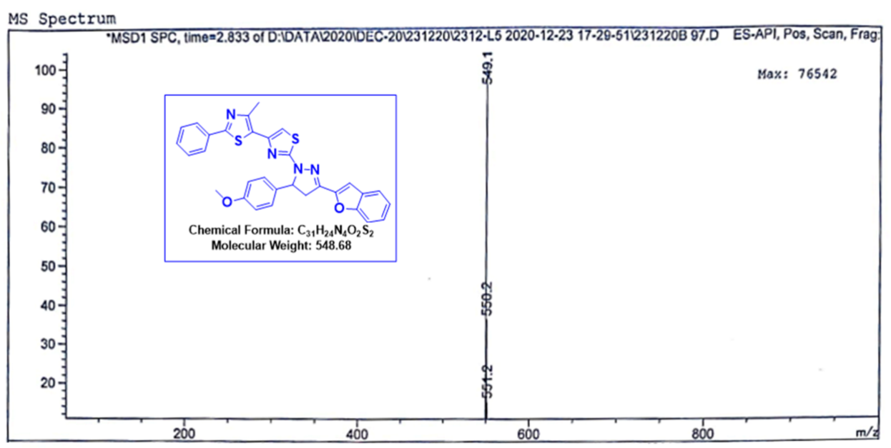
Fig S32. Mass spectrum of compound (4k).

